PowerBI final deliverable
  - Het Lux Lab
By: Barnabas Katona

Introduction
In this document I aim to show my initiatives and contributions to the final PowerBI deliverable to HetLuxLab. I created this PowerBI project after I finished my main contributions described in the “HetlLuxLab_python_final_deliv_contributions.pdf”. The main purpose of this project was to validate the results provided by the Python version and to improve my individual PowerBI skills. I am very pleased to say that both of those goals were achieved.

Main Body
The homepage looks as the following:
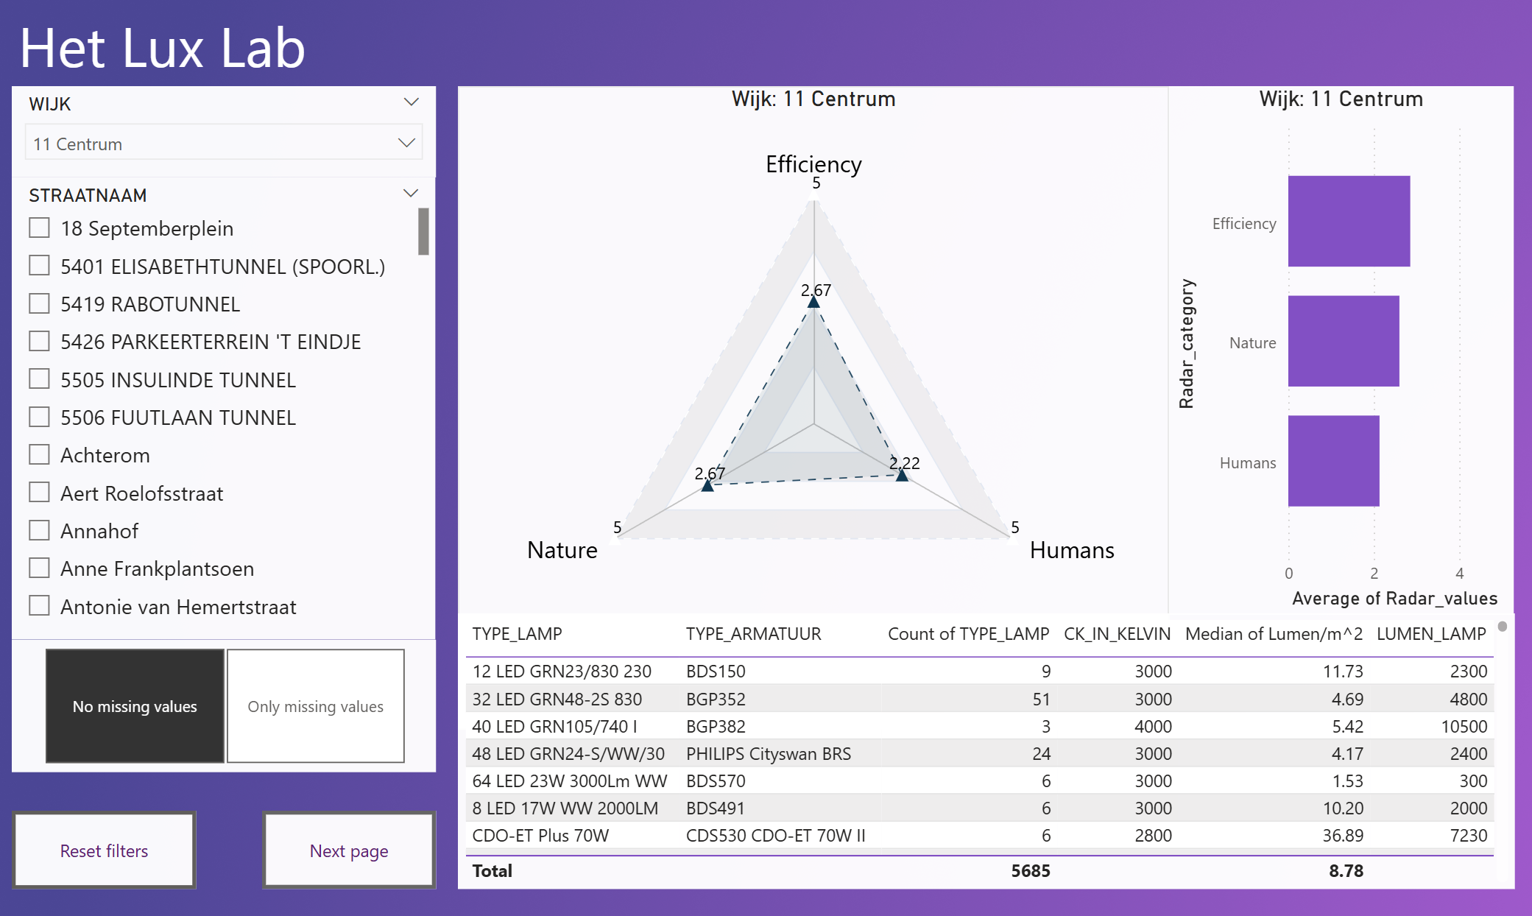
First the user should select a “Wijk” on the top left drop-down list, then a specific “Street” from the list below. After this 3 main components of the page are filled, the radar graph, the column graph and the table view.
The spider graph shown in the middle of the screen show the relationships between the specific criterias created by LuxLab on a scale of 1-5. This was a bit challenging to create as PowerBI doesn’t have a built in Radar graph function. I explored several external packages until I was able to reach the one shown above.
The table view on the bottom shows very specific details about the lamp posts in the selected Street. The rows are grouped by the “TYPE_LAMP” and “TYPE_ARMARATUUR” combinations and several columns are showing details to the user. The User can click a row and then a new bar is going to be created in the bar plot, which shows how the specific lamp armaratuur combination compares to the rest of the lamps in the street. The client had given very positive feedback about this feature.
The Bar plot graph shows the same information as the Radar graph, with the added functionality mentioned in the previous paragraph.

Functions
- Filter data on “Wijk”
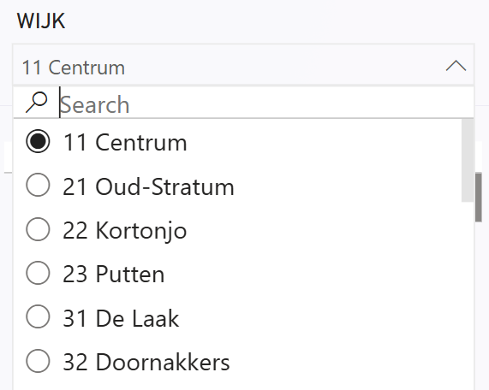
- Filter data on “Straat”
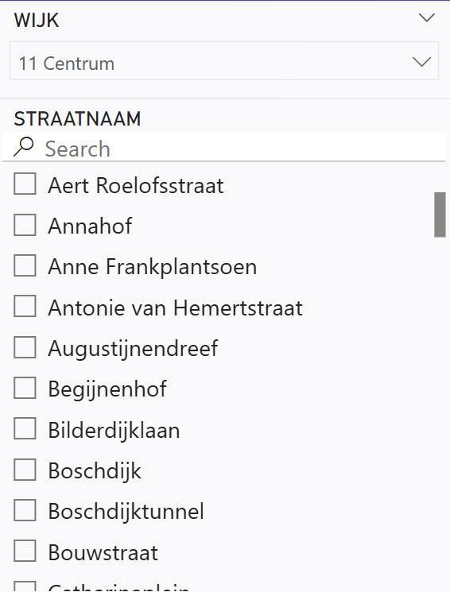
- Filter data on “TYPE_LAMP” and “TYPE_ARMARATUUR” combinations
- Filter data based on whether all the columns are filled in all rows of the selected combinations above
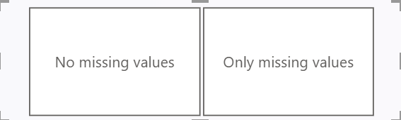
- Radar graph showing selected the selected area’s relation to HetLuxLab’s criterias
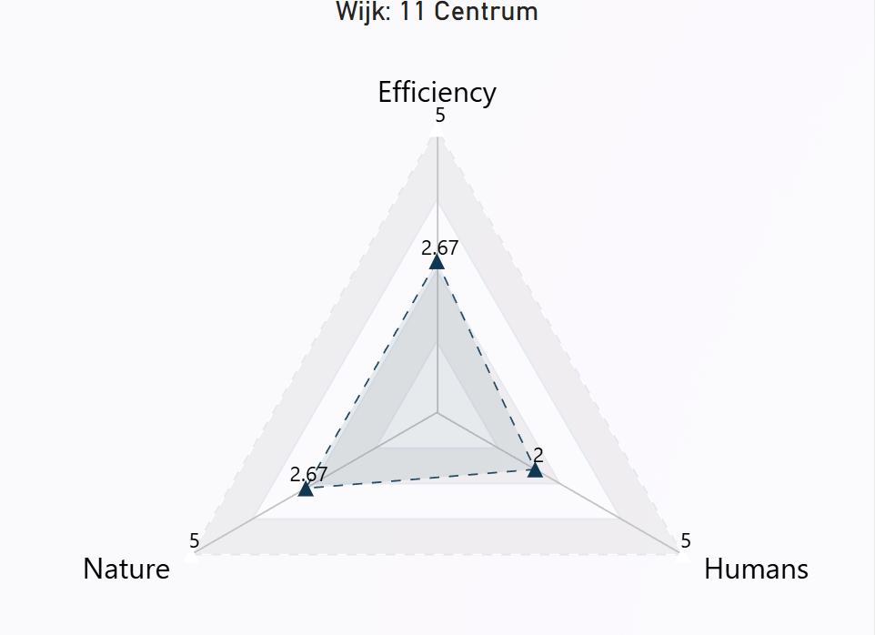
- Bar graph showing showing selected the selected area’s relation to HetLuxLab’s criterias (The first image shows when a lamp combination is selected, second image shows when its for the overall street)
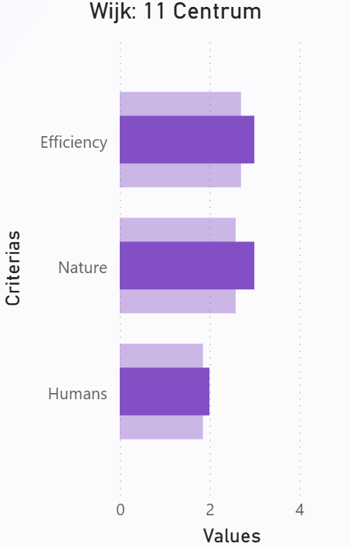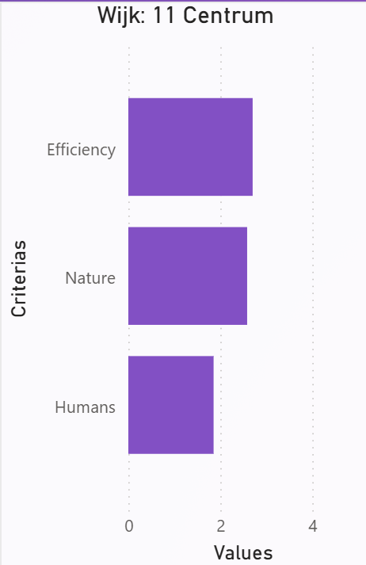
- Table view showing street level lamp combinations and aggregated data such as;
  - Lamp count
  - Colour temperature in Kelvin
  - Brightness in Lumen
  - Lumen square meters (Lumen / ( 1meter pole height * 8 = surface area in square meters))
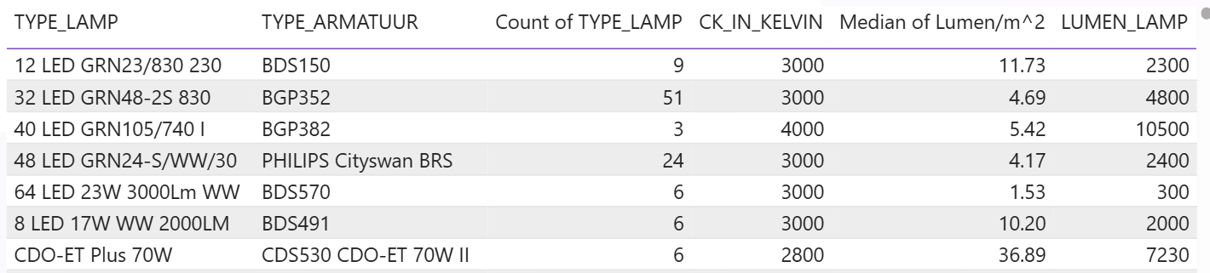
- Automatically update graph titles based on the data filters

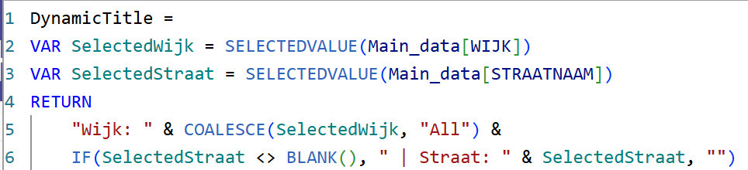
- Added button to direct users to the next page (for future iterations)

Validation
Before the making of this product I created several prototypes and demoed it to the client described in “HetLuxLab_python_deliv_contributions.pdf” document. During the making of the Python version I also asked the client to give feedback on multiple occasions. I had the chance to demo this PowerBI version once (at the time of the making of this document) and the clients really loved it. It is a more user friendly application than the Python one. I will give a final handover presentation to the client no the 19th of June (planned). In case they request changes it can be implemented in the remaining time.

Future Recommendations
- Interactive mapping could be developed in the future to allow users to visualize lamp post locations directly on a map, improving spatial awareness and decision-making.
- Improve the filtering system by:
  - Enabling multi-select options for “Wijk”, “Straat”, and lamp combinations and new functionality where the user can select lamps by drawing on a map.
  - Allowing advanced filters such as date of installation, energy usage, or maintenance frequency.
- More in-depth analysis on the selected data:
  - Introduce historical comparisons or trends (if time-series data becomes available).
  - Add benchmark comparisons (e.g. comparing one street against Wijk averages).
  - Allow user-defined weighting of criteria used in radar/bar graphs.
- Further develop the extra page:
  - Use it for detailed reports, data summaries, or exporting features (e.g. PDF/CSV download).
  - Consider using it as a drill-through page for deeper inspection of selected lamp configurations.

