Mean- VS. Median-unbiased stock-recruit parameters in Operating model

R Markdown File Link:
https://github.com/Bai-Li-NOAA/Age_Structured_Stock_Assessment_Model_Comparison/blob/full-features/ASSAMC/docs/MedianMeanSRparamsOM.Rmd

1. Operating Model with median- or mean-unbiased stock-recruit parameters

1.1 Mean-unbiased stock-recruit parameters
- Beverton-Holt Model
E1: $R_{y+1}=\frac{0.8R_{0}hS_{y}}{0.2R_{0}ϕ_{0}(1−h)+S_{y}(h−0.2)}×BC_{mean}$
E2: $R_{eq}=\frac{R_{0}(4hϕ_{F}−(1−h)ϕ_{0})}{(5h−1)ϕ_{F}})$
Here, virgin recruitment $R_{0}$ and steepness $h$ are mean values, and $BC_{mean}=exp(−σ_{R}^{2}/2)$
- Ricker model
E3: $R_{y+1}=\frac{S_{y}}{ϕ_{0}}exp(h(1−\frac{S_{y}}{R_{0}ϕ_{0}}))×BC_{mean}$
E4: $R_{eq}=\frac{R_{0}}{ϕ_{F}/ϕ_{0}}(1+\frac{log(ϕ_{F}/ϕ_{0})}{h})$
Here, virgin recruitment $R_{0}$ and steepness $h$ are mean values, and $BC_{mean}=exp(−σ_{R}^{2}/2)$

1.2 Median-unbiased stock-recruit parameters
- Beverton-Holt Model
E5: $R_{y+1}=\frac{0.8R_{0}hS_{y}}{0.2R_{0}ϕ_{0}(1−h)+S_{y}(h−0.2)}$
E6: $R_{eq}=\frac{R_{0}(BC_{median}4hϕ_{F}−(1−h)ϕ_{0})}{(5h−1)ϕ_{F}})$
Here, virgin recruitment $R_{0}$ and steepness $h$ are mean values, and $BC_{median}=exp(σ_{R}^{2}/2)$
- Ricker model
E7: $R_{y+1}=\frac{S_{y}}{ϕ_{0}}exp(h(1−\frac{S_{y}}{R_{0}ϕ_{0}}))$
E8: $R_{eq}=\frac{R_{0}}{ϕ_{F}/ϕ_{0}}(1+\frac{log(BC_{median}×ϕ_{F}/ϕ_{0})}{h})$
Here, virgin recruitment $R_{0}$ and steepness $h$ are median values, and $BC_{median}=exp(σ_{R}^{2}/2)$

2. Simulated population with Beverton-Holt model
- Forward projection without fishing mortality
- Simulation number = 100
- Simulation model year = 100
- Steepness $h$ tested: 0.21, 0.4, 0.6, 0.8, 1
- Standard deviation of log recruitment $σ_{R}$: 0.2, 0.4, 0.6, 0.8, 1, 1.2, 1.4, 1.6, 1.8, 2
- M = 0.2

2.1 OM_Mean with mean-unbiased stock-recruit parameters
- Known mean $R_{0}$ and $h$ -> OM_Mean -> $SSB$/$S0_{mean}$
- Mean steepness $h$ tested: 0.21, 0.4, 0.6, 0.8, 1
- Standard deviation of log recruitment $σ_{R}$: 0.2, 0.4, 0.6, 0.8, 1, 1.2, 1.4, 1.6, 1.8, 2
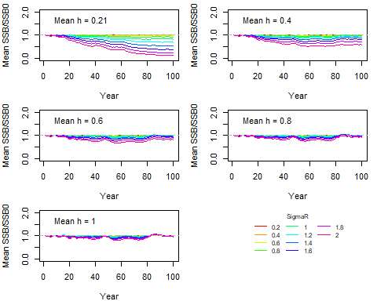
Figure 1. Temporal trend of mean (SSB/SSB_0) over 100 iteration runs under various combinations of steepness h and standard deviation of log recruitment sigmaR.

2.2 OM_Median with median-unbiased stock-recruit parameters
- Known median $R_{0}$ and $h$ -> OM_Median -> $SSB$/$S0_{mean}$
- Median steepness $h$ tested: 0.21, 0.4, 0.6, 0.8, 1
- Standard deviation of log recruitment $σ_{R}$: 0.2, 0.4, 0.6, 0.8, 1, 1.2, 1.4, 1.6, 1.8, 2
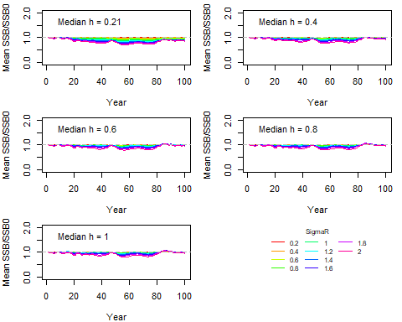
Figure 2. Temporal trend of mean (SSB/SSB_0) over 100 iteration runs under various combinations of steepness h and standard deviation of log recruitment sigmaR.

2.3 OM_Median with converted median-unbiased stock-recruit parameters from means
- Known mean $R_{0}$ and $h$ -> Convert to median $R_{0}$ and $h$ -> OM_Median -> $SSB$/$S0_{mean}$
## meanh_vec logR_sd_vec meanR0_vec converted_medianR0 converted_medianh
## 1 0.21 0.2 1e+06 6.673377e+05 0.20670124
## 2 0.40 0.2 1e+06 9.683179e+05 0.39520974
## 3 0.60 0.2 1e+06 9.762384e+05 0.59519054
## 4 0.80 0.2 1e+06 9.788786e+05 0.79678079
## 5 1.00 0.2 1e+06 9.801987e+05 1.00000000
## 6 0.21 0.4 1e+06 -2.916454e+05 0.19703569
## 7 0.40 0.4 1e+06 8.769862e+05 0.38096245
## 8 0.60 0.4 1e+06 9.077396e+05 0.58065556
## 9 0.80 0.4 1e+06 9.179908e+05 0.78689241
## 10 1.00 0.4 1e+06 9.231163e+05 1.00000000
## 11 0.21 0.6 1e+06 -1.767460e+06 0.18169206
## 12 0.40 0.6 1e+06 7.364323e+05 0.35767604
## 13 0.60 0.6 1e+06 8.023243e+05 0.55612871
## 14 0.80 0.6 1e+06 8.242882e+05 0.76964262
## 15 1.00 0.6 1e+06 8.352702e+05 1.00000000
## 16 0.21 0.8 1e+06 -3.600696e+06 0.16179597
## 17 0.40 0.8 1e+06 5.618385e+05 0.32619067
## 18 0.60 0.8 1e+06 6.713788e+05 0.52135328
## 19 0.80 0.8 1e+06 7.078923e+05 0.74389157
## 20 1.00 0.8 1e+06 7.261490e+05 1.00000000
## 21 0.21 1.0 1e+06 -5.610285e+06 0.13884391
## 22 0.40 1.0 1e+06 3.704491e+05 0.28792871
## 23 0.60 1.0 1e+06 5.278368e+05 0.47638386
## 24 0.80 1.0 1e+06 5.802994e+05 0.70812487
## 25 1.00 1.0 1e+06 6.065307e+05 1.00000000
## 26 0.21 1.2 1e+06 -7.622562e+06 0.11456614
## 27 0.40 1.2 1e+06 1.788036e+05 0.24499897
## 28 0.60 1.2 1e+06 3.841027e+05 0.42200821
## 29 0.80 1.2 1e+06 4.525357e+05 0.66067291
## 30 1.00 1.2 1e+06 4.867523e+05 1.00000000
## 31 0.21 1.4 1e+06 -9.494774e+06 0.09071586
## 32 0.40 1.4 1e+06 4.977582e+02 0.20013271
## 33 0.60 1.4 1e+06 2.503733e+05 0.36019108
## 34 0.80 1.4 1e+06 3.336652e+05 0.60019900
## 35 1.00 1.4 1e+06 3.753111e+05 1.00000000
## 36 0.21 1.6 1e+06 -1.112897e+07 0.06882210
## 37 0.40 1.6 1e+06 -1.551403e+05 0.15637315
## 38 0.60 1.6 1e+06 1.336448e+05 0.29431156
## 39 0.80 1.6 1e+06 2.299065e+05 0.52654860
## 40 1.00 1.6 1e+06 2.780373e+05 1.00000000
## 41 0.21 1.8 1e+06 -1.247530e+07 0.04997690
## 42 0.40 1.8 1e+06 -2.833621e+05 0.11655507
## 43 0.60 1.8 1e+06 3.747844e+04 0.22889964
## 44 0.80 1.8 1e+06 1.444253e+05 0.44183808
## 45 1.00 1.8 1e+06 1.978987e+05 1.00000000
## 46 0.21 2.0 1e+06 -1.352637e+07 0.03472593
## 47 0.40 2.0 1e+06 -3.834635e+05 0.08275690
## 48 0.60 2.0 1e+06 -3.759766e+04 0.16874683
## 49 0.80 2.0 1e+06 7.769097e+04 0.35121436
## 50 1.00 2.0 1e+06 1.353353e+05 1.00000000

Figure 3. Temporal trend of mean (SSB/SSB_0) over 100 iteration runs under various combinations of steepness h and standard deviation of log recruitment sigmaR.

2.4 OM_Mean with converted mean-unbiased stock-recruit parameters from medians
- Known median $R_{0}$ and $h$ -> Convert to mean $R_{0}$ and $h$ -> OM_Mean -> $SSB$/$S0_{mean}$
## medianh_vec logR_sd_vec medianR0_vec converted_meanR0 converted_meanh
## 1 0.21 0.2 1e+06 1339383 0.2133372
## 2 0.40 0.2 1e+06 1032322 0.4048095
## 3 0.60 0.2 1e+06 1024242 0.6047903
## 4 0.80 0.2 1e+06 1021548 0.8031808
## 5 1.00 0.2 1e+06 1020201 1.0000000
## 6 0.21 0.4 1e+06 2399223 0.2235798
## 7 0.40 0.4 1e+06 1133259 0.4193444
## 8 0.60 0.4 1e+06 1099944 0.6190375
## 9 0.80 0.4 1e+06 1088840 0.8124935
## 10 1.00 0.4 1e+06 1083287 1.0000000
## 11 0.21 0.6 1e+06 4313252 0.2414172
## 12 0.40 0.6 1e+06 1315548 0.4438713
## 13 0.60 0.6 1e+06 1236661 0.6423240
## 14 0.80 0.6 1e+06 1210365 0.8272547
## 15 1.00 0.6 1e+06 1197217 1.0000000
## 16 0.21 0.8 1e+06 7335746 0.2679741
## 17 0.40 0.8 1e+06 1603404 0.4786467
## 18 0.60 0.8 1e+06 1452553 0.6738093
## 19 0.80 0.8 1e+06 1402270 0.8463550
## 20 1.00 0.8 1e+06 1377128 1.0000000
## 21 0.21 1.0 1e+06 11898517 0.3047191
## 22 0.40 1.0 1e+06 2037954 0.5236161
## 23 0.60 1.0 1e+06 1778466 0.7120713
## 24 0.80 1.0 1e+06 1691969 0.8683324
## 25 1.00 1.0 1e+06 1648721 1.0000000
## 26 0.21 1.2 1e+06 18714478 0.3532176
## 27 0.40 1.2 1e+06 2687093 0.5779918
## 28 0.60 1.2 1e+06 2265320 0.7550010
## 29 0.80 1.2 1e+06 2124729 0.8915135
## 30 1.00 1.2 1e+06 2054433 1.0000000
## 31 0.21 1.4 1e+06 28962865 0.4146135
## 32 0.40 1.4 1e+06 3663130 0.6398089
## 33 0.60 1.4 1e+06 2997347 0.7998673
## 34 0.80 1.4 1e+06 2775420 0.9142207
## 35 1.00 1.4 1e+06 2664456 1.0000000
## 36 0.21 1.6 1e+06 44623547 0.4887705
## 37 0.40 1.6 1e+06 5154624 0.7056884
## 38 0.60 1.6 1e+06 4115968 0.8436268
## 39 0.80 1.6 1e+06 3769749 0.9350082
## 40 1.00 1.6 1e+06 3596640 1.0000000
## 41 0.21 1.8 1e+06 69091917 0.5732380
## 42 0.40 1.8 1e+06 7484945 0.7711004
## 43 0.60 1.8 1e+06 5863708 0.8834449
## 44 0.80 1.8 1e+06 5323296 0.9528577
## 45 1.00 1.8 1e+06 5053090 1.0000000
## 46 0.21 2.0 1e+06 108336142 0.6626385
## 47 0.40 2.0 1e+06 11222490 0.8312532
## 48 0.60 2.0 1e+06 8666867 0.9172431
## 49 0.80 2.0 1e+06 7814993 0.9672734
## 50 1.00 2.0 1e+06 7389056 1.0000000

Figure 4. Temporal trend of mean (SSB/SSB_0) over 100 iteration runs under various combinations of steepness h and standard deviation of log recruitment sigmaR.

3. Simulated population with Ricker model

3.1 OM_Mean with mean-unbiased stock-recruit parameters
- Known mean $R_{0}$ and $h$ -> OM_Mean -> $SSB$/$S0_{mean}$
- Mean steepness $h$ tested: 0.21, 0.4, 0.6, 0.8, 1
- Standard deviation of log recruitment $σ_{R}$: 0.2, 0.4, 0.6, 0.8, 1, 1.2, 1.4, 1.6, 1.8, 2
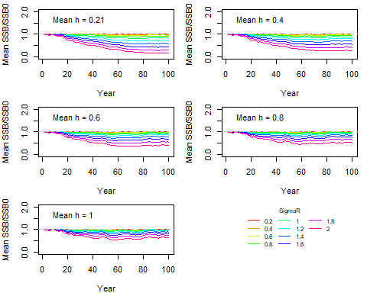
Figure 5. Temporal trend of mean (SSB/SSB_0) over 100 iteration runs under various combinations of steepness h and standard deviation of log recruitment sigmaR.

3.2 OM_Median with median-unbiased stock-recruit parameters
- Known median $R_{0}$ and $h$ -> OM_Median -> $SSB$/$S0_{mean}$
- Median steepness $h$ tested: 0.21, 0.4, 0.6, 0.8, 1
- Standard deviation of log recruitment $σ_{R}$: 0.2, 0.4, 0.6, 0.8, 1, 1.2, 1.4, 1.6, 1.8, 2
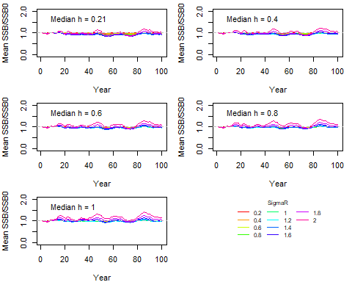
Figure 6. Temporal trend of mean (SSB/SSB_0) over 100 iteration runs under various combinations of steepness h and standard deviation of log recruitment sigmaR.

3.3 OM_Median with converted median-unbiased stock-recruit parameters from means
- Known mean $R_{0}$ and $h$ -> Convert to median $R_{0}$ and $h$ -> OM_Median -> $SSB$/$S0_{mean}$
## meanh_vec logR_sd_vec meanR0_vec converted_medianR0 converted_medianh
## 1 0.21 0.2 1e+06 904761.9 0.19
## 2 0.40 0.2 1e+06 950000.0 0.38
## 3 0.60 0.2 1e+06 966666.7 0.58
## 4 0.80 0.2 1e+06 975000.0 0.78
## 5 1.00 0.2 1e+06 980000.0 0.98
## 6 0.21 0.4 1e+06 619047.6 0.13
## 7 0.40 0.4 1e+06 800000.0 0.32
## 8 0.60 0.4 1e+06 866666.7 0.52
## 9 0.80 0.4 1e+06 900000.0 0.72
## 10 1.00 0.4 1e+06 920000.0 0.92
## 11 0.21 0.6 1e+06 142857.1 0.03
## 12 0.40 0.6 1e+06 550000.0 0.22
## 13 0.60 0.6 1e+06 700000.0 0.42
## 14 0.80 0.6 1e+06 775000.0 0.62
## 15 1.00 0.6 1e+06 820000.0 0.82
## 16 0.21 0.8 1e+06 -523809.5 -0.11
## 17 0.40 0.8 1e+06 200000.0 0.08
## 18 0.60 0.8 1e+06 466666.7 0.28
## 19 0.80 0.8 1e+06 600000.0 0.48
## 20 1.00 0.8 1e+06 680000.0 0.68
## 21 0.21 1.0 1e+06 -1380952.4 -0.29
## 22 0.40 1.0 1e+06 -250000.0 -0.10
## 23 0.60 1.0 1e+06 166666.7 0.10
## 24 0.80 1.0 1e+06 375000.0 0.30
## 25 1.00 1.0 1e+06 500000.0 0.50
## 26 0.21 1.2 1e+06 -2428571.4 -0.51
## 27 0.40 1.2 1e+06 -800000.0 -0.32
## 28 0.60 1.2 1e+06 -200000.0 -0.12
## 29 0.80 1.2 1e+06 100000.0 0.08
## 30 1.00 1.2 1e+06 280000.0 0.28
## 31 0.21 1.4 1e+06 -3666666.7 -0.77
## 32 0.40 1.4 1e+06 -1450000.0 -0.58
## 33 0.60 1.4 1e+06 -633333.3 -0.38
## 34 0.80 1.4 1e+06 -225000.0 -0.18
## 35 1.00 1.4 1e+06 20000.0 0.02
## 36 0.21 1.6 1e+06 -5095238.1 -1.07
## 37 0.40 1.6 1e+06 -2200000.0 -0.88
## 38 0.60 1.6 1e+06 -1133333.3 -0.68
## 39 0.80 1.6 1e+06 -600000.0 -0.48
## 40 1.00 1.6 1e+06 -280000.0 -0.28
## 41 0.21 1.8 1e+06 -6714285.7 -1.41
## 42 0.40 1.8 1e+06 -3050000.0 -1.22
## 43 0.60 1.8 1e+06 -1700000.0 -1.02
## 44 0.80 1.8 1e+06 -1025000.0 -0.82
## 45 1.00 1.8 1e+06 -620000.0 -0.62
## 46 0.21 2.0 1e+06 -8523809.5 -1.79
## 47 0.40 2.0 1e+06 -4000000.0 -1.60
## 48 0.60 2.0 1e+06 -2333333.3 -1.40
## 49 0.80 2.0 1e+06 -1500000.0 -1.20
## 50 1.00 2.0 1e+06 -1000000.0 -1.00

Figure 7. Temporal trend of mean (SSB/SSB_0) over 100 iteration runs under various combinations of steepness h and standard deviation of log recruitment sigmaR.

3.4 OM_Mean with converted mean-unbiased stock-recruit parameters from medians
- Known median $R_{0}$ and $h$ -> Convert to mean $R_{0}$ and $h$ -> OM_Mean -> $SSB$/$S0_{mean}$
## medianh_vec logR_sd_vec medianR0_vec converted_meanR0 converted_meanh
## 1 0.21 0.2 1e+06 1095238 0.23
## 2 0.40 0.2 1e+06 1050000 0.42
## 3 0.60 0.2 1e+06 1033333 0.62
## 4 0.80 0.2 1e+06 1025000 0.82
## 5 1.00 0.2 1e+06 1020000 1.02
## 6 0.21 0.4 1e+06 1380952 0.29
## 7 0.40 0.4 1e+06 1200000 0.48
## 8 0.60 0.4 1e+06 1133333 0.68
## 9 0.80 0.4 1e+06 1100000 0.88
## 10 1.00 0.4 1e+06 1080000 1.08
## 11 0.21 0.6 1e+06 1857143 0.39
## 12 0.40 0.6 1e+06 1450000 0.58
## 13 0.60 0.6 1e+06 1300000 0.78
## 14 0.80 0.6 1e+06 1225000 0.98
## 15 1.00 0.6 1e+06 1180000 1.18
## 16 0.21 0.8 1e+06 2523810 0.53
## 17 0.40 0.8 1e+06 1800000 0.72
## 18 0.60 0.8 1e+06 1533333 0.92
## 19 0.80 0.8 1e+06 1400000 1.12
## 20 1.00 0.8 1e+06 1320000 1.32
## 21 0.21 1.0 1e+06 3380952 0.71
## 22 0.40 1.0 1e+06 2250000 0.90
## 23 0.60 1.0 1e+06 1833333 1.10
## 24 0.80 1.0 1e+06 1625000 1.30
## 25 1.00 1.0 1e+06 1500000 1.50
## 26 0.21 1.2 1e+06 4428571 0.93
## 27 0.40 1.2 1e+06 2800000 1.12
## 28 0.60 1.2 1e+06 2200000 1.32
## 29 0.80 1.2 1e+06 1900000 1.52
## 30 1.00 1.2 1e+06 1720000 1.72
## 31 0.21 1.4 1e+06 5666667 1.19
## 32 0.40 1.4 1e+06 3450000 1.38
## 33 0.60 1.4 1e+06 2633333 1.58
## 34 0.80 1.4 1e+06 2225000 1.78
## 35 1.00 1.4 1e+06 1980000 1.98
## 36 0.21 1.6 1e+06 7095238 1.49
## 37 0.40 1.6 1e+06 4200000 1.68
## 38 0.60 1.6 1e+06 3133333 1.88
## 39 0.80 1.6 1e+06 2600000 2.08
## 40 1.00 1.6 1e+06 2280000 2.28
## 41 0.21 1.8 1e+06 8714286 1.83
## 42 0.40 1.8 1e+06 5050000 2.02
## 43 0.60 1.8 1e+06 3700000 2.22
## 44 0.80 1.8 1e+06 3025000 2.42
## 45 1.00 1.8 1e+06 2620000 2.62
## 46 0.21 2.0 1e+06 10523810 2.21
## 47 0.40 2.0 1e+06 6000000 2.40
## 48 0.60 2.0 1e+06 4333333 2.60
## 49 0.80 2.0 1e+06 3500000 2.80
## 50 1.00 2.0 1e+06 3000000 3.00

Figure 8. Temporal trend of mean (SSB/SSB_0) over 100 iteration runs under various combinations of steepness h and standard deviation of log recruitment sigmaR.

