Recruitment Bias Adjustment in Ricker Model
- R Markdown File Link:
- https://github.com/Bai-Li-NOAA/Age_Structured_Stock_Assessment_Model_Comparison/blob/full-features/ASSAMC/docs/RickerBiasAdjustment.Rmd

1. Ricker model in BAM, SS, and AMAK and the conversion function

1.1 BAM method
E1: $R_{y+1}=\frac{S_{y}}{ϕ_{0}}exp(h(1−\frac{S_{y}}{R_{0}ϕ_{0}}))$
E2: $R_{eq}=\frac{R_{0}}{ϕ_{F}/ϕ_{0}}(1+\frac{log(BC_{BAM}×ϕ_{F}/ϕ_{0})}{h})$
Here, virgin recruitment $R_{0}$ and steepness $h$ are median values, and $BC_{BAM}=exp(σ_{R}^{2}/2)$

1.2 SS method
E3: $R_{y+1}=\frac{S_{y}}{ϕ_{0}}exp(h(1−\frac{S_{y}}{R_{0}ϕ_{0}}))×BC_{SS}$
E4: $R_{eq}=\frac{R_{0}}{ϕ_{F}/ϕ_{0}}(1+\frac{log(ϕ_{F}/ϕ_{0})}{h})$
Here, virgin recruitment $R_{0}$ and steepness $h$ are mean values, and $BC_{SS}=exp(−σ_{R}^{2}/2)$

1.3 AMAK method (To be compared...)
E5: $R_{y+1}=\frac{S_{y}}{ϕ_{0}}exp(α(1−\frac{S_{y}}{R_{0}ϕ_{0}}))$
E6: $α=log(\frac{−4h}{h−1})$

1.4 Compare BAM and SS estimates following Erik's method
## True_Median_R0=1e+06
## True_Median_h=0.75
## BAM_Median_R0=1000000.00000038
## BAM_Median_h=0.751492136924072
## SS_Mean_R0=1240775.05458453
## SS_Mean_h=0.931148807247154
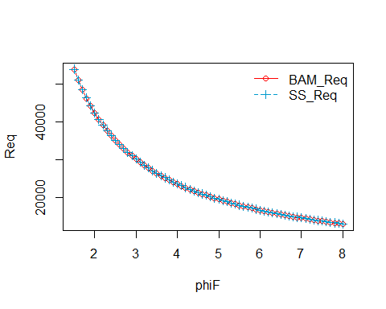
Figure 1. Equilibrium R over phiF from BAM (red solid line) and SS (blue dash line). It demonstrates that with correct conversion from median to mean values, BAM and SS should produce almost identical estimates.

1.5 Conversion function

1.5.1 The conversion function following Chris's method
convertSRparms <- function(R0, h, phi, sigmaR, mean2med){
BC <- ifelse(mean2med == TRUE, exp(-0.5 * sigmaR^2), exp(0.5 * sigmaR^2))
S0BC <- R0 * phi * (1 + log(BC) / h)
R0BC <- S0BC / phi
Rnew <- BC * 0.2 *S0BC / phi * exp(h * (1 - 0.2 * S0BC/ (R0 * phi)))
hBC <- Rnew /R0BC
return(list(S0BC = S0BC, R0BC = R0BC, hBC = hBC))
}

1.5.2 Inputs (Median R0, median h, phi, sigmaR, mean2med) and outputs (Mean R0BC and mean hBC)
## R0=1e+06
## h=0.75
## phi=0.01025625
## sigmaR=0.6
## mean2med=FALSE
## R0BC=1240000
## hBC=0.420867209283096
The converted mean steepness (hBC) is different compared to the SS_Mean_h from section 1.4.

1.5.3 Validation check
BC <- ifelse(mean2med == TRUE, exp(-0.5 * sigmaR^2), exp(0.5 * sigmaR^2))
S.vec <- seq(0, R0 * phi, length.out = 1000)
R.vec <- S.vec / phi * exp(h * (1 - S.vec/ (R0 * phi)))
R.vecBC <- R.vec * BC
R.calc <- S.vec / phi * exp(p$hBC * (1 - S.vec / (p$R0BC * phi)))
diff <- R.calc - R.vecBC
range(diff)
## [1] -228384.5 0.0
plot(S.vec, R.vecBC, col="red", xlab="SSB", ylab="R", type="l", lty=1)
lines(S.vec, R.calc, col="deepskyblue3", lty=2)
legend("topleft",
legend=c("BAM_R", "SS_R"),
col=c("red", "deepskyblue3"),
lty=c(1,2),
bty="n")
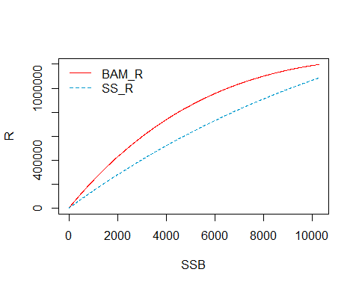
Figure 2. Mean recruitment over SSB from BAM (red solid line) and SS (blue dash line). The estimates from BAM and SS are not identical like the results from section 1.4. The conversion of steepness needs to be checked, so I read Dorn 2002 paper to seek a solution.

2. Ricker model from Dorn 2002 and the conversion function

2.1 Curvature parameter $α$ and steepness $h$ from Dorn 2002
The Ricker curve with parameters median virgin recruitment $R_{0}$ and curvature parameter $α$ is
E7: $R_{y+1}=\frac{S_{y}}{ϕ_{0}}exp(α(1−\frac{S_{y}}{R_{0}ϕ_{0}}))$
The steepness $h$ from Dorn 2002 is
E8: $h=\frac{\frac{0.2S_{y}}{ϕ_{0}}exp(α(1−\frac{0.2S_{y}}{R_{0}ϕ_{0}}))}{\frac{S_{y}}{ϕ_{0}}exp(α(1−\frac{S_{y}}{R_{0}ϕ_{0}}))}$
E9: $h=0.2exp(α(1−\frac{0.2S_{y}}{R_{0}ϕ_{0}})−α(1−\frac{S_{y}}{R_{0}ϕ_{0}}))$
E10: $h=0.2exp(\frac{0.8S_{0}α}{R_{0}ϕ_{0}})=0.2exp(0.8α)$
The curvature parameter $α$ from Dorn 2002 is
E11: $α=\frac{log(5h)}{0.8}=1.25log(5h)$
The equations were derived following Mangel et al. 2009 and Sampson 2008.
The $α$ from Dorn 2002 is equivalent to the steepness $h$ in BAM and SS (E1-E4).
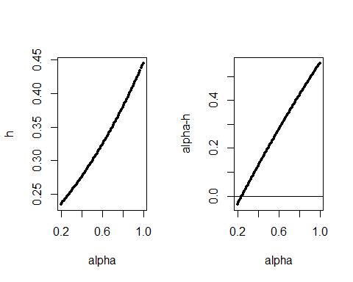
Figure 3. The difference between $α$ and steepness $h$ in the Ricker model from Dorn 2002.

2.2 The final conversion function with consideration of conversion between $α$ and true steepness $h$ in Dorn 2002:
hBC <- 1.25log(5Rnew /R0BC)
convertSRparms <- function(R0, h, phi, sigmaR, mean2med){
BC <- ifelse(mean2med == TRUE, exp(-0.5 * sigmaR^2), exp(0.5 * sigmaR^2))
S0BC <- R0 * phi * (1 + log(BC) / h)
R0BC <- S0BC / phi
Rnew <- BC * 0.2 *S0BC / phi * exp(h * (1 - 0.2 * S0BC/ (R0 * phi)))
hBC <- 1.25*log(5*Rnew /R0BC)
return(list(S0BC = S0BC, R0BC = R0BC, hBC = hBC))
}

2.3 Inputs (Median R0, median h, phi, sigmaR, mean2med) and outputs (Mean R0BC and mean hBC)
## R0=1e+06
## h=0.75
## phi=0.01025625
## sigmaR=0.6
## mean2med=FALSE
## R0BC=1240000
## hBC=0.93
The converted mean steepness (hBC) is the same compared to the SS_Mean_h from section 1.4.

2.4 Validation check
BC <- ifelse(mean2med == TRUE, exp(-0.5 * sigmaR^2), exp(0.5 * sigmaR^2))
S.vec <- seq(0, R0 * phi, length.out = 1000)
R.vec <- S.vec / phi * exp(h * (1 - S.vec/ (R0 * phi)))
R.vecBC <- R.vec * BC
R.calc <- S.vec / phi * exp(p$hBC * (1 - S.vec / (p$R0BC * phi)))
diff <- R.calc - R.vecBC
range(diff)
## [1] -2.328306e-10 4.656613e-10
plot(S.vec, R.vecBC, col="red", xlab="SSB", ylab="R", type="l", lty=1)
lines(S.vec, R.calc, col="deepskyblue3", lty=2)
legend("topleft",
legend=c("BAM_R", "SS_R"),
col=c("red", "deepskyblue3"),
lty=c(1,2),
bty="n")
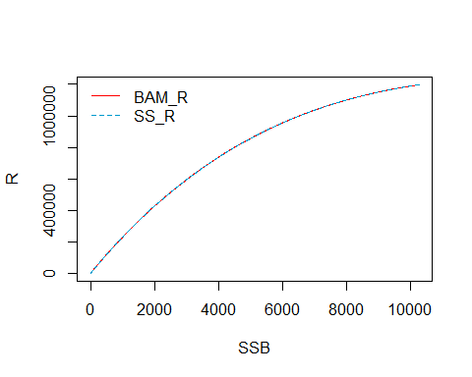
Figure 4. Mean recruitment over SSB from BAM (red solid line) and SS (blue dash line). The estimates from BAM and SS are identical, like the results from section 1.4. The final conversion function is correct.

2.5. Median and mean virgin recruitment and steepness over a range of steepness and sigmaR
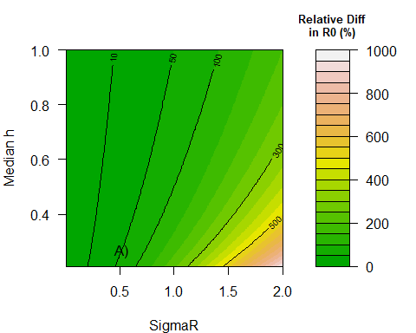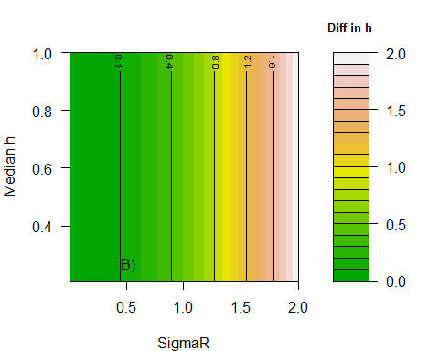
Figure 5. A) Relative difference in virgin recruitment (%; $\frac{(meanR_{0}−medianR_{0})}{medianR_{0}}×100$) over possible combination of median steepness and standard deviation of recruitment using the stock-recruitment parameters conversion function. B) Difference in steepness ($mean_{h}−median_{h}$) over possible combination of median steepness and standard deviation of recruitment using the stock-recruitment parameters conversion function. Here, $h$ is steepness in BAM and SS, but it's $α$ from Dorn 2002.

