Mean- VS. Median-unbiased stock-recruit parameters in Operating model

### **R Markdown File Link:**

<https://github.com/Bai-Li-NOAA/Age_Structured_Stock_Assessment_Model_Comparison/blob/full-features/ASSAMC/docs/MedianMeanSRparamsOM.Rmd>

## 1. Operating Model with median- or mean-unbiased stock-recruit parameters

### 1.1 Mean-unbiased stock-recruit parameters

* Beverton-Holt Model

E1: $R_{y+1}=\frac{0.8R_{0}hS_{y}}{0.2R_{0}ϕ_{0}(1−h)+S_{y}(h−0.2)}×BC_{mean}$

E2: $R_{eq}=\frac{R_{0}(4hϕ_{F}−(1−h)ϕ_{0})}{(5h−1)ϕ_{F}})$

Here, virgin recruitment $R_{0}$ and steepness $h$ are mean values, and $BC_{mean}=exp(−σ_{R}^{2}/2)$

* Ricker model

E3: $R_{y+1}=\frac{S_{y}}{ϕ_{0}}exp(h(1−\frac{S_{y}}{R_{0}ϕ_{0}}))×BC_{mean}$

E4: $R_{eq}=\frac{R_{0}}{ϕ_{F}/ϕ_{0}}(1+\frac{log(ϕ_{F}/ϕ_{0})}{h})$

Here, virgin recruitment $R_{0}$ and steepness $h$ are mean values, and $BC_{mean}=exp(−σ_{R}^{2}/2)$

### 1.2 Median-unbiased stock-recruit parameters

* Beverton-Holt Model

E5: $R_{y+1}=\frac{0.8R_{0}hS_{y}}{0.2R_{0}ϕ_{0}(1−h)+S_{y}(h−0.2)}$

E6: $R_{eq}=\frac{R_{0}(BC_{median}4hϕ_{F}−(1−h)ϕ_{0})}{(5h−1)ϕ_{F}})$

Here, virgin recruitment $R_{0}$ and steepness $h$ are mean values, and $BC_{median}=exp(σ_{R}^{2}/2)$

* Ricker model

E7: $R_{y+1}=\frac{S_{y}}{ϕ_{0}}exp(h(1−\frac{S_{y}}{R_{0}ϕ_{0}}))$

E8: $R_{eq}=\frac{R_{0}}{ϕ_{F}/ϕ_{0}}(1+\frac{log(BC_{median}×ϕ_{F}/ϕ_{0})}{h})$

Here, virgin recruitment $R_{0}$ and steepness $h$ are median values, and $BC_{median}=exp(σ_{R}^{2}/2)$

## 2. Simulated population with Beverton-Holt model

* Forward projection without fishing mortality
* Simulation number = 100
* Simulation model year = 100
* Steepness $h$ tested: 0.21, 0.4, 0.6, 0.8, 1
* Standard deviation of log recruitment $σ_{R}$: 0.2, 0.4, 0.6, 0.8, 1, 1.2, 1.4, 1.6, 1.8, 2
* M = 0.2

### 2.1 OM_Mean with mean-unbiased stock-recruit parameters

* Known mean $R_{0}$ and $h$-> OM_Mean -> $SSB$/ $S0_{mean}$
* Mean steepness $h$ tested: 0.21, 0.4, 0.6, 0.8, 1
* Standard deviation of log recruitment $σ_{R}$: 0.2, 0.4, 0.6, 0.8, 1, 1.2, 1.4, 1.6, 1.8, 2

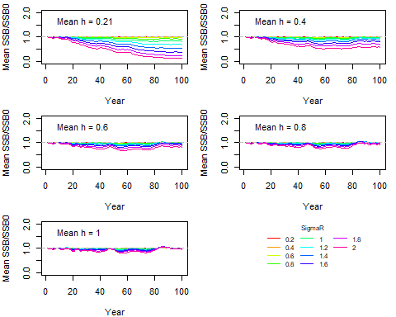

Figure 1. Temporal trend of mean (SSB/SSB_0) over 100 iteration runs under various combinations of steepness h and standard deviation of log recruitment sigmaR.

### 2.2 OM_Median with median-unbiased stock-recruit parameters

* Known median $R_{0}$ and $h$-> OM_Median -> $SSB$/ $S0_{mean}$
* Median steepness $h$ tested: 0.21, 0.4, 0.6, 0.8, 1
* Standard deviation of log recruitment $σ_{R}$: 0.2, 0.4, 0.6, 0.8, 1, 1.2, 1.4, 1.6, 1.8, 2

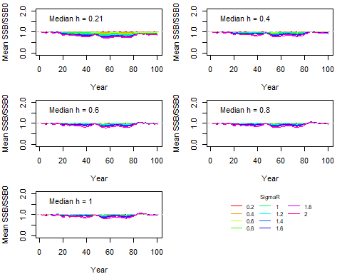

Figure 2. Temporal trend of mean (SSB/SSB_0) over 100 iteration runs under various combinations of steepness h and standard deviation of log recruitment sigmaR.

### 2.3 OM_Median with converted median-unbiased stock-recruit parameters from means

* Known mean $R_{0}$ and $h$-> Convert to median $R_{0}$ and $h$-> OM_Median -> $SSB$/ $S0_{mean}$

## meanh_vec logR_sd_vec meanR0_vec converted_medianR0 converted_medianh  
## 1 0.21 0.2 1e+06 6.673377e+05 0.20670124  
## 2 0.40 0.2 1e+06 9.683179e+05 0.39520974  
## 3 0.60 0.2 1e+06 9.762384e+05 0.59519054  
## 4 0.80 0.2 1e+06 9.788786e+05 0.79678079  
## 5 1.00 0.2 1e+06 9.801987e+05 1.00000000  
## 6 0.21 0.4 1e+06 -2.916454e+05 0.19703569  
## 7 0.40 0.4 1e+06 8.769862e+05 0.38096245  
## 8 0.60 0.4 1e+06 9.077396e+05 0.58065556  
## 9 0.80 0.4 1e+06 9.179908e+05 0.78689241  
## 10 1.00 0.4 1e+06 9.231163e+05 1.00000000  
## 11 0.21 0.6 1e+06 -1.767460e+06 0.18169206  
## 12 0.40 0.6 1e+06 7.364323e+05 0.35767604  
## 13 0.60 0.6 1e+06 8.023243e+05 0.55612871  
## 14 0.80 0.6 1e+06 8.242882e+05 0.76964262  
## 15 1.00 0.6 1e+06 8.352702e+05 1.00000000  
## 16 0.21 0.8 1e+06 -3.600696e+06 0.16179597  
## 17 0.40 0.8 1e+06 5.618385e+05 0.32619067  
## 18 0.60 0.8 1e+06 6.713788e+05 0.52135328  
## 19 0.80 0.8 1e+06 7.078923e+05 0.74389157  
## 20 1.00 0.8 1e+06 7.261490e+05 1.00000000  
## 21 0.21 1.0 1e+06 -5.610285e+06 0.13884391  
## 22 0.40 1.0 1e+06 3.704491e+05 0.28792871  
## 23 0.60 1.0 1e+06 5.278368e+05 0.47638386  
## 24 0.80 1.0 1e+06 5.802994e+05 0.70812487  
## 25 1.00 1.0 1e+06 6.065307e+05 1.00000000  
## 26 0.21 1.2 1e+06 -7.622562e+06 0.11456614  
## 27 0.40 1.2 1e+06 1.788036e+05 0.24499897  
## 28 0.60 1.2 1e+06 3.841027e+05 0.42200821  
## 29 0.80 1.2 1e+06 4.525357e+05 0.66067291  
## 30 1.00 1.2 1e+06 4.867523e+05 1.00000000  
## 31 0.21 1.4 1e+06 -9.494774e+06 0.09071586  
## 32 0.40 1.4 1e+06 4.977582e+02 0.20013271  
## 33 0.60 1.4 1e+06 2.503733e+05 0.36019108  
## 34 0.80 1.4 1e+06 3.336652e+05 0.60019900  
## 35 1.00 1.4 1e+06 3.753111e+05 1.00000000  
## 36 0.21 1.6 1e+06 -1.112897e+07 0.06882210  
## 37 0.40 1.6 1e+06 -1.551403e+05 0.15637315  
## 38 0.60 1.6 1e+06 1.336448e+05 0.29431156  
## 39 0.80 1.6 1e+06 2.299065e+05 0.52654860  
## 40 1.00 1.6 1e+06 2.780373e+05 1.00000000  
## 41 0.21 1.8 1e+06 -1.247530e+07 0.04997690  
## 42 0.40 1.8 1e+06 -2.833621e+05 0.11655507  
## 43 0.60 1.8 1e+06 3.747844e+04 0.22889964  
## 44 0.80 1.8 1e+06 1.444253e+05 0.44183808  
## 45 1.00 1.8 1e+06 1.978987e+05 1.00000000  
## 46 0.21 2.0 1e+06 -1.352637e+07 0.03472593  
## 47 0.40 2.0 1e+06 -3.834635e+05 0.08275690  
## 48 0.60 2.0 1e+06 -3.759766e+04 0.16874683  
## 49 0.80 2.0 1e+06 7.769097e+04 0.35121436  
## 50 1.00 2.0 1e+06 1.353353e+05 1.00000000



Figure 3. Temporal trend of mean (SSB/SSB_0) over 100 iteration runs under various combinations of steepness h and standard deviation of log recruitment sigmaR.

### 2.4 OM_Mean with converted mean-unbiased stock-recruit parameters from medians

* Known median $R_{0}$ and $h$-> Convert to mean $R_{0}$ and $h$-> OM_Mean -> $SSB$/ $S0_{mean}$

## medianh_vec logR_sd_vec medianR0_vec converted_meanR0 converted_meanh  
## 1 0.21 0.2 1e+06 1339383 0.2133372  
## 2 0.40 0.2 1e+06 1032322 0.4048095  
## 3 0.60 0.2 1e+06 1024242 0.6047903  
## 4 0.80 0.2 1e+06 1021548 0.8031808  
## 5 1.00 0.2 1e+06 1020201 1.0000000  
## 6 0.21 0.4 1e+06 2399223 0.2235798  
## 7 0.40 0.4 1e+06 1133259 0.4193444  
## 8 0.60 0.4 1e+06 1099944 0.6190375  
## 9 0.80 0.4 1e+06 1088840 0.8124935  
## 10 1.00 0.4 1e+06 1083287 1.0000000  
## 11 0.21 0.6 1e+06 4313252 0.2414172  
## 12 0.40 0.6 1e+06 1315548 0.4438713  
## 13 0.60 0.6 1e+06 1236661 0.6423240  
## 14 0.80 0.6 1e+06 1210365 0.8272547  
## 15 1.00 0.6 1e+06 1197217 1.0000000  
## 16 0.21 0.8 1e+06 7335746 0.2679741  
## 17 0.40 0.8 1e+06 1603404 0.4786467  
## 18 0.60 0.8 1e+06 1452553 0.6738093  
## 19 0.80 0.8 1e+06 1402270 0.8463550  
## 20 1.00 0.8 1e+06 1377128 1.0000000  
## 21 0.21 1.0 1e+06 11898517 0.3047191  
## 22 0.40 1.0 1e+06 2037954 0.5236161  
## 23 0.60 1.0 1e+06 1778466 0.7120713  
## 24 0.80 1.0 1e+06 1691969 0.8683324  
## 25 1.00 1.0 1e+06 1648721 1.0000000  
## 26 0.21 1.2 1e+06 18714478 0.3532176  
## 27 0.40 1.2 1e+06 2687093 0.5779918  
## 28 0.60 1.2 1e+06 2265320 0.7550010  
## 29 0.80 1.2 1e+06 2124729 0.8915135  
## 30 1.00 1.2 1e+06 2054433 1.0000000  
## 31 0.21 1.4 1e+06 28962865 0.4146135  
## 32 0.40 1.4 1e+06 3663130 0.6398089  
## 33 0.60 1.4 1e+06 2997347 0.7998673  
## 34 0.80 1.4 1e+06 2775420 0.9142207  
## 35 1.00 1.4 1e+06 2664456 1.0000000  
## 36 0.21 1.6 1e+06 44623547 0.4887705  
## 37 0.40 1.6 1e+06 5154624 0.7056884  
## 38 0.60 1.6 1e+06 4115968 0.8436268  
## 39 0.80 1.6 1e+06 3769749 0.9350082  
## 40 1.00 1.6 1e+06 3596640 1.0000000  
## 41 0.21 1.8 1e+06 69091917 0.5732380  
## 42 0.40 1.8 1e+06 7484945 0.7711004  
## 43 0.60 1.8 1e+06 5863708 0.8834449  
## 44 0.80 1.8 1e+06 5323296 0.9528577  
## 45 1.00 1.8 1e+06 5053090 1.0000000  
## 46 0.21 2.0 1e+06 108336142 0.6626385  
## 47 0.40 2.0 1e+06 11222490 0.8312532  
## 48 0.60 2.0 1e+06 8666867 0.9172431  
## 49 0.80 2.0 1e+06 7814993 0.9672734  
## 50 1.00 2.0 1e+06 7389056 1.0000000



Figure 4. Temporal trend of mean (SSB/SSB_0) over 100 iteration runs under various combinations of steepness h and standard deviation of log recruitment sigmaR.

## 3. Simulated population with Ricker model

### 3.1 OM_Mean with mean-unbiased stock-recruit parameters

* Known mean $R_{0}$ and $h$-> OM_Mean -> $SSB$/ $S0_{mean}$
* Mean steepness $h$ tested: 0.21, 0.4, 0.6, 0.8, 1
* Standard deviation of log recruitment $σ_{R}$: 0.2, 0.4, 0.6, 0.8, 1, 1.2, 1.4, 1.6, 1.8, 2

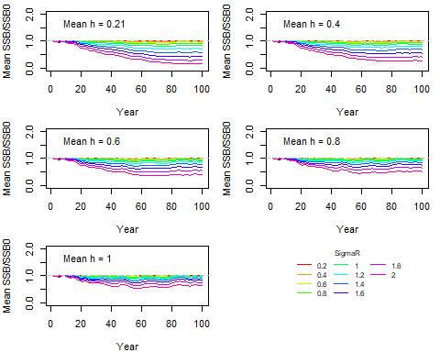

Figure 5. Temporal trend of mean (SSB/SSB_0) over 100 iteration runs under various combinations of steepness h and standard deviation of log recruitment sigmaR.

### 3.2 OM_Median with median-unbiased stock-recruit parameters

* Known median $R_{0}$ and $h$-> OM_Median -> $SSB$/ $S0_{mean}$
* Median steepness $h$ tested: 0.21, 0.4, 0.6, 0.8, 1
* Standard deviation of log recruitment $σ_{R}$: 0.2, 0.4, 0.6, 0.8, 1, 1.2, 1.4, 1.6, 1.8, 2

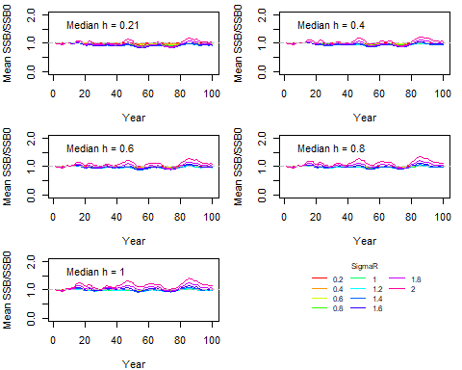

Figure 6. Temporal trend of mean (SSB/SSB_0) over 100 iteration runs under various combinations of steepness h and standard deviation of log recruitment sigmaR.

### 3.3 OM_Median with converted median-unbiased stock-recruit parameters from means

* Known mean $R_{0}$ and $h$-> Convert to median $R_{0}$ and $h$-> OM_Median -> $SSB$/ $S0_{mean}$

## meanh_vec logR_sd_vec meanR0_vec converted_medianR0 converted_medianh  
## 1 0.21 0.2 1e+06 904761.9 0.19  
## 2 0.40 0.2 1e+06 950000.0 0.38  
## 3 0.60 0.2 1e+06 966666.7 0.58  
## 4 0.80 0.2 1e+06 975000.0 0.78  
## 5 1.00 0.2 1e+06 980000.0 0.98  
## 6 0.21 0.4 1e+06 619047.6 0.13  
## 7 0.40 0.4 1e+06 800000.0 0.32  
## 8 0.60 0.4 1e+06 866666.7 0.52  
## 9 0.80 0.4 1e+06 900000.0 0.72  
## 10 1.00 0.4 1e+06 920000.0 0.92  
## 11 0.21 0.6 1e+06 142857.1 0.03  
## 12 0.40 0.6 1e+06 550000.0 0.22  
## 13 0.60 0.6 1e+06 700000.0 0.42  
## 14 0.80 0.6 1e+06 775000.0 0.62  
## 15 1.00 0.6 1e+06 820000.0 0.82  
## 16 0.21 0.8 1e+06 -523809.5 -0.11  
## 17 0.40 0.8 1e+06 200000.0 0.08  
## 18 0.60 0.8 1e+06 466666.7 0.28  
## 19 0.80 0.8 1e+06 600000.0 0.48  
## 20 1.00 0.8 1e+06 680000.0 0.68  
## 21 0.21 1.0 1e+06 -1380952.4 -0.29  
## 22 0.40 1.0 1e+06 -250000.0 -0.10  
## 23 0.60 1.0 1e+06 166666.7 0.10  
## 24 0.80 1.0 1e+06 375000.0 0.30  
## 25 1.00 1.0 1e+06 500000.0 0.50  
## 26 0.21 1.2 1e+06 -2428571.4 -0.51  
## 27 0.40 1.2 1e+06 -800000.0 -0.32  
## 28 0.60 1.2 1e+06 -200000.0 -0.12  
## 29 0.80 1.2 1e+06 100000.0 0.08  
## 30 1.00 1.2 1e+06 280000.0 0.28  
## 31 0.21 1.4 1e+06 -3666666.7 -0.77  
## 32 0.40 1.4 1e+06 -1450000.0 -0.58  
## 33 0.60 1.4 1e+06 -633333.3 -0.38  
## 34 0.80 1.4 1e+06 -225000.0 -0.18  
## 35 1.00 1.4 1e+06 20000.0 0.02  
## 36 0.21 1.6 1e+06 -5095238.1 -1.07  
## 37 0.40 1.6 1e+06 -2200000.0 -0.88  
## 38 0.60 1.6 1e+06 -1133333.3 -0.68  
## 39 0.80 1.6 1e+06 -600000.0 -0.48  
## 40 1.00 1.6 1e+06 -280000.0 -0.28  
## 41 0.21 1.8 1e+06 -6714285.7 -1.41  
## 42 0.40 1.8 1e+06 -3050000.0 -1.22  
## 43 0.60 1.8 1e+06 -1700000.0 -1.02  
## 44 0.80 1.8 1e+06 -1025000.0 -0.82  
## 45 1.00 1.8 1e+06 -620000.0 -0.62  
## 46 0.21 2.0 1e+06 -8523809.5 -1.79  
## 47 0.40 2.0 1e+06 -4000000.0 -1.60  
## 48 0.60 2.0 1e+06 -2333333.3 -1.40  
## 49 0.80 2.0 1e+06 -1500000.0 -1.20  
## 50 1.00 2.0 1e+06 -1000000.0 -1.00



Figure 7. Temporal trend of mean (SSB/SSB_0) over 100 iteration runs under various combinations of steepness h and standard deviation of log recruitment sigmaR.

### 3.4 OM_Mean with converted mean-unbiased stock-recruit parameters from medians

* Known median $R_{0}$ and $h$-> Convert to mean $R_{0}$ and $h$-> OM_Mean -> $SSB$/ $S0_{mean}$

## medianh_vec logR_sd_vec medianR0_vec converted_meanR0 converted_meanh  
## 1 0.21 0.2 1e+06 1095238 0.23  
## 2 0.40 0.2 1e+06 1050000 0.42  
## 3 0.60 0.2 1e+06 1033333 0.62  
## 4 0.80 0.2 1e+06 1025000 0.82  
## 5 1.00 0.2 1e+06 1020000 1.02  
## 6 0.21 0.4 1e+06 1380952 0.29  
## 7 0.40 0.4 1e+06 1200000 0.48  
## 8 0.60 0.4 1e+06 1133333 0.68  
## 9 0.80 0.4 1e+06 1100000 0.88  
## 10 1.00 0.4 1e+06 1080000 1.08  
## 11 0.21 0.6 1e+06 1857143 0.39  
## 12 0.40 0.6 1e+06 1450000 0.58  
## 13 0.60 0.6 1e+06 1300000 0.78  
## 14 0.80 0.6 1e+06 1225000 0.98  
## 15 1.00 0.6 1e+06 1180000 1.18  
## 16 0.21 0.8 1e+06 2523810 0.53  
## 17 0.40 0.8 1e+06 1800000 0.72  
## 18 0.60 0.8 1e+06 1533333 0.92  
## 19 0.80 0.8 1e+06 1400000 1.12  
## 20 1.00 0.8 1e+06 1320000 1.32  
## 21 0.21 1.0 1e+06 3380952 0.71  
## 22 0.40 1.0 1e+06 2250000 0.90  
## 23 0.60 1.0 1e+06 1833333 1.10  
## 24 0.80 1.0 1e+06 1625000 1.30  
## 25 1.00 1.0 1e+06 1500000 1.50  
## 26 0.21 1.2 1e+06 4428571 0.93  
## 27 0.40 1.2 1e+06 2800000 1.12  
## 28 0.60 1.2 1e+06 2200000 1.32  
## 29 0.80 1.2 1e+06 1900000 1.52  
## 30 1.00 1.2 1e+06 1720000 1.72  
## 31 0.21 1.4 1e+06 5666667 1.19  
## 32 0.40 1.4 1e+06 3450000 1.38  
## 33 0.60 1.4 1e+06 2633333 1.58  
## 34 0.80 1.4 1e+06 2225000 1.78  
## 35 1.00 1.4 1e+06 1980000 1.98  
## 36 0.21 1.6 1e+06 7095238 1.49  
## 37 0.40 1.6 1e+06 4200000 1.68  
## 38 0.60 1.6 1e+06 3133333 1.88  
## 39 0.80 1.6 1e+06 2600000 2.08  
## 40 1.00 1.6 1e+06 2280000 2.28  
## 41 0.21 1.8 1e+06 8714286 1.83  
## 42 0.40 1.8 1e+06 5050000 2.02  
## 43 0.60 1.8 1e+06 3700000 2.22  
## 44 0.80 1.8 1e+06 3025000 2.42  
## 45 1.00 1.8 1e+06 2620000 2.62  
## 46 0.21 2.0 1e+06 10523810 2.21  
## 47 0.40 2.0 1e+06 6000000 2.40  
## 48 0.60 2.0 1e+06 4333333 2.60  
## 49 0.80 2.0 1e+06 3500000 2.80  
## 50 1.00 2.0 1e+06 3000000 3.00



Figure 8. Temporal trend of mean (SSB/SSB_0) over 100 iteration runs under various combinations of steepness h and standard deviation of log recruitment sigmaR.