Recruitment Bias Adjustment in Ricker Model

* **R Markdown File Link:**
* <https://github.com/Bai-Li-NOAA/Age_Structured_Stock_Assessment_Model_Comparison/blob/full-features/ASSAMC/docs/RickerBiasAdjustment.Rmd>

## 1. Ricker model in BAM, SS, and AMAK and the conversion function

### 1.1 BAM method

E1: $R_{y+1}=\frac{S_{y}}{ϕ_{0}}exp(h(1−\frac{S_{y}}{R_{0}ϕ_{0}}))$

E2: $R_{eq}=\frac{R_{0}}{ϕ_{F}/ϕ_{0}}(1+\frac{log(BC_{BAM}×ϕ_{F}/ϕ_{0})}{h})$

Here, virgin recruitment $R_{0}$ and steepness $h$ are median values, and $BC_{BAM}=exp(σ_{R}^{2}/2)$

### 1.2 SS method

E3: $R_{y+1}=\frac{S_{y}}{ϕ_{0}}exp(h(1−\frac{S_{y}}{R_{0}ϕ_{0}}))×BC_{SS}$

E4: $R_{eq}=\frac{R_{0}}{ϕ_{F}/ϕ_{0}}(1+\frac{log(ϕ_{F}/ϕ_{0})}{h})$

Here, virgin recruitment $R_{0}$ and steepness $h$ are mean values, and $BC_{SS}=exp(−σ_{R}^{2}/2)$

### 1.3 AMAK method (To be compared...)

E5: $R_{y+1}=\frac{S_{y}}{ϕ_{0}}exp(α(1−\frac{S_{y}}{R_{0}ϕ_{0}}))$

E6: $α=log(\frac{−4h}{h−1})$

### 1.4 Compare BAM and SS estimates following Erik's method

## True_Median_R0=1e+06  
## True_Median_h=0.75  
## BAM_Median_R0=1000000.00000038  
## BAM_Median_h=0.751492136924072  
## SS_Mean_R0=1240775.05458453  
## SS_Mean_h=0.931148807247154

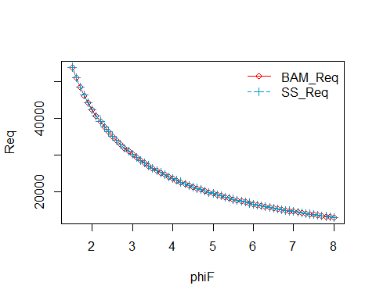

Figure 1. Equilibrium R over phiF from BAM (red solid line) and SS (blue dash line). **It demonstrates that with correct conversion from median to mean values, BAM and SS should produce almost identical estimates.**

### 1.5 Conversion function

#### 1.5.1 The conversion function following Chris's method

convertSRparms <- function(R0, h, phi, sigmaR, mean2med){  
 BC <- ifelse(mean2med == TRUE, exp(-0.5 * sigmaR^2), exp(0.5 * sigmaR^2))  
 S0BC <- R0 * phi * (1 + log(BC) / h)  
 R0BC <- S0BC / phi  
 Rnew <- BC * 0.2 *S0BC / phi * exp(h * (1 - 0.2 * S0BC/ (R0 * phi)))  
 hBC <- Rnew /R0BC  
 return(list(S0BC = S0BC, R0BC = R0BC, hBC = hBC))  
}

#### 1.5.2 Inputs (Median R0, median h, phi, sigmaR, mean2med) and outputs (Mean R0BC and mean hBC)

## R0=1e+06  
## h=0.75  
## phi=0.01025625  
## sigmaR=0.6  
## mean2med=FALSE  
## R0BC=1240000  
## hBC=0.420867209283096

**The converted mean steepness (hBC) is different compared to the SS_Mean_h from section 1.4.**

#### 1.5.3 Validation check

BC <- ifelse(mean2med == TRUE, exp(-0.5 * sigmaR^2), exp(0.5 * sigmaR^2))  
S.vec <- seq(0, R0 * phi, length.out = 1000)  
R.vec <- S.vec / phi * exp(h * (1 - S.vec/ (R0 * phi)))  
R.vecBC <- R.vec * BC  
R.calc <- S.vec / phi * exp(p$hBC * (1 - S.vec / (p$R0BC * phi)))  
diff <- R.calc - R.vecBC  
range(diff)

## [1] -228384.5 0.0

plot(S.vec, R.vecBC, col="red", xlab="SSB", ylab="R", type="l", lty=1)  
lines(S.vec, R.calc, col="deepskyblue3", lty=2)  
legend("topleft",   
 legend=c("BAM_R", "SS_R"),   
 col=c("red", "deepskyblue3"),   
 lty=c(1,2),  
 bty="n")

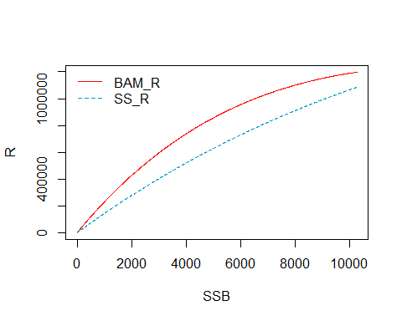

Figure 2. Mean recruitment over SSB from BAM (red solid line) and SS (blue dash line). **The estimates from BAM and SS are not identical like the results from section 1.4. The conversion of steepness needs to be checked, so I read Dorn 2002 paper to seek a solution.**

## 2. Ricker model from Dorn 2002 and the conversion function

### 2.1 Curvature parameter $α$ and steepness $h$ from Dorn 2002

The Ricker curve with parameters median virgin recruitment $R_{0}$ and curvature parameter $α$ is

E7: $R_{y+1}=\frac{S_{y}}{ϕ_{0}}exp(α(1−\frac{S_{y}}{R_{0}ϕ_{0}}))$

The steepness $h$ from Dorn 2002 is

E8: $h=\frac{\frac{0.2S_{y}}{ϕ_{0}}exp(α(1−\frac{0.2S_{y}}{R_{0}ϕ_{0}}))}{\frac{S_{y}}{ϕ_{0}}exp(α(1−\frac{S_{y}}{R_{0}ϕ_{0}}))}$

E9: $h=0.2exp(α(1−\frac{0.2S_{y}}{R_{0}ϕ_{0}})−α(1−\frac{S_{y}}{R_{0}ϕ_{0}}))$

E10: $h=0.2exp(\frac{0.8S_{0}α}{R_{0}ϕ_{0}})=0.2exp(0.8α)$

The curvature parameter $α$ from Dorn 2002 is

E11: $α=\frac{log(5h)}{0.8}=1.25log(5h)$

The equations were derived following [Mangel et al. 2009](https://www.researchgate.net/publication/267878032_Estimating_stock-recruitment_steepness_from_life_history_information_A_case_study_of_north_Pacific_bluefin_tuna_Thunnus_orientalis) and [Sampson 2008](http://oregonstate.edu/instruct/fw431/sampson/LectureNotes/15-Recruitment3.pdf).

The $α$ from Dorn 2002 is equivalent to the steepness $h$ in BAM and SS (E1-E4).

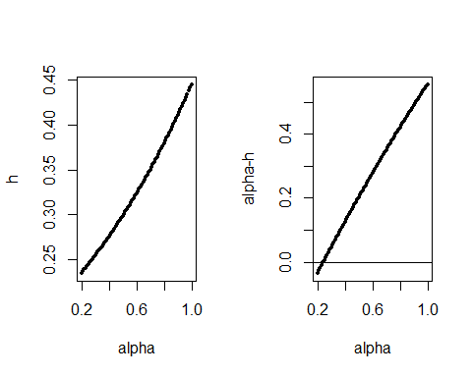

Figure 3. The difference between $α$ and steepness $h$ in the Ricker model from Dorn 2002.

### 2.2 The final conversion function with consideration of conversion between $α$ and true steepness $h$ in Dorn 2002:

**hBC <- 1.25*log(5*Rnew /R0BC)**

convertSRparms <- function(R0, h, phi, sigmaR, mean2med){  
 BC <- ifelse(mean2med == TRUE, exp(-0.5 * sigmaR^2), exp(0.5 * sigmaR^2))  
 S0BC <- R0 * phi * (1 + log(BC) / h)  
 R0BC <- S0BC / phi  
 Rnew <- BC * 0.2 *S0BC / phi * exp(h * (1 - 0.2 * S0BC/ (R0 * phi)))  
 hBC <- 1.25*log(5*Rnew /R0BC)  
 return(list(S0BC = S0BC, R0BC = R0BC, hBC = hBC))  
}

### 2.3 Inputs (Median R0, median h, phi, sigmaR, mean2med) and outputs (Mean R0BC and mean hBC)

## R0=1e+06  
## h=0.75  
## phi=0.01025625  
## sigmaR=0.6  
## mean2med=FALSE  
## R0BC=1240000  
## hBC=0.93

**The converted mean steepness (hBC) is the same compared to the SS_Mean_h from section 1.4.**

### 2.4 Validation check

BC <- ifelse(mean2med == TRUE, exp(-0.5 * sigmaR^2), exp(0.5 * sigmaR^2))  
S.vec <- seq(0, R0 * phi, length.out = 1000)  
R.vec <- S.vec / phi * exp(h * (1 - S.vec/ (R0 * phi)))  
R.vecBC <- R.vec * BC  
R.calc <- S.vec / phi * exp(p$hBC * (1 - S.vec / (p$R0BC * phi)))  
diff <- R.calc - R.vecBC  
range(diff)

## [1] -2.328306e-10 4.656613e-10

plot(S.vec, R.vecBC, col="red", xlab="SSB", ylab="R", type="l", lty=1)  
lines(S.vec, R.calc, col="deepskyblue3", lty=2)  
legend("topleft",   
 legend=c("BAM_R", "SS_R"),   
 col=c("red", "deepskyblue3"),   
 lty=c(1,2),  
 bty="n")

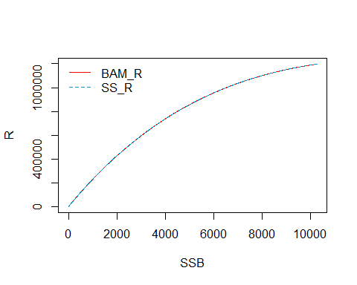

Figure 4. Mean recruitment over SSB from BAM (red solid line) and SS (blue dash line). **The estimates from BAM and SS are identical, like the results from section 1.4. The final conversion function is correct.**

### 2.5. Median and mean virgin recruitment and steepness over a range of steepness and sigmaR

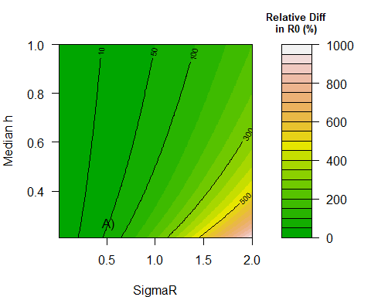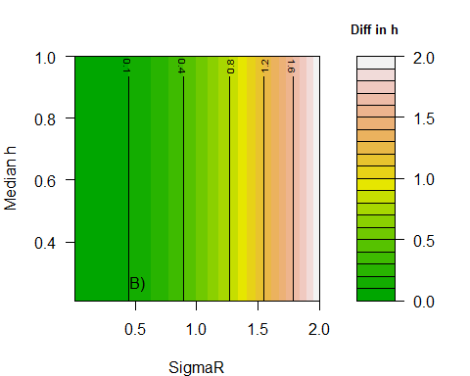

Figure 5. A) Relative difference in virgin recruitment (%; $\frac{(meanR_{0}−medianR_{0})}{medianR_{0}}×100$) over possible combination of median steepness and standard deviation of recruitment using the stock-recruitment parameters conversion function. B) Difference in steepness ($mean_{h}−median_{h}$) over possible combination of median steepness and standard deviation of recruitment using the stock-recruitment parameters conversion function. Here, $h$ is steepness in BAM and SS, but it's $α$ from Dorn 2002.