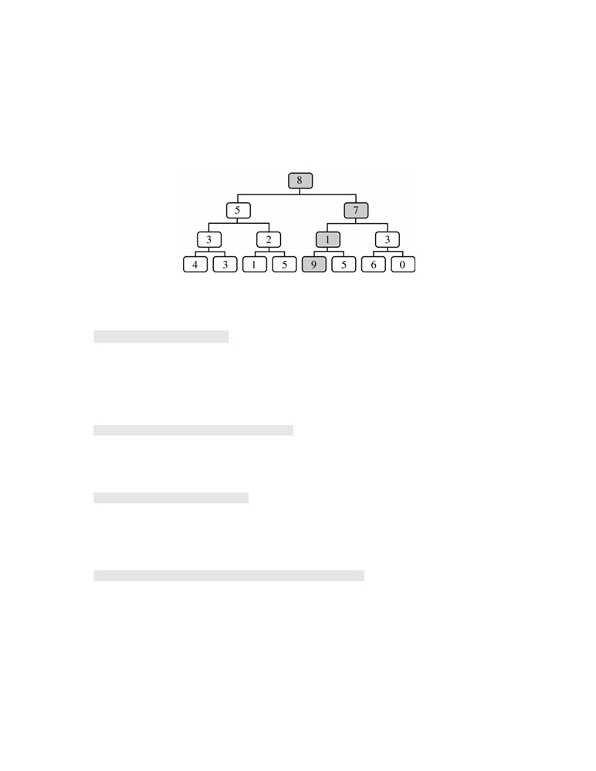

3. A game called TreeBall has been created in which a player drops a ball into the top of the game board. The score
is computed by summing the values in the nodes along the path that the ball follows.
The game board for TreeBall is a full binary tree in which the root represents the top of the game board. For
this question, assume that a full binary tree is one in which all leaves are at the same level and all non-leaf nodes have exactly two children. Each node in the tree contains an integer from 0 to 9. The diagram below shows an example TreeBall game board with 4 levels. In this example, the path with the greatest total is shown by the shaded nodes from the root (8) to the leaf (9). The score for this path is 25 = 8 + 7 + 1 + 9.

The declaration for the GameBoard class is shown below.
public class GameBoard
{
private TreeNode root; // the root of the tree

/** Creates a full binary tree rooted at root with numLevels levels
* with a random integer from 0 to 9, inclusive, generated for each node
* @param numLevels the number of levels in the tree
* Precondition: numLevels > 0
*/
public GameBoard(int numLevels)
{ /* to be implemented in part (b) */ }

/** @return the maximum path score for this GameBoard
*/
public int getMaxScore()
{ return getMaxHelper(root); }

/** @param current the root of the subtree to be processed
* @return the maximum path score for the subtree rooted at current
*/
private int getMaxHelper(TreeNode current)
{ /* to be implemented in part (a) */ }

// There may be fields, constructors, and methods that are not shown.
}

