

4. This question involves reasoning about the code from the Marine Biology Simulation case study. A copy of the
code is provided as part of this exam.
Suppose that you want to visit all locations of a square environment in a single loop. There is a familiar interface for this purpose: the iterator. In this question, you will complete a method in a class EnvIterator that
implements the Iterator interface.

Here is an incomplete definition of the EnvIterator class.

public class EnvIterator implements Iterator<Location>
{
private Environment env; // the environment over which to iterate private Location loc; // the next location to be returned

/** @param anEnv the environment over which to iterate
* Precondition: anEnv is square, i.e., anEnv.numRows() == anEnv.numCols()
*/
public EnvIterator(BoundedEnv anEnv)
{
env = anEnv;
loc = new Location(0, 0);
}

/** @return true if this EnvIterator has more elements
* false otherwise
*/
public boolean hasNext()
{ return env.isValid(loc); }

/** Precondition: hasNext() returns true
* Postcondition: loc has been updated to the successor location * @return the next location in the environment
*/
public Location next()
{ /* to be implemented in part (a) */ }

/** Throws an UnsupportedOperationException since it is impossible to * remove a location from an environment.
*/
public void remove()
{ throw new UnsupportedOperationException(); }
}

© 2007 The College Board. All rights reserved.
Visit apcentral.collegeboard.com (for AP professionals) and www.collegeboard.com/apstudents (for students and parents).
GO ON TO THE NEXT PAGE.
-13-
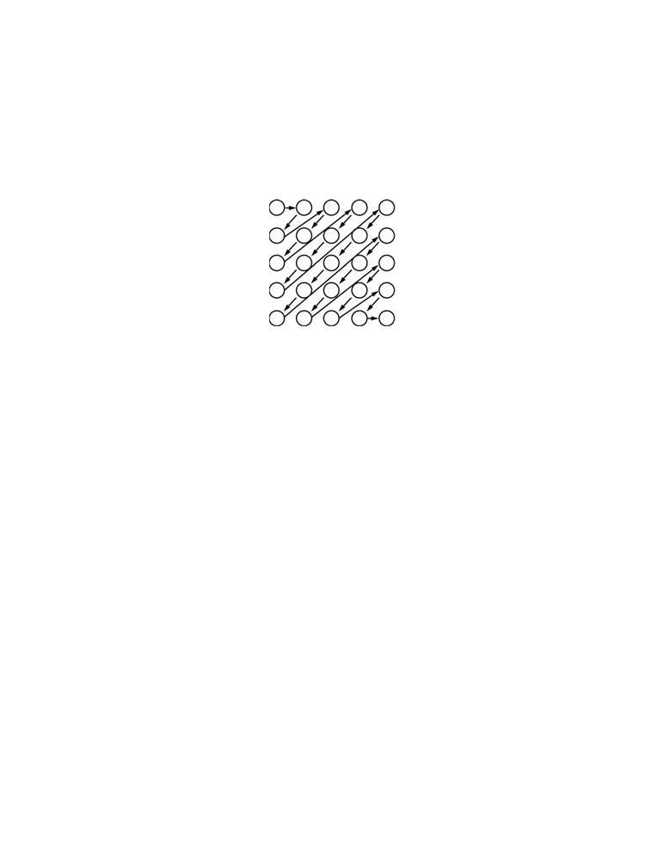

2007 AP® COMPUTER SCIENCE AB FREE-RESPONSE QUESTIONS

(a) Write the EnvIterator method next. The next method should return the next location in the
environment, that is, the location that is referenced in the loc instance field when the method is called.
The next method should also update the loc instance field to the successor location, as described
below. Note that the first location returned by next is (0, 0) as initialized in the EnvIterator
constructor.
Your implementation of next should allow the iterator to visit all elements of a square BoundedEnv, following the diagonal pattern shown in the diagram below.

The following describes the algorithm for determining the successor location in the diagonal pattern shown in the diagram above.
1. If the current location is at the bottom edge of the environment, move to the top of the next diagonal. For
example, in the diagram given above, (4, 1) is followed by (2, 4).
2. Otherwise, if the current location is at the left edge of the environment, move to the top of the next
diagonal. For example, in the diagram given above, (1, 0) is followed by (0, 2).
3. Otherwise, move down and left. For example, in the diagram given above, (1, 1) is followed by (2, 0).

Complete method next below.

/** Precondition: hasNext() returns true
* Postcondition: loc has been updated to the successor location * @return the next location in the environment
*/
public Location next()

© 2007 The College Board. All rights reserved.
Visit apcentral.collegeboard.com (for AP professionals) and www.collegeboard.com/apstudents (for students and parents).
GO ON TO THE NEXT PAGE.
-14-


2007 AP® COMPUTER SCIENCE AB FREE-RESPONSE QUESTIONS

(b) A client class contains the method emptyLocs, which returns a list of the first n empty locations when
a given square environment env is traversed by an EnvIterator. If there are fewer than n empty
locations in env, emptyLocs should return all of them.

For example, suppose the environment env is as shown in the diagram below where x indicates

an occupied location. In this example, the call emptyLocs(env,
[(0, 1), (1, 0), (2, 0), (0, 3), (1, 2)].

0 1 2 3
0 x x
1 x x
2 x
3 x

Complete method emptyLocs below.

/** @param env the environment over which to iterate
5) returns a list of locations

* Precondition: env is square, i.e., env.numRows() == env.numCols()

* @param n the desired number of empty locations to be returned

* Precondition: n > 0

* @return a list of the first n empty locations;

* all empty locations if there are fewer than n empty locations.

* Locations are ordered in the order in which they are visited by the EnvIterator
*/
public List<Location> emptyLocs(BoundedEnv env, int n)

STOP

END OF EXAM

