**PBC HW7 Q3 Report**

電機四 B09602017 白宗民

1. **Analyze the Total Number of Lent and Returned of Every Stations**

**Finding 1: The peak of the rent and return occur at 8 a.m. and 6 p.m.**

🡪 This one is valid since the working time of Taiwan. 🡪 more insights at Section 4.

**Finding 2:** **Some people do not return the bike properly or maybe go on some overnight bike travel?!**

🡪 If the condition continues, the company need to trace the bikes and locate the bikes.

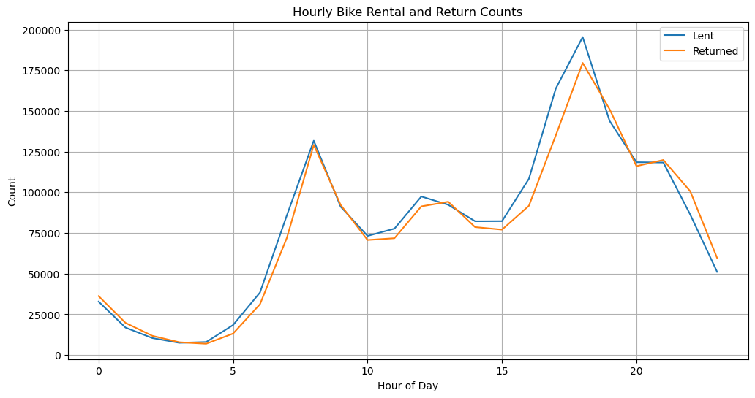

Fig 1. Hourly Bike Rental and Return Count.

1. **Analyze the Condition of Weekdays and Weekends**

Fig 2. shows the condition of average rentals and returns on weekdays and weekends. Which is pretty valid since weekend everyone wants to be at home. But we can see that the rental is truly larger than returned, which we suggest in Section 1.

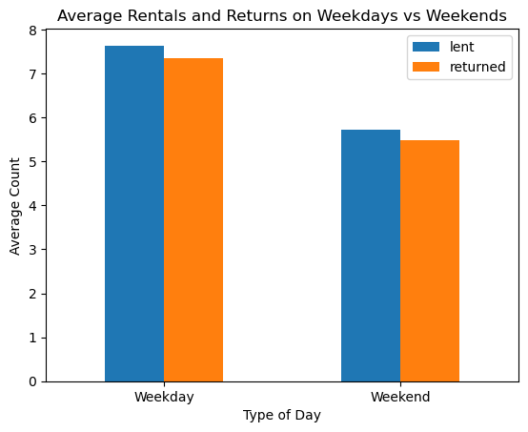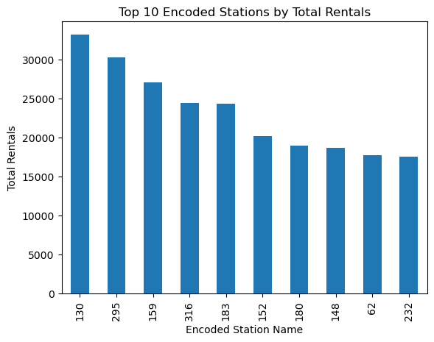

Fig 2. Weekday v.s. Weekends. Fig 3. Top 10 Total Rental Stations.

1. **Analyze the Top 10 Total Rental Stations**

Fig 3. Shows the top 10 total rental stations, which I encoded first and the corresponding stations’ name are:

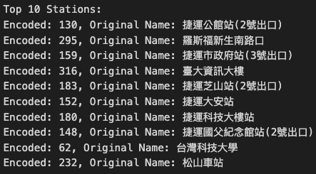

As a results, we know that the 公館站(2號出口) is the most popular station.

And the station probably needs to be larger for the needs.

And the top 10 stations are located at either near the school or near the office area.

1. **Analyze the Total Rental Amount by Hour at Gongguan Station**

Fig 4. shows that the peaks occur at 8 a.m., 12 p.m. and 6 p.m. 🡪 valid for college student, might be freshman who go to 早九 and some elder go to eat lunch for the class afternoon (this would not occur at office area so the Fig 1. would not have this condition) and all the students tend to go home at 6 p.m. so it’s the highest peak.

The company should have more staff to help refill the bike and make the station able to return the bike at these peaks.

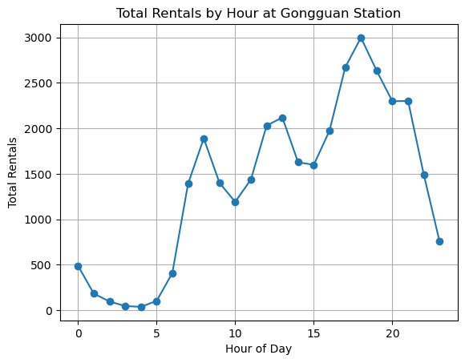

Fig 4. Total Rentals by Hour at Gongguan Station.

1. **Analyze the Difference Between Gongguan and the Others**

Fig 5. shows the average rentals of the Gongguan station and the average of the rentals of all the other stations.

🡪 obviously that the Gongguan stations is extremely higher than the average of the Taipei City.

🡪 Same opinion, the Gongguan station should be larger and have more bikes.

🡪 And probably some of the stations should be smaller to balance the needs.

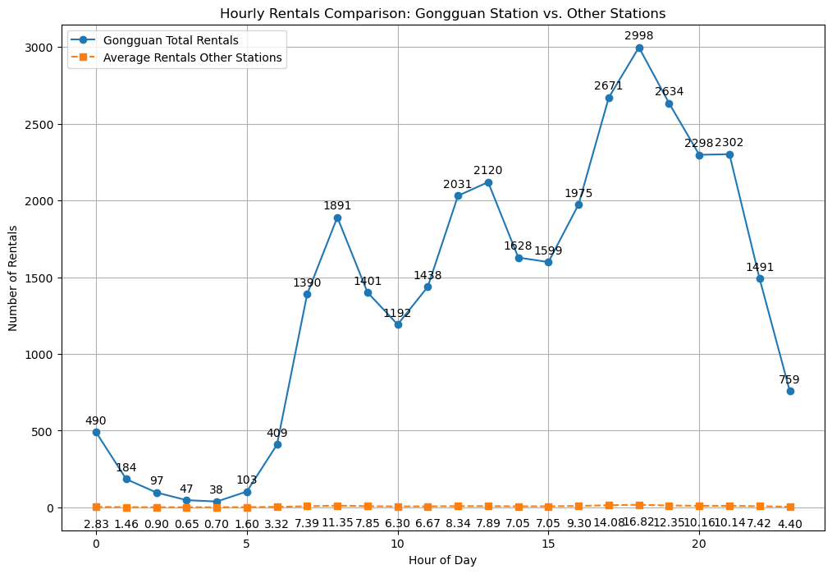

Fig 5. Hourly Rental Comparison of Gongguan Station vs Other Stations

1. **Analyze the Difference of Daily Rentals and Returns**

Since I find out that the rentals and returns are not the same in the previous section, I draw the difference between to verify this condition.

Fig 6. shows that they are really different, and the # of difference is not small to be honest. 🡪 I think the company should aware of this condition to prevent the thief?

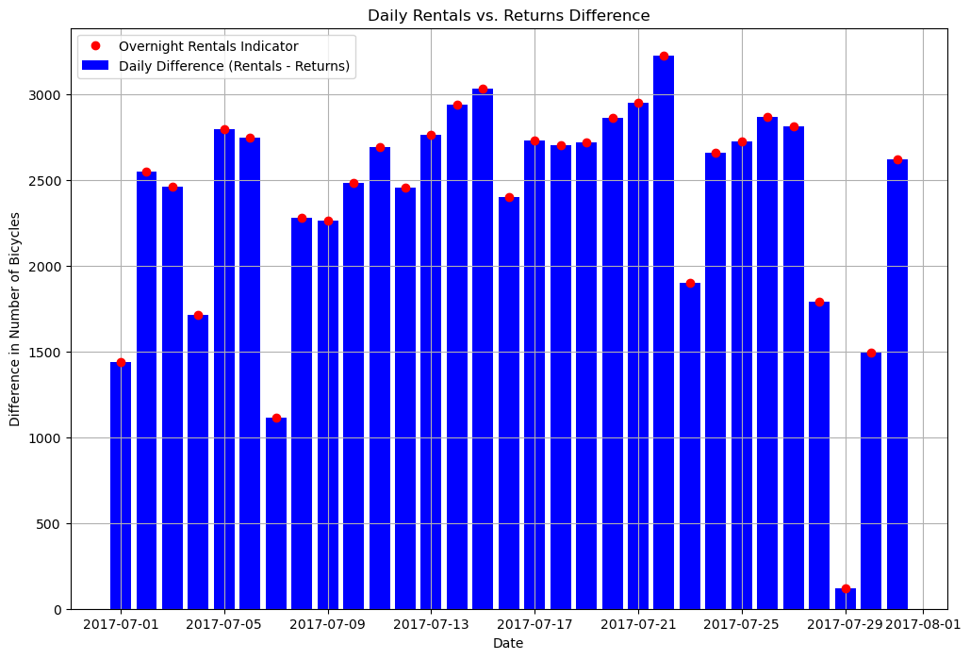

Fig 6. Daily Rentals vs. Returns Difference.

1. **Analyze the Correlation Coefficient Between Rentals and Other Indices**

Analyze the correlation between rentals and temperature, relative humidity, wind speed, precipitation, and station pressure.

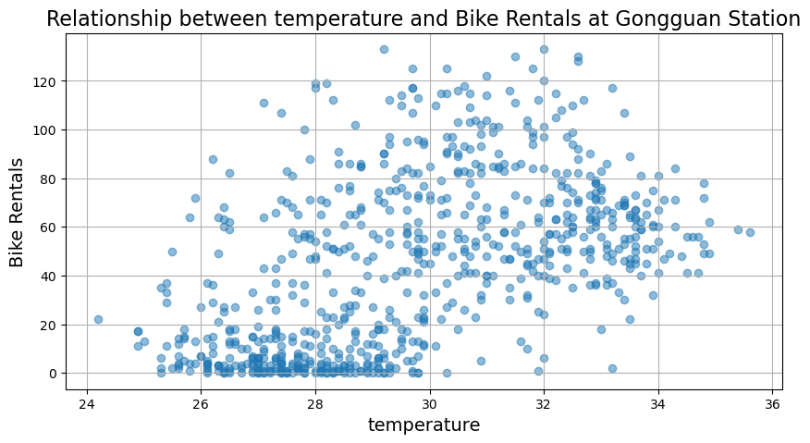 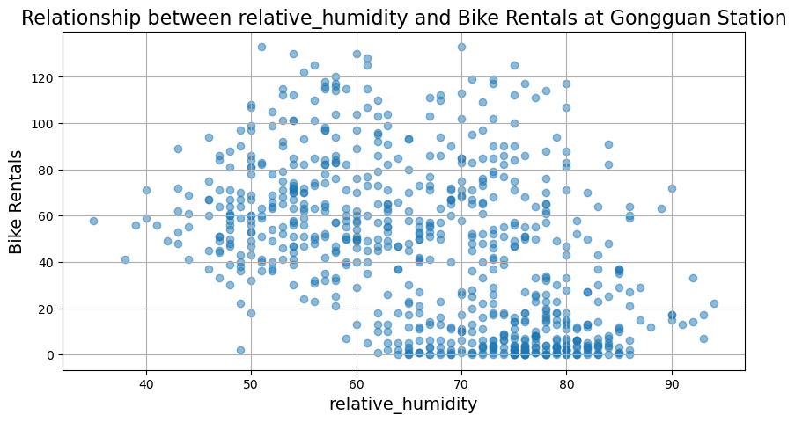

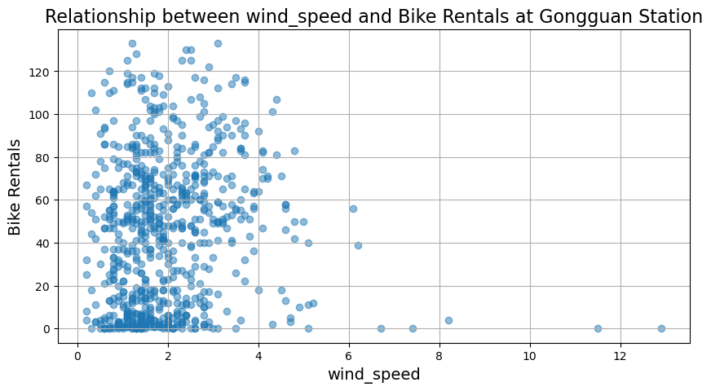 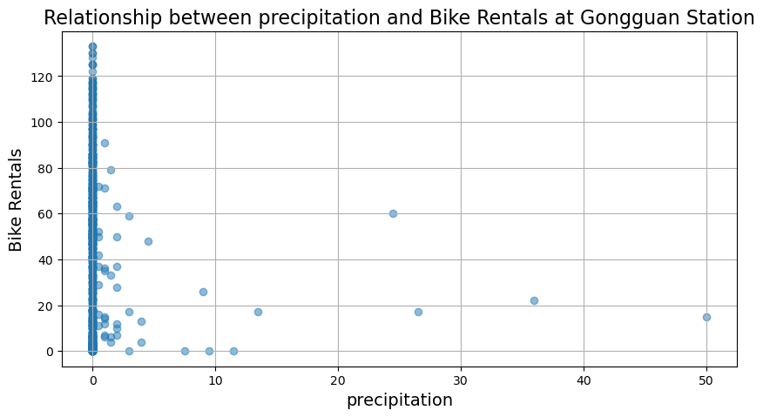

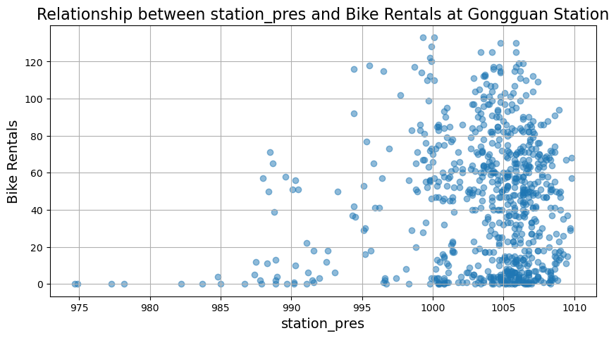

**Temperature**: 0.51 🡪 More people ride the bike while the weather is better.

**Humidity**: -0.46 🡪 Less people ride the bike if it’s too wet and uncomfortable.  
**Wind** **Speed**: 0.08 🡪 Barely not related.

**Precipitation**: -0.08 🡪 Barely not related.

**Pressure**: 0.09 🡪 Barely not related.

* This is just a fun fact I want to know, not suggest anything.

1. **Instruction:**
   1. **All the figure are plot by matplotlib (11 figures total)**
   2. **All the blue words are my suggestions.**
   3. **This is an interesting HW!**