**Filters to compare:**

JPDA

PDA

GM_PHD

GM_CPHD

PMBM

**Scenarios to compare:**

1. no intersection, fixed cardinality

In this scenario, four targets are initiated and there would be no intersection whatsoever when the track progresses, also there will be no cardinality change. The objective of this scenario is to act as a baseline. All trackers should perform well for this scenario.

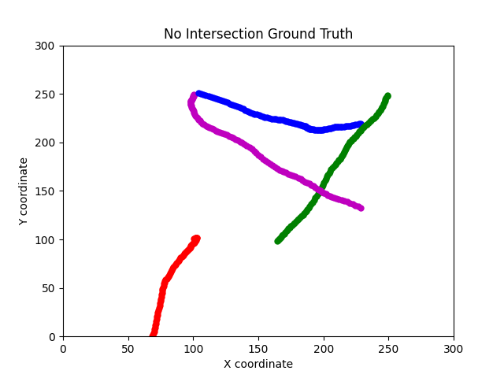

2. intersection, fixed cardinality

The four tracks will meet at n_scan/2 steps, and the cardinality will remain the same through out the simulation. The objective of this scenario is the compare how the 5 trackers fare against the intersection point.

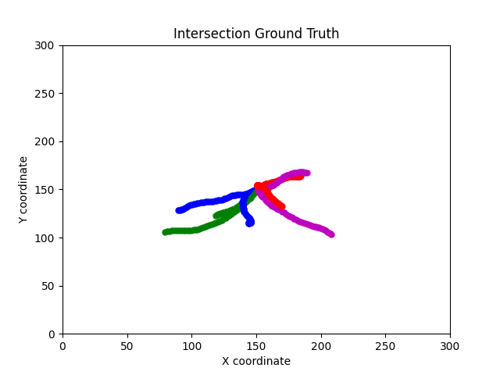

3. no intersection, varying cardinality

In this scenario, four targets are initiated and there would be no intersection whatsoever when the track progresses. However, there will be cardinality changes every 30 scans, in dicated by the color changes in the following graph. The objective of this scenario is to see how the trackers fare against cardinality variation.

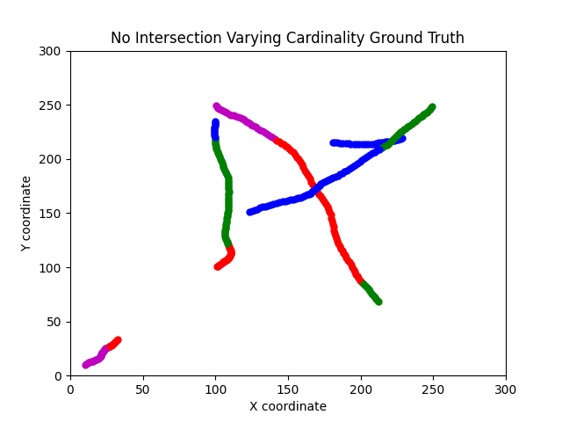

4. intersection, varying cardinality

The tracks will meet at n_scan/2 steps, and the cardinality will change every 30 scans. The objective of this scenario is the compare how the 5 trackers fare against the intersection point and cardinality variation.

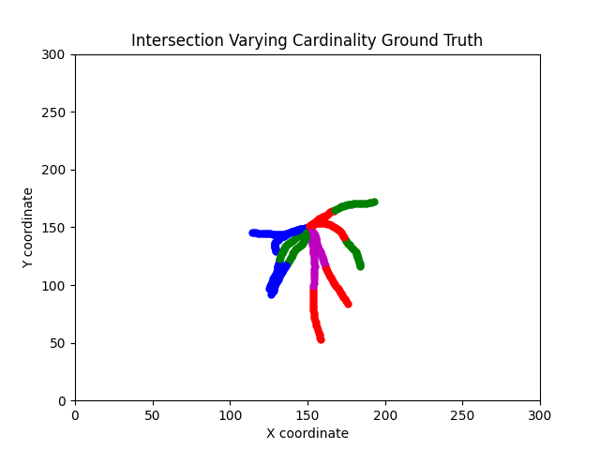

5. travel in proximity

This scenario has 4 targets travel in proximity, without any cardinality changes. This scenario is designed to mimic the road traffic where cars are moving in tandem.

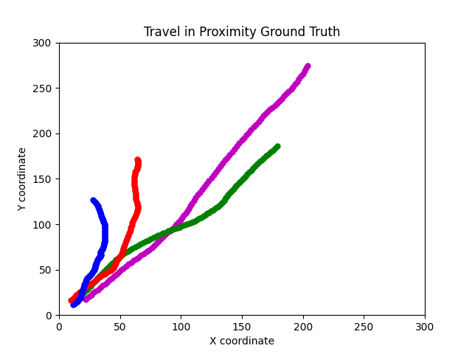

6. intersection, more than one cardinality change

This scenario is designed to be the highest difficulty. At n_scan/2 step, there would be intersection. There would also be multiple varying cardinalities. Such as disappearing of more than one object, appearing of more than one object, simultaneous disappearing and appearing of objects.

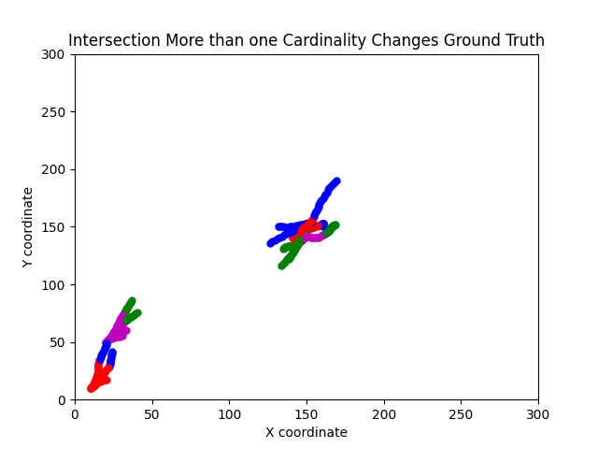

1. **No Intersection, Fixed Cardinality**

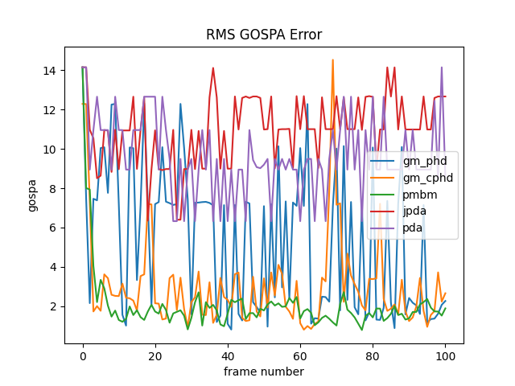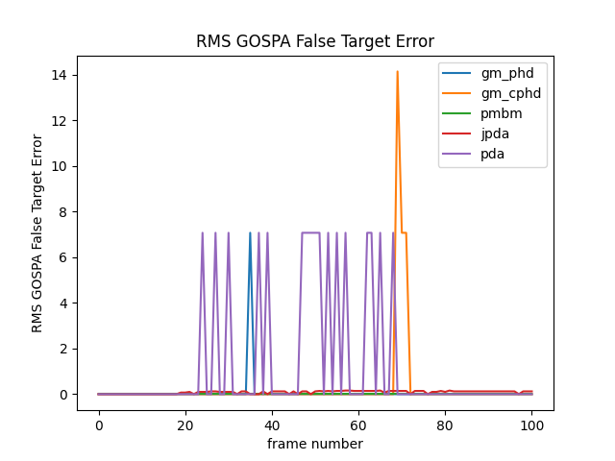

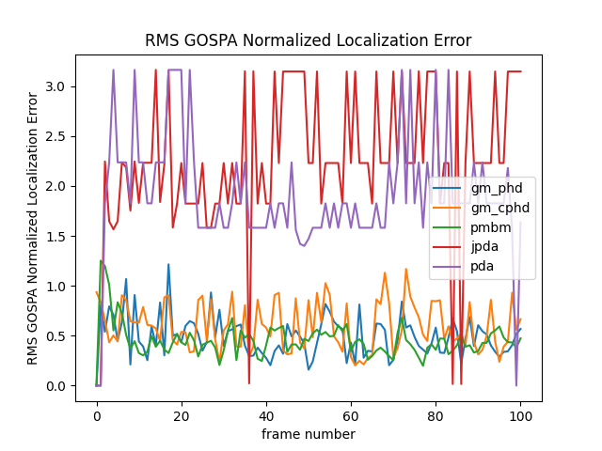

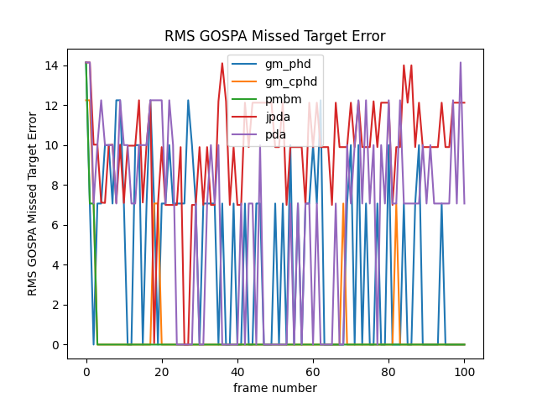

1. **Intersection, Fixed Cardinality**

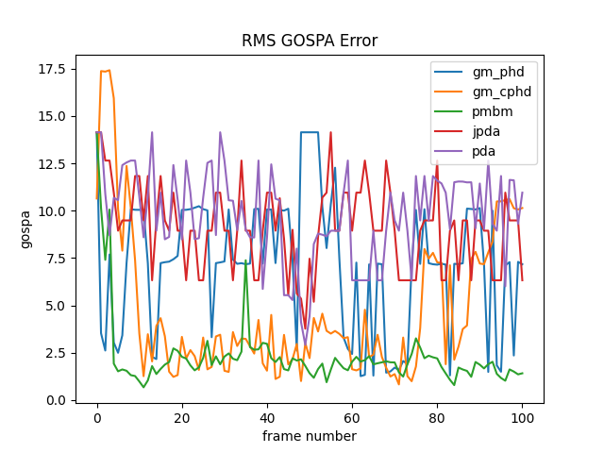

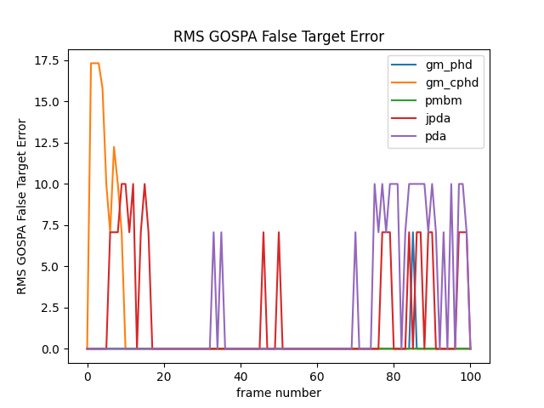

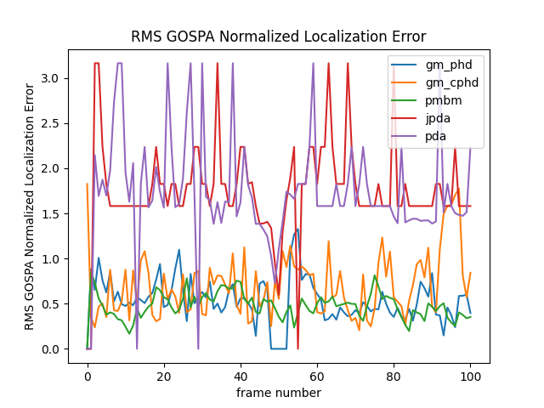

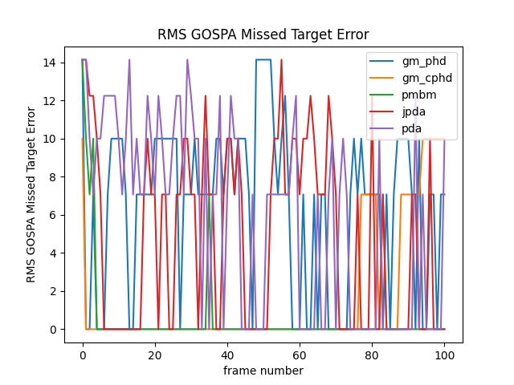

1. **No Intersection, Varying Cardinality**

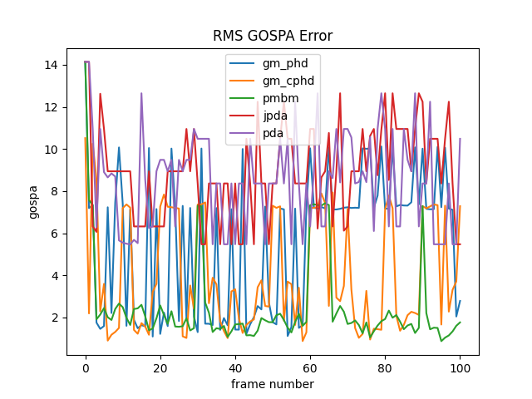

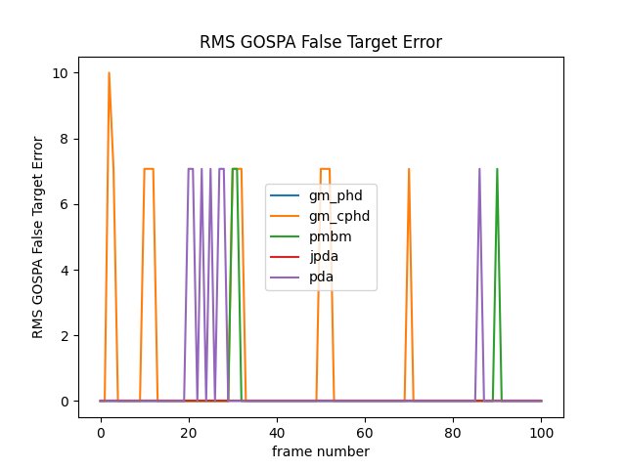

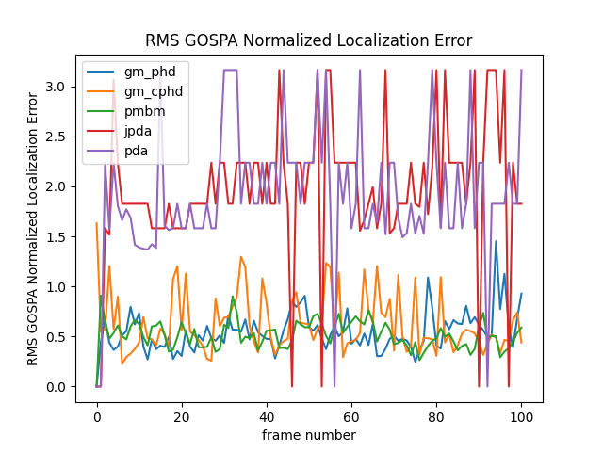

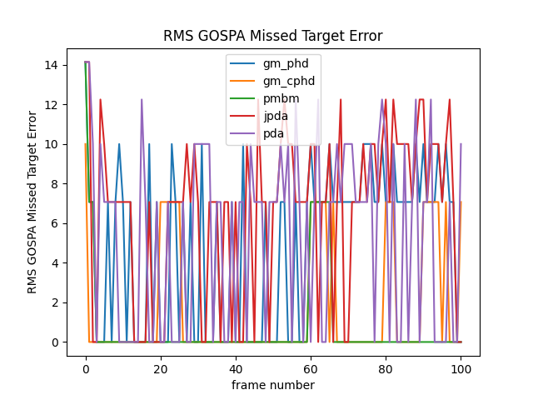

1. **Intersection, Varying Cardinality**

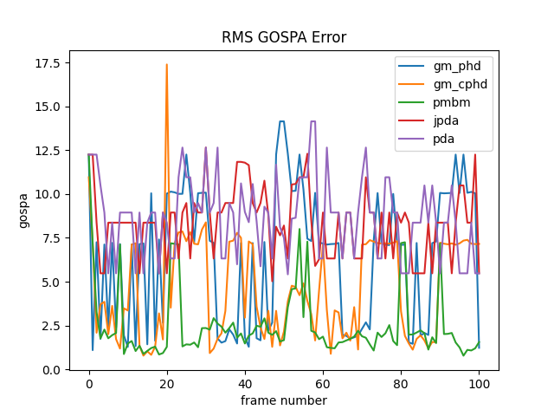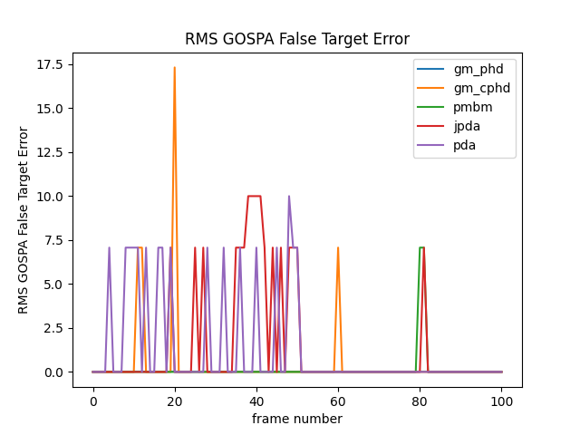

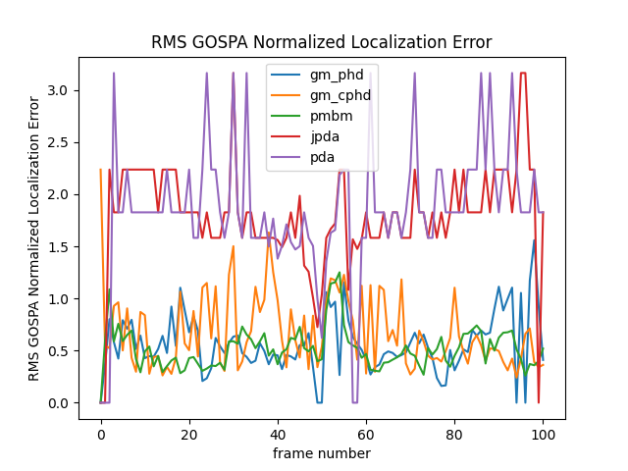

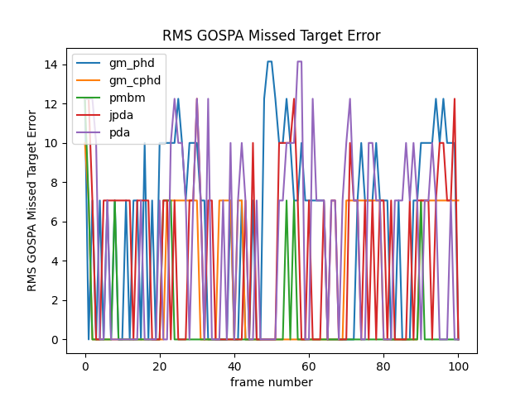

**5. Travel in Proximity**

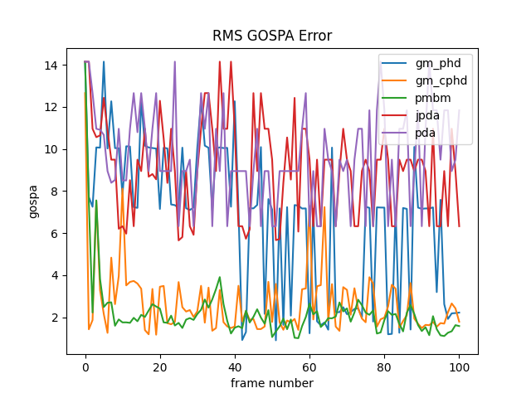

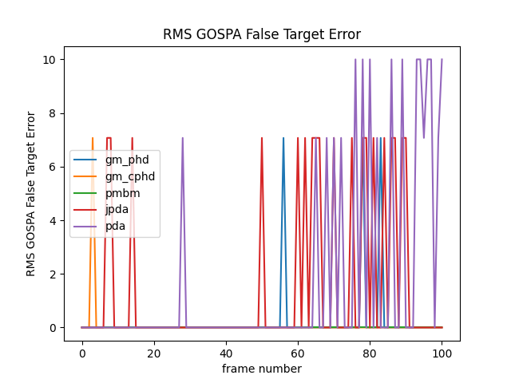

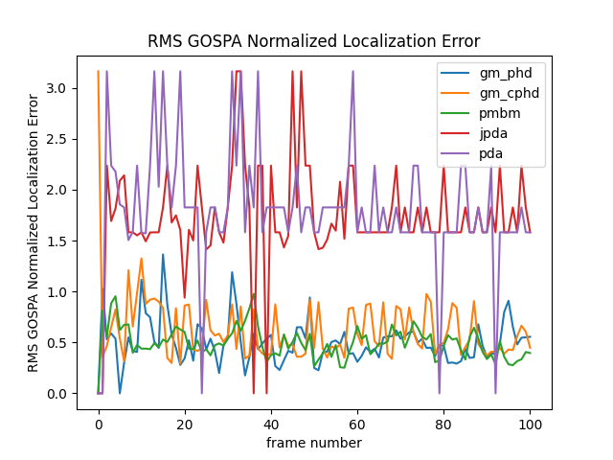

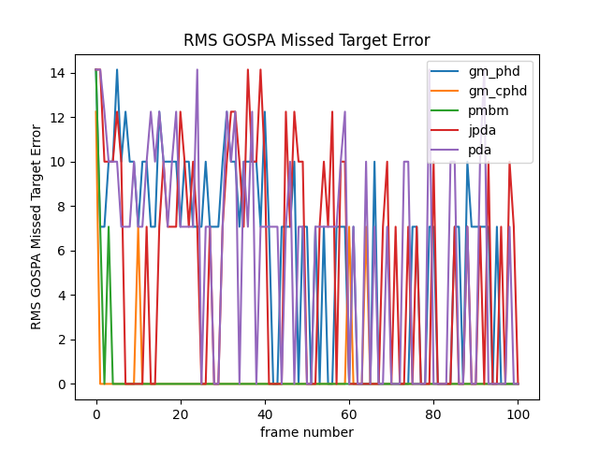

**6. Intersection, more than one cardinality change**

