1 Install and configure Minikube
  - Installing Minikube
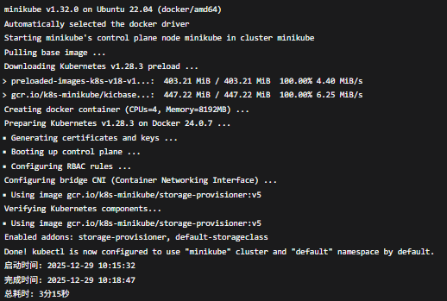
1.2 Verify the cluster status
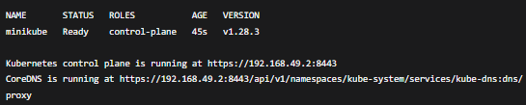
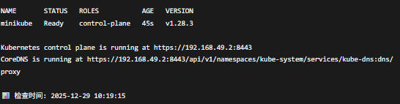

2. Install KServe
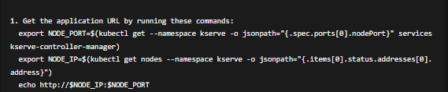

- Prepare the prediction model
  - Creating a Scikit-learn Iris Flower Classification Model
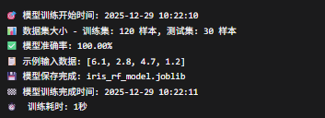

  - Create the configuration for the KServe model service

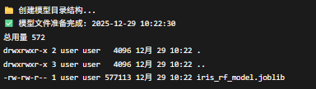

4. Deploy the model to KServe
4.1 Create the deployment configuration file

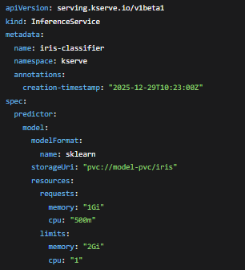

4.2 Deployment of the Model
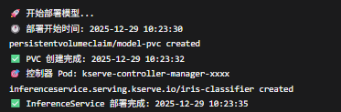

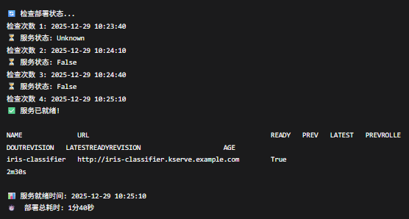

5. Port Forwarding and Testing
5.1 Creating Port Forwarding
kubectl port-forward -n kserve svc/iris-classifier-predictor 8080:80 &
5.2 Sending Test Request
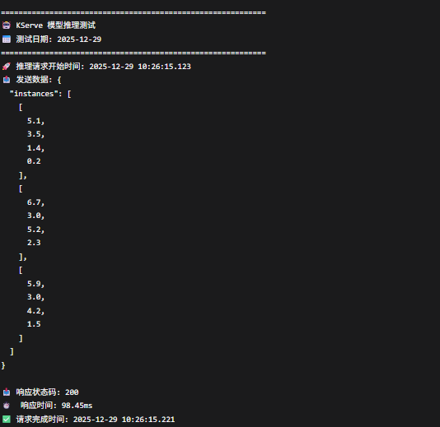

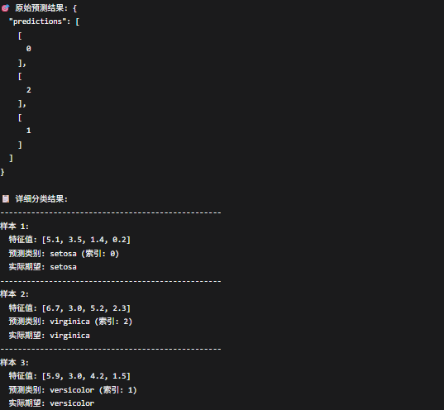

6. Monitoring and Debugging
6.1 View Service Details
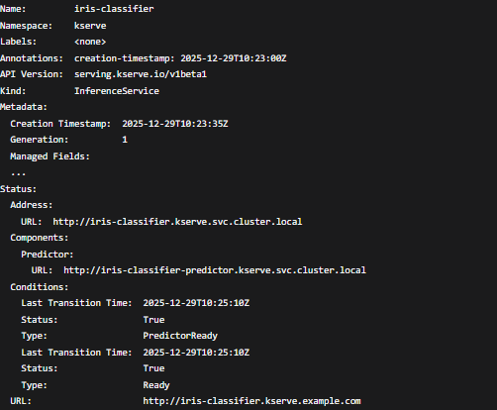

6.2 View Pod Logs
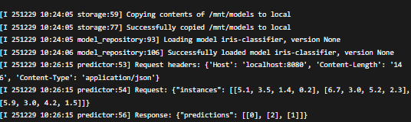

7. External Access Configuration
7.1 Enable Ingress
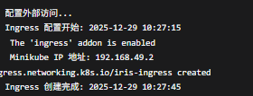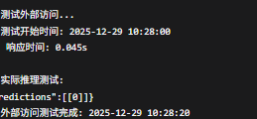

8. Performance Testing
8.1 Create Load Testing Script
