- Install Docker Desktop
  - Install WSL (as my OS is Windows11)
Open cmd (Run as Administrator)
Run wsl --install
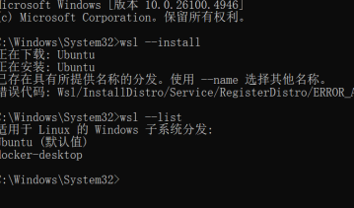
Restart the computer

  - download and install Docker Desktop
Visit the official Docker website to download the Docker Desktop installation package: https://www.docker.com/products/docker-desktop/.

Install Docker Desktop

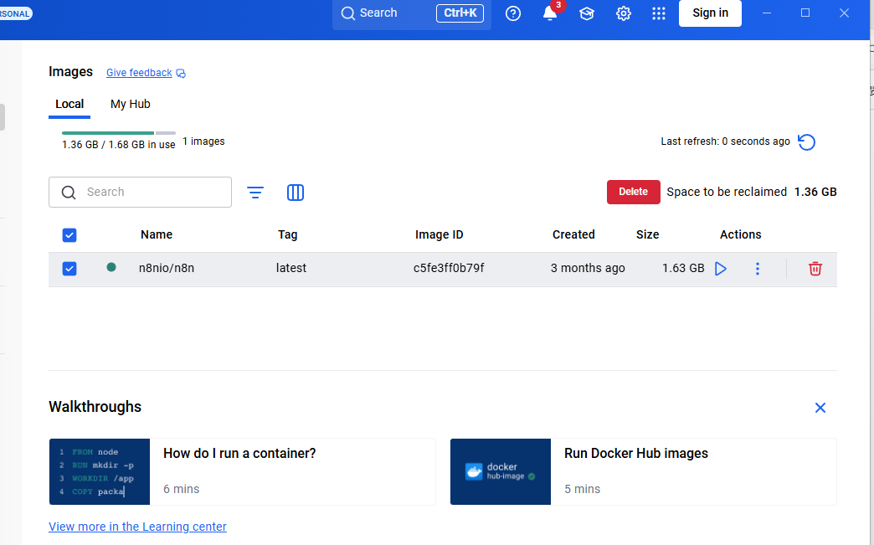

Run “docker run hello-world” in cmd and see:
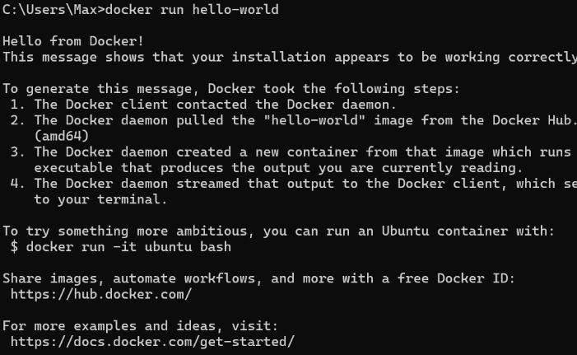

- Use Docker to install Gitea

In this folder, create a subfolder named data to store database, warehouse and other data.
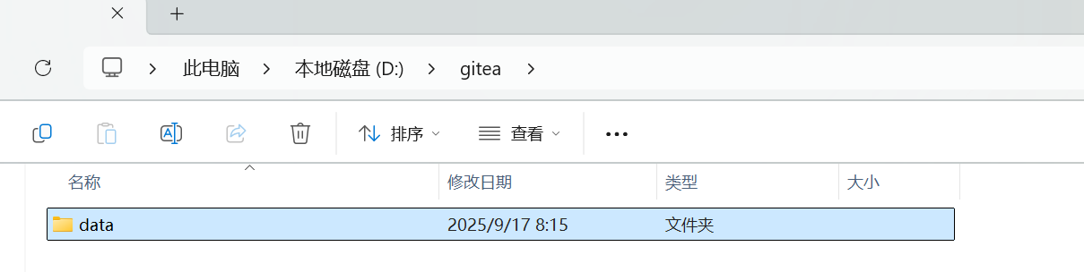
- Running the Gitea container with Docker
- run “docker pull gitea/gitea:latest” to pull (download) Gitea's Docker image
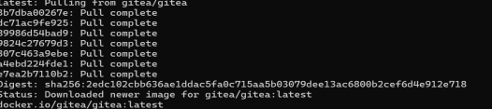
- run “docker run -it -p 3000:3000 -p 2222:22 --name gitea -v D:/gitea/data:/data gitea/gitea:latest” to run Gitea Docker
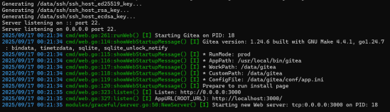

- Configure Gitea
- Visit http://localhost:3000 in your browser.
- see the Gitea installation configuration page. Fill in the following information:

Database Type: Select SQLite3 (the simplest, no additional installation required).

Application URL: http://localhost:3000.

Gitea installation path: /data/gitea.

Administrator Account and Password: Create your own administrator account.

- Click "Install Gitea Now."
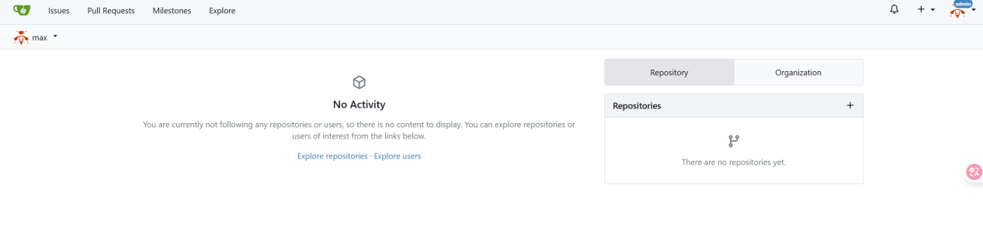
- finish the lab task
- gitea suport LFS 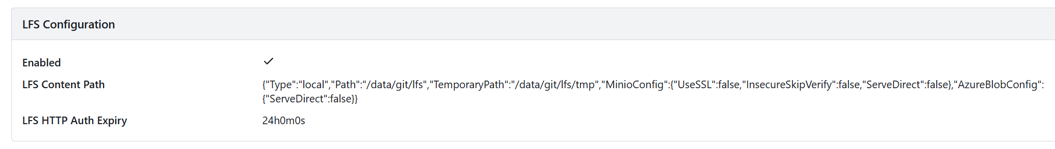
- Create a repo with a large file(1G+)

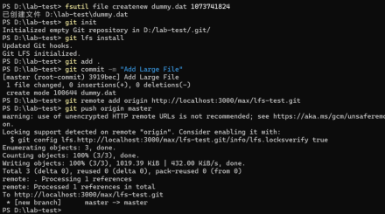

- Create a module repository and submit your work
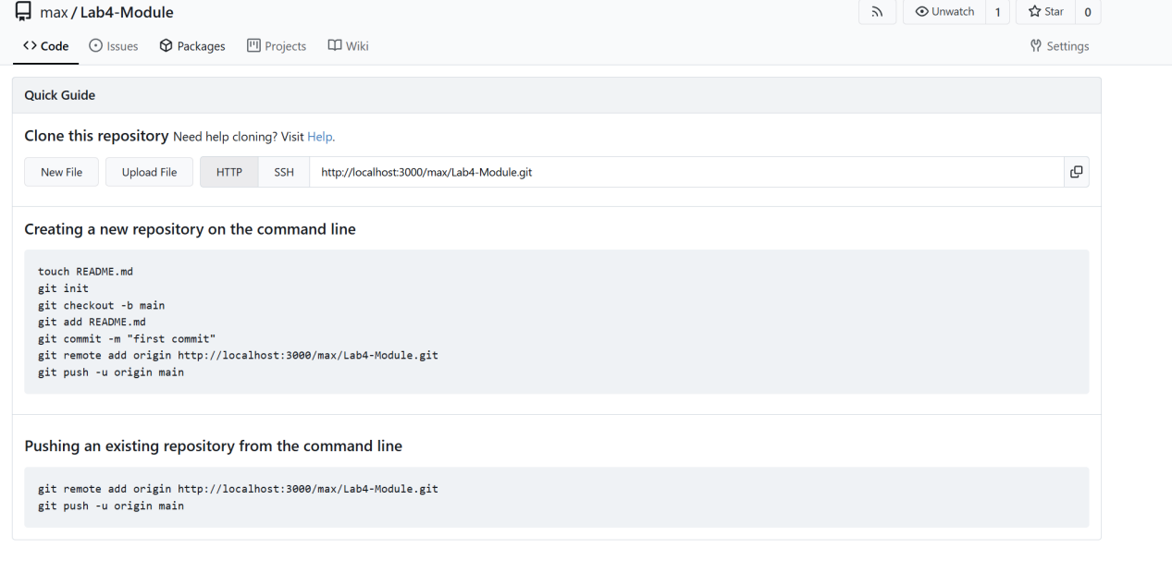
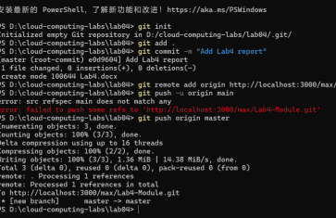

Download MySQL database
Download Gitea binaries from the official website
