1.Download and install Istio
Go to the Istio release page to download the installation file for your OS

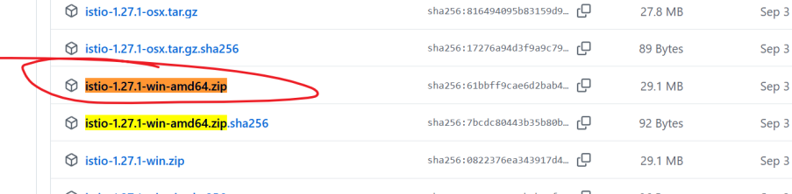

2.add istio to path

3.Install Istio using the demo profile, without any gateways
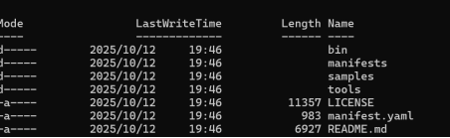

Add a namespace label to instruct Istio to automatically inject Envoy sidecar proxies when you
verify CRD
Install CRD
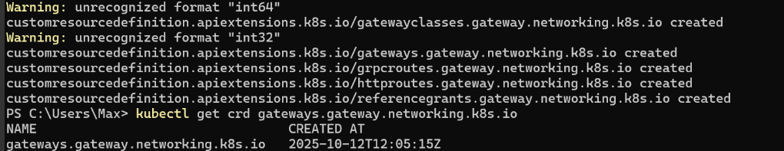

Deploy the sample application

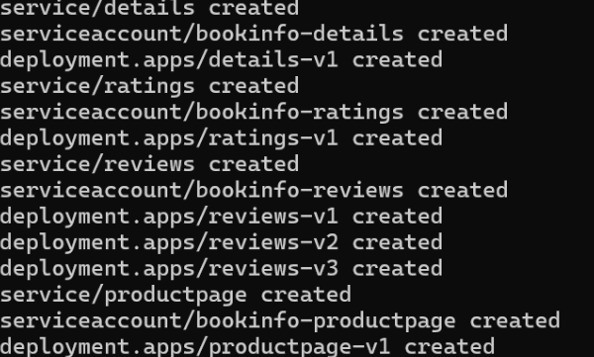
The application will start. As each pod becomes ready, the Istio sidecar will be deployed along with it.
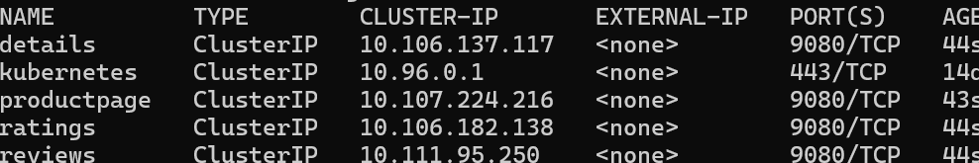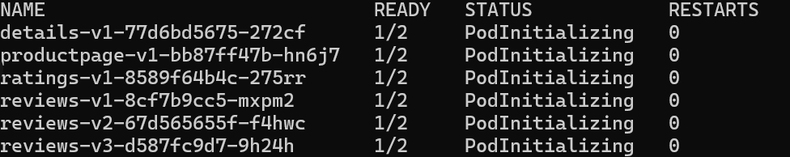
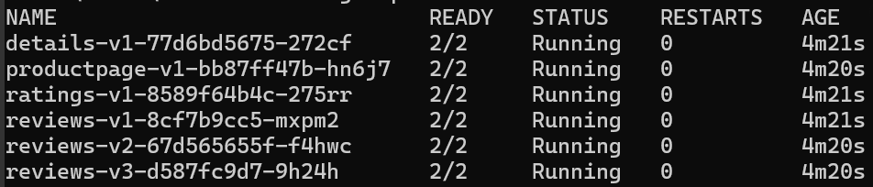

4.Open the application to outside traffic
Create a Kubernetes Gateway for the Bookinfo application:
Change the service type to ClusterIP by annotating the gateway
To check the status of the gateway, run:
Access the application
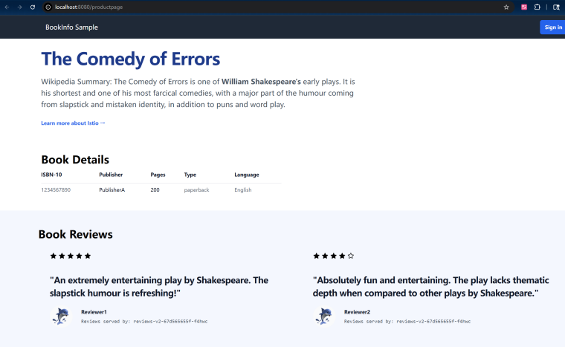

5.View the dashboard
Install Kiali and the other addons and wait for them to be deployed.
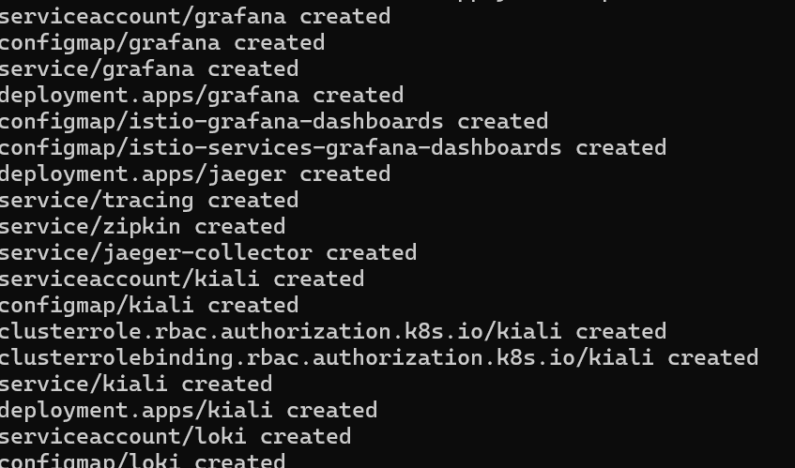

Access the Kiali dashboard.
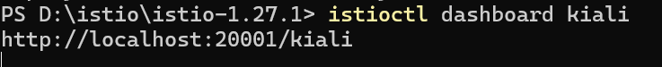

In the left navigation menu, select Graph and in the Namespace drop down, select default.
