0. Read the instructions here: https://github.com/slackhq/nebula

1. You should make your own configuration file for all participating comptuers. use a data comparison utility such as Meld and [Beyond Compare] to compare the configuration files attached to see where the changes should be made.

- Run nebula and check the connectivity between your computer and the light house. The IP address of the light house in the overlay network is 192.168.100.1. Please note that the config.yaml for the lighthouse is already properly prepared.

<imgwidth="625" height="475" alt="Image" src="https://github.com/user-attachments/assets/d0222232-f8c0-480e-9690-7d7d326c2fd1" />

3. some useful example commands for MAC OS:
brew install nebula
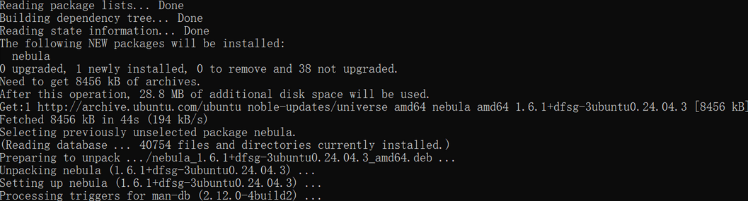、
<img width="718" height="228" alt="Image" src="https://github.com/user-attachments/assets/d53c8bb0-0dc4-4f45-93b0-605741911613" />

nebula-cert -version

<img width="720" height="27" alt="Image" src="https://github.com/user-attachments/assets/a068ff83-7e88-498b-9fa6-63e39f7f5b4d" />

nebula-cert ca –name #it will report error. No worries.

<img width="728" height="36" alt="Image" src="https://github.com/user-attachments/assets/ba20411a-ff65-4b7c-808a-b93f4cd6fa1c" />

nebula-cert ca –name "LeiNetwork"

<img width="738" height="19" alt="Image" src="https://github.com/user-attachments/assets/33317659-3066-48ef-a52f-956a92db80af" />

nebula-cert sign -name "lighthouse" -ip "192.168.100.1/24"
nebula-cert sign -name "MBP15" -ip "192.168.100.15/24"
nebula-cert sign -name "mini" -ip "192.168.100.10/24"
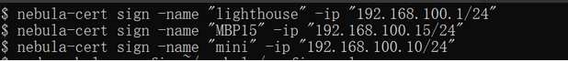

<img width="724" height="43" alt="Image" src="https://github.com/user-attachments/assets/9cd41f41-1b83-4882-8d2e-b19156c672cc" />

sudo nebula -config ~/.nebula/config.yaml
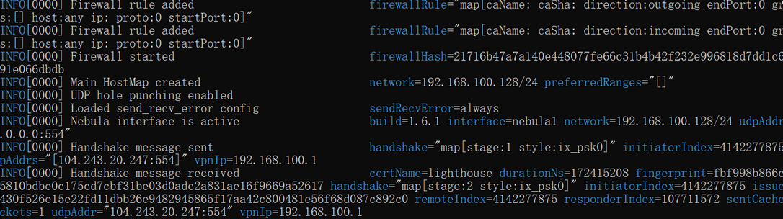
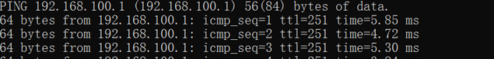

<img width="748" height="340" alt="Image" src="https://github.com/user-attachments/assets/f99a7ecf-bd16-453b-887a-4732a973a914" />

