Lab 2
BaiYunfeng

- Creation of Alibaba Cloud virtual machine
  - Connect to the Alibaba Cloud virtual machine

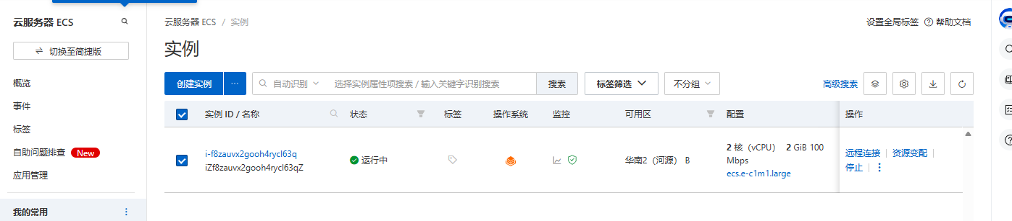
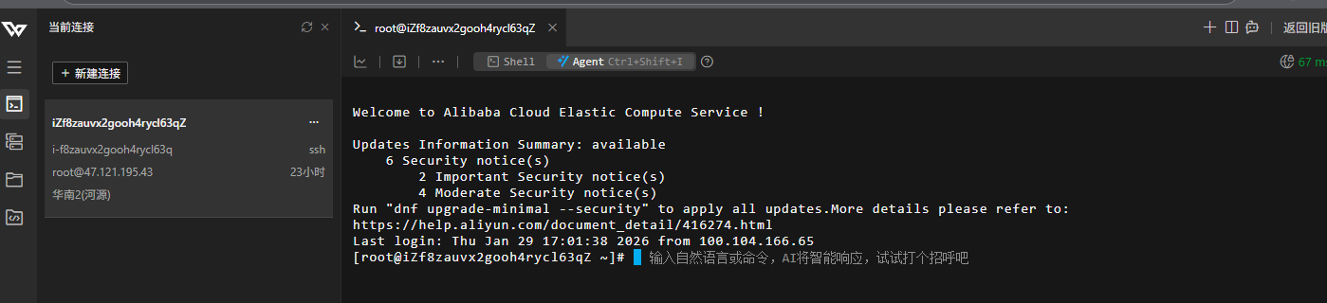

- Deploy Nebula Lighthouse on an Alibaba Cloud virtual machine
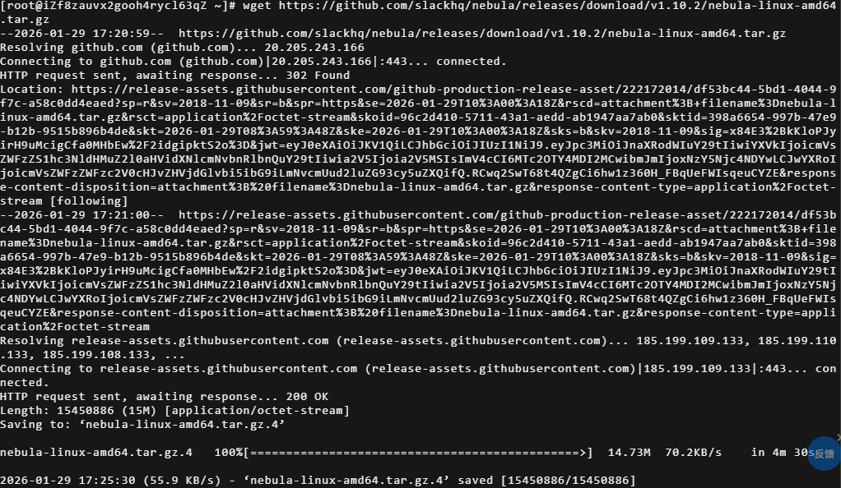
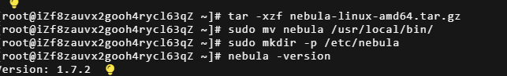
  - Configure Windows environment variables

- Generate Nebula Certificate (on Windows 11)
3.1 Generate CA certificate
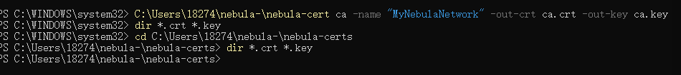
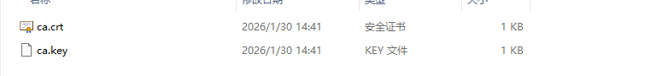

3.2 Generate Lighthouse certificate

3.3 Generate Windows client certificate

- Configure Alibaba Cloud Lighthouse
4.1 Upload the certificate
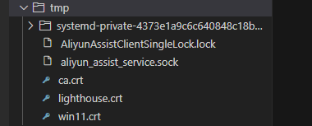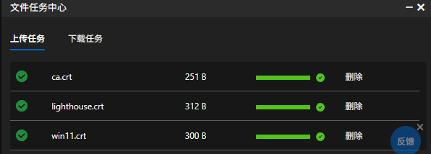

4.2 Configure Nebula on Alibaba Cloud VM

4.3 Create a Systemd service and start it
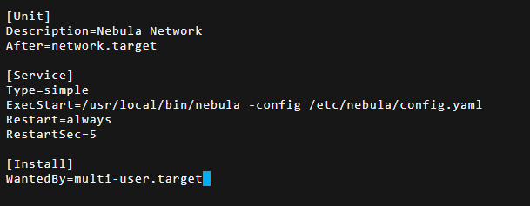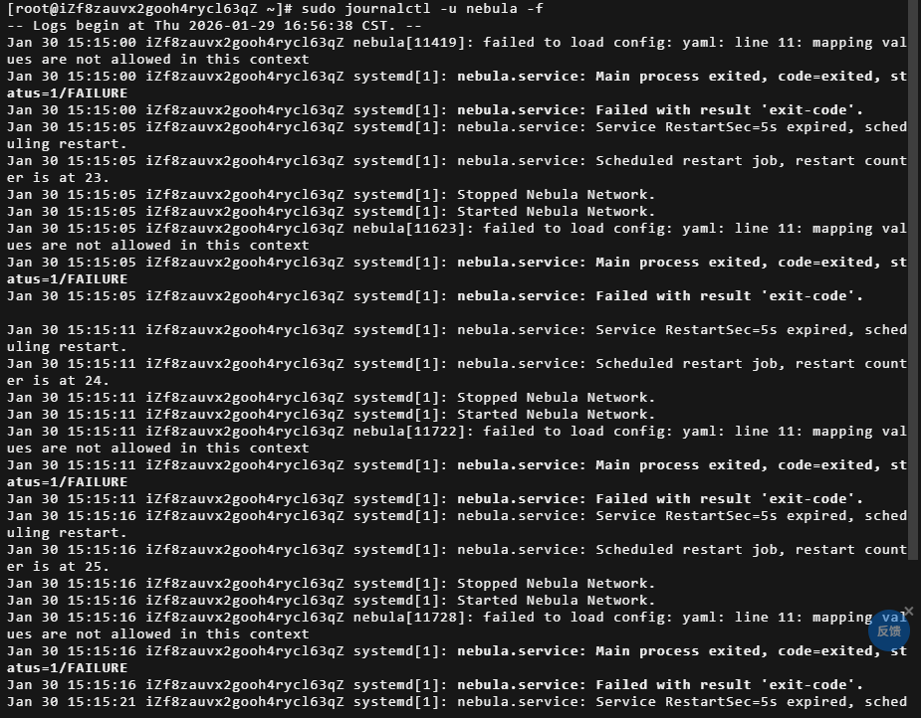

- Windows 11 Client Configuration

