Lab 6
BaiYunfeng
1.hello-minikube

1.1 Install kubectl on Windows

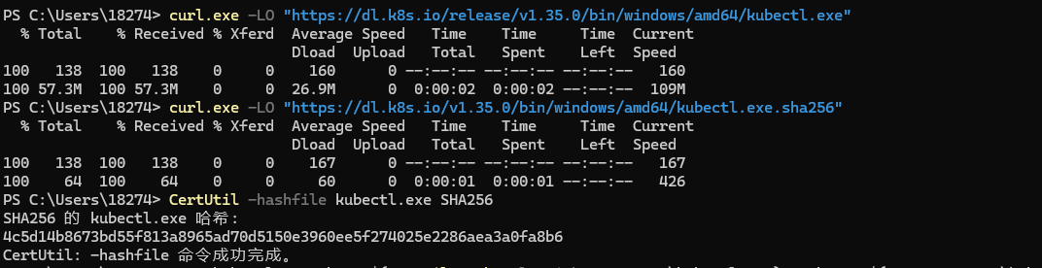
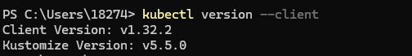

1.2 Create a Minikube cluster
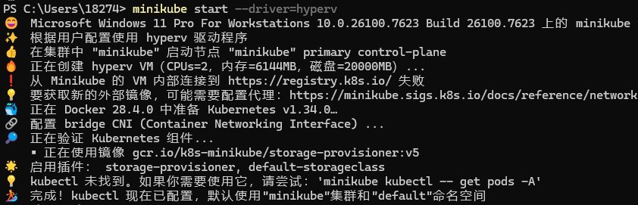

1.3 Open the dashboard
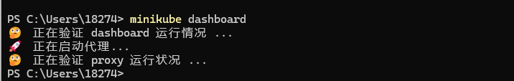

1.4 Create Deployment

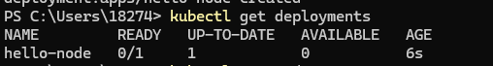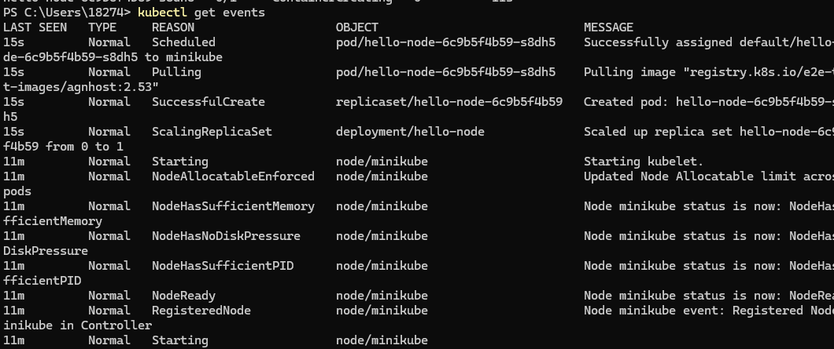
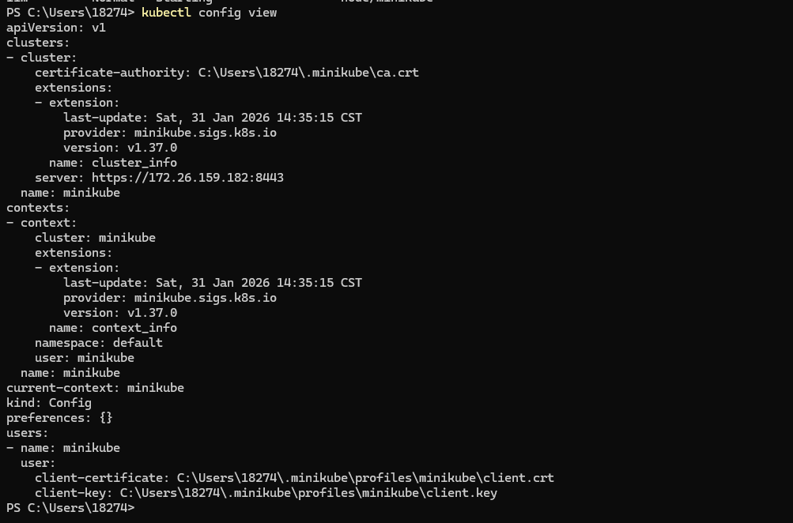

1.5 Create Service
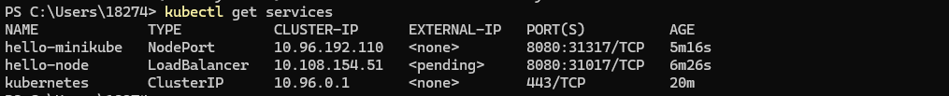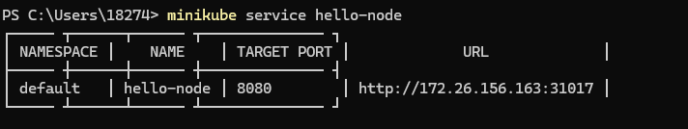

1.6 Enable the plugin
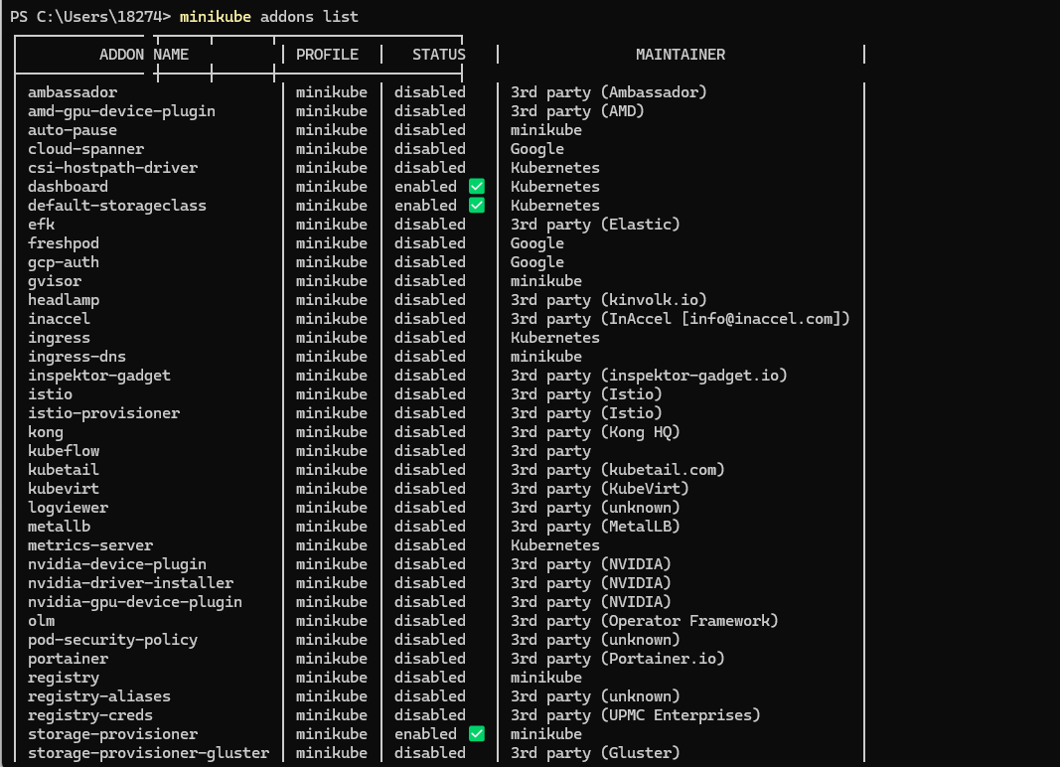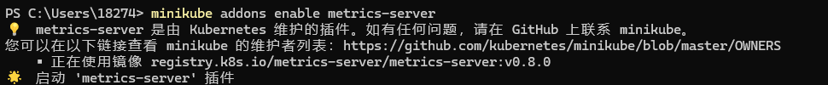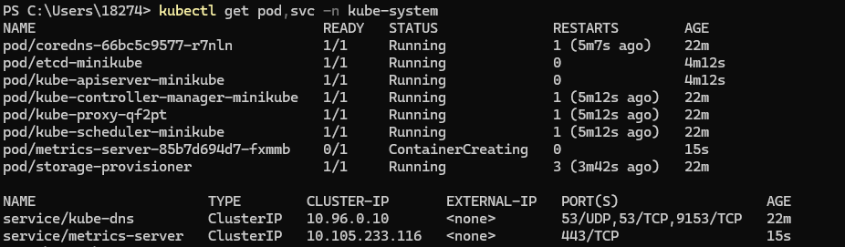

1.7 Cleaning

- deploy-intro
  - Deploy an application

  - View the application
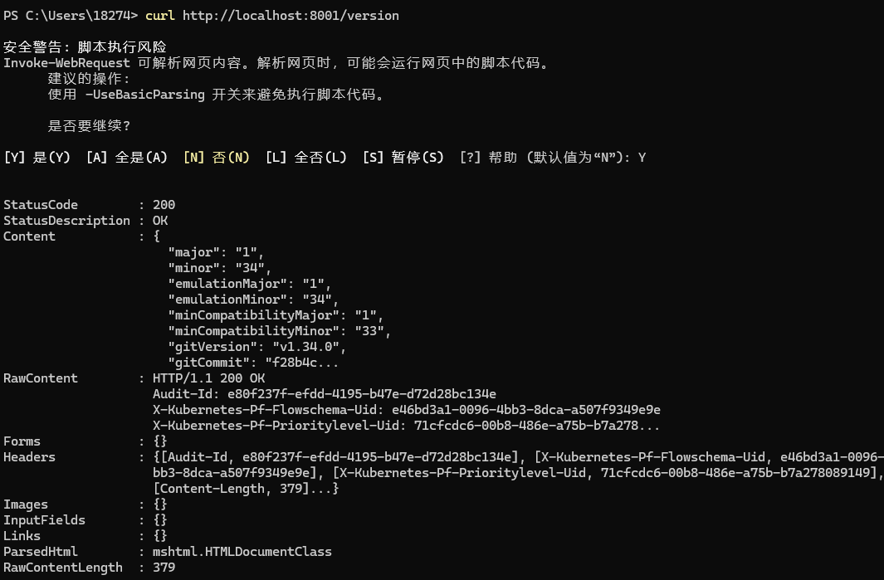

- explore-intro
  - Check the application configuration

- expose-intro
  - Create a new Service
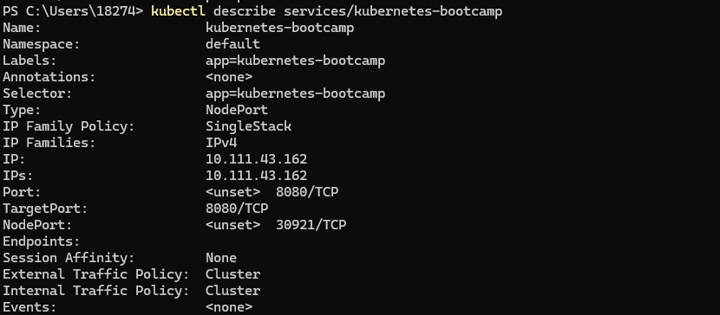

  - Use labels
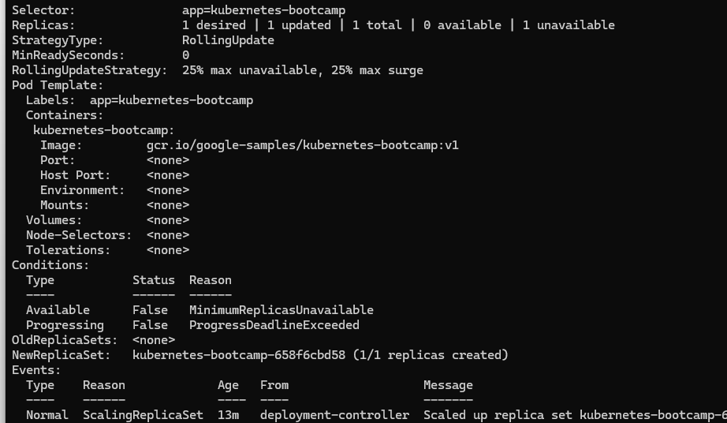
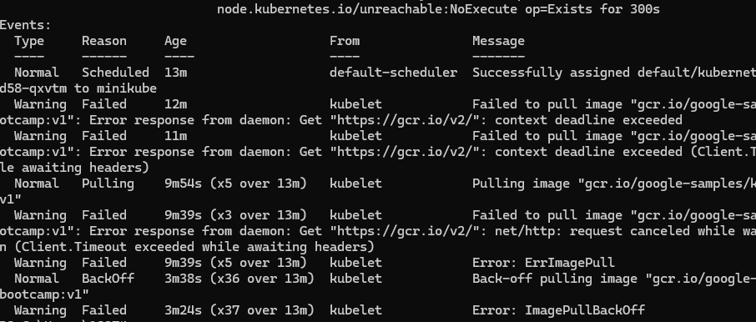

  - Delete a Service

- scale-intro
  - Scaling Deployment
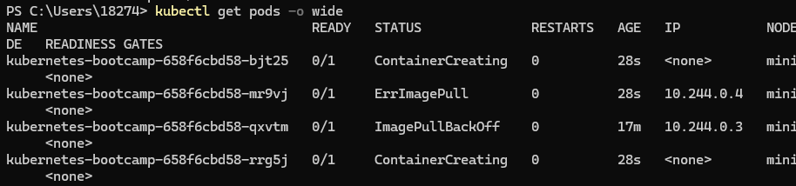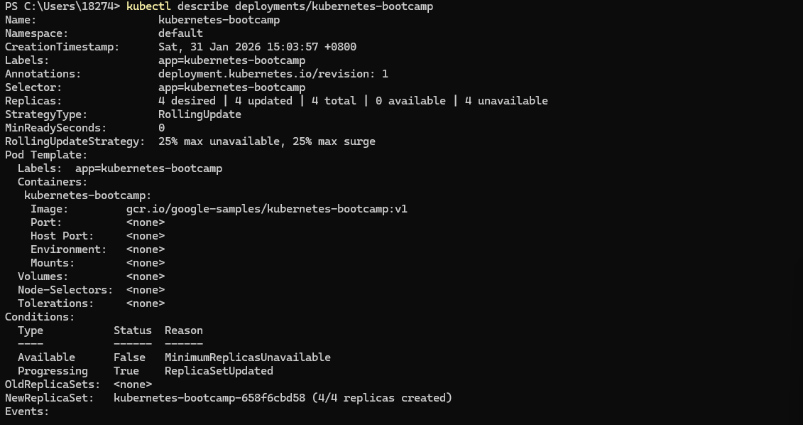

  - Load balancing

  - Resize
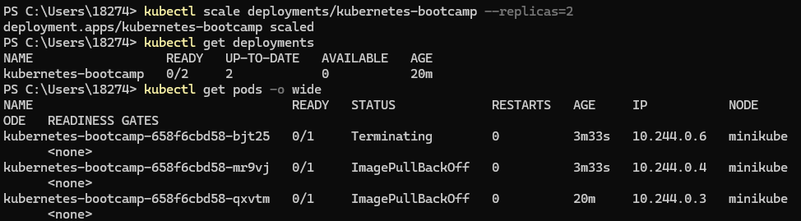
- update-intro
  - Update the version of the application

  - Verify update

  - Rollback the update
