Lab 8
BaiYunfeng
- traffic-shifting
  - Apply weight-based routing
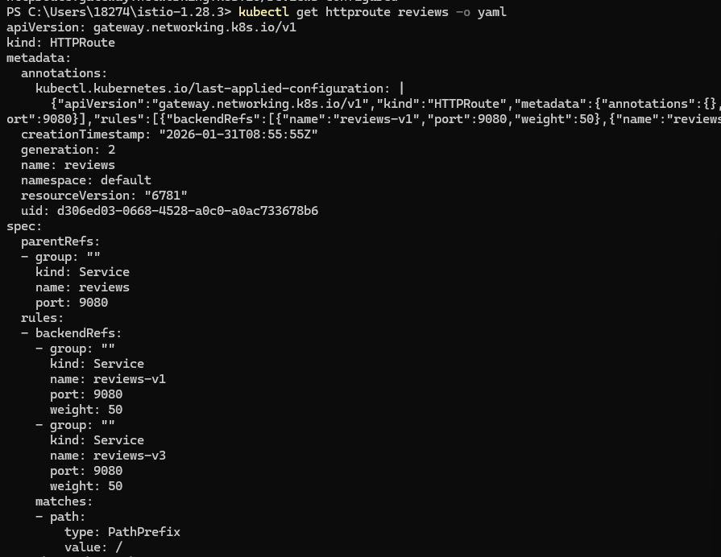

  - Cleanup

- request-routing
  - Route to version 1
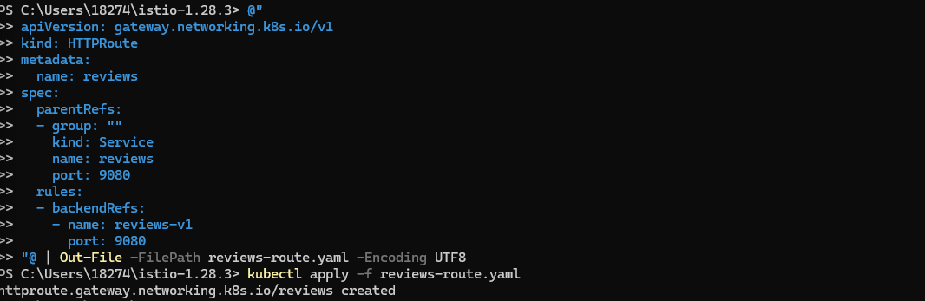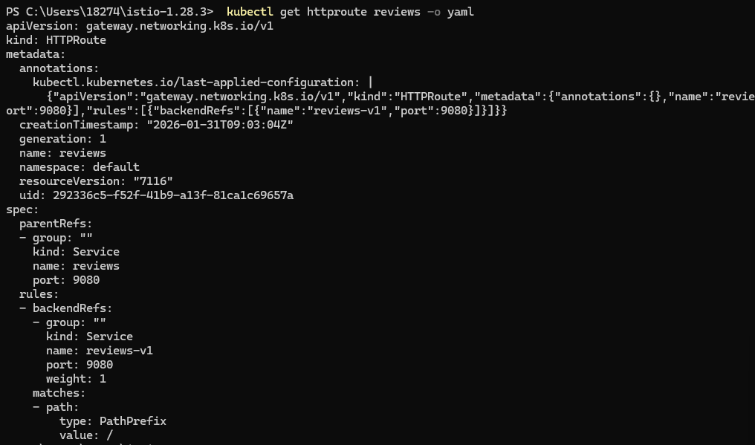

  - Route based on user identity
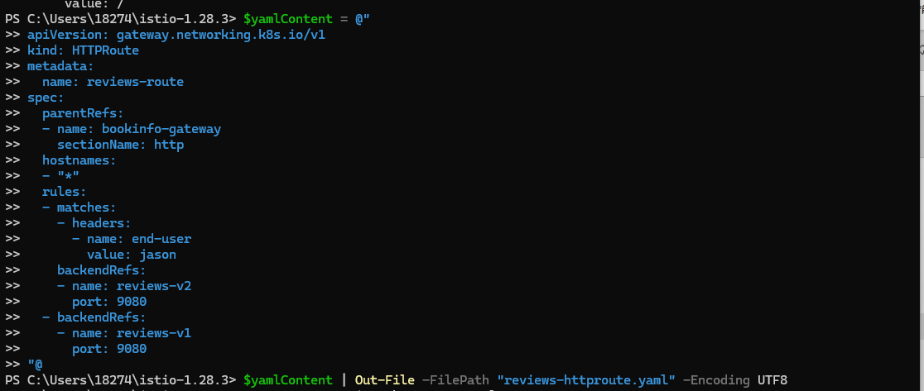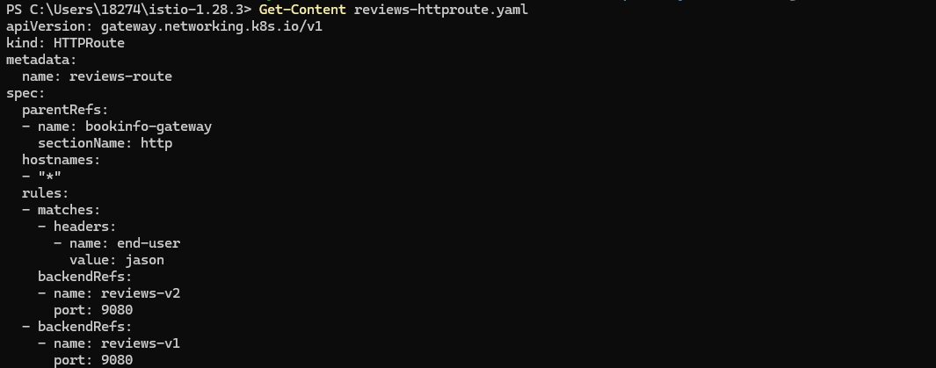
  - Cleanup

- fault-injection
  - Injecting an HTTP delay fault
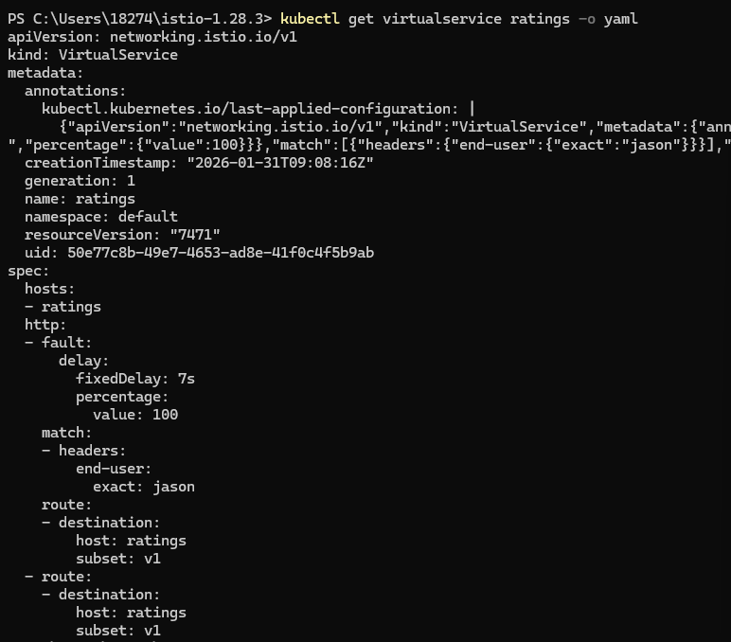

  - Injecting an HTTP abort fault
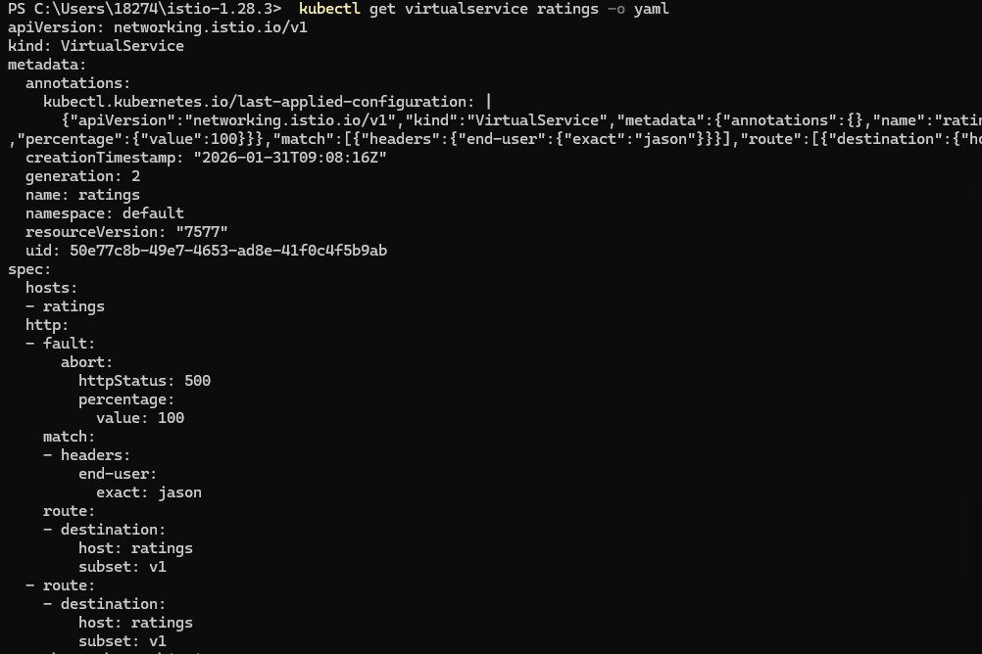

- circuit-breaking
  - Before you begin

  - Configuring the circuit breaker
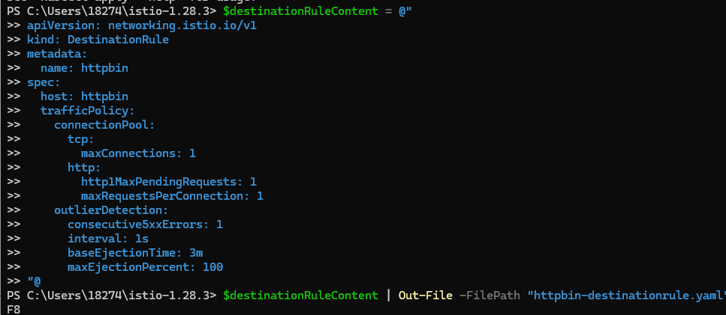
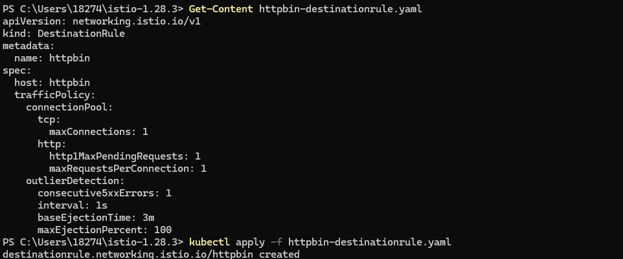
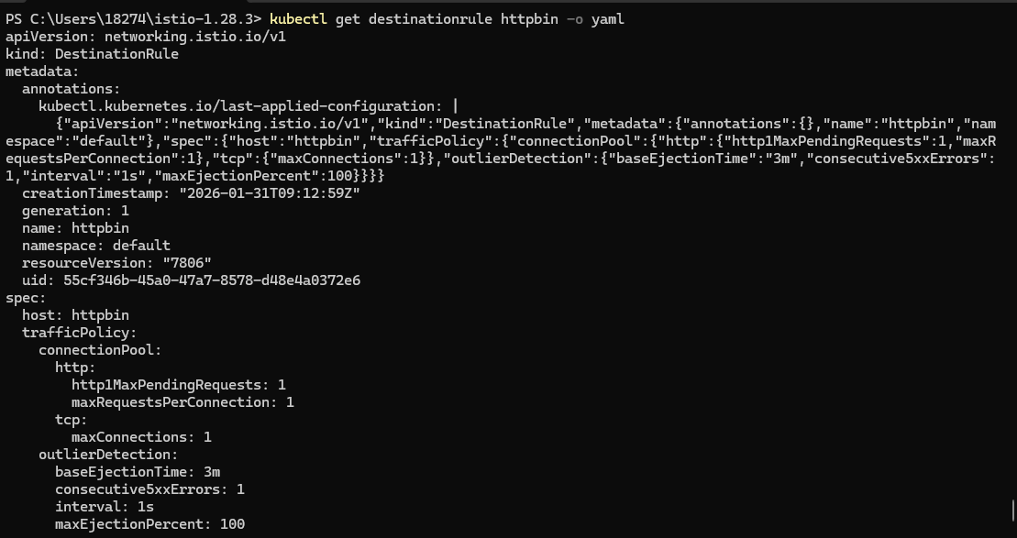

  - Adding a client
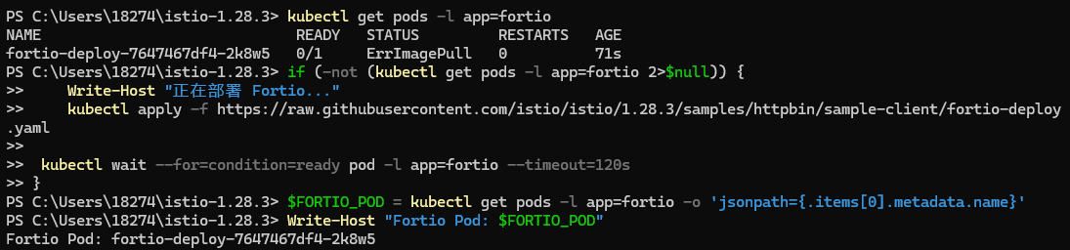

  - Tripping the circuit breaker
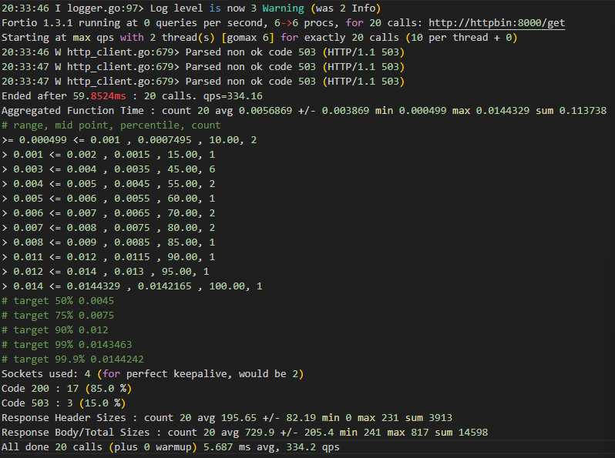

  - Cleaning up

