Lab 9
BaiYunfeng

1.Install a networking layer
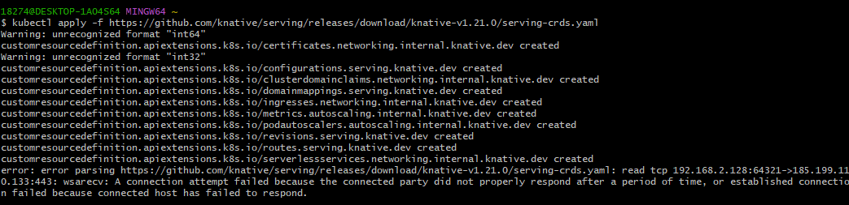
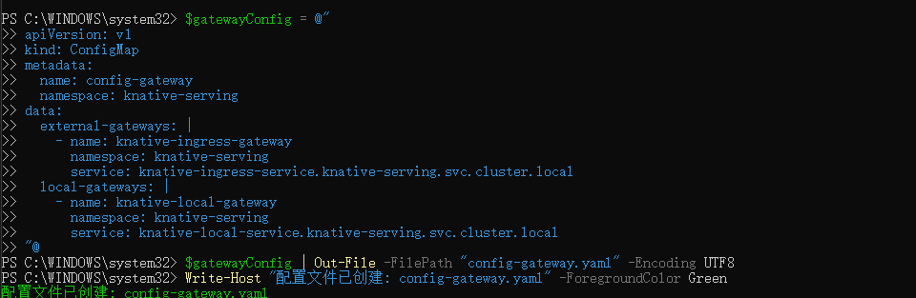

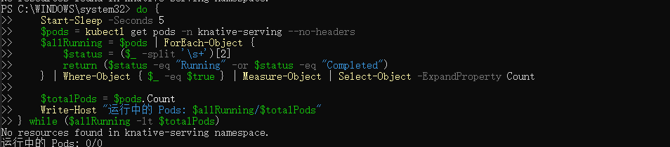

- cert-manager
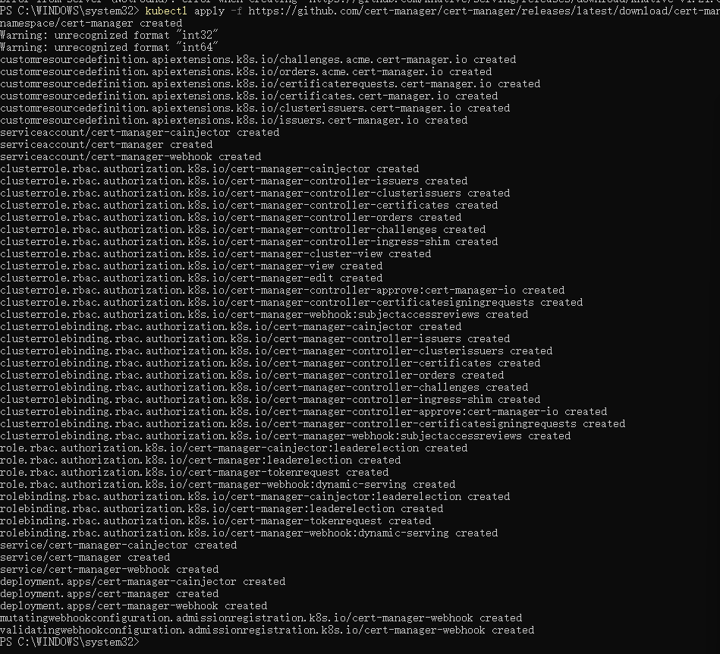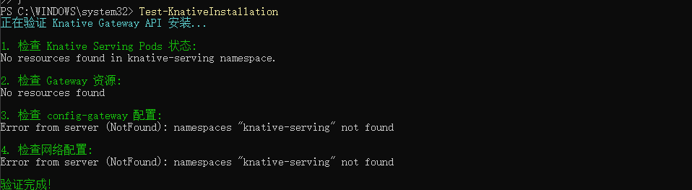

3Installing Knative Eventing on Minikube
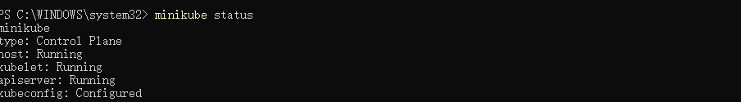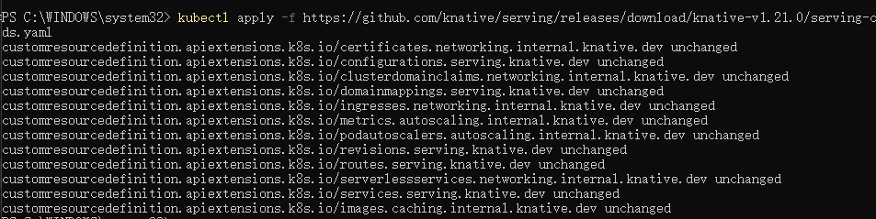

- Install the default Channel layer

4.Installation script
