**Effortlessly Customizable Layout: Using Fieldset in LWC for Omniscript**

**Summary :**

Develop a comprehensive LWC component for editable layouts, using fieldset functionality for use in omniscript. Implement user field access validation to ensure data security. Empower users with customizable layouts while maintaining strict field-level permissions. Enhance usability, security, and flexibility for diverse application scenarios, ensuring seamless data presentation and interaction.

**Problem** **:**

The project aims to develop an LWC component to display layout in omniscript using fieldset with user field access validation, enhancing usability, security, and flexibility.

**Solution :**

Firstly we have to build fieldset, where we need to add all field which you want to show in omniscrpit.

Eg:

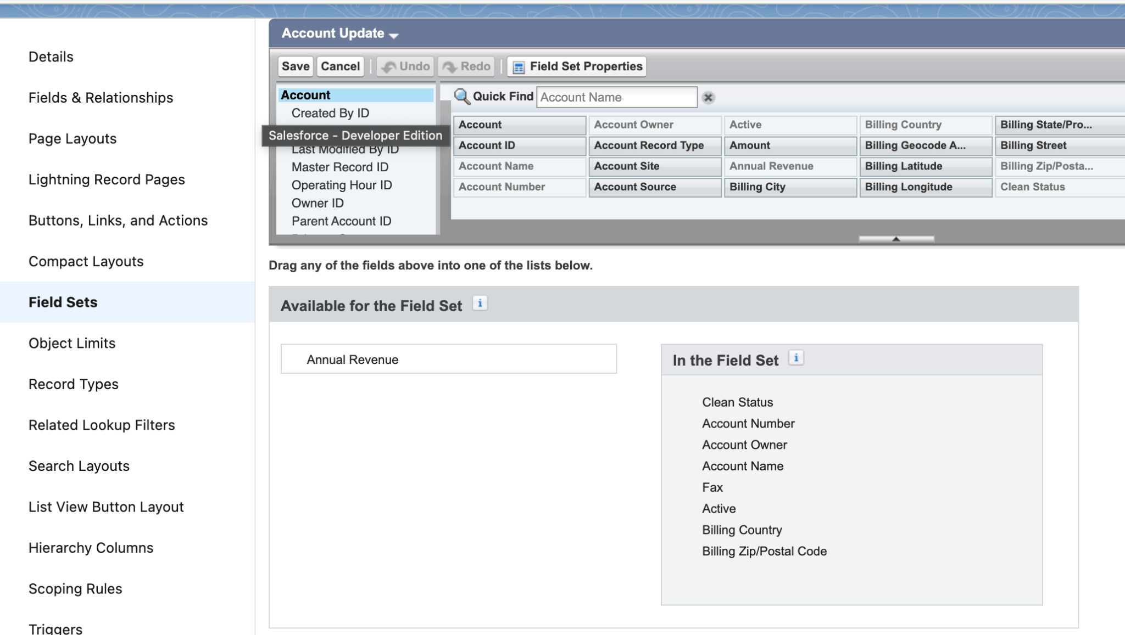

Here we build a LWC (**os_PageLayoutFromFieldsetComponent**) which take fieldset Name, objectName and recordid as input parameter from OS.

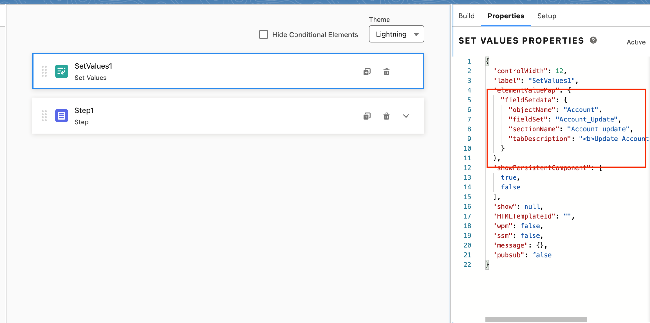

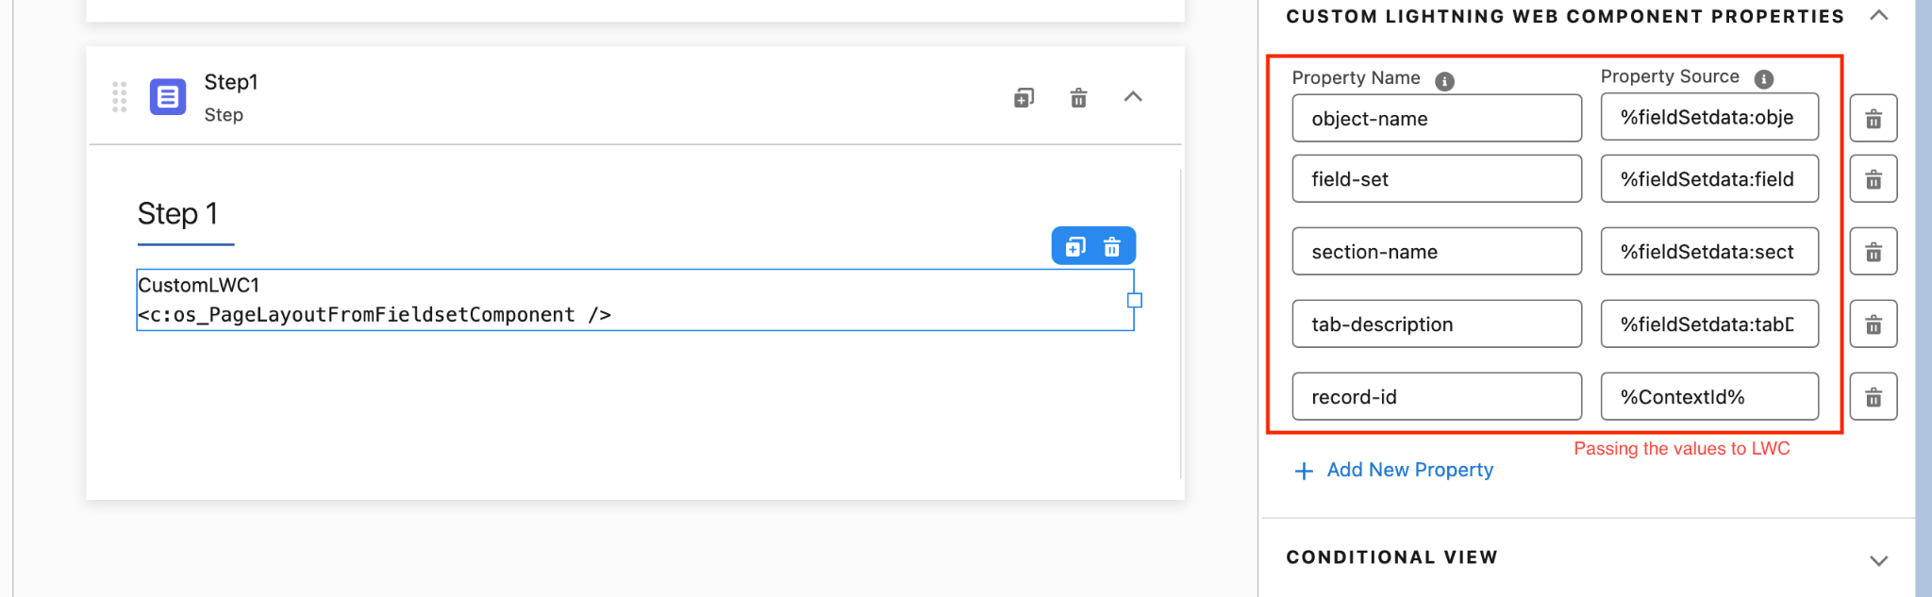

Once configure on preview on passing context id to OS. it will show all the fields in two column layout. 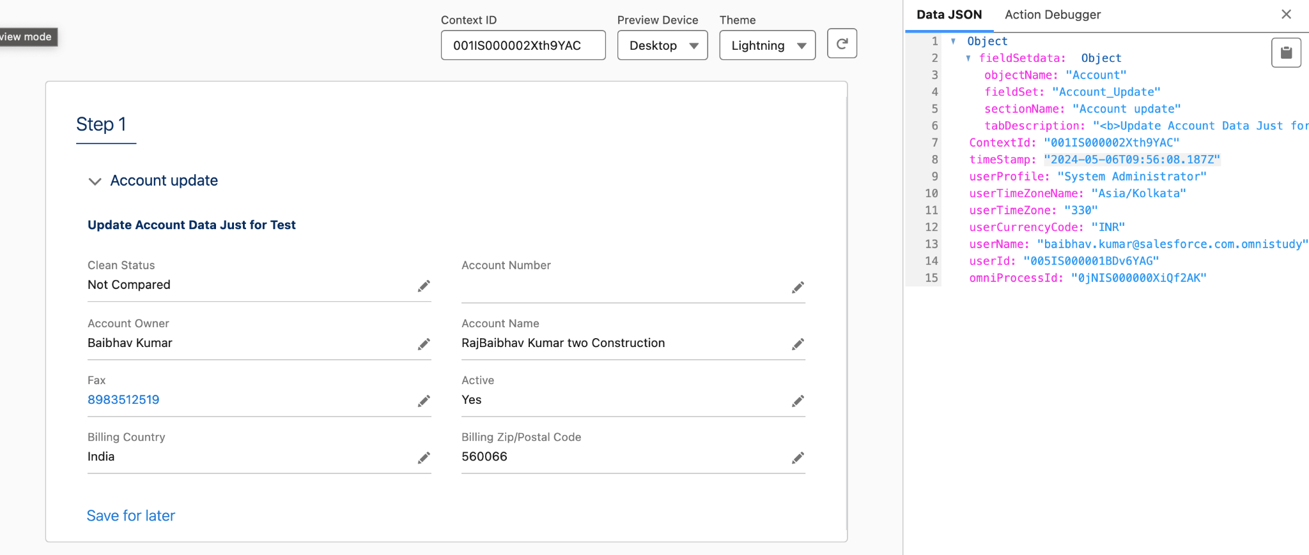

Here we can edit fields values .

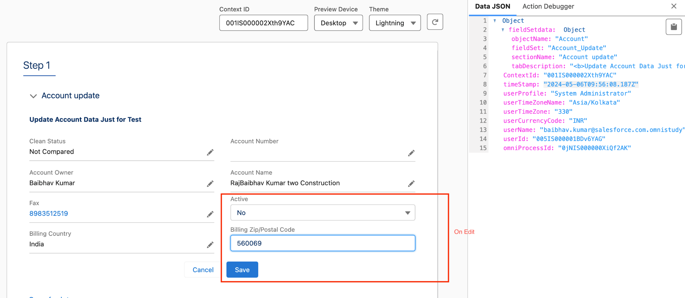

On save it save the new value to record and also update OS data JSON with “changedFieldsWithValue” key which contain all fields with changed values.

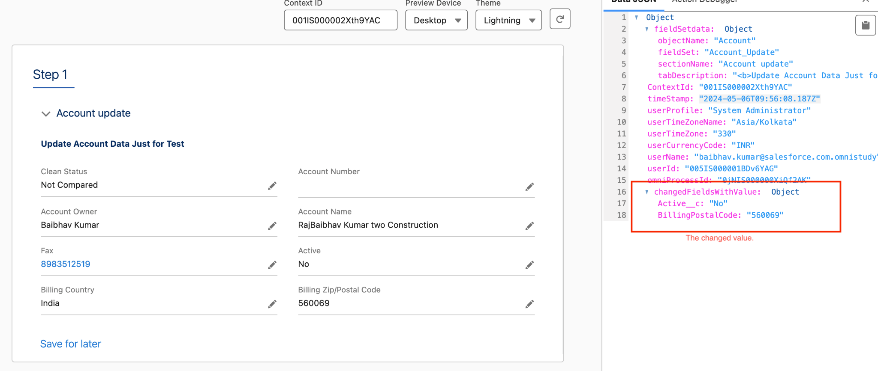

Updating Omniscript layouts with added or removed fields can be cumbersome and time-consuming. This project seeks to streamline the process by developing an LWC component that utilizes fieldset functionality. By simply updating the fieldset, users can easily modify Omniscript layouts, ensuring efficient management and customization of field configurations.

Note: Please refer to attached Code.