**Basics of Solar Energy**

The Sun is always there; and is the ultimate source of Energy How many photons (energy) reach the surface of the Earth on Average? The energy balance in the atmosphere is shown here:

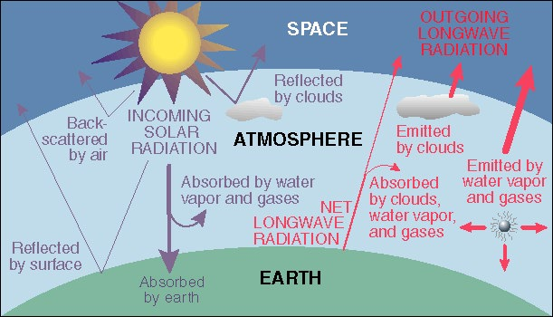

The main components in this diagram are the following:

* Short wavelength (optical wavelengths) radiation from the Sun reaches the top of the atmosphere.
* Clouds reflect 17% back into space. If the earth gets more cloudy, as some climate models predict, more radiation will be reflected back and less will reach the surface
* 8% is scattered backward by air molecules:

• 6% is actually directly reflected off the surface back into space

• So the total reflectivity of the earth is 31%. This is technically known as an Albedo . Note that during Ice Ages, the Albedo of the earth increases. Note: that we measure energy in units of Watt-hours. A watt is not a unit of Energy; it is a measure of power

ENERGY = POWER x TIME

1 Kilowatt Hour = 1KWH = 1000 watts used in one hour = 10 100 watt light bulbs left on for an hour Incident Solar Energy on the ground:

* Average over the entire earth = 164 Watts per square meter over a 24 hour day So the entire planet receives 84 Terawatts of Power our current worldwide consumption is about 12 Terawatts.
* There is a large amount of infrastructure (e.g. cost) required to convert from potential to deliverable energy. 8 hour summer day, 40-degree latitude - 600 Watts per sq. meter.
* So over this 8 hour day, one receives: 8 hours x 600 Watts per sq. m = 4800 watt-hours per sq. m which equals 4.8 kilowatthours per sq. m. This is equivalent to 0.13 gallons of gasoline. For 1000 square feet of horizontal area (typical roof area) this is equivalent to 12 gallons of gas or about 450 kWh

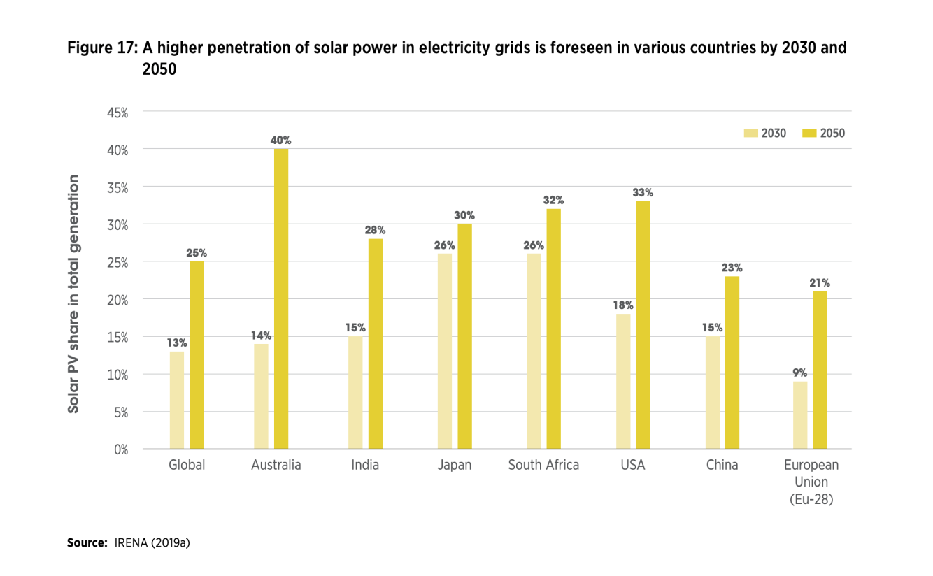

**Basic Solar Maths** How much electricity is produced by a solar panel? What about a roof-top installation? You will find some basic calculations here below. The Watt measures the rate of energy conversion and it is the main unit of power used in photovoltaic. 1 kilowatt (kW) 1000 watts 1 megawatt (MW) 1000 kW or 1000000 watts 1 gig watt (GW) 1000 MW or 1000000000 watts 1 Terawatt (TW) 1000 GW or 1000000000000 watts PW P = peak (peak-performance of a module)

**How much energy does one panel produce**? Electrical energy is generally measured in kilowatt-hours (kWh). If a solar panel produces 100 watts for 1 hour, it has produced 100 watt-hours or 0.1 kWh. The amount of energy produced per day will depend on the area, shading, orientation, and watt-class of the panel. In areas with high irradiation, a properly oriented panel that produces 100 Watts at noon on a sunny day will produce an average of about 0.5 kWh/day during the winter and 0.8 kWh/day during the summer months. In an area with low irradiation, the same panel will still produce about 0.25 kWh/day during the winter and 0.6 kWh/day during summer months. An effective orientation for a solar panel installation is 100 per cent south, at an angle of 10- 20°. There are several standard measurements to describe a solar panel installation.

**System Sizing Calculation Method** -This is a simplified, “laypersons” overview of how solar energy systems calculations are made. The solar estimates provided via our Agencies and Earth Ambassador Agents are much more complex and complete. This simplified overview is meant only to provide the reader with a very basic understanding of some solar energy system calculation methods. The easy way is to use the My Solar Estimator – Solar Calculator link below but you should read this entire page to gain an understanding of how Solar PV system is properly sized and outputs calculated.

**Photovoltaic (PV)** is the direct conversion of light into electricity. Certain materials, like silicon, naturally release electrons when they are exposed to light, and these electrons can then be harnessed to produce an electric current. Several thin wafers of silicon are wired together and enclosed in a rugged protective casing or panel. PV panels produce direct current (DC) electricity, which must be converted to alternating current (AC) electricity to run standard household appliances.

An inverter connected to the PV panels is used to convert the DC electricity into AC electricity. The amount of electricity produced ¡s measured in watts (W). A kilowatt (kW) is equal to 1,000 watts. A Megawatt (MW) is equal to 1,000,000 Watts or 1,000 Kilowatts. The amount of electricity used over a given period of time is measured in kilowatt-hours (KWh). What is a solar rating? The solar rating is a measure of the average solar energy (also called “Solar Irradiance”) available at a location in an average year. Radiant power is expressed in power per unit area: usually Watts/sq-meter, or kW/sq-meter. The total daily Irradiation (Wh/sq-meter) is calculated by the integration of the irradiance values (W/sq-meter). Solar Electric (Photovoltaic) System Calculations – Off grid system only Estimating Solar Electric (PV) System Size: Are of Solar Panels On average (as a general “rule of thumb”) modern photovoltaic (PV) solar panels will produce 8 – 10 watts per square foot of solar panel area. For example, a roof area of 20 feet by 10 feet is 200 square feet (20 ft x 10 ft). This would produce, roughly, 9 watts per sq-foot, or 200 sqft x 9 watts/sqft = 1,800 watts (1.8 kW) of electric power.

Converting Power (watts or kW) to Energy (kWh) One kilowatt-hour (1 kWh) means an energy source supplies 1,000 watts (1 kW) of energy for one hour. Generally, a solar energy system will provide output for about 5 hours per day. So, if you have a 1.8 kW system size and it produces for 5 hours a day, 365 days a year: This solar energy system will produce 3,285 kWh in a year (1.8 kW x 5 hours x 365 days). If the PV panels are shaded for part of the day, the output would be reduced in accordance with the shading percentage. For example, if the PV panels receive 4 hours of direct sun shine a day (versus the standard 5 hours), the panels are shaded 1 divided by 5 = 20% of the time (80% of assumed direct sunshine hours received). In this case, the output of a 200 squarefoot PV panel system would be 3,285 kWh per year x 80% = 2,628 kWh per year.

**PV systems**

Types of PV systems PV systems can be very simple, consisting of just a PV module and load, as in the direct powering of a water pump motor, which only needs to operate when the sun shines. However, when for example a whole house should be powered, the system must be operational day and night. It also may have to feed both AC and DC loads, have reserve power and may even include a back-up generator. Depending on the system configuration, we can distinguish three main types of PV systems: stand-alone, grid-connected, and hybrid. The basic PV system principles and elements remain the same. Systems are adapted to meet particular requirements by varying the type and quantity of the basic elements. A modular system design allows easy expansion, when power demands change.

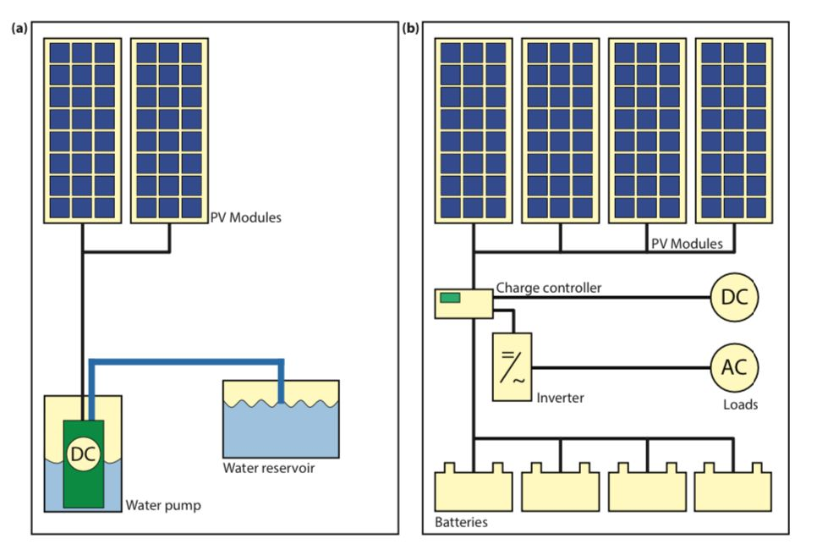

Figure 15.1: Schematic representation of (a) a simple DC PV system to power a water pump with no energy storage and (b) a complex PV system including batteries, power conditioners, and both DC and AC loads

**Stand-alone systems** -Stand-alone systems rely on solar power only. These systems can consist of the PV modules and a load only or they can include batteries for energy storage. When using batteries charge regulators are included, which switch off the PV modules when batteries are fully charged, and may switch off the load to prevent the batteries from being discharged below a certain limit. The batteries must have enough capacity to store the energy produced during the day to be used at night and during periods of poor weather. Figure 15.1 shows schematically examples of stand-alone systems; (a) a simple DC PV system without a battery and (b) a large PV system with both DC and AC loads.

**Grid-connected systems** Grid-connected PV systems have become increasingly popular for building integrated applications. As illustrated in Fig. 15.2, they are connected to the grid via inverters, which convert the DC power into AC electricity. In small systems as they are installed in residential homes, the inverter is connected to the distribution board, from where the PV-generated power is transferred into the electricity grid or to AC appliances in the house. These systems do not require batteries, since they are connected to the grid, which acts as a buffer into that an oversupply of PV electricity is transported while the grid also supplies the house with electricity in times of insufficient PV power generation. Large PV fields act as power stations from that all the generated PV electricity is directly transported to the electricity grid. They can reach peak powers of up to several hundreds of MWp. Figure 15.3 shows a 25.7 MWp system installed in Germany.

**Hybrid systems** Hybrid systems consist of combination of PV modules and a complementary method of electricity generation such as a diesel, gas or wind generator. A schematic of an hybrid system shown in Fig. 15.4. In order to optimise the different methods of electricity generation, hybrid systems typically require more sophisticated controls than stand-alone or grid-connected PV systems. For example, in the case of an PV/diesel system, the diesel engine must be started when the battery reaches a given discharge level and stopped again when battery reaches an adequate state of charge. The back-up generator can be used to recharge batteries only or to supply the load as well.

**Components of a PV system**

As we have seen earlier in this book, a solar cell can convert the energy contained in the solar radiation into electrical energy. Due to the limited size of the solar cell it only delivers a limited amount of power under fixed current-voltage conditions that are not practical for most applications. In order to use solar electricity for practical devices, which require a particular voltage and/or current for their operation, a number of solar cells have to be connected together to form a solar panel, also called a PV module. For large-scale generation of solar electricity solar panels are connected together into a solar array. Although, the solar panels are the heart of a PV system, many other components are required for a working system, that we already discussed very briefly above. Together, these components are called the Balance of System (BOS). Which components are required depends on whether the system is connected to the electricity grid or whether it is designed as a stand-alone system. The most important components belonging to the BOS are:

• A mounting structure is used to fix the modules and to direct them towards the sun.

• Energy storage is a vital part of stand-alone systems because it assures that the system can deliver electricity during the night and in periods of bad wheather. Usually, batteries are used as energystorage units.

• DC-DC converters are used to convert the module output, which will have a variable voltage depending on the time of the day and the weather conditions, to a fixed voltage output that e. g. can be used to charge a battery or that is used as input for an inverter in a grid-connected system.

• Inverters or DC-AC converters are used in gridconnected systems to convert the DC electricity originating from the PV modules into AC electricity that can be fed into the electricity grid.

• Cables are used to connect the different components of the PV system with each other and to the electrical load. It is important to choose cables of sufficient thickness in order to minimise resistive losses. Even though not a part of the PV system itself, the electric load, i.e. all the electric appliances that are connected to it have to be taken into account during the planning phase. Further, it has to be considered whether the loads are AC or DC loads. The different compontents of a PV system are schematically presented in FiG.

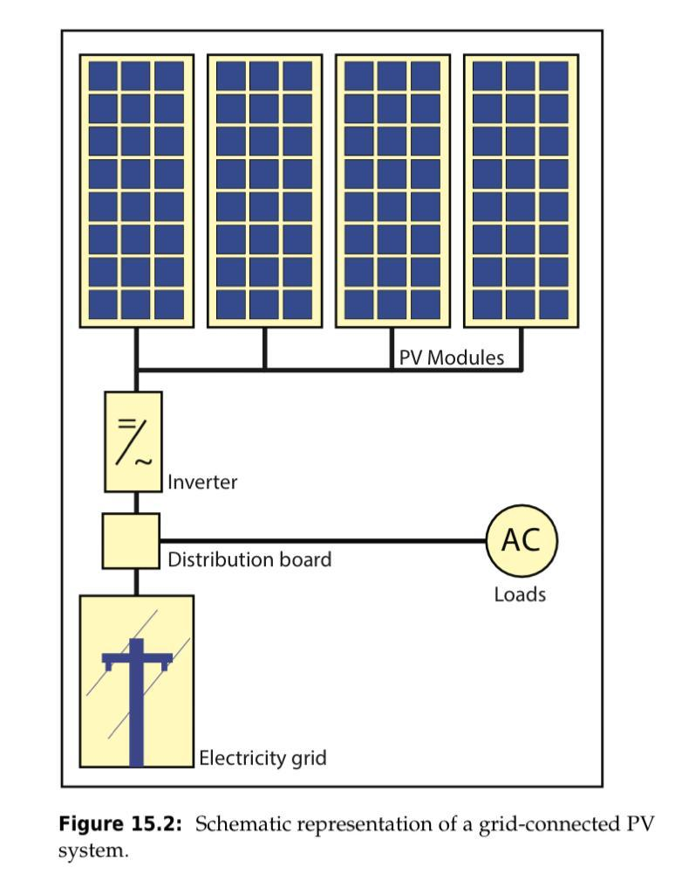

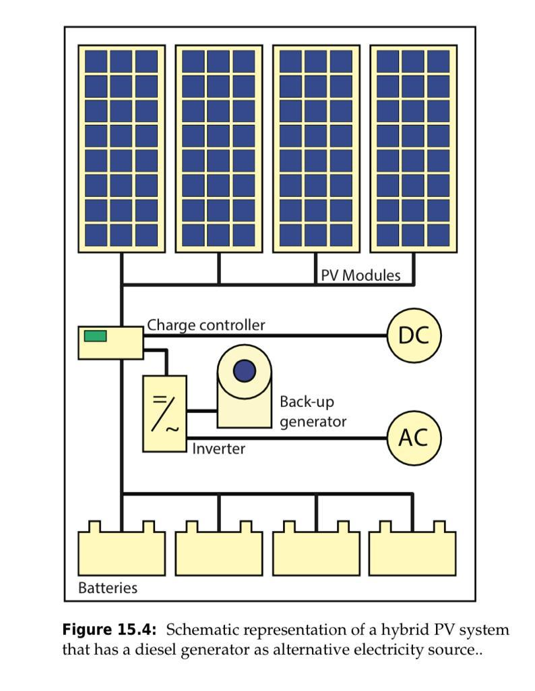

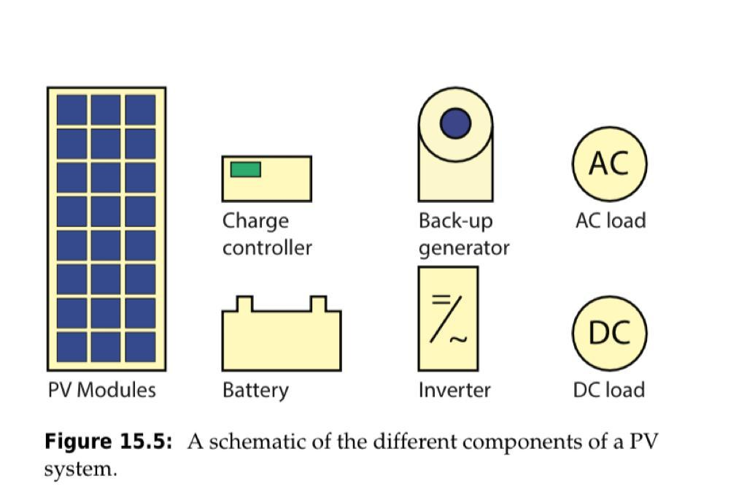

**Components of PV Systems**

**PV modules**

In this section we will discuss PV modules (or solar modules), their fabrication and how to to determine their performance. Before we start with the actual treatment of PV modules, we briefly want to introduce different terms. Figure 17.1 (a) shows a crystalline solar cell, which we discussed in Chapter 12. For the moment we will consider only modules that are made from this type of solar cells. A PV module, is a larger device in which many solar cells are connected, as illustrated in Fig. 17.1 (b). The names PV module and solar module are often used interchangeably. A solar panel, as illustrated in Fig. 17.1 (c), consists of several PV modules that are electrically connected and mounted on a supporting structure. Finally, a PV array consists of several solar panels. An example of such an array is shown in Fig. 17.1 (d). This array consists of two strings of two solar panels each, where string means that these panels are connected in series.

**Series and parallel connections in PV** modules

If we make a solar module out of an ensemble of solar cells, we can connect the solar cells in different ways: first, we can connect them in a series connection as shown in Fig. 17.2 (a). In a series connection the voltages add up. For example, if the open circuit voltage of one cell is equal to 0.6 V, a string of three cells will deliver an open circuit voltage of 1.8 V. For solar cells with a classical front metal grid, a series connection can be established by connecting the bus bars at the front side with the back contact of the neighbouring cell, as illustrated in Fig. 17.2 (b)

. For series connected cells, the current does not add up but is determined by the photocurrent in each solar cell. Hence, the total current in a string of solar cells is equal to the current generated by one single solar cell. Figure Fig. 17.2 (d) shows the I-V curve of solar cells connected in series. If we connect two solar cells in series, the voltages add up while the current stays the same. The resulting open circuit voltage is two times that of the single cell.

If we connect three solar cells in series, the open circuit voltage becomes three times as large, whereas the current still is that of one single solar cell. Secondly, we can connect solar cells in parallel as illustrated in Fig. 17.2 (c), which shows three solar cells connected in parallel. If cells are connected in parallel, the voltage is the same over all solar cells, while the currents of the solar cells add up. If we connect e.g. three cells in parallel, the current becomes three times as large, while the voltage is the same as for a single cell, as illustrated in Fig. 17.2 (d)

. The reader may have noticed that we used I-V curves, i.e. the current-voltage characteristics, in the previous paragraphs. This is different to Parts II and III, where we used I-V curves instead, i.e. the current density - voltage characteristics. The reason for this switch from J to I is that on module level, the total current that the module can generate is of higher interest than the current density. As the area of a module is a constant, the shapes of the I-V and J-V curves of a module are similar. For a total module, therefore the voltage and current output can be partially tuned via the arrangements of the solar cell connections. Figure 17.3 (a) shows a typical PV module that contains 36 solar cells connected in series. If a single junction solar cell would have a short circuit current of 5 A, and an open circuit voltage of 0.6 V, the total module would have an output of Voc = 36 · 0.6 V = 21.6 V and Isc = 5 A.

However, if two strings of 18 series-connected cells are connected in parallel, as illustrated in Fig. 17.3 (b), the output of the module will be Voc = 18 · 0.6 V = 10.8 V and Isc = 2 × 5 A = 10 A. In general, for the I-V characteristics of a module consisting of m identical cells in series and n identical cells in parallel the voltage multiplies by a factor m while the current multiplies by a factor n. Modern PV modules often contain 60 (10 × 6), 72 (9 × 8) or 96 (12 × 8) solar cells that are usually all connected in series in order to minimise resistive losses.

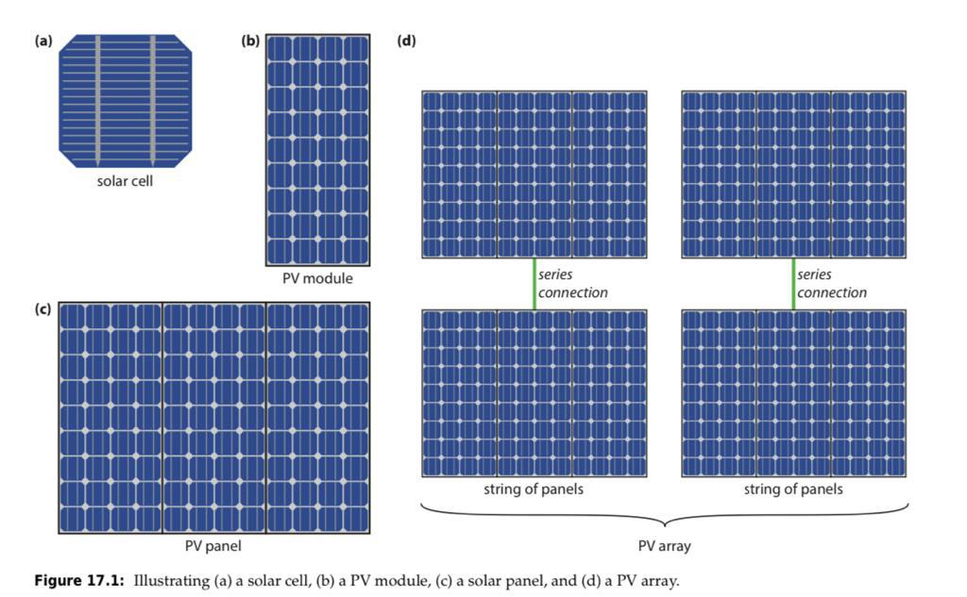

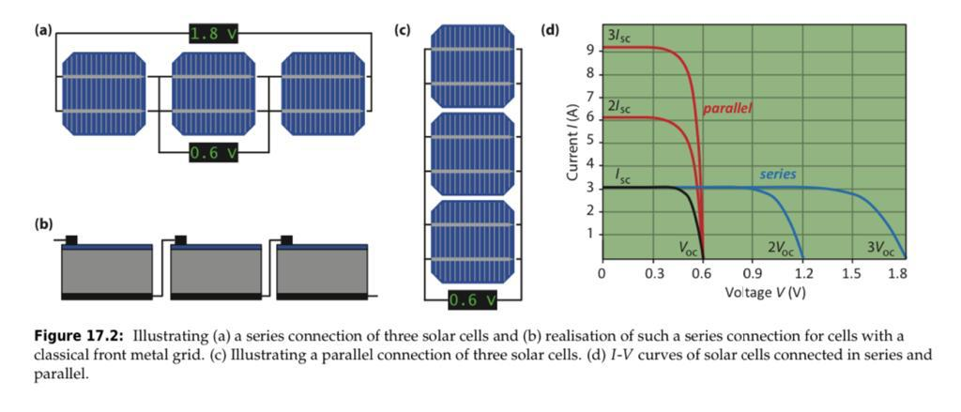

PV module parameters In a nutshell, for a PV module a set of parameters can be defined, similar than for solar cells. The most common parameters are the open circuit voltage Voc, the short circuit current Isc and the module fill factor FFM. On module level, we have to distinguish between the aperture area efficiency and the module efficiency. The aperture area is defined as the area of the PV-active parts only. The total module area is given as the aperture area plus the dead area consisting of the interconnections and the edges of the module. Clearly, the aperture area efficiency is larger than the module efficiency. Determining the the efficiency and the fill factor of a PV module is less straight-forward than determining voltage and current. In an ideal world with perfectly matched solar cells and no losses, one would expect that the efficiency and fill factor at both the module and cell levels to be the same. This is not the case in real life. As mentioned above. The cells are connected with each other using interconnects that induce resistive losses. Further, there might be small mismatches in the interconnected cells.

For example, if m × n cells are interconnected, the cell with the lowest current in a string of m cells in series determines the module current. Similarly, the string with the lowest voltage in the n strings that are connected in parallel dictates the module voltage. The reason for mismatch between individual cells are inhomogeneities that occur during the production process. Hence, in practice PV module perform a little less than what one would expect from ideally matched and interconnected solar cells. This loss in performance translates to a lower fill factor and efficiency at module level. If the illumination across the module is not constant or if the module is heats up non-uniformly, the module performance reduces even further.

Often, differences between cell and module performance are mentioned in datasheets that are provide by the module manufacturers. For example, the datasheet of a Sanyo HIT-N240SE10 module gives a cell level efficiency of 21.6%, but a module level efficiency of only 19%. Despite all the technological advancements being made at solar cell level for improving the efficiency, still a lot must be done at the PV systems level to ensure a healthy PV yield. For the performance of a PV system, not only the module performance is important, but also the yield of the PV system.

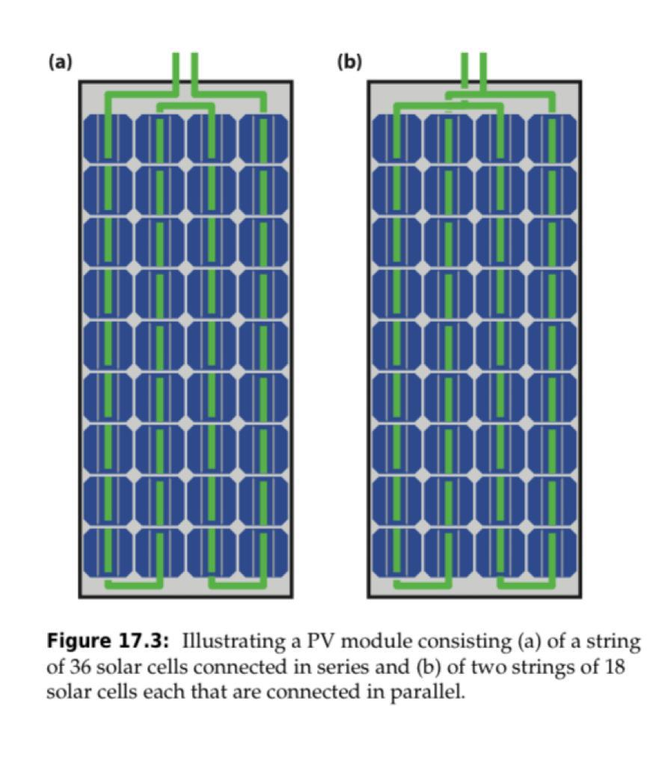

**Partial shading and bypass diodes**

PV modules have so-called bypass diodes integrated. To understand the reason for using such diodes, we have to consider modules in real-life conditions, where they can be partially shaded, as illustrated in Fig. 17.4 (a). The shade can be from an object nearby, like a tree, a chimney or a neighbouring building. It also can be caused by a leaf that has fallen from a tree. Partial shading can have significant consequences for the output of the solar module.

To understand this, we consider the situation in which one solar cell in the module shaded for a large part shaded. For simplicity, we assume that all six cells are connected in series. This means that the current generated in the shaded cell is significantly reduced. In a series connection the current is limited by the cell that generates the lowest current, this cell thus dictates the maximum current flowing through the module. In Fig. 17.4 (b) the theoretical I-V curve of the five unshaded solar cells and the shaded solar cell is shown. If the cells are connected to a constant load R, the voltage across the module is dropping due to the lower current generated.

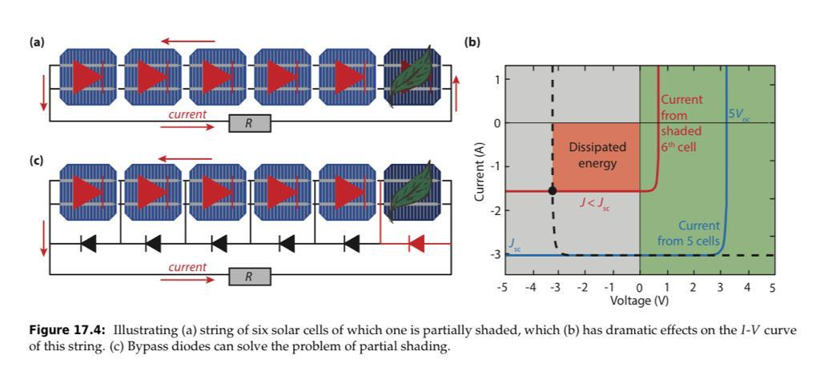

However, since the five unshaded solar cells are forced to produce high voltages, they act like a reverse bias source on the shaded solar cell. The dashed line in Fig. 17.4 (b) represents the reverse bias load put on the shaded cell, which is the I-V curve of the five cells, reflected across the vertical axis equal to 0 V. Hence, the shaded solar cell does not generate energy, but starts to dissipate energy and heats up. The temperature can increase to such a critical level, that the encapsulation material cracks, or other materials wear out. Further, high temperatures generally lead to a decrease of the PV output as well. These problems occurring from partial shading can be prevented by including bypass diodes in the module, as illustrated in 17.4 (c). a diode blocks the current when it is under negative voltage, but conducts a current when it is under positive voltage. If no cell is shaded, no current is flowing through the bypass diodes. However, if one cell is (partially) shaded, the bypass diode starts to pass current through because of the biasing from the other cells.

As a result current can flow around the shaded cell and the module can still produce the current equal to that of a unshaded single solar cell. For cells that are connected in parallel, partial shading is less of a problem, because the currents generated in the others cells do not need to travel through the shaded cell. However, a module consisting of 36 cells in parallel have very high currents (above 100 A) combined with a very low voltage (approx. 0.6 V). This combination would lead to very high resistive losses in the cables; further an inverter that has only 0.6 V as input will not be very efficient, as we will see in Section 17.3. Therefore, combining the cells in series and using bypass diodes is much better an option to do.

**Fabrication of PV modules**

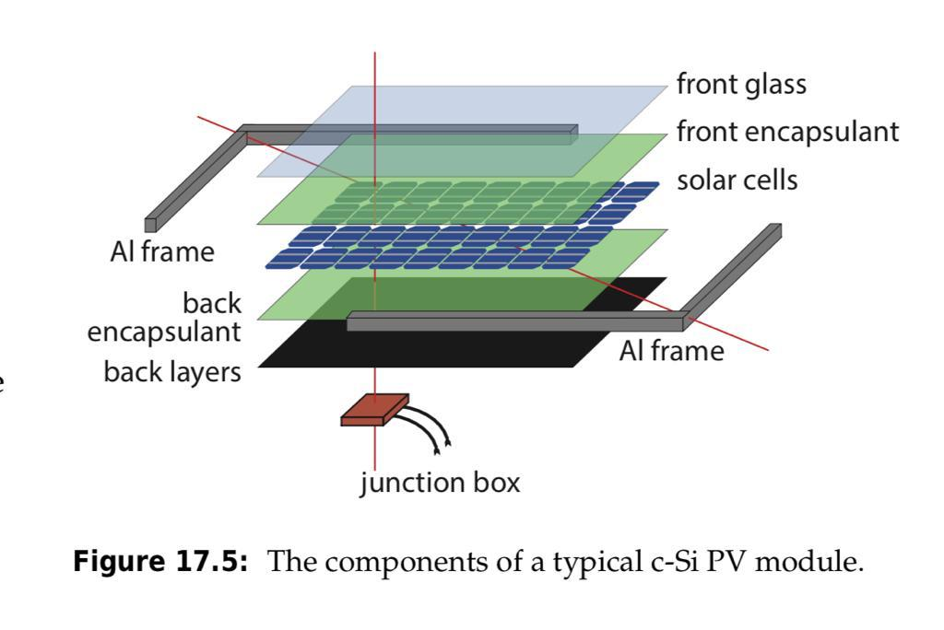

As discussed in the subsection 17.1.5, a PV module must withstand various influences in order to survive a lifetime of 25 years or even longer. In order to ensure a long lifetime, the components of that a PV module is built must be well chosen. Fig. 17.5 shows the typical components of a usual crystalline silicon PV module. Of course, the layer stack may consist of different materials dependent on the manufacturer. The major components are:

• Soda-lime glass with a thickness of several millimetres, which provides mechanical stability while being transparent for the incident light. It is important the glass has a low iron content because iron leads to absorption of light in the glass which can lead to losses. Further, the glass must be tempered in order to increase its resistance to impacts.

• The solar cells are sandwiched in between two layers of encapsulants. The most common material is ethylene-vinyl-acetate (EVA), which is a thermoplastic polymer (plastic). This means that it goes into shape when it is heated but that these changes are reversible.

• The back layer acts as a barrier against humidity and other stresses. Depending on the manufacturer, it can be another glass plate or a composite polymer sheet. A material combination that is often used is PVF-polyester-PVF, where PVF stands for polyvinyl fluoride, which is often known by its brand name Tedlar®. PVF has a low permeability for vapours and is very resistive against weathering. A typical polyester is polyethylene terephthalate (PET)

• A frame usually made from aluminium is put around the whole module in order to enhance the mechanical stability.

• A junction box usually is placed at the back of the module. In it the electrical connections to the solar cell are connected with the wires that are used to connect the module to the other components of the PV system. One of the most important steps during module production is laminating, which we briefly will explain for the case that EVA is used as encapsulant. For lamination, the whole stack consisting of front glass, the encapsulants, the interconnected solar cells, and the back layer are brought together in a laminator, which is heated above the melting point of EVA, which is around 120°C. This process is performed in vacuo in order to ensure that air, moisture and other gasses are removed from within the module stack. After some minutes, when the EVA is molten, pressure is applied and the temperature is increased to about 150°C. Now the curing process starts, i.e. a curing agent, which is present in the EVA layer, starts to cross-link the EVA chains, which means that transverse bonds between the EVA molecules are formed. As a result, EVA has elastomeric, rubberlike properties. The choice of the layers that light traverses before entering the solar cell is also very important from an optical point of view. If this layers have an increasing refractive index, they act as antireflective coating and thus can enhance the amount of light that is in-coupled in the solar cell and finally absorbed, which increases the current produced by the solar cell.

**Lifetime testing of PV Modules**

The typical lifetime of PV systems is about 25 years. In these as little maintenance as possible should be required on the system components, especially the PV modules are required to be maintenance free. Furthermore, degradation in the different components of that Components of PV Systems the module is made should be little: manufacturers typically guarantee a power between 80% and 90% of the initial power after 25 years. During the lifetime of 25 years or more, PV modules are exposed to various external stress from various sources

• temperature changes between night and day as well as between winter and summer,

• mechanical stress for example from wind, snow and hail,

• stress by agents transported via the atmosphere such as dust, sand, salty mist and other agents,

• moisture originating from rain, dew and frost

, • humidity originating from the atmosphere,

• irradiance consisting of direct and indirect irradiance from the sun; mainly the highly-energetic UV radiation is challenging for many materials.

Before PV modules are brought to the market, they are usually tested extensively in order to assure their stability against these various stresses. The required tests are extensively defined in the standards IEC 61215 for modules based on crystalline silicon solar cells and in IEC 61646 for thin-film modules. Since the modules cannot be tested during a period of 25 years, accelerated stress testing must be performed. The required tests are

• Thermal cycles for studying whether thermal stress leads to broken interconnects, broken cells, electrical bond failure, adhesion of the junction box,

• Damp heat testing to see whether the modules suffer from corrosion, delamination, loss of adhesion and elasticity of the encapsulant, adhesion of the junction box,

• Humidity freeze testing in order to test delamination, adhesion of the junction box,

• UV testing, because UV light can lead to delamination, loss of adhesion and elasticity of the encapsulant, ground fault due to backsheet degradation. Mainly, UV light can lead to a discoloration of the encapsulant and back sheet, which means that they get yellow. This can lead to losses in the amount of light that reaches the solar cells.

• Static mechanical loads in order to test whether strong winds or heavy snow loads lead to structural failures, broken glass, broken interconnect ribbons or broken cells.

• Dynamic mechanical load, which can lead to roken glass, broken interconnect ribbons or broken cells.

• Hot spot testing in order to see whether hot spots due to shunts in cells or inadequate bypass diode protection are present.

• Hail testing to see whether the module can handle the mechanical stress induced by hail. Copyright Delft University of Technology, 2014 This copy is provided for free, for personal use only. 17.1. PV modules 261

• Bypass diode thermal testing to study whether overheating of these diodes causes degradation of the encapsulant, backsheet or the junction box.

• Salt spray testing to see whether salt that is present in salty mist or that is used in salty water for snow and ice removal leads to corrosion of PV module components.

How these tests are to be performed is defined in other standards, for example IEC 61345 for UV testing and IV 61701 for salt-mist corrosion testing Usually these tests are carried out by organisations like TÜV Rheinland. Refining the test requirements and understanding which accelerated tests are required to guarantee a lifetime of 25 years and more is subject to ongoing research and development.

**Thin-film modules**

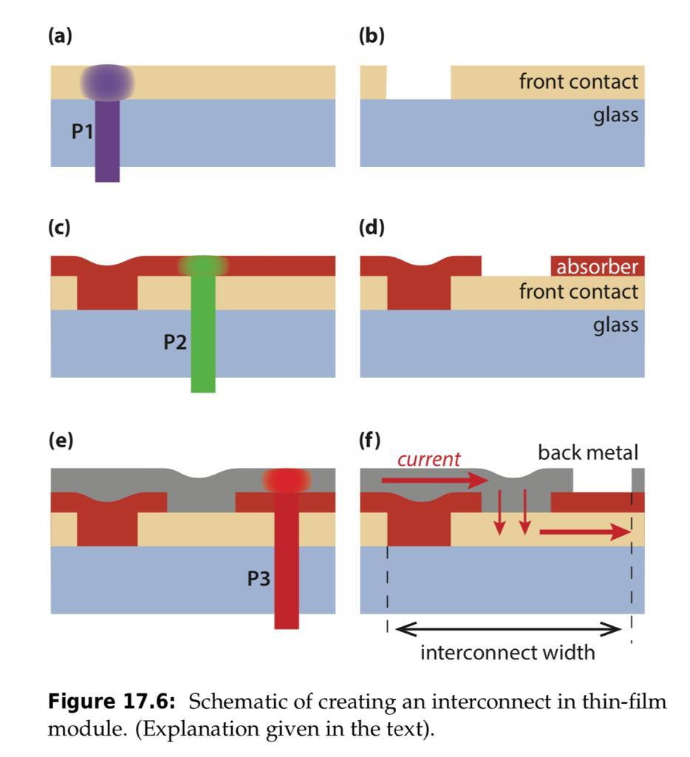

Making thin-film modules is very different from making modules from c-Si solar cells. While for c-Si technology producing solar cells and producing PV modules are two distinct steps, in thin-film technology producing cells and modules cannot be separated from each other. To illustrate this we look at a PV module where the thin-films are deposited in superstrate configuration on glass, as illustrated in Fig. 17.6. For making such a module, a transparent front contact, a stack of (photo)active layers that also contain one or more semiconductor junctions, and a metallic back contact are deposited onto each other. In industrial production, the glass plates on that these layers are deposited can be very large, with sizes significantly exceeding 1 × 1 m2 .

Such a stack of layers deposited onto a large glass plate in principle forms one very large solar cell that will produce a very high current. Since all the current would have to be transported across the front and back contacts, which are very thin, resistive losses in the module is even a bigger problem than for c-Si modules. Therefore, the module is produced such that it consists of many very narrow cells of about 1 cm width and the length being equal to the module length. These cells then are connected in series across the width of the module. On the very left and right of the module metallic busbars collect the current and conduct it to the bottom of the module where they are connected with external cables.

The series connection is established with laser scribing. In total, three laser scribes are required for separating two cells from each other and establishing a series connection between them. The first laser scribe, called P1, is performed after the transparent front contact is deposited, as shown in Fig. 17.6 (a). The wavelength of the laser is such that the laser light is absorbed in the front contact and the material is evaporated, leaving a “gap” in the front contact, as shown in Fig. 17.6 (b). Components of PV Systems Then the photoactive layers are deposited onto the front contact and also fill the gaps. Then, the second laser scribe, called P2, is performed, as illustrated in Fig. 17.6 (c). The laser wavelength has to be chosen such that it is not absorbed in the transparent front contact but in the absorber layer. For example, if the absorber consists of amorphous silicon, green laser light can be used. The P2 scribe leaves a gap in the absorber layer, as illustrated in Fig. 17.6 (d). The next step is the deposition of the metallic back contact that also fills the P2 gap. Finally, the third laser scribe (P3) is performed as illustrated in Fig. 17.6 (e). The wavelength for this scribe has to be chosen such that it is neither absorbed in the front contact nor in the absorber stack, so it is, for example, infrared. The P3 scribe shoots a gap into the back contact, as shown in Fig. 17.6 (f).

To understand the action of the laser scribes, we take a look at Fig. 17.6 (f): the P1 scribe filled with absorber material forms an barrier, since the absorber is orders of magnitudes less conductive than the transparent front contact. Similar, the P3 scribes forms an insulating gap in the metallic back contact. However, the P2 scribe that also is filled with metal forms a highly conducting connection between the front and back contacts – here the actual series connection is performed. For example, for making CIGS solar cells, first the molybdenum back contact is deposited on top of the glass substrate and the cell areas are defined by P1 laser scribes. Then the CIGS p layer and the CdS n layer are deposited including a P2 laser scribe step. Finally the intrinsic and n-doped zinc oxide is deposited, followed by a final P3 laser scribe step.

Now the front TCO electrode is connected with the Molybdenum back contact of the next solar cell. The performance of such an interconnect established via laser scribes and hence the total module performance is determined by several things. First, the P2 scribe has to be highly conductive, This means that it has to be wide enough and that there must be no barrier at the interface between the front contact and the metal of the P2 scribe. Further, the P1 and P3 scribes must perform good barriers to effectively separate the cells from each other. Thirdly, the region between the P1 and P3 scribes does not contribute to the the current generated by the module.

Therefore, the ratio between this width and the total cell width (including the scribes) has to be as small as possible. Another issue is the fact that the three laser scribes are performed in different steps of production and thus often in different machines. Further, the distance between the scribes might be different at the different processes when they are performed at different temperatures. This, aligning the glass plates in all the production steps is extremely important for manufacturing high-quality thin-film modules. The production steps and also the exact processing of the laser scribes is of course dependent on which thinfilm technology is used and even on the manufacturer itself. However, the basic principles and the action behind these processes is valid in general. One advantage of thin-film PV technology is that they can be deposited onto flexible substrates. For example, the Dutch company HyET Solar developed a technology, where thin-film silicon layers are deposited onto a temporary aluminium substrate .

After the solar cell layers are encapsulated on the back side, the temporary substrate is etched away, and the front side is encapsulated. This results in a very low weight flexible substrate, which can be integrated for example in curved roof top elements. A very big advantage is that such very light modules can be installed on simple roof top constructions that only can handle little ballast. On such roofs, heave PV panels with glass cannot be installed. Further, if such flexible modules are directly integrated into roofing elements, installation costs can be reduces significantly. Often, installation costs are the largest contributor to the non-modular costs of a PV system. Currently, only thin-film silicon technologies have demonstrated flexible modules with reasonable efficiencies.

**LEAD ACID BATTERIES**

Introduction Lead acid batteries are the most common large-capacity rechargeable batteries. They are very popular because they are dependable and inexpensive on a cost-per-watt base. There are few other batteries that deliver bulk power as cheaply as lead acid, and this makes the battery cost-effective for automobiles, electrical vehicles, forklifts, marine and uninterruptible power supplies (UPS).

Lead acid batteries are built with a number of individual cells containing layers of lead alloy plates immersed in an electrolyte solution, typically made of 35% sulphuric acid (H2SO4) and 65% water (Figure 1). Pure lead (Pb) is too soft and would not support itself, so small quantities of other metals are added to get the mechanical strength and improve electrical properties. The most common additives are antimony (Sb), calcium (Ca), tin (Sn) and selenium (Se). When the sulphuric acid comes into contact with the lead plate, a chemical reaction is occurring and energy is produced.

Lead acid batteries are heavy and less durable than nickel (Ni) and lithium (Li) based systems when deep cycled or discharged (using most of their capacity). Lead acid batteries have a moderate life span and the charge retention is best among rechargeable batteries. The lead acid battery works well at cold temperatures and is superior to lithium-ion when operating in sub-zero conditions. Lead acid batteries can be divided into two main classes: vented lead acid batteries (spillable) and valve regulated lead acid (VRLA) batteries (sealed or non-spillable).

**Vented Lead Acid Batteries**

**Hazards**

Vented lead acid batteries are commonly called “flooded”, “spillable” or “wet cell” batteries because of their conspicuous use of liquid electrolyte (Figure 2). These batteries have a negative and a positive terminal on their top or sides along with vent caps on their top. The purpose of the vent caps is to allow for the escape of gases formed, hydrogen and oxygen, when the battery is charging. During normal operation, water is lost due to evaporation. In addition, the vent caps allow water and acid levels of the battery to be checked during maintenance.

The main hazards associated with lead acid batteries are:

1) Chemical (corrosive) hazards

2) Risk of fire or explosion

3) Electrical shocks

4) Ergonomic hazards related to their heavy weight

5) Transportation hazards

Acid burns to the face and eyes comprise about 50% of injuries related to the use of lead acid batteries. The remaining injuries were mostly due to lifting or dropping batteries as they are quite heavy.

**Chemical Hazards**

**Sulphuric Acid**

Lead acid batteries are usually filled with an electrolyte solution containing sulphuric acid. This is a very corrosive chemical (pH<2) which can permanently damage the eyes and produce serious chemical burns to the skin. Sulphuric acid is also poisonous, if swallowed. The lead alloys found in batteries are also harmful to humans and can also seriously damage the environment.

When working with battery acid, the following precautions must be taken:

* Wear the proper personal protective equipment (PPE), specifically splash-proof goggles, acidresistant lab coat or apron, safety shoes and rubber gloves. A face shield must also be wornwhen refilling batteries with electrolytes.
* Know where the emergency showers and emergency eyewash stations are located; they must be located near lead acid battery storage and charging areas.
* Slowly pour concentrated acid into water; do not add water to acid. (warning: electrolyte will become hot; do not close battery vents until electrolyte has cooled down).
* Use non-metallic containers and funnels.
* Ensure neutralizers (e.g. baking soda) are available for immediate use.
* Use extreme care to avoid spilling or splashing the sulphuric acid solution.

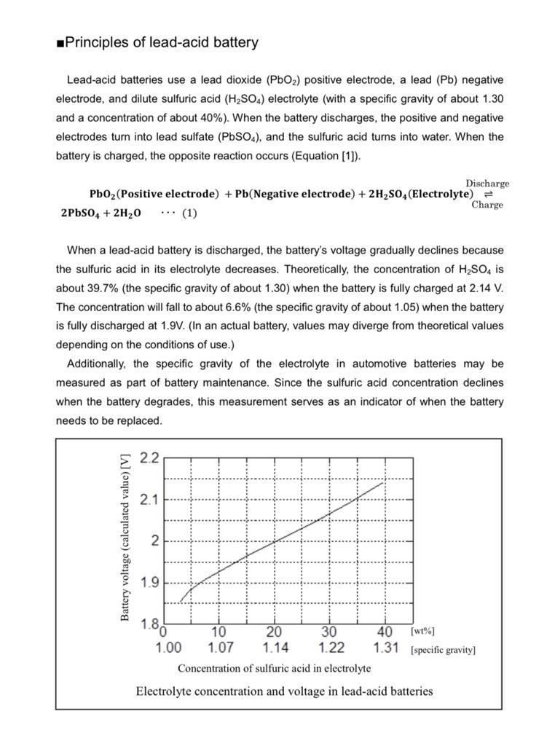

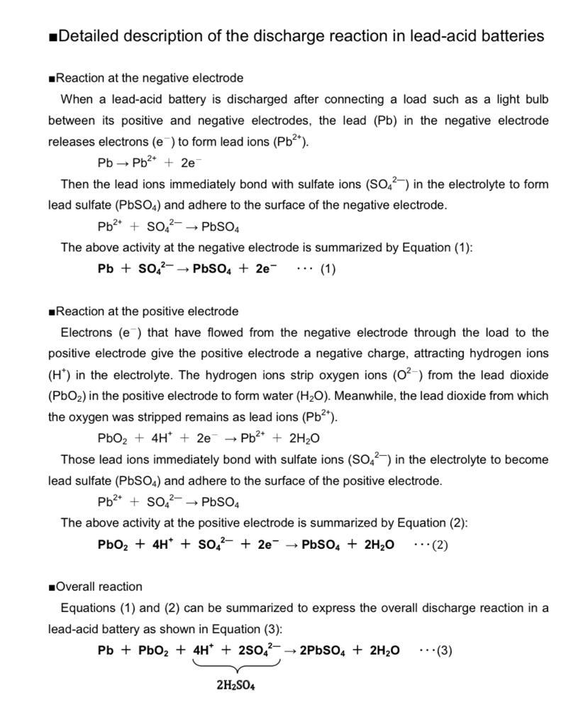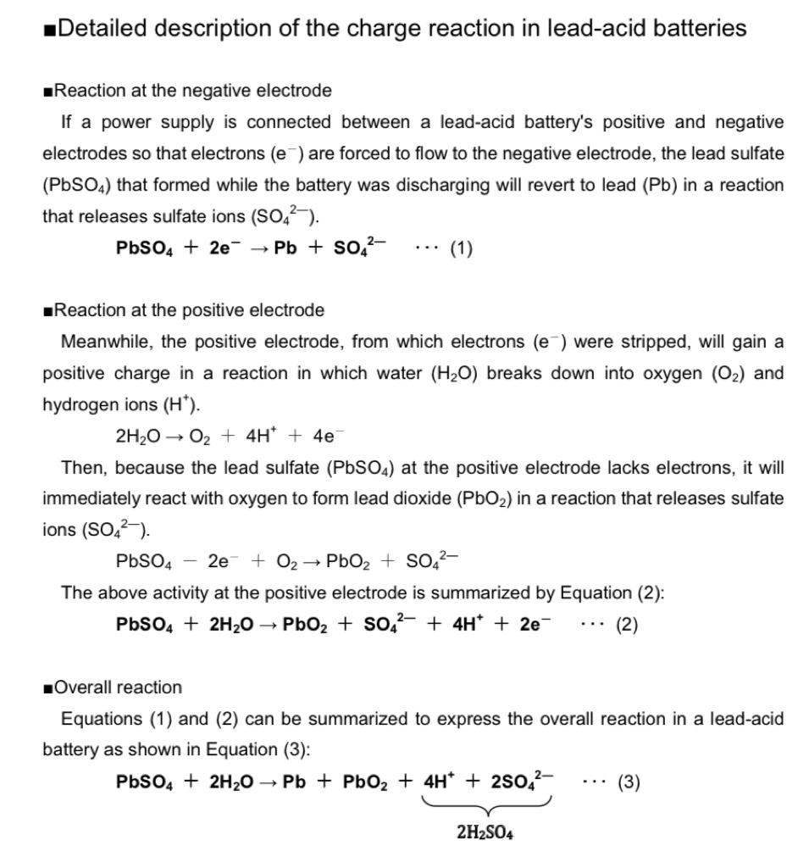

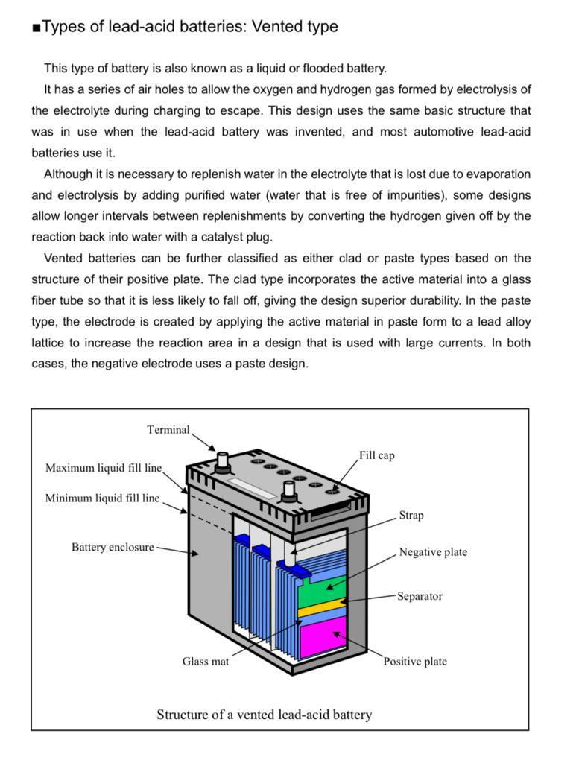

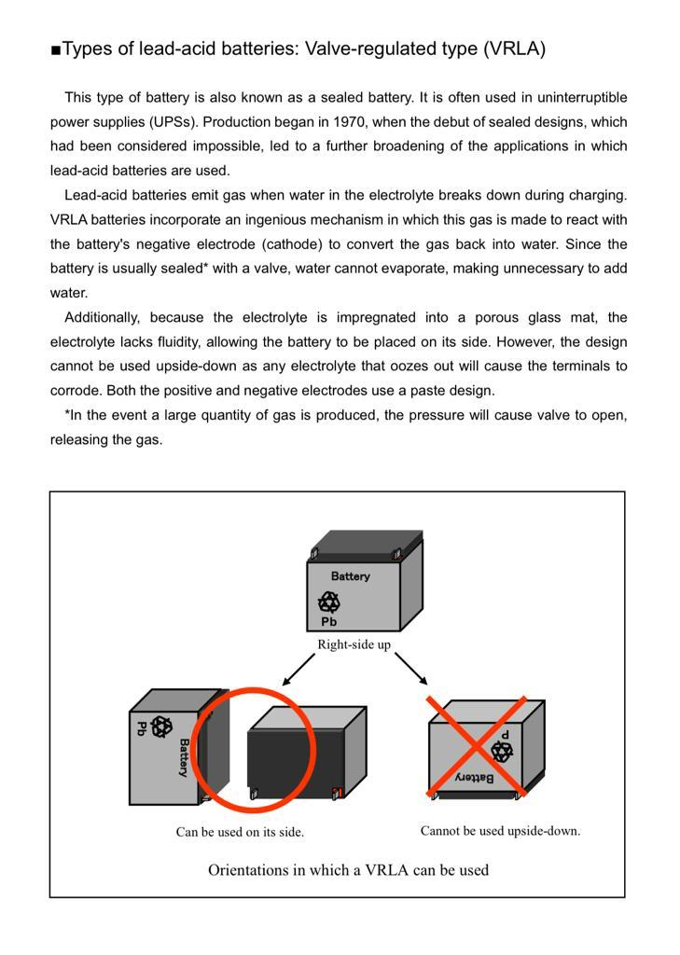

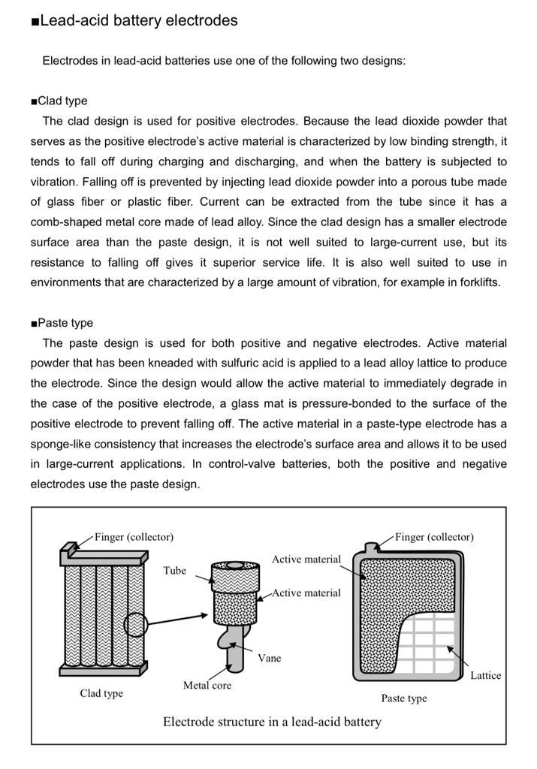

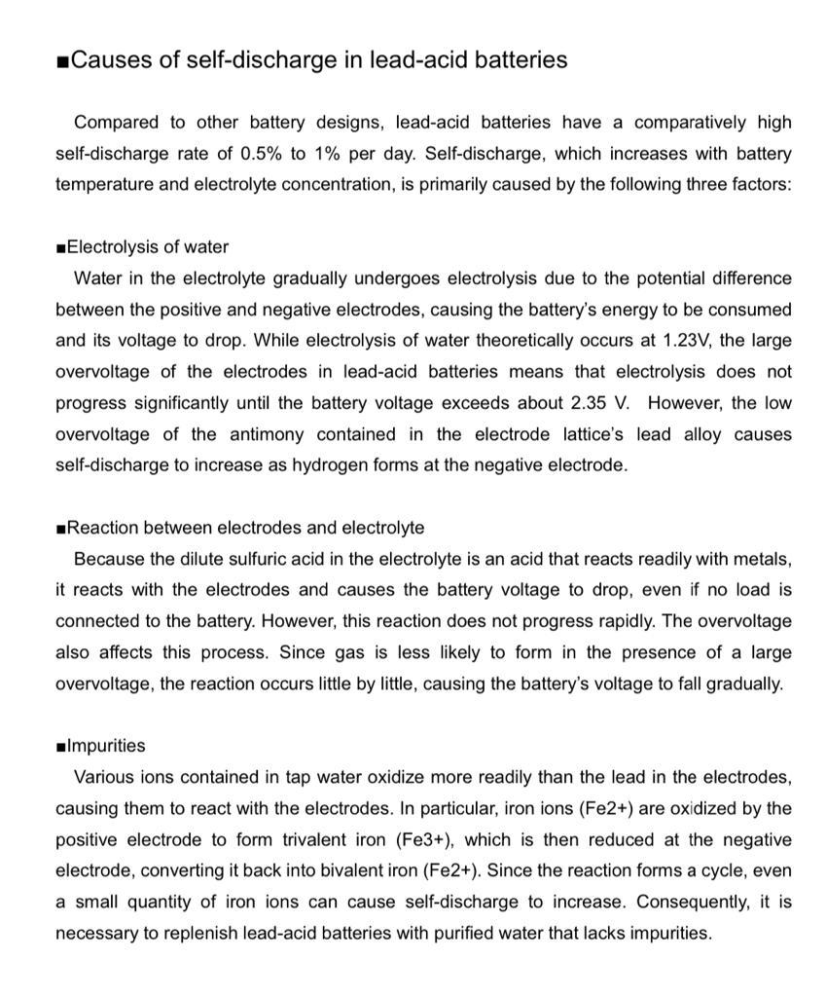

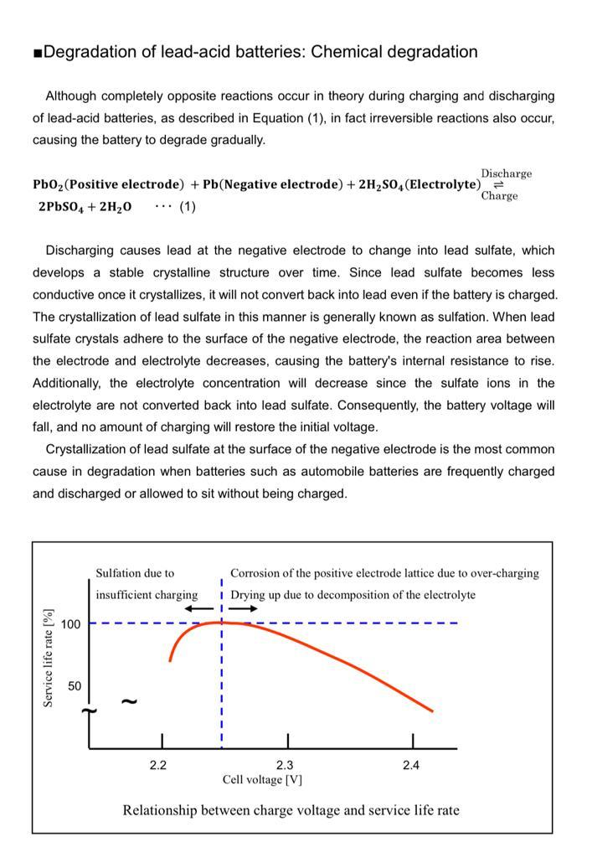

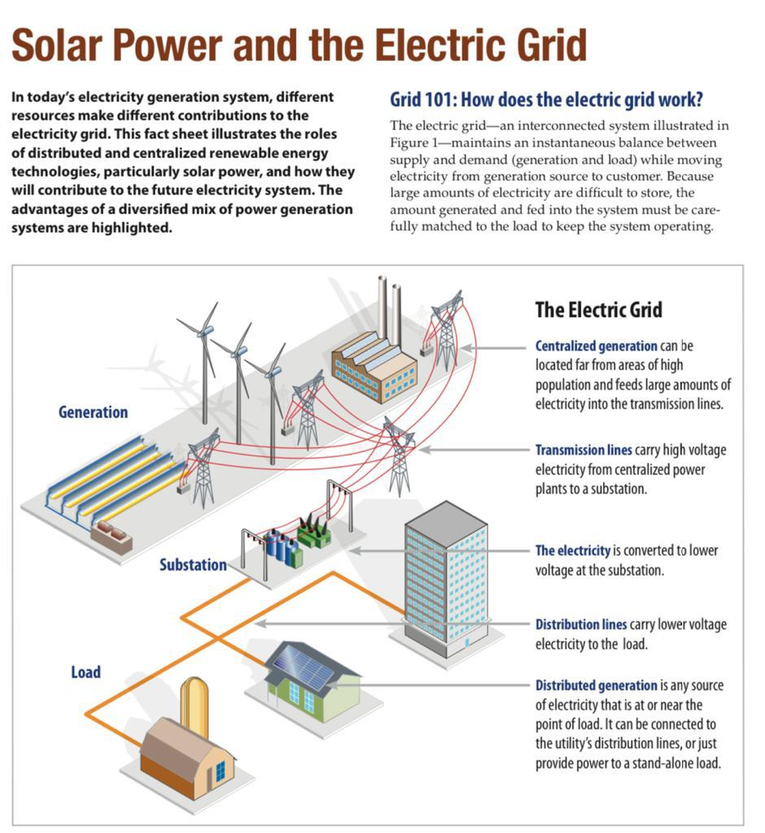

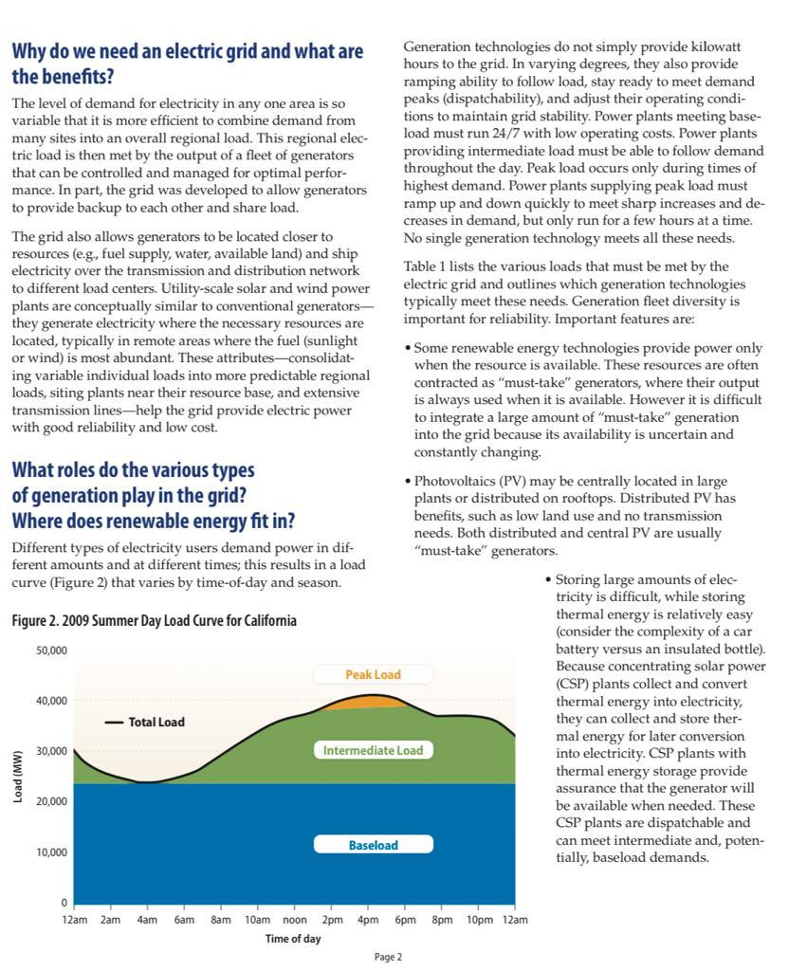

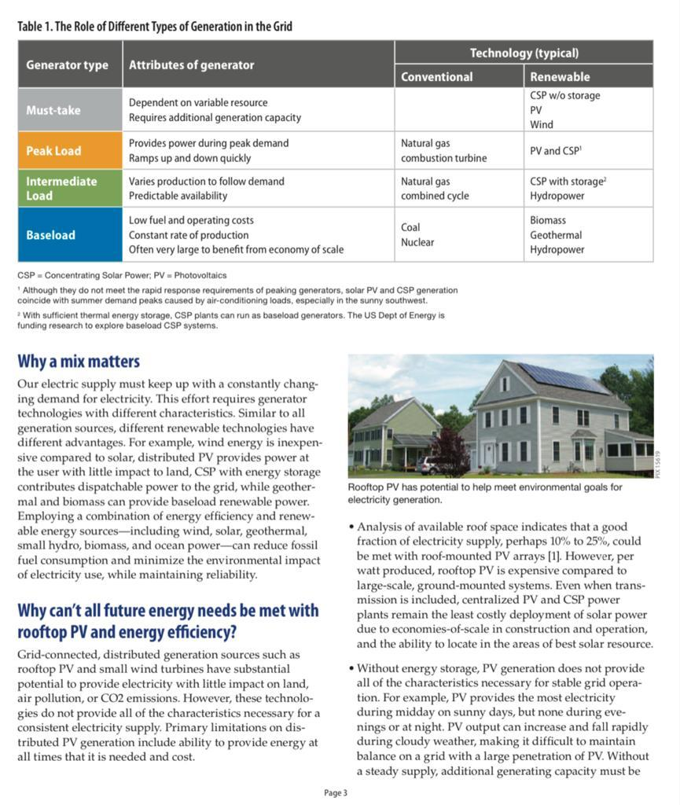

**Grid-connected photovoltaic system driven by load**

Operating principle:

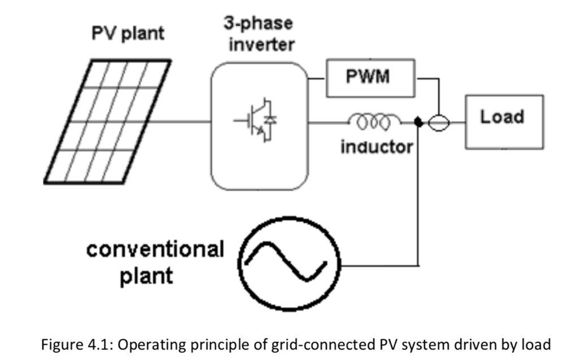

Figure 4.1 describes a common schematic principle for a single stage grid-connected photovoltaic system: where a photovoltaic plant provides a DC voltage, the DC voltage is then transferred to AC voltage by a 3-phase inverter controlled by a PWM technique, the inductor is then used to provide a suitable coupling with the grid and minimize the currents fluctuations in the lines

. A conventional plant is coupled to the network to feed the load in parallel with the photovoltaic plant. The PWM technique which controls the switching of IGBTs in the inverter shall operate in a way that track the current of the load sensed by a current sensor and inject it into the grid as shown in figure 4.2.

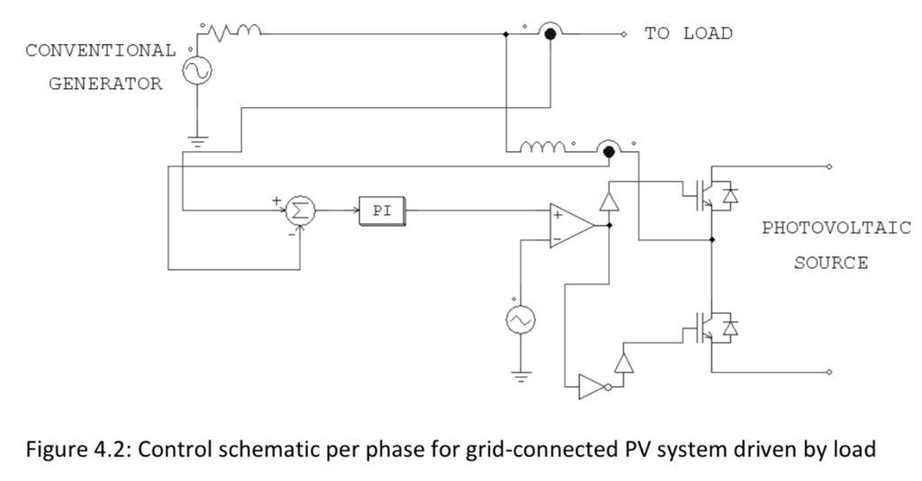

As figure 4.2 shows, the current flowing to the load side is sensed and then injected by the photovoltaic source to compensate for the power drawn from the conventional plant. Proportional Integral controllers with feedbacks are used in the simulation to fasten the compensation process and decrease the oscillations In this type, the DC voltage bus at the input of the inverter must be higher than the grid voltage, and this is very obvious and natural because we know that the current flows inside conductors and semi-conductors from the higher voltage to the lower voltage. So we need to arrange the photovoltaic modules of the photovoltaic plant in a way to have a big number of them in series in each string to reach higher voltages.

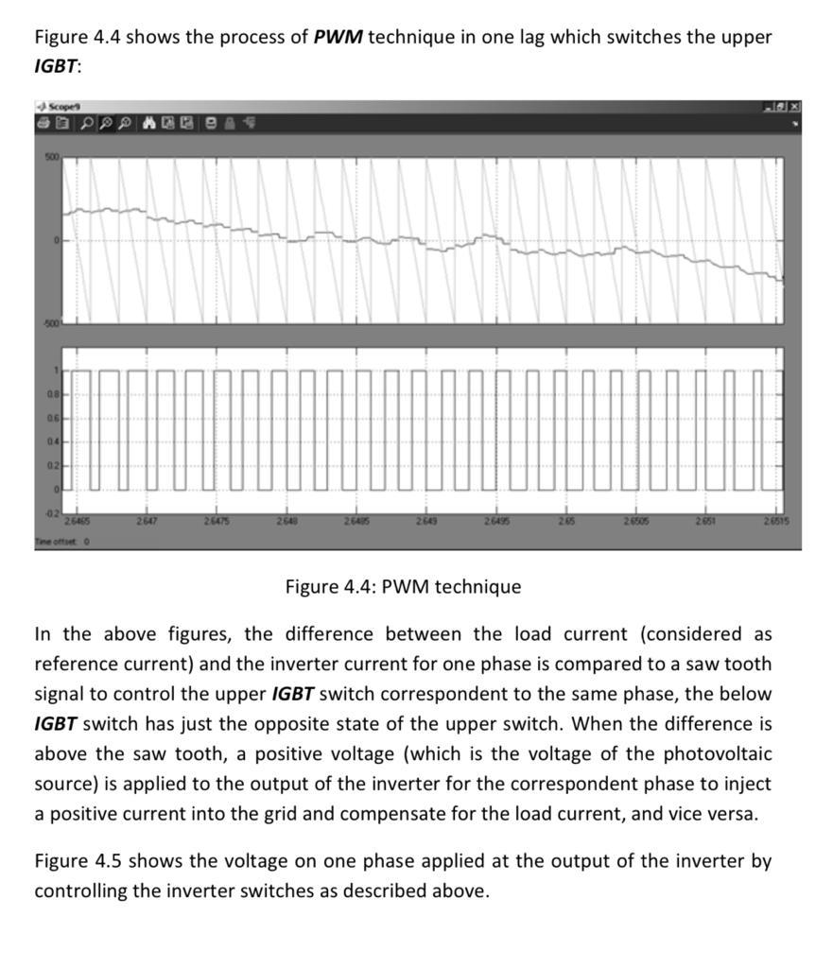

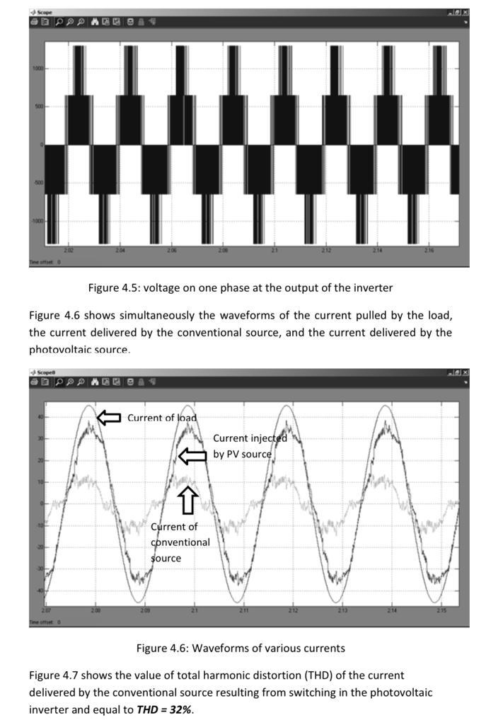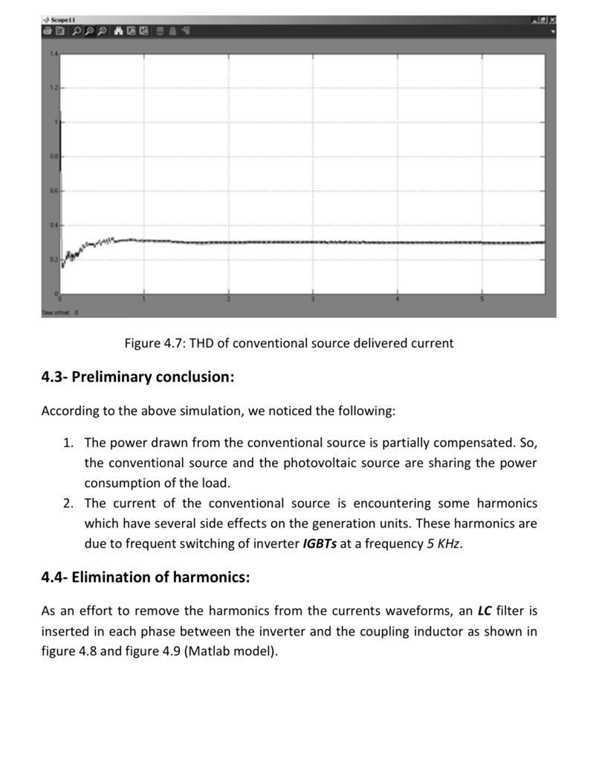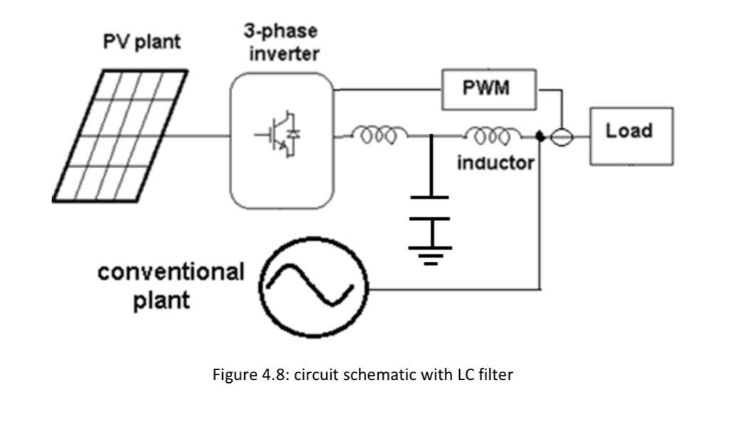

This simulation shows us the improvement in the tracking of the load current and in the filtration of harmonics as in figure 4.10. The new THD value of the conventional source delivered current is shown in figure 4.11 where it has decreased from 32% to 20%.However, the LC filter causes phase shifting of the current in reference with the grid voltage, which worsen also the power factor at the conventional source unit. But this issue can be ignored due to the small value of the current drawn from the conventional source.

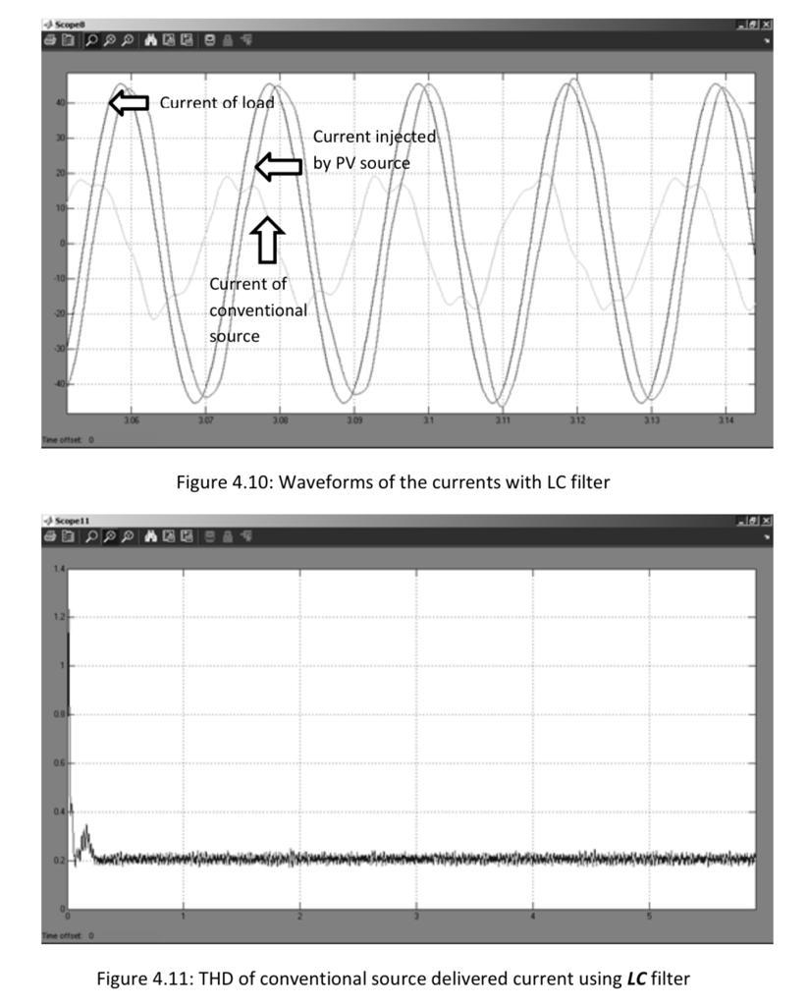

**off-grid solar power systems**

Solar power for everyone – anytime and ANywhere More than 1.3 billion people around the globe still do not have access to electricity. The reason is simple. It is too expensive to build the infrastructure to connect them to the power distribution grid, especially in rural regions. Some communities may attempt to fill the gap with noisy, pollutive diesel generators, but rising fuel and transportation costs often make generators uneconomical. Economic development is impossible without electricity.

Health, education, and clean drinking water all depend on electric power. Ultimately, people can only produce products and services locally thus making their community more prosperous if they live in a place where they can use electricity. Energy independence with solar power There is a simple, reliable, and low-cost solution for a decentralized energy supply: PV-powered off-grid systems. They can be used to build stable, decentralized power distribution grids in remote locations not connected to the public power grid.

Furthermore, because off-grid solar power systems are efficient, require few resources, can be used worldwide and are effective in combating climate change, they help developing countries bypass the “fossil fuel era,” a fact especially true for those with large populations. 4 Off-grid solutions for solar power supply Solar home system – power for household use A solar home system provides basic off-grid power service for one household. This is a low-cost, easy-toassemble PV plant consisting of only a few components. One to two solar modules, a charge controller, and a car battery supply enough electricity for the lights, television, and radio.

A solar home system provides users with comfort and improved access to information, but it cannot, however, supply enough power to operate tools, machines or large buildings. It is not a commercial system and cannot be leveraged to drive local economic development. Solar home systems are ideal for sparsely populated regions with long distances between single houses. In industrialized countries, similar technology is used for campers and small gardens not connected to the power distribution grid.

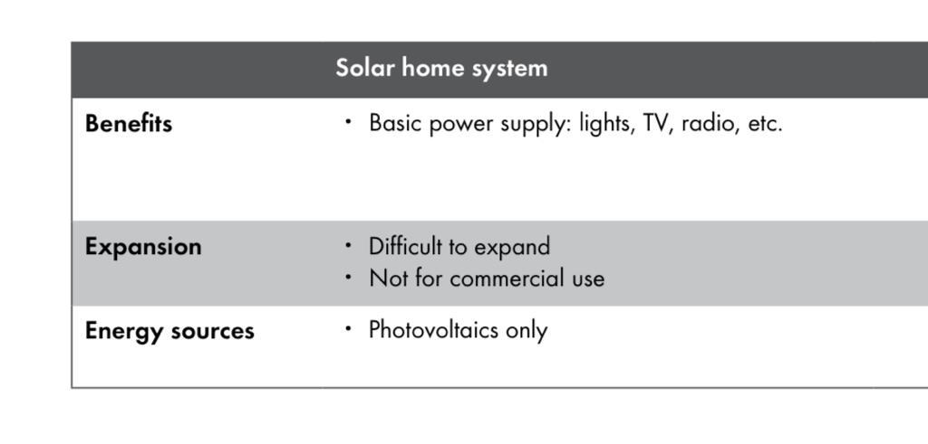

SMA solar off-grid systems – empowering people worldwide Many rural regions are too sparsely populated to justify building a central energy supply system. This is where SMA solar hybrid systems excel. They can supply buildings, factories, or even entire towns with reliable off-grid AC power using renewable energies.

In contrast to solar home systems, hybrid systems can integrate other generating systems such as PV, wind, hydropower, or diesel generators, even if they are located relatively far away. Hybrid power systems can power any household appliances, electrical tools, or machines that run on standard AC power.

Being modular, they can grow with users’ needs at any time and that helps drive economic growth. After all, people can only establish themselves as local providers of products and services when they can operate machines and equipment locally and cost-effectively. Solar hybrid systems can be used in any location that lacks a stable power supply. In Germany, for example, they supply electricity for remote buildings such as farms, businesses, weekend homes and vacation cabins.

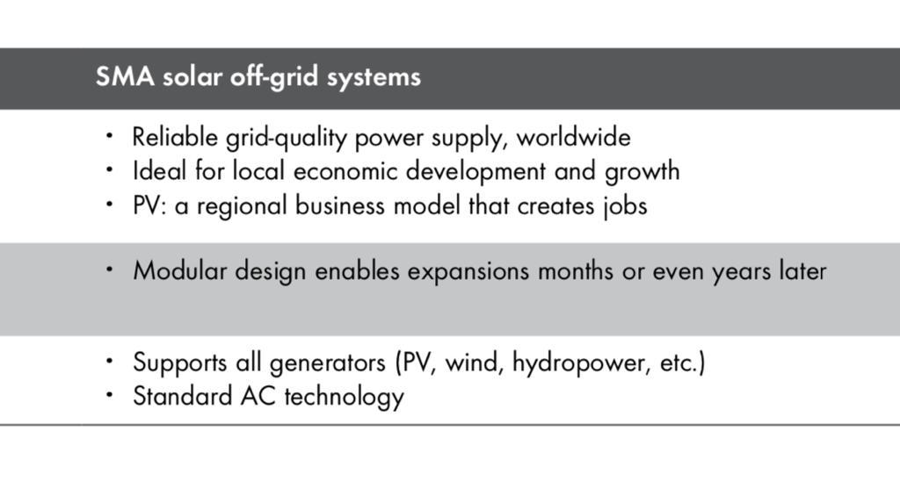

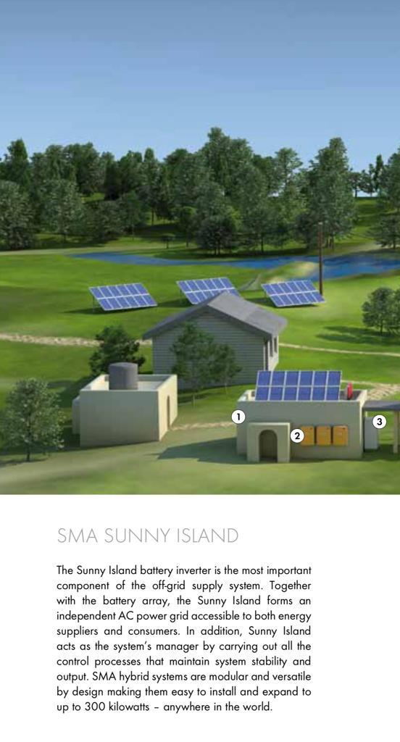

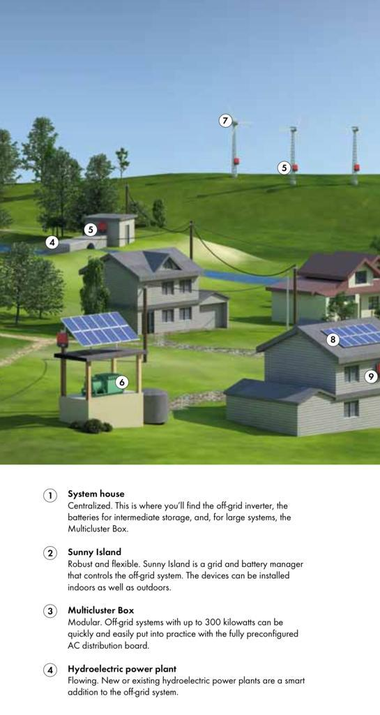

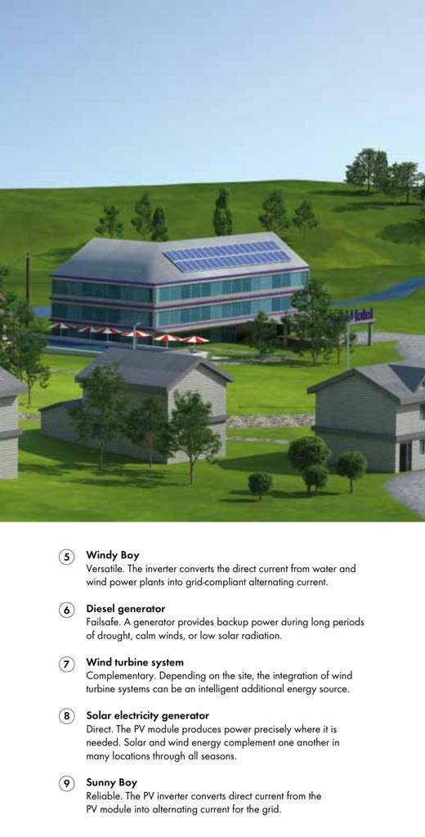

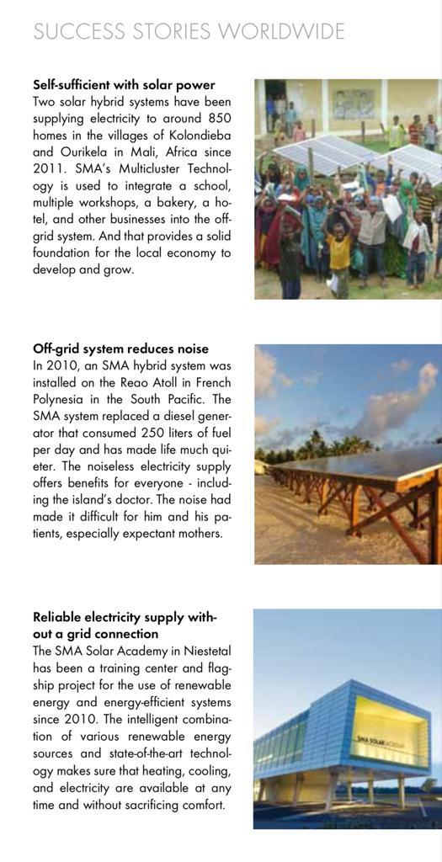

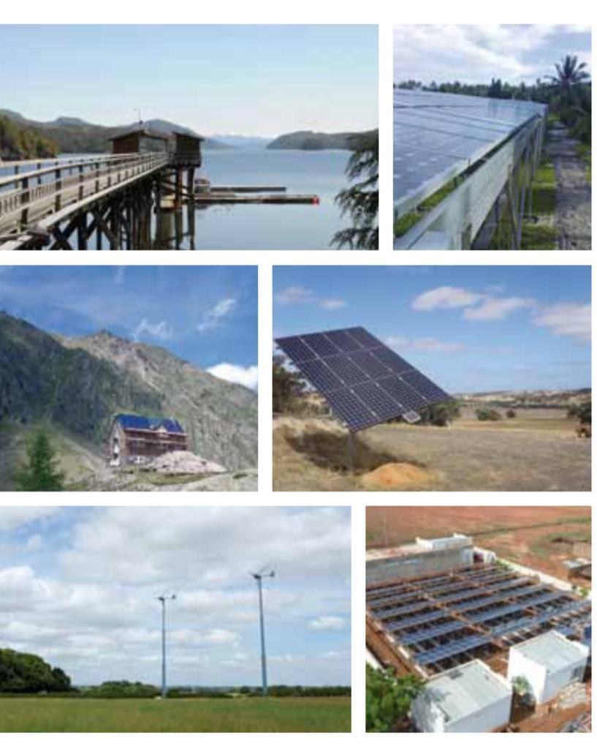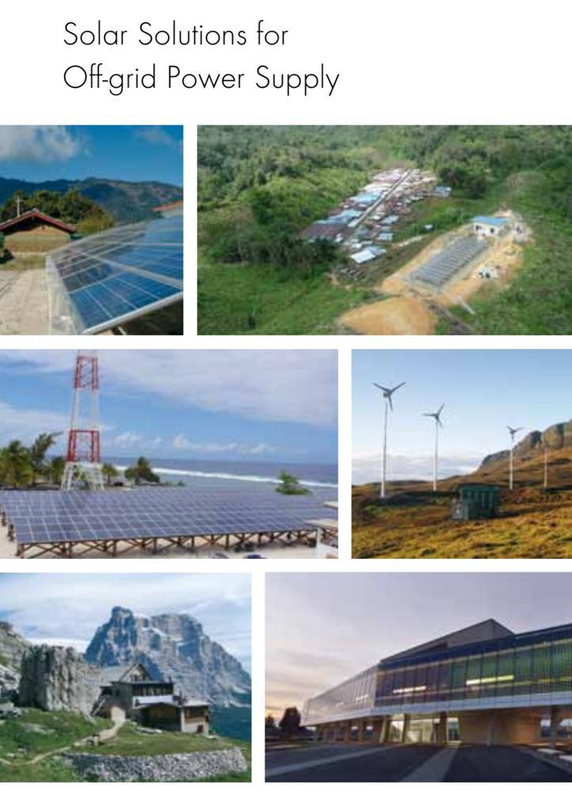

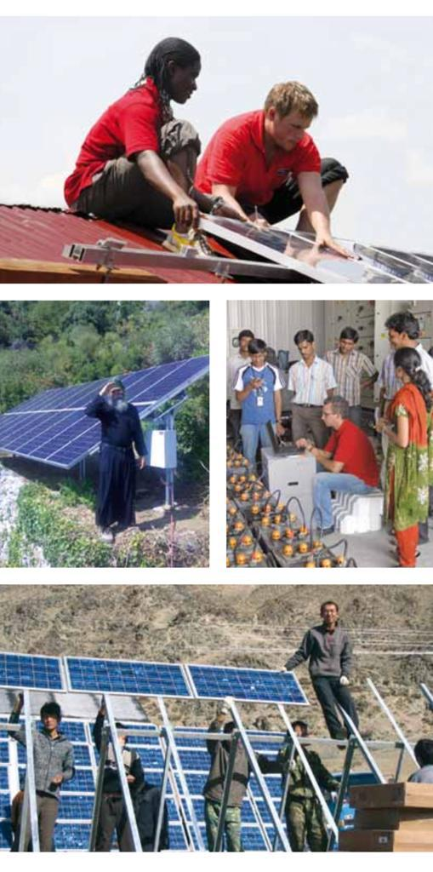

**1)CALCULATION FOR ENERGY GENERATED BY 1 SQUARE METER OF SOLAR PANEL**

IN 1 SQUARE FEET POWER GENERATED IS 9 WATT (EXPERIMENTAL AND UNIVERSAL APPROXIMATE VALUE)

POWER=ENERGY/TIME

1SQMETER=10.7638SQFEET

POWER PRODUCED IN 1 SQUARE METER OF SOLAR PANEL =9 X 10.7638

=96.875WATT

ENERGY GENERATED IN 1SQMETER OF SOLAR PANEL IS 96.875 WATT HOUR.

**2)CALCULATE THE AREA OF SOLAR PANEL TO GENERATE 1MW POWER**

TO GENERATE 1MW OF POWER

96.875WATT POWER IS PRODUCE BY 1SQ METER OF SOLAR PANEL

1 WATT IS GENERATED BY 1/96.875 SQ METER OF SOLAR PANEL

1MW POWER IS GENERATED BY 1000000/96.875 SQ METER

=10322.5806 SQUARE METER OF SOLAR PANEL

(ALL THE VALUE IS CALCULATED ONLY FOR 1 HOUR)

**JADAVPUR UNIVERSITY**

DEPT-POWER ENGINEERING

UG-III ,MAJOR PROJECT TOPIC**- SOLAR PANEL FUNCTIONS,SYSTEM AND** **LEAD ACID BATTERIES**

UNDER GUIDANCE OF- PROF SM

STUDENTS UNDER THIS PROJECT-

1)SAYAN BERA -001911501078

2)SALIL KISKU-0019115010

3)JUNAID ALAM-001911501038