https://github.com/Baibhavi-rgh/portfolio.git

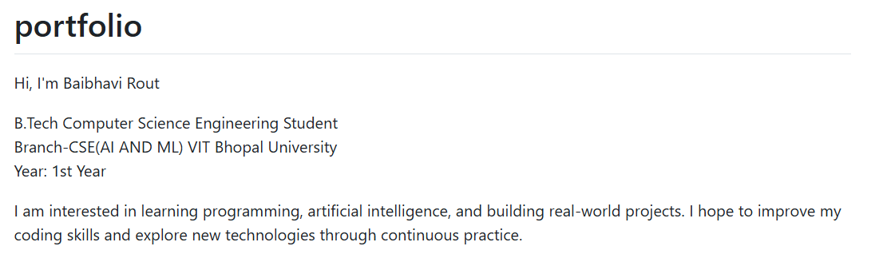

EDUCATIONAL SECTION IN LINKDIN
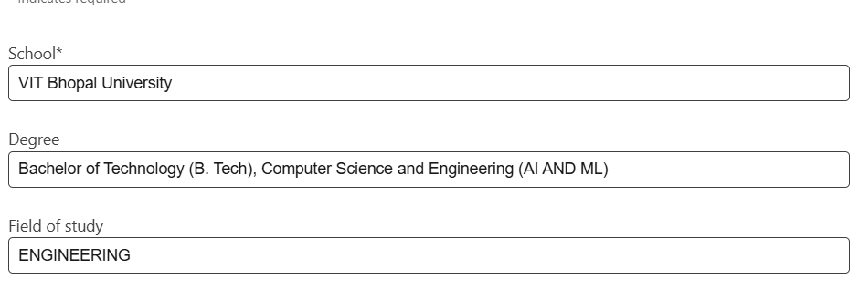

Account in Kaggle
