GHANA COMMUNICATION TECHNOLOGY UNIVERSITY
Faculty of Computing and Information Systems
ENCE 216
Mobile Computing & App Development
LAB GUIDE
Building a Netflix-Style Streaming App
Splash · Login · Registration · Browse · Detail — and the Routing Behind Them
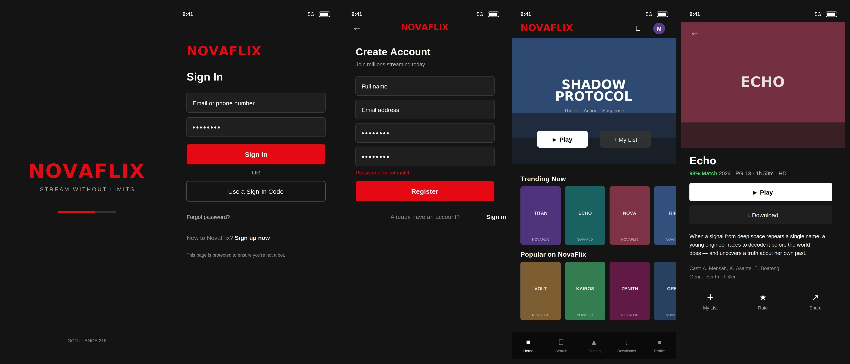
Estimated time: 2–3 hours · Prerequisites: Flutter SDK, basic Dart, the previous routing lab

1. What You Will Build
In this lab you will build NovaFlix, a Netflix-style streaming app. It has the same five-screen skeleton every real app uses — a splash, a login, a registration form, a main browse page, and a detail page you navigate into — but dressed in a dark, cinematic streaming theme with poster rails and a bottom navigation bar.
As with the Online Doctor lab, the streaming app is just the vehicle. The real subject is navigation and routing: how screens are stacked, replaced, cleared, and how data travels between them. This lab deliberately goes one step further than the last by introducing two professional techniques:
- onGenerateRoute — a central function that builds routes needing typed arguments, so the receiving screen gets its data through its constructor instead of digging it out itself.
- A `BottomNavigationBar` with `IndexedStack` — to show that switching tabs is *not* the same as routing, an idea students very often confuse.
Here are the five screens you will produce:

The five NovaFlix screens, left to right: Splash → Login → Register → Browse → Detail.

2. Key Concept Recap: The Navigator Is a Stack
Flutter manages screens (called routes) on a stack — a pile where the top item is what the user sees. Four operations move screens on and off that pile, and choosing the right one is the whole skill of routing.
Method | What it does | Where we use it in NovaFlix
pushNamed | Puts a new screen on top; the old one stays underneath. | Login → Register; Browse → Detail
pop | Removes the top screen, revealing the one below. | Register → Login; Detail back arrow
pushReplacementNamed | Swaps the top screen; the old one is destroyed. | Splash → Login
pushNamedAndRemoveUntil | Pushes a screen and clears everything below it. | Login → Browse; Sign-out → Login

Decision rule: Before every navigation, ask “Should the user be able to press back and return to this screen?” If no, you want a *replace* or *remove-until*. If yes, you want a plain *push*.

3. Project Set-up & Folder Structure
Create the project and open it:
flutter create novaflix
cd novaflix
flutter run

Then organise lib/ exactly like this. Notice we now add a models folder — as apps grow, data classes live separately from screens.
lib/
├─ main.dart <- route table + onGenerateRoute
├─ models/
│ └─ movie.dart <- Movie + Category + sample data
└─ screens/
├─ splash_screen.dart
├─ login_screen.dart
├─ register_screen.dart
├─ browse_screen.dart
└─ detail_screen.dart

4. Step 1 — The Data Model
Before any screen, we define what a “movie” is. Bundling related fields into a Movie class is what later lets us hand a whole title to the detail screen as one object. We also define a Category (a named row of movies) and a small hard-coded catalogue.

File: lib/models/movie.dart
import 'package:flutter/material.dart';

class Movie {
final String title;
final String genre;
final int year;
final String maturity; // e.g. "PG-13"
final String duration; // e.g. "1h 58m"
final int matchPercent; // e.g. 98 -> "98% Match"
final String description;
final Color color; // poster placeholder colour

const Movie({
required this.title,
required this.genre,
required this.year,
required this.maturity,
required this.duration,
required this.matchPercent,
required this.description,
required this.color,
});
}

class Category {
final String name;
final List<Movie> movies;
const Category({required this.name, required this.movies});
}

Why a model class? Without it you would pass half a dozen loose strings between screens and quickly lose track. One Movie object keeps a title’s data together and travels as a single argument.
Below the classes, add a featured title and a catalogue list of two categories (Trending Now, Popular on NovaFlix), each holding four Movie objects. The full data is in the accompanying project zip — copy it in, or invent your own titles.

5. Step 2 — main.dart: Two Routing Techniques Side by Side
This is the heart of the lab. MaterialApp is configured with both a routes map (for screens that take no arguments) and an onGenerateRoute function (for the detail screen, which needs a typed Movie).

File: lib/main.dart
import 'package:flutter/material.dart';
import 'models/movie.dart';
import 'screens/splash_screen.dart';
import 'screens/login_screen.dart';
import 'screens/register_screen.dart';
import 'screens/browse_screen.dart';
import 'screens/detail_screen.dart';

void main() => runApp(const NovaFlixApp());

class NovaFlixApp extends StatelessWidget {
const NovaFlixApp({super.key});

static const Color novaRed = Color(0xFFE50914);
static const Color novaBlack = Color(0xFF141414);

@override
Widget build(BuildContext context) {
return MaterialApp(
title: 'NovaFlix',
debugShowCheckedModeBanner: false,
theme: ThemeData(
brightness: Brightness.dark,
scaffoldBackgroundColor: novaBlack,
primaryColor: novaRed,
// ...input + button theming (see zip)...
),

// 1) Simple named routes (no arguments):
initialRoute: '/',
routes: {
'/': (context) => const SplashScreen(),
'/login': (context) => const LoginScreen(),
'/register': (context) => const RegisterScreen(),
'/browse': (context) => const BrowseScreen(),
},

// 2) onGenerateRoute handles routes that need a typed argument:
onGenerateRoute: (settings) {
if (settings.name == '/detail') {
final movie = settings.arguments as Movie; // type-checked here
return MaterialPageRoute(
builder: (context) => DetailScreen(movie: movie),
settings: settings,
);
}
return null; // fall through for unknown routes
},
);
}
}

Understanding onGenerateRoute
With a plain routes map, every screen is built with no information. That is fine for the splash or login. But the detail screen must know *which* movie to show. There are two ways to deliver it:
- Read it inside the screen with ModalRoute.of(context)!.settings.arguments as Movie — the technique from the previous lab. It works, but the screen has to trust the cast and there is no single place that documents what argument the route expects.
- Build it in `onGenerateRoute` — extract and type-check the argument once, in main.dart, then pass it straight into DetailScreen(movie: movie). The screen then simply declares required this.movie. This is cleaner, type-safe, and keeps all route logic in one file.
This lab uses technique 2 so you can compare the two and understand why larger apps prefer it.

6. Step 3 — Splash Screen
The splash shows the brand for three seconds, then replaces itself with the login screen using pushReplacementNamed, so the splash can never be reached again with the back button.
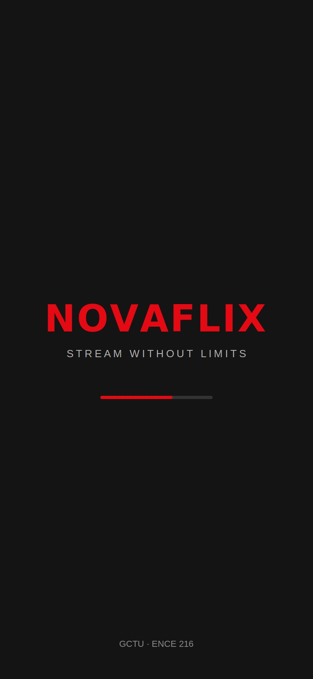
Screen 1 — the splash screen.

File: lib/screens/splash_screen.dart
import 'package:flutter/material.dart';
import '../main.dart';

class SplashScreen extends StatefulWidget {
const SplashScreen({super.key});
@override
State<SplashScreen> createState() => _SplashScreenState();
}

class _SplashScreenState extends State<SplashScreen> {
@override
void initState() {
super.initState();
// Run ONCE: wait 3s, then replace splash with login.
Future.delayed(const Duration(seconds: 3), () {
if (mounted) {
Navigator.pushReplacementNamed(context, '/login');
}
});
}

@override
Widget build(BuildContext context) {
return Scaffold(
backgroundColor: NovaFlixApp.novaBlack,
body: Center(
child: Column(
mainAxisAlignment: MainAxisAlignment.center,
children: const [
Text('NOVAFLIX',
style: TextStyle(
color: NovaFlixApp.novaRed,
fontSize: 44, fontWeight: FontWeight.bold,
letterSpacing: 2)),
SizedBox(height: 12),
Text('STREAM WITHOUT LIMITS',
style: TextStyle(color: Color(0xFFB3B3B3),
fontSize: 13, letterSpacing: 3)),
SizedBox(height: 40),
SizedBox(width: 140,
child: LinearProgressIndicator(
color: NovaFlixApp.novaRed,
backgroundColor: Color(0xFF333333))),
],
),
),
);
}
}

Key ideas: initState() is the right place for run-once logic. Future.delayed is asynchronous “wait then do”. The mounted check stops a crash if the user leaves before the timer fires.

7. Step 4 — Login Screen
The login screen teaches form validation and two different navigations: a plain pushNamed to Register, and a stack-clearing pushNamedAndRemoveUntil to Browse on success.
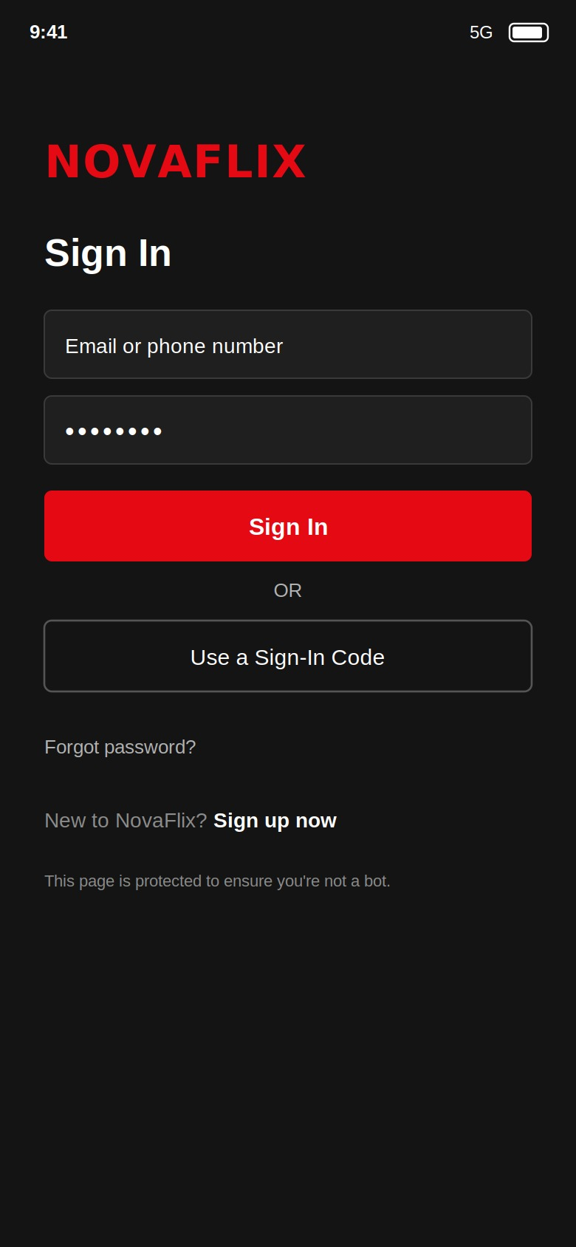
Screen 2 — the sign-in screen.

File: lib/screens/login_screen.dart (key parts)
final _formKey = GlobalKey<FormState>();
final _emailController = TextEditingController();
final _passwordController = TextEditingController();

void _signIn() {
if (_formKey.currentState!.validate()) {
// Clear splash + login so 'back' on Browse exits the app.
Navigator.pushNamedAndRemoveUntil(
context, '/browse', (route) => false);
}
}

The form fields use validators that return an error string when input is bad and null when it is good:
TextFormField(
controller: _emailController,
keyboardType: TextInputType.emailAddress,
decoration: const InputDecoration(hintText: 'Email or phone number'),
validator: (value) {
if (value == null || value.trim().isEmpty) return 'Please enter your email';
if (!value.contains('@') || !value.contains('.')) return 'Please enter a valid email';
return null; // null == valid
},
),

The “Sign up now” link uses a plain push so the user can return:
GestureDetector(
onTap: () => Navigator.pushNamed(context, '/register'),
child: const Text('Sign up now',
style: TextStyle(color: Colors.white, fontWeight: FontWeight.bold)),
)

Common mistake: Validators are backwards from what students expect — you return the error message for bad input and null for good input. Returning null is success.

8. Step 5 — Registration Screen
Registration shows cross-field validation (the confirm-password field compares itself to the password field) and, on success, pops back to the login screen sitting underneath it.
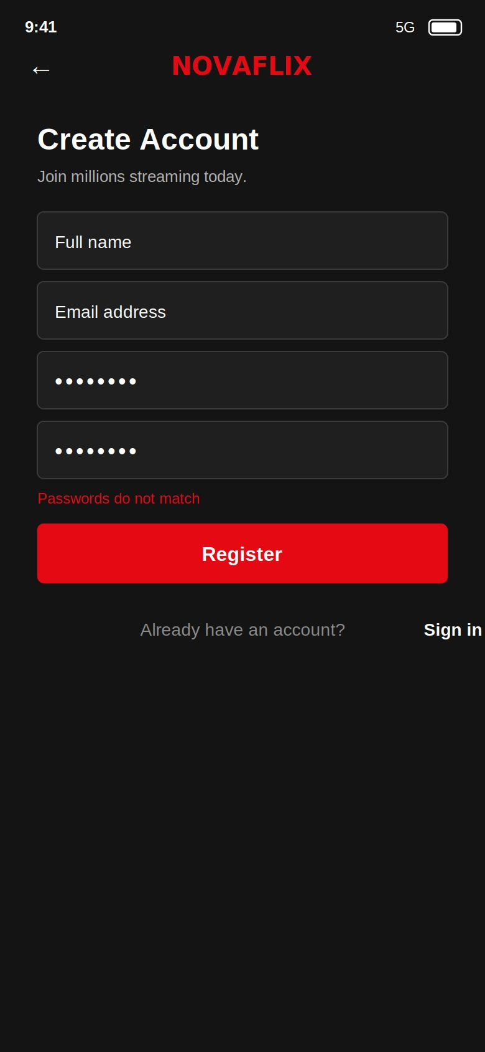
Screen 3 — the registration form, showing the “Passwords do not match” validation state.

File: lib/screens/register_screen.dart (key parts)
void _register() {
if (_formKey.currentState!.validate()) {
ScaffoldMessenger.of(context).showSnackBar(
const SnackBar(content: Text('Account created! Please sign in.'),
backgroundColor: Colors.green),
);
Navigator.pop(context); // reveal the Login screen beneath
}
}

// Cross-field validation on the confirm-password field:
TextFormField(
controller: _confirmController,
obscureText: true,
decoration: const InputDecoration(hintText: 'Confirm password'),
validator: (value) {
if (value != _passwordController.text) return 'Passwords do not match';
return null;
},
),

Why pop, not push? Login is already on the stack beneath Register. To go back to it you pop Register off. Pushing /login again would stack a *second* login screen on top — a common bug.

9. Step 6 — Browse Screen (Bottom Nav + Poster Rails)
The browse screen is the “home base” after sign-in. It owns a BottomNavigationBar and swaps between five tabs using an IndexedStack. Its Home tab shows a hero banner and horizontal poster rails; tapping a poster routes to the detail page with the chosen `Movie` as an argument.
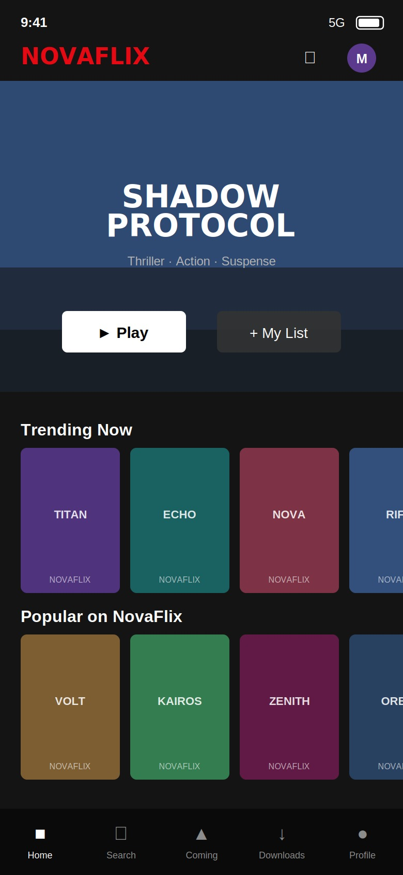
Screen 4 — the browse page: hero banner, poster rails, and a bottom navigation bar.

Concept: switching tabs is NOT routing
This is the single most important idea on this screen. When the user taps Home / Search / Downloads, we do not push a route. We simply change a number (_currentIndex) and let IndexedStack show a different child. All five tabs stay alive in memory, so their scroll positions are preserved.
int _currentIndex = 0;

final List<Widget> _tabs = const [
_HomeTab(),
_PlaceholderTab(icon: Icons.search, label: 'Search'),
_PlaceholderTab(icon: Icons.upcoming, label: 'Coming Soon'),
_PlaceholderTab(icon: Icons.download, label: 'Downloads'),
_PlaceholderTab(icon: Icons.person, label: 'Profile'),
];

@override
Widget build(BuildContext context) {
return Scaffold(
body: IndexedStack(index: _currentIndex, children: _tabs),
bottomNavigationBar: BottomNavigationBar(
currentIndex: _currentIndex,
type: BottomNavigationBarType.fixed,
onTap: (index) => setState(() => _currentIndex = index), // NO Navigator!
items: const [
BottomNavigationBarItem(icon: Icon(Icons.home), label: 'Home'),
BottomNavigationBarItem(icon: Icon(Icons.search), label: 'Search'),
BottomNavigationBarItem(icon: Icon(Icons.upcoming), label: 'Coming Soon'),
BottomNavigationBarItem(icon: Icon(Icons.download), label: 'Downloads'),
BottomNavigationBarItem(icon: Icon(Icons.person), label: 'Profile'),
],
),
);
}

The poster rail and passing the argument
Each category is a horizontal ListView.builder. Tapping a poster pushes /detail and sends the whole Movie through the arguments parameter:
void _openDetail(BuildContext context, Movie movie) {
Navigator.pushNamed(context, '/detail', arguments: movie);
}

// inside the horizontal ListView.builder:
GestureDetector(
onTap: () => onTapMovie(movie), // -> _openDetail(context, movie)
child: Container(
width: 100,
decoration: BoxDecoration(
color: movie.color,
borderRadius: BorderRadius.circular(6),
),
child: Center(child: Text(movie.title.toUpperCase())),
),
)

The Home tab’s app bar also has a sign-out button, which clears the stack back to login — the same pushNamedAndRemoveUntil pattern as a fresh sign-in:
IconButton(
icon: const Icon(Icons.logout),
onPressed: () => Navigator.pushNamedAndRemoveUntil(
context, '/login', (route) => false),
)

10. Step 7 — Detail Screen (Receiving a Typed Argument)
The detail screen is where onGenerateRoute pays off. Because main.dart already extracted and type-checked the Movie, this screen receives it cleanly through its constructor — no ModalRoute lookup, no cast inside the widget.
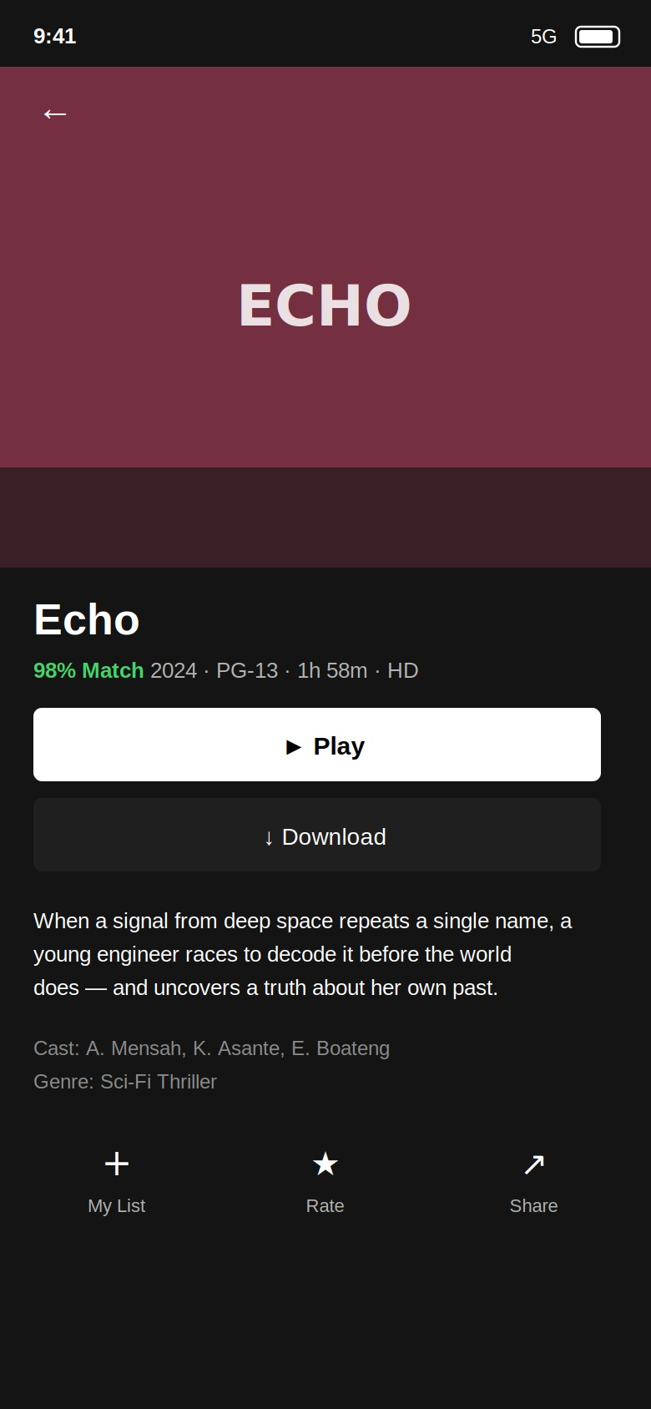
Screen 5 — the detail page, built from the Movie passed in as a route argument.

File: lib/screens/detail_screen.dart (key parts)
class DetailScreen extends StatelessWidget {
final Movie movie; // <- received via constructor
const DetailScreen({super.key, required this.movie});

@override
Widget build(BuildContext context) {
return Scaffold(
body: CustomScrollView(
slivers: [
SliverAppBar(
expandedHeight: 300,
pinned: true,
// back arrow here auto-calls Navigator.pop(context)
flexibleSpace: FlexibleSpaceBar(
background: Container(color: movie.color),
),
),
SliverToBoxAdapter(
child: Padding(
padding: const EdgeInsets.all(16),
child: Column(
crossAxisAlignment: CrossAxisAlignment.start,
children: [
Text(movie.title,
style: const TextStyle(fontSize: 26, fontWeight: FontWeight.bold)),
Text('${movie.matchPercent}% Match · '
'${movie.year} · ${movie.maturity} · ${movie.duration}'),
// ...Play button, Download button, description...
],
),
),
),
],
),
);
}
}

Compare the two labs: Online Doctor read the argument *inside* the chat screen with ModalRoute.of(context). NovaFlix builds it in onGenerateRoute and injects it through the constructor. Both are valid — the constructor approach is safer and is what you should reach for as projects grow.

11. Run & Test — The Routing Checklist
Run flutter run and walk this checklist. Each row exercises one navigation concept.
# | Action | Expected result | Concept tested
1 | Launch, wait 3s | Splash auto-advances to Login | pushReplacementNamed
2 | Press back on Login | App exits (no return to splash) | splash was replaced
3 | Tap “Sign up now”, then back | Register opens, then returns to Login | pushNamed + pop
4 | Type mismatched passwords | “Passwords do not match” appears | cross-field validation
5 | Register correctly | Green SnackBar, lands on Login | pop + SnackBar
6 | Sign in correctly | Browse opens | pushNamedAndRemoveUntil
7 | Press back on Browse | App exits (no return to Login) | stack was cleared
8 | Tap bottom-nav tabs | Body changes, NO new back arrow | IndexedStack (not routing)
9 | Tap a poster | Detail opens with THAT movie’s data | onGenerateRoute + arguments
10 | Press back on Detail | Returns to Browse | pop
11 | Tap sign-out icon | Back to Login, stack cleared | pushNamedAndRemoveUntil

12. Navigation Cheat Sheet
// Forward, keep current screen underneath:
Navigator.pushNamed(context, '/route');

// Forward WITH a typed argument:
Navigator.pushNamed(context, '/detail', arguments: movie);

// Receive it (constructor style, via onGenerateRoute) -> DetailScreen(movie: movie)
// Receive it (in-screen style):
final movie = ModalRoute.of(context)!.settings.arguments as Movie;

// Back one screen:
Navigator.pop(context);

// Replace current screen (no going back):
Navigator.pushReplacementNamed(context, '/login');

// Forward and clear everything below:
Navigator.pushNamedAndRemoveUntil(context, '/browse', (route) => false);

// Switch a tab (NOT routing):
setState(() => _currentIndex = index);

13. Exercises (Submit Before Next Lab)
- Easy: Change the splash delay to 4 seconds and the brand red to your own hex colour throughout the app.
- Easy: Add a “Forgot password?” tap on the login screen that shows a SnackBar “Reset link sent”.
- Medium: Add a third category row (e.g. “Ghanaian Cinema”) with three new Movie objects of your own.
- Medium: On the detail screen, make the Play button navigate to a new PlayerScreen (/player) that shows the movie title and a big play icon. Pass the Movie to it the same way as the detail route.
- Challenge: Make the Search tab actually filter the catalogue by title as the user types, and tapping a result routes to the detail page. (You will combine setState filtering with pushNamed + arguments.)
- Thought question (3–4 sentences): Why is switching bottom-nav tabs done with IndexedStack and setState instead of Navigator.push? What would go wrong with the back button if each tab were a pushed route?

14. Common Errors & Fixes
Symptom | Likely cause | Fix
Could not find a generator for route “/detail” | onGenerateRoute returned null for it | Ensure the if (settings.name == '/detail') branch returns a MaterialPageRoute
type 'Null' is not a subtype of type 'Movie' | Pushed /detail without arguments | Always pass arguments: movie when pushing /detail
Tabs lose scroll position when switched | Used a plain widget swap instead of IndexedStack | Wrap the tab bodies in IndexedStack
Back button returns to Login after sign-in | Used pushNamed instead of pushNamedAndRemoveUntil | Clear the stack with (route) => false
setState() called after dispose() | Splash timer fired after leaving | Guard with if (mounted)

End of Lab Guide — ENCE 216, Mobile Computing & App Development.

