GHANA COMMUNICATION TECHNOLOGY UNIVERSITY
Faculty of Computing and Information Systems
ENCE 216 · Mobile Computing & App Development
LAB GUIDE
Building a “Send Money” App
Named Routes, Passing Data & popUntil — with a Reusable Widget
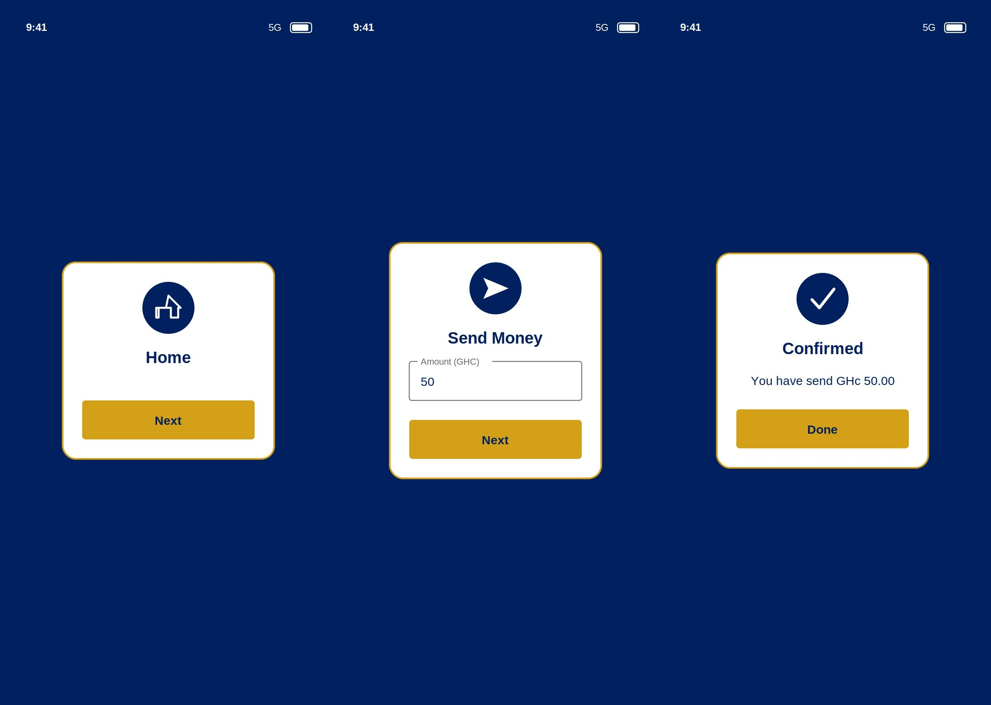
Estimated time: 1.5–2 hours · Prerequisites: Flutter SDK, basic Dart

1. What You Will Build
In this lab you will build SendMoney, a small three-screen money-transfer demo in the GCTU colours (navy and amber). It is deliberately tiny so the focus stays on navigation — the part of every app that connects screens together.
The three screens are:
- Home — a welcome card with a Next button.
- Send Money — a card with a text box where you type an amount.
- Confirmed — a card that shows the amount you sent and a Done button that returns you home.

The three screens: Home → Send Money → Confirmed.
Although it is small, this app teaches four professional ideas you will use in every Flutter project:
- Named routes — giving each screen a name like /send and registering them in one place.
- Passing data between screens — sending the typed amount from Send Money to Confirmed.
- `popUntil` — jumping straight back to the first screen in one call, instead of popping one at a time.
- A reusable widget — one ScreenCard design used by all three screens, so you write the layout once.

2. Key Concept: The Navigator Stack
Flutter keeps your screens on a stack — a pile where the top item is what you see. You add a screen with push and remove one with pop (which is also what the back button does).
Method | What it does | In this app
pushNamed | Add a named screen on top. | Home → Send; Send → Confirmed
pop | Remove the top screen. | (the back button)
popUntil(isFirst) | Pop repeatedly until the first screen is on top. | Confirmed → Home (Done button)

🔑 Key idea: popUntil is the new idea in this lab. After Home → Send → Confirmed there are three screens on the stack. Instead of popping twice, Navigator.popUntil(context, (route) => route.isFirst) removes screens until the first one (Home) is showing — one line, any depth.

3. Project Set-up & Folder Structure
Create the project and open it:
flutter create send_money_app
cd send_money_app
flutter run

Inside lib/, build this structure. Notice the widgets folder — shared building blocks live separately from screens.
lib/
├─ main.dart <- app + route table
├─ theme.dart <- brand colours
├─ screens/
│ ├─ home_screen.dart
│ ├─ send_money_screen.dart
│ └─ confrimed_screen.dart
└─ widgets/
└─ screen_card.dart

✨ Tip: The import paths depend on this exact layout. A file in screens/ reaches the widget with ../widgets/screen_card.dart and the theme with ../theme.dart (the .. means “go up one folder”). If your imports show red, check your folders match the tree above.

4. Step 1 — theme.dart (Brand Colours)
First, define the two GCTU colours once so every screen can reuse them. Putting colours in constants means you change them in one place, not fifty.

File: lib/theme.dart
import 'package:flutter/material.dart';

const Color KNavy = Color(0XFF002060);
const Color KAmber = Color(0xffd4A017);

🔑 Key idea: Color(0xFF002060) is a hex colour. The first two digits after 0x are FF = fully opaque (the alpha channel); the remaining six are the red-green-blue value. 002060 is GCTU navy.

5. Step 2 — The Reusable Widget: ScreenCard
This is the cleverest part of the app. All three screens share the same look: a white card with an icon, a title, an optional middle section, and a button. Instead of building that three times, we build it once as a ScreenCard and let each screen fill in the differences.
ScreenCard accepts five pieces of information through its constructor: an icon, a title, a buttonLabel, an onPressed action, and an optional body.

File: lib/widgets/screen_card.dart
import 'package:flutter/material.dart';
import '../theme.dart';

class ScreenCard extends StatelessWidget {
final IconData icon;
final String title;
final Widget body;
final String buttonLabel;
final VoidCallback onPressed;

const ScreenCard({
super.key,
required this.icon,
required this.title,
required this.buttonLabel,
required this.onPressed,
this.body = const SizedBox.shrink(),
});

@override
Widget build(BuildContext context) {
return Scaffold(
backgroundColor: KNavy,
body: Center(
child: Container(
width: 260,
padding: const EdgeInsets.all(24),
decoration: BoxDecoration(
color: Colors.white,
borderRadius: BorderRadius.circular(16),
border: Border.all(color: KAmber, width: 2),
),
child: Column(
mainAxisSize: MainAxisSize.min,
children: [
CircleAvatar(
radius: 32,
backgroundColor: KNavy,
child: Icon(icon, color: Colors.white, size: 30),
),
const SizedBox(height: 16),
Text(
title,
style: const TextStyle(
color: KNavy, fontSize: 20, fontWeight: FontWeight.bold,
),
),
const SizedBox(height: 16),
body,
const SizedBox(height: 24),
SizedBox(
width: double.infinity,
child: ElevatedButton(
onPressed: onPressed,
style: ElevatedButton.styleFrom(
backgroundColor: KAmber,
foregroundColor: KNavy,
padding: const EdgeInsets.symmetric(vertical: 14),
),
child: Text(
buttonLabel,
style: const TextStyle(fontWeight: FontWeight.bold),
),
),
),
],
),
),
),
);
}
}

Three ideas to understand here
- `final` fields + constructor — each screen passes its own icon, title, label and action when it creates a ScreenCard. The widget is a template; the values fill the blanks.
- `VoidCallback onPressed` — this is a *function* passed in from outside. The card does not know what the button should do; the screen decides and hands the action over. The card just calls it.
- The `body` slot — body defaults to const SizedBox.shrink() (an invisible empty box). Screens that need a middle section (like the amount field) pass their own widget; screens that do not simply leave it out.
🔑 Key idea: This pattern — a parent widget that takes a child widget and a callback — is called composition, and it is how professional Flutter apps stay DRY (Don’t Repeat Yourself). Master it here on a small scale.

6. Step 3 — main.dart: The Route Table
main.dart starts the app and registers all three screens as named routes. The routes map links a name (like /send) to the screen that should appear.

File: lib/main.dart
import 'package:flutter/material.dart';
import 'screens/home_screen.dart';
import 'screens/send_money_screen.dart';
import 'screens/confrimed_screen.dart';
import 'theme.dart';

void main() {
runApp(const SendMoneyApp());
}

class SendMoneyApp extends StatelessWidget {
const SendMoneyApp({super.key});

@override
Widget build(BuildContext context) {
return MaterialApp(
title: 'SendMoneyApp',
debugShowCheckedModeBanner: false,
theme: ThemeData(scaffoldBackgroundColor: KNavy),
initialRoute: '/',
routes: {
'/': (context) => const HomeScreen(),
'/send': (context) => const SendMoneyScreen(),
'/confirm': (context) => const ConfrimedScreen(),
},
);
}
}

🔑 Key idea: initialRoute: '/' is the screen shown first. Each entry in routes maps a name to a screen. From now on, anywhere in the app, Navigator.pushNamed(context, '/send') opens the Send Money screen — no need to import it there.
⚠ Watch out: Route names are just text. If you type '/sen' instead of '/send', the app crashes with “Could not find a generator for route”. Copy route names carefully — the computer cannot spell-check them for you.

7. Step 4 — Home Screen
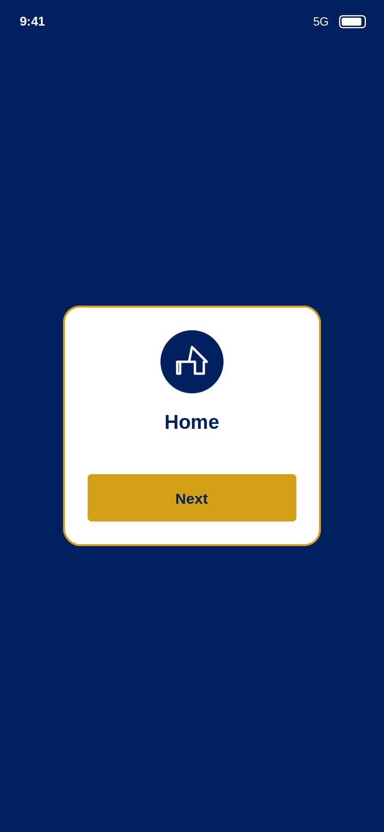
Screen 1 — Home.
The Home screen is tiny: it just builds a ScreenCard and, when Next is pressed, pushes the /send route.

File: lib/screens/home_screen.dart
import 'package:flutter/material.dart';
import '../widgets/screen_card.dart';

class HomeScreen extends StatelessWidget {
const HomeScreen({super.key});

@override
Widget build(BuildContext context) {
return ScreenCard(
icon: Icons.home,
title: 'Home',
buttonLabel: 'Next',
onPressed: () { Navigator.pushNamed(context, '/send'); },
);
}
}

🔑 Key idea: See how short this is? All the layout lives in ScreenCard. The screen only supplies what is different: the home icon, the title, and what the button does. That is the payoff of the reusable widget.

8. Step 5 — Send Money Screen (Input + Passing Data)
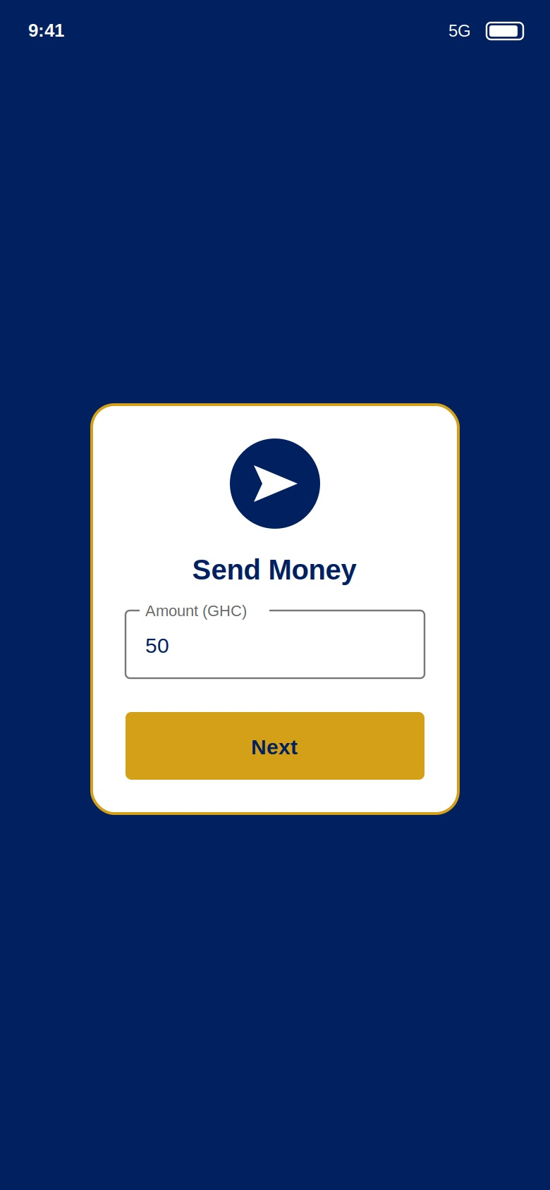
Screen 2 — Send Money, with an amount field.
This screen is a StatefulWidget because it must remember what the user types. It uses a TextEditingController to read the amount, and when Next is pressed it converts the text to a number and passes it to the Confirmed screen as an argument.

File: lib/screens/send_money_screen.dart
import 'package:flutter/material.dart';
import '../widgets/screen_card.dart';

class SendMoneyScreen extends StatefulWidget {
const SendMoneyScreen({super.key});

@override
State<SendMoneyScreen> createState() => _SendMoneyScreenState();
}

class _SendMoneyScreenState extends State<SendMoneyScreen> {
final TextEditingController _amount = TextEditingController();

@override
void dispose() {
_amount.dispose();
super.dispose();
}

@override
Widget build(BuildContext context) {
return ScreenCard(
icon: Icons.send,
title: 'Send Money',
buttonLabel: 'Next',
body: TextField(
controller: _amount,
keyboardType: TextInputType.number,
decoration: const InputDecoration(
labelText: 'Amount (GHC)',
border: OutlineInputBorder(),
),
),
onPressed: () {
final value = double.tryParse(_amount.text) ?? 0;
Navigator.pushNamed(context, '/confirm', arguments: value);
},
);
}
}

What is happening here
- `TextEditingController _amount` connects to the TextField so you can read what was typed with _amount.text.
- `dispose()` frees the controller when the screen closes — always dispose controllers to avoid memory leaks.
- `double.tryParse(_amount.text) ?? 0` turns the typed text into a number. tryParse returns null if the text is not a valid number, and ?? 0 then uses 0 instead, so the app never crashes on bad input.
- `arguments: value` is the key line: it attaches the amount to the /confirm route so the next screen can read it.
⚠ Watch out: If you type letters or leave the box empty, tryParse fails and the amount becomes 0 — the app still moves on and shows “0.00”. Improving this is one of your exercises at the end.

9. Step 6 — Confirmed Screen (Receiving Data + popUntil)
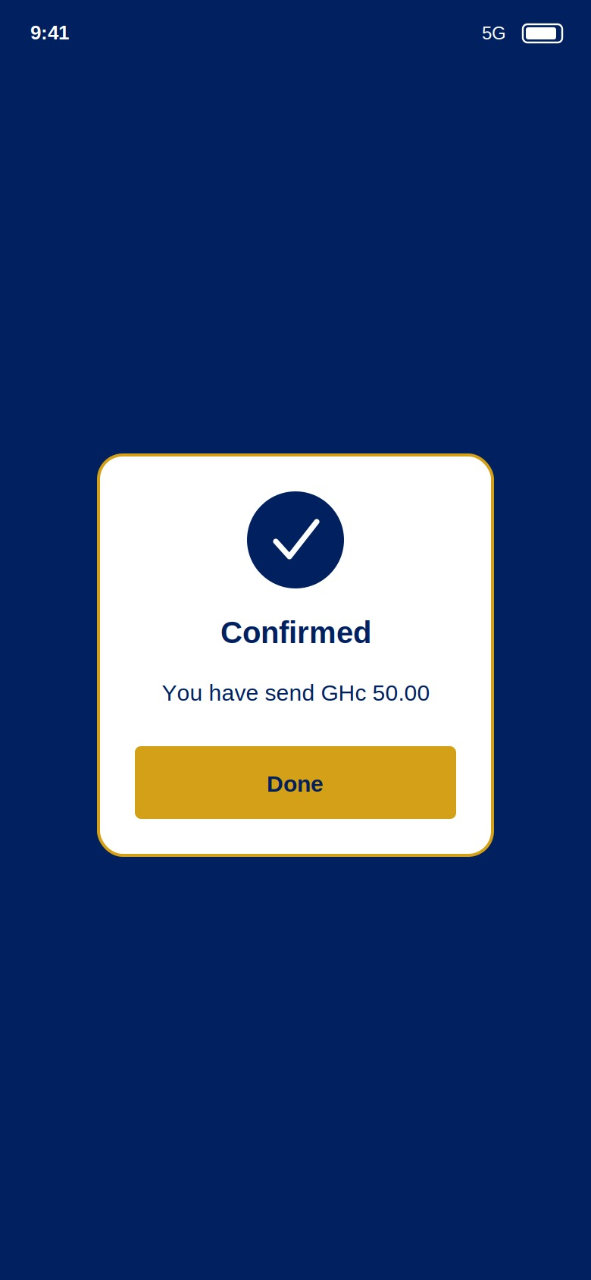
Screen 3 — Confirmed, showing the amount it received.
The Confirmed screen receives the amount that Send Money sent, displays it, and its Done button uses popUntil to return all the way to Home.

File: lib/screens/confrimed_screen.dart
import 'package:flutter/material.dart';
import '../widgets/screen_card.dart';
import '../theme.dart';

class ConfrimedScreen extends StatelessWidget {
const ConfrimedScreen({super.key});

@override
Widget build(BuildContext context) {
final amount = ModalRoute.of(context)!.settings.arguments as double;
return ScreenCard(
icon: Icons.check,
title: 'Confirmed',
buttonLabel: 'Done',
body: Text(
'You have send GHc ${amount.toStringAsFixed(2)}',
textAlign: TextAlign.center,
style: const TextStyle(color: KNavy, fontSize: 16),
),
onPressed: () {
Navigator.popUntil(context, (route) => route.isFirst);
},
);
}
}

The two ideas to take away
- Receiving the argument: ModalRoute.of(context)!.settings.arguments as double reads the value that was attached to this route, and as double tells Dart what type it is. toStringAsFixed(2) formats it to two decimal places (e.g. 50.00).
- `popUntil(... route.isFirst)` keeps popping screens until the first one (Home) is back on top. This is cleaner than calling pop twice, and it works no matter how many screens are stacked.
⚠ Watch out: If you open /confirm without passing an amount, the as double cast fails and the app crashes. A route that reads an argument has a contract: callers must always provide it.

10. Run & Test — Checklist
Run flutter run and walk through this. Each row checks one idea.
# | Action | Expected result | Concept
1 | Launch the app | Home card appears on navy background | initialRoute
2 | Tap Next on Home | Send Money screen opens | pushNamed
3 | Type 50, tap Next | Confirmed shows “… GHc 50.00” | passing + receiving arguments
4 | Leave amount blank, tap Next | Confirmed shows “… 0.00” (no crash) | tryParse ?? 0
5 | Tap Done on Confirmed | Jumps straight back to Home | popUntil(isFirst)
6 | Tap the system back button on Send | Returns to Home | pop

11. Navigation Cheat Sheet
// Open a named screen:
Navigator.pushNamed(context, '/send');

// Open a screen AND pass data:
Navigator.pushNamed(context, '/confirm', arguments: value);

// Receive that data on the next screen:
final amount = ModalRoute.of(context)!.settings.arguments as double;

// Go back one screen:
Navigator.pop(context);

// Go back to the very first screen in one call:
Navigator.popUntil(context, (route) => route.isFirst);

12. Exercises (Submit Before Next Lab)
- Easy: Change the brand colours in theme.dart (e.g. a green and gold) and watch all three screens update from that single change.
- Easy: On the Confirmed screen, change the message to also greet the user, e.g. “Thank you! You sent …”.
- Medium — polish the app: Fix the small issues in the starter code: rename confrimed_screen.dart / ConfrimedScreen to the correct spelling confirmed (remember to update the import and the route in main.dart), correct “You have send” to “sent”, and change the currency text from “GHc” to “GH₵”. Confirm the app still runs.
- Medium: In send_money_screen.dart, stop the app from continuing when the amount is empty or 0. If value <= 0, show a SnackBar (“Enter a valid amount”) and do not navigate.
- Challenge: Add a fourth screen /recipient between Send and Confirmed where the user types a phone number. Pass both the amount and the phone number to Confirmed. (Hint: you can pass a small Map, e.g. arguments: {'amount': value, 'phone': phone}, and read each key on the other side.)
- Thought question (3–4 sentences): The Done button uses popUntil(isFirst) instead of pushNamed('/'). What is the difference on the Navigator stack, and why would pushing Home again be the wrong choice?

13. Common Errors & Fixes
Symptom | Likely cause | Fix
“Could not find a generator for route” | Misspelled route name | Match the name exactly to a key in the routes map
Null is not a subtype of type 'double' | Opened /confirm without an amount | Always pass arguments: value when pushing /confirm
Imports underlined red | Folder structure doesn’t match | Check screens/ and widgets/ exist and the ../ paths are right
Amount always shows 0.00 | Typed letters, or blank field | Type digits; tryParse only reads valid numbers
Card overflows / yellow stripes | Long body widget on a small card | Keep the body compact, or wrap in scrolling (later topic)

End of Lab Guide — ENCE 216, Mobile Computing & App Development.

