DATA 603 – Homework 1: Generalization
Bailey Jannuzzi
Sep 25, 2026

The dataset I selected for this project was CIFAR-10, and I trained a ResNet-18 using empirical risk minimization (ERM) for 20 epochs on the CIFAR-10 dataset. I then evaluated it on both the In-distribution and out-of-distribution test set. The in-distribution test set is the standard test split for CIFAR-10 and the out-of-distribution test set comes from CIFAR-10-C, applying synthetic corruptions to the same standard test split images at a chosen severity level of 3/5. These corruptions spanned 4 categories: Gaussian noise, motion blur, fog, and reduced contrast. I chose these categories to get a general spread of different types of corruptions the model may see in a real dataset. The severity of 3 was chosen as a moderate value that was strong enough to create a real accuracy gap without making that gap too severe.
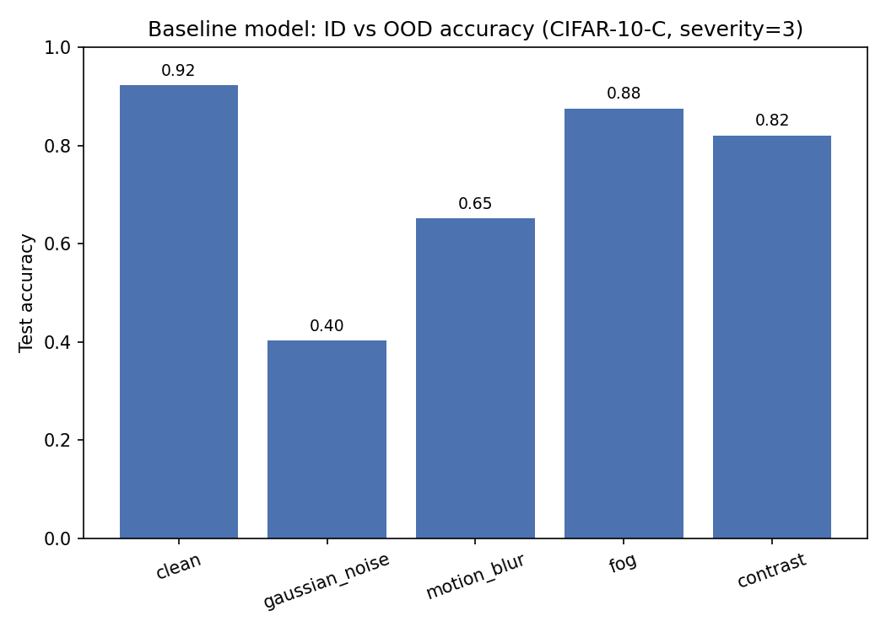
The baseline model reached a reasonable accuracy of 92.2%, on the clean test. However, the accuracy of the baseline model dropped significantly across every corruption type: 87.6% under fog, 82.0% under contrast reduction, 65.1% under motion blur, and 40.2% under Gaussian noise. The difference in severity of the accuracy drop was highly variable, with fog only costing 4.6 percentage points, but Gaussian noise cost the model 52 percentage points.

Condition | Baseline Accuracy (Rounded to 3 decimals)
clean | 0.922
fog | 0.876
contrast | 0.820
motion_blur | 0.651
gaussian_noise | 0.402

The model’s performance changed due to it being trained on only clean images. With this dataset the model learned a specific method for how to analyze the pixel images, relying on precise pixel statistics, rather than looking at general features across a lot of images. This resulted in the model failing to translate well when tested on corrupted images. This understanding of the model training makes a lot of sense when looking at the significant drop in accuracy under Gaussian noise or motion blur. A Gaussian noise corruption disrupts each pixel independently, and motion blur ruins fine edges. These corruptions keep the general structure of an image, but disturbs the parts of the image the model is trained to rely on. This investigation shows how while a model might perform very well initially, generalization tests are needed to both test and improve accuracy and transferability.
One reasonable way to improve model generalizability is to include corrupted images into its initial training set. This allows the model to learn how to handle these corrupted images, which then allows it to more correctly adapt to situations where images are not perfectly clean images. Though it requires more knowledge on what images the model might encounter, which is not always known.

Graduate Extension:
For the graduate extension, I wanted to ask if data augmentation that does not match the CIFAR-10-C corruptions still improves the model’s robustness to distributional shifts and what it costs to in-distribution accuracy.
To do this I trained a secondary model that was identical in architecture and training procedure as the baseline model. This model only differed from the baseline model in its augmentation pipeline; instead of just training with random crop (4px padding) and horizontal flip, I also trained the model using color jitter (±40%) and random erasing (p = 0.25, 2-15% area). I then evaluated both models on the same clean test set as well as the same four types of CIFAR-10-C corrupted conditions.
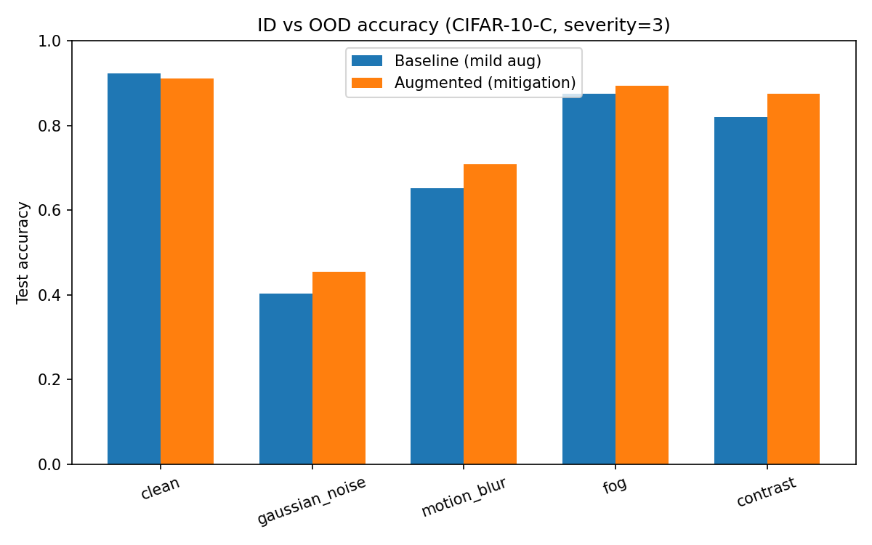
Viewing the output for both models and all conditions, I found a similar trend with decreasing accuracy between clean and corrupted conditions in both the baseline and augmented models; however, the augmented model showed higher accuracy than the baseline model across all corrupted conditions, though it showed a small decrease in accuracy of clean images (-0.012), presenting a small trade-off.

Condition | Baseline Accuracy (Rounded to 3 decimals) | Augmented Accuracy (Rounded to 3 decimals) | Delta  (Rounded to 3 decimals)
clean | 0.922 | 0.910 | -0.012
gaussian_noise | 0.402 | 0.454 | +0.052
motion_blur | 0.651 | 0.709 | +0.057
fog | 0.876 | 0.894 | +0.018
contrast | 0.820 | 0.874 | +0.054

The results for Gaussian noise and motion blur are the most informative as neither color jitter or random erasing resemble those corruptions. Both still improved by about 5 percentage points between the baseline and augmented model. This suggests that augmentation does not have to match the conditions completely to improve robustness, and that with this augmentation during training the model learned to be less reliant on pixel-precision and learned more transferable features. This is different from the contrast and fog gains, which are harder to draw conclusions from because they overlap similar corruption effects as color jitter.
One thing that stood out, even with improved accuracy, was that the augmented model still struggled (below 71% accuracy) with motion blur and gaussian noise conditions compared to fog and contrast reduction. From this, I conclude that more training augmentations aimed towards gaussian noise and motion blur could further improve the model’s generalizability, though this would start moving towards a matched approach.

The code for this project is uploaded onto my GitHub repo (https://github.com/Bailey-JJ/DATA_603/tree/main/homework/homework_01).

