## An Introduction GNU/Linux 1.0

So what is Linux? Linux is a kernel founded by Linus Torvalds on September 17, 1991. A Kernel, a fancy word for very sophisticated bundled piece of software that is in charge of communicating specific hardware instructions with other software. **Figure 1-1** will give you a visual perspective of what a kernel is

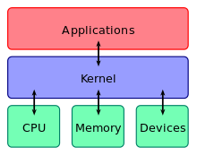**Figure 1.1**

So if Linux is a kernel what makes it so special? Linux can be combined with other software to become a complete Operating System. The most commonly bundled software is the GNU Operating System. GNU, founded by Richard Stallman, is intended to have its users experience a free operating system without any limitations of proprietary software. Stallman created GNU with sole reason to be able to redistribute software without any legal repercussions. Both the Linux kernel and the GNU software suit are free to download and redistribute, so it didn't take long for GNU/Linux to be born. There are millions of maintainers of the Linux Kernel and of the GNU software suit and these projects can be found on devices all over the world. From web servers, home computers, to airline systems and robotic machines, GNU/Linux is virtually EVERYWHERE.

Eventually the community started to create their own versions of GNU/Linux operating systems called *distributions, distro* for short*.* With the hope to create a distro that satisfies the different needs of people using them. For instance people have created different distros to improve privacy (<https://tails.boum.org/>) or simply create a small enough distro that virutally any computer can run (<http://puppylinux.org/>) . There are thousands of distros out there with their own particular reason of existence. Here are the some of the most popular.

### Top Distros:

**Debian(Mint, Ubuntu, Kali**) (**debian.org)**: Debian is the most popular Linux Distribution in the world, it supports hundreds of CPU architectures and thousands of packages(programs, libraries, modules, etc) It is the base for many other awesome distributions such as Linux Mint(**linuxmint.com**), Ubuntu (**ubuntu.com**), and Kali(**kali.org**). Debian is not so user friendly because of its installer and system design, I recommend installing Linux Mint/Ubuntu for your first install of Linux.

**Redhat(centOS, Scientific Linux. Fedora)**(**redhat.com):** RedHat Linux is the leading Enterprise level distribution out there. Think of RedHat as the Microsoft Windows of Linux. For this distribution a licence is needed in order to download security updates and patches. This distro is extremely stable but is not free. Recently Redhat has announced a student program, where you can download and install RedHat enterprise linux for free! All you need to do is sign up with your CSUSB.edu email address. I have done this myself and i'm using this on one of my laptops. There are free versions of Redhat called CentOS and Fedora. CentOs is the exact same as Redhat, down to every package and Fedora is the testing ground for Redhat meaning this distro testes all the new packages and programs that will be in the future releases of redhat. CentOS and fedora are free.

**OpenSuse**(**Opensuse.org).**  Another Enterprise Linux Distribution, not as popular as Red Hat and a distro I absolutely hate with all my passion. I never want to use this distro as long as I live. There is a free version you can download and try out. Although I do not like it, maybe it can be different for you.

**Gentoo(Funtoo, Pentoo, Sabayon)(gentoo.org):** This distribution is not for beginners and I do not recommend installing it for your first distro unless you enjoy banging your head on the keyboard. Gentoo is a Linux distribution that focuses on extreme user choice. The installer is barebone minimum and the user has to do everything from partitioning his or her hard drive manually to downloading and compiling the Linux kernel. Gentoo was created to have the user maximize their system with every choice imaginable.There is a distribution that is based off of gentoo called *sabayon* that is user friendly. Gentoo is for Linux hobbyist who like to configure their system down to every last bit.

**Arch**(Antergos, Manjaro, Assault). **(archlinux.org):** Arch linux is a fast yet bleeding edge distribution. Arch like gentoo requires a user to do a lot of things manually, like partition your own hard drives, edit your own configuration files and install your own drivers. Although arch is not as grueling as Gentoo, Arch is still pretty tough for beginners because arch requires to have some sort of knowledge of how Linux works on the system level. Arch is intended for a user to have a minimal but fast system that is not bloated with applications that are not needed. As their motto, KISS (Keep It Simple Stupid). Arch is all about choice and performance.

For more distros and more information about the popularity of these distros, which packages these distros use and what mainline kernel they support. Please vist **distrowatch.com**

## An Introduction to GNU/Linux Software 1.1

One thing that is safe to say with linux is that

**Desktops:**

**Plasma** **KDE** : K Desktop Environment . One of the most advanced desktops when it comes to user control. I personally use this because it has everything I need and it is absolutely beautiful. I highly recommend this desktop. **https://www.kde.org/workspaces/plasmadesktop/**

**Gnome:** (GNU Network Object Model Environment). One of the most popular desktops out there. If you have used linux there's a 90% chance that you have already used this desktop. A lot of distros have it as their main desktop EX: redhat, fedora

**LXDE:** Lightweight X11 Desktop Environment. If you have used a raspberry Pi, with   
 raspbian. This is what is on the GUI. **http://lxde.org/**

**XFCE:** “Ecks Eff See Eee”. The name Xfce originally stood for XForms Common Environment, but since then, Xfce was rewritten twice and doesn't use XForms toolkit anymore. The name survived, but the F is no longer capitalized (not “XFce”, but “Xfce”). Currently the acronym doesn't stand for anything (suggestion: X Freakin' Cool Environment). xfce.org

**Cinnamon:** Back in the day when Gnome 2 was upgraded to Gnome 3, a lot of linux users were pissed off because they did not like Gnome 3 at all. I was one of these people who found Gnome 3 to be annoying and anti-productive. It was very difficult to get simple tasks done, task like right clicking your desktop. In result, the most popular distro out right now “Linux Mint”, forked gnome 3 and created their own desktop that many people love to get the traditional desktop feel.

**MATE:** Because Gnome 3 release was a complete failure, the Linux community decided they wanted to keep Gnome 2 so some developers have maintained the Gnome 2 desktop and created the MATE desktop. It's basically the same as Gnome 2 and it even ses the same code base.

These are the few main desktop environments for linux. Others include

* LXQT
* Patheon
* Openbox
* blackBlox
* Flux
* Awesome
* Budgie
* Deepin

Arch Wiki has a pretty Good List of desktops, I recommend you install these and try them out for yourself. It is extremely important to know these desktops, Many companies use different desktops for different scenarios, weather its memory and CPU limitations or simply a choice preference. I Guarantee you that these desktops will show up more than once. https://wiki.archlinux.org/index.php/desktop_environment

**Display Managers:**  KDM, GDM, SDDM, SLIM, XDM, LightDM, MDM, LXM

**File Managers:** Dolphin(KDE Plasma), Nautilus(GNOME), Nemo(Cinnamon), Caja(MATE), Thunar(XFCE), PCMAnFM (OTHER).

**VNC Virtual Network Computing :** TigerVNC(Popular), x11VNC(x11 graphical server), Vino, Vinagre(ubuntu), KRDC(KDE), TightVNC, RealVNC

## Installing Linux Mint with VirtualBox 1.2

Now then, I feel like you have enough information to not be completely scared of GNU/Linux. Let's go ahead and download Linux Mint from (<https://linuxmint.com/download.php>) ￼￼￼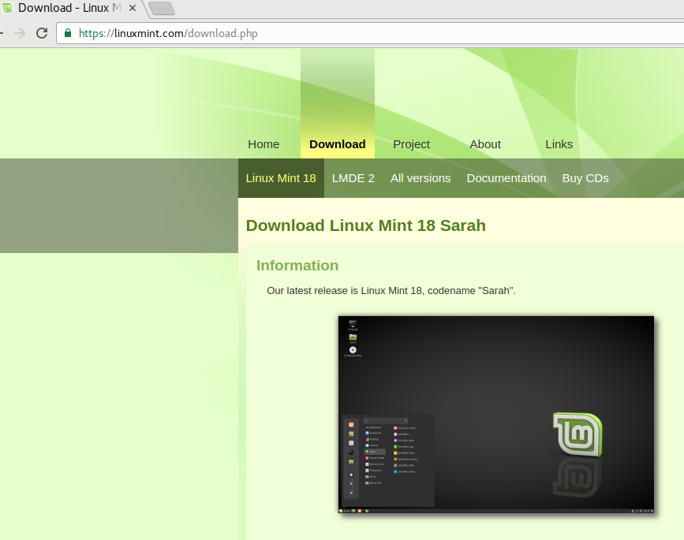

Note: there is a couple of things going on here.

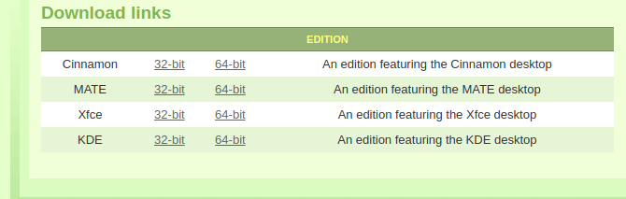

What the heck is 32bit? 64bit? These are processor architecture extensions, two of the most common types to be exact, you may also see them in the future as 32bit (i386,i686) 64bit (amd64, x86_64). For more information please read (https://en.wikipedia.org/wiki/X86-64)

Directly from your friends over at microsoft,

*“The terms* ***32-bit*** *and 64-bit refer to the way a computer's processor (also called a CPU), handles information. The 64-bit version of Windows handles large amounts of random access memory (RAM) more effectively than a* ***32-bit*** *system.”*

I’m assuming you have at least a 32 bit processor, about 90% of the worlds computers handle these instruction sets, since 64 bit is backwards compatible. So for the sake of this guide, downloading a 32 bit iso (an iso an image of ) is okay.

Next thing that is going on is, Which desktop should I choose? I am assuming you come from a windows background, so we are going to go ahead and download cinnamon, since it reminds me the windows GUI.

**click the cinnamon 32bit download link and choose a link that is in the USA.**

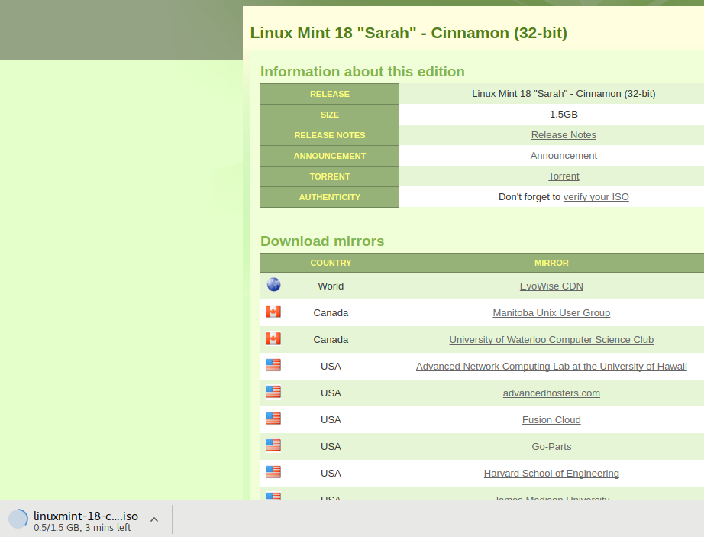

Now while that's downloading, we want to download a pretty awesome piece of software called virtualBox. What virtualbox does is, it emulates a virtual Operating system onto your existing operating system! It's basically having a system inside your system while you system!. Don't worry this will make sense in a bit.

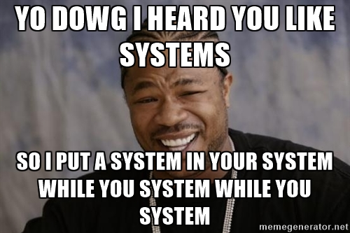

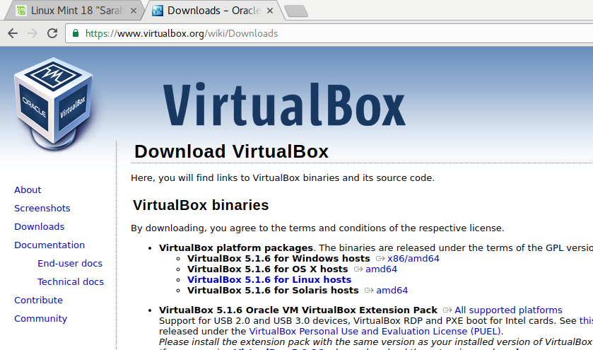Lets focus here for a bit, for windows, download the windows host, Mac users download the OSX host. And if you are using linux or solaris, i'm going to assume you know what you are doing. Note: here is that 32bit/64bit stuff again, but this time showing their extensions. So download this and install it and proceed to the next part.

Once you have downloaded and installed virtualbox, run the program and you should have a window very similar to this. In my case, I already have a couple of virtual machines, so don't worry if you don't have these installed. We are going to add a new machine right now, from the Linux Mint ISO we downloaded.

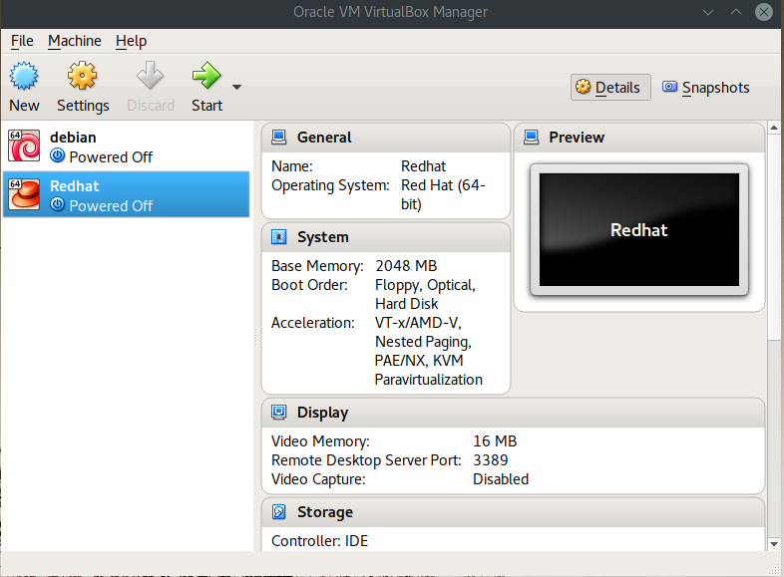

So click new, name the machine, in my case I named it Linux Mint. Notice that for the *Version:* type, virtualbox will notice it as “Ubuntu”, that's okay. Linux Mint is based off of Ubuntu.

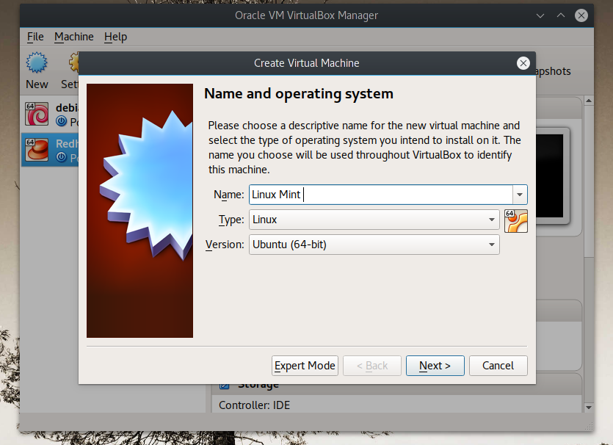

Now this step is very important, Virtualbox is prompting you to select how much Memory you want your virtualbox machine to have aside from the memory that your computer is already using up. In my case I am running an Arch Linux machine that uses a total of 1.5 GB out of 6 GB of ram. So this makes me want to use at least 2GB of ram aside from my 1.5GB. Once I install and run this machine my memory will be up to almost 4G of ram.

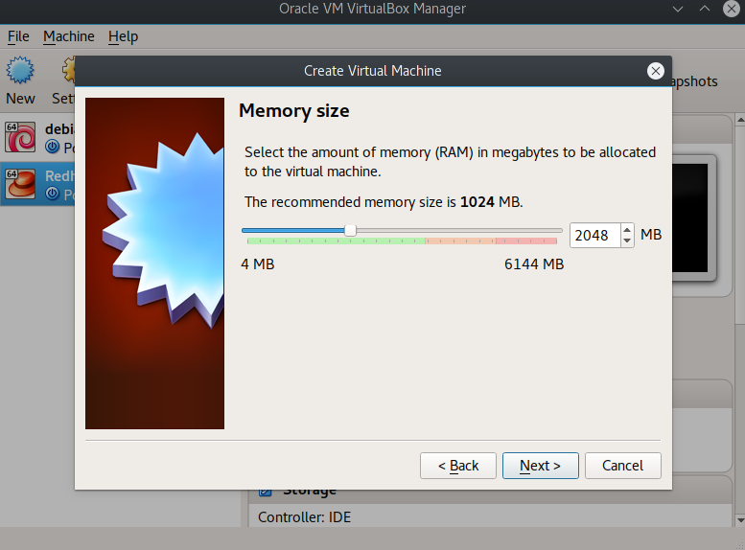

Now for the next step, *Hard Drive* Space let's go ahead and select 30 GB. For this type of learning environment, 30GB should be plenty of space.

Select:

* “Create a Virtual Hard disk now” and click *Create*
* “ VDI( VirtualBox Disk Image) “ and click *Next*
* “Dynamically allocated” and click *next*
* “ File Location and Size” leave as *Linux Mint”* as this is the name of our VM and set the *virtual hard disk*  to 30GB. And click *Create*

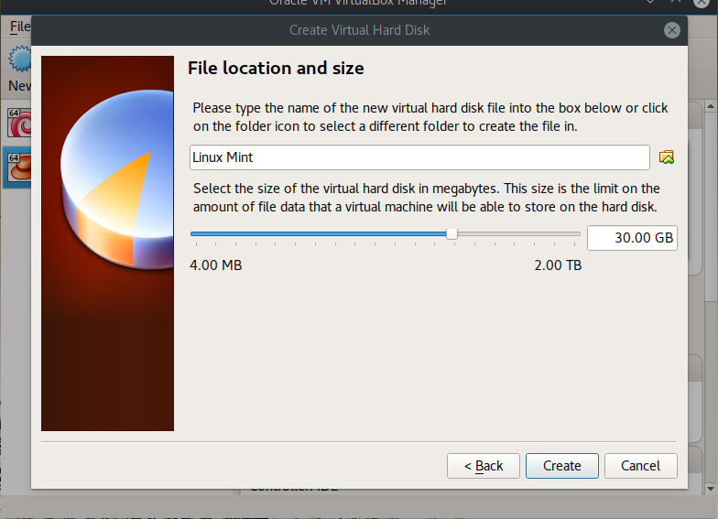

Now you should have a window like this. Click on the Linux Mint option if it not already highlighted and click start.

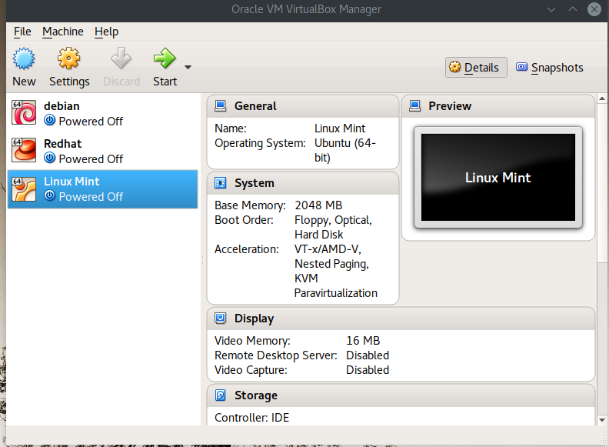

Now this next step is also very important. As soon as you click start, VirtualBox will ask you to select the *start-up*  disk. What it's really asking for is an image to an operating system. In our case VirtualBox wants to know where it's going to be installing Linux Mint from. So let's navigate to the ISO we downloaded earlier. In my case, I placed the Iso into my Documents folder. Click the little folder with an arrow icon to navigate to the Linux Mint ISO.

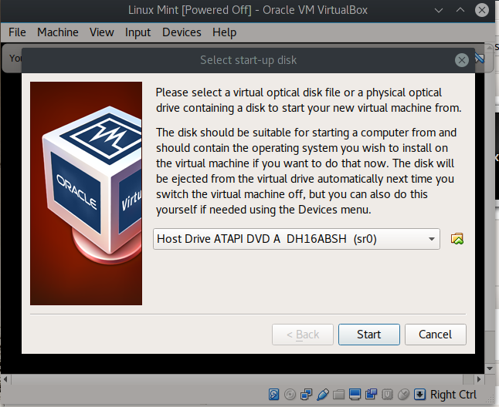

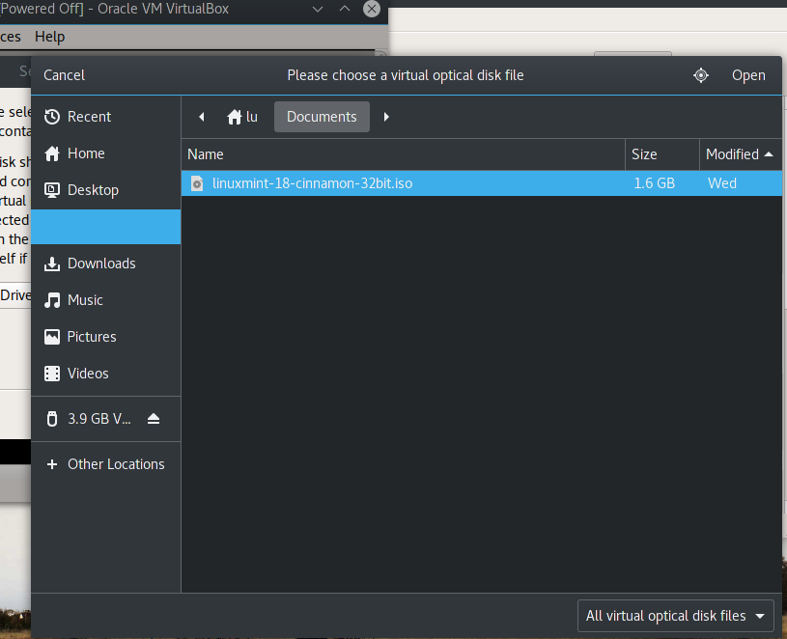

Once you have found your image click *open*  and then *start.*

Now Linux Mint will do a whole bunch of awesome Linux Stuff in the background and boot directly to the *Cinnamon Desktop!*

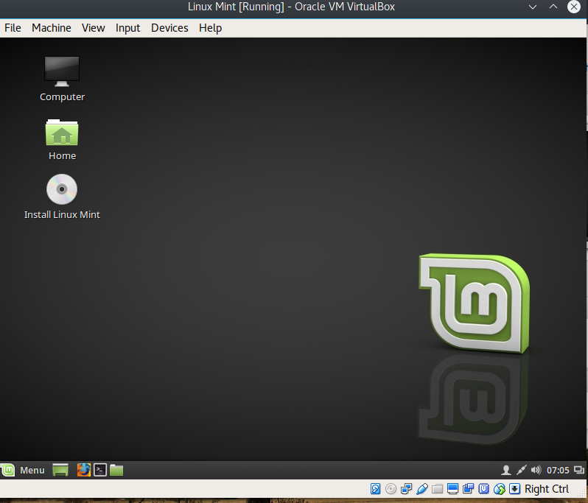

Now remember we have simply booted an installation media as if we were trying to install Linux Mint on actual hardware. The next step is to actually Install the OS. So click the CD/DVD/BLU RAY icon and lets install Linux Mint!

For the Installer(by window title):

* **Welcome:** select your preferred language
* **Preparing to Instal Linux Mint**: “*Third Party Software*” In Linux basically means software that is not free. Like *Adobe Flash, MP3 Codecs, Proprietary device drivers, such as HP printer drivers etc..* It may or may not be necessary for a user to install these *packages* to have an “out of the box” experience, meaning everything on your system will work, *device drivers, Network, netflix, Video/Audio playback*. Keep in mind that Linux Mint is designed to have an “out of the box experience since it focuses on users replacing their windows machine with Linux. Some Linux Distributions require the user to have all of these *Third Party Packages*  to be installed manually. So for this install just go ahead and click the box and click continue.
* For more information on why I personally choose not to install these third party packages and why im such a Windows hater, read the following link about the dangers of third party software https://www.gnu.org/philosophy/third-party-ideas.html

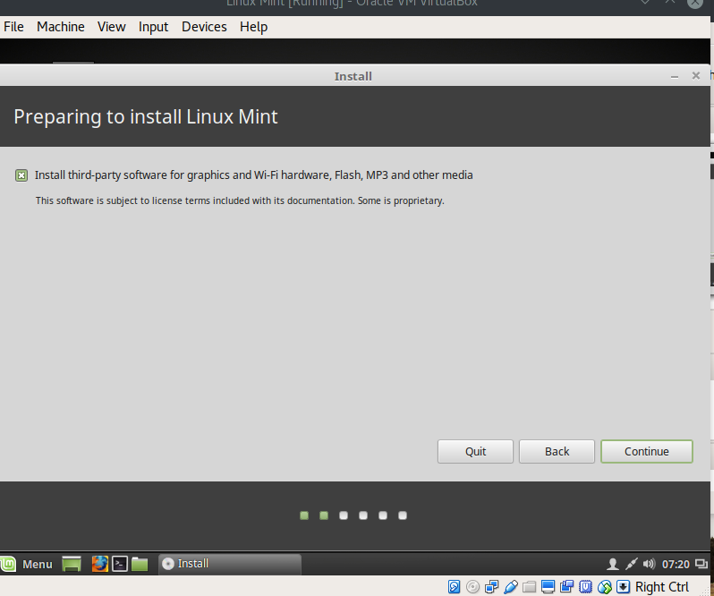

* **Installation Type:** *“This computer currently has not detected operating systems. What would you like to do?”* . The nice things about beginning Linux distros, is that the user hardly ever has to create his or her own *partitions. Partitioning* a disk is basically dividing the whole disk into sections so that different sections of the disk can perform different task. Take for instance the following example **Figure 1.2**

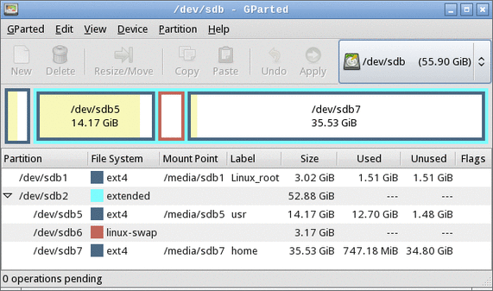

**Figure 1.2 (Gparted or Gnome Parted)** *is the default graphical partitioning tool for the Gnome desktop.*

* In **Figure 1.2** , this user has various partitions that perform different functions. For instance the *linux-swap* partition is in charge of managing memory once the RAM in the computer is full. The *swap space* will act as a different source for memory. It basically acts like RAM, once the computer's memory is full, this is ideal for computers with lower memory. DO NOT EXPECT SWAP TO BE A SUBSTITUTE FOR RAM. Don't expect to have 256MB of ram and try to install a distro that requires at least 1GB, the system will not boot. *Ext4* is the standard filesystem for Linux, think of it as FAT32 for windows XP or NTFS for Windows 7+.
* The *Extended* partitionis special. Usually when a user has a traditional partition scheme, a user is only allowed up to FOUR *primary* partitions, in this case the user has Seven, Three being *Primary*, One Being *extended* and Three being *Logical*. Extended allows a user to create 1 Partition that can contain an infinite amount of *Logical* partitions. For more information about partitions read <http://www.howtogeek.com/184659/beginner-geek-hard-disk-partitions-explained/>

In Our case we are not partition manually so just go ahead and click***Erase disk and install Linux Mint****.* I'll show you how to partition manually later on in this document.

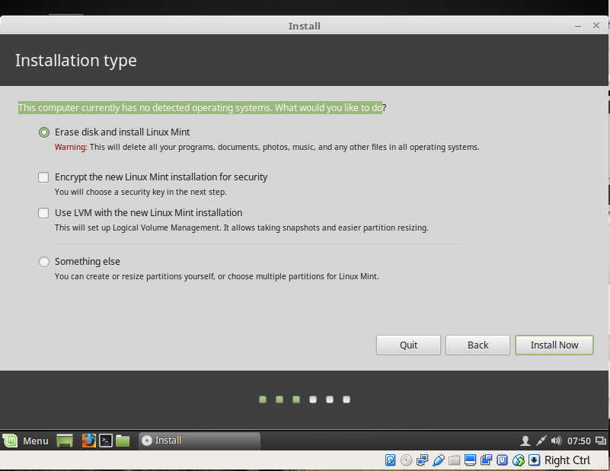

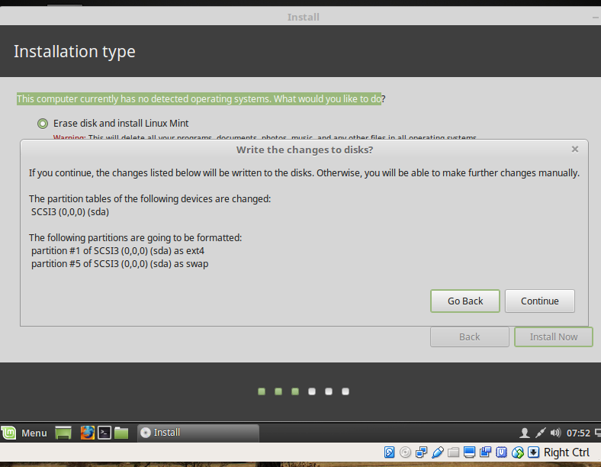

* The Linux Mint installer is going to create a couple of partitions for us. The ext4 partition that will hold all of our programs and system via “root /”. Note the root partitions is always mounted as “ / “. and a swap partition will also be created.
* Now that's all the technical stuff for now. Finish the installer and proceed to the next step

Choose the closest city to you.

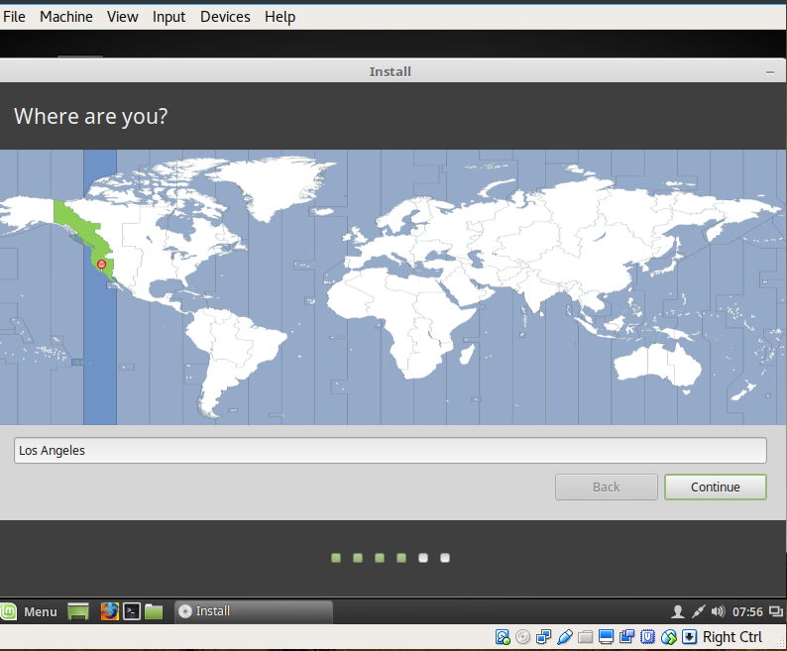

Select your prefered keyboard. In my case i'm using US

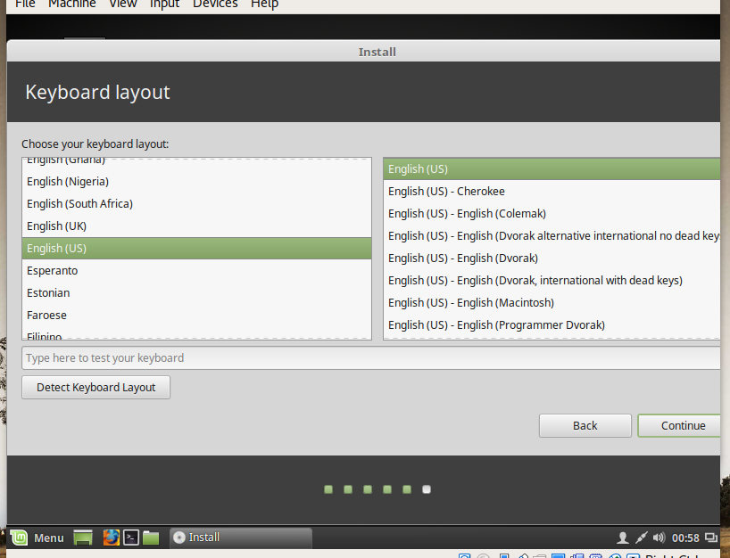

Fill out some credential stuff. (this will be your main user)

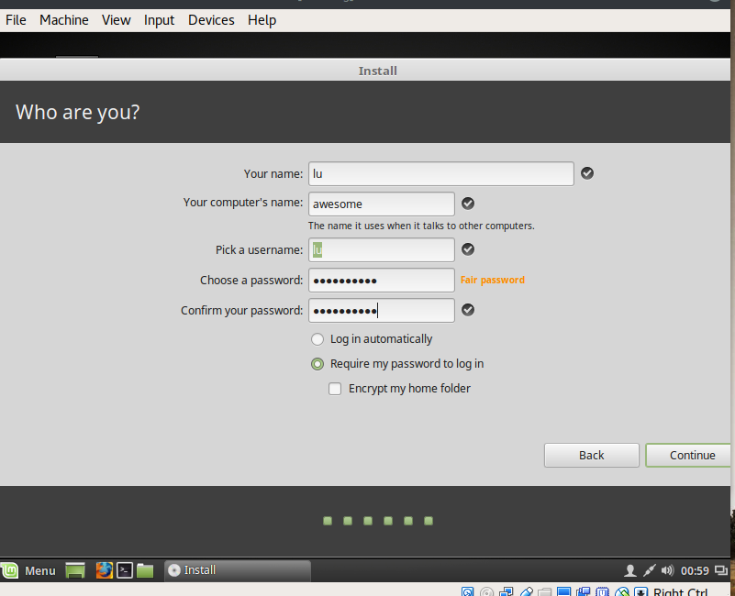

Now wait for installer to finish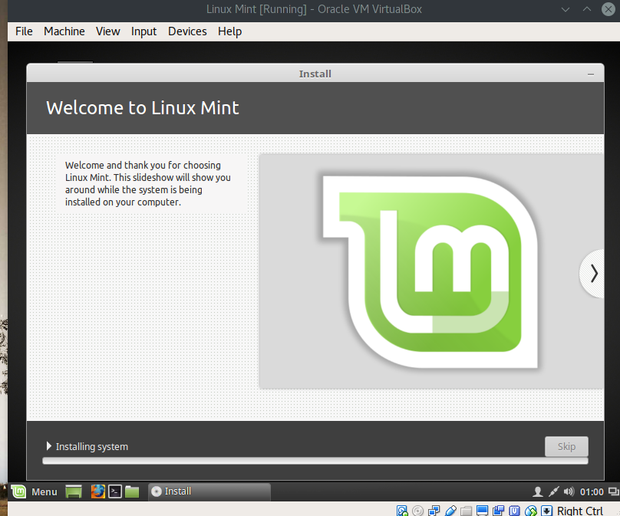

Once the installer finishes, reboot the virtual machine and power it on. Once powered on log in the with user you created earlier.

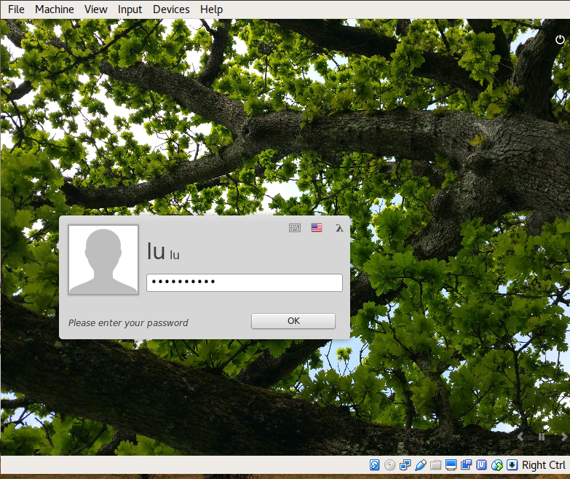

Now that's it for this chapter. We went over a lot of material. Mess around with Linux Mint for a bit and see how different Linux can be. The next chapter I will dive into the Linux Terminal .