哈尔滨工业大学计算机科学与技术学院
实验报告

课程名称：数据结构与算法
课程类型：必修
实验项目：实验二
实验题目：树型结构及应用
实验日期：11月6日

班级：1903008
学号：1190200708
姓名：熊峰

设计成绩 | 报告成绩 | 指导老师
 |  | 翟德明

一、实验目的
1. 练习二叉树的操作：
（1）对树的初始化，递归输入与非递归输入。
（2）对树的先序递归遍历与先序非递归遍历。
（3）对树的中序递归遍历与中序非递归遍历。
（4）对树的后序递归遍历与后序非递归遍历。
（5）利用队列层序遍历。
（6）利用两个栈模拟队列层序遍历。
（7）递归求树的结点个数。
（8）递归求树的高度。
（9）递归删除二叉树。
（10）递归交换二叉树所有结点。
（11）非递归复制二叉树。
（12）判断是否完全二叉树。
（13）求公共父节点
2.练习队列的操作，并利用两个栈模拟队列的入队及出队的操作。
二、实验要求及实验环境
实验要求：
先序输入二叉树，或利用数组输入。
例：
递归输入1：
ab##cd##ef###
AB##DFK##I##CEH##J##G##
ABD##FK##I##CEH##J##G##
abdh##i##ej###cf##g##
非递归输入2：
1 A 2 B 3 C 4 D 5 E 6 F 7 G 8 H 9 I 13 J 0 0
实验环境：
Visual Studio 2019
三、设计思想（本程序中的用到的所有数据抽象数据性ADT的定义，主程序的流程图及各程序模块之间的调用关系）
1. 所用的抽象数据性ADT的定义
1）逻辑结构
树型结构-二叉树、栈、队列。
struct node
{
ELEmentType data;
struct node* Lchild;
struct node* Rchild;
};
struct queue
{
TREE data[MAX_SIZE];
int front;
int rear;
};
struct stack
{
TREE data;
struct stack* next;
};
2) 存储结构
二叉树、栈、队列。
2. 主程序流程图及各程序模块之间的调用关系
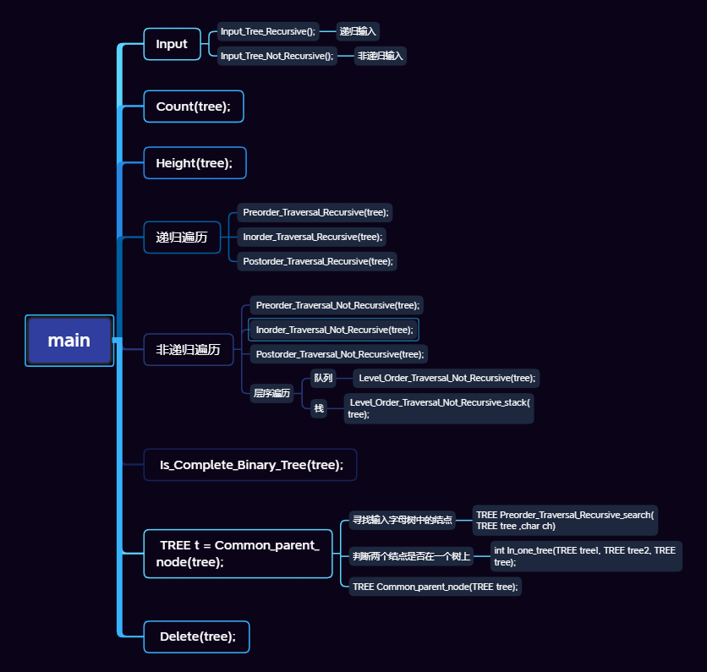
由于原算法复杂度较高，对求公共父节点优化：
//优化思路，先递归找到公共父节点
//如果节点等于node1或node2，则返回该节点的值给父节点
//如果节点的左右子树分别包括node1和node2节点,则为所求结点
//找到父节点后，再递归寻找其所有父节点

四、测试结果（要求程序运行截图）
测试用例与测试结果
- 测试用例:ab##cd##ef### b e
输入的树的结构如下
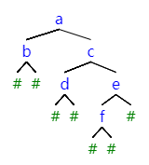
测试结果如下:
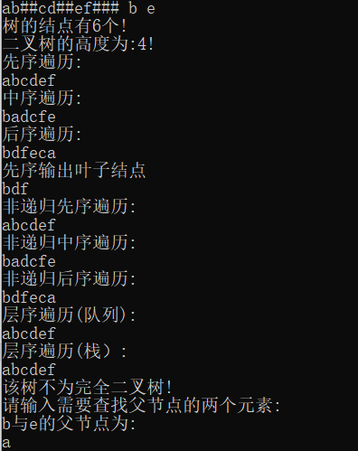
- 测试用例:AB##DFK##I##CEH##J##G## J G
输入的树的结构如下
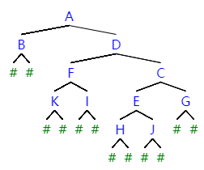
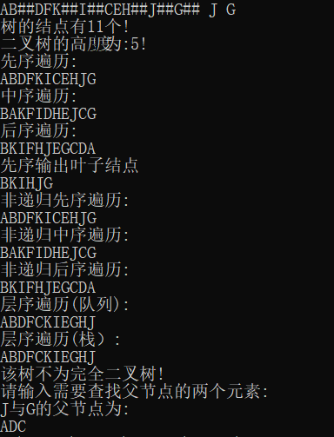
- 测试用例:1 A 2 B 3 C 4 D 5 E 6 F 7 G 8 H 9 I 13 J 0 0 H I
输入的树的结构如下
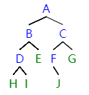
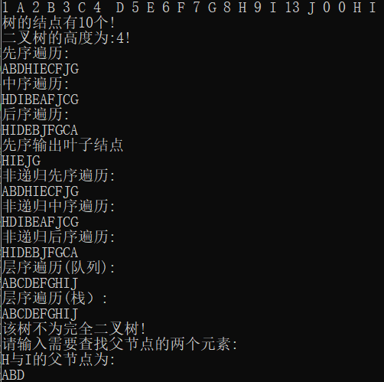
- 测试用例:ABDH##I##EJ###CF##G## D I
输入的树的结构如下
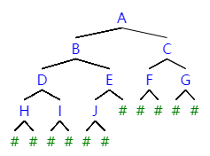
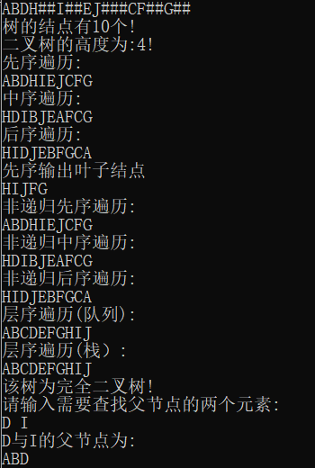
五、经验体会与不足
经验体会：
- 加强对树的操作。
- 加强对递归的理解。
- 熟悉栈的使用。
- 用栈模拟队列。
不足：
- 没有输入检查，程序健壮性不足。
- 输入提示较少。
六、附录：源代码（带注释）
main.cpp
- #include"Tree.h"

- int main()
- {
- TREE tree;
- //递归输入
- tree = Input_Tree_Recursive();

- //交换二叉树所有结点
- //Exchange(tree);
- //Level_Order_Traversal_Not_Recursive(tree);

- //非递归输入
- //tree = Input_Tree_Not_Recursive();

- //结点数和二叉树的高度
- cout << "树的结点有" << Count(tree) << "个!" << endl;
- cout << "二叉树的高度为:" << Height(tree) << "!" << endl;

- //递归遍历

- //先序遍历
- cout << "先序遍历:" << endl;
- Preorder_Traversal_Recursive(tree);
- cout << endl;
- //中序遍历
- cout << "中序遍历:" << endl;
- Inorder_Traversal_Recursive(tree);
- cout << endl;
- //后序遍历
- cout << "后序遍历:" << endl;
- Postorder_Traversal_Recursive(tree);
- cout << endl;
- //先序叶子
- cout << "先序输出叶子结点" << endl;
- Preorder_Traversal_Recursive_leaf(tree);
- cout << endl;
- //非递归遍历

- //先序遍历
- //先序
- Preorder_Traversal_Not_Recursive(tree);
- //中序
- Inorder_Traversal_Not_Recursive(tree);
- //后序
- Postorder_Traversal_Not_Recursive(tree);

- //层序遍历
- Level_Order_Traversal_Not_Recursive(tree);
- //层序遍历_栈模拟队列
- Level_Order_Traversal_Not_Recursive_stack(tree);

- //树的复制
- //TREE tree_copy = Copy_Tree(tree);
- //Preorder_Traversal_Recursive(tree_copy);

- //判断是否是完全二叉树
- Is_Complete_Binary_Tree(tree);

- //求公共父节点
- //TREE t = Common_parent_node(tree);
- //if (t)
- // cout << t->data;

- TREE t = Common_parent_optimize(tree);
- int k = Search_node(tree, t);
- cout << t->data;
- //二叉树的删除
- Delete(tree);

- return 0;
- }

Stack.h
- #pragma once
- #ifndef STACK_H
- #define STACK_H
- #include"Tree.h"

- struct stack
- {
- TREE data;
- struct stack* next;
- };

- typedef struct stack* STACK;

- STACK Init_Stack()
- {
- STACK s1 = new stack;
- s1->data = nullptr;
- s1->next = nullptr;
- return s1;
- }

- STACK Push_Stack(STACK s, TREE m)
- {
- STACK s1;
- s1 = new stack;
- s1->data = m;
- s1->next = s->next;
- s->next = s1;
- return s;
- }
- TREE Pop_Stack(STACK s)
- {

- if (s->next != nullptr)
- {
- TREE m;
- STACK s1;
- s1 = s->next;
- s->next = s->next->next;
- m = s1->data;
- delete s1;
- return m;
- }
- }
- bool Is_empty(STACK s)
- {
- if (s->next == nullptr)
- return true;
- else
- return false;
- }
- TREE Top_Stack(STACK s)
- {
- if (s->next)
- return s->next->data;
- }

- #endif
Queue.h
- #pragma once
- #ifndef QUEUE_H
- #define QUEUE_H
- #include"Tree.h"
- const int MAX_SIZE = 20;

- struct queue
- {
- TREE data[MAX_SIZE];
- int front;
- int rear;
- };
- queue Init_Queue()
- {
- queue q;
- q.front = MAX_SIZE - 1;
- q.rear = MAX_SIZE - 1;
- return q;

- }
- bool Empty(queue q)
- {
- if (q.rear == q.front)
- return true;
- else
- return false;
- }
- TREE Front(queue q)
- {
- if (Empty(q)) return nullptr;
- else {
- return (q.data[(q.front + 1) % MAX_SIZE]);
- }
- }
- queue EnQueue(TREE t, queue q)
- {
- if ((q.rear + 1) % MAX_SIZE == q.front)
- cout << "队列满";
- else
- {
- q.rear = (q.rear + 1) % MAX_SIZE;
- q.data[q.rear] = t;
- }
- return q;
- }
- queue DeQueue(queue q)
- {
- if (Empty(q))
- cout << "空队列" << endl;
- else
- q.front = (q.front + 1) % MAX_SIZE;
- return q;
- }

- #endif
Create_tree.cpp
- #include"Tree.h"

- //用递归对树输入
- TREE Input_Tree_Recursive()
- {
- TREE t;
- char ch;
- cin >> ch;
- if (ch == '#')
- t = nullptr;
- else
- {
- t = new node;
- t->data = ch;
- t->Lchild = Input_Tree_Recursive();
- t->Rchild = Input_Tree_Recursive();
- }
- return t;
- }
- //非递归输入
- TREE Input_Tree_Not_Recursive()
- {
- const int max = 50;
- TREE t, bt = nullptr;
- TREE s[max] = { nullptr };
- int i, j;
- ELEmentType ch;
- cin >> i >> ch;
- while (i != 0 && ch != 0)
- {
- t = new node;
- t->data = ch;
- t->Lchild = nullptr;
- t->Rchild = nullptr;
- if (i == 1)
- {
- bt = t;
- s[i] = t;
- }
- else
- {
- s[i] = t;
- j = i / 2;
- if (i % 2 == 0)
- s[j]->Lchild = t;
- else
- s[j]->Rchild = t;
- }
- cin >> i >> ch;
- }
- return bt;
- }

- //计算树的结点个数
- int Count(TREE tree)
- {
- if (tree == nullptr)
- return 0;
- else
- return 1 + Count(tree->Lchild) + Count(tree->Rchild);

- }

- //计算二叉树高度的递归算法
- int Height(TREE tree)
- {
- if (tree == nullptr)
- return 0;
- else
- {
- int m = Height(tree->Lchild);
- int n = Height(tree->Rchild);
- return (m > n) ? (m + 1) : (n + 1);
- }
- }

- //删除二叉树的递归算法
- void Delete(TREE tree)
- {
- if (tree)
- {
- Delete(tree->Lchild);
- Delete(tree->Rchild);
- delete tree;
- }
- }
Tree.h
- #pragma once
- #ifndef TREE_H
- #define TREE_H
- #include<iostream>

- using namespace std;

- typedef char ELEmentType;
- struct node
- {
- ELEmentType data;
- struct node* Lchild;
- struct node* Rchild;
- };

- typedef struct node* TREE;

- //对树输入 递归与非递归
- //递归输入树
- TREE Input_Tree_Recursive();
- //非递归输入
- TREE Input_Tree_Not_Recursive();

- //计算树的结点个数
- int Count(TREE tree);
- //求二叉树的高度
- int Height(TREE tree);
- //删除二叉树的递归算法
- void Delete(TREE tree);

- //遍历算法 递归
- //先序
- void Preorder_Traversal_Recursive(TREE tree);
- //中序
- void Inorder_Traversal_Recursive(TREE tree);
- //后序
- void Postorder_Traversal_Recursive(TREE tree);
- //先序输出叶子
- void Preorder_Traversal_Recursive_leaf(TREE tree);
- //非递归
- //先序
- void Preorder_Traversal_Not_Recursive(TREE tree);
- //中序
- void Inorder_Traversal_Not_Recursive(TREE tree);
- //后序
- void Postorder_Traversal_Not_Recursive(TREE tree);
- //层序
- void Level_Order_Traversal_Not_Recursive(TREE tree);
- //层序_用栈模拟队列
- void Level_Order_Traversal_Not_Recursive_stack(TREE tree);

- //交换二叉树所有结点子树
- void Exchange(TREE tree);
- //复制树
- TREE Copy_Tree(TREE tree);

- //判断是否是完全二叉树
- void Is_Complete_Binary_Tree(TREE tree);

- //求公共父节点
- TREE Preorder_Traversal_Recursive_search(TREE tree, char ch);
- int Preorder_Traversal_Recursive_search_1(TREE tree, TREE tree1);
- int In_one_tree(TREE tree1, TREE tree2, TREE tree);
- TREE Common_parent_node(TREE tree);

- //优化后的算法
- //优化思路，先递归找到公共父节点
- //如果节点等于node1或node2，则返回该节点的值给父节点
- //当前节点的左右子树分别包括node1和node2节点,则为所求结点
- //找到父节点后，再寻找其所有父节点

- //求公共结点
- TREE Common_parent(TREE tree, TREE node1, TREE node2);
- int Search_node(TREE tree, TREE t);
- //输入两个结点
- //并判断结点是否在树中
- //若在树中
- //利用TREE Common_parent(TREE root, TREE p, TREE q);求公共结点
- TREE Common_parent_optimize(TREE root);
- void Common_all(TREE tree,TREE t);

- #endif

Traversal.cpp
- #include"Stack.h"
- #include"Queue.h"
- #include"Tree.h"
- //遍历
- //递归
- //先序
- void Preorder_Traversal_Recursive(TREE tree)
- {
- if (tree)
- {
- cout << tree->data;
- Preorder_Traversal_Recursive(tree->Lchild);
- Preorder_Traversal_Recursive(tree->Rchild);
- }
- }
- //中序
- void Inorder_Traversal_Recursive(TREE tree)
- {
- if (tree)
- {
- Inorder_Traversal_Recursive(tree->Lchild);
- cout << tree->data;
- Inorder_Traversal_Recursive(tree->Rchild);
- }
- }
- //后序
- void Postorder_Traversal_Recursive(TREE tree)
- {
- if (tree)
- {
- Postorder_Traversal_Recursive(tree->Lchild);
- Postorder_Traversal_Recursive(tree->Rchild);
- cout << tree->data;
- }
- }
- //先序打印叶子结点
- void Preorder_Traversal_Recursive_leaf(TREE tree)
- {
- if (tree)
- {
- if (!tree->Lchild && !tree->Rchild)
- cout << tree->data;

- Preorder_Traversal_Recursive_leaf(tree->Lchild);
- Preorder_Traversal_Recursive_leaf(tree->Rchild);
- }
- }

- //非递归
- //先序
- void Preorder_Traversal_Not_Recursive(TREE tree)
- {
- cout << "非递归先序遍历:" << endl;
- STACK s = Init_Stack();
- TREE t = tree;
- while (t != nullptr || !Is_empty(s))
- {
- while (t != nullptr)
- {
- cout << t->data;
- Push_Stack(s, t);
- t = t->Lchild;
- }
- if (!Is_empty(s))
- {
- t = Pop_Stack(s);
- t = t->Rchild;
- }
- }
- cout << endl;

- }
- //中序
- void Inorder_Traversal_Not_Recursive(TREE tree)
- {
- cout << "非递归中序遍历:" << endl;
- STACK s = Init_Stack();
- TREE t = tree;
- while (t != nullptr || !Is_empty(s))
- {
- while (t != nullptr)
- {

- Push_Stack(s, t);
- t = t->Lchild;
- }
- if (!Is_empty(s))
- {
- t = Pop_Stack(s);
- cout << t->data;
- t = t->Rchild;
- }
- }
- cout << endl;
- }
- //后序
- //对先序的改造
- //从根左右改造称根右左
- //在压入栈中
- //在输出时的顺序就变为了左右根
- //输出结果为后序遍历
- void Postorder_Traversal_Not_Recursive(TREE tree)
- {
- cout << "非递归后序遍历:" << endl;
- STACK s = Init_Stack();
- TREE t = tree;
- STACK s1 = Init_Stack();
- while (t != nullptr || !Is_empty(s))
- {
- while (t != nullptr)
- {
- Push_Stack(s1, t);
- Push_Stack(s, t);
- t = t->Rchild;
- }
- if (!Is_empty(s))
- {
- t = Pop_Stack(s);
- t = t->Lchild;
- }
- }
- while (Is_empty(s1) == false)
- {
- cout << Pop_Stack(s1)->data;
- }
- cout << endl;
- }
- //层序
- void Level_Order_Traversal_Not_Recursive(TREE tree)
- {
- if (tree == nullptr)
- cout << "树是空!" << endl;
- else
- {
- cout << "层序遍历(队列):" << endl;
- queue q = Init_Queue();
- TREE t = tree;
- q = EnQueue(t, q);
- while (!Empty(q))
- {
- t = Front(q);
- cout << t->data;
- q = DeQueue(q);

- if (t->Lchild != nullptr)
- q = EnQueue(t->Lchild, q);
- if (t->Rchild != nullptr)
- q = EnQueue(t->Rchild, q);
- }
- }
- cout << endl;
- }
- //调用栈的层序遍历
- void Level_Order_Traversal_Not_Recursive_stack(TREE tree)
- {
- if (!tree)
- cout << "树为空!";
- else
- {
- cout << "层序遍历(栈）:" << endl;
- STACK s1 = Init_Stack();
- STACK s2 = Init_Stack();
- TREE t = tree;
- s1 = Push_Stack(s1, t);
- while (!Is_empty(s1))
- {
- t = Pop_Stack(s1);
- cout << t->data;

- if (t->Lchild != nullptr)
- {
- while (!Is_empty(s1))
- {
- s2 = Push_Stack(s2, Pop_Stack(s1));
- }
- s1 = Push_Stack(s1, t->Lchild);
- while (!Is_empty(s2))
- {
- s1 = Push_Stack(s1, Pop_Stack(s2));
- }
- }
- if (t->Rchild != nullptr)
- {
- while (!Is_empty(s1))
- {
- s2 = Push_Stack(s2, Pop_Stack(s1));
- }
- s1 = Push_Stack(s1, t->Rchild);
- while (!Is_empty(s2))
- {
- s1 = Push_Stack(s1, Pop_Stack(s2));
- }
- }
- }
- }
- cout << endl;
- }

- void Exchange(TREE tree)
- {
- TREE p = tree;
- TREE temp;

- if (p != nullptr)
- {
- temp = p->Lchild;
- p->Lchild = p->Rchild;
- p->Rchild = temp;
- Exchange(p->Lchild);
- Exchange(p->Rchild);
- }
- }

- TREE Copy_Tree(TREE tree)
- {
- TREE t_copy = nullptr;
- TREE t_copy1 = nullptr;
- if (tree)
- {
- TREE t1[MAX_SIZE];
- int flag = 0;
- int flag1 = 0;
- STACK s = Init_Stack();
- STACK s1 = Init_Stack();
- TREE t = tree;
- while (t != nullptr || !Is_empty(s))
- {
- while (t != nullptr)
- {
- Push_Stack(s, t);
- if (t_copy == nullptr && !flag)
- {
- t_copy = new node;
- flag = 1;
- t_copy1 = t_copy;
- Push_Stack(s1, t_copy);
- }
- else
- {
- if (flag1 == 0)
- {
- t_copy->Lchild = new node;
- Push_Stack(s1, t_copy->Lchild);
- t_copy = t_copy->Lchild;
- }
- else
- {
- Push_Stack(s1, t_copy);
- flag1 = 0;
- }
- }
- t_copy->data = t->data;
- t_copy->Lchild = nullptr;
- t_copy->Rchild = nullptr;
- t = t->Lchild;
- }
- if (!Is_empty(s))
- {
- t = Pop_Stack(s);
- t_copy = Pop_Stack(s1);
- if (t->Rchild != nullptr)
- {
- t_copy->Rchild = new node;
- t_copy->Rchild->data = t->Rchild->data;
- t_copy->Rchild->Lchild = nullptr;
- t_copy->Rchild->Rchild = nullptr;
- t_copy = t_copy->Rchild;
- flag1 = 1;
- }
- t = t->Rchild;
- }
- }
- }
- return t_copy1;
- }

- //判断是否是完全二叉树
- //思路
- //若队列中front的元素的左右节点都为空 或 左不空 右空
- //此时继续front队列元素，若有节点的左右节点不为空 则不为完全二叉树
- //若队列中front出的元素左右节点不为空
- //则继续front
- //若左空右不空，则必不为二叉树
- void Is_Complete_Binary_Tree(TREE tree)
- {
- int flag = 0;
- int flag1 = 0;
- if (tree == nullptr)
- flag = 1;
- else
- {
- queue q = Init_Queue();
- TREE t = tree;
- q = EnQueue(t, q);
- while (!Empty(q))
- {
- t = Front(q);
- if (t->Lchild != nullptr || t->Rchild != nullptr)
- {
- if (flag1 == 1)
- {
- flag = 1;
- break;
- }
- if (t->Lchild != nullptr && t->Rchild != nullptr)
- {
- q = DeQueue(q);
- q = EnQueue(t->Lchild, q);
- q = EnQueue(t->Rchild, q);
- }
- else if (t->Lchild == nullptr && t->Rchild != nullptr)
- {
- flag = 1;
- break;
- }
- else if (t->Lchild != nullptr && t->Rchild == nullptr)
- {
- q = DeQueue(q);
- flag1 = 1;
- }
- }
- else
- {
- q = DeQueue(q);
- flag1 = 1;
- }
- }

- }
- if (flag)
- cout << "该树不为完全二叉树!" << endl;
- else
- cout << "该树为完全二叉树!" << endl;
- }

- //寻找公共双亲节点
- //加入对输入结点是否存在的判断
- //思路：
- //判断两个结点是否在同一棵左子树或右子树
- //（1）若不同在左子树且不同在右子树
- //则此时父节点为根节点
- //return tree
- //（2）若同时在左节点(右节点)
- //则令t=t->Lchild(t=t->Rchild)
- //在次判断是否
- //在同一左子树或右子树
- //到(1)中的返回条件

- TREE Preorder_Traversal_Recursive_search(TREE tree, char ch)
- {
- STACK s = Init_Stack();
- TREE t = tree;
- while (t != nullptr || !Is_empty(s))
- {
- while (t != nullptr)
- {
- if (t->data == ch)
- return t;
- Push_Stack(s, t);
- t = t->Lchild;
- }
- if (!Is_empty(s))
- {
- t = Pop_Stack(s);
- t = t->Rchild;
- }
- }
- return nullptr;
- }

- int Preorder_Traversal_Recursive_search_1(TREE tree, TREE tree1)
- {

- STACK s = Init_Stack();
- TREE t = tree;
- while (t != nullptr || !Is_empty(s))
- {
- while (t != nullptr)
- {
- if (t == tree1)
- return 1;
- Push_Stack(s, t);
- t = t->Lchild;
- }
- if (!Is_empty(s))
- {
- t = Pop_Stack(s);
- t = t->Rchild;
- }
- }
- return 0;
- }

- int In_one_tree(TREE tree1, TREE tree2, TREE tree)
- {
- if (Preorder_Traversal_Recursive_search_1(tree, tree1) == 1)
- {
- if (Preorder_Traversal_Recursive_search_1(tree, tree2) == 1)
- {
- return 1;
- }
- }

- else
- return 0;
- }

- TREE Common_parent_node(TREE tree)
- {

- if (tree == nullptr)
- cout << "该树为空!" << endl;
- else
- {
- TREE t = tree;
- char ch, ch1;
- cout << "请输入需要查找父节点的两个元素:" << endl;
- cin >> ch >> ch1;
- TREE node1, node2;
- node1 = Preorder_Traversal_Recursive_search(tree, ch);
- if (!node1)
- {
- cout << "该树中无" << ch << "元素!";
- return nullptr;
- }
- node2 = Preorder_Traversal_Recursive_search(tree, ch1);
- if (!node2)
- {
- cout << "该树中无" << ch1 << "元素!";
- return nullptr;
- }
- cout << ch << "与" << ch1 << "的父节点为:" << endl;
- while (t)
- {
- if (node1 == t || node2 == t)
- return t;

- if (t->Lchild != nullptr && t->Rchild != nullptr)
- {
- if (In_one_tree(node1, node2, t->Lchild) == 0 &&
- In_one_tree(node1, node2, t->Rchild) == 0)
- return t;

- else if (In_one_tree(node1, node2, t->Lchild) == 1)
- {
- cout << t->data;
- t = t->Lchild;
- }
- else if (In_one_tree(node1, node2, t->Rchild) == 1)
- {
- cout << t->data;
- t = t->Rchild;
- }
- }
- else if (t->Lchild != nullptr && t->Rchild == nullptr)
- {
- t = t->Lchild;
- }
- else if (t->Lchild == nullptr && t->Rchild != nullptr)
- {
- t = t->Rchild;
- }
- }

- return t;
- }
- }

- //以下为查找公共双亲结点的一些改进
- //算法复杂度较低的求公共双亲结点算法
- TREE Common_parent_optimize(TREE tree)
- {
- if (tree == nullptr)
- cout << "该树为空!" << endl;
- else
- {
- TREE t = tree;
- char ch, ch1;
- cout << "请输入需要查找父节点的两个元素:" << endl;
- cin >> ch >> ch1;
- TREE node1, node2;
- node1 = Preorder_Traversal_Recursive_search(tree, ch);
- if (!node1)
- {
- cout << "该树中无" << ch << "元素!";
- return nullptr;
- }

- node2 = Preorder_Traversal_Recursive_search(tree, ch1);
- if (!node2)
- {
- cout << "该树中无" << ch1 << "元素!";
- return nullptr;
- }
- TREE common;
- common = Common_parent(t, node1, node2);
- return common;
- }
- }

- int Search_node(TREE tree, TREE t)
- {
- if (!tree)
- return 0;
- if (tree == t)
- return 1;
- if (tree)
- if (Search_node(tree->Lchild, t) || Search_node(tree->Rchild, t))
- {
- cout << tree->data << " ";
- return 1;
- }
- return 0;
- }

- TREE Common_parent(TREE tree, TREE node1, TREE node2)
- {
- if (tree == nullptr)
- return nullptr;
- if (tree == node1 || tree == node2)
- return tree;
- TREE left = Common_parent(tree->Lchild, node1, node2);
- TREE right = Common_parent(tree->Rchild, node1, node2);
- if (left && right)
- return tree;
- else if (left && !right)
- return left;
- else if (!left && right)
- return right;
- else if (!left && !right)
- return nullptr;
- }

