These “ear savers” were design by a Boy Scout named Quinn Callander.

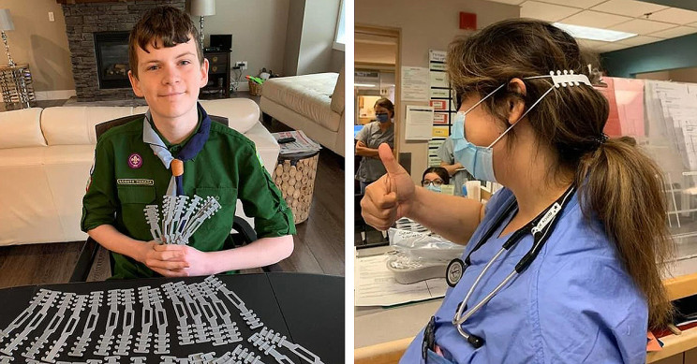
3D-printed and distributed by the members and friends of BARN, the Bainbridge Artisan Resource Network. Contact eta.lead@bainbridgebarn.org if you need more of them!

