FACE SHIELDS DROP-OFF

3DVerkstan
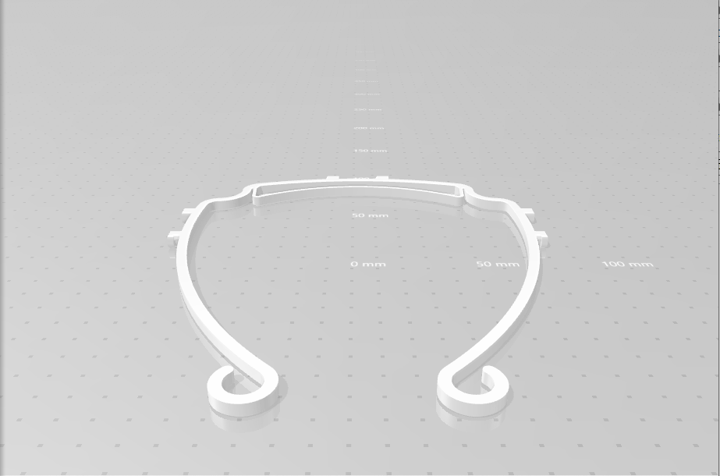
Label with quantity, material, and style. Handle wearing gloves and mask.
FACE SHIELDS DROP-OFF

Kitsap-modified Prusa
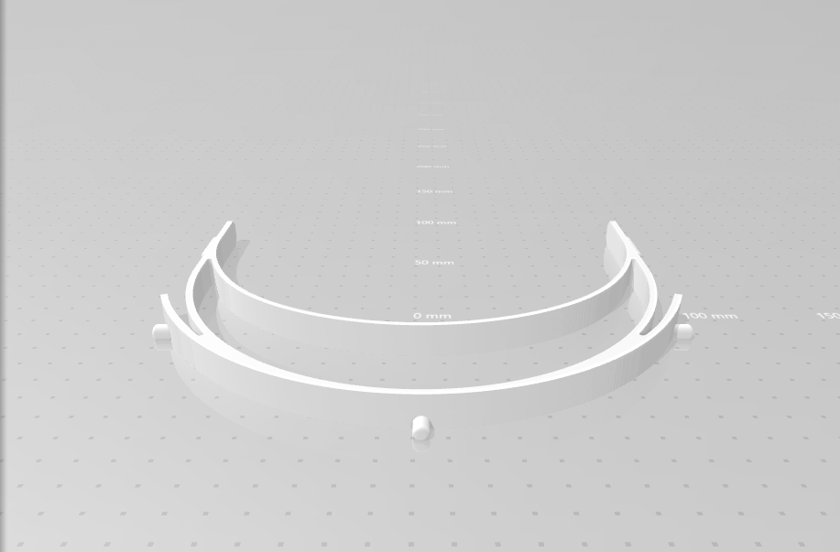
Label with quantity, material, and style. Handle wearing gloves and mask.

