LunarGrid
Distributed Spatial Analytics of the Lunar Surface
Bainty Kaur Chugh – 253316 · MSc Data Science and Geoinformatics
Digital University Kerala, Thiruvananthapuram
Course: Spatial Big Data Analytics · 12th November 2026

Abstract
The Moon's surface is covered in impact craters, and its poles may hide water ice inside craters that never see sunlight. Where craters are crowded, where the ground is steep, and where light and shadow fall are questions that matter both to planetary science and to choosing safe, useful landing sites. This project, called LunarGrid, puts these ingredients on one map and studies them together. It combines three independent crater catalogues (1.3 to 10.7 million craters each), a global laser-altimetry elevation model (118 m per pixel) and polar maps of sunlight and permanent shadow (240 m per pixel).
The data were aligned in a single spherical reference frame, linked through tile, pixel and grid-cell indices, and analysed with density maps, hotspot statistics (Getis-Ord Gi*), a strict permutation test, DBSCAN clustering, association rules and K-means. The heavy lifting used Apache Spark and Apache Sedona, which spread spatial work across many processor cores.
Main findings. The three catalogues agree on where craters are but not on how many. Crater density climbs steadily towards the north pole but not towards the south pole. A hotspot near 70°S, 155°W shows up in all three catalogues and survives the strictest test. Permanently shadowed ground holds fewer small craters but more large ones than sunlit ground at the same latitude. Spark and Sedona only beat a single computer above roughly 10 million records, so their value here is in scalability rather than speed on today's data.
Keywords: lunar craters; spatial big data; GIS; polar stereographic projection; hotspot analysis; Getis-Ord Gi*; permanent shadow; Apache Spark; Apache Sedona

1. Introduction

1.1 Why look at craters, slopes and shadows together?
Craters are the Moon's diary. Because they pile up over time, the more craters a patch of ground has, the older it generally is. Slope matters because a lander cannot safely touch down on steep ground. Shadow matters because the floors of some polar craters have not seen sunlight for billions of years, and spacecraft data suggest they may contain water ice, a resource for future missions.
Normally these three things are studied separately, with different data in different map systems. LunarGrid treats them as one spatial problem: each is a map layer, the layers must be lined up exactly, and the relationships between them must be measured with statistics that respect the curved geometry of a sphere.

1.2 What was missing
- One catalogue, one story. Many studies use a single crater catalogue, so it is unclear whether a pattern belongs to the Moon or to the catalogue.
- Layers that do not fit. Crater positions, elevation and illumination come in different coordinate systems and resolutions, and near the poles a flat map is badly distorted.
- Grid tricks at the poles. A grid of equal degrees covers very different ground areas at different latitudes, which can make hotspots look significant when they are not.
- Unknown scale threshold. It is not obvious how big a dataset must be before a distributed engine like Spark is worth using.

1.3 Research questions
The project asks: how do crater density, terrain steepness, and shadow or sunlight vary across the Moon, and where do they cluster, especially near the poles? This is split into five questions:
RQ | Question
RQ1 | Where are craters dense, and where do they form clusters or hotspots?
RQ2 | How do crater density and size relate to elevation and slope?
RQ3 | How do shadow and sunlight vary near the poles, and do craters in shadow differ from craters in light?
RQ4 | Do independent crater catalogues lead to the same conclusions?
RQ5 | At what data size does distributed processing outperform a single machine?

2. Study area and data
The study area is the whole Moon, with a closer look at the two polar caps poleward of 65° latitude. The Moon is treated as a sphere of radius 1,737.4 km. It has no sea level, so heights are measured from this reference sphere; negative values simply lie below it. Six data layers were used:
Layer | What it is | Size / resolution | Used for
Robbins catalogue | Long-standing reference, mapped from LRO imagery | 1,296,796 craters ≥ 1 km | Reference positions and sizes
LU5M812TGT | Automatic-detection catalogue (Zenodo) | 5,691,533 craters, mostly ≥ 0.4 km | Second opinion; small craters
LUC-GRAS200 | Deep-learning catalogue (CLPDS) | 10,699,651 craters, 0.2 to 2,050 km | Third opinion; secondary-crater labels
LOLA elevation | NASA laser-altimeter global height map | 118 m/pixel; about 4.2 billion pixels | Elevation and slope
LOLA polar illumination | Average sunlight and permanent shadow, each pole | 240 m/pixel; 6,420 × 6,420 per pole | Light and shadow
South-pole shadow map | Barker et al. (2023) | 20 m/pixel; south of 80°S | Fine shadow detail

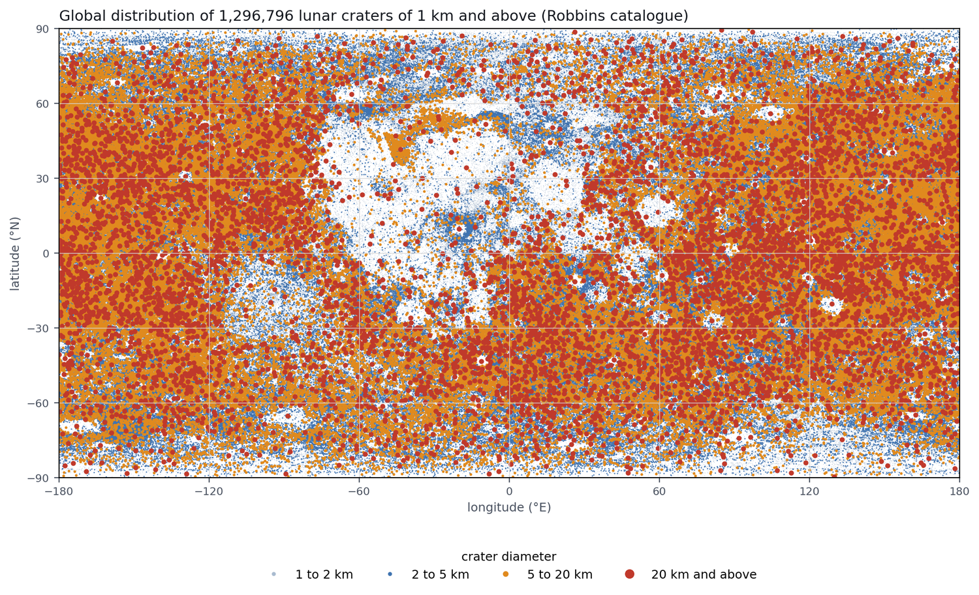
Figure 1. Every crater of 1 km and above in the Robbins catalogue (1.3 million). Dark near-side maria (centre) are sparsely cratered; the highlands are crowded.
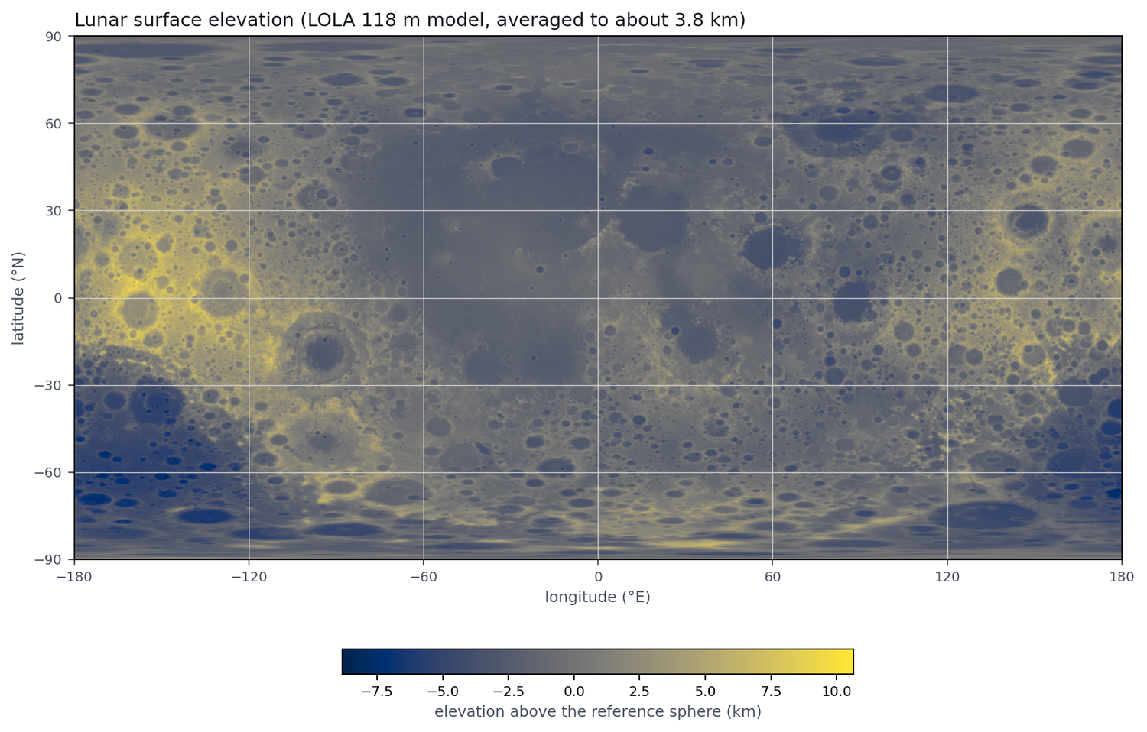 | 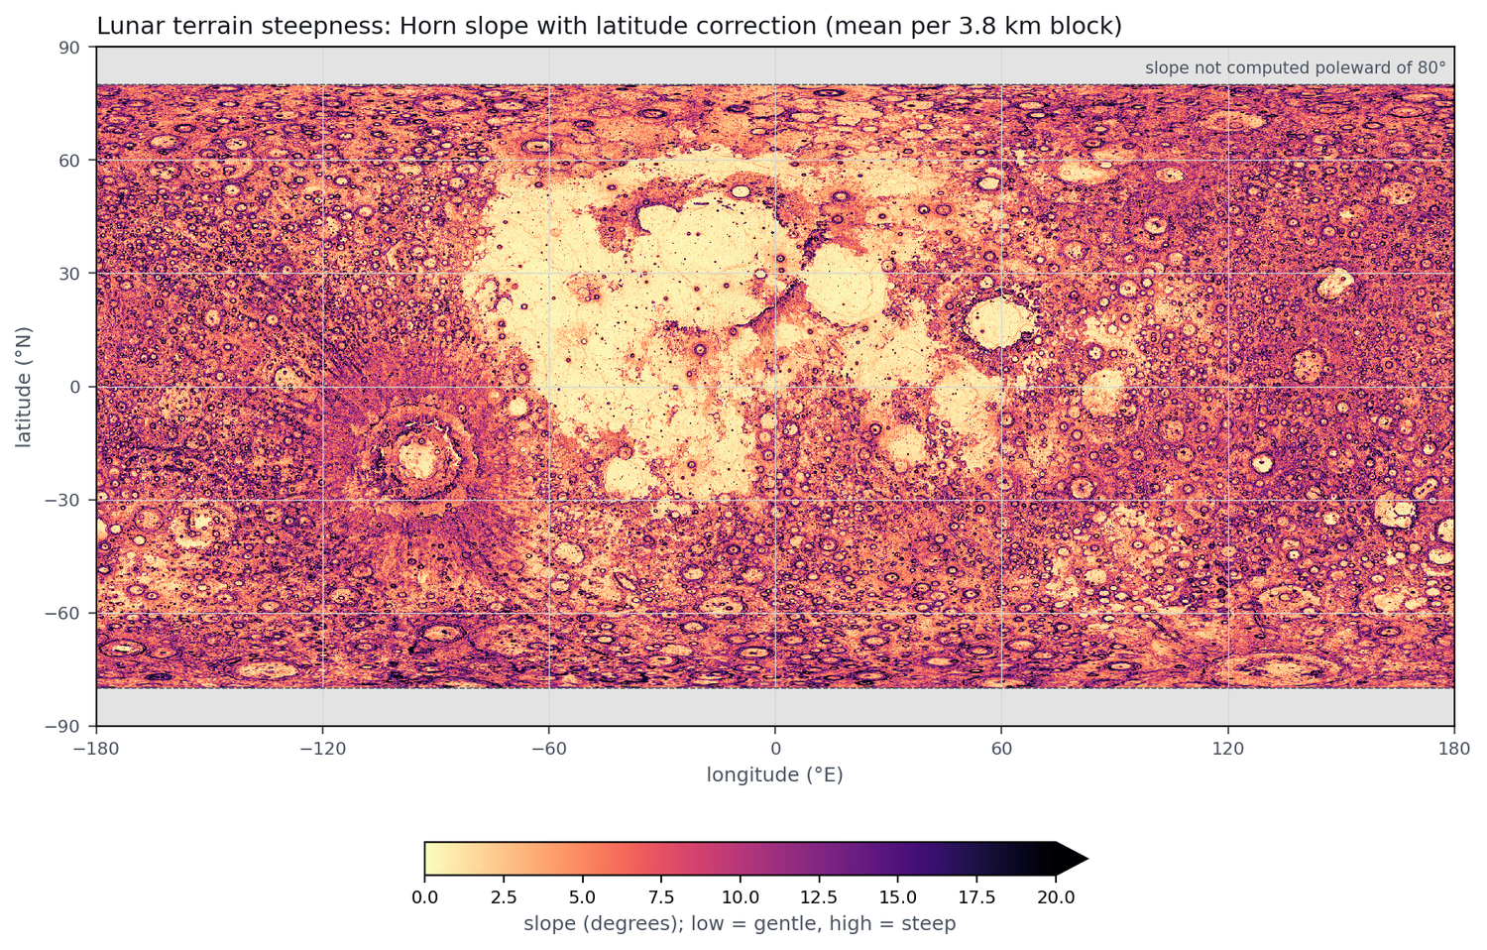
Figure 2. Left: global elevation (118 m model). Right: terrain steepness (Horn slope, latitude-corrected). The smooth maria are gentle; the highlands are steep.

3. Data preparation (preprocessing)
Raw data from different sources never line up by themselves. Most of the effort in this project went into cleaning the layers and joining them correctly, and every step was checked before the next one was built on it.

3.1 Cleaning and harmonising the catalogues
All three catalogues were reduced to the same minimal table: longitude, latitude and diameter (km). Robbins stores longitude from 0° to 360°, so it was converted to the −180° to 180° range used by the elevation map; otherwise every crater east of 180° would land on the wrong side of the Moon. In LU5M812TGT, 370 out-of-range longitudes were wrapped by ±360°, a width-based diameter and a height-based diameter were compared (height matched Robbins best and became the working diameter), and 15,678 oddly shaped detections were flagged but kept. Its confidence score was deliberately not used as a filter, because it depends on size: filtering would remove mostly small craters and bias every size comparison.

3.2 Cross-checking the catalogues
Before trusting the newer catalogues, each Robbins crater was searched for in the others: a match needed a centre within a quarter of the crater's diameter and a diameter between half and double. The size condition matters: without it, large craters were "matched" to small craters sitting inside them, giving absurd size ratios. With it, 74% to 96% of Robbins craters were found in each catalogue (weakest for LUC-GRAS200 at 1 to 2 km), with diameters agreeing to within 2 to 3%.

3.3 Giving every crater an elevation and a slope
Each crater was given the height of the elevation-map pixel under its centre (all 1,296,796 fell inside the map). Slope was computed with Horn's method, which compares each pixel with its eight neighbours. The key fix was a latitude correction: on this map a pixel is 118 m wide on paper, but on the ground it is only 118 m × cos(latitude) wide. Ignoring that makes high-latitude terrain look falsely flat. A test with artificial planes tilted at exactly 10° shows the problem clearly:
Latitude of test plane | Uncorrected slope | Corrected slope
30° | 8.68° | 10.0°
60° | 5.04° | 10.0°
75° | 2.61° | 10.0°
Because the flat map is too stretched near the poles, slope is reported only up to 80° latitude.

3.4 Tiling the Moon
To compare places fairly, the Moon was cut into 2,592 tiles of 5° × 5°. A crater's tile follows directly from its coordinates, and tile area was computed on the sphere so that polar tiles are correctly smaller. Density is always expressed as craters per 1,000 km².

3.5 Polar layers and the equal-area grid
The polar illumination maps use a polar stereographic projection (positions are metres from the pole), so each of the 191,401 craters poleward of 65° had to be converted into that system before reading the map. The conversion was verified by reproducing every map corner to the metre and confirming that no crater landed outside the data.
A key lesson about grids. Tiles of equal degrees get narrow towards the poles: the 288 tiles above 80° are 11% of all tiles but cover only 1.5% of the Moon, and a polar tile can touch up to 143 neighbours instead of the usual 16. A hotspot test on this grid flagged every polar tile as hot, which was an artefact of the grid, not a fact about the Moon. The fix was an equal-area polar grid: 20 km square cells (4,669 per pole) whose true areas are corrected for map stretching. This changed the answer for the south pole completely.

4. Methods and techniques
Each technique below is described in everyday terms, followed by what it was used for.
Technique | Plain-language idea | Used to answer
Density mapping | Count craters in each tile or cell and divide by the true ground area. | RQ1, RQ2
Getis-Ord Gi* | For each cell, ask: are this cell and its neighbours (within 61 km) together much denser than the Moon-wide average? A high score marks a hotspot, a low score a cold spot. | RQ1, RQ4
Permutation test | Shuffle crater densities among comparable cells 999 times and see how often chance alone produces a hotspot as strong. Needed because neighbouring cells are not independent; the usual "Z > 2.58" rule flagged 8% to 23% of cells even on flat data. | RQ1, RQ3
DBSCAN clustering | Group points that have enough close neighbours, with no preset number of clusters. | RQ1
Association rules (FP-Growth) | Find labels that occur together more than chance ("if in shadow, then latitude 80–90°"), measured by lift (1 = no link). | RQ2, RQ3
K-means | Sort craters into groups by size, slope, elevation and latitude; the silhouette score tells how real the groups are. | RQ2
Control analyses | Split by near/far side, north/south, elevation thirds and longitude sectors to make sure a pattern is not caused by something else. | RQ1, RQ4
Catalogue comparison | Repeat every analysis on all three catalogues and measure the overlap of their hotspots (Jaccard index). | RQ4
Benchmark | Time the same jobs on one machine and on Spark with 1 to 16 cores, with inputs from 1.3 to 42.8 million rows. | RQ5

5. How Apache Spark and Apache Sedona were used

5.1 What they are, and why they matter for this project
Apache Spark splits a big dataset into pieces (partitions) and processes them in parallel on many cores or machines. Apache Sedona adds the spatial vocabulary on top of Spark: point and polygon types, spatial joins ("which tile contains this crater?"), raster reading, and spatial statistics. Together they let ordinary spatial operations scale to data that no longer fits comfortably on one computer, such as billions of elevation pixels or catalogues with tens of millions of craters.
The work ran on a shared university DGX server, with Spark in local mode capped at 16 cores and a 32 GB driver, using PySpark 4.0 and Sedona 1.9.1. A strict rule was followed: every step was first built with conventional single-machine tools to give a reference answer, then rebuilt in Spark and Sedona and compared with it. Any difference therefore meant a bug, never a surprise.

5.2 What was done in Spark and Sedona
Step | Sedona / Spark feature | Result vs. reference
Crater points and tile counts | ST_Point builds geometry; Spark groups by tile | Identical
Crater-to-tile spatial join | Tiles as polygons; ST_Intersects join | Identical after fix (see below)
Elevation under each crater | Raster reader; RS_Values reads all craters of a tile at once; small lists broadcast to workers | Identical after two fixes
Tile elevation statistics | RS_SummaryStatsAll across 36 band files | Differences ~1e-8 (rounding)
Slope | Own latitude-corrected function run on 36 latitude bands in parallel | Matched to 0.0000003°
Clustering | ST_DBSCAN in polar metres | Ran for 48 settings
Hotspots | Distance-band weights and g_local (Gi*) | Z-scores match to 1e-13
K-means, FP-Growth | Spark MLlib | Ran (21 s and 39 s)

5.3 Lessons learned along the way
- File layout decides parallelism. The 8.5 GB elevation map, stored as one file, ran as a single task for over 16 minutes. Cutting it into 36 tiled band files let Spark use all 16 cores.
- Strict versus inclusive joins. ST_Contains dropped 217 craters lying exactly on tile borders; ST_Intersects (keeping one tile per crater) fixed it.
- Never trust documentation alone. RS_Values counted pixels from 0, not 1, and already applied the file's 0.5 scale, so doing it again halved every elevation. Both were found only by comparing against the reference.
- Earth-based defaults on the Moon. Sedona's DBSCAN "spheroid" option uses Earth's ellipsoid; distances came out about 3.7 times too long. All clustering therefore used planar distances in polar stereographic metres.
- Unknown projection. The elevation map uses a custom Moon projection Sedona reported as SRID 0, so pixel positions were used instead of letting Sedona transform coordinates silently.

5.4 Does Spark actually make it faster?
Honest answer: not at today's catalogue sizes. Median run times (seconds) for the two benchmark jobs, tile counts and polar cells:
Craters in input | Single machine | Spark, 16 cores | Spark, 1 core
1.3 million | 0.07 / 0.06 | 0.26 / 0.33 | 0.31 / 0.39
10.7 million | 0.40 / 0.30 | 0.27 / 0.33 | 0.86 / 0.86
42.8 million | 1.47 / 1.10 | 0.57 / 0.57 | 3.87 / 3.09
Spark's start-up of 4 to 5 seconds outweighs its benefit on the real catalogues. It starts to win at about 10 million rows (1.5× faster) and is 2.6× faster at 42.8 million, with 5.4 to 6.8× speed-up from 1 to 16 cores. The design is therefore justified by scale and future growth (finer terrain products, larger catalogues), and the same code will run unchanged on a multi-node cluster.

6. Analysis and results

6.1 Catalogues agree on where, not on how many
Counted per 5° tile, the catalogues correlate strongly (0.94 to 0.97), so they place craters in the same regions. Their totals differ, however:
Craters with diameter | Robbins | LU5M812TGT | LUC-GRAS200
1 km and above | 1,296,796 | 1,998,113 | 1,813,169
2 km and above | 443,016 | 696,037 | 474,339
20 km and above | 6,973 | 7,573 | 7,171
Above 2 km, LUC-GRAS200 and Robbins nearly agree, while LU5M812TGT lists about 60% more. Without ground truth, we cannot say whether the extra craters are real or false detections. The practical lesson: report every result for several catalogues side by side.

6.2 Density rises towards the poles, mostly in the north
On the 5° tiles, median density rises steadily from equator to pole in every catalogue (Robbins: 29 craters per 1,000 km² at 0° to 30°, 65 at 80° to 90°). Part of this is an illusion: the dark, young maria sit near the equator on the near side and make it look empty. On the equal-area polar grid, the true picture emerges: the north pole ring is 2.08× (Robbins), 1.95× and 1.67× denser than the 65° to 70° ring, while in the south the same ratios are only 1.15, 1.03 and 0.92. The north gradient holds in every longitude sector (24 of 24 comparisons), whereas the south is patchy with no consistent polar trend.
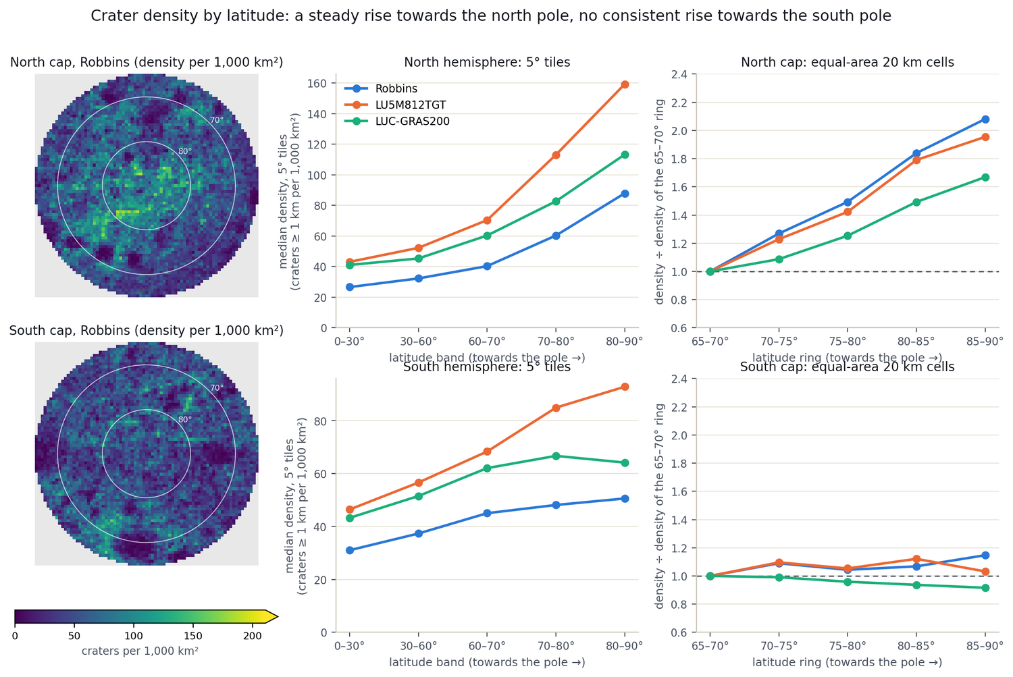
Figure 3. Crater density by latitude. Left maps: Robbins density on each polar cap. Centre: 5° tiles. Right: equal-area cells, relative to the 65°–70° ring. North rises steadily; south stays flat.
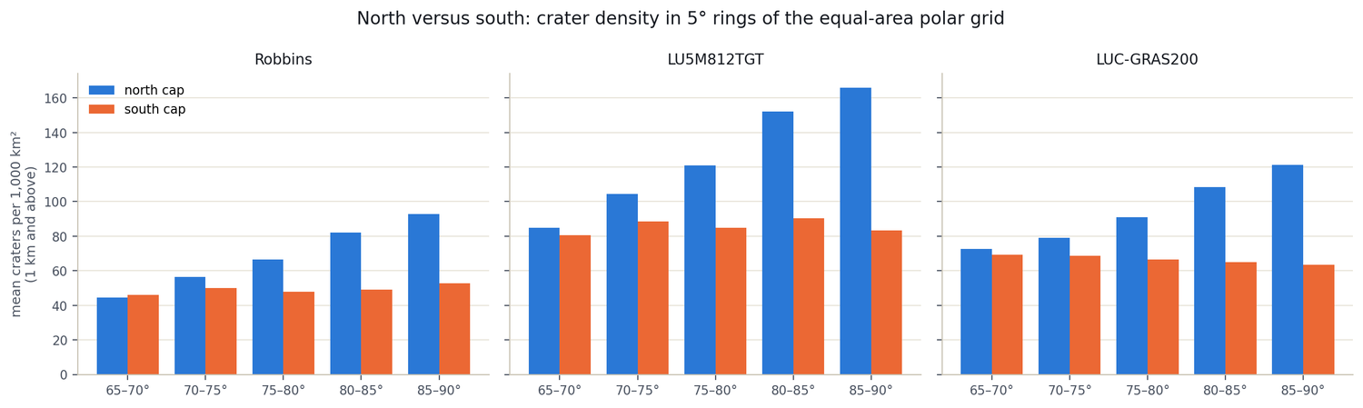
Figure 4. North versus south crater density in 5° rings of the equal-area polar grid, for all three catalogues.

6.3 Polar hotspots
Getis-Ord Gi* highlights where dense areas group together. All three catalogues paint visibly the same picture. The most consistent hotspot is in the south at about 68°S to 73°S, 151°W to 157°W, where density is two to five times the cap average; in the north, the strongest cells are near 82°N to 83°N, 34°W to 42°W.
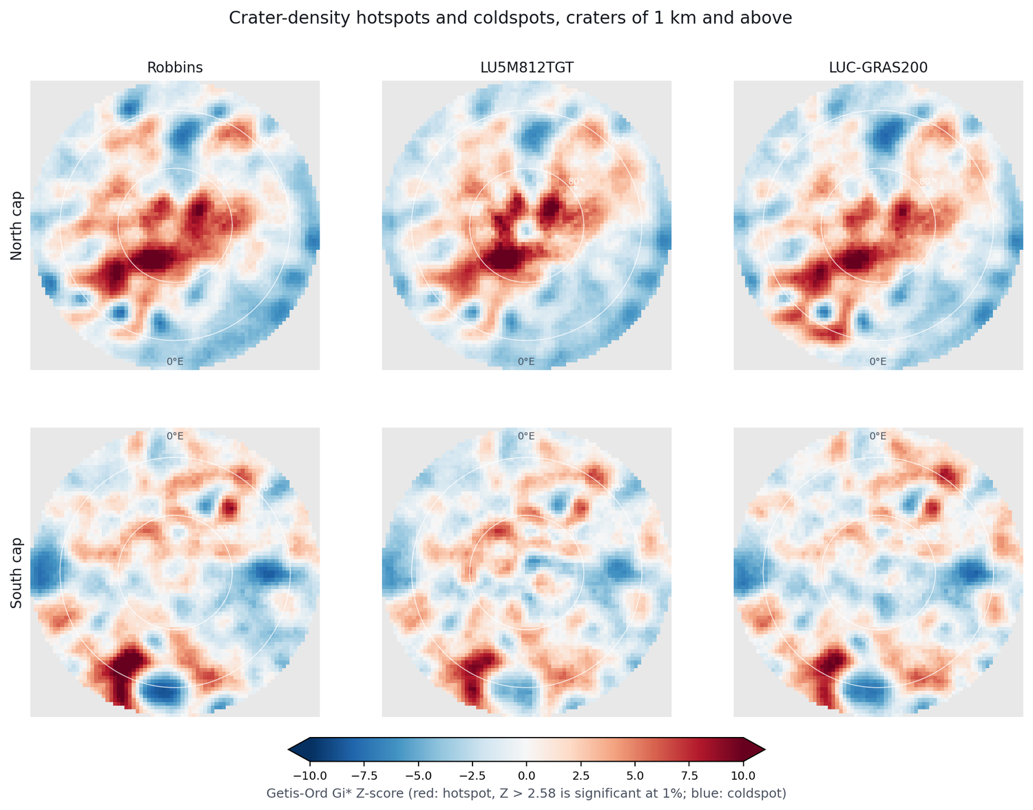
Figure 5. Hotspots (red) and cold spots (blue) of craters ≥ 1 km on each polar cap, for the three catalogues. Z > 2.58 is significant under the basic test.
The top 5% of cells overlap far more than chance (Jaccard 0.44 to 0.90, against 0.03 for random sets); agreement is better for craters ≥ 2 km because catalogues disagree most about 1 to 2 km craters. The basic test is too generous, so a strict max-T permutation test was applied, leaving a small, stable core: 36 cells in the north and 158 in the south that all three catalogues confirm (craters ≥ 1 km). Controlling for sunlight changed almost nothing, so the hotspots are not an illumination artefact.
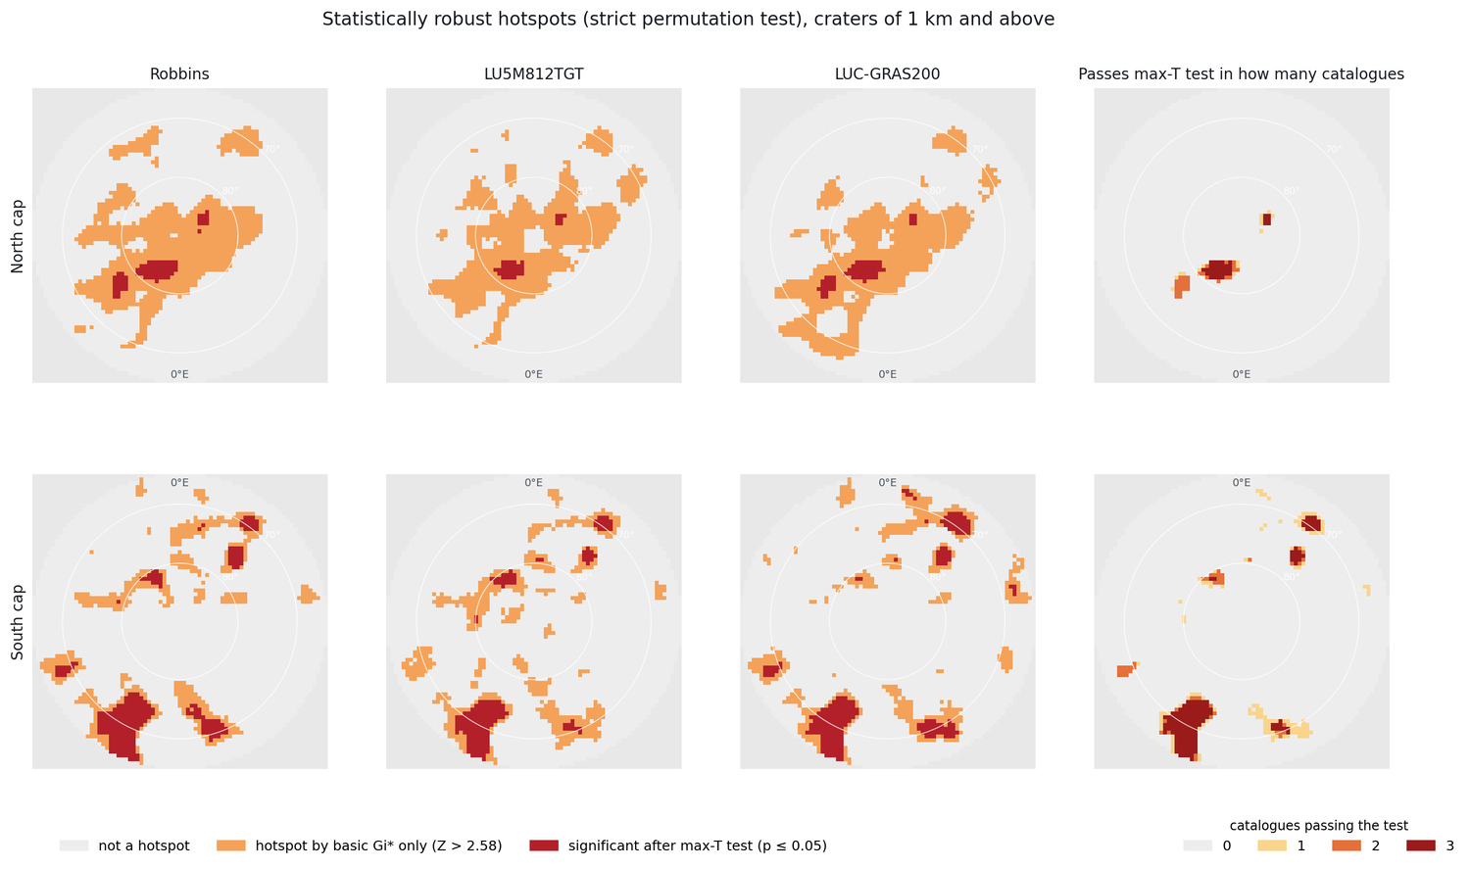
Figure 6. Hotspots surviving the strict permutation test (dark red). Right column: in how many of the three catalogues each cell passes.
The main south hotspot lies in low terrain (median −4,165 m against −1,145 m for other cells) inside the South Pole–Aitken basin, the Moon's largest and oldest basin. That fits a heavily cratered, ancient surface, though this geological reading was not tested here.

6.4 Light and shadow
Craters sit in permanent shadow 2.7 to 4.7 times more often than a random place (for example 19.1% of craters against 7.2% of the area on the 20 m south-pole map). This is expected, since crater floors collect shadow, and it also confirms that the crater and illumination layers are correctly aligned.
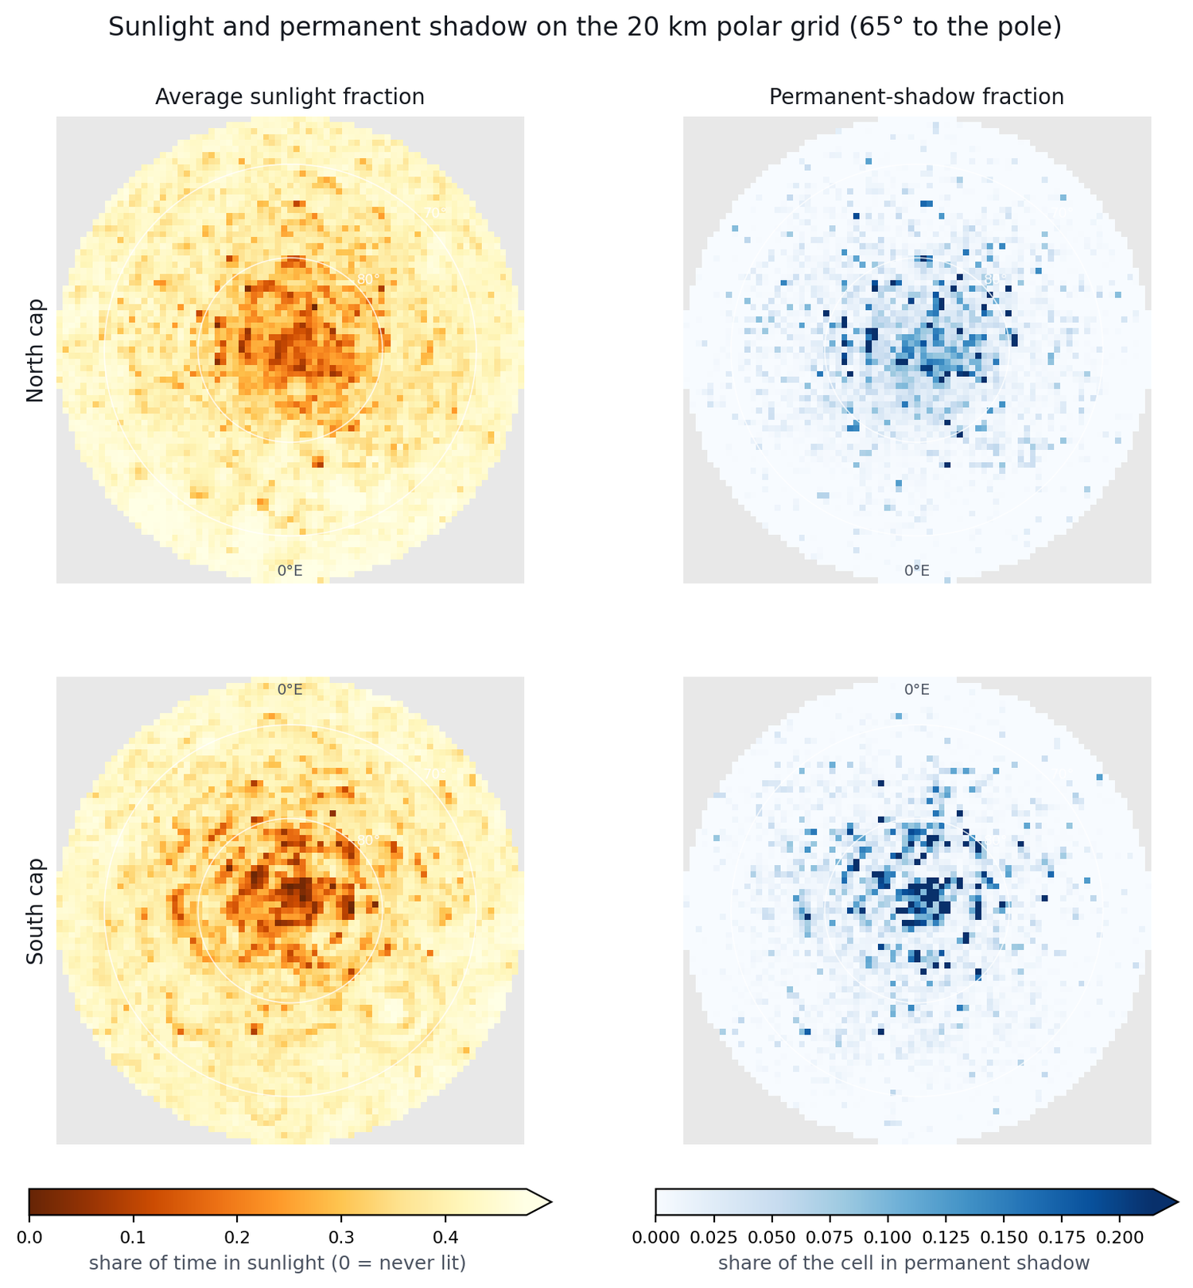
Figure 7. Average sunlight (left) and permanent shadow (right) on the 20 km polar grids. Darker orange = less light; darker blue = more shadow.
At the scale of 20 km cells the story is more nuanced. Cells with more than 5% permanent shadow hold fewer craters overall than lit cells at the same latitude, but the effect depends on crater size:
Shadowed ÷ lit density | Robbins | LU5M812TGT | LUC-GRAS200
1 to 2 km craters (north) | 0.74 | 0.65 | 0.72
2 to 5 km craters (north) | 0.85 | 0.76 | 0.86
10 km and above (north) | 1.65 | 1.50 | 1.67
10 km and above (south) | 2.10 | 1.72 | 1.95
Small craters are 25% to 35% scarcer in shadow, large ones 1.5 to 2 times more frequent. Two explanations remain open: small craters may be genuinely rarer on terrain dominated by large crater floors, or they may simply be harder to detect in dim imagery. Large craters also create shadow themselves, so part of this link is built in.
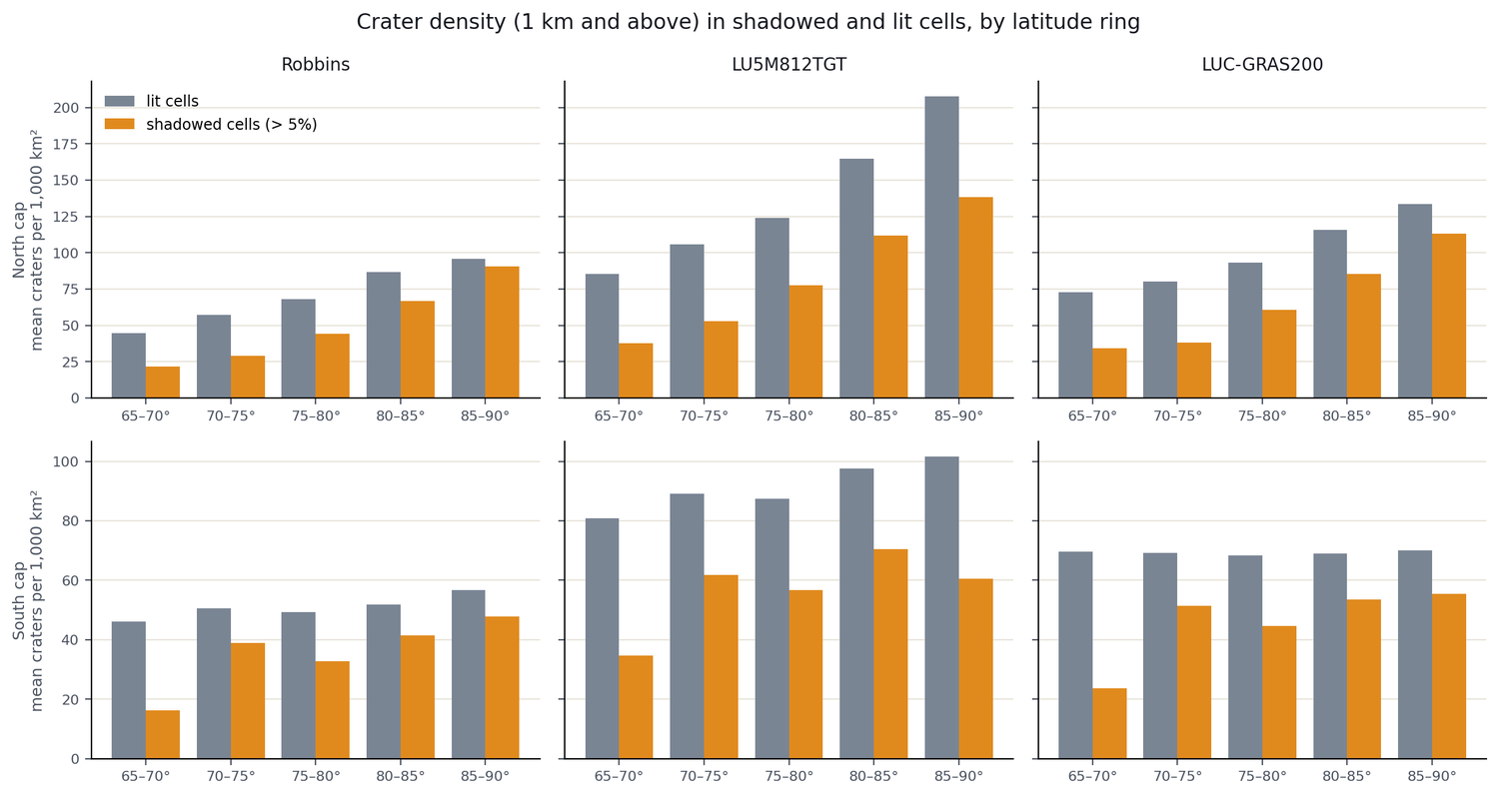
Figure 8. Crater density (≥ 1 km) in shadowed (orange) and lit (grey) cells by latitude ring. Shadowed cells are less dense, and the gap narrows towards the pole.

6.5 Steepness, clustering and craters' own properties
Slope. Within each latitude ring, the steepest third of cells has 14% to 20% fewer craters than average, mostly because small craters are missing, while large craters make up a bigger share (for Robbins in the north: 21%, 33% and 39% of craters are ≥ 2 km in gentle, middle and steep cells). Since crater walls are steep, large craters partly create the steep terrain, so this is again partly structural.
DBSCAN. Clustering craters near the poles failed to give a stable answer: at ε = 2 km, 42% to 96% of craters were "noise", and from ε = 10 km, 96% to 100% joined one giant cluster. Crater positions form a continuous density field, not separate islands, so hotspot statistics were the better tool.
K-means and association rules. K-means found only weak structure (silhouette 0.38 at three groups; one group has larger, steeper craters, median 3.7 km and 13.8°), meaning crater types form a continuum. Association rules mostly reproduced known geography; the polar rules confirm that about 74% of craters in shadow lie poleward of 80° (lift 3.7). The link between shadow and low sunlight is built into the data and is not a finding.
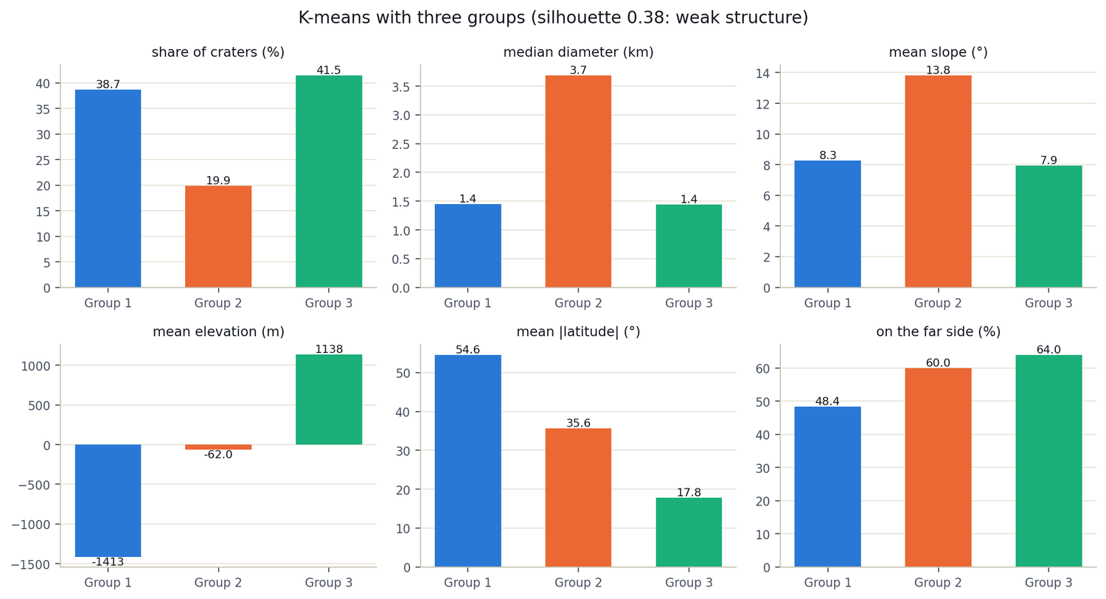
Figure 9. K-means with three groups: share of craters, median diameter, slope, elevation, latitude and far-side share. Weak structure (silhouette 0.38).
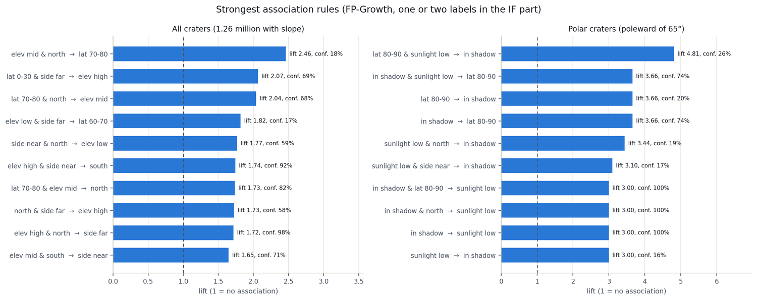
Figure 10. Strongest association rules (lift; 1 = no association) for all craters (left) and polar craters (right).

7. Why spatial data matters
Almost every conclusion in this project depends on where something is, not just what it is. A few examples show why the "spatial" part is the heart of the work rather than decoration:
- The map system changes the numbers. The same slope reads 10° or 2.6° depending on whether the map's distortion is corrected. The same pole looks like a hotspot or not depending on whether the grid is equal-area.
- Location is the key that joins data. Craters, elevation and shadow have nothing in common except position. Spatial indexing and joins attached terrain and light to millions of craters.
- Neighbours are not independent. Ordinary statistics assume independent observations; places near each other resemble each other. Spatial statistics (Gi*, permutation tests) are designed for exactly this, and without them a map full of "significant" hotspots would have been reported.
- The choice of areal unit matters. Using 5° tiles or 20 km equal-area cells changed the south-pole conclusion, a textbook case of the modifiable areal unit problem.
- Scale demands spatial engines. Billions of pixels and tens of millions of points need spatial partitioning, which is what Sedona provides on top of Spark.

8. Conclusions
- A distributed spatial pipeline now combines three crater catalogues, a global elevation model and polar illumination maps into one consistent, verified framework.
- The catalogues share the spatial pattern of craters but differ in counts (up to 60% above 2 km), so results must be reported per catalogue.
- Polar enrichment of craters is real in the north cap and absent as a consistent trend in the south once latitude, terrain and map distortion are controlled.
- Reproducible hotspots exist in both caps, are not caused by illumination, and a conservative test keeps a small core of them, notably near 70°S, 155°W.
- Craters concentrate in permanent shadow, but shadowed regions hold fewer small and more large craters than lit ones.
- DBSCAN and K-means describe crater data poorly because it forms continuous gradients; hotspot statistics suit it better.
- Spark and Sedona pay off from about 10 million records; on current catalogues one machine is faster, so their value is scalability.

9. Limitations
- Catalogues are not fully independent. They share image and elevation sources, and no ground truth shows which is most complete.
- No uncertainty ranges. Counts are point values; detection errors were not propagated into the hotspot maps.
- The permutation test shows organised clustering, not its cause. Neighbouring cells are related, so the number of independent hotspots is far smaller than the cells flagged.
- Coarse terrain and light data. The 118 m model is rough for 1 to 2 km craters; slope stops at 80°; shadow was read at crater centres only; illumination is a long-term average.
- Elevation is only a proxy for geology. Mare, highland and ejecta units were not mapped, and the north–south asymmetry is measured but unexplained.
- Secondary craters. Their labels do not cover 1 to 2 km craters near the poles, so that question stays open for the most numerous sizes.
- Benchmark scope. Tests ran on one shared machine with warm caches, so they do not predict multi-node or cold-disk performance. Grid sizes (20 km, 5°) were fixed, so sensitivity to other choices is untested.

Future work
Planned next steps include mapping where the catalogues disagree and checking those places in imagery; shuffling cells only within the same terrain class; comparing size-frequency distributions to separate age effects from detection limits; repeating the analysis at several grid sizes; using the 20 m south-pole data; adding a mare/highland map; running the benchmark on a multi-node cluster with data stored in GeoParquet or PostGIS; and resampling craters by detection probability to give uncertainty ranges.

Key references and data sources
Robbins (2019) JGR Planets 124; Smith et al. (2010) Space Sci. Rev. 150 (LOLA); Barker et al. (2023) Planet. Sci. J. 4; Getis & Ord (1992) Geogr. Anal. 24; Ord & Getis (1995) Geogr. Anal. 27; Ester et al. (1996) KDD-96 (DBSCAN); Han et al. (2000) SIGMOD Rec. 29 (FP-Growth); Horn (1981) Proc. IEEE 69; Benjamini & Hochberg (1995) JRSS B 57; Rousseeuw (1987) JCAM 20; Snyder (1987) USGS PP 1395; Openshaw (1984) CATMOG 38; Zaharia et al. (2016) CACM 59 (Spark); Yu et al. (2019) GeoInformatica 23 (GeoSpark/Sedona); Colaprete et al. (2010) Science 330; Li et al. (2018) PNAS 115. Data: LU5M812TGT (Zenodo 13990480); LUC-GRAS200 v1.0.0 (CLPDS); NASA PGDA LOLA polar products; NASA/USGS LOLA 118 m DEM. Software: Apache Spark and Apache Sedona.

