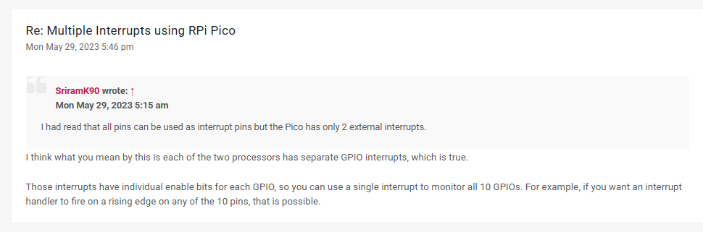https://forums.raspberrypi.com/viewtopic.php?t=352004

<https://datasheets.raspberrypi.com/rp2040/rp2040-datasheet.pdf>

<https://electrocredible.com/raspberry-pi-pico-external-interrupts-button-micropython/#google_vignette>