SMART FILE

A Major Project-I Report
Submitted in Partial fulfilment for the award of
Bachelor of Technology in Department of Artificial Intelligence & Machine Learning

Submitted to
RAJIV GANDHI PROUDYOGIKI VISHWAVIDYALAYA
BHOPAL (M.P)



MAJOR PROJECT-I REPORT
Submitted by
Pawan Nagar [0103AL211121] Tarun Bairagi [0103AL211188] Rishav Kumar [0103AL211145]

Under the supervision of
Dr. Anju Singh
Professor


Department of Artificial Intelligence & Machine Learning
Lakshmi Narain College of Technology, Bhopal (M.P.)
Session
2024-25

LAKSHMI NARAIN COLLEGE OF TECHNOLOGY, BHOPAL

Department of Artificial Intelligence & Machine Learning


CERTIFICATE

This is to certify that the work embodied in this project work entitled ”SMART FILE” has been satisfactorily completed by the Pawan Nagar [0103AL211121], Tarun Bairagi [0103AL211188], Rishav Kumar [0103AL211145]. It is a bonafide piece of work, carried out under the guidance in Department of CSE, Lakshmi Narain College of Technology, Bhopal for the partial fulfilment of the Bachelor of Technology during the academic year 2024-2025.

Guide By Approved By

Dr. Anju Singh Dr. Tripti Saxena Professor Professor & Head

LAKSHMI NARAIN COLLEGE OF TECHNOLOGY, BHOPAL

Department of Artificial Intelligence & Machine Learning

ACKNOWLEDGEMENT

We express our deep sense of gratitude to Dr. Anju Singh, professor department of CSE, L.N.C.T., Bhopal. Whose kindness valuable guidance and timely help encouraged us to complete this project.

A special thank goes to Dr. Tripti Saxena (HOD) who helped us in completing this project work.She exchanged her interesting ideas & thoughts which made this project work successful.

We would also thank our institution and all the faculty members without whom this project work would have been a distant reality.

Pawan Nagar [0103AL211121] Tarun Bairagi [0103AL211188]

Rishav Kumar [0103AL211145]

INDEX

S.NO. | TOPICS | PAGES
1. | Problem Domain Description | 5-8
2. | Literature Survey | 9-11
3. | Major objective & scope of project | 12-13
4. | Problem Analysis and requirement specification | 14-16
5. | Detailed Design (Modelling and ERD/DFD) | 17-19
6. | Hardware/Software platform environment | 20-22
7. | Snapshots of Input & Output | 23-27
8. | Coding | 28-49
9. | Project limitation and Future scope | 50-51
10. | References | 52

CHAPTER 1
PROBLEM DOMAIN DESCRIPTION

In today's digital landscape, individuals and organizations are inundated with an overwhelming volume of files and documents in diverse formats, such as PDFs, Word documents, images, and scanned files. The sheer amount of information stored across multiple files can pose significant challenges when it comes to efficient organization, retrieval, and management. Traditional file management systems, which primarily rely on basic metadata like filenames and dates, often fall short in providing a robust solution for content-based search and retrieval. This limitation leads to inefficiencies, wasted time, and reduced productivity, especially in scenarios where users need to find files based on their internal content rather than external attributes.
1.1. Challenges in Traditional File Management:
- Limited Search Capabilities: Conventional systems depend on filenames, tags, or folder structures to locate files, making it difficult to search for documents based on specific content within the files. Users frequently face challenges in locating files that contain particular information, such as legal documents with specific clauses, scanned images with text data, or records containing unique identifiers.
- Manual Data Extraction: Retrieving precise information from documents is often a manual, labor-intensive process. For instance, extracting an Aadhaar number or a specific invoice detail from a scanned PDF typically requires the user to open the file, visually scan through its contents, and manually copy the required data. This not only consumes valuable time but also increases the potential for human error.
- Scalability Issues: As the volume of files grows, the efficiency of traditional file management systems diminishes. The lack of advanced search algorithms and indexing mechanisms results in slow query responses, hampering the ability to quickly access the necessary files in a large repository.
- Lack of Intelligent Features: Traditional file systems are limited to basic operations like renaming, deleting, downloading, or organizing files into folders. They lack intelligent features that could help users derive insights from the content of their documents, such as automated text extraction, content tagging, and smart search capabilities.

1.2. Proposed Solution: Smart File
To address these pressing challenges, Smart File introduces an advanced, AI-powered file management system designed to transform the way users interact with their files. The core of Smart File's innovation lies in its ability to leverage cutting-edge technologies like Natural Language

Processing (NLP), Optical Character Recognition (OCR), and Machine Learning to enhance the traditional file management experience.

1.2.1. Key Features of Smart File:
      - Content-Based File Search: Smart File goes beyond simple metadata search by enabling users to find files based on the actual content within them. By extracting text from various file formats (PDFs, Word documents, images) using OCR and NLP techniques, Smart File generates detailed, searchable tags. This empowers users to perform full-text searches, dramatically reducing the time spent hunting for documents.

      - Automated Text Extraction and Tag Generation: Utilizing libraries such as pdfplumber, textract, and pytesseract, Smart File automatically extracts text from uploaded files. This text is processed using SpaCy's NLP capabilities to generate relevant tags, making content discovery faster and more accurate.

      - Intelligent Chat-Based Query System: Smart File introduces a unique, chat-driven interface that allows users to retrieve specific information directly from their files. For example, if a user has uploaded an Aadhaar document, they can simply type "Tarun Aadhaar" into the chat, and the system will extract and present the Aadhaar number from the file without needing to open it. This feature significantly enhances user experience by providing direct access to critical data points.
      - Comprehensive File Management Operations: Beyond content search, Smart File offers a suite of traditional file management features, such as uploading, renaming, deleting, viewing, and downloading files. These functionalities are seamlessly integrated into a user-friendly interface, ensuring a smooth user experience.
      - Scalability and Efficiency: Smart File is designed to handle large volumes of files with optimized indexing and search algorithms, ensuring high performance even as the file repository grows. It is an ideal solution for organizations that need to manage extensive document archives while maintaining quick access to critical information.

1.3. Impact and Benefits
By addressing the limitations of traditional file management systems, Smart File provides a transformative solution that improves productivity, reduces manual effort, and enhances the accessibility of critical information. Its innovative use of AI and machine learning not only streamlines file organization but also empowers users to unlock the full potential of their data.
Smart File is positioned to be a game-changer in file management, especially for professionals in fields like legal, healthcare, finance, and administration, where quick and accurate access to document content is essential.

1.4. Project Description
Smart File is an advanced, AI-powered file management system built using Django, designed to revolutionize the way users store, search, and interact with their digital documents. The project addresses the limitations of traditional file management by introducing content-based search capabilities, automated text extraction, and intelligent data retrieval, making it easier for users to efficiently organize and access their files.
In today's data-driven world, individuals and organizations often struggle to manage an ever-growing repository of files, which can include PDFs, Word documents, images, and scanned files. Traditional file systems rely on basic metadata like filenames and folder structures, which are insufficient when users need to find files based on their internal content. Smart File tackles this challenge by leveraging state-of-the-art technologies like Natural Language Processing (NLP), Optical Character Recognition (OCR), and Machine Learning, providing users with an intelligent and intuitive file management solution.
1.4.1 Key Features of Smart File:
- Content-Based Search: Unlike conventional file systems that depend on filenames, Smart File enables users to search files based on the actual text content within them. It uses powerful text extraction tools (pdfplumber, textract, docx2txt, and pytesseract) to extract text from different file types, automatically generating searchable tags. This ensures users can quickly find relevant files by searching for specific keywords or phrases contained within the documents.
- Automated Tag Generation: The application utilizes NLP libraries like SpaCy to analyze the extracted text and generate meaningful tags for each uploaded file. These tags enhance the search functionality, allowing users to retrieve files more efficiently.
- AI-Driven Data Extraction via Chat Interface: Smart File introduces a unique chat-based interface that allows users to extract specific information from their files without opening them. For instance, users can type a query like "Tarun Aadhaar" to directly extract the Aadhaar number from a previously uploaded document. This feature significantly speeds up data retrieval, particularly for large files or complex datasets.
- Comprehensive File Management: Beyond its intelligent search capabilities, Smart File provides standard file management features such as uploading, renaming, deleting, downloading, and viewing files directly in the browser. The application supports multiple file formats, ensuring versatility in handling different types of documents.
- User-Friendly Interface: The system is designed with a responsive and intuitive UI using HTML, CSS, and JavaScript, making it easy for users to interact with their files. Dynamic previews, quick actions, and real-time search results enhance the overall user experience.
- Scalability and Efficiency: Built with Django, Smart File ensures high performance and scalability, making it suitable for both individual users and organizations with extensive document repositories. The system is optimized for fast search queries, even as the database of files grows.

1.5. Technologies Used:
- Backend: Django (Python) for robust web application development.
- Text Extraction: pdfplumber, textract, docx2txt for processing PDFs and Word documents; pytesseract for OCR on images.
- Natural Language Processing: SpaCy for tag generation and content analysis.
- Frontend: HTML, CSS, JavaScript for a responsive and interactive user interface.
1.6. Impact and Use Cases: Smart File is designed for professionals and organizations across various industries that require efficient document management and data retrieval. It is particularly beneficial for sectors like legal, healthcare, finance, and research, where quick access to document content is crucial. By providing both traditional file operations and advanced AI-driven capabilities, Smart File bridges the gap between conventional file management and modern data accessibility needs, boosting productivity and reducing the time spent searching for critical information.

CHAPTER 2
LITERATURE SURVEY

2.1. Evolution of File Management Systems
The evolution of file management systems has seen a rapid transformation from basic file storage solutions to more sophisticated platforms that offer advanced functionalities such as content extraction, search optimization, and automated categorization. With the growing volume and complexity of digital files, the need for systems that can do more than just store files—systems that understand and interpret the content of these files—has never been greater. Smart File is built with this vision in mind, integrating various existing technologies and methodologies to create a comprehensive solution for modern file management [1][2].
2.2. Traditional File Management Systems
Traditional file management systems focus primarily on organizing and storing files based on their metadata—file names, types, and storage locations. However, these systems face limitations when users need to find files based on the actual content inside them, rather than just the file name or type. Early systems also lacked the ability to perform intelligent operations such as automatic categorization or data extraction from different formats.
Systems like Windows File Explorer or macOS Finder provide users with basic search and organizational functionalities but are insufficient for more advanced use cases, especially when dealing with diverse file formats like PDFs, Word documents, or images [3]. Additionally, these systems do not offer advanced search capabilities or automated content-based file categorization, limiting their effectiveness for professional environments that handle large volumes of files.
2.3. Advances in Text Extraction from Files
As the demand for extracting meaningful data from files increased, several libraries and frameworks emerged to bridge the gap. Text extraction from PDFs, Word documents, and images is a fundamental challenge that has been addressed with a range of tools, each optimized for different file types.
- PDF Text Extraction: Libraries like pdfplumber and PyPDF2 are widely used for extracting text from PDF files [4][5]. While effective for simple documents, PDFs with complex structures (like scanned documents or PDFs with images) often present difficulties in text extraction. This is where OCR (Optical Character Recognition) technologies come into play.
- OCR Technologies: Tesseract OCR, one of the most well-known open-source OCR engines, allows for text extraction from images and scanned documents. Integrated into tools like
pytesseract, it enables Smart File to extract text from image-based files such as scanned PDFs or photographs of documents [6]. These OCR techniques are essential for making documents like handwritten notes or scanned forms searchable.
- Word Document Text Extraction: Libraries such as textract and docx2txt provide effective methods for extracting text from Word documents. While textract works across multiple formats (including PDFs and images), docx2txt is specialized for extracting text from Word files, making it a reliable choice for processing document-based content [7][8].
These text extraction techniques, particularly when combined with OCR, allow Smart File to process a variety of file types, ensuring that no matter the format, the content can be analyzed and indexed for search.

2.4. Natural Language Processing for Tagging and Search
Once text is extracted, the next step is to make it searchable and discoverable. Traditional file systems have limited search capabilities, often relying on exact matches of keywords or filenames. However, with the advancement of Natural Language Processing (NLP), systems can now generate semantic search capabilities, improving the accuracy and relevance of search results.
- NLP in File Systems: Technologies like SpaCy and NLTK (Natural Language Toolkit) have revolutionized text processing by allowing systems to understand the context of the text, identify keywords, and generate meaningful tags [2][9]. By employing NLP techniques, Smart File can extract key terms from uploaded files and generate a list of relevant tags for each document. This not only facilitates faster searches but also helps in organizing files based on their content rather than just metadata.
- Content-Based Search: With the help of NLP, Smart File enables users to search for files based on the context of the text inside them. This is a huge leap from traditional file systems that only rely on exact keyword matches. By understanding the content of files, Smart File can provide results that are far more relevant, making it easier to locate documents that contain specific information—even if the search terms are not explicitly stated in the file name [10][11].

2.5. Chatbots and Interactive Data Retrieval
In recent years, the integration of chatbots and conversational agents has become increasingly popular in enhancing user interactions with systems. These conversational agents enable users to ask questions in natural language and receive relevant responses, improving usability and accessibility.
- File Interaction via Chat: Chatbots have already been integrated into various systems for customer service, but their use in file management systems is still a novel concept. By allowing users to interact with the system via a chat interface, Smart File takes file management to a new level. For example, if a user uploads an Aadhaar card, they could simply type "extract Aadhaar number" in the chat, and Smart File would automatically fetch and display the requested information [12]. This makes data retrieval as simple as having a conversation, significantly enhancing the user experience.
This type of AI-driven interaction eliminates the need for users to manually search through documents, especially when they are looking for specific data points. It’s a more intuitive way to interact with files, especially in a system where multiple formats and types of data are being handled simultaneously.

2.6. File Security and Privacy Concerns
As file management systems increasingly handle sensitive personal and business data, security and privacy have become paramount concerns. Many systems rely on encryption and secure access protocols to protect files from unauthorized access, and Smart File will not be an exception.
- Data Encryption: Files stored within the system must be encrypted to ensure that they remain private. Similarly, communications between the client and server should be secured through SSL/TLS encryption. Smart File will implement these security measures to ensure that sensitive data, like financial records or personal identification information (e.g., Aadhaar numbers), is protected at all times.
- Access Control: Implementing role-based access control (RBAC) ensures that only authorized users can access certain files or perform specific operations on them. This adds an additional layer of security, especially for collaborative environments where files are shared among multiple users [13].

2.7. Scalability and Cloud Integration
As file systems grow, they often face challenges in terms of scalability. The system must handle large volumes of files without compromising performance. Cloud-based solutions have become essential for providing scalable file storage and management.
- Cloud Storage: Smart File can leverage cloud storage solutions like Amazon S3, Google Cloud Storage, or Azure Blob Storage to store files securely while ensuring that they are easily accessible[13][14][15]. These cloud storage services allow the system to scale dynamically as more users and files are added, providing a robust infrastructure for long-term growth.
- Load Balancing and Performance Optimization: To handle heavy traffic and large file uploads, Smart File will need to implement load balancing and optimize its backend systems to ensure fast processing times and minimal downtime. This is essential for maintaining the system’s reliability and user satisfaction.

CHAPTER 3
MAJOR OBJECTIVES & SCOPE OF PROJECT

3.1. Major Objectives:
- Intelligent Content-Based File Search One of the primary objectives of Smart File is to enable users to search for files based on the actual content within the files, not just the file names or metadata. By leveraging advanced text extraction techniques and NLP, the project aims to provide a content-centric search capability that allows users to quickly locate files based on keywords, phrases, or specific data points within the file.
- Automated Text Extraction The project aims to automate the process of extracting text from various file types, including PDFs, Word documents, and images. Using tools like pdfplumber, textract, docx2txt, and pytesseract, the system will automatically extract text from these file types, enabling it to convert non-searchable content (such as images or scanned PDFs) into searchable data.
- Dynamic Tag Generation for Files A key goal of the project is to implement automatic tag generation through NLP techniques using SpaCy. The extracted text will be analyzed to generate relevant tags, which will facilitate faster and more accurate search results. This will significantly enhance the user experience by offering a more intuitive way to organize and search files.
- AI-Based Data Retrieval via Chat Interface A unique objective of Smart File is to integrate an AI-driven chat interface that allows users to query their files and retrieve specific information directly without needing to manually search through each file. For example, users can ask for specific data points (e.g., "Tarun Aadhaar") and the system will extract the relevant information (e.g., Aadhaar number) from the document, making data retrieval seamless and efficient.
- Comprehensive File Management System The project seeks to build a full-featured file management system, including standard operations such as file upload, download, rename, delete, and in-browser file viewing. The application will support a wide variety of file types and will aim to provide a user-friendly interface for managing these files.
- Scalable and Efficient Architecture An essential objective is to ensure that the application is scalable and efficient, capable of handling a large number of files and complex search queries without performance degradation. By utilizing Django as the backend framework and optimizing database interactions, the project will ensure that users can quickly retrieve files even as the system grows in scale.

3.2. Scope of Project:
- User Types and File Operations The scope of the project includes support for individual users as well as organizations that need to manage files with advanced search and retrieval capabilities. The core operations of the system will include file uploads, downloads, renaming, and deletion, which will be available to users with appropriate permissions.
- File Types Supported The project will focus on handling various file formats such as PDFs, Word documents, and Images. The system will integrate various libraries to extract text from these files, including OCR for image-based text extraction. While the initial implementation will focus on these formats, there is potential for future extensions to support more file types as needed.
- Integration of AI for Data Extraction The project will integrate AI-based data extraction through a chat interface. This feature will allow users to interact with their files by asking specific questions about the content, such as extracting a name or number from a document. This functionality will make the system more user-friendly and eliminate the need to manually open and search through documents.
- Search Functionality and Tagging System The application will support powerful search functionality powered by tags. Users will be able to search for files based on the tags generated from the content of the files. As part of the scope, the system will also allow for more advanced search options, such as searching within specific file types or dates.
- File Previewing The system will allow users to preview files directly in the browser for supported formats, such as PDFs and images. This feature will enhance the user experience by enabling users to view their files without the need to download them first.
- User Interface and Interaction The scope includes developing a simple yet effective user interface for interacting with the system. The application will be built using HTML, CSS, and JavaScript to ensure it is both visually appealing and responsive on various devices.
- Security and Authentication The project will incorporate user authentication to manage access to the file system. Each user will have a unique account with the ability to upload, search, and manage their own files. The system will use JWT authentication to secure users' interactions and maintain their privacy.

CHAPTER 4
PROBLEM ANALYSIS AND REQUIREMENT SPECIFICATION

4.1. Requirement Specification:
To deliver an efficient, reliable, and scalable system, the following technologies will be utilized:
4.1.1 Technology Stack
- Backend Framework:
Django: A robust Python-based framework that will serve as the foundation for creating web applications. It will handle file uploads, content extraction, and the logic for search functionality.
- Frontend Technologies:
HTML and CSS: These will form the basis of the user interface, providing a clean and intuitive design.
JavaScript: For dynamic interactions on the front-end, ensuring that the file management and search processes are smooth and user-friendly.
- Database:
MySQL: This relational database will store metadata about the uploaded files and their extracted contents. It will support efficient indexing and searching of file content.
- Machine Learning Models & Text Extraction:
PyPDF2 and Textract: These Python libraries will extract text from PDF and Word documents respectively.
Tesseract OCR: This tool will be used for Optical Character Recognition (OCR) to extract text from images, enabling the system to read scanned documents and images.
- ML Models for Content Classification: Pre-trained ML models such as BERT (Bidirectional Encoder Representations from Transformers) or spaCy will be used to enhance the system’s ability to understand and classify content from uploaded files, such as identifying sensitive information (e.g., Aadhaar numbers, contact details, etc.).

4.2. Functional Requirements:
The core features of Smart File revolve around the following:

- File Upload and Storage:
Users will be able to upload files in a variety of formats (PDFs, images, and Word documents). These files will be processed and stored efficiently in the database.
- Content-Based Search:
Rather than relying on file names alone, Smart File enables users to search for specific pieces of information within their files. Whether it's a phone number, a date, or a name, the system will search through the actual content of the files and return relevant results.
ML models will be utilized to enhance search accuracy, particularly for complex queries. For example, using NLP models like BERT, the system will understand the context of the search query (e.g., finding Aadhaar number or address details) and return the most relevant results.
- File Management Operations:
After uploading the files, users will have the ability to rename, delete, or download them. This ensures that managing files remains easy and efficient, even as the file count grows.
- OCR for Images:
Tesseract OCR will be used to process image files. If a user uploads a scanned document, the system will use OCR to extract text and make it searchable. This is particularly useful for scanned PDFs or images of documents.
- ML-Driven Data Extraction:
Using ML models, Smart File will intelligently extract key pieces of information from documents and images. For example, once a file is uploaded, the system will analyze the content and identify relevant data, such as phone numbers, names, Aadhaar numbers, and other details. These extracted data points will be indexed and made searchable, enabling users to query them effectively.

4.3. Non-Functional Requirements:
To ensure the system operates smoothly and provides an optimal user experience, the following non-functional requirements will be prioritized:
- Performance:
Smart File must handle large files efficiently. Whether the user is uploading a large PDF or performing a complex search query, the system should return results quickly and without delay. The ML models used for content extraction and search must be optimized for performance.
- Security:
Even though authentication isn't part of the current version of the project, ensuring the security of uploaded files and data will be essential. Files will be stored securely and protected against unauthorized access.
- Usability:
The interface will be intuitive, with a clean design that makes uploading, searching, and managing files as straightforward as possible. Users should be able to perform tasks quickly, whether they’re uploading files or searching for specific content inside them.
- Scalability:
While the project is initially aimed at personal and small business users, the architecture will be scalable to handle increased loads, such as large file uploads or simultaneous user requests, should the need arise.

4.4. Additional Considerations:
- User Authentication & Access Control:
Though not part of the current version, future versions of the system could implement user authentication to ensure file security and enable user-specific data management (e.g., file ownership, permission-based access).
- Search Customization & Filtering:
Users could benefit from additional features like advanced search filters (e.g., search by file type, date range, or specific tags) to further refine their queries and improve search results.
4.5. Problem Analysis:
By addressing the limitations of traditional file management systems, Smart File provides a transformative solution that improves productivity, reduces manual effort, and enhances the accessibility of critical information. Its innovative use of AI and machine learning not only streamlines file organization but also empowers users to unlock the full potential of their data. Smart File is positioned to be a game-changer in file management, especially for professionals in fields like legal, healthcare, finance, and administration, where quick and accurate access to document content is essential.

CHAPTER 5
DETAILED DESIGN (MODELING & ERD/DFD)

5.1. ER Diagram
Figure 5.1 represents an Entity-Relationship (ER) Diagram, illustrating the relationships between different entities in a database system. The diagram includes the following entities:

    - fileapp_file: Represents files with attributes such as file_name, file_content, and content_hash.

    - fileapp_tag: Represents tags with the attribute tag_name.

    - fileapp_filetag: Acts as a junction table, linking fileapp_file and fileapp_tag.

    - notes_note: Stores note-related data, such as content, file associations, and timestamps for creation and updates.

    - notes_note_tag: Serves as a mapping table to associate notes (note_id) with tags (tag_id).

    - notes_geminiresponsecache: Likely stores cached responses with attributes like query, response, and created_at.
The relationships between these entities are shown using connectors, demonstrating how data from different tables interact. For instance:
Many-to-Many relationships are supported by intermediary tables like fileapp_filetag and notes_note_tag.
This diagram provides a clear representation of the data structure and relationships for managing files, notes, tags, and cached responses.

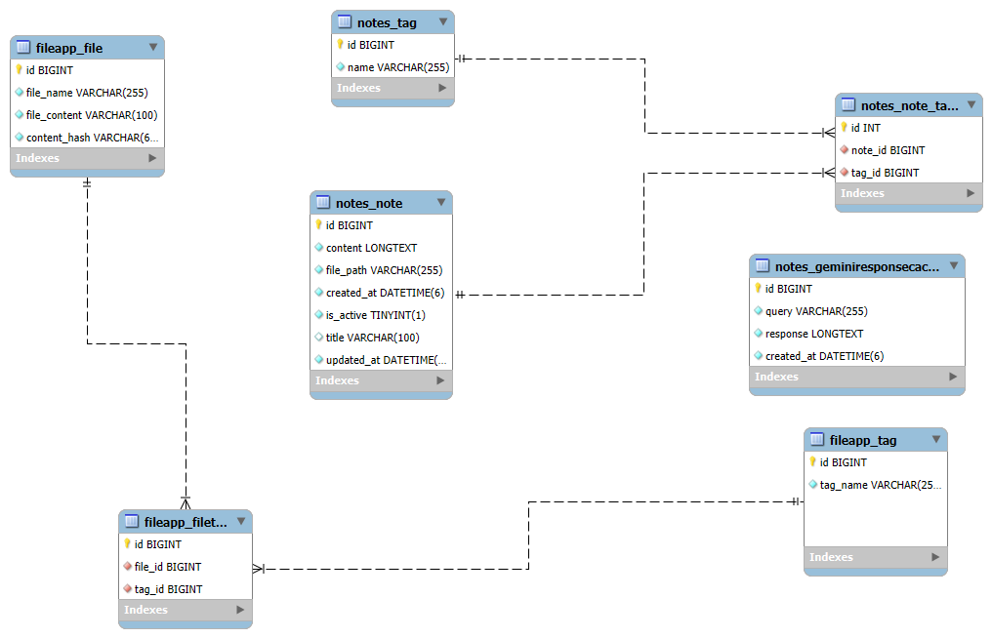
Fig 5.1 Entity relational diagram

5.2. Data Flow Diagram
Fig 5.2 represents a Data Flow Diagram (DFD) of a "SmartFile AI-Powered File Management System." It outlines the key processes and components involved in handling and managing files within the system. The diagram highlights the interaction between the user, admin, and the system, along with the steps for file upload, processing, and retrieval.

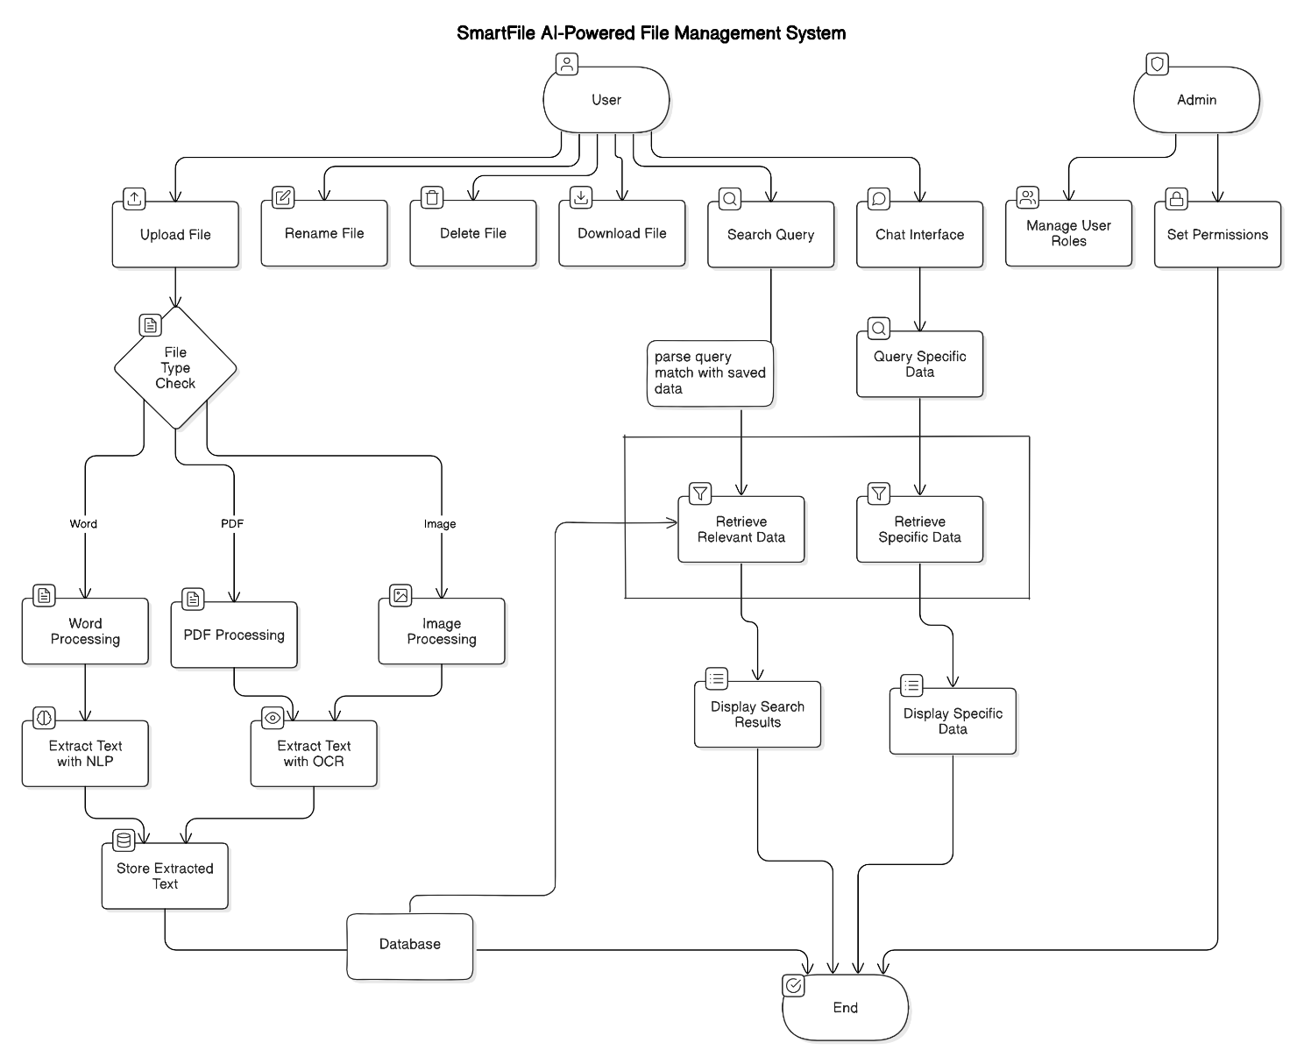
Fig 5.2 Data Flow Diagram

CHAPTER 6
HARDWARE/SOFTWARE PLATFORM ENVIRONMENT

6.1. Hardware Requirements:
To ensure seamless operation of the Smart File system, the following hardware configuration is recommended:
- Processor (CPU):
A multi-core processor (e.g., Intel i5 or higher) is essential to handle multiple concurrent operations like text extraction, real-time search processing, and managing simultaneous user requests.
- Memory (RAM):
A minimum of 8GB RAM is recommended for development purposes. For production environments, 16GB RAM or more is ideal, as it ensures smooth performance when handling large files, complex text extraction tasks, and efficient search operations.
- Storage:
The system should have at least 500GB of SSD storage for the initial phase of the project. SSDs are preferred over traditional hard drives due to their faster read/write speeds, which significantly enhances the system's ability to handle large files and improve the performance of content extraction and searches.
- Network:
A stable and high-speed internet connection with at least 50 Mbps is required to support fast uploads and downloads, as well as real-time processing of search queries and file management tasks.

6.2. Software Requirements:
The Smart File platform will be developed and deployed using a combination of robust software tools and libraries, chosen for their ability to support the system’s core functionalities:
6.2.1 Operating System:
The platform can be developed on either Windows or Linux (Ubuntu), with Ubuntu being the preferred choice for production environments due to its compatibility and stability with open-source tools such as Django, Python, and MySQL.

6.2.2 Backend Development:
- Django:
Django will be the backbone of the backend, providing a reliable and secure framework for building web applications. It will manage file uploads, metadata storage, content extraction processes, and implement the core business logic for searching and retrieving files.
    - Frontend Development:
A. HTML5 and CSS3:
HTML5 and CSS3 will be used to design a responsive and clean interface, making it easy for users to upload, manage, and search files in a visually appealing way.
B. JavaScript:
JavaScript will add interactivity to the frontend, enabling features such as dynamic file previews, search result display, and user actions like file renaming or deletion.
6.2.4 Database:
A. MySQL:
MySQL will be the database system for storing the metadata about uploaded files, extracted text, and generated tags. MySQL’s high performance in querying large datasets will be crucial for fast search operations and efficient data retrieval.
6.2.5 Text Extraction and Machine Learning Models:
A.Tesseract OCR:
This open-source OCR engine will be used for extracting text from image-based files (e.g., scanned documents or images). This tool converts non-searchable text (e.g., from scanned PDFs or images) into machine-readable data, enabling full-text search capabilities.
- PyPDF2 & Textract:
PyPDF2 and Textract are Python libraries used for extracting text from PDF and Word documents, respectively. These libraries will enable the system to convert document contents into searchable text, making it easier for users to find specific information within these file types.
- spaCy:
spaCy is a powerful Natural Language Processing (NLP) library used to process the extracted text from files. It will help generate meaningful tags from the text, enabling more efficient and accurate search results. spaCy supports features like tokenization, part-of-speech tagging, and named entity recognition (NER), which are essential for improving search accuracy.
- BERT (Bidirectional Encoder Representations from Transformers):
BERT will enhance the semantic search capabilities of the system. This pretrained deep learning model will enable Smart File to understand the context behind user queries, allowing for more relevant search results. Rather than relying solely on keyword matching, BERT allows the system to interpret the intent of queries and return accurate results based on context (e.g., recognizing specific personal data such as Aadhaar numbers).
    - Development Tools:
A. VS Code (Visual Studio Code):
VS Code will be used as the integrated development environment (IDE) for both backend and frontend development. It supports various programming languages, including Python, JavaScript, and HTML/CSS, and provides features like version control and code debugging, making it an efficient choice for development.
B. Python:
Python will be the core programming language used for backend development, specifically for tasks like text extraction, machine learning model integration, and data handling.
C. Git:
Git will be employed for version control, allowing multiple developers to collaborate effectively. It will track changes in code, manage different versions of the project, and simplify the deployment process.

CHAPTER 7
SANAPSHOTS OF INPUT & OUTPUT

7.1. Upload And Search Files:
Figure 7.1 illustrates the user interface of a "Smart File" application. It comprises two main sections:
7.1.1. Upload a File: This section allows users to upload files by selecting them from their device. It includes a "Choose File" option and an "Upload" button to complete the process.

7.1.2. Search Files: Users can search for specific files by entering a query in the provided search bar and clicking the "Search" button.
The interface is simple and user-friendly, with a clear separation of uploading and searching functionalities. Below, a placeholder indicates search results or a message if no files are found.

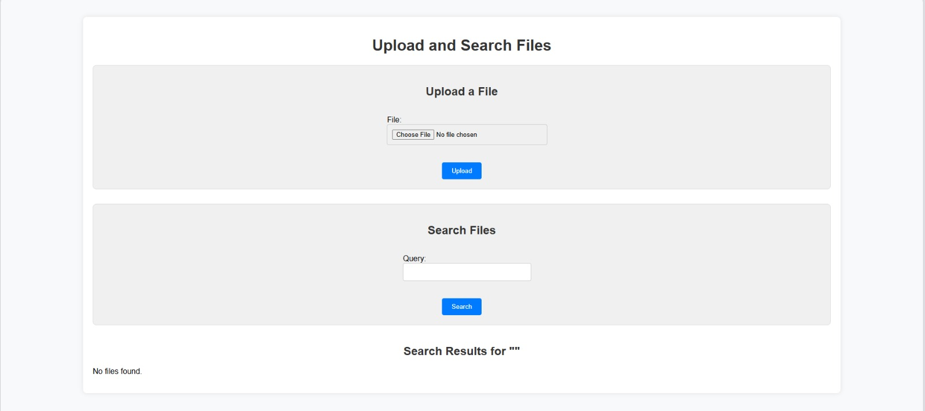
Fig 7.1 User Interface of Smart File

Figure 7.2 illustrates the process of searching for a file within a system interface. The user inputs a query ("tarun") and receives a search result with a matching file displayed. The interface provides options to download or delete the selected file. The screenshot highlights a functional file management system that supports basic search and file handling operations.

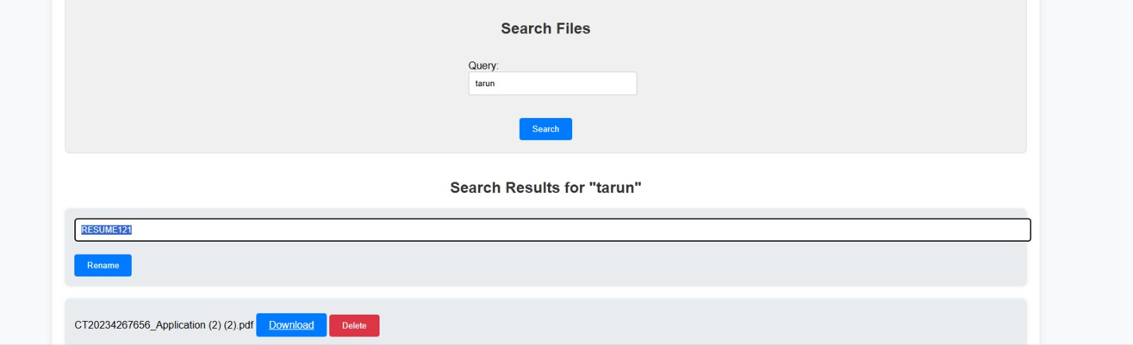
Fig 7.2 Searching for file

Figure 7.3 appears to be the result of a search function in an application interface, showcasing a search query for "tarun." The results display two downloadable files, labeled "RESUME121.pdf" and "CT20234267656_Application(2)(2).pdf," each with options to download or delete the file.

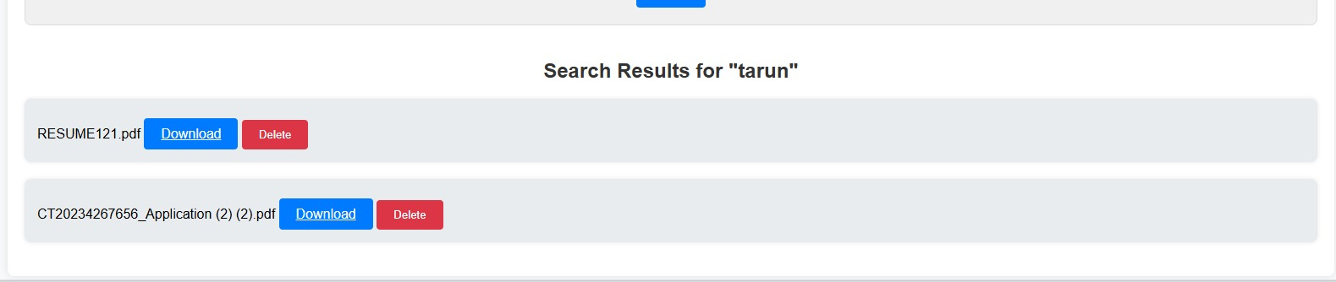
Fig 7.3 Result of Search

Figure 7.4 appears to show a representation of file management, likely within a computer or online storage system, as depicted by the image. The interface includes folders and files arranged in a grid view, each labeled with names such as "Test Set," "Header," and other file or folder names. This figure is used to illustrate how users can organize, manage, and access files within a digital environment, emphasizing the importance of structured storage for ease of navigation and file retrieval. The title "File Management" highlights the focus on organizing digital content efficiently.

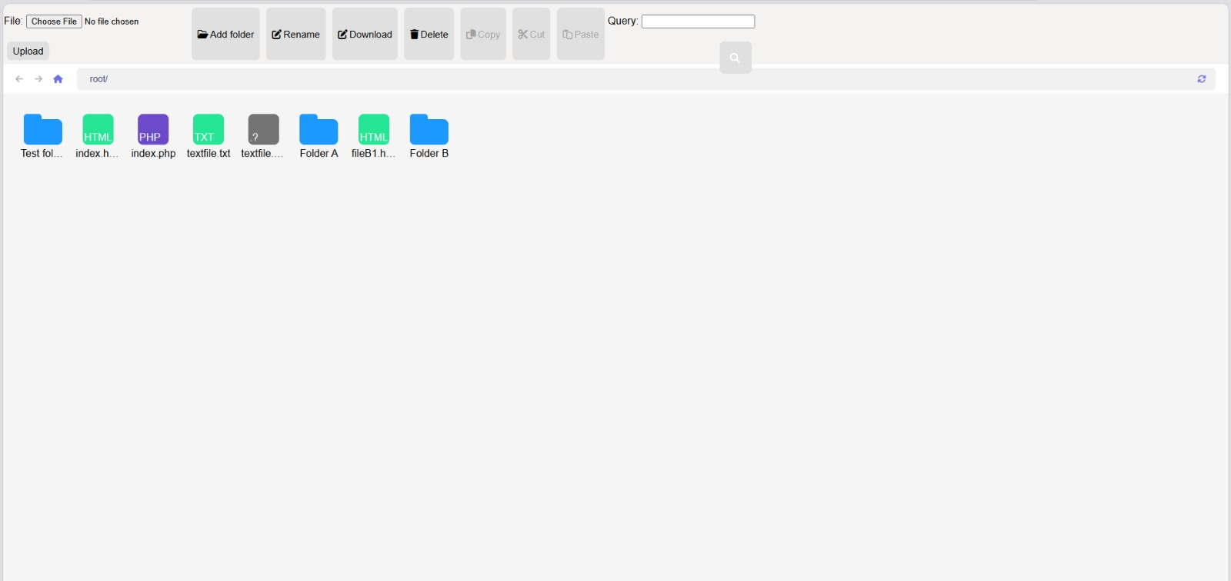
Fig 7.4 File Management

7.2. AI-Based Smart Searching Interface:
Fig 7.5 and Fig 7.6 depicts an AI-based smart searching interface named "RareNote Chat." The interface provides options for users to interact in different modes, such as "Search Mode" and "Genius Mode," enabling AI-assisted search and note-taking functionalities. Users can input their queries in a text box at the bottom, and the system appears to leverage AI algorithms for precise and intelligent results. This system likely enhances productivity by streamlining search processes with contextual AI support.

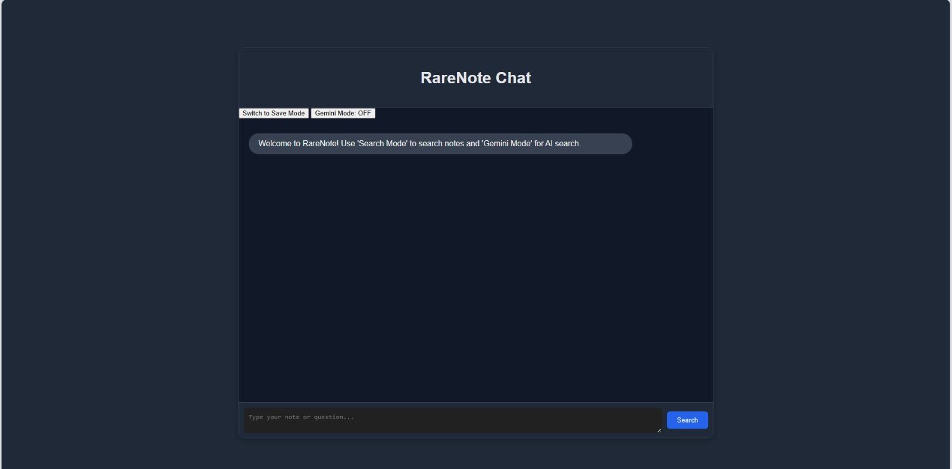
Fig 7.5 AI based smart searching

Fig 7.7 illustrates an AI-based result display from "RareNote Chat." The interface shows multiple error messages, such as "Error saving your note" and "Error processing your search," indicating potential issues with the system's functionality. The figure emphasizes the importance of error handling and user feedback mechanisms in AI-driven applications. Despite errors, the interface retains its layout for note-taking and query input, highlighting its design for managing interactions even during technical disruptions.
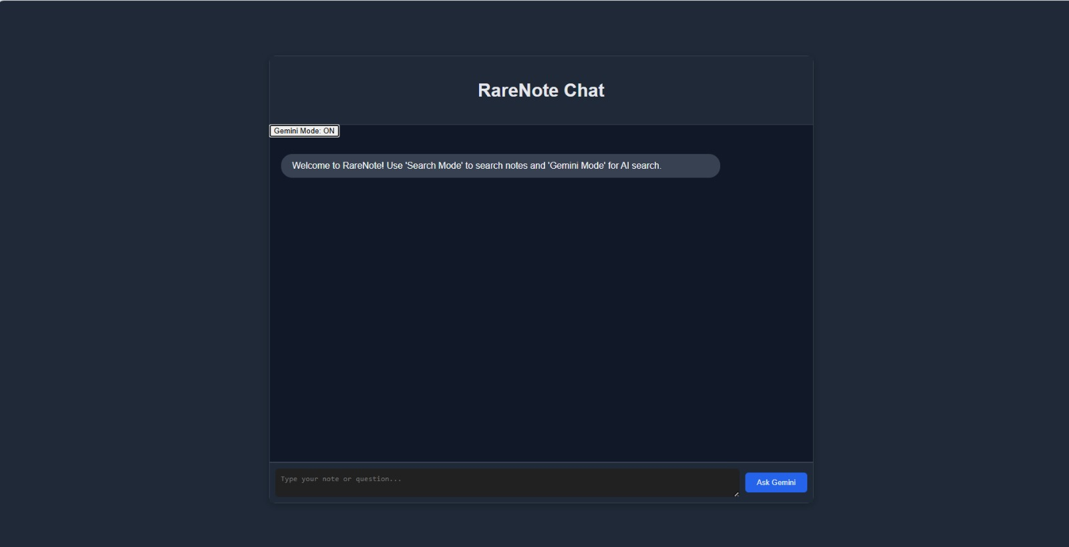
Fig 7.6 Switching AI mode

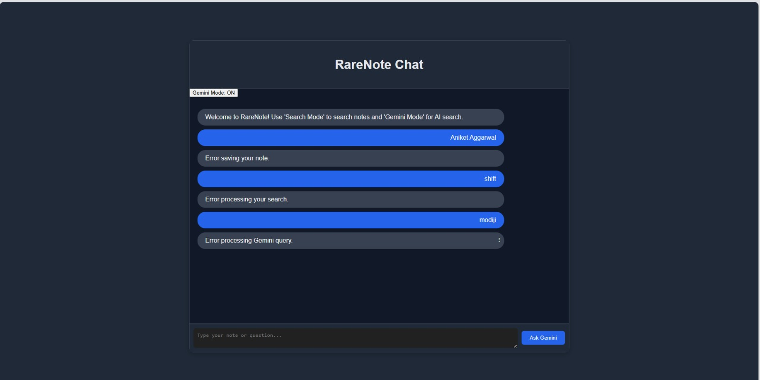
Fig 7.7 AI based result of file.

CHAPTER 8
CODING

8.1. HTML:
<!DOCTYPE html>
<html lang="en">
<head>
<meta charset="UTF-8">
<meta name="viewport" content="width=device-width, initial-scale=1.0">
<title>Smart Files - Upload, Search, and Chat</title>
<link rel="stylesheet" href="styles.css">
<script src="<https://code.jquery.com/jquery-3.6.0.min.js>"></script>
</head>
<body>
<div id="container">
<div id="chat-container">
<header id="header">
<h1>NoteGPT</h1>
</header>
<!-- Toggle between Save and Search Modes -->
<div id="toggle-container">
<button id="toggle-button">Switch to Search Mode</button>
<button id="gemini-toggle-button">Gemini Mode: OFF</button>
</div>
<!-- Chat Box for displaying messages -->
<div id="chat-box">
<div class="bot-message">
Welcome to NoteGPT! Use 'Search Mode' to search files/notes, 'Gemini Mode' for AI search, and 'Save Mode' to save notes.
</div>
</div>
<!-- Input container for sending messages -->
<div id="input-container">
<textarea id="chat-input" placeholder="Type your message..."></textarea>
<button id="send-button">Send</button>
</div>
</div>
<div id="file-container">
<!-- File Upload Section -->
<section class="upload-section">
<h2>Upload a File</h2>
<form id="upload-form" enctype="multipart/form-data">
<input type="file" id="file-upload" name="file">
<button type="submit">Upload</button>
</form>
</section>
<!-- Search Section -->
<section class="search-section">
<h2>Search Files</h2>
<form id="search-form">
<input type="text" id="search-query" placeholder="Enter search query">
<button type="submit">Search</button>
</form>
<div id="search-results"></div>
</section>
</div>
</div>
<script src="script.js"></script>
</body>
</html>

8.2. CSS (styles.css):
/* Global Styles */
body {
font-family: 'Helvetica Neue', Arial, sans-serif;
background-color: #1f2937;
color: #e5e7eb;
display: flex;
justify-content: center;
align-items: center;
height: 100vh;
margin: 0;
}
#container {
display: flex;
width: 90%;
height: 90vh;
justify-content: space-between;
}
/* Chat Container */
#chat-container {
width: 60%;
display: flex;
flex-direction: column;
border-radius: 12px;
background-color: #111827;
border: 1px solid #374151;
box-shadow: 0 4px 12px rgba(0, 0, 0, 0.25);
}
#header {
padding: 20px;
text-align: center;
background-color: #1f2937;
border-bottom: 1px solid #374151;
}
#chat-box {
flex: 1;
padding: 20px;
overflow-y: auto;
border-bottom: 1px solid #374151;
}
#input-container {
display: flex;
padding: 10px;
background-color: #1f2937;
border-top: 1px solid #374151;
}
#chat-input {
flex: 1;
padding: 10px;
background-color: #111827;
border: none;
border-radius: 6px;
color: #e5e7eb;
resize: vertical;
max-height: 150px;
outline: none;
}
#send-button {
padding: 10px 20px;
margin-left: 10px;
background-color: #2563eb;
color: white;
border: none;
border-radius: 6px;
cursor: pointer;
transition: background-color 0.3s ease;
}
#send-button:hover {
background-color: #1d4ed8;
}
/* Toggle Buttons */
#toggle-container {
display: flex;
justify-content: space-between;
padding: 10px;
}

button {
background-color: #2563eb;
color: #f1f5f9;
padding: 10px;
border: none;
border-radius: 6px;
cursor: pointer;
transition: background-color 0.3s ease;
}
button:hover {
background-color: #1d4ed8;
}
/* File Upload and Search Container */
#file-container {
width: 35%;
display: flex;
flex-direction: column;
justify-content: space-around;
}
/* Upload Section */
.upload-section,
.search-section {
padding: 20px;
background-color: #111827;
border-radius: 12px;
border: 1px solid #374151;
}

.upload-section h2,
.search-section h2 {
text-align: center;
margin-bottom: 20px;
}
input[type="file"],
input[type="text"] {
width: 100%;
padding: 10px;
margin-bottom: 10px;
background-color: #1f2937;
border: none;
color: #e5e7eb;
border-radius: 6px;
}
button {
width: 100%;
padding: 10px;
background-color: #2563eb;
color: white;
border: none;
border-radius: 6px;
cursor: pointer;
}
#search-results {
margin-top: 20px;
color: #f3f4f6;
}

/* Message Styles */
.user-message, .bot-message {
padding: 12px 20px;
border-radius: 20px;
margin: 10px 0;
max-width: 80%;
}

.user-message {
background-color: #2563eb;
color: #f1f5f9;
align-self: flex-end;
text-align: right;
}

.bot-message {
background-color: #374151;
color: #f3f4f6;
align-self: flex-start;
}
8.3. JavaScript (script.js):
$(document).ready(function () {
let mode = 'save'; // Default mode is 'Save Mode'
let geminiMode = false; // Gemini Mode is initially OFF

// Toggle between Save Mode and Search Mode
$('#toggle-button').click(function () {
if (geminiMode) return; // Do nothing if Gemini Mode is on

if (mode === 'save') {
mode = 'search';
$('#toggle-button').text('Switch to Save Mode');
$('#send-button').text('Search');
} else {
mode = 'save';
$('#toggle-button').text('Switch to Search Mode');
$('#send-button').text('Save');
}
});

// Toggle Gemini Mode ON/OFF
$('#gemini-toggle-button').click(function () {
geminiMode = !geminiMode;
if (geminiMode) {
$('#gemini-toggle-button').text('Gemini Mode: ON');
$('#toggle-button').hide(); // Hide local toggle button
$('#send-button').text('Ask Gemini');
} else {
$('#gemini-toggle-button').text('Gemini Mode: OFF');
$('#toggle-button').show();
$('#send-button').text(mode === 'save' ? 'Save' : 'Search');
}
});

// Send message when button clicked
$('#send-button').click(function () {
const message = $('#chat-input').val().trim();
if (message === '') return;

addMessageToChat('user-message', message);
$('#chat-input').val('');

const csrftoken = getCookie('csrftoken');

if (geminiMode) {
// Send request to Gemini AI
$.ajax({
type: 'POST',
url: '/gemini_query/',
data: { message: message },
headers: { 'X-CSRFToken': csrftoken },
success: function (data) {
addMessageToChat('bot-message', data.response, true);
},
error: function () {
addMessageToChat('bot-message', 'Error processing Gemini query.');
}
});
} else if (mode === 'search') {
// Local Search Mode
$.ajax({
type: 'POST',
url: '/search_notes/',
data: { message: message },
headers: { 'X-CSRFToken': csrftoken },
success: function (data) {
addMessageToChat('bot-message', data.response, true);
},
error: function () {
addMessageToChat('bot-message', 'Error processing your search.');
}
});
} else {
// Local Save Mode
$.ajax({
type:

'POST',
url: '/save_note/',
data: { message: message },
headers: { 'X-CSRFToken': csrftoken },
success: function (data) {
addMessageToChat('bot-message', data.response);
},
error: function () {
addMessageToChat('bot-message', 'Error saving your note.');
}
});
}
});

// File Upload Handling
$('#upload-form').submit(function (event) {
event.preventDefault();
const fileInput = $('#file-upload')[0];
const formData = new FormData();
formData.append('file', fileInput.files[0]);

$.ajax({
type: 'POST',
url: '/upload_file/',
data: formData,
contentType: false,
processData: false,
success: function (data) {
alert('File uploaded successfully.');
},
error: function () {
alert('Error uploading file.');
}
});
});

// File Search Handling
$('#search-form').submit(function (event) {
event.preventDefault();
const query = $('#search-query').val().trim();

$.ajax({
type: 'POST',
url: '/search_files/',
data: { query: query },
success: function (data) {
$('#search-results').html('');
if (data.files.length > 0) {
data.files.forEach(function (file) {
$('#search-results').append(`<div>${file.name}</div>`);
});
} else {
$('#search-results').text('No files found.');
}
},
error: function () {
alert('Error searching files.');
}
});
});

function addMessageToChat(className, message, isHtml = false) {
const messageDiv = $('<div>').addClass(className);
if (isHtml) {
messageDiv.html(message);
} else {
messageDiv.text(message);
}
$('#chat-box').append(messageDiv);
$('#chat-box').scrollTop($('#chat-box')[0].scrollHeight);
}

function getCookie(name) {
let cookieValue = null;
if (document.cookie && document.cookie !== '') {
const cookies = document.cookie.split(';');
for (let cookie of cookies) {
cookie = cookie.trim();
if (cookie.substring(0, name.length + 1) === (name + '=')) {
cookieValue = decodeURIComponent(cookie.substring(name.length + 1));
break;
}
}
}
return cookieValue;
}
});

8.4. Python (View.py):
import os
import re
from datetime import datetime
from django.conf import settings
from django.http import JsonResponse
from django.shortcuts import render
from django.views.decorators.csrf import csrf_exempt
from django.core.files.storage import default_storage
from django.core.files.base import ContentFile
from sentence_transformers import SentenceTransformer, util
from sklearn.feature_extraction.text import TfidfVectorizer
from transformers import T5Tokenizer, T5ForConditionalGeneration, pipeline
from .models import Note, Tag, File, FileTag # Assuming models for Note, Tag, File, and FileTag
import torch
import networkx as nx
from google.generativeai import configure, GenerativeModel

# Load environment variables
configure(api_key=os.getenv('GEMINI_API_KEY'))

# Initialize models
t5_tokenizer = T5Tokenizer.from_pretrained("t5-base")
t5_model = T5ForConditionalGeneration.from_pretrained("t5-base")
search_model = SentenceTransformer('all-MiniLM-L6-v2')
ner_pipeline = pipeline("ner", model="dslim/bert-base-NER")
knowledge_graph = nx.Graph()
tag_to_file_map = {}

# Load existing files into the model (search model & knowledge graph)
def load_existing_notes_and_files():
notes = list(Note.objects.all().values_list('content', flat=True))
search_model.encode(notes, convert_to_tensor=True)
for note in notes:
add_to_knowledge_graph(note)

files = list(File.objects.all())
for file in files:
file_tags = FileTag.objects.filter(file=file).values_list('tag__name', flat=True)
for tag in file_tags:
if tag not in tag_to_file_map:
tag_to_file_map[tag] = set()
tag_to_file_map[tag].add(file.file_name)

load_existing_notes_and_files()

# Save new notes into the database
@csrf_exempt
def save_note_view(request):
if request.method == 'POST':
content = request.POST.get('message', '').strip()
if content == '':
return JsonResponse({'response': 'Note content cannot be empty.'})

# Save note content to a date-specific file
file_path = save_note_to_file(content)
note = Note.objects.create(content=content, file_path=file_path)

# Extract tags from the note
tags = extract_tags(content)
for tag in tags:
if tag not in tag_to_file_map:
tag_to_file_map[tag] = set()
tag_to_file_map[tag].add(file_path)

# Update the model and knowledge graph
all_notes = list(Note.objects.all().values_list('content', flat=True))
search_model.encode(all_notes, convert_to_tensor=True)
add_to_knowledge_graph(content)

return JsonResponse({'response': 'Note saved successfully.'})

return JsonResponse({'response': 'Invalid request method.'}, status=400)
# Search notes and files using semantic search and graph inference
@csrf_exempt
def search_notes_view(request):
if request.method == 'POST':
query = request.POST.get('message', '').strip()
if not query:
return JsonResponse({'response': 'Query cannot be empty.'})
# Infer from the knowledge graph
inferred_answer = infer_from_knowledge_graph(query)
if inferred_answer:
return JsonResponse({'response': inferred_answer})
# Use semantic search to find relevant notes
results = search_notes(query)
if results:
return JsonResponse({'response': "<br>".join(results)})
return JsonResponse({'response': 'No relevant notes found.'})
return JsonResponse({'response': 'Invalid request method.'}, status=400)
def search_notes(query):
query_embedding = search_model.encode(query, convert_to_tensor=True)
all_notes = list(Note.objects.all().values_list('content', flat=True))
note_embeddings = search_model.encode(all_notes, convert_to_tensor=True)
cosine_scores = util.pytorch_cos_sim(query_embedding, note_embeddings)[0]
top_results = torch.topk(cosine_scores, k=5)
results = []
for idx in top_results.indices:
note = all_notes[idx]
answer = generate_answer_t5(query, note)
if answer:
results.append(answer)
return results
# Generate an answer using the T5 model for question-answering
def generate_answer_t5(question, context):
input_text = f"question: {question} context: {context}"
input_ids = t5_tokenizer.encode(input_text, return_tensors="pt")
outputs = t5_model.generate(input_ids, max_length=50, num_beams=4, early_stopping=True)
return t5_tokenizer.decode(outputs[0], skip_special_tokens=True)

# Infer relationships from the knowledge graph
def infer_from_knowledge_graph(query):
entities = ner_pipeline(query)
main_entity = entities[0]['word'] if entities else None
if main_entity in knowledge_graph:
neighbors = list(knowledge_graph.neighbors(main_entity))
return ', '.join(neighbors) if neighbors else None
return None

# Add to the knowledge graph using named entity recognition
def add_to_knowledge_graph(note):
entities = ner_pipeline(note)
for entity in entities:
entity_word = entity['word']
if entity_word not in knowledge_graph:
knowledge_graph.add_node(entity_word)

relationship_patterns = [
(r'(\\w+) is a type of (\\w+)', 'is_a_type_of'),
(r'(\\w+) related to (\\w+)', 'related_to')
]
for pattern, relation in relationship_patterns:
matches = re.findall(pattern, note)
for match in matches:
entity1, entity2 = match
knowledge_graph.add_edge(entity1, entity2, relation=relation)

# File Upload
@csrf_exempt
def upload_file_view(request):
if request.method == 'POST':
uploaded_file = request.FILES['file']
file_name = uploaded_file.name
file_path = os.path.join(settings.MEDIA_ROOT, file_name)

# Save file to media directory
default_storage.save(file_path, ContentFile(uploaded_file.read()))

# Extract tags from the file content
file_content = extract_file_content(file_path)
tags = extract_tags(file_content)

# Save file metadata and tags in the database
file_instance = File.objects.create(file_name=file_name)
for tag in tags:
tag_obj, _ = Tag.objects.get_or_create(name=tag)
FileTag.objects.create(file=file_instance, tag=tag_obj)

return JsonResponse({'response': 'File uploaded successfully.'})

return JsonResponse({'response': 'Invalid request method.'}, status=400)

# Extract text content from uploaded files (e.g., PDF, DOC)
def extract_file_content(file_path):
try:
if file_path.endswith('.pdf'):
# Implement PDF text extraction
return 'Extracted content from PDF'
elif file_path.endswith('.docx'):
# Implement DOCX text extraction
return 'Extracted content from DOCX'
except Exception as e:
print(f"Error extracting content: {e}")
return ''

# Search Files
@csrf_exempt
def search_files_view(request):
if request.method == 'POST':
query = request.POST.get('query', '').strip()
if not query:
return JsonResponse({'response': 'Query cannot be empty.'})

# Perform tag-based search
files_found = search_files_by_tags(query)

if files_found:
return JsonResponse({'files': [{'name': file.file_name} for file in files_found]})

return JsonResponse({'files': []})

return JsonResponse({'response': 'Invalid request method.'}, status=400)

def search_files_by_tags(query):
query_tags = extract_tags(query)
file_hits = set()
for tag in query_tags:
if tag in tag_to_file_map:
file_hits.update(tag_to_file_map[tag])
return File.objects.filter(file_name__in=file_hits)

# Utility Functions
def save_note_to_file(content):
notes_directory = settings.NOTES_DIR
if not os.path.exists(notes_directory):
os.makedirs(notes_directory)

date_str = datetime.now().strftime('%Y-%m-%d')
file_name = f"notes_{date_str}.txt"
file_path = os.path.join(notes_directory, file_name)

with open(file_path, 'a') as file:
file.write(content + "\\n")
return file_path

def extract_tags(content):
vectorizer = TfidfVectorizer(max_features=90, stop_words='english')
X = vectorizer.fit_transform([content])
feature_names = vectorizer.get_feature_names_out()
tfidf_scores = X.toarray()[0]
sorted_words = sorted(zip(feature_names, tfidf_scores), key=lambda x: x[1], reverse=True)
top_tags = [word for word, score in sorted_words][:90]
return top_tags

CHAPTER 9
PROJECT LIMITATION & FUTURE SCOPE

9.1. Project Limitations
- Limited File Compatibility: While Smart File excels with popular file types, it faces challenges with certain complex or proprietary formats, such as encrypted files and those with non-standard encoding. This limitation can restrict the system’s flexibility, impacting users who work with a variety of specialized documents.
- OCR Precision Limitations: Smart File’s OCR technology, though effective, isn’t perfect—especially with low-quality scans, handwritten documents, or busy backgrounds. In these cases, text extraction accuracy can suffer, potentially resulting in missed or incorrect data and necessitating manual verification.
- Performance Constraints on Large Files: When handling large, high-resolution documents or multi-page PDFs, Smart File may experience slower processing times. These performance bottlenecks can impact productivity for users managing extensive document libraries or needing rapid file retrieval.
- Limited Contextual Understanding in NLP: Despite Smart File’s use of NLP for tagging and searching, its ability to fully grasp document context remains limited. This can make it difficult for the system to consistently interpret nuanced search queries or prioritize the most relevant information in complex documents.
- Data Privacy and Security Risks: Although Smart File includes CSRF protection and secure file handling, managing highly sensitive information—such as legal, financial, or medical records—requires heightened security measures. Privacy and data protection standards must continually be strengthened to address potential vulnerabilities, especially as cyber threats evolve.
- Reliance on Third-Party Libraries: Smart File’s core functions depend on external libraries for OCR, NLP, and text extraction. This reliance introduces potential risks if these libraries encounter compatibility issues, lack support, or become outdated, which could compromise Smart File’s capabilities until new solutions are implemented.

9.2. Future Scope
- Advanced OCR and NLP Capabilities: Incorporating advanced deep-learning models could dramatically enhance Smart File’s OCR accuracy, particularly for difficult-to-read documents, such as handwritten text or low-quality scans. This evolution would enable more reliable data extraction across all document types.
- Multi-Language Support Expansion: With the global nature of digital work, adding multi-language support would position Smart File as a versatile tool for diverse users. By implementing language-specific NLP models and multi-script OCR capabilities, Smart File could handle content across languages and scripts, facilitating cross-cultural document management.
- Enhanced Semantic Search and AI Insights: Future versions of Smart File could feature semantic search, allowing users to search by intent rather than exact keywords. For instance, users could type “find last year’s contract” and receive relevant results based on meaning. Additionally, AI could provide insights like document summaries and flagged sections, making file interactions more intuitive.
- Cloud Integration for Cross-Platform Access: Integrating with popular cloud services such as Google Drive, Dropbox, and OneDrive would streamline Smart File’s functionality, enabling users to manage, search, and retrieve files directly from multiple platforms, offering seamless accessibility across devices.
- Team Collaboration Features: Smart File could grow into a collaborative hub, allowing users to share files, leave comments, and co-edit documents in real time. These enhancements would make it ideal for teams who need to work together on documents, fostering productivity through centralized and interactive file management.
- Intelligent Document Categorization and Tagging: By incorporating machine learning for auto-categorization, Smart File could recognize and classify documents like invoices, contracts, and reports automatically. This feature would simplify file organization and make search results more relevant by associating files with specific tags based on their content.
- Enhanced Security Measures for Confidential Files: Future security upgrades could include end-to-end encryption, stricter access controls, and multi-factor authentication, ensuring that Smart File remains a trusted platform for managing highly sensitive data. This would be crucial for industries with stringent data protection requirements, such as healthcare, legal, and finance.
- Mobile Accessibility for On-the-Go Users: Developing a mobile app would bring Smart File’s robust features to mobile devices, allowing users to search, upload, and manage files directly from their smartphones or tablets. A mobile app would offer greater flexibility, particularly for users who need secure access to their files while traveling or in the field.
With these enhancements, Smart File can evolve into a transformative solution, shaping the future of intelligent file management for individuals, teams, and organizations.

CHAPTER 10
REFERENCES

- https://www.djangoproject.com/

- https://spacy.io/

- https://networkx.github.io/

- https://github.com/jsvine/pdfplumber

- https://pypdf2.readthedocs.io/

- https://github.com/madmaze/pytesseract

- https://github.com/deanmalmgren/textract

- https://github.com/ankushshah89/docx2txt

- https://www.nltk.org/

- https://github.com/huggingface/transformers

- https://www.sbert.net/

- https://ai.google/tools/generative-ai/

- https://aws.amazon.com/s3/

- https://cloud.google.com/storage

- https://azure.microsoft.com/en-us/services/storage/blobs/

