AI-Assisted Coding Assignment-G.3
Lab 9: Documentation Generation – Automatic Documentation and Code Comments
Name: Vaishnavi Bairagoni
HT No.: 2303A51347
Batch: 20

Task 1: Basic Docstring Generation
- Python Function with Manual Google-Style Docstring
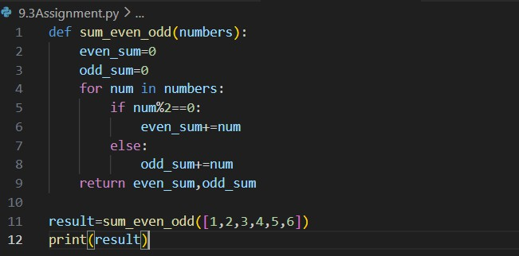
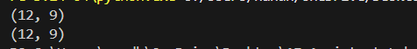

- AI-Generated Docstring
Prompt: Add a Google-style docstring to this function without modifying the code logic.
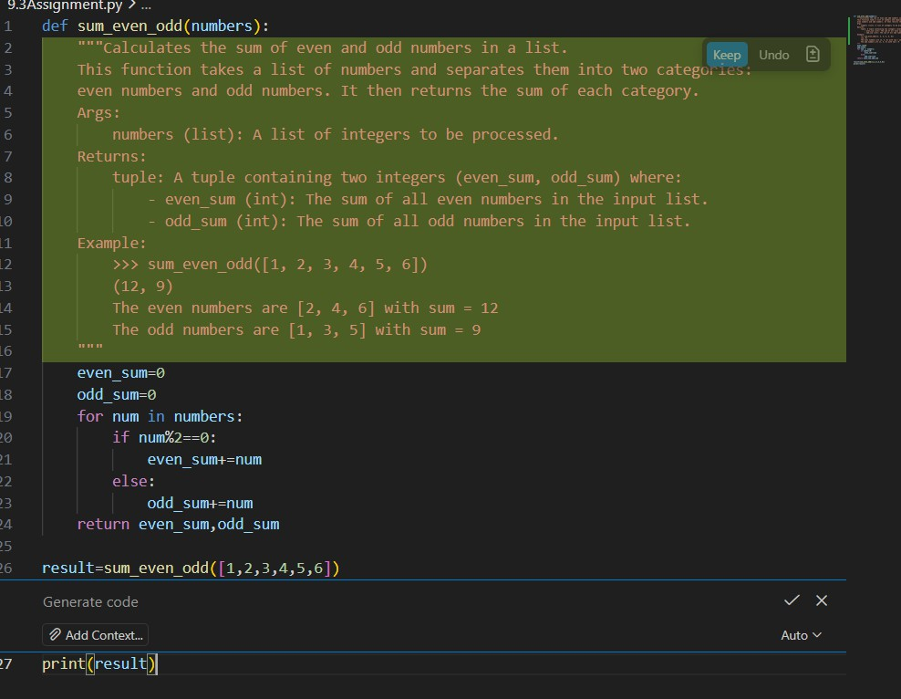
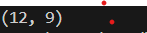

Observation:
During this experiment, a Python function was written to calculate the sum of even and odd numbers in a list. A manual Google-style docstring was added to the function, and an AI-generated docstring was also produced using an AI-assisted coding tool.It was
observed that the manually written docstring was more detailed and included clear descriptions, structured formatting, and example usage. The AI-generated docstring was correct and readable but shorter and sometimes missing examples or detailed explanations.This experiment showed that AI tools can quickly generate
documentation, which helps save time. However, manual review and refinement are necessary to ensure clarity, completeness, and accuracy in documentation.

Task 2: Automatic Inline Comments
- Manually Written Inline Comments
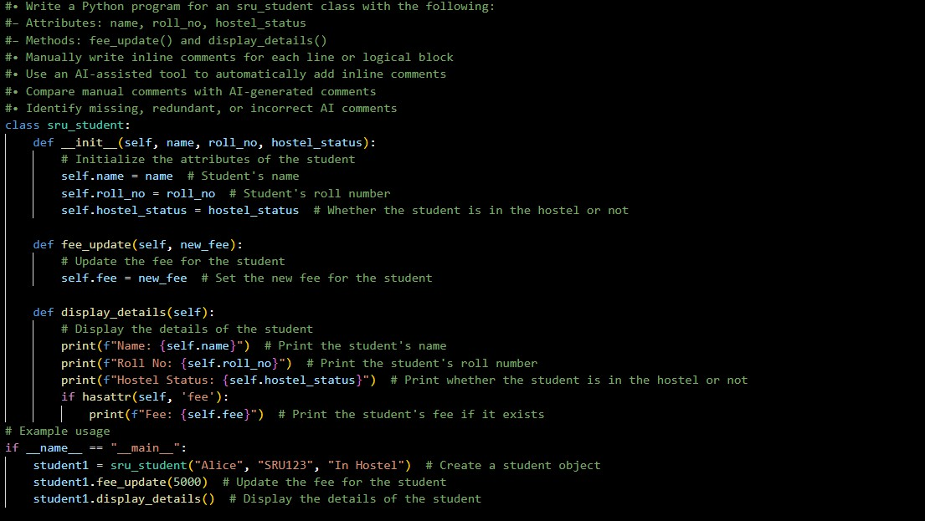
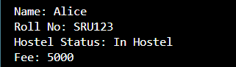

- AI-Generated Inline Comments Prompt:
Add meaningful inline comments to this Python class without modifying the code.

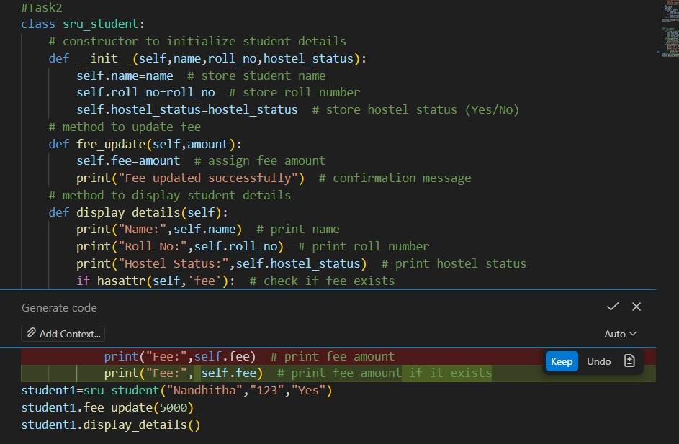
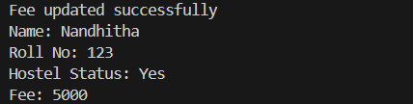

Observation
In this experiment, a Python class for managing student details was implemented.
Inline comments were first written manually to explain each part of the code. Then, an AI-assisted tool was used to automatically generate inline comments for the same program.It was observed that AI-generated comments were clear and helped in understanding the basic functionality of the code. However, some comments were
generic and less detailed compared to manually written comments. Manual comments were more precise and better explained the logic of the program.This experiment
showed that AI tools can quickly generate useful inline comments, but developers should review them to ensure accuracy, clarity, and completeness.

Task 3: Module-Level and Function-Level Documentation
- Python Script with Manual NumPy-Style Docstrings
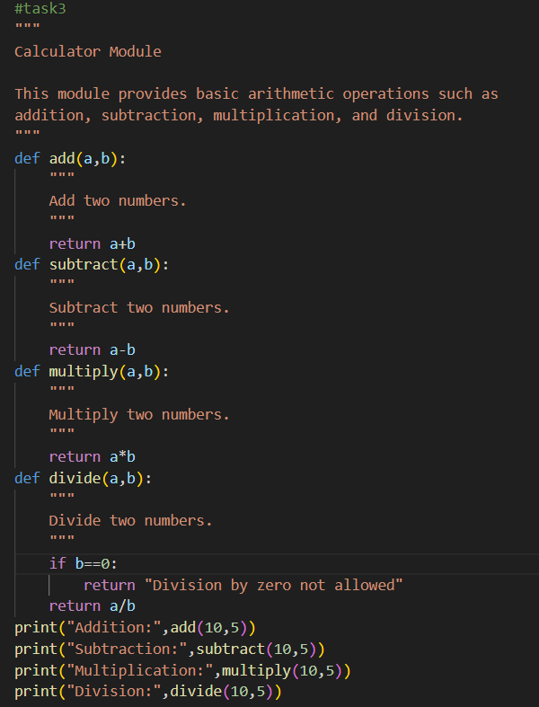

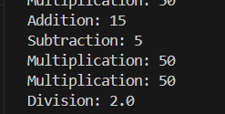

- AI-Generated Module and Function Documentation
Prompt:Add a module-level docstring and function-level docstrings to this Python calculator code without changing the logic.
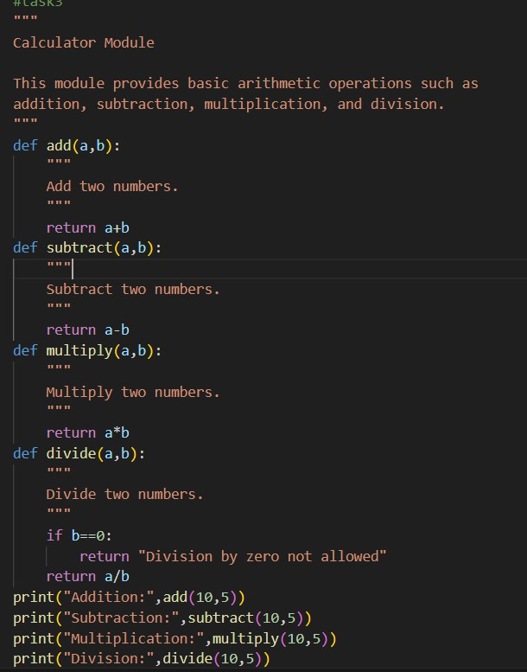

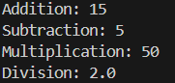

Observation
In this experiment, a calculator module containing multiple functions such as addition, subtraction, multiplication, and division was developed. Manual NumPy-style
docstrings were written for each function to provide structured documentation. Then,
AI-assisted tools were used to generate module-level and function-level documentation automatically.It was observed that the manually written documentation was more
detailed and followed a clear NumPy-style structure with proper parameter and return descriptions. The AI-generated documentation was correct and readable but shorter and less detailed in some sections.This experiment demonstrated that AI tools can
quickly generate documentation for multi-function scripts, which helps improve development speed. However, manual review and refinement are necessary to ensure completeness, accuracy, and proper structure in professional documentation.

