FitSense

A
Devops and Full Stack Development Course Project Report
in partial fulfilment of the degree

Bachelor of Technology
in
Computer Science & Engineering

By

Vaishnavi Bairagoni 2303A51347
Archana Kashaboina 2303A51329

Under the guidance of
N.Venkatesh
Assistant Professor

Submitted to
School of Computer Science and Artificial Intelligence




DEPARTMENT OF COMPUTER SCIENCE & ARTIFICIAL INTELLIGENCE

CERTIFICATE

This is to certify that the Devops and Full Stack Development Report entitled
“FitSense” is a record of bonafide work carried out by the student Vaishnavi Bairagoni bearing Roll No 2303A51347 and Archana Kashaboina 2303A51329 during the academic year 2025-26 in partial fulfillment of the award of the degree of Bachelor of Technology in Computer Science & Engineering by the SR University, Ananthasagar, Warangal.

Lab In-charge Head of the Department

N.Venkatesh Dr. Sandeep

Asst.Professor Dept of CSE, Assoc.Prof. & HOD( CSE)

SR University, SR University,

Ananthasagar, Warangal. Ananathasagar, Warangal.

ACKNOWLEDGEMENT

We owe an immense debt of gratitude to our esteemed project guide, Mr. N.Venkatesh , Assistant Professor, for his exceptional support and valuable guidance throughout the course of this project. His unwavering encouragement, coupled with his profound technical knowledge, has been a constant source of motivation for us. From the very beginning, his insightful suggestions and intellectual advice have been pivotal in shaping our ideas and aligning our efforts toward the successful completion of this endeavour. His patience and constructive feedback at every stage inspired us to think critically and deliver our best.

We are equally indebted to Dr.Sandeep , Associate Professor and Head of the Department of Computer Science and Artificial Intelligence, whose expert supervision and professional expertise added immense value to our work. Her clear vision, attention to detail, and inspiring leadership provided us with the clarity and focus necessary to approach our challenges effectively. Her words of encouragement and willingness to address our doubts have been instrumental in building our confidence and fostering our problem-solving skills.

We would also like to take this opportunity to extend our heartfelt gratitude and profound respect to our beloved Vice Chancellor, Prof. Deepak Garg, for his unwavering support and visionary guidance. His steadfast encouragement and commitment to fostering academic excellence have provided us with a conducive environment to pursue our project with passion and dedication. His inspiring leadership and belief in the potential of students like us have been a constant source of motivation, driving us to strive for excellence in every aspect of this project.

Furthermore, we would like to express our sincere appreciation to all the teaching and non-teaching staff of the Department of Computer Science and Engineering. Their timely support, valuable suggestions, and administrative assistance have greatly contributed to the smooth execution of this project. The collaborative and nurturing environment they have fostered has played a significant role in our academic journey and has encouraged us to push the boundaries of our knowledge and capabilities.

Finally, we are deeply thankful to everyone who, directly or indirectly, supported us throughout this endeavour. This project would not have been possible without the collective efforts and encouragement of those around us, and we will forever cherish their contributions.

TABLE OF CONTENTS

Sl. No | CONTENT | Page No.
1 | ABSTRACT | 1
2 | OBJECTIVE OF THE PROJECT | 2
3 | TECHONOLOGIES USED IN THE PROJECT | 3-4
4 | ELEMENTS USED IN THE PROJECT | 5
5 | DESIGNS (Screens) & RESULTS | 6-9
6 | IMPLEMENTATION (Code) | 10-15
7 | CONCLUSION | 16
8 | DEPLOYMENT LINK | 16

ABSTRACT

The project titled "FitSense" is a web-based fitness tracking application designed to enhance the management of personal health and workout activities. This interactive platform provides users with an intuitive and modern interface to record, monitor, and analyze their fitness routines efficiently.
The application consists of multiple interconnected modules, including Dashboard, Workouts, Analytics, Suggestions, and Profile, each serving a specific purpose. The Dashboard offers an overview of the user’s fitness progress, including workout statistics, calories burned, and activity streaks. The Workouts module enables users to log, edit, and manage their exercise routines, ensuring structured tracking of fitness activities.
A key feature of FitSense is its AI-based workout suggestion system, which generates personalized workout plans based on user inputs such as mood, energy level, and available time. This intelligent functionality enhances user engagement by providing tailored fitness recommendations.
The Analytics module presents visual insights through charts and trends, allowing users to evaluate their performance and consistency over time. Additionally, the Profile section enables users to manage personal information and track achievements, contributing to a personalized user experience.
The application is developed using modern web technologies including React for the frontend, Node.js and Express.js for the backend, and MongoDB for data storage. Axios is used for efficient API communication, and Framer Motion enhances the interface with smooth animations.
FitSense demonstrates how full-stack web technologies can be utilized to create a scalable, user-friendly, and intelligent fitness tracking system. The project highlights the importance of data-driven decision-making in personal health management and provides a foundation for future enhancements in digital fitness solutions.

1

OBJECTIVE OF THE PROJECT

The primary objective of the "FitSense" project is to develop a comprehensive and user-friendly fi
tness tracking platform that enables individuals to monitor their physical activities, analyze performance, and receive personalized workout recommendations. The application is designed to achieve the following key objectives:
Centralized Fitness Tracking:
To provide a unified platform where users can log, manage, and access all their workout-related data, including exercise type, duration, calories burned, and activity history in an organized manner.
Enhanced User Engagement:
To improve user motivation and consistency by offering an intuitive interface, real-time feedback, and progress tracking through dashboards and activity summaries.
Personalized Workout Recommendations:
To implement an intelligent suggestion system that generates customized workout plans based on user inputs such as mood, energy level, and available time, enhancing the overall fitness experience.
Data Visualization and Insights:
To present fitness data through interactive charts and analytics, enabling users to understand trends, monitor performance, and make informed decisions about their health.
Efficient Data Management:
To ensure secure and efficient handling of user data, including authentication, storage, and retrieval, using modern backend technologies and database systems.
Improved User Experience:
To design a responsive and visually appealing interface with smooth animations and intuitive navigation, making the application accessible across devices.
Error Handling and Reliability:
To incorporate proper validation and error-handling mechanisms that ensure the system remains stable, user-friendly, and resilient to invalid inputs and system failures.
Scalability and Future Enhancement:
To develop a flexible and scalable architecture that can support future features such as advanced analytics, social sharing, and integration with wearable fitness devices.
By achieving these objectives, the FitSense project demonstrates how modern web technologies can be effectively utilized to promote healthier lifestyles, improve user engagement, and provide intelligent, data-driven fitness solutions.

2
TECHNOLOGIES USED
The FitSense application is developed using modern web technologies that ensure scalability, performance, and a rich user experience. The key technologies used in the project are as follows:

1. React (Frontend Library)
- Used to build a dynamic and interactive user interface.
- Enables component-based architecture for better code organization and reusability.
- Handles state management using React Hooks for efficient data flow.
- Provides fast rendering and smooth user experience.

2. Vite (Build Tool)
- Used for fast development and optimized production builds.
- Provides instant server start and hot module replacement (HMR).
- Enhances overall development speed and efficiency.

3. CSS (Cascading Style Sheets)
- Used to design the visual layout and styling of the application.
- Implements modern UI techniques such as glassmorphism and gradient effects.
- Ensures responsive design for different screen sizes and devices.
- Enhances user experience with smooth transitions and animations.

4. JavaScript (JS)
- Adds interactivity and dynamic behavior to the application.
- Handles user events such as form inputs, button clicks, and validations.
- Enables communication between frontend and backend through API calls.

5. Node.js (Backend Runtime)
- Provides a server-side runtime environment for executing JavaScript.
- Handles asynchronous operations efficiently.
- Powers the backend logic and API services.

6. Express.js (Backend Framework)
- Used to build RESTful APIs for handling requests and responses.
- Manages routing, middleware, and server-side logic.
- Ensures structured and scalable backend architecture.

3

7. MongoDB (Database)
- A NoSQL database used to store user data and workout records.
- Provides flexibility in handling structured and unstructured data.
- Enables efficient data retrieval and scalability.

8. Mongoose (ODM Library)
- Facilitates interaction between Node.js and MongoDB.
- Defines schemas and models for structured data management.
- Ensures data validation and consistency.

9. Axios (HTTP Client)
- Used for communication between frontend and backend.
- Handles API requests and responses efficiently.
- Implements interceptors for authentication and error handling.

10. Framer Motion (Animation Library)
- Adds smooth animations and transitions to the UI.
- Enhances user experience with interactive and responsive motion effects.

11. React Hot Toast (Notification Library)
- Provides real-time feedback to users through toast notifications.
- Used for success, error, and informational messages.

Additional Tools and Features
- JWT Authentication: Ensures secure user login and session management.
- Responsive Design: Adapts the interface for mobile, tablet, and desktop devices.
- Error Handling System: Provides user-friendly messages for invalid inputs and API failures.
- Browser Developer Tools: Used for debugging and performance optimization.

The combination of these technologies enables FitSense to deliver a scalable, efficient, and user-friendly fitness tracking system with modern design and real-time interactivity.

4
ELEMENTS USED IN THE PROJECT

The FitSense application integrates several functional and user interface elements to provide a complete fitness tracking experience. These elements are designed to ensure smooth interaction, efficient data handling, and an intuitive user experience.
The application consists of multiple pages, including Dashboard, Workouts, Analytics, Suggestions, and Profile. Each page serves a specific purpose. The Dashboard provides an overview of user activity such as total workouts, calories burned, and recent progress. The Workouts page allows users to add, edit, and delete workout records. The Suggestions page generates workout plans based on user inputs like mood, energy level, and available time. The Analytics page displays workout data in the form of charts and trends, while the Profile page allows users to manage personal information and account settings.
Navigation is handled through a sidebar, which enables users to switch between different sections of the application easily. Forms are used throughout the application for user input, including login, registration, workout entry, and profile updates.
Interactive elements such as buttons, dropdowns, and input fields are used to enhance usability. Features like modals are implemented for adding and editing workouts without navigating away from the page. Toast notifications are used to provide feedback for actions such as successful login, errors, or data updates.
The application also includes dynamic components that update in real time, such as workout lists and analytics charts. Animations are incorporated using motion effects to improve the visual experience and make interactions smoother.
From a user experience perspective, the application is designed to be responsive, ensuring it works across devices such as mobile phones, tablets, and desktops. Basic validation is implemented in forms to prevent invalid data entry and improve reliability.
These elements together contribute to creating a functional, interactive, and user-friendly fitness tracking application.
.

5
DESIGN & RESULTS
SCREENS
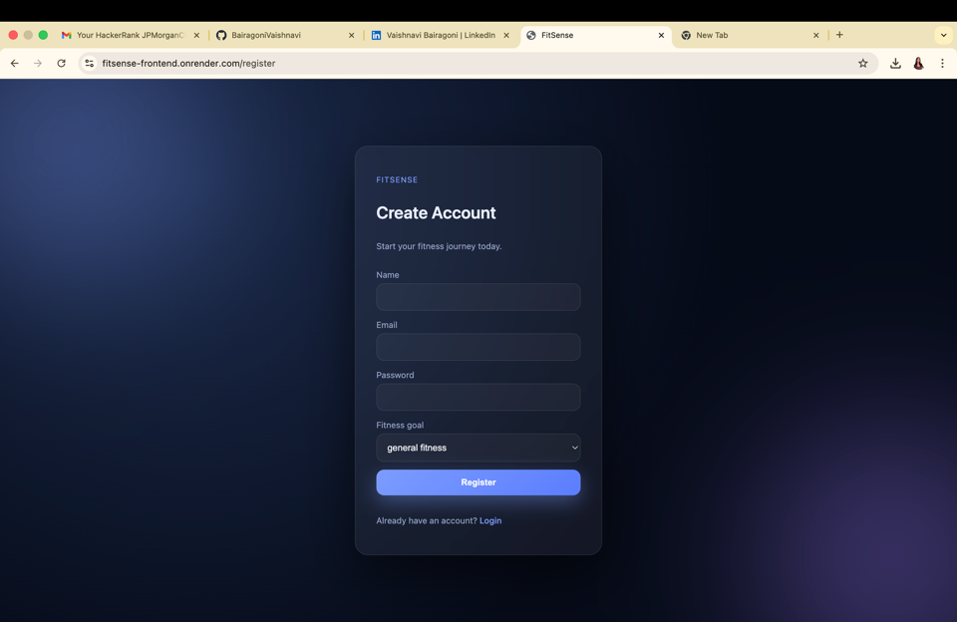
Register Page Login Page
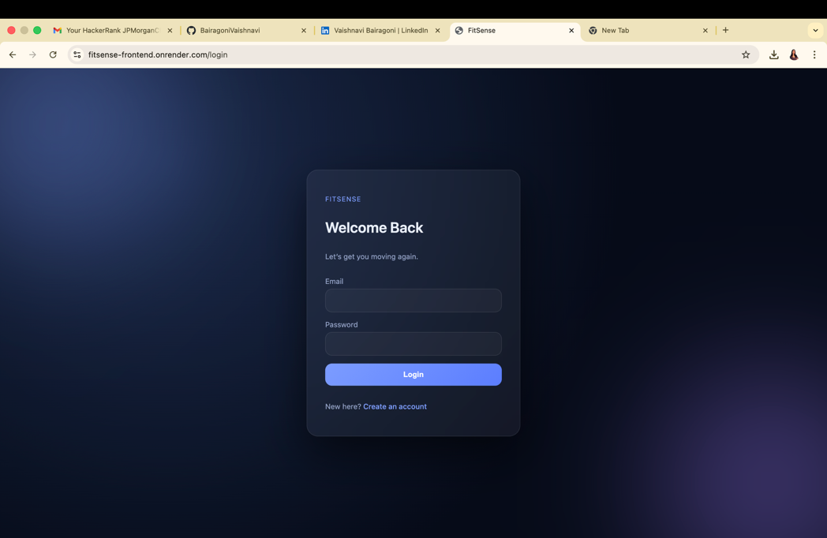
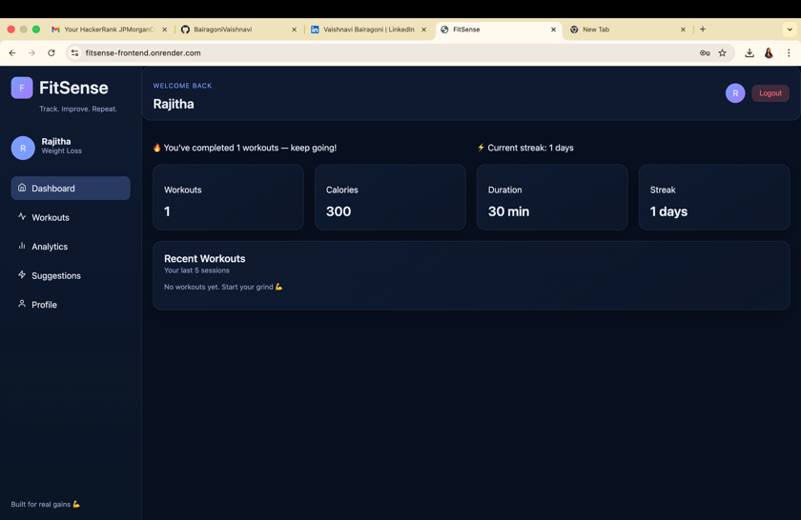
Dashboard Page

6
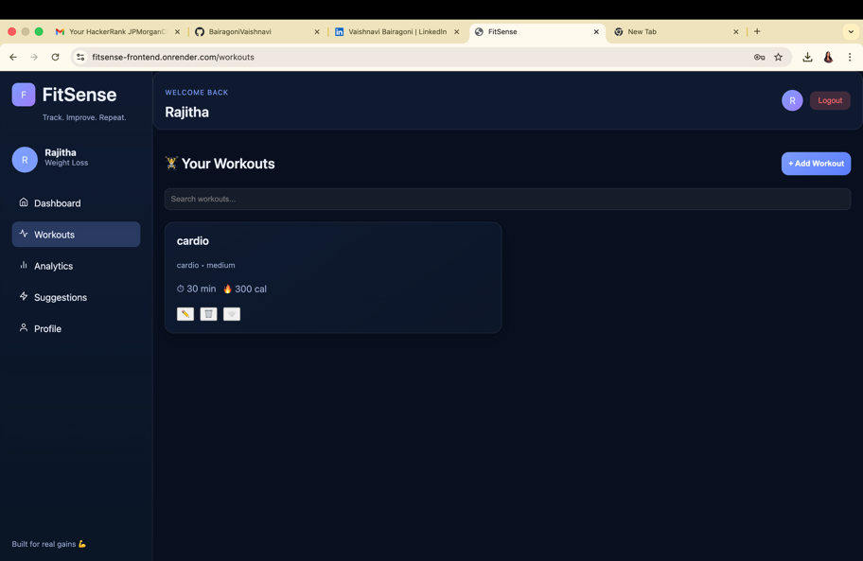
Workouts Page

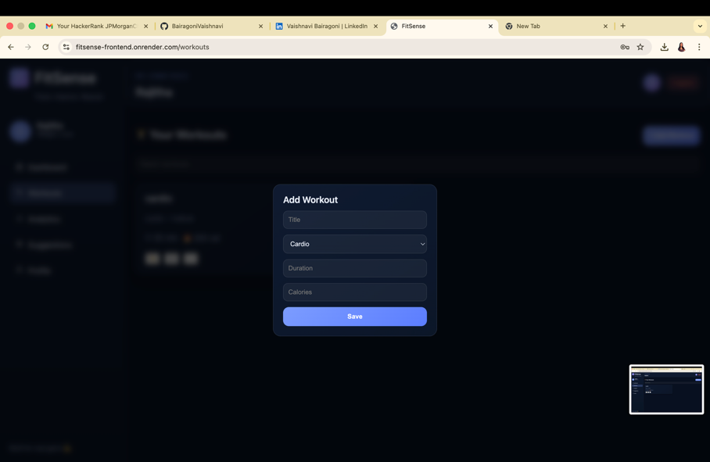

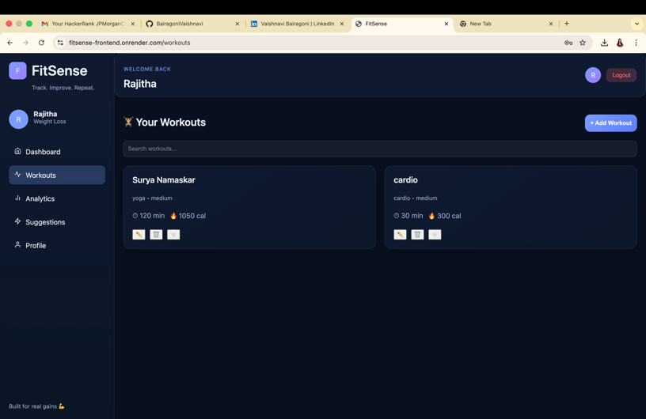

7

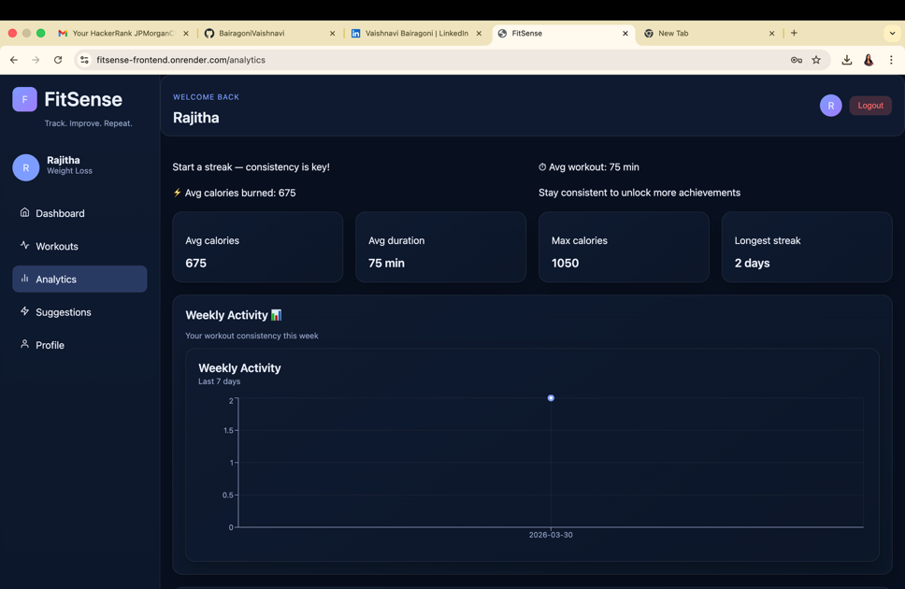
Analytics Page

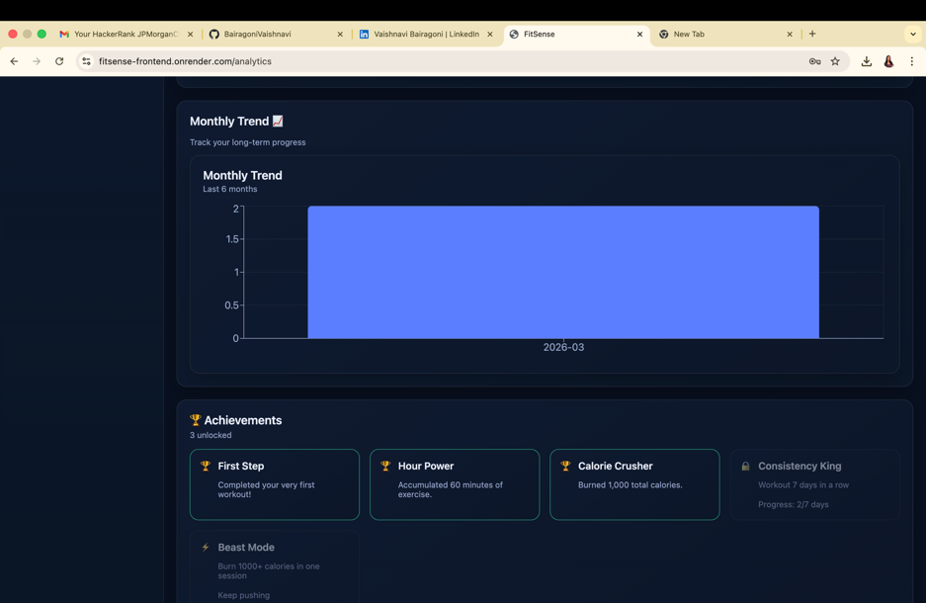

8

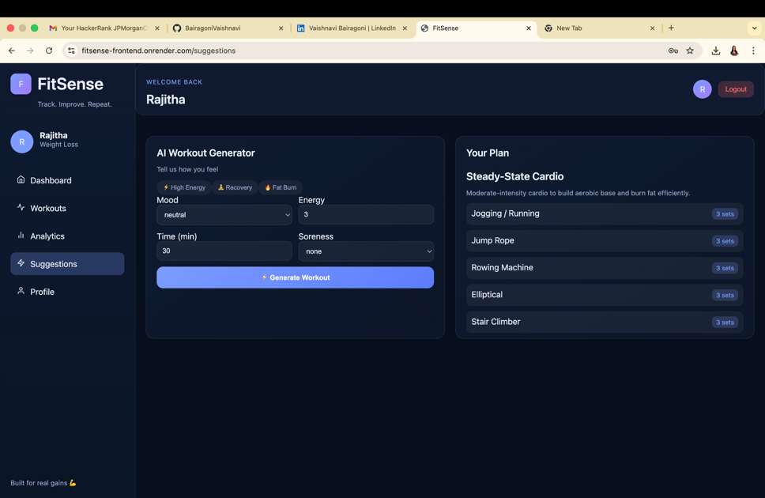
Suggestions Page

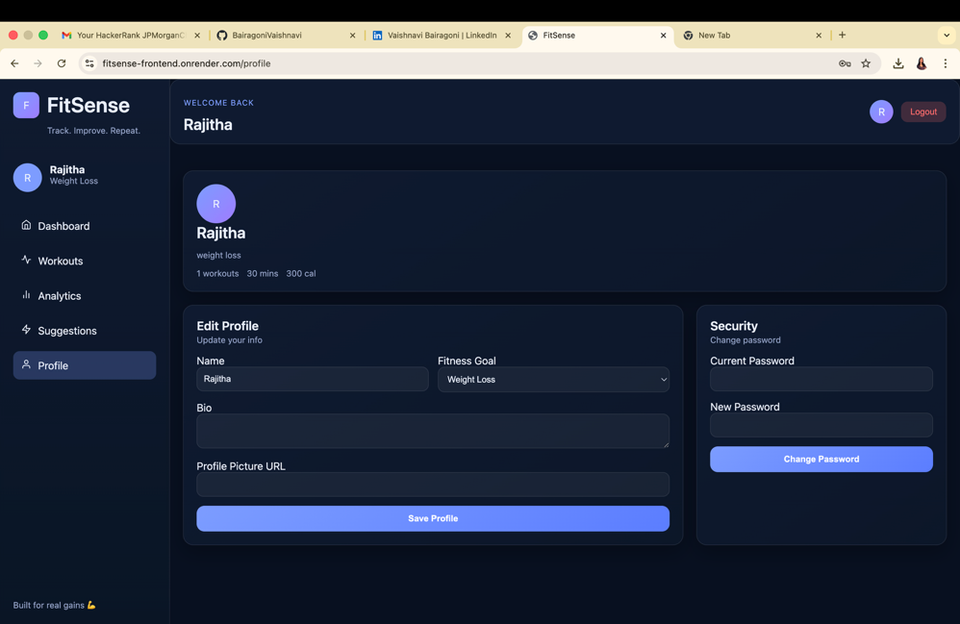

Profile Page

9
IMPLEMENTATION
The FitSense application is implemented using a full-stack MERN architecture, where the frontend, backend, and database work together to provide a seamless fitness tracking experience.
The frontend is developed using React and structured into multiple components such as Dashboard, Workouts, Suggestions, Analytics, and Profile. Each component is responsible for rendering specific parts of the user interface and handling user interactions. React Hooks are used for managing state and updating the UI dynamically based on user actions and API responses.
User interaction begins with authentication. When a user registers or logs in, the frontend sends a request to the backend API using Axios. The backend, built with Node.js and Express.js, processes the request, validates the input, and authenticates the user. Upon successful login, a JSON Web Token (JWT) is generated and sent back to the client, which is then used for authenticated requests.
The backend is structured using routes and controllers. Routes define the API endpoints such as authentication, workouts, suggestions, and analytics. Controllers contain the logic for handling requests, performing validations, and interacting with the database.
MongoDB is used as the database to store user information and workout records. Mongoose is used to define schemas and models, ensuring that data is stored in a structured format. When a user adds a workout, the frontend sends the data to the backend, which stores it in the database. Similarly, when fetching workouts or analytics, the backend retrieves data from MongoDB and sends it to the frontend.
The Suggestions module works by sending user inputs such as mood, energy level, and time to the backend, where a predefined logic generates a workout plan. This plan is then returned to the frontend and displayed to the user.
The Analytics module processes stored workout data and presents it visually using charts, allowing users to track their performance over time.
Error handling is implemented both on the frontend and backend. The frontend displays user-friendly messages using toast notifications, while the backend returns appropriate error responses for invalid requests.
Overall, the implementation follows a structured flow where the frontend handles user interaction, the backend processes logic and API requests, and the database manages persistent data storage.

10

BACKEND:

App.js :
const express = require('express');
const cors = require('cors');
const morgan = require('morgan');

const { notFound, errorHandler } = require('./middleware/errorMiddleware');

const app = express();

// ── CORS (FIXED)
app.use(cors({
origin: [
"http://localhost:5173",
"https://fitsense-frontend.onrender.com"
],
credentials: true
}));

// Handle preflight requests (IMPORTANT)
app.options("*", cors());

// ── Body parsers
app.use(express.json({ limit: '10kb' }));
app.use(express.urlencoded({ extended: false }));

// ── HTTP request logger (dev only)
if (process.env.NODE_ENV === 'development') {
app.use(morgan('dev'));
}

// ── Health check
app.get('/api/health', (req, res) => {
res.json({
success: true,
message: ' FitSense API is running',
env: process.env.NODE_ENV,
timestamp: new Date().toISOString(),
});
});

// ── API Routes
app.use('/api/auth', require('./routes/authRoutes'));
app.use('/api/workouts', require('./routes/workoutRoutes'));
app.use('/api/analytics', require('./routes/analyticsRoutes'));
app.use('/api/suggestion', require('./routes/suggestionRoutes'));

// ── Error handling (must be last)
app.use(notFound);
app.use(errorHandler);

module.exports = app;

Server.js :

// Load env variables FIRST before any other import
const dotenv = require('dotenv');
dotenv.config();

const app = require('./app');
const connectDB = require('./config/db');

const PORT = process.env.PORT || 5000;

// ── Boot sequence
const startServer = async () => {
try {
// 1. Connect to MongoDB
await connectDB();

// 2. Start HTTP server
app.listen(PORT, () => {
console.log('\n');
console.log(` FitSense API started`);
console.log(` Port : ${PORT}`);
console.log(` Env : ${process.env.NODE_ENV || 'development'}`);
console.log(` Health : http://localhost:${PORT}/api/health`);
console.log('n');
});
} catch (error) {
console.error(' Failed to start server:', error.message);
process.exit(1);
}
};

// ── Graceful shutdown
process.on('unhandledRejection', (reason) => {
console.error(' Unhandled Promise Rejection:', reason);
process.exit(1);
});

process.on('SIGTERM', () => {
console.log('SIGTERM received — shutting down gracefully');
process.exit(0);
});

startServer();

FRONTEND:

Axios.js:

import axios from 'axios'

const api = axios.create({
baseURL: 'https://fitsense-backend.onrender.com/api',
headers: {
'Content-Type': 'application/json',
},
})

api.interceptors.request.use((config) => {
const token = localStorage.getItem('token')
if (token) {
config.headers.Authorization = `Bearer ${token}`
}
return config
})

export default api

AuthContext.js:

import { createContext, useContext, useEffect, useMemo, useState } from 'react'
import {
getCurrentUser,
loginUser,
registerUser,
updateProfile as apiUpdateProfile,
changePassword as apiChangePassword
} from '../api/authApi'

const AuthContext = createContext(null)

export function AuthProvider({ children }) {
const [user, setUser] = useState(null)
const [token, setToken] = useState(localStorage.getItem('token') || '')
const [loading, setLoading] = useState(true)

useEffect(() => {
const boot = async () => {
if (!token) {
setLoading(false)
return
}

try {
const res = await getCurrentUser()
setUser(res.data)
} catch {
localStorage.removeItem('token')
setToken('')
setUser(null)
} finally {
setLoading(false)
}
}

boot()
}, [token])

const login = async (payload) => {
const res = await loginUser(payload)

const userData = res.data
const nextToken = userData?.token

if (nextToken) {
localStorage.setItem('token', nextToken)
setToken(nextToken)
setUser(userData)
}

return res
}

const register = async (payload) => {
const res = await registerUser(payload)

const userData = res.data
const nextToken = userData?.token

if (nextToken) {
localStorage.setItem('token', nextToken)
setToken(nextToken)
setUser(userData)
}

return res
}

const logout = () => {
localStorage.removeItem('token')
setToken('')
setUser(null)
}

const updateProfile = async (payload) => {
const res = await apiUpdateProfile(payload)
setUser(res.data)
return res
}

const changePassword = async (payload) => {
return apiChangePassword(payload)
}

const value = useMemo(
() => ({
user,
token,
loading,
login,
register,
logout,
updateProfile,
changePassword,
}),
[user, token, loading]
)

return <AuthContext.Provider value={value}>{children}</AuthContext.Provider>
}

export const useAuth = () => {
const ctx = useContext(AuthContext)
if (!ctx) throw new Error('useAuth must be used inside AuthProvider')
return ctx
}

15

CONCLUSION

The FitSense project successfully demonstrates the development of a full-stack fitness tracking application that enables users to manage and monitor their workout activities effectively. By integrating features such as user authentication, workout management, personalized suggestions, and analytics, the application provides a complete and practical solution for fitness tracking.
The use of technologies like React, Node.js, Express.js, and MongoDB ensures that the system is functional, scalable, and capable of handling real-time user interactions. The application also emphasizes user experience through a structured interface, responsive design, and interactive elements.
Throughout the development process, challenges such as API integration, data handling, and UI consistency were addressed, leading to a more stable and reliable system. The project highlights the importance of proper validation, error handling, and seamless communication between frontend and backend components.
Overall, FitSense achieves its objective of creating a user-friendly and efficient platform for tracking fitness activities. It also provides a strong foundation for future improvements, such as enhanced analytics, advanced recommendation systems, and integration with external fitness devices.
This project demonstrates how full-stack web development can be applied to solve real-world problems and deliver meaningful digital solutions in the health and fitness domain.

DEPLOYED LINK:

https://fitsense-frontend.onrender.com you can find the deployed app here

