CSP-554 Big Data Technologies
Bairi Rohith Reddy – Assignment 9

HBase
Start up a Hadoop cluster as previously, but instead of choosing the “Core Hadoop” configuration chose the “HBase” configuration
- ssh -i /c/Users/rohit/OneDrive/Desktop/all_files/BIGDATA/emrkey-pair.cer hadoop@ec2-34-200-220-199.compute-1.amazonaws.com
Log on to the master Hadoop EC2 VM as per previous assignments and enter ‘hbase shell’ to start the HBase shell.
- hbase shell
Exercise 1)
Create an HBase table with the following characteristics
Table Name: csp554Tbl
First column family: cf1
Second column family: cf2
Then execute the DESCRIBE command on the table and return command you wrote and the output as the results of this exercise.
- create 'csp554Tbl', {NAME => 'cf1'}, {NAME => 'cf2'}
- describe 'csp554Tbl'
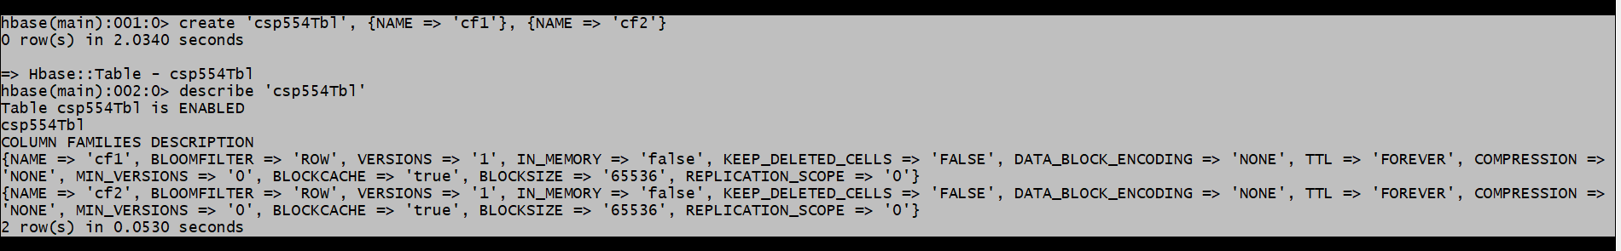
Exercise 2)
Put the following data into the table created in exercise 1:
- put 'csp554Tbl', 'Row1', 'cf1:name', 'Sam'
- put 'csp554Tbl','Row2','cf1:name','Ahmed'
- put 'csp554Tbl','Row1','cf2:job','Pilot'
- put 'csp554Tbl','Row2','cf2:job','Doctor'
- put 'csp554Tbl','Row1','cf2:level','LZ3'
- put 'csp554Tbl','Row2','cf2:level','AR7'
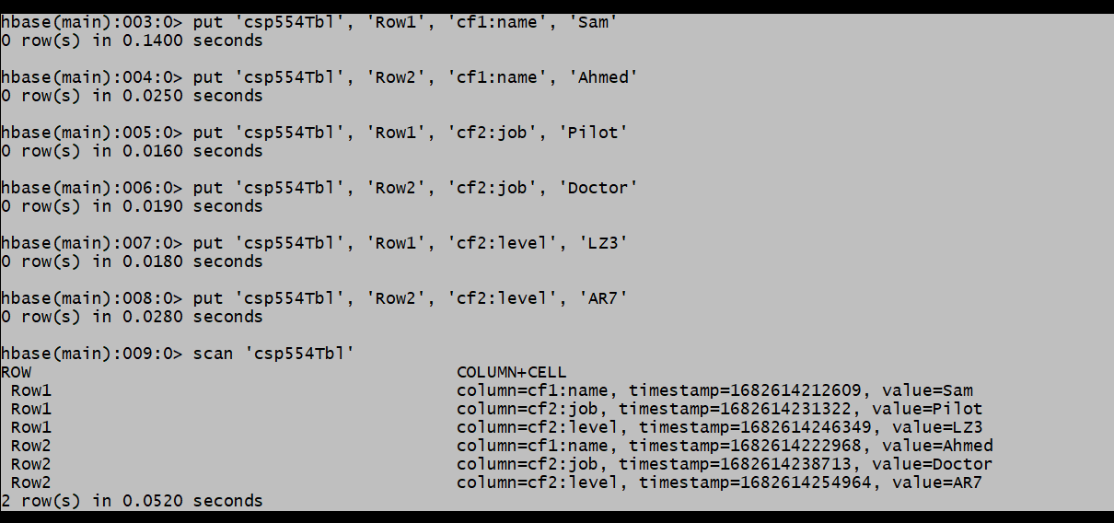
- scan 'csp554Tbl'
Exercise 3) (1 point)
Using the above table write a command that will get the value associated with row (Row1), column family (cf2) and column/qualifier (level). Provide the command and its result as the output of this exercise.
- get 'csp554Tbl', 'Row1', {COLUMN => [ 'cf2', 'cf2:level']}
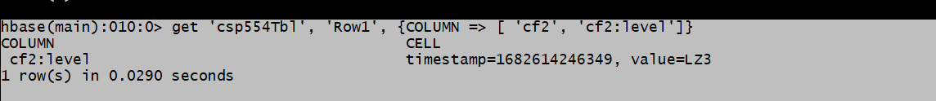
Exercise 4) (1 point)
Using the above table write command that will get the value associated with row (Row2), column family (cf1) and column/qualifier (name). Provide the command and its result as the output of this exercise.
- get 'csp554Tbl', 'Row2',{COLUMN=> 'cf1:name'}
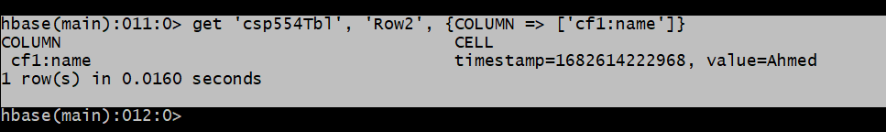

Exercise 5) (1 point)
Using the above table write a SCAN command that will return information about only two rows using the LIMIT modifier. Provide the command and its result as the output of this exercise.
- scan 'csp554Tbl' ,{LIMIT=> 2}
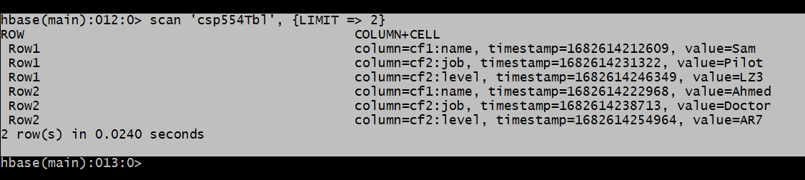
Cassandra
Exercise 1) (1 point)
Read the article “A Big Data Modeling Methodology for Apache Cassandra” and provide a ½ page summary including your comments and impressions.
The article presents a comprehensive methodology for designing data models in Apache Cassandra, a popular distributed NoSQL database system designed to handle large amounts of data across multiple commodity servers. The methodology includes three stages: conceptual modeling, logical modeling, and physical modeling. Each stage is described in detail, providing practical tips and examples to illustrate the concepts.

The paper "A Big Data Modeling Methodology for Apache Cassandra" offers a comprehensive approach to modeling data in Apache Cassandra, a distributed database management system designed to handle large amounts of data across multiple servers. The authors propose a three-step process for modeling data in Cassandra: conceptual modeling, logical modeling, and physical modeling. They stress the importance of considering performance when designing data models for Cassandra and offer guidelines for achieving high write and read throughput while minimizing query latency.

The Cassandra data model is based on tables, where each table is a collection of partitions that contain rows with similar structures. A table schema includes columns with primitive, complex, or counter data types. A primary key is a combination of a partition key and a clustering key that uniquely identifies a row in a table. CQL, a syntax similar to SQL, is used to express queries over tables. CQL doesn't support binary operations like joins, instead relying on query predicate rules for efficiency and scalability.

Conceptual modeling defines entities and their relationships in the domain being modeled. Logical modeling maps the conceptual model into tables, columns, and primary keys in Cassandra. Physical modeling describes how data will be physically stored on disk and how queries can efficiently retrieve that data from the cluster. The authors propose a query-driven approach to mapping from a conceptual to a logical data model, where entities and relationships map to table rows, and attributes map to columns in a table. They also propose four data modeling principles: know your data, know your questions, data nesting, and data duplication. Mapping patterns are introduced to automate Cassandra database schema design.

In summary, the paper provides a practical and informative guide to modeling data in Cassandra. The three-step process, query-driven mapping, and data modeling principles provide a structured approach to designing effective data models. The guidelines and best practices for optimizing performance offer useful insights for developers and data architects working with Cassandra.
Exercise 2) (1 point)
Step A – Start an EMR cluster
- ssh -i /c/Users/rohit/OneDrive/Desktop/all_files/BIGDATA/emrkey-pair.cer hadoop@ec2-3-231-147-225.compute-1.amazonaws.com
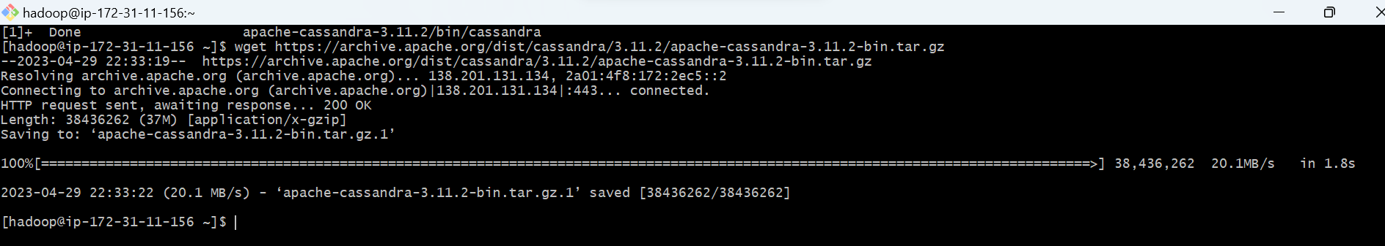
Step B – Install the Cassandra database software and start it
- wget https://archive.apache.org/dist/cassandra/3.11.2/apache-cassandra-3.11.2-bin.tar.gz
- tar -xzvf apache-cassandra-3.11.2-bin.tar.gz
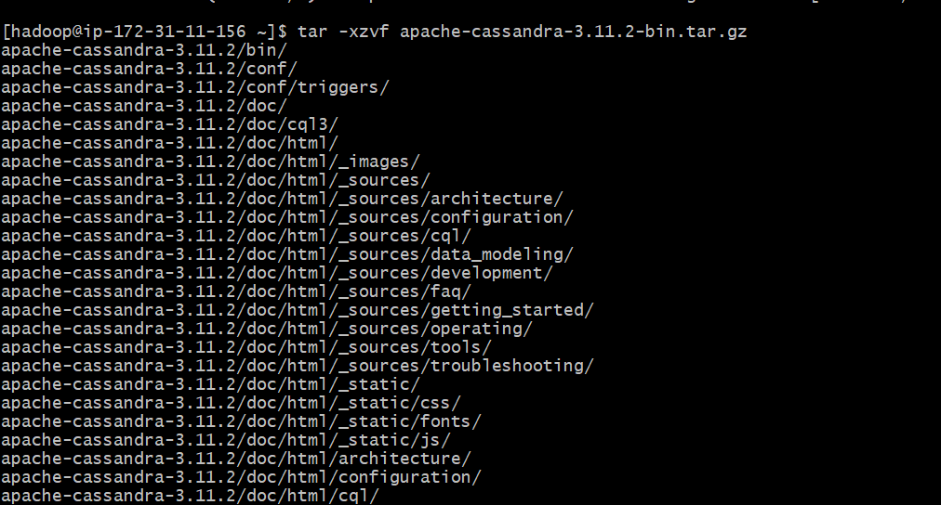
apache-cassandra-3.11.2/bin/cassandra &
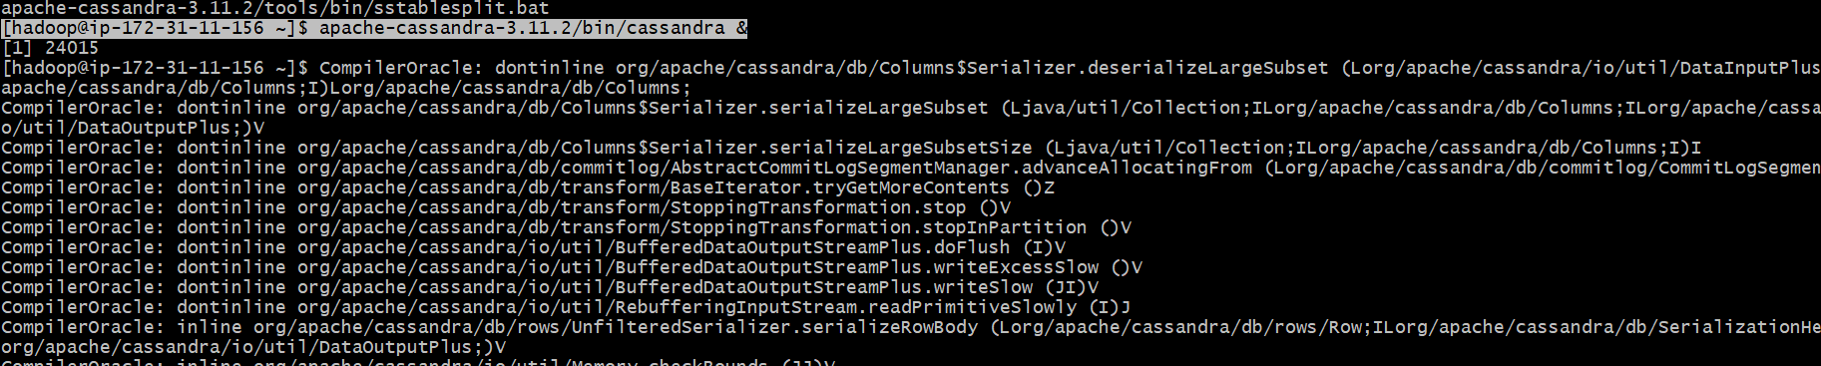
Step C – Run the Cassandra interactive command line interface
- ssh -i /c/Users/rohit/OneDrive/Desktop/all_files/BIGDATA/emrkey-pair.cer hadoop@ec2-3-231-147-225.compute-1.amazonaws.com
- apache-cassandra-3.11.2/bin/cqlsh
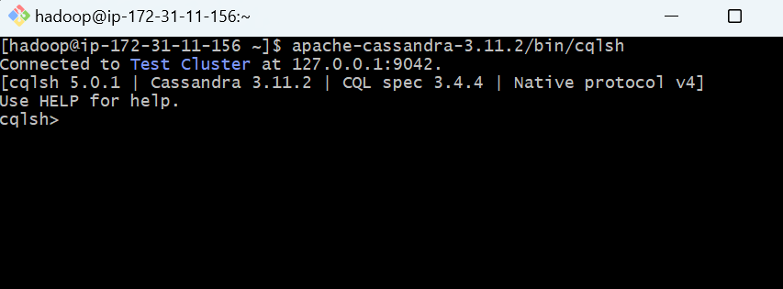

Step D – Prepare to edit your Cassandra code
- Create a file in your working (home) directory called init.cql using your Edit-term (or using your PC/MAC and then scp it to the EMR master node) and enter the following command. Use your IIT id as the name of your keyspace… For example, if your id is A1234567, then replace below with that value:
- vi init.cql ( and enter the following command in the file).
- CREATE KEYSPACE A20526972 WITH REPLICATION = { 'class' : 'SimpleStrategy', 'replication_factor' : 1 };
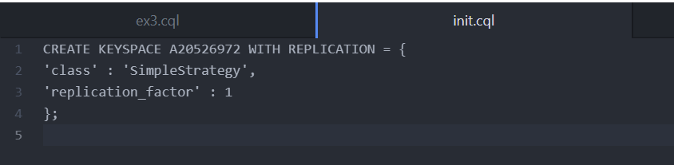

b) source './init.cql'
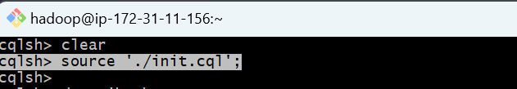

c) To check if your script file has created a keyspace execute the following in the CQL shell:
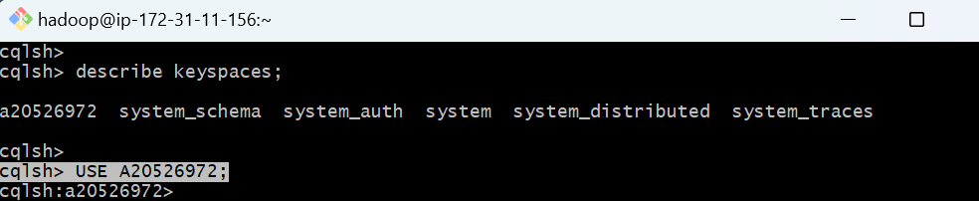
- describe keyspaces;

d) At this point you have created a keyspace unique to you. So, make that keyspace the default by entering the following into the CQL shell:
- USE A20526972;
- nano ex2.cql
- CREATE TABLE A20526972.Music(
artistName text,
albumName text,
numberSold int,
Cost int,
PRIMARY KEY(artistName, albumName)) WITH CLUSTERING ORDER BY(albumName DESC);
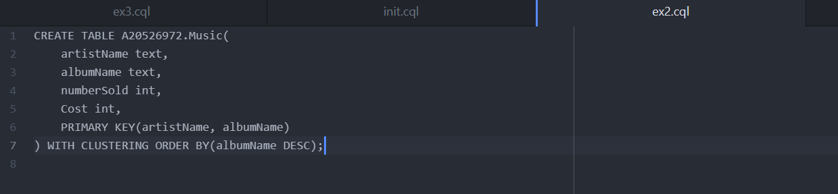
- source './ex2.cql';
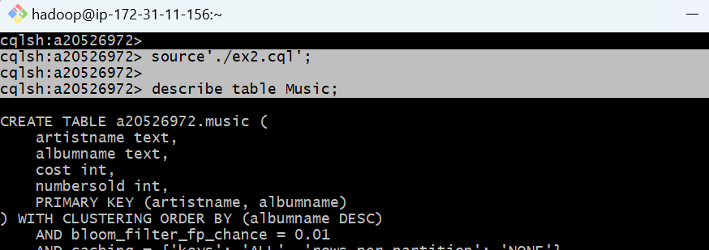
- DESCRIBE TABLE Music;

Exercise 3) (1 point)
Now create a file in your working directory called ex3.cql using the Edit-Term. In this file write the commands to insert the following records into table ‘Music
- Execute ex3.cql. Provide the content of this file as the result of this exercise.

- vi ex3.cql
insert into Music(artistName,albumName,numberSold,cost) values ('Mozart','Greatest Hits',100000,10);

insert into Music(artistName,albumName,numberSold,cost) values ('Taylor Swift','Fearless',2300000,15);

insert into Music(artistName,albumName,numberSold,cost) values ('Black Sabbath','Paranoid',534000,12);

insert into Music(artistName,albumName,numberSold,cost) values ('Katy Perry','Prism',800000,16);

insert into Music(artistName,albumName,numberSold,cost) values ('Katy Perry','Teenage Dream',750000,14);

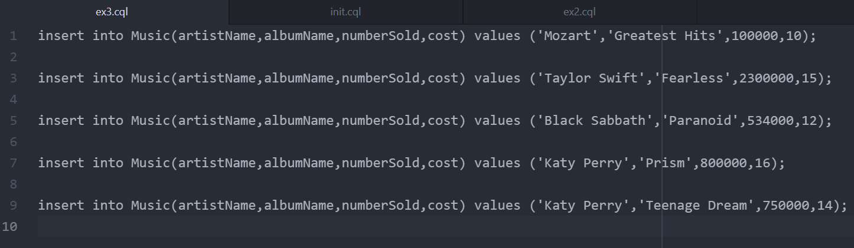
- Execute the command ‘SELECT * FROM Music;’ and provide the output of this command as another result of the exercise.
- source './ex3.cql'
- SELECT * FROM Music;
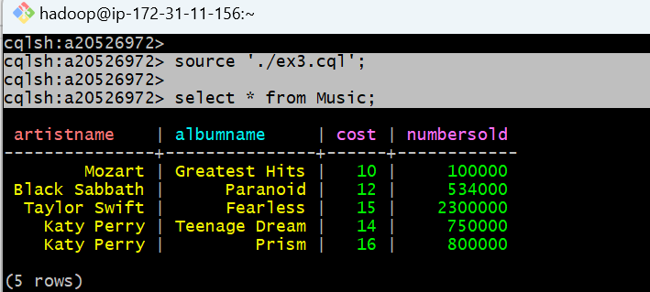

Exercise 4) (1 point)
- Now enter this command directly into the cql shell
  - SELECT * FROM Music where artistName = 'Katy Perry';
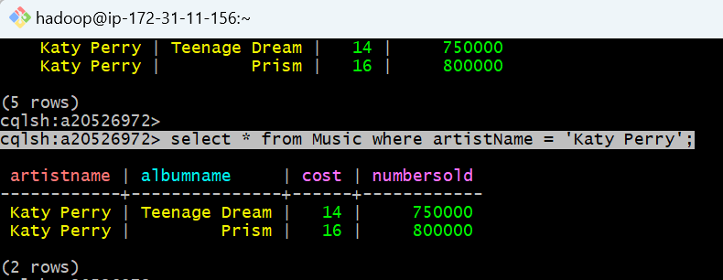

Exercise 5) (1 point)
Now enter this command in the cassandra shell.
  - SELECT FROM Music where numberSold >= 700000 ALLOW FILTERING;
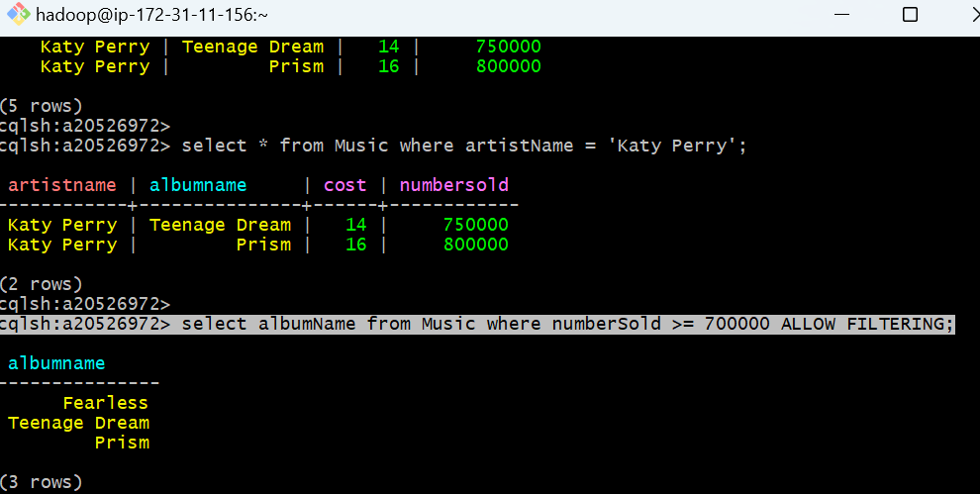
MongoDB

Step A – Start an EMR cluster

- ssh -i /c/Users/rohit/OneDrive/Desktop/all_files/BIGDATA/emrkey-pair.cer hadoop@ec2-34-200-220-199.compute-1.amazonaws.com

Step B – Download the assignment software (mongoex.tar, mongodb-org-4.2.repo) to master node

- scp -i /c/Users/rohit/OneDrive/Desktop/all_files/BIGDATA/emrkey-pair.cer /c/Users/rohit/OneDrive/Desktop/all_files/BIGDATA/Homework-Assignments/Homework-9/mongodb-org-4.2.repo hadoop@ec2-34-239-161-175.compute-1.amazonaws.com:/home/hadoop

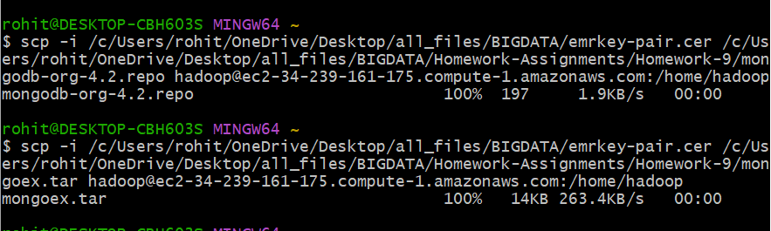
- scp -i /c/Users/rohit/OneDrive/Desktop/all_files/BIGDATA/emrkey-pair.cer /c/Users/rohit/OneDrive/Desktop/all_files/BIGDATA/Homework-Assignments/Homework-9/mongoex.tar hadoop@ec2-34-239-161-175.compute-1.amazonaws.com:/home/hadoop

Step C – Install assignment software (mongoex.zip, mongodb-org-4.2.repo)

- sudo cp mongodb-org-4.2.repo /etc/yum.repos.d
- tar -xvf mongoex.tar
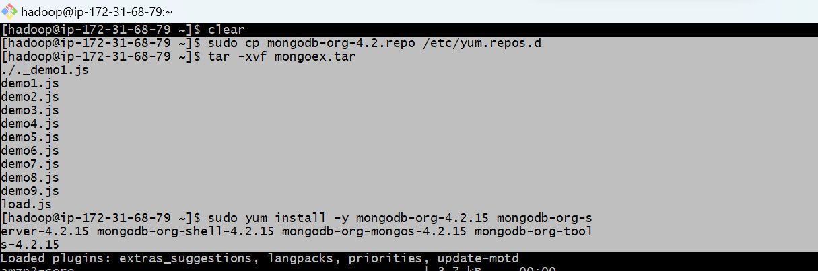
Step D – Install and start MongoDB

- sudo yum install -y mongodb-org-4.2.15 mongodb-org-server-4.2.15 mongodb-org-shell-4.2.15 mongodb-org-mongos-4.2.15 mongodb-org-tools-4.2.15
- sudo systemctl start mongod

Step E – Start the MongoDB Shell (Command Line Interpreter)
- mongo

Step F – Edit mongo query language files
Step G – Setting up the assignment database
Now, in the MongoDB shell, using the CLI-Term, create a database called “assignment” by entering the following into the MongoDB shell:
- use assignment;

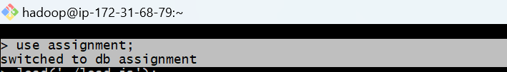
This will set the shell variable ‘db’ to this new database.
Load a collection called ‘unicorns’ with sample data by executing the script load.js in the MongoDB shell as follows (don’t cut and paste this, type it in manually):
- load('./load.js');
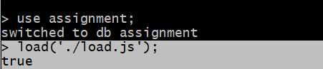

Note, look at the content of the script file (via the other terminal window you have opened to the EC2 instance) to see how each unicorn is described.

Confirm this has all worked by executing the following command in the MongoDB shell:
- db.unicorns.find();
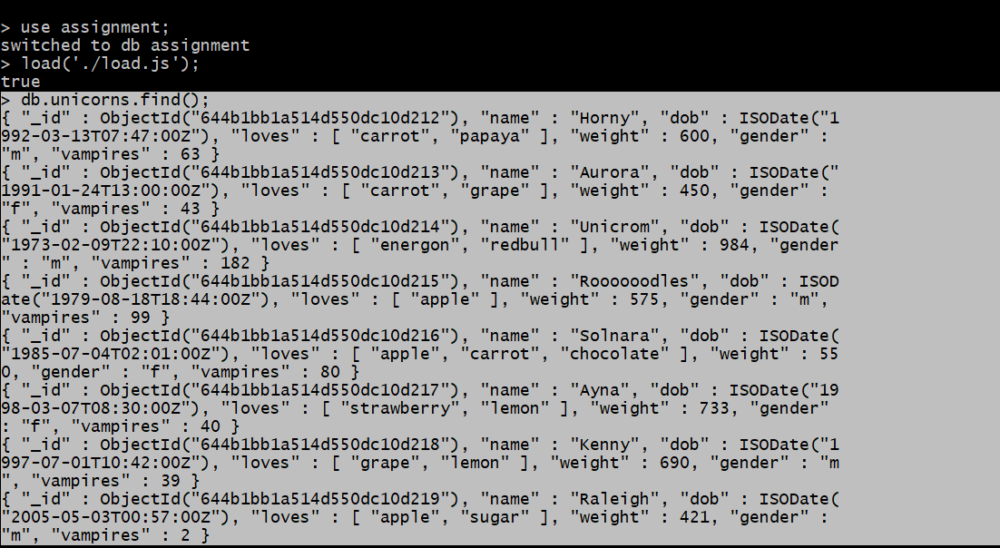

Note, the files named “demo*.js” (also included in the mongoex.tar file) provide examples of how to operate in the unicorn collection. These are a VERY good idea to review and understand and will present you with information helpful in completing the assignment. Also, try them out by typing something like

Exercise 1) (1 point)

Write a command that finds all unicorns having weight less than 500 pounds. Include the code you executed and some sample output as the result of this exercise. Recall you can place the command, if you choose, into a file, say ‘ex1.js’ and execute it with the load command as above and similarly for the following exercises.

- db.unicorns.find({weight : { $lt : 500 }});
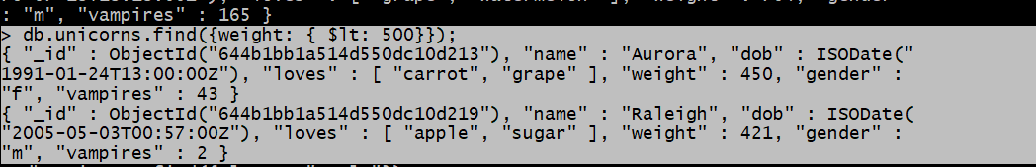
Exercise 2) (1 point)
Write a command that finds all unicorns who love apples. Hint, search for “apple”. Include the code you executed and some sample output as the result of this exercise.
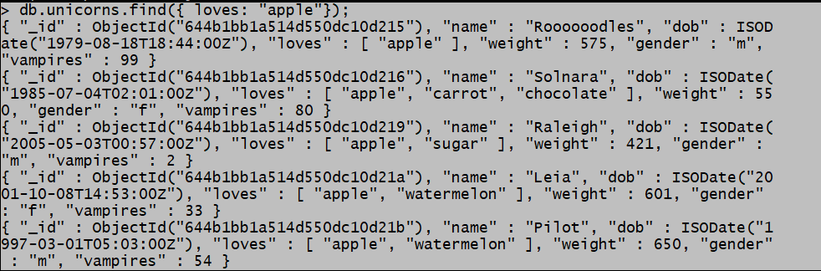
- db.unicorns.find({loves: 'apple'});

Exercise 3) (1 point)
Write a command that adds a unicorn with the following attributes to the collection. Note dob means “Date of Birth.”
- db.unicorns.insert({name: 'Malini', dob: new Date(2008, 11, 03), loves:['pears', 'grapes'], weight: 450, gender: 'F', vampires: 23, horns : 1});
- db.unicorns.find();
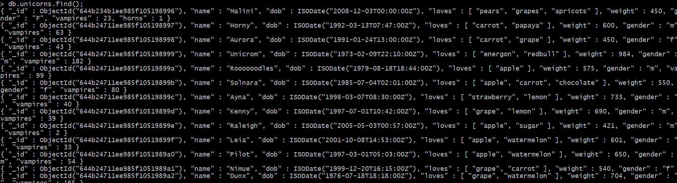

Exercise 4) (1 point)
Write a command that updates the above record to add apricots to the list of things Malini loves. Include the code you executed and some sample output showing the addition.
- db.unicorns.update({name: 'Malini'}, {$push : {loves: ['apricots'] } } );
- db.unicorns.find({ name: "Malini" });
Exercise 5) (1 point)
Write a command that deletes all unicorns with weight more than 600 pounds. Include the code you executed and some sample output as the result of this exercise
- db.unicorns.find();
- db.unicorns.deleteMany({ weight: { $gt : 600 } } );
- db.unicorns.find();
