Metro-Line-optimization

Submitted by:
Bairy Shreyas – 102317134
Pinninti Sriram – 102317168

BE Third Year CSE/COE

Submitted to:
Dr. Anjula Mehto
Assistant Professor



Computer Science and Engineering Department Thapar Institute of Engineering and Technology, Patiala

November 2025

TABLE OF CONTENTS

S. No | Topic | Page No.
1 | Introduction or Project Overview | 3
2 | Problem Statement | 3
3 | Overview of the Dataset used | 4
4 | Project workflow | 4
5 | Results | 5
6 | Conclusion | 7

Introduction or Project Overview

This project focuses on predicting optimal metro station locations in Chennai using machine learning. By studying the infrastructure and growth patterns of major Indian cities like Bangalore and Hyderabad, we train predictive models (Random Forest and XGBoost) to analyze features such as population density, traffic index, rent values, and civic infrastructure. These insights allow the system to recommend metro expansion paths and high‑potential station points within Chennai. The project also includes generating a map‑based visualization of the predicted metro route.

Problem Statement

Urban metro expansion requires analyzing multiple factors such as population growth, infrastructure distribution, traffic conditions, and land availability. Traditional planning is manual, time‑consuming, and often misses future growth hotspots. The problem addressed in this project is how to use machine learning to automate metro station identification by learning from existing metropolitan cities, and then apply the same logic to Chennai to support data‑driven metro planning.

Overview of the Dataset used

The dataset used is custom‑compiled from various online sources. It integrates:
- Population Density (GeoIQ)
- Rent Prices (MagicBricks)
- Traffic Index and Civic Infrastructure including hospitals, schools, entertainment zones (Google Maps API)
- Railway Lines & Geographic Coordinates (public maps)

Training Cities: Bangalore and Hyderabad
Prediction Target: Chennai
Features include population density, rent, coordinates, number of buildings, presence of civic services, and traffic conditions. The datasets were cleaned, normalized, and merged for machine learning.

Project Workflow

1. Data Collection: Gathering datasets from GeoIQ, MagicBricks, Google Maps API, and public sources.
2. Preprocessing: Handling missing values, cleaning coordinates, normalizing features, and merging datasets.
3. Training ML Models: Random Forest and XGBoost classifiers were trained on Bangalore and Hyderabad data.
4. Evaluation: Models were evaluated using Accuracy and F1‑Score.
5. Prediction on Chennai: The best‑performing model was used to predict suitable metro installation points.
6. Visualization: Output was plotted on a Chennai map. A final metro path was created based on predicted nodes.

Results

Correlation Heatmap:
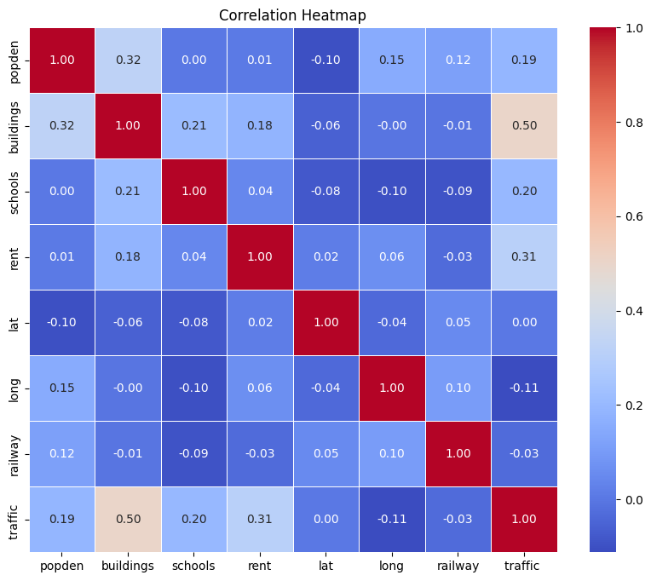
Metro Installation Prediction – Random Forest Model:

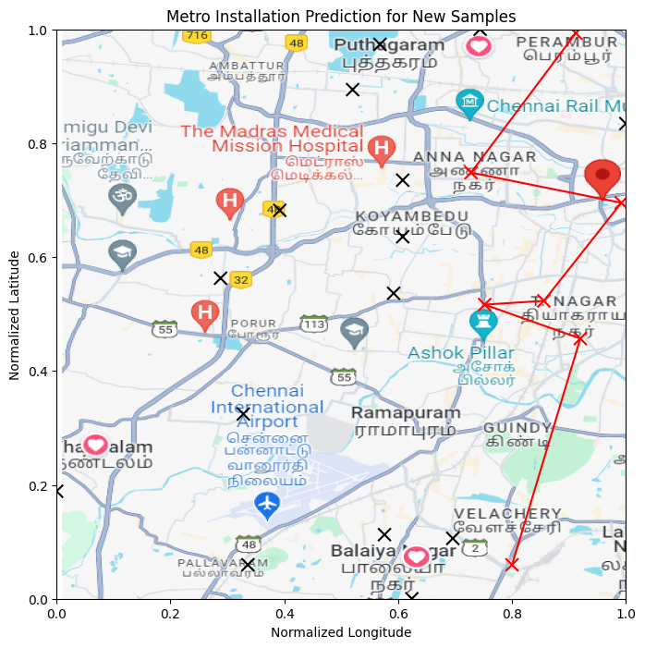
Metro Installation Prediction – XGBoost Model:
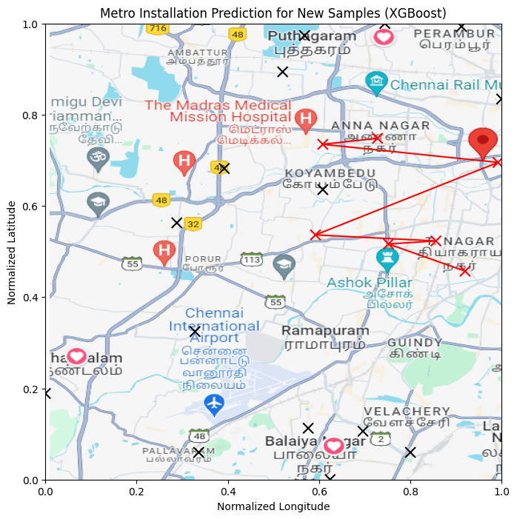
The Random Forest model achieved approximately 81% accuracy and an F1‑Score of 87%, while XGBoost achieved around 86% accuracy and a 91% F1‑Score. Due to its superior performance, XGBoost was selected for the final Chennai prediction. Both models successfully identified viable station points. The predicted XGBoost map shows a more stable clustering of locations and cleaner route generation.

Conclusion

This project demonstrates how machine learning can support metro expansion planning in fast‑growing cities. By analyzing real‑world urban features and learning patterns from multiple metropolitan datasets, the system can produce reliable recommendations for new metro stations. The results show that ensemble models like XGBoost perform exceptionally well for this purpose. The project can be extended by incorporating real‑time data or optimizing routes using graph algorithms to generate complete metro line designs.

