**Object Detection with SSD Mobile Net Model**

Object detection is a computer vision technique for locating instances of objects in images or videos. Object detection algorithms typically leverage machine learning or deep learning to produce meaningful results. The goal of object detection is to replicate this intelligence using a computer.

To train a custom object detection model with the Tensorflow Object Detection API, you need to go through the following steps:

1. **Image Labeling**
2. **Creation of tfrecord files**
3. **Environment setup for object detection**
4. **Configuring files**
5. **Train and export interference graph**
6. **Model Testing**
7. **Tflite file creation**
8. **Adding metadata to Tflite file**
9. **Errors and Solutions**
10. **Image Labeling**

Dataset (images) labeling is required for the training purpose. Install labelimg for the same. Image Labeling is the process of recognizing different entities in an image. You can recognize various entities like animals, plants, food, activities, colors, things, fictional characters, drinks etc. with Image Labeling

* Clone the labelimg from GitHub

$git clone https://github.com/qaprosoft/labelImg.git

$pyrcc5 -o resources.py resources.qrc

Refer <https://github.com/qaprosoft/labelImg>

* Open cmd and go to labelImg-master directory run the labelimg.py
* Create folders like images/train, images/test and Upload training images and testing images to images/train and images/test respectively.
* Open train and test directory and start labeling, Xml file will be created in respective directory.

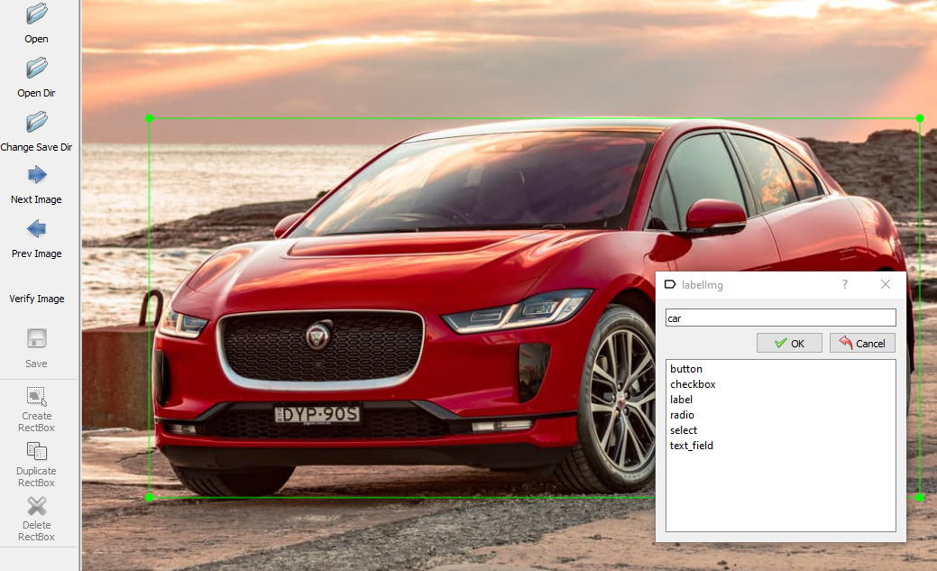

1. **Creation of tfrecord files**

Now we need to convert these XML files to singular CSV files that can be then converted to the TFRecord files. To do this, I am going to make use of some of the code from <https://github.com/datitran/raccoon_dataset>, with some minor changes.

* First we have to convert xml to csv. Within the xml_to_csv script, I changed:

def main ():

image_path = os.path.join(os.getcwd(), 'annotations')

xml_df = xml_to_csv(image_path)

xml_df.to_csv('raccoon_labels.csv', index=None)

print ('Successfully converted xml to csv.')

**To:**

def main():

for directory in ['train','test']:

image_path = os.path.join(os.getcwd(), 'images/{}'.format(directory))

xml_df = xml_to_csv(image_path)

xml_df.to_csv('data/{}_labels.csv'.format(directory), index=None)

print('Successfully converted xml to csv.')

**Note:** Make sure images/* and xml_to_csv.py in same directory**.**

* Run the xml_to_csv.py it will create test_labels.csv and train_lables.csv in data directory. Please verify the images path mention in the csv files are correct and absolute path is mentioned.
* Now, grab [**generate_tfrecord.py**](https://github.com/datitran/raccoon_dataset/blob/master/generate_tfrecord.py)**.** The only modification that you will need to make here is in the class_text_to_int function.

# TO-DO replace this with label map

def class_text_to_int(row_label):

if row_label == 'car':

return 1

elif row_label == 'bike':

return 2

else:

None

* Run generate_tfrecord.py with the below command

$python generate_tfrecord.py --csv_input=data/train_labels.csv -- output_path=data/train.record

$python generate_tfrecord.py --csv_input=data/test_labels.csv -- output_path=data/test.record

**Note:** Given path in create_tf_example function should correct for test and train cases.

1. **Environment setup for object detection**

* Object detection is a [computer vision](https://heartbeat.fritz.ai/the-5-computer-vision-techniques-that-will-change-how-you-see-the-world-1ee19334354b) technique whose aim is to detect objects such as cars, buildings, and human beings, just to mention a few. The objects can generally be identified from [either pictures or video feeds](https://heartbeat.fritz.ai/detecting-objects-in-videos-and-camera-feeds-using-keras-opencv-and-imageai-c869fe1ebcdb).
* Create environment, for this create a directory “computer_vision”

$mkdir computer_vision

$cd computer_vision

* Upgrade your pip. pip version must be greater than version 19.0

$pip install --upgrade pip

* The next step is to make sure that we have all the libraries and modules that we need to run the object detector on our machine.
* Here is a list of libraries that the project depends on. (Most of the dependencies comes with Tensorflow by default)
* Pycocotools
* pillow
* Cython
* Contextlib2
* Scipy
* pyyaml
* livs
* tf_slim
* tf-models-official
* In case if you find any of the module missing just execute pip install in your environment to install.

**Note:** Tensorflow package will be installed with tf-model-official

* Clone the models from GitHub

$git clone <https://github.com/tensorflow/models.git>

$cd XXX//models/research

* Execute the following command from the research/ directory to compile the Protocol Buffer.

$protoc object_detection/protos/*.proto --python_out=.

* PYTHONPATH is an environment variable which you can set to add additional directories where python will look for modules and packages. For most installations, you should not set these variables since they are not needed for Python to run. Python knows where to find its standard library.

$export PYTHONPATH=$PYTHONPATH:'pwd':'pwd'/slim

* Create setup.py file in research directory with below code.

"""Setup script for object_detection."""

from setuptools import find_packages

from setuptools import setup

REQUIRED_PACKAGES = ['Pillow>=1.0', 'Matplotlib>=2.1', 'Cython>=0.28.1']

setup(

name='object_detection',

version='0.1',

install_requires=REQUIRED_PACKAGES,

include_package_data=True,

packages=[p for p in find_packages() if p.startswith('object_detection')],

description='Tensorflow Object Detection Library',

)

$ python setup.py build

$ python setup.py install

* Now we have all the dependencies installed, let’s use implement custom Object Detection with ssd models.

<https://github.com/tensorflow/models/blob/master/research/object_detection/g3doc/tf2_detection_zoo.md>

Above link will give the list of object detection model, Hear I took [SSD MobileNet V2 FPNLite 640x640](http://download.tensorflow.org/models/object_detection/tf2/20200711/ssd_mobilenet_v2_fpnlite_640x640_coco17_tpu-8.tar.gz) because it is very less size and speed (ms) 39 and mean average precision (mAP) 28.2 with coco data set.

Best model should have high mAP.

$cd XXX/computer_vision/models/research/object_detection

$wget “paste model URL and run”

$ tar –xvzf path/ssd_mobilenet_v2_fpnlite_640x640_coco17_tpu-8.tar.gz

* After extracting ssd_mobilenet_v2_fpnlite_640x640_coco17_tpu-8.tar.gz, it gives two directories (checkpoint, saved model) and one file (Pipeline.config)

1. **Configuring files**

* Create pbtxt file, it links labels to some integer values. The Tensor Flow **Object Detection** API needs this **file** for training and **detection** purposes

$ mkdir training

$ cd training

$ touch object-detection.pbtxt

Open pbtxt file and write below

item {

id: 1

name: 'car'

}

item {

id: 2

name: 'bike'

}

* For custom object detection eight changes have to make in pipline.config

1. num_classes: 2 line no 3

Change the number of classes to number of objects you want to detect.

My case I am detecting two and this changes can done in line no 3

1. batch_size: 10

Change the batch size as you wish, if we give high batch size we get memory error, this changes can be done in line no 135

1. fine_tune_checkpoint: “ssd_mobilenet_v2_fpnlite_640x640_coco17_ tpu-8/checkpoint/ckpt-0"

Change fine_tune_checkpoint to the path of the model.ckpt file, this changes done in line no 165

1. fine_tune_checkpoint_type: "detection"

Change fine_tune_checkpoint_type to detection line no 171

1. label_map_path: "training/object-detection.pbtxt" line no 175
2. input_path: "Path/data/train.record”

Change input_path of the train_input_reader to the path of the train.record, this changes done in line no 177

1. label_map_path: " training/object-detection.pbtxt " line in 185
2. input_path: "Path/data/test.record"

Input_path of the eval_input_reader to the path of the test.record, this

Changes done in line no 189

* **Note:** Line numbers will change in different models

1. **Train and Export inference graph**

* Run model_main_tf2.py which is there in research/object_detection
* $python model_main_tf2.py --pipeline_config_path=path/pipeline.config

--model_dir=path/training/training_check_point -- num_train_steps=10000 --sample_1_of_n_eval_example=1 --num_eval_steps=1

**Note:** Model_dir indicates check points saving path and num_train_steps indicates number of epochs.

* To make it easier to use and deploy your model, I recommend converting it to a frozen graph file. This can be done with exporter_main_v2.py script.

$python exporter_main_v2.py --input_type image_tensor --pipeline_config_path path/pipeline.config --trained_checkpoint_dir path/training/training_check_point --output_directory path/object_detection/exported-mobile-model

Note: Results will be saved in exported-mobile-model directory

* To convert object detection model to tensorflowlite format, first export with export_tflite_graph_tf2.py script.

$python export_tflite_graph_tf2.py --pipeline_config_path path/pipeline.config --trained_checkpoint_dir path/training/training_check_point --output_directory path/object_detection/model_dir

Note: At this time only SSD model can support tflite format, refer this

https://github.com/tensorflow/models/blob/master/research/object_detection/g3doc/running_on_mobile_tensorflowlite.md

1. **Model Testing**

* For testing the model we should follow object_detection_tutorial.ipynb file, this file is use to test the predefine model. But here we are testing our custom model with some changes.

**Link:**

<https://github.com/tensorflow/models/blob/master/research/object_detection/colab_tutorials/object_detection_tutorial.ipynb>

* Install object detection api

$pip install tensorflow-object-detection-api

* Open above link and import the given libraries and change the model_dir in load_model function with your model directory i.e. exported-mobile-model/saved_model
* Change PATH_TO_LABELS and PATH_TO_TEST_IMAGES_DIR and run, you will see the resulted images.

1. **Tflite file creation**

* TensorFlow Lite is Tensor Flow’s lightweight solution for mobile and embedded devices. It lets you run machine-learned models on mobile devices with low latency, so you can take advantage of them to do classification, regression and computer vision models. This Tflite model we can directly integrate with mobile application.
* Below python code is you to convert export_tflite_graph_tf2 to Tflite format.

import tensorflow as tf

model = tf.saved_model.load("path/model_dir/saved_model")

model.signatures[tf.saved_model.DEFAULT_SERVING_SIGNATURE_DEF_KEY]

.inputs[0].set_shape([1, 640, 640, 3])  # height and width in pipline.config file

tf.saved_model.save(model, "saved_model_updated", signatures=model .signatures[tf.saved_model.DEFAULT_SERVING_SIGNATURE_DEF_KEY])

converter = tf.lite.TFLiteConverter.from_saved_model(saved_model_dir=

'path/model_dir/saved_model', signature_keys=['serving_default'])

converter.optimizations = [tf.lite.Optimize.DEFAULT]

converter.target_spec.supported_ops = [tf.lite.OpsSet.TFLITE_BUILTINS,

tf.lite.OpsSet.SELECT_TF_OPS]

tflite_model = converter.convert()

open("path/to/save/ssd_mobile_640.tflite", "wb").write(tflite_model)

1. **Adding metadata to Tflite file**

* TensorFlow Lite metadata provides a standard for model descriptions. The metadata is an important source of knowledge about what the model does and its input / output information.

Follow this link to fill metadata:

https://www.tensorflow.org/lite/convert/metadata

* There are three parts to the model metadata in the [schema](https://github.com/tensorflow/tflite-support/blob/master/tensorflow_lite_support/metadata/metadata_schema.fbs):

1. **Model information** - Overall description of the model as well as items such as license terms.
2. **Input information** - Description of the inputs and pre-processing required such as normalization.
3. **Output information** - Description of the output and post-processing required such as mapping to labels.

* Before adding metadata to your model, you will need to tflite-support

$pip install tflite-support

$ touch path/labelmap.txt

* Write the labels in labelmap.txt, for my case I am using two class labels

car

bike

**Note:** Whatever label names we written in labelmap.txt that will display when object is detected. Tflite model and labelmap.txt both required to integrate with mobile application.

1. **Errors and Solutions**

* [AttributeError: module 'tensorflow.python.keras.utils.generic_utils' has no attribute 'populate_dict_with_module_objects'](https://stackoverflow.com/questions/61137954/attributeerror-module-tensorflow-python-keras-utils-generic-utils-has-no-attr)

Follow this link:

<https://stackoverflow.com/questions/61137954/attributeerror-module-tensorflow-python-keras-utils-generic-utils-has-no-attr>

pip install tensorflow==2.1.0

* <https://stackoverflow.com/questions/63899220/attributeerror-module-tensorflow-core-keras-layers-experimental-preprocessing>

Follow this link:

<https://stackoverflow.com/questions/63899220/attributeerror-module-tensorflow-core-keras-layers-experimental-preprocessing>

pip install tensorflow –upgrade

* For memory reduce the batch size in pipeline.config