**ML model deployment in GCP**

**Installation of Google cloud SDK**

* Open this <https://cloud.google.com/sdk/docs/#windows> and click Cloud SDK installer to download the exe file and run.
* It will ask for the login to your google cloud account, login and continue.

**Creation of project name in Google cloud**

* Login to google cloud platform, go to IAM & Admin -> Manage Resources.
* Create new project bases on your requirement.

**Creation of required files**

* Go to directory where the flask and other html templates are there.
* Creation app.yaml file

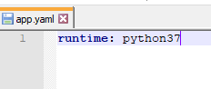

This file required version of python used in this project

* Creation of requirements.txt file

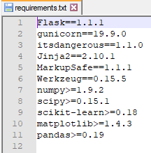

This file contain packages and it versions used in this project

**Deployment steps**

* Go to google cloud terminal execute “cd directory of where the pkl and flask”

Note: flask file name must be main.py

* Run command “gcloud init” it will ask for the creation and Re-initialize configuration

**Configuration:**

A configuration defines the structure of your deployment, including the type and properties of the resources that are part of the deployment.

* Choose the account you would like to use to perform operation and select the project name.
* Run command “gcloud app deploy app.yaml --project project_name”

It will ask choose the region where you want your app engine application and gives the target URL for our application like deployed service [default] to [URL]

Note: If the model is deployed incorrect we can see the errors in Error Reporting in google cloud platform.

<https://console.developers.google.com/apis/library/cloudbuild.googleapis.com?project=iris-model-278511&pli=1>