CarePulse: Diseases Detection

MINOR PROJECT REPORT
Submitted in partial fulfillment of the requirement for the Degree of Bachelors of Engineering in Computer Science & Engineering
Submitted To:



PARUL UNIVERSITY, VADODARA, GUJARAT (INDIA)

Group Member
1. Pandey Sanjit Vinod | 2303051057094
2. Baisampayan Dey | 2301051247023
3. Dhruv Motaval | 2301051247009
4. Aryan Patil | 2301051247002
Under The Guidance of Mrs. Arpita Meet Vaidya Assistance Professor CSE- PIT

DEPARTMENT OF COMPUTER SCIENCE & ENGINEERING PARUL INSTITUTE OF TECHNOLOGY VADODARA, GUJARAT SESSION: AY 2024-2025

Parul University
Parul Institute of Technology



(Session: 2024 -2025)
DEPARTMENT OF COMPUTER SCIENCE & ENGINEERING

CERTIFICATE

This is to certify that Pandey Sanjit Vinod, Baisampayan Dey, Dhruv Motaval, Aryan Patil Students of CSE VI Semester of “Parul Institute of Technology, Vadodara” has completed their Minor Project titled “CarePulse: Disease Detection”, as per the syllabus and has submitted a satisfactory report on this project as a partial fulfillment towards the award of degree of Bachelor of Technology in Computer Science and Engineering under Parul University, Vadodara, Gujarat (India).

GUIDE NAME Prof. Sumitra Menaria DR. Swapnil Parikh Mrs. Arpita Meet Vaidya Head (CSE) Principal

Assistance Professor CSE – PIT
IT, Vadodara PIT, Vadodara

DECLARATION

We the undersigned solemnly declare that the project report “CarePulse: Disease Detection” is based on my own work carried out during the course of our study under the supervision of MRs. Arpita Meet Vaidya, Assistance Professor, CSE- PIT.

We assert the statements made and conclusions drawn are the outcomes of my own work. I further certify that
- The work contained in the report is original and has been done by us under the general supervision of our supervisor.
- The work has not been submitted to any other Institution for any other degree / diploma / certificate in this university or any other University of India or abroad.
- We have followed the guidelines provided by the university in writing the report.

Whenever we have used materials (data, theoretical analysis, and text) from other sources, we have given due credit to them in the text of the report and giving their details in the references.

1. Pandey Sanjit Vinod | 2303051057094 | …………………...
2. Baisampayan Dey | 2301051247023 | ……………………
3. Dhruv Motaval | 2301051247009 | ……………………
4. Aryan Patil | 2301051247002 | ……………………

ACKNOWLEDGEMENT

In this semester, we have completed our project on “CarePulse: Disease Detection”. During this time, all the group members collaboratively worked on the project and learnt about the industry standards that how projects are being developed in IT Companies. We also understood the importance of teamwork while creating a project and got to learn the new technologies on which we are going to work in near future.

We gratefully acknowledge for the assistance, cooperation guidance and clarification provided by “Mrs. ” during the development of our project. We would also like to thank our Head of Department Prof. Sumitra Menaria and our Principal Dr. Swapnil Parikh Sir for giving us an opportunity to develop this project. Their continuous motivation and guidance helped us overcome the different obstacles for completing the Project.

We perceive this as an opportunity and a big milestone in our career development. We will strive to use gained skills and knowledge in our best possible way and we will work to improve them.

1. Pandey Sanjit Vinod | 2303051057094 | …………………...
2. Baisampayan Dey | 2301051247023 | ……………………
3. Dhruv Motaval | 2301051247009 | ……………………
4. Aryan Patil | 2301051247002 | ……………………

LIST OF FIGURES

Figure No. | Figure Title | Page No.
Fig 1.1 | DFD Level 0 Diagram | 8
Fig 1.2 | DFD Level 1 Diagram | 8
Fig 1.3 | DFD Level 2 Diagram | 8
Fig 2 | Use case Diagram | 9
Fig 3 | UML Diagram | 9
Fig 4 | ER Diagram | 10
Fig 5.1 | Sign Up | 12
Fig 5.2 | Sign In | 12
Fig 5.3 | User Form 1 | 13
Fig 5.4 | User Form 2 | 13
Fig 5.5 | Homepage | 14
Fig 5.6 | Step Counts | 14
Fig 5.7 | Water Intake | 15
Fig 5.8 | Calories Burn | 15
Fig 5.9 | Workout | 16
Fig 5.10 | Heart Monitor | 16
Fig 5.11 | Emergency Help | 17
Fig 5.12 | Notification’s | 17
Fig 5.13 | Profile | 18
Fig 5.14 | Contact Us | 18

LIST OF ABBREVIATIONS

S.No. | Abbreviation | Full Form
1 | AI | Artificial Intelligence
2 | ML | Machine Learning
3 | ECG | Electrocardiogram
4 | SpO₂ | Blood Oxygen Saturation
5 | HRV | Heart Rate Variability
6 | GDPR | General Data Protection Regulation.
7 | HIPAA | Health Insurance Portability and Accountability Act.
8 | BLE | Bluetooth Low Energy
9 | CNN | Convolutional Neural Network
10 | RNN | Recurrent Neural Network
11 | AR | Augmented Reality
12 | API | Application Programming Interface
13 | SDK | Software Development Kit
14 | UI | User Interface
15 | UX | User Experience
16 | ER | Entity-Relationship
17 | DFD | Data Flow Diagram
18 | UML | Unified Modeling Language
19 | LR | Linear Regression
20 | SVM | Support Vector Machine

ABSTRACT

CAREPULSE is revolutionizing healthcare by integrating wearable devices, smartphones, and machine learning (ML) for real-time disease detection and health monitoring. Smartwatches and other wearables collect vast amounts of health data, including heart rate, oxygen levels, ECG readings, and activity patterns. This data is then analyzed by advanced ML algorithms, which identify potential risks and detect warning signs of serious conditions like heart attacks, arrhythmias, and hypertension. If an abnormality is detected, CAREPULSE immediately sends alerts to the user, allowing them to take timely action. In critical situations, the app can also notify emergency contacts or healthcare providers to ensure rapid medical intervention. Beyond emergency detection, CAREPULSE continuously monitors health trends, offering personalized insights and preventive recommendations to improve overall well-being. By shifting healthcare from a reactive to a proactive approach, CAREPULSE empowers users to stay ahead of potential health issues, ultimately reducing hospital visits, lowering healthcare costs, and saving lives.

INDEX

CHAPTERS | TOPIC | PAGE No.
Chapter I | INTRODUCTION | 1
I.I | Overview | 1
I.II | Problem Statement | 1
I.III | Objectives | 1
I.IV | Applications and Scope | 1-2
I.V | Organization of Report | 2
Chapter II | LITERATURE REVIEW | 3-4
Chapter III | METHODOLOGY | 5
III.I | Background / Overview of Methodology | 5
III.II | Project Platforms Used in the Project | 5
III.III | Proposed Methodology | 6
III.IV | Project Modules | 7
III.V | Diagrams | 8-10
Chapter IV | SYSTEM REQUIREMENTS | 11
IV.I | Software Requirements | 11
IV.II | Hardware Requirements | 11
Chapter V | EXPECTED OUTCOMES (with GUI) | 12-18
Chapter VI | CONCLUSION & FUTURE SCOPE | 19
VI.I | Conclusion | 19
VI.II | Future Scope | 19-20
Chapter VII | REFERENCES | 21-22
Chapter VII | Weekly Report (Xerox / Original) | 23

Chapter I: Introduction

Overview:
Wearable AI technologies like smartwatches and health monitors help a user in keeping track of very vital health parameters such as heart rate and SpO₂ levels. However, these devices are not often used for real-time disease detection. This is where CarePulse comes into play-it leverages machine learning to extract valuable indicators from smartwatch data to identify people at risk of heart disease, arrhythmia, hypertension, and stress. The mobile application sends instant alert notifications to the user and gives personalized insights to motivate the user to seek preventive steps towards healthier living.

Problem Statement:
Despite all the marvels in modern technology, it is still an ancient disadvantage for healthcare to carry on with the early detection of diseases. A lot of wearable technologies do not act on the resulting alerts, and such important health information goes unutilized, especially in the case of heart diseases.
Many-a-time patients fail to detect the onset of their symptoms, while sheer mileage to a facility and the time is the other resistance factors that prevent timely medical intervention.

Objectives:

  - Continuous Health Monitoring: Monitoring of heart rate, oxygen level, ECG signals, and movement on a real-time basis and analyzing the patterns.
  - Machine Learning for Disease Detection: A model is trained to detect possible early signs of disease and high-risk health conditions with remarkable accuracy.
  - Real-Time Alerts and Notifications: Send instant alerts for abnormal conditions and suggest medical evaluations or lifestyle changes.
  - User-Friendly Mobile Application: Create an intuitive interface for visualizing health trends and accessing historical data.
  - Privacy and Security Compliance: Safe storage of users' data with due consideration for GDPR, HIPAA, etc.

Applications and Scope:

  - Preventive Health Care and Early Detection of Events: By monitoring vital signs continuously and sending real-time alerts, this application establishes connections for easy detection of cardiovascular diseases, arrhythmias, and

stress conditions in patients..

  - Remote Patient Monitoring and Emergency Services: This type of monitoring allows a health professional to monitor patients while distant and allows instant warning to a caregiver or medical team in case the patient experiences any critical health abnormalities.

  - Health Analyses Using AI: Machine Learning for pattern recognition of Heart Rate, Oxygen, and ECG Data for personal insights and recommendations for proactive health management.

  - Fitness and Stress Management: Assists users, including athletes and professionals, in optimizing physical performance and mental well-being by monitoring stress, fatigue, and recovery metrics.
  - Able to expand with the most advanced AI models to incorporate augmented reality (AR) visualizations and to cover more diseases, namely diabetic conditions, and respiratory diseases.

  - Supports multi-language accessibility to ensure usability worldwide, even while following multiple health data privacy regulations, including GDPR and HIPAA, for confirming safe and ethical handling of data.

Organization of Report:
This report presents the project in a number of chapters, presenting the various aspects of the project in terms of the project's development, methodology, requirements, expected outcomes, and future scope.

Chapter II: Literature Review

Current Health Monitoring Applications and Wearable Technology

Google Fit, Apple Health, and Samsung Health:
    - These applications provide basic functionalities for tracking heart rate, step count, and activity levels; however, they do not offer real-time disease detection.
    - Their primary role is to serve as data collectors, rather than functioning as intelligent health advisors that utilize ML-driven analytics.

Smartwatch Health Monitoring (Apple Watch, Fitbit, Garmin):
    - Such devices are equipped with capabilities including heart rate tracking, ECG monitoring, and SpO₂ measurement.
    - Nonetheless, most of these devices rely on basic threshold-based alerts instead of employing machine learning-powered predictive analytics.
- Artificial Intelligence and Machine Learning in Disease Detection

Neural Networks for Health Monitoring:
    - Convolutional Neural Networks (CNNs) and Recurrent Neural Networks (RNNs) are extensively utilized in the domains of medical image processing and signal analysis.
    - A I-based models for ECG and heart rate analysis are proficient in detecting conditions such as arrhythmias, hypertension, and stress-related disorders.

Heart Rate Variability (HRV) and Anomaly Detection:
    - Machine learning models analyze HRV patterns to predict cardiovascular diseases and to identify early warning signs.
    - AI-based anomaly detection for SpO₂ and ECG is vital in recognizing oxygen deficiencies, heart disorders, and initial disease symptoms.
- Flutter as a Platform for Cross-Platform Health Applications

FlutterFlow Framework for Application Development:
    - The Flutter framework provides cross-platform compatibility, which enables

the CarePulse application to operate seamlessly on both Android systems.
    - It offers a high-performance user interface that integrates real-time health monitoring dashboards.

Integration with Smartwatch Sensors:
    - The Flutter framework facilitates seamless Bluetooth connectivity to retrieve data from smartwatches and fitness bands.
    - Thereby supporting real-time data visualization and interactive reports tailored for both users and healthcare providers.

- Predictive Health Analytics and Personalized Artificial Intelligence Models

Machine Learning Based Risk Prediction:
    - These supervised learning models predict potential health risks using historical health data, while the AI ones also learn to recognize patterns in heart rate, blood oxygen levels, and physical activity to give early warning alerts.

Personalized Health Recommendations:
    - AI models designed to make recommendations based on individual health history and activity level.
    - The models further improve in recommended accuracy for diseases using adaptive learning techniques over time.
- Datasets and Resources for AI Training

Medical datasets for training AI models:
    - One of such dataset is the MIT-BIH Arrhythmia Database, which serves as an example of data set heavily referenced when making ECG-based disease- detecting models.
      - More sources are PhysioNet and the Kaggle Health Datasets, which provide
real-world data for a more practical baseline for machine learning in health care.

AI Frameworks for Health Monitoring:
    - The ones usually voted for are tensor flow and PyTorch, the majority of which are often trained and deployed for machine learning applications, for instance, real-time disease detection.

    - Using scikit-learn and keras, persons can also create other predictive analytic models for real-time disease detection.
- Privacy, Security, and Ethical Issues

Protection of Health Data and Compliance:
    - AI-enabled health applications must also comply with data protection regulations, including those of the General Data Protection Regulation, Health Insurance Portability and Accountability Act, as well as California Consumer Privacy Act. CarePulse will thus enforce end-to-end encryption for the removal of sensitive health data.

On the Ethics of AI in Healthcare:
    - It is quite necessary that machine learning model be trained under different data sets, in order to minimize bias for disease detection.
    - Transparency with respect to the data and ensuring that informed consent is taken from users, will pave way towards a trust-based user-health environment model.

CHAPTER III: Methodology
- Background / Overview of Methodology
A well-organized and multi-phased approach, which includes data collection from smartwatches, real- time data processing, AI-based disease detection, and mobile app user interface, all forms the base of CarePulse. This system works on algorithms based on machine learning to analyze data of health collected from wearable devices, unusual patterns and gives immediate feedback.
CarePulse is essentially a health monitor based on AI and constantly evaluates vital signs including heart rate, level of SpO₂, and ECG in monitoring health risks, unlike the previous system of health monitoring, which took a lot of time to interpret and was not very accurate. CarePulse has focused on establishing an intelligent system for real-time health data, risk assessment for diseases, and preventive advice for health management. The message is captured on a mobile application developed using Flutter, while predictive analytics are rolled out by machine learning algorithms.
- Project Platforms Used in the Project
To develop and deploy CAREPULSE, various software platforms and technologies are used:

Development Platforms:
    - Programming language- Python (for AI/ML) and Dart for Flutter UI.
    - Frameworks & Libraries:
      - TensorFlow & Keras: AI model development
      - Scikit-Learn: Machine learning algorithms for health risk classification
      - Flutter: Frontend for mobile application
      - Flask/Django: Backend API for AI processing

Database & Storage:
        - Firebase: User data and recommendation history storage
        - Cloud storage: Secure storage for health data and AI models

AI & Predictive Analytics Tools:
        - Pre-trained Models: LR, SVM
        - Deep Learning Algorithms

Testing & Security:
        - Testing Frameworks: Selenium, PyTest for functionality testing.
        - Security Protocols: End-to-end encryption, GDPR and HIPAA compliance for data privacy.

Proposed Methodology:
The project follows a structured methodology divided into key phases:

Phase 1: Need Analysis and Data Collection:
  - Collect real-time data from smart wearables/smartphones, including heart rate, SpO2, and ECG.The AI could be trained on user preference and known medical datasets.
  - Analyze the different contemporary AI-based healthcare monitoring systems to derive practices.

Phase 2: Data Preprocessing and Anomaly Detection:
  - Clean and filter health data for unwanted noise and outlier.
  - In addition to that, provide normalization for heart, SpO2, and ECG readings to provide standardized input to the AI model.
  - Anomaly detection as a procedure will be conducted to indicate certain unusual behavior patterns in an individual.

Phase 3: Disease Prediction and Risk Scoring through AI:
  - CNN-LSTM type deep learning model is developed to predict cardiovascular risks.
  - The health risk scores will be computed as deviations from the average values.
  - Establishment of low, moderate, and high-risk alert levels.

Phase 4: User Interaction and Mobile Application Development:
  - An easy Health monitoring app based on Flutter for real-time health monitoring.
  - Personalization of health insights, trend analysis, and immediate alerts.
  - Users can look at past health reports and AI recommendations.

Phase 5: Testing & Performance Optimization:
  - Functional and usability testing to ensure seamless data flow.
  - Optimization of rapid processing and less false positives through AI model.
  - Deployment of model in cloud for improved performance.

Phase 6: Future Enhancements:
  - Health visualization can be enhanced with some AR options.
  - Extend disease detection to diabetes, mental health, and respiratory diseases.
  - Voice-based AI providing immediate access to health advice.

Project Modules:
The system is divided into several modules, each handling a specific functionality:

User Authentication & Profile Management
    - Secure login by Firebase Authentication & OAuth integration.
    - User profile defining his health history and activity.

Health Data Collection & Smartwatch Connectivity
    - Real-time data fetch from smartwatches via Bluetooth Low-energy
    - Background sync on applications for continuous health monitoring activity.

AI-Based Health Risk Prediction

    - Implementation of deep learning models in the form of CNN, STM, and Decision Trees to analyze health data.
    - Makes predictions about health risk through detection of anomalies and trend analysis techniques.

Alert System & Health Insights Dashboard

    - Real-time alerts for heart rate, oxygen levels, and abnormal ECG pattern recognition.
    - Health trend, report, and recommendation from doctor.

Cloud-Based Data Storage & Security

    - Strengthened secure storage of health data with Firebase/PostgreSQL.
    - Medical field services secure vis-a-vis HIPAA and GDPR.

- Diagrams:
- DFD Diagram:
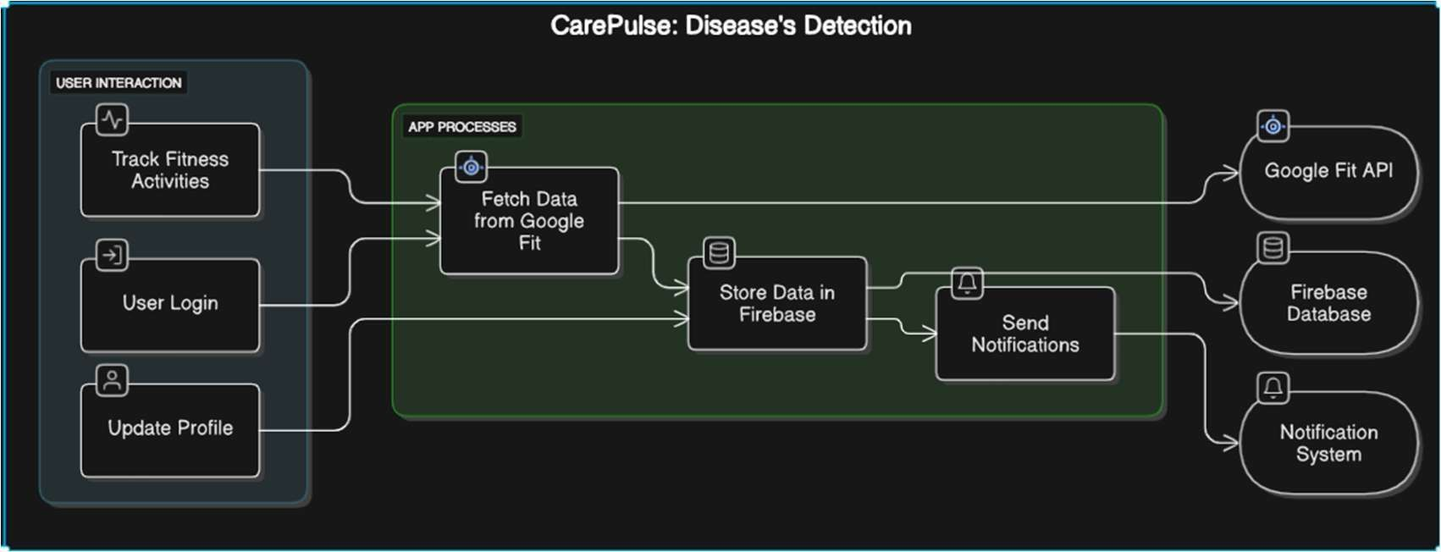

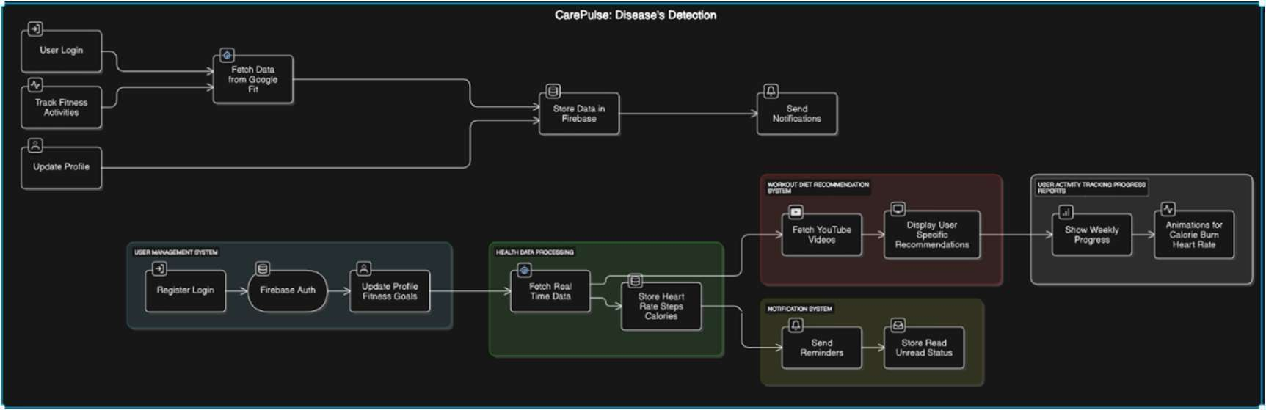

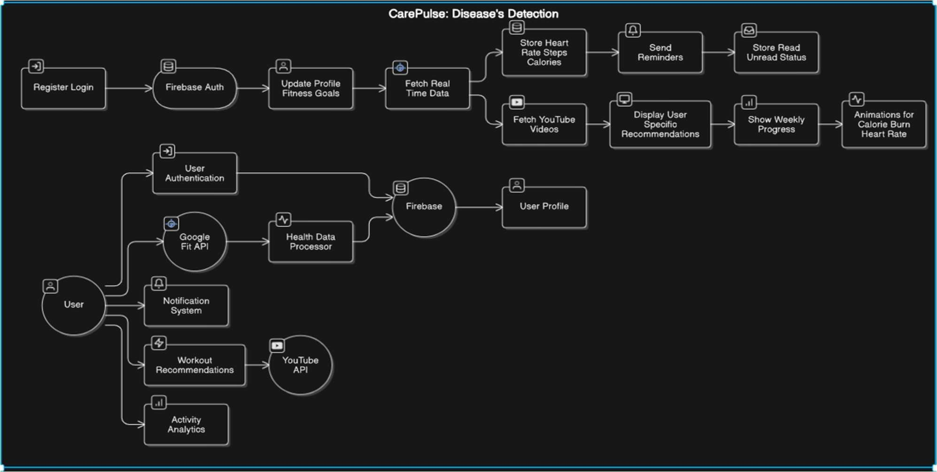

Fig. 1.3: DFD Level 2 Diagram

- Use case Diagram:
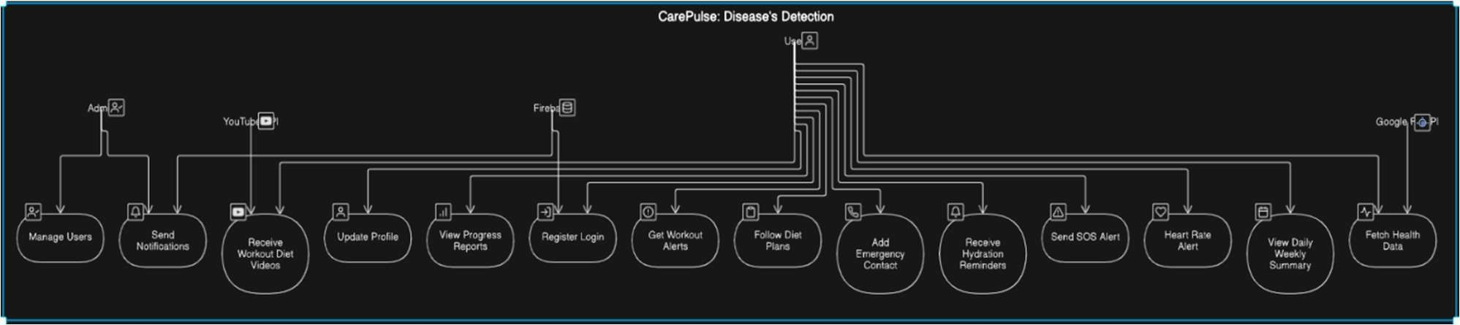
Fig. 2: Use case Diagram
- UML Diagram:
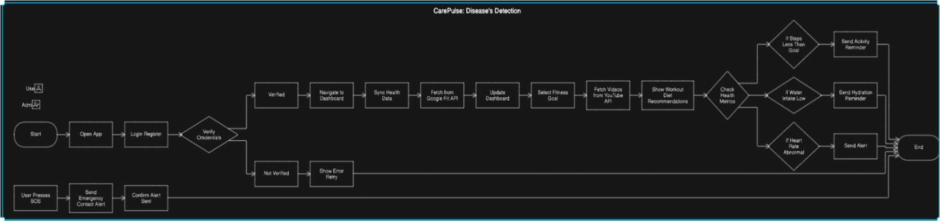

- ER Diagram:
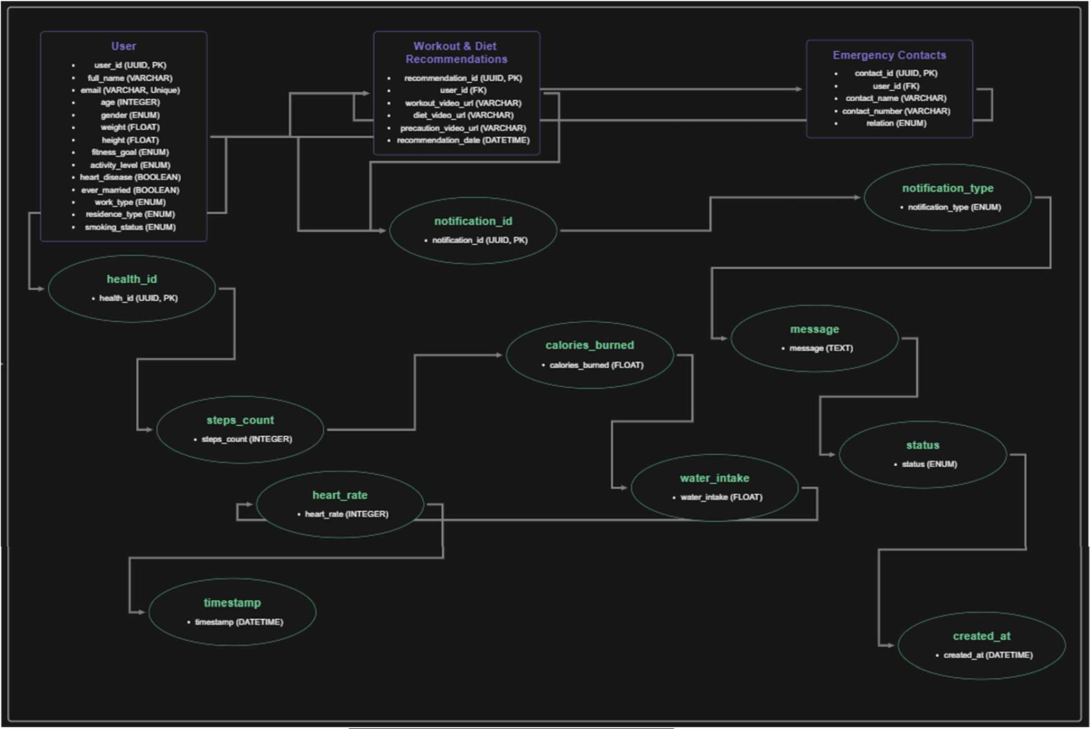
Fig. 4: ER Diagram

Chapter IV: System Requirements

Software Requirements:
  - Operating System: Android 8.0 (Oreo) or later
  - Development Framework: Flutter Flow
  - Backend: Firebase (Real-time Database & Authentication)
  - Machine Learning Frameworks: TensorFlow Lite (for on-device ML processing)
  - Storage Requirement: 200MB–500MB (including cached health data)

APIs & SDKs:
    - Google Fit API (for health data access)
    - Bluetooth Low Energy (BLE) SDK (for smartwatch connectivity)

Security & Compliance:
    - AES-256 encryption for health data storage.
    - GDPR & HIPAA compliance for user privacy.

Hardware Requirements:
- Minimum Requirements:
  - Operating System: Android 8.0 (Oreo) or later
  - Processor: Quad-Core (1.8 GHz or higher)
  - RAM: 3GB
  - Storage: 200MB free space.
  - Display: Minimum 5.0-inch screen (to ensure readability of health insights)
  - Connectivity: Bluetooth & Internet access for real-time data sync.
  - Sensors: Basic health tracking sensors (Heart rate monitor support, if available)

Recommended Requirements:
  - Operating System: Android 10 or later
  - Processor: Octa-Core (2.0 GHz or higher)
  - RAM: 4GB or more (for smooth app performance)
  - Storage: 500MB free space (for future updates & cached health data)

  - Display: 5.5-inch or larger screen (for optimal UI/UX experience)
  - Connectivity: Bluetooth 5.0+ & stable Wi-Fi/mobile data for faster real-time sync.
  - Sensors: Advanced health sensors (ECG, SpO₂, Heart rate monitor, Wear OS compatibility).

Fig 5.1: Sign Up

Chapter V: Expected Outcomes (with GUI)

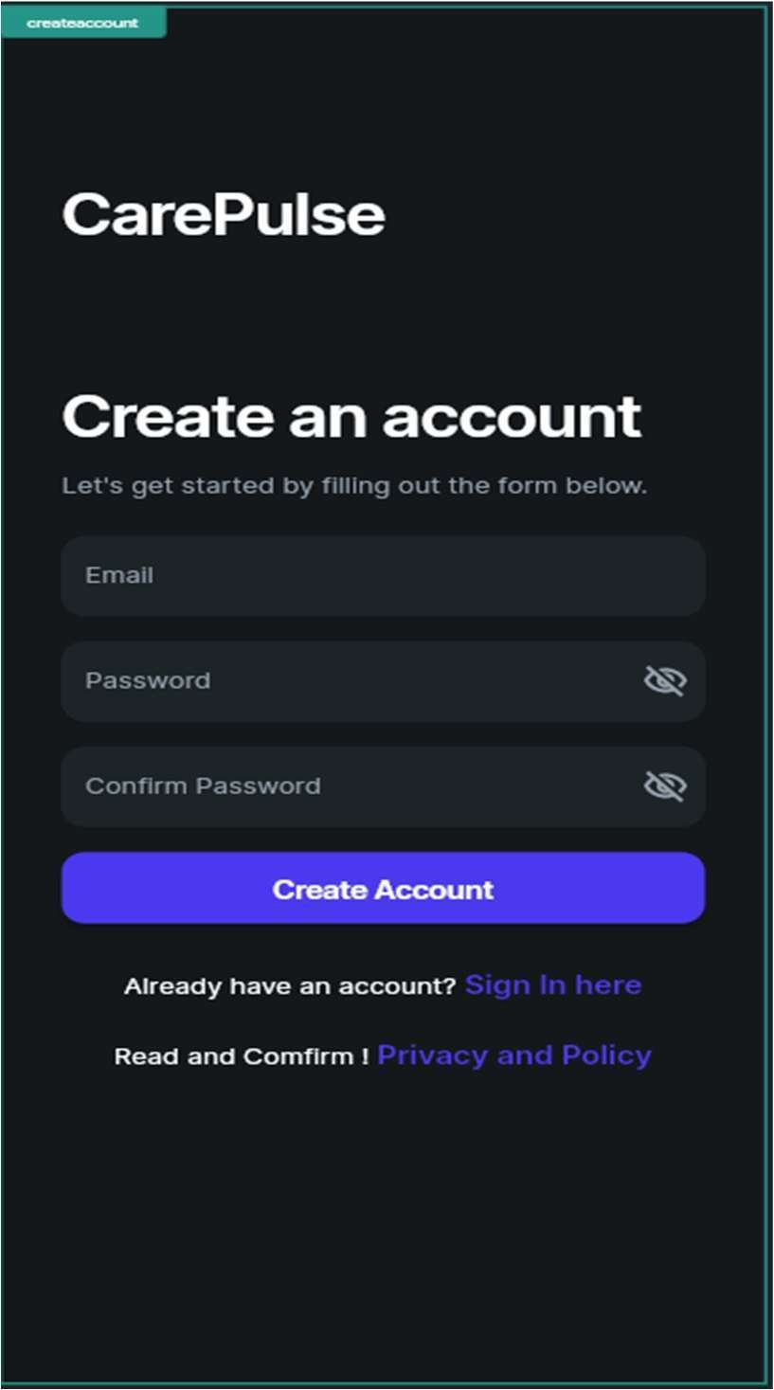
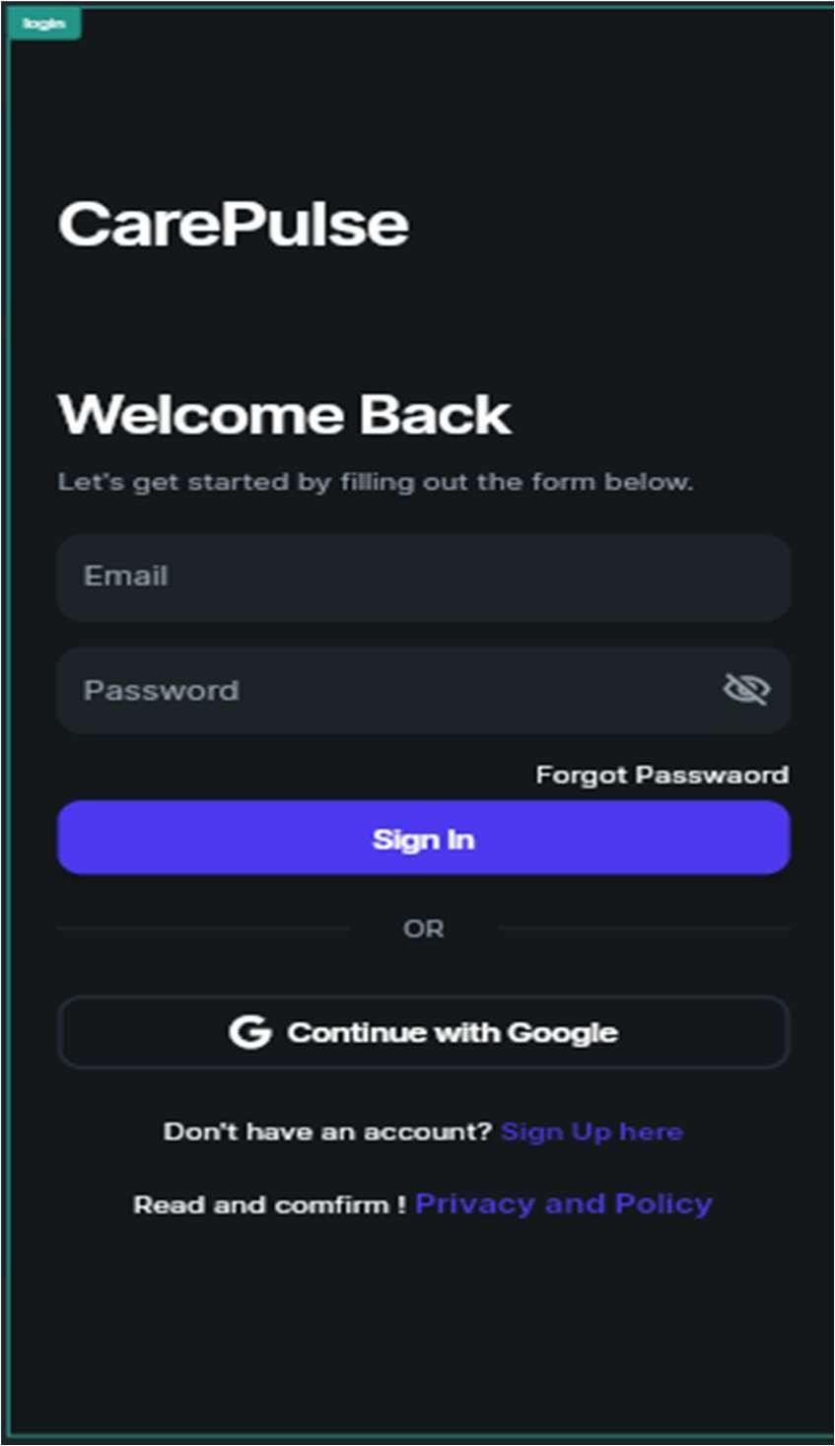

- Sign Up & Sign In:

Fig 5.3: User Form 1
Fig 5.4: User Form 2
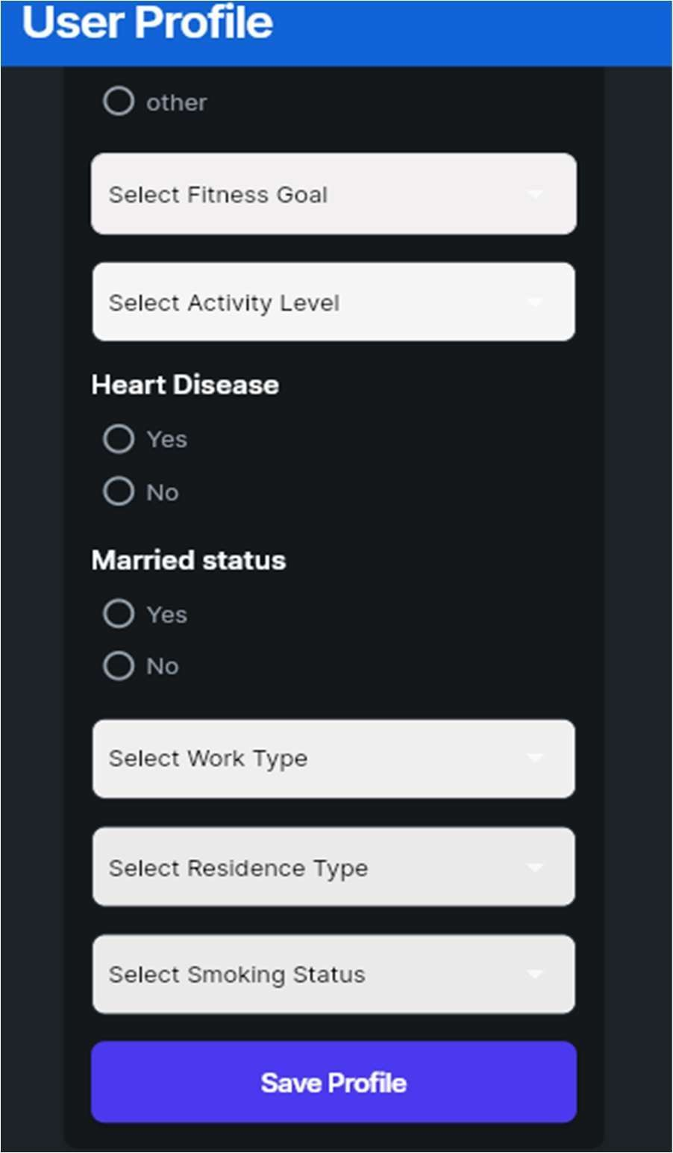
- User Form:
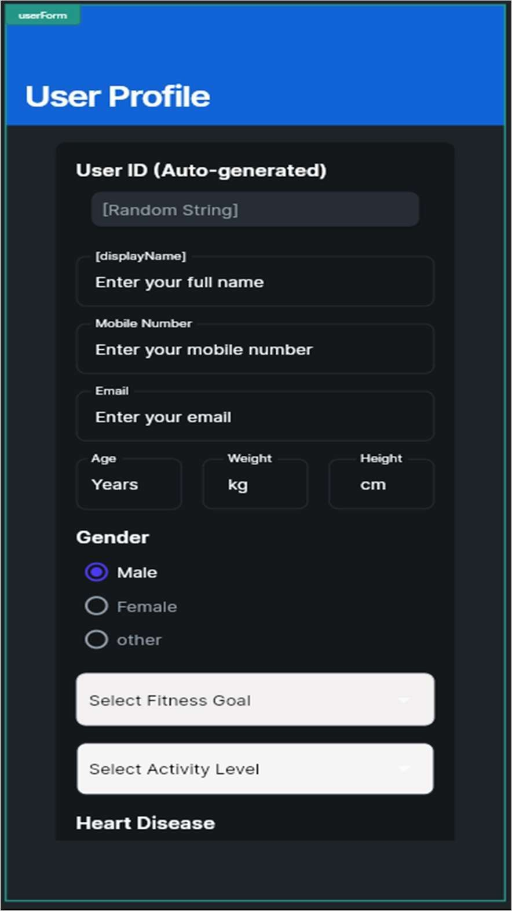

Fig 5.6: Step Counts
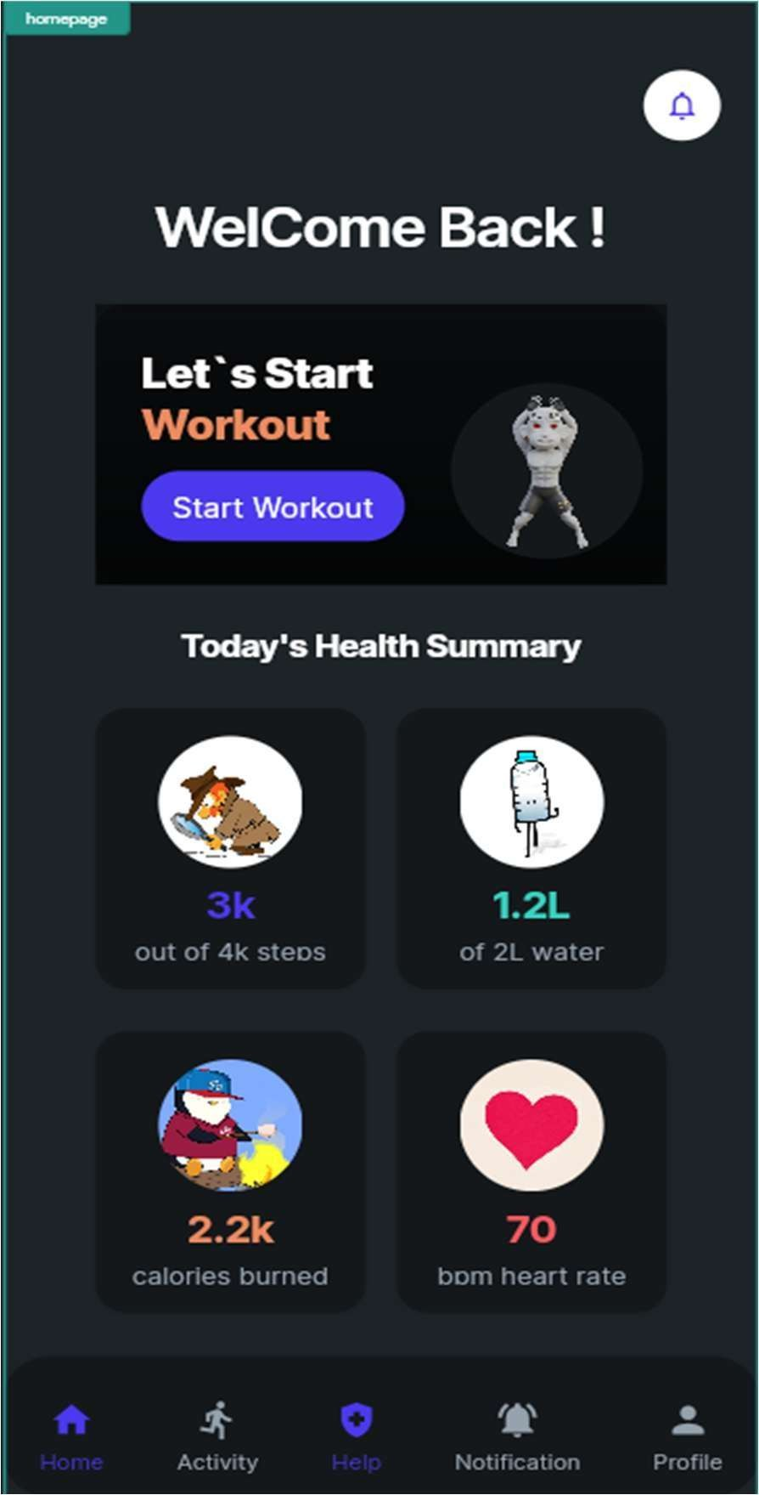

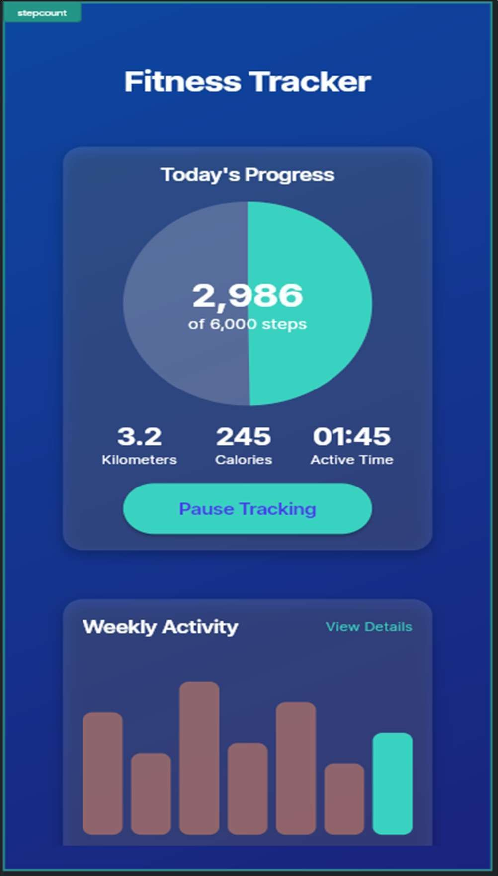
- Homepage:

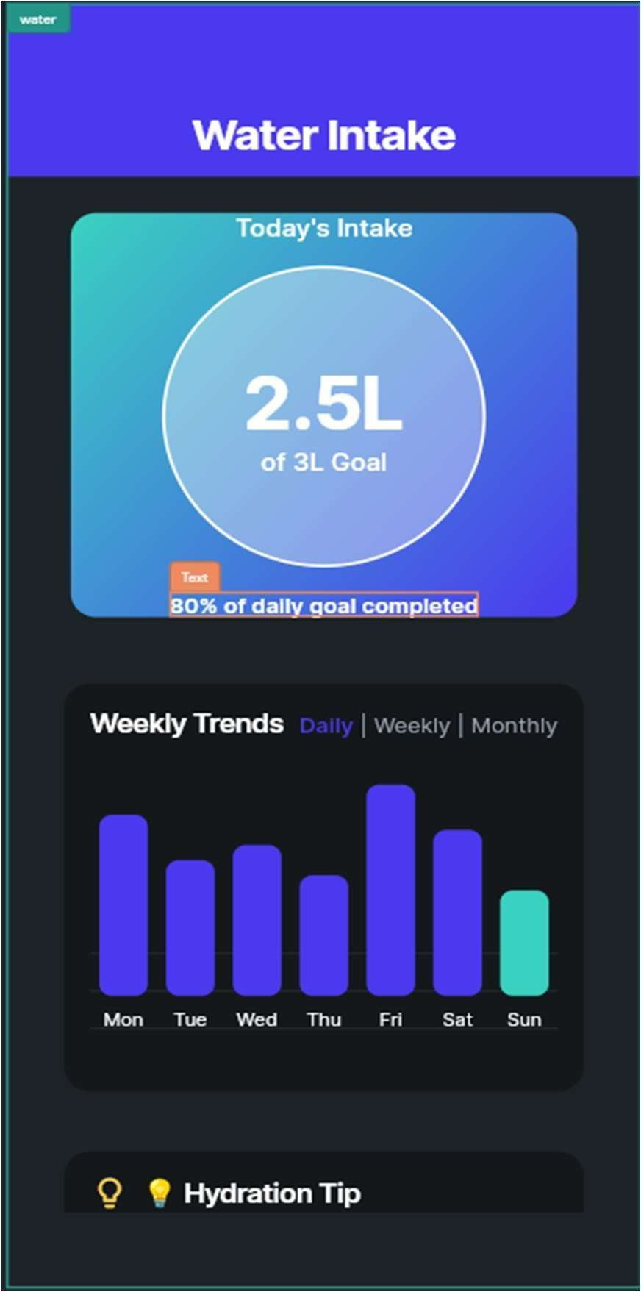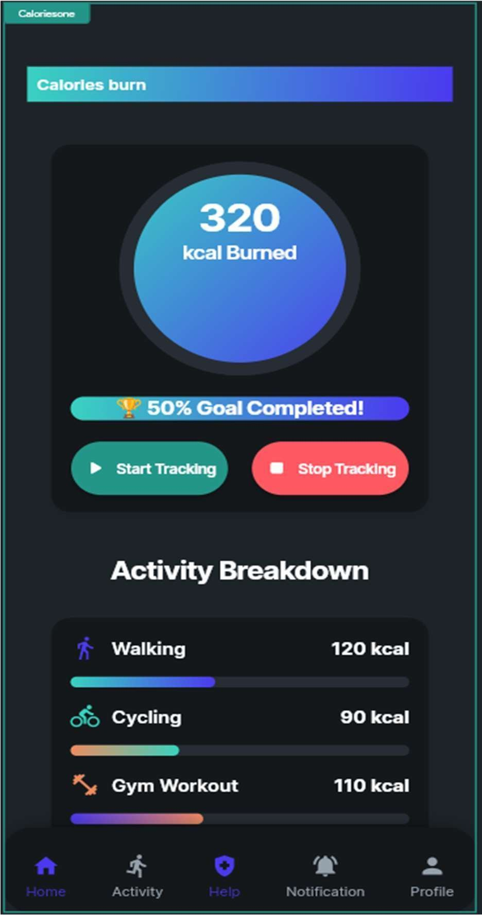
Fig 5.7: Water Intake
Fig 5.8: Calories Burn

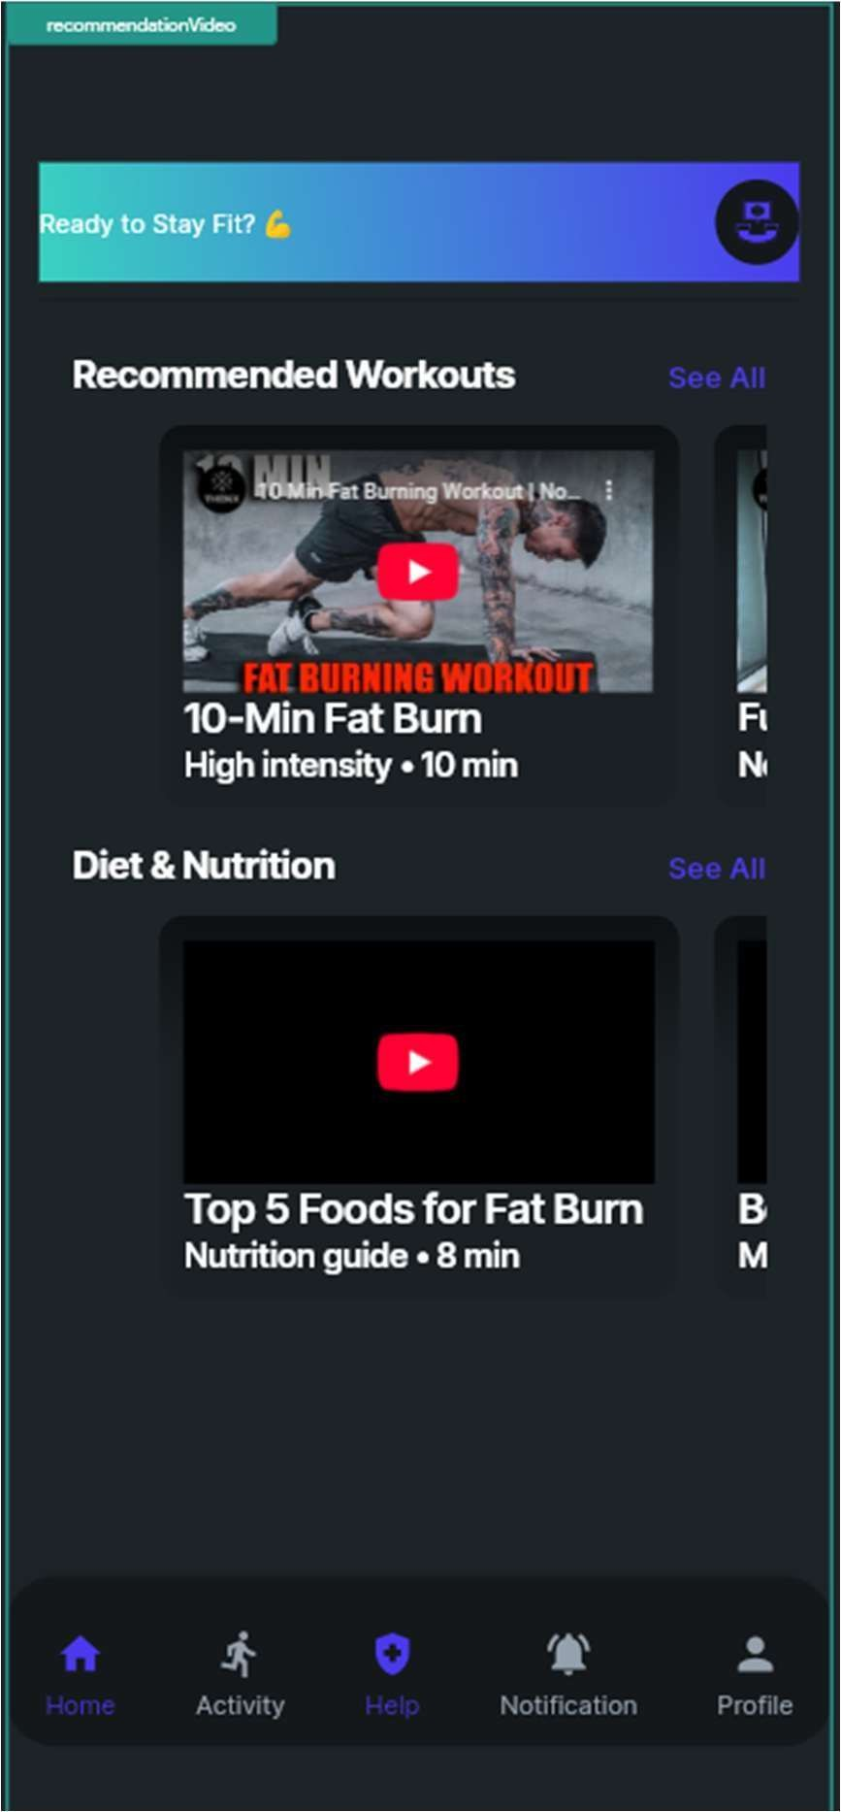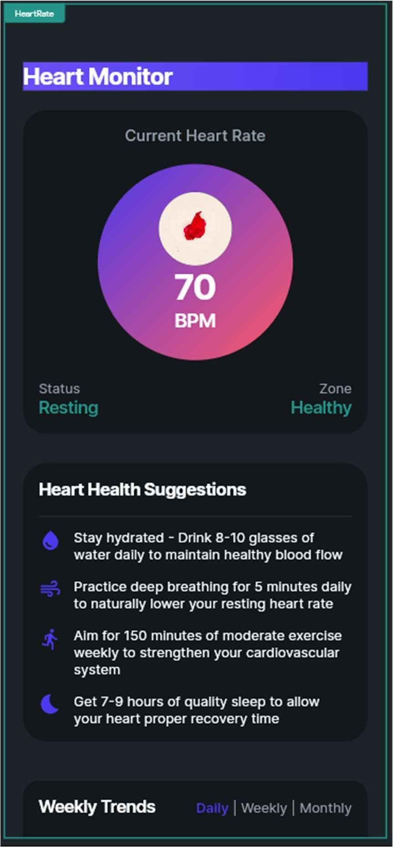
Fig 5.9: Workout
Fig 5.10: Heart Monitor

Fig 5.12: Notification’s
Fig 5.11: Emergency Help

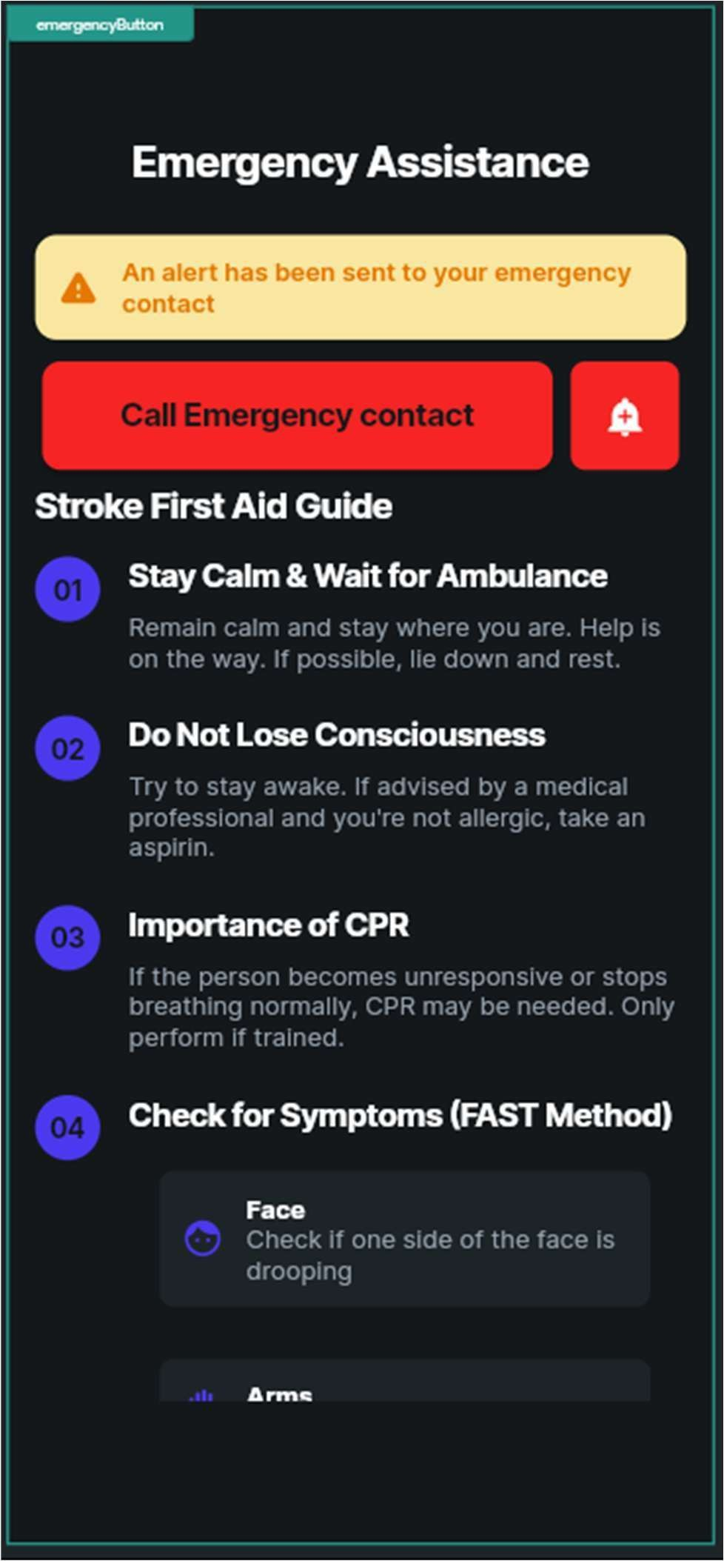
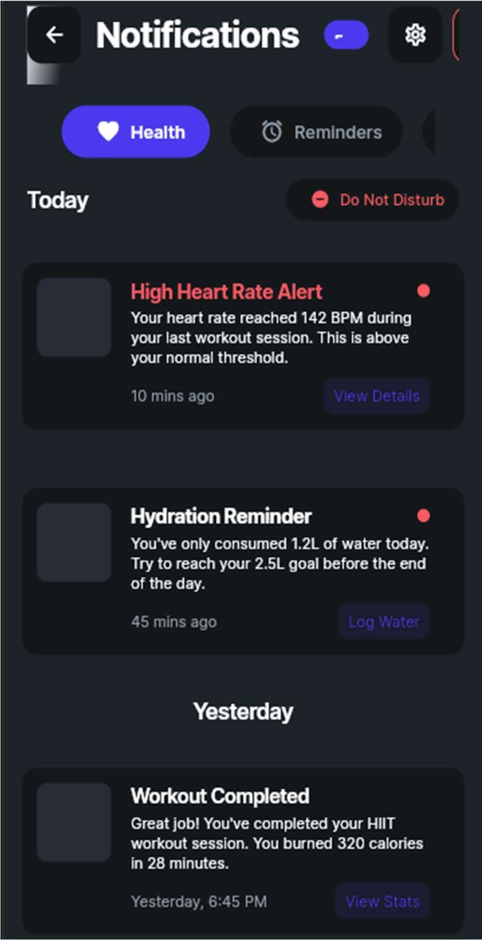
Help Page: V. Notification Page:

- Profile Page:
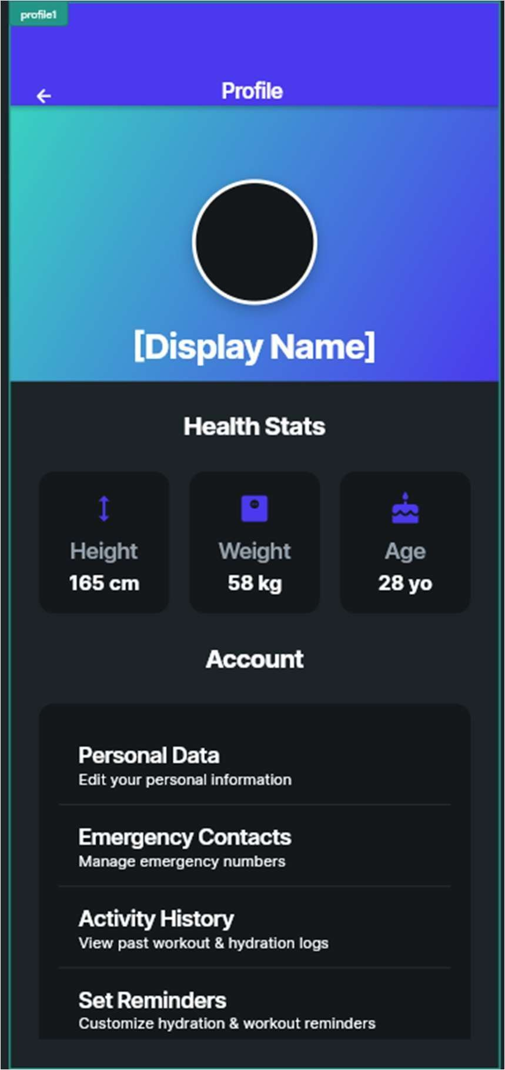
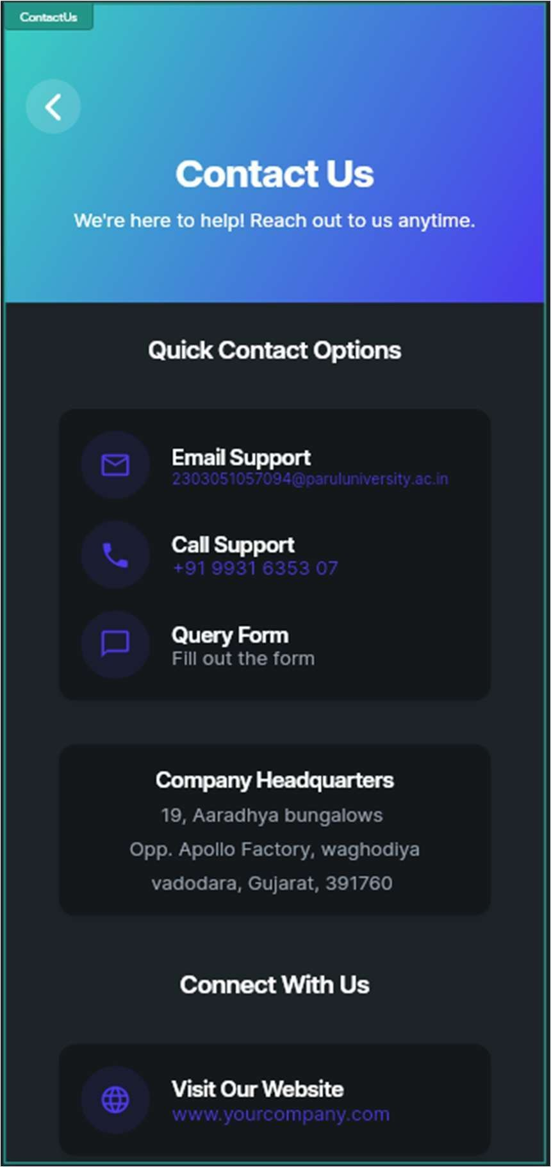

Fig 5.13: Profile
Fig 5.14: Contact Us

Chapter VI: Conclusion & Future Scope

Conclusion:
The CarePulse Application has been designed for health monitoring and detection disease using a combination of sensors that comes from wearables/smartphone along with machine learning and real-time data analysis. With many people already relying much on wearables/smartphones for healthcare, it needs a bridge that connects the worlds of personal AI-enabled health insights and beyond simple data collection. CarePulse does that by creating an intelligent system that continuously monitors some contextually relevant health metrics like heart rate, SpO₂, ECG patterns, and it also uses AI to alert caution about possible health risks.

Using FlutterFlow for app development, CarePulse creates a fluid, functional experience for users interacting with real-time health profiles with the app, bringing such technology to the masses. Machine learning models embedded in the design help discover signs of irregularity in vital signs, disease risk prediction, and face users with suggestions on possible health issues.

One of the best features of CarePulse is that it offers preventive healthcare services to a person. For example, instead of being told all the symptoms by the doctor after serious deterioration of the condition's status, the patient is warned, which encourages him to preempt the condition before worsening symptoms appear. The intuitive UI, smartwatch integration, and cloud-based records of health information not only makes the app quite potent in taking care of one's own health but also manages to attach value to it by allowing it to be the future of self-management.

Apart from it, privacy and security of data are the primary concerns of the system and are built to standards of GDPR and HIPAA compliance, thus safeguarding sensitive medical data.
Having historical health trends stored and analyzed, the user can keep a tab of his/her health over time and finally make changes to his/her lifestyle.

CarePulse is not simply a health application-it is almost that, but it makes step toward the revolution of access to cheap healthcare and an early diagnosis of diseases into being a more reliable, accurate, and user-friendly experience.

Future Scope:
  - Expanded Disease Detection Capabilities: Future updates will soon be added using AI models to detect other health issues such as a risk of diabetes, respiratory issues, and mental health indicators in stress, anxiety, and sleep disorders.
  - Integration with Wear OS & More Smartwatches: The application will be made for Wear OS, extending compatibility apart from the supported smart device brands originally.
  - Augmented Reality (AR) for Health Visualization: Health monitoring through AR becomes entertaining and allows visualization of trends in such a way that vital stats are seen rather than going into the dull standard methods.
  - Voice & AI Chatbot Assistance: The CarePulse AI is more user- friendly and improves accessibility. Voice-based health inquiries and chatbot symptom tracking with instant medical advice will be carried out through voice calls.
  - Integrated with Telemedicine & Doctor Consultation: Based on AI health report findings, telemedicine integration platforms would enable CarePulse to facilitate users' consultations with certified healthcare professionals.
  - Multilingual Global Accessibility: This will go multilingual, hence making the application accessible for users across borders and thereby improving healthcare access in various countries.
  - Offline Mode & AI Processing on Device: By integrating TensorFlow Lite to enable offline mode, the application will keep managing the health data locally and cut down on Internet reliance while supporting real-time AI-based predictions even in quite isolated places.

Chapter VII: References
- Books & Research Papers
  - Chollet, F. (2018). Deep Learning with Python. Manning Publications. (Useful for understanding deep learning concepts and applying them in mobile apps.)
  - Zhang, Y., & Zheng, Y. (2020). Artificial Intelligence in Healthcare. Springer. (Relevant for developing healthcare-related apps with AI integration.)
  - Kelleher, J. D., Mac Carthy, M., & Korvir, P. (2015). Fundamentals of Machine Learning for Predictive Data Analytics. MIT Press. (Provides a foundation for implementing machine learning algorithms in apps.)
  - Kingma, D. P., & Ba, J. (2015). Adam: A Method for Stochastic Optimization. arXiv preprint arXiv:1412.6980. (Important for understanding optimization techniques used in app-based AI models.)
  - Wang, Y., & Zhang, J. (2021). AI-Powered Mobile App Development.
  - Springer. (Focuses on the integration of AI in mobile app development.)
  - Raschka, S. (2015). Python Machine Learning. Packt Publishing. (Provides insights into implementing machine learning models that can be used in mobile apps.)
  - Bishop, C. M. (2006). Pattern Recognition and Machine Learning. Springer. (For implementing machine learning algorithms that can be deployed in apps.)
  - Sze, V., Chen, Y., & Yang, T. (2017). Efficient Processing of Deep Neural Networks: A Tutorial and Survey. Foundations and Trends® in Electronic Design Automation. (Provides techniques for optimizing deep learning models for mobile devices.)
- Official Documentation & Online Resources
  - TensorFlow Lite Documentation: https://www.tensorflow.org/lite
  - PyTorch Mobile Documentation: https://pytorch.org/mobile
  - Google Developers. (2020). ML Kit for Firebase: https://developers.google.com/ml-kit
  - Keras Documentation: https://keras.io/

  - Eraser: https://app.eraser.io/dashboard/all

- Development Tools & Platforms Used
  - FlutterFlow – Used for designing and building the Care Pulse mobile app.
  - Google Fit API – Integrated for accessing health and fitness data from Android devices.
  - Google Firebase Console – Used for real-time database, authentication, and cloud functions.
  - Google Cloud Console – Utilized for cloud-based AI model deployment and secure health data storage.

