1. To estimate the thresholds

Thresholds: to define whether a given randomized trial sequence is valid in terms of uniformity, distance to the middle point, and unpredictability.

1. Switch on the loop_and_plot_valid_trials function line in the generate_triallist

function.

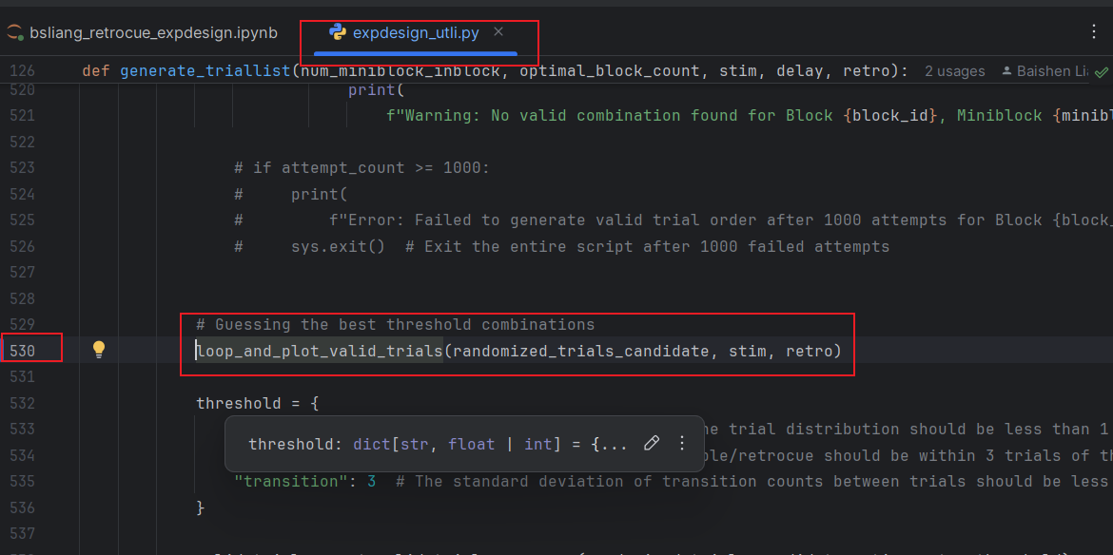

1. Make a debug note to the following line

1. Check the looping parameters (range to find the best fit threshold)

1. Restart Jupyter notebook
2. Run all cell above

1. And debug this cell

1. A graph of a graph with lines and dots

   Description automatically generated with medium confidenceEstimate the thresholds that allow SOME sequence alive but are strictest.
2. Set the thresholds

1. Run and get the trial sequence
2. Restart Jupyter notebook
3. Run the main script totally

1. If you want to see the histograms of balancing parameters:

Switch this on.

1. Remember to copy the output files to the ***results*** path

