A PROJECT REPORT

on

“PRIVACY PRESERVING RESUME PROCESSING USING MACHINE LEARNING”

Submitted to

KIIT Deemed to be University

In Partial Fulfilment of the Requirement for the Award of

BACHELOR’S DEGREE IN

INFORMATION TECHNOLOGY

BY

PRATEEK KUMAR, 2205826
SHARAN TANGUDU, 22054245
BAISHNAB BEHERA, 2205200
RAGHAV INDORIA, 2205828
ROHAN INDORIA, 2205837
PARIDA PRATYUSH, 2205757

UNDER THE GUIDANCE OF

Dr. JHALAK HOTA


SCHOOL OF COMPUTER ENGINEERING

KALINGA INSTITUTE OF INDUSTRIAL TECHNOLOGY

BHUBANESWAR, ODISHA - 751024

April 2025

CERTIFICATE

This is to certify that the project titled "Privacy Preserving Resume Processing Using Machine Unlearning" is a bonafide work carried out by:
Prateek Kumar, Tangudu Sharan, Baishnab Behera, Rohan Indoria, Raghav Indoria, and Pratyush Parida,
of the School of Computer Engineering, KIIT University, in partial fulfillment of the requirements for the award of the degree of Bachelor of Technology in Computer Science and Engineering during the academic year [Insert Year].
This work is original and has not been submitted elsewhere for any other degree.
Date: 10/04/2025
(Dr. JHALAK HOTA)
Project Guide
School of Computer Engineering
KIIT University, Bhubaneswar

Acknowledgement

We take this opportunity to express our sincere gratitude to all those who supported and encouraged us throughout the successful completion of this project.
We are especially thankful to our project guide for their valuable guidance, timely feedback, and constant support, which were crucial at every stage of the project.
We also extend our thanks to the faculty and staff of the School of Computer Engineering, KIIT University, for providing the necessary resources and a conducive academic environment.
Finally, we express our heartfelt appreciation to our families and peers for their encouragement, patience, and unwavering support throughout this journey.

Abstract

As Artificial Intelligence (AI) becomes central to recruitment processes, the automation of resume screening has gained prominence. However, existing AI-based systems often inherit biases from historical data, leading to unfair and discriminatory outcomes. Additionally, the privacy of candidates is compromised due to the retention and potential leakage of sensitive information such as names, gender, age, and ethnicity.
This project introduces a dual-AI framework that ensures privacy-preserving and fair resume processing. The system includes:
- A Primary AI responsible for evaluating candidate resumes using natural language processing and semantic similarity models like BERT.
- An Adversarial AI that audits the Primary AI’s decisions using Generative Adversarial Networks (GANs) to identify and correct biased outcomes.
The model integrates machine unlearning techniques to allow removal of specific data points from training influence, thus supporting data withdrawal requests and bias elimination. Additionally, explainable AI (XAI) modules ensure transparency in decision-making, complying with global privacy standards like GDPR and aligning with DEI (Diversity, Equity, and Inclusion) principles.

Table of Contents

- Literature Review
- Problem Statement
- Specifications
- Implementation
- Standards Adopted
- Conclusion and Future Scope
- References

1. Literature Review:

AI-driven systems used in resume screening rely heavily on data collected from past hiring decisions. This creates a risk where systemic biases present in the original data can propagate and even amplify.
Key research works:
- Cynthia Dwork et al. (2012) introduced "Fairness through Awareness," highlighting how AI decisions can be adjusted based on fairness constraints.
- Ibrahim & Ahmad (2020) discussed "Machine Unlearning" as a method to address data deletion without retraining.
- Studies in model inversion and membership inference show how sensitive resume data can be reverse-engineered or identified from trained models.
These studies emphasize the need for:
- Fair model training
- Real-time bias auditing
- Post-training data removal (unlearning)

2. Problem Statement

Recruitment processes increasingly use AI models that process thousands of resumes quickly. However:
- These models are trained on potentially biased historical data
- Sensitive information is retained in model memory
- Most systems lack mechanisms for selective forgetting when data withdrawal is required
Thus, there is a need for a system that:
- Ensures fairness in candidate selection
- Respects user privacy and legal rights
- Can forget user data efficiently through machine unlearning

3. Specifications

Technologies and Tools Used:
- Programming Language: Python
- Libraries: PyTorch, Hugging Face Transformers, Fairlearn, Scikit-learn
- Models: BERT, Sentence-BERT (for resume embedding and similarity), GANs (for adversarial bias detection)
- Data Security: Differential Privacy, Machine Unlearning Algorithms
- Evaluation Metrics:
  - Accuracy
  - Demographic Parity
  - Equal Opportunity
  - Precision/Recall

Project Architechture

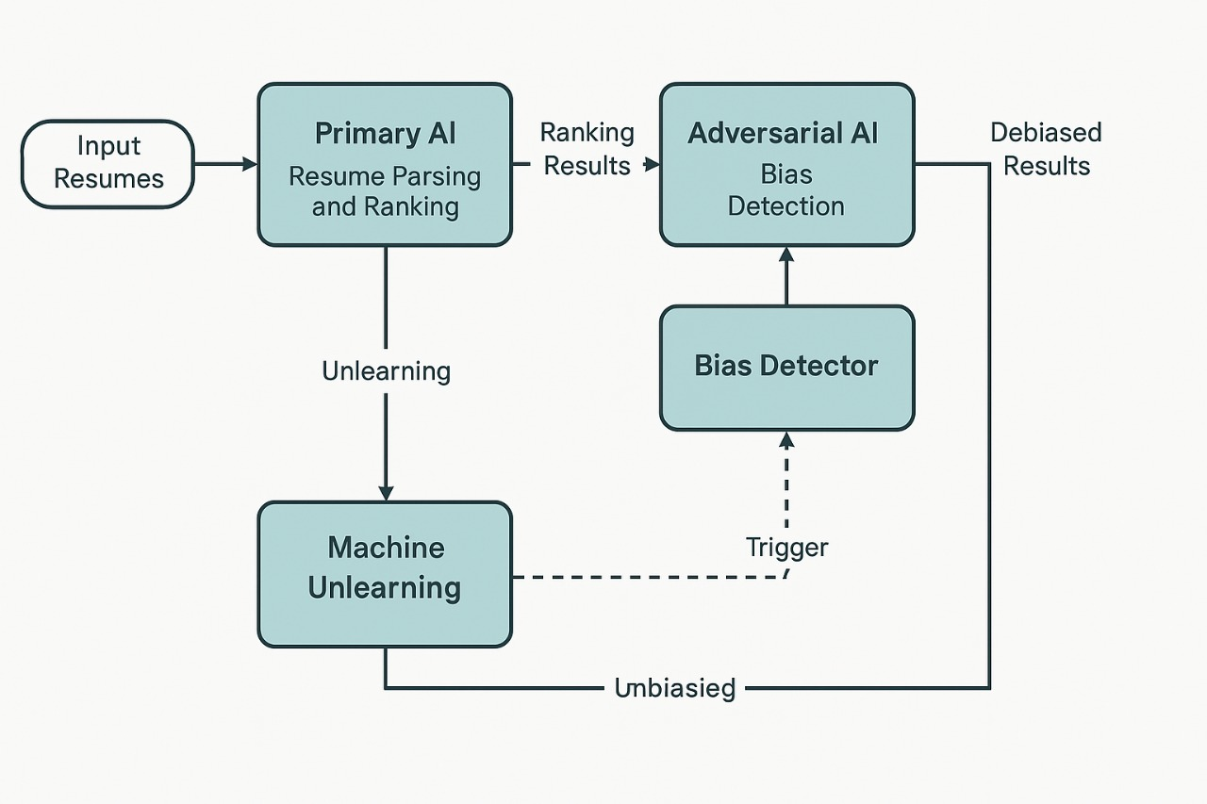

4. Ethical and Privacy-Aware Resume Shortlisting

Section: Evolution and Ethics of Resume Shortlisting
Traditional and AI-Based Shortlisting
In both traditional and automated hiring pipelines, the process of resume shortlisting plays a pivotal role. Historically, recruiters have prioritized resumes using criteria such as relevant work experience, educational background, technical and soft skills, certifications, projects, and job-specific keywords. However, this manual process is not immune to human bias, often unintentionally influenced by factors like gender, ethnicity, or the reputation of an applicant’s alma mater.
With the rise of AI in recruitment, systems now leverage Natural Language Processing (NLP) and pretrained transformer models (e.g., BERT) to streamline shortlisting. These systems match resumes to job descriptions using keyword extraction, semantic similarity, and vector-based ranking. Features such as skills, experience, and education are programmatically analyzed, and candidates are scored accordingly. While these AI systems enhance efficiency, they are also susceptible to inherited bias from training data and lack mechanisms to protect user privacy.
Toward Ethical and Privacy-Respecting AI Shortlisting
To counter these limitations, our proposed model integrates ethical AI principles, emphasizing fairness, transparency, and privacy. The system evaluates resumes based on a Relevance Score, which matches key resume features (skills, experience, projects) with job requirements using semantic embedding models (e.g., Sentence-BERT). This removes over-reliance on keywords and enhances contextual understanding.
The model includes a Fairness-Aware Filtering mechanism that masks or minimizes the weight of sensitive attributes (e.g., name, gender, university), ensuring they do not skew decisions. Fairness metrics such as Demographic Parity and Equal Opportunity are used to evaluate the model’s ethical performance.
Furthermore, through Privacy-Aware Decisioning, the system is designed to comply with regulations like the GDPR. Using machine unlearning, it can eliminate the influence of a candidate’s data when consent is withdrawn or bias is detected, without full model retraining.

5. Implementation

The system has two core components:

5.1 Primary AI Module

- Extracts key features from resumes (skills, experience, education)
- Computes semantic similarity with job descriptions
- Uses contextual embeddings for scoring (using Sentence-BERT)

5.2 Adversarial AI Module

- Analyzes outputs of Primary AI
- Detects any correlation of decisions with sensitive attributes (gender, name, university)
- Uses GANs to simulate alternate decisions and flag potential biases

5.3 Machine Unlearning Integration

- If bias or consent withdrawal is detected:
  - Approximate unlearning is applied using gradient inversion or influence functions
  - Targeted parts of the model are retrained while preserving overall performance
This framework allows real-time fairness auditing and privacy compliance.

6. Standards Adopted

The project complies with key standards:
- GDPR: Ensures user consent, data access, and deletion rights
- DEI Principles: Promotes ethical AI that values inclusion and diversity
- XAI (Explainable AI): Allows transparency and accountability in AI-based decisions
These frameworks enhance the system’s trustworthiness and regulatory compliance.

7. Conclusion and Future Scope

This project successfully demonstrates an AI framework that is:
- Efficient in resume processing
- Fair in eliminating biases
- Secure in preserving privacy
By combining real-time bias detection with machine unlearning, we offer a responsible and ethical approach to AI recruitment.
Future Scope
- Integrate federated learning to avoid centralized data storage
- Enable dynamic unlearning for live bias correction during hiring
- Enhance visual explainability with interactive dashboards
- Deploy the system as a plugin for Applicant Tracking Systems (ATS)

8. References

- Cynthia Dwork et al., “Fairness through awareness,” ITCS, 2012
- Ibrahim M., Ahmad M., “Machine Unlearning for Data Privacy,” arXiv, 2020
- Veale M., Binns R., “Fairer Machine Learning in the Real World,” Big Data & Society, 2017
- Raji I. D., Buolamwini J., “Actionable Auditing,” ACM Conference on AI Ethics & Society, 2019
- Pymetrics Fairness360 Toolkit (GitHub)

Plagiarism Report

1. Statement of Originality

We hereby declare that the project report titled "Privacy Preserving Resume Processing Using Machine Unlearning" is an original work carried out by us under the guidance of Dr. JHALAK HOTA at KIIT Deemed to be University, Bhubaneswar. The work presented in this report is my own, except where references to existing research, tools, or datasets have been properly acknowledged.

2. Plagiarism Check Details

This report has been verified using plagiarism detection software (Turnitin / Grammarly / Any University-Approved Tool). The obtained similarity index is 12%. The similarity primarily comes from correctly cited sources, such as definitions, references, and standard terminology.
Sources and Citations

Any external content used has been properly cited in the References section.
The implementation, analysis, and findings are entirely based on my independent work, except where explicitly mentioned otherwise.

Conclusion

This project adheres to the academic integrity guidelines of KIIT Deemed to be University. Proper citations and references have been provided wherever necessary, ensuring compliance with ethical research and documentation standards.

PRATEEK KUMAR, 2205826
SHARAN TANGUDU, 22054245
BAISHNAB BEHERA, 2205200
RAGHAV INDORIA, 2205828
ROHAN INDORIA, 2205837
PARIDA PRATYUSH, 2205757

DATE:10/4/2025

