Human Flavor Protocol
Full Visualization Report

286 Novels · 194 Analyses · 32 Deep Analyses · 9 Author Evolution Lines
v4.0 · 2026-04-22

Part 1: Full Library Distributions
Histograms of 6 key metrics across all 286 novels. Dashed line = median.
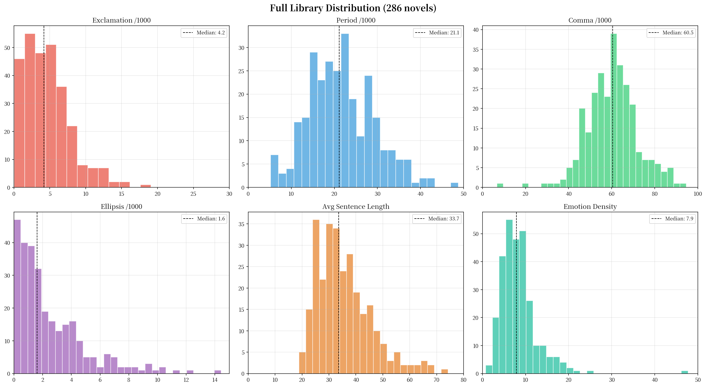
Key observations:
• Exclamation: heavily right-skewed, median ~4, long tail to 44 (射门)
• Period: bimodal distribution, peaks at ~15 and ~28
• Comma: near-normal, centered around 55-65
• Ellipsis: extreme right-skew, most novels < 3, outliers up to 14
• Avg sentence length: normal-ish, median ~35 chars
• Emotion density: right-skewed, median ~10

Part 2: Fingerprint Heatmap (Top 100)
Row-normalized heatmap of 9 metrics across top 100 novels by word count.
Brighter = higher relative value within that metric row.
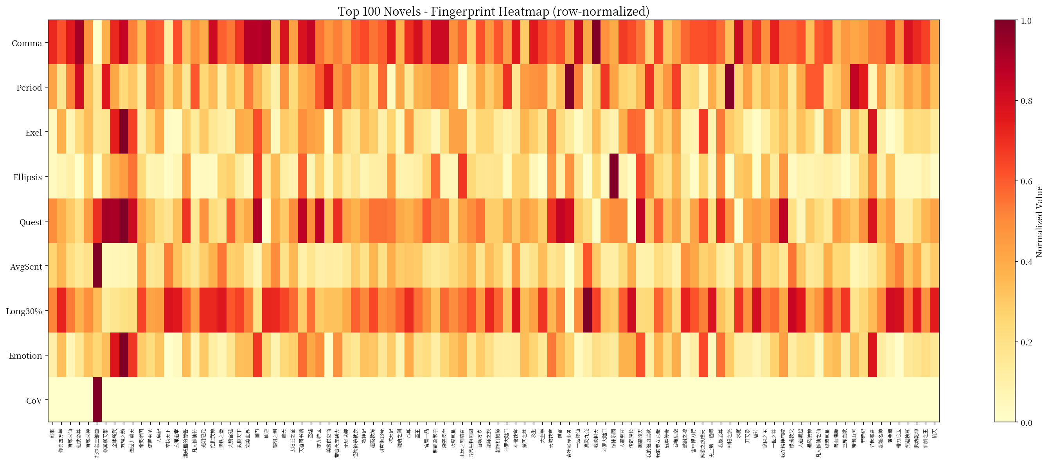

Part 3: Individual Author Evolution Curves
Each author tracked through 4 punctuation metrics across their career novels.

3.1 Yuantong (4 novels: Xiling -> YCBJWL -> LMZJ -> SHYJ)
Comma extremely low (40-48, lowest in library). Period: drops then recovers. Exclamation: steady decline 2.2 -> 1.7. Ellipsis: rising trend 3.4 -> 4.7.
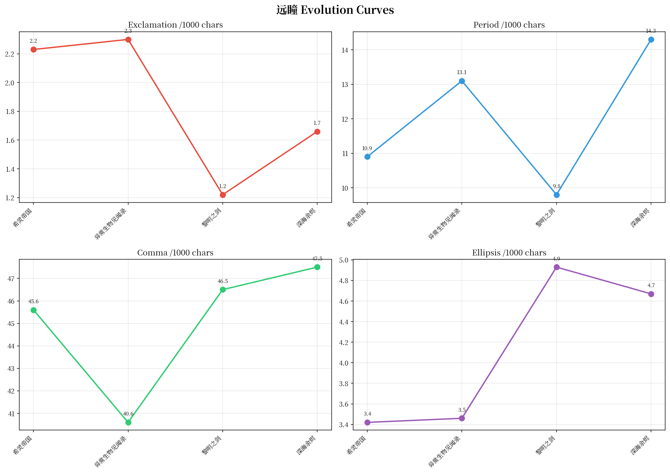

3.2 Zhouzi (3 novels: LOL -> DWLM -> YDMS)
Dramatic exclamation cliff: 10.62 -> 5.17 -> 3.48 (-67%). Period transformation: stable 13-14 then jumps to 23.8 (+68%).
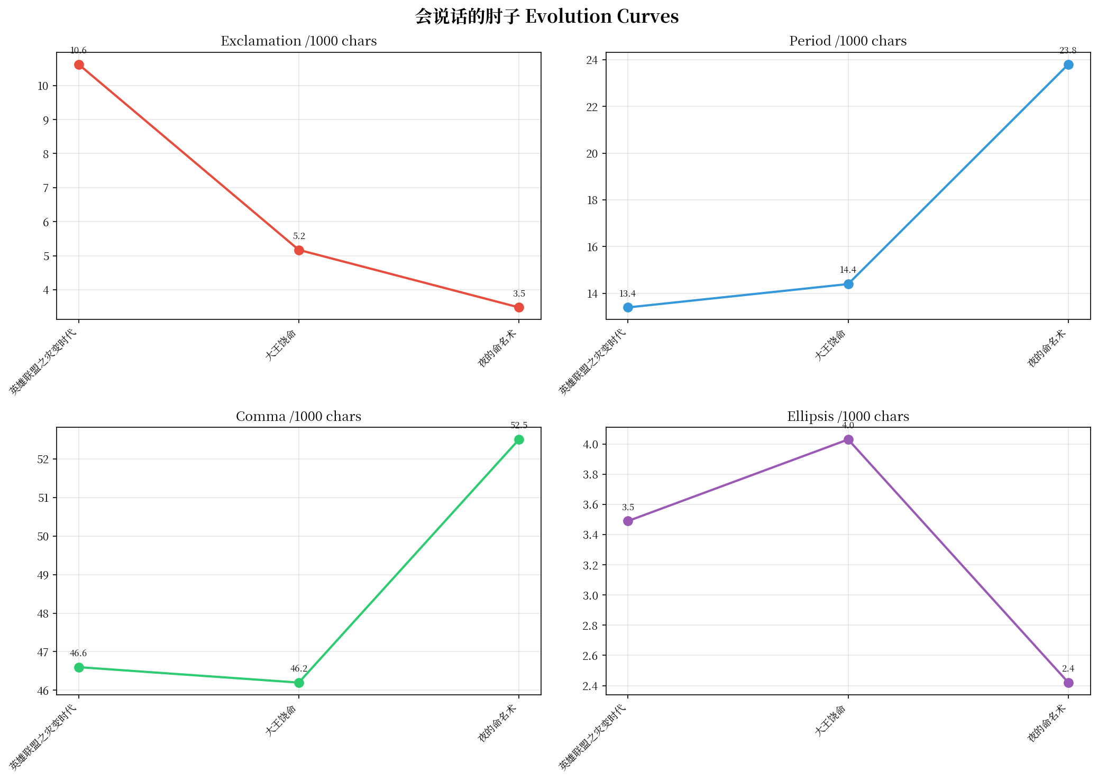

3.3 Huangfuqi (6 novels)
Exclamation stable 5.77-7.65. Period swings 149% (14.5-36.1) — genre-driven oscillation. Comma rising trend 50.5 -> 67.0.
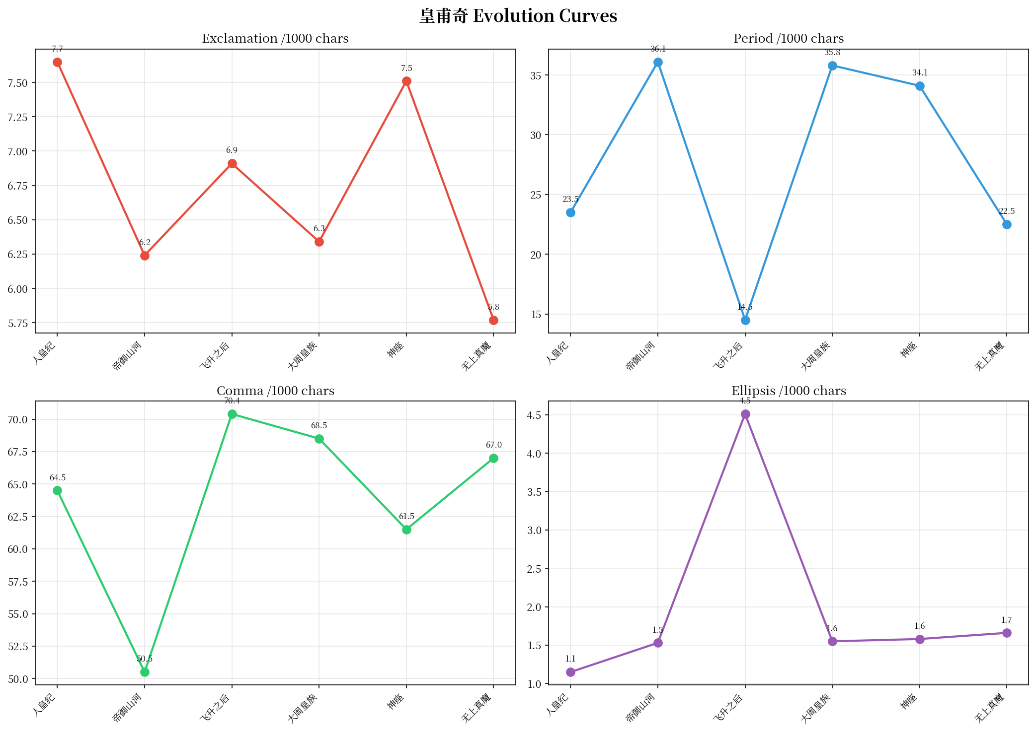

3.4 Mengru Shenji (7 novels)
Most extreme linear convergence in library: exclamation 10.49 -> 0.52 (95% decline). Comma peak at 佛本是道 (84.6, #3 in library).
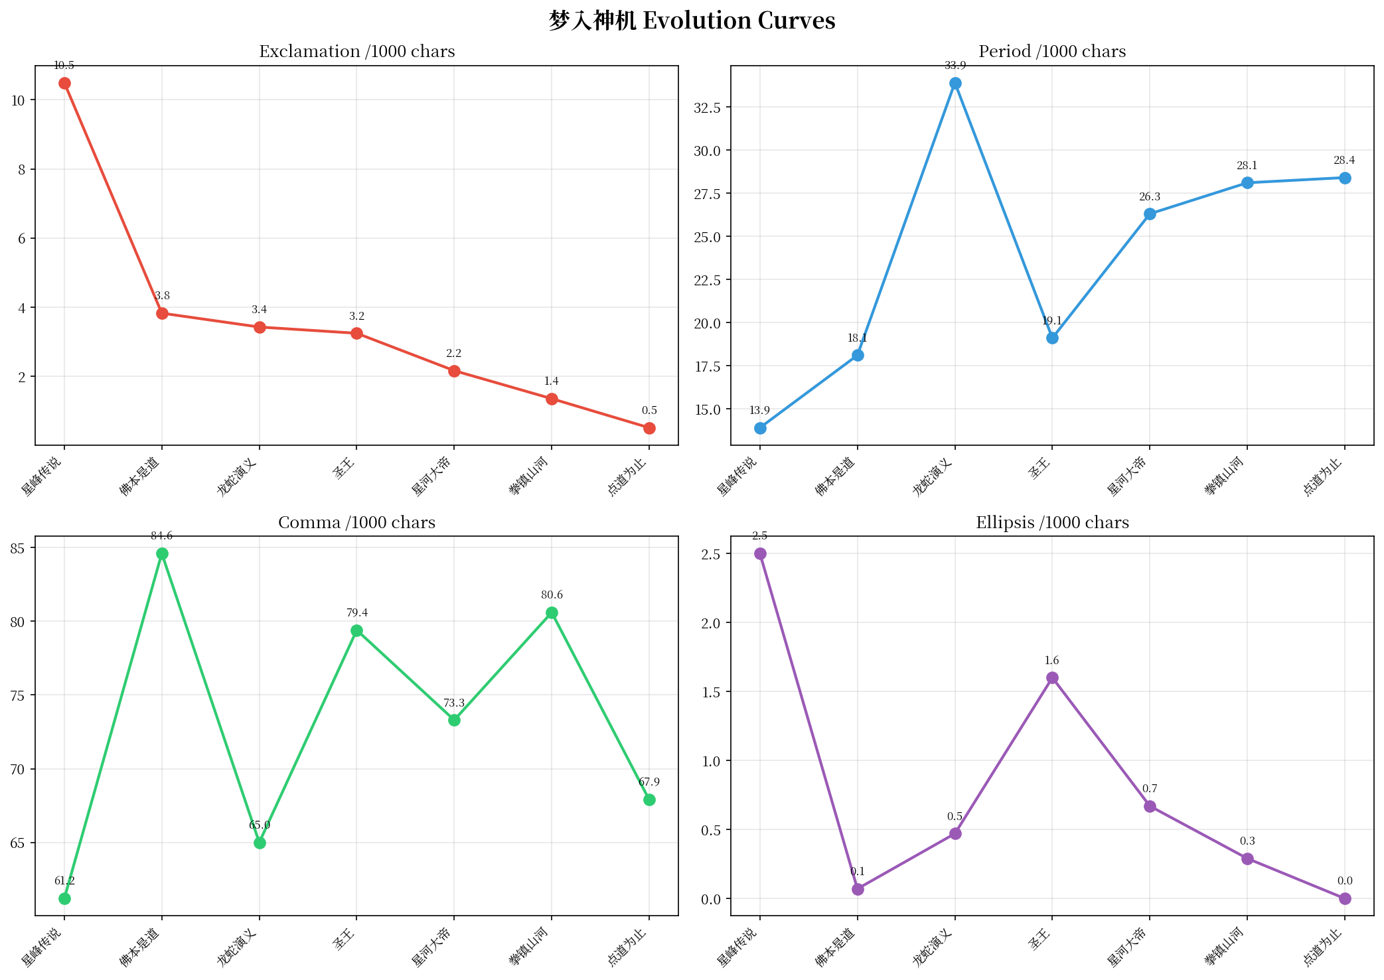

3.5 Tian Can Tu Dou (5 novels)
Ellipsis collapse: 6+ -> ~0 (near-zero, most extreme in library). Period doubles: 12 -> 26.
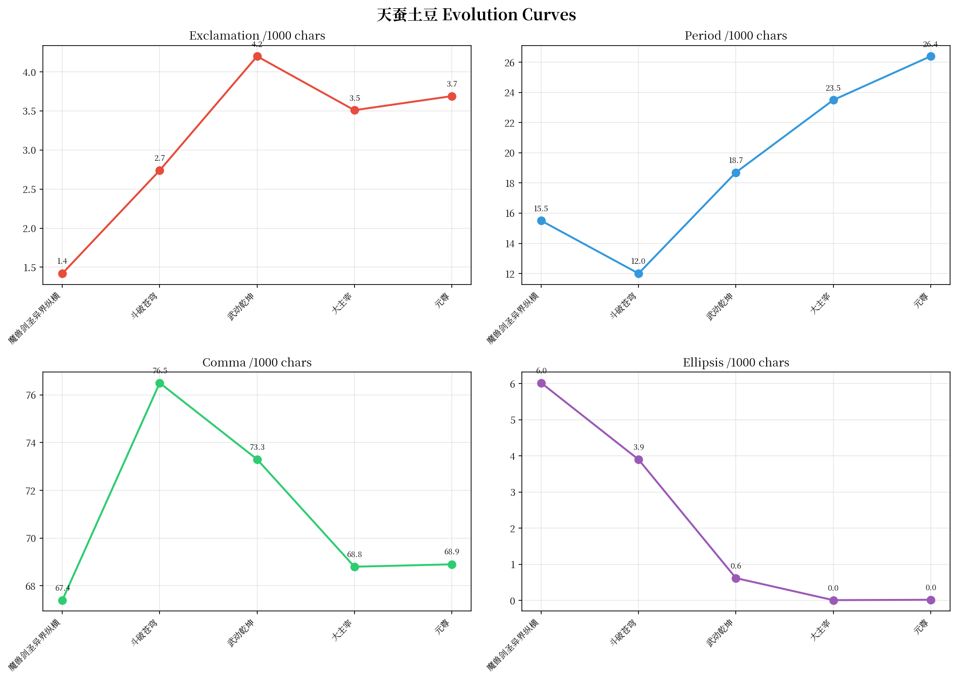

3.6 Mao Ni (6 novels)
U-curve pattern: period 22 -> 16 -> 28. Exclamation always below 1.6 (extreme cold). Comma stable.
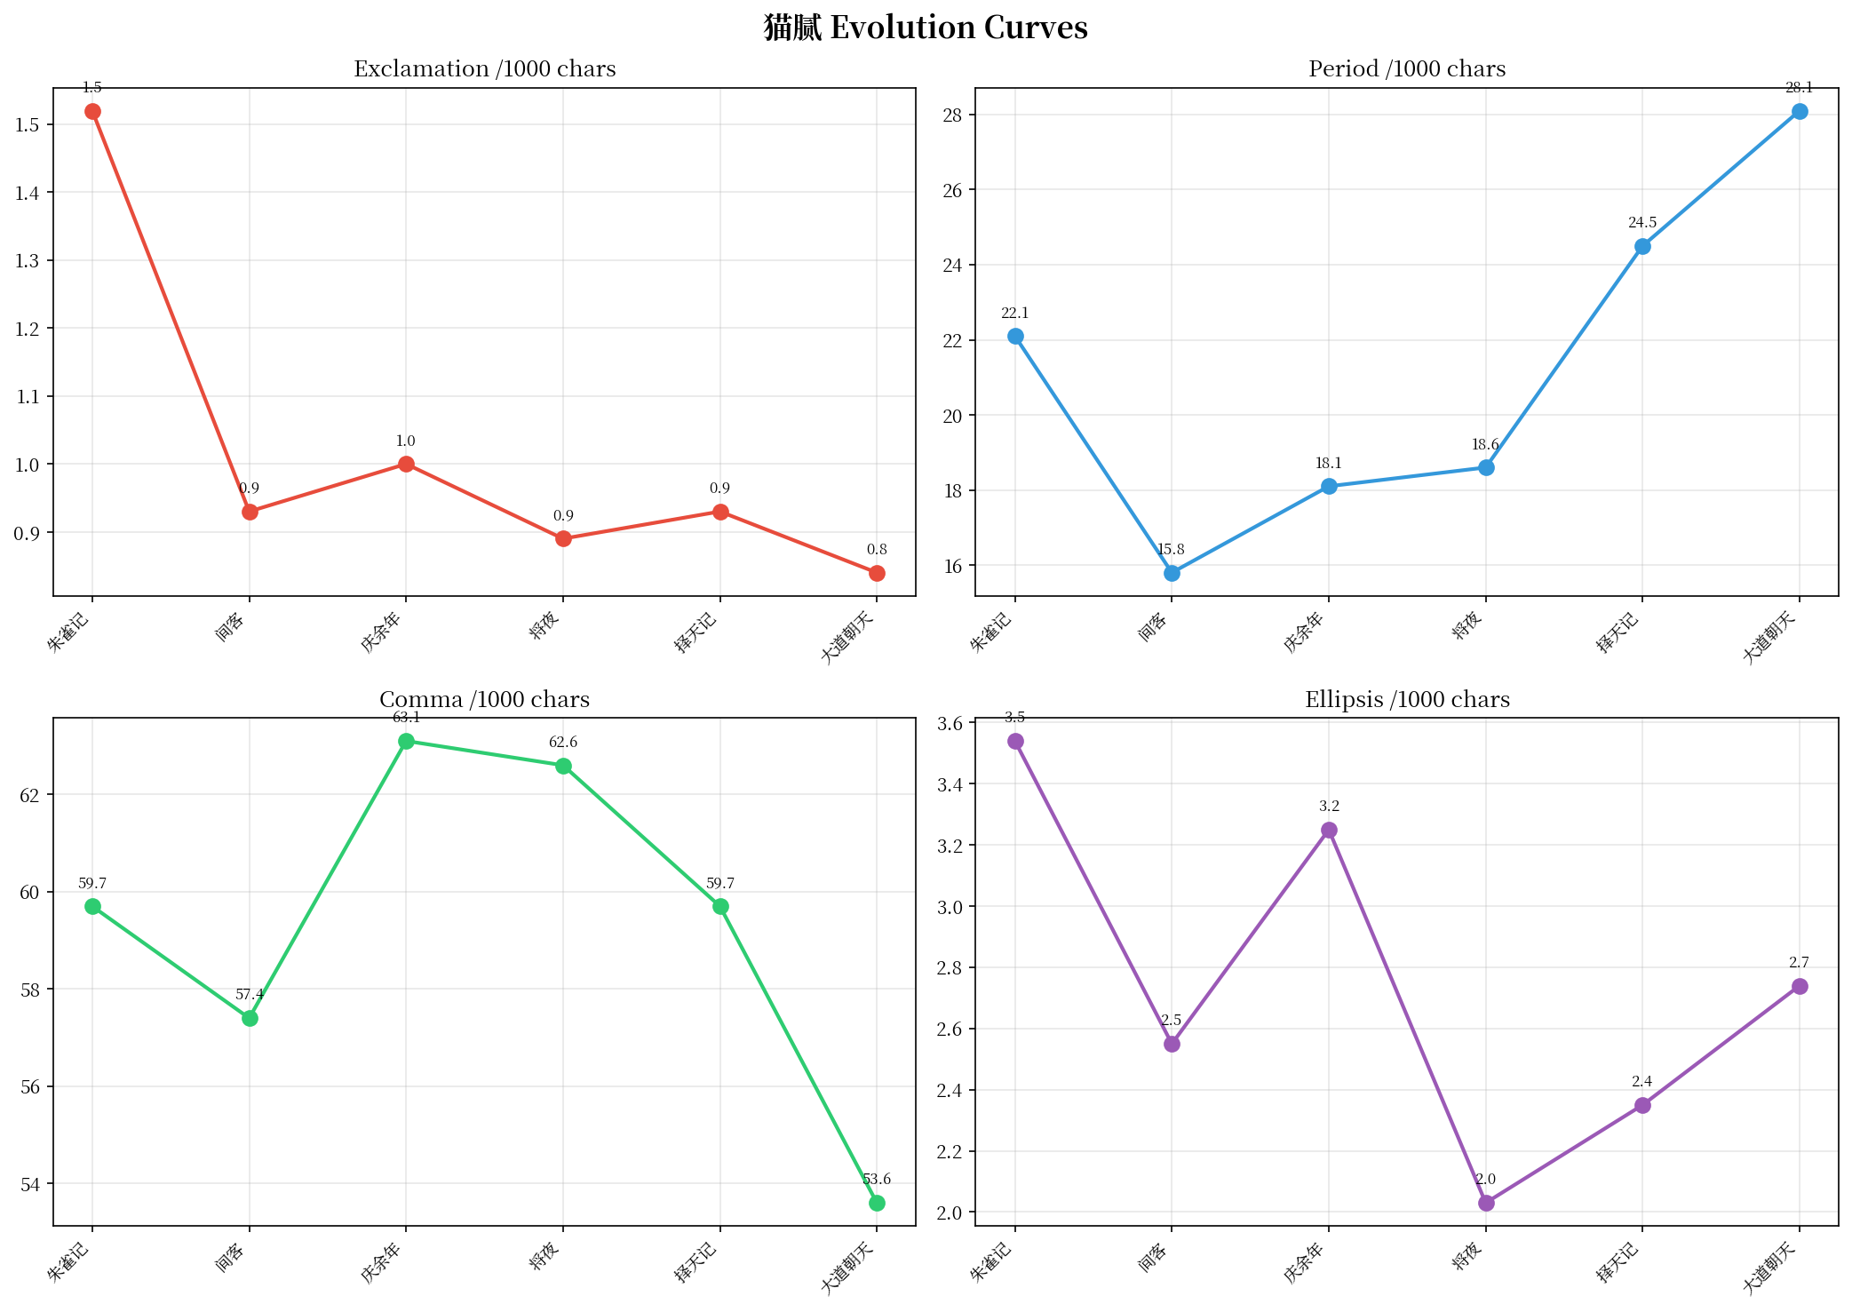

3.7 Xue Hong (7 novels)
Turning point at 开天录. Comma diverges: 63 -> 47 -> 60. Exclamation variable by genre.
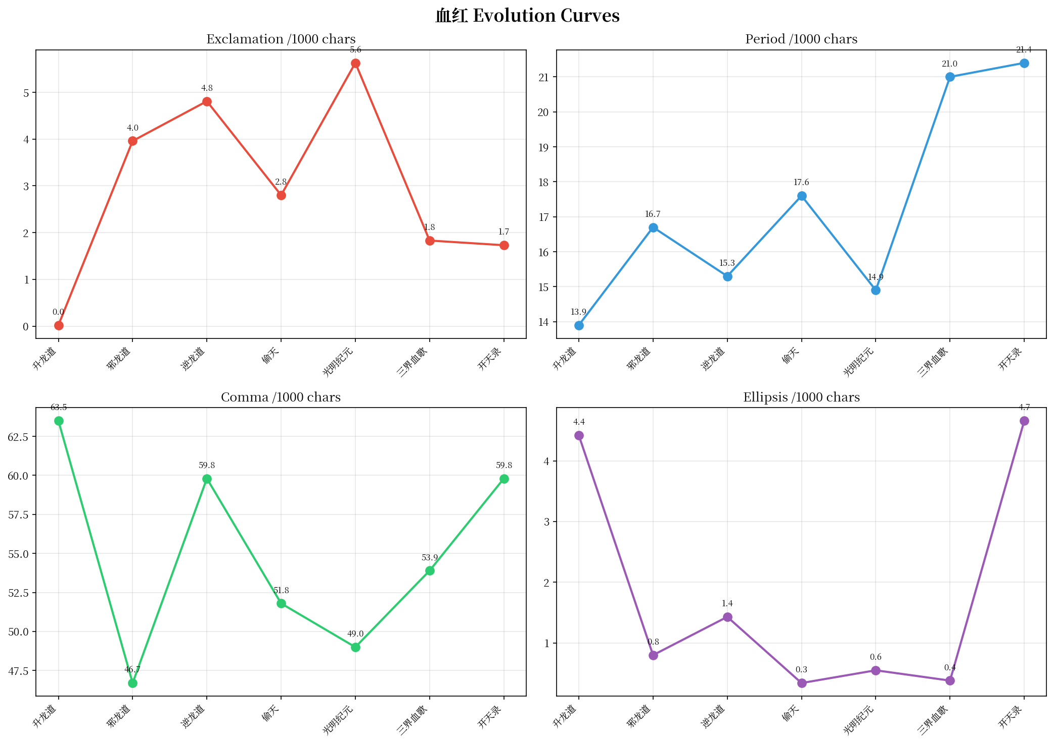

3.8 Fenghuo Xizhu Hou (3 novels)
Ultra-long sentences (68.1 avg in 陈二狗, highest original Chinese). Exclamation near-zero throughout.
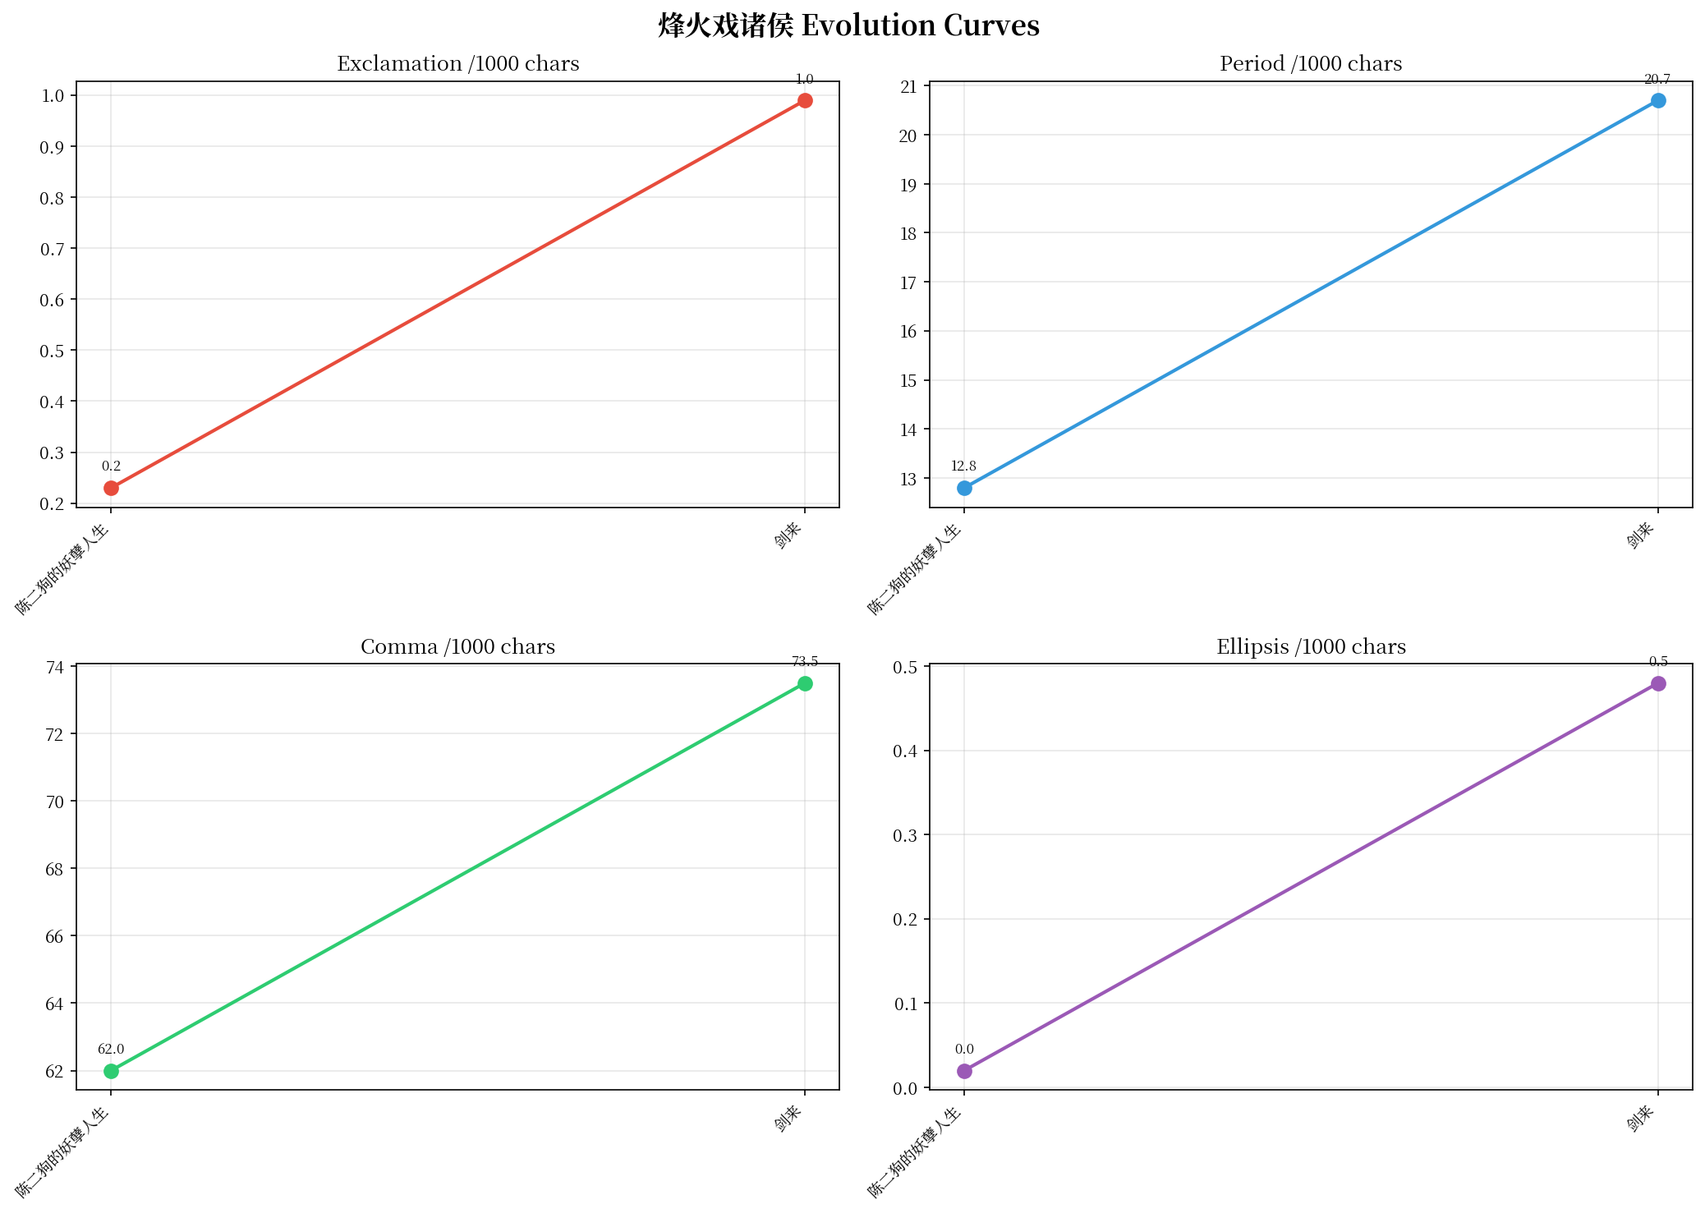

3.9 Er Gen (5 novels)
Period stable high (27-29 range). Comma varies. Consistent "serious" fingerprint across career.
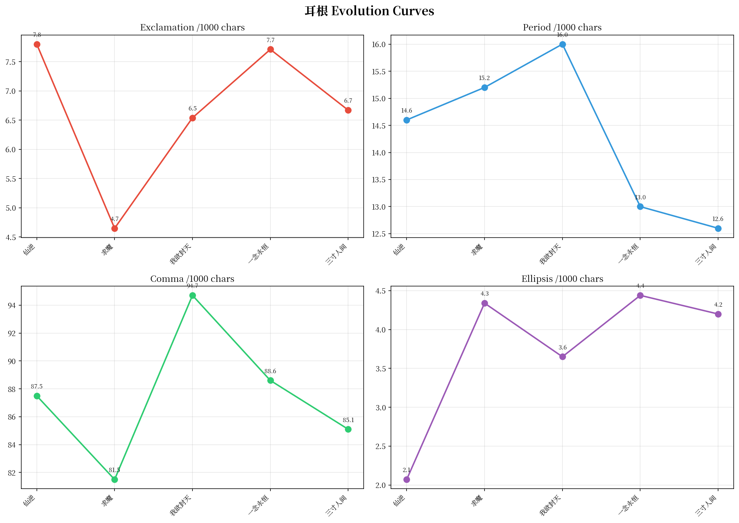

Part 4: Author Aggregated Comparisons
All 9 main authors plotted on the same axes for direct comparison.

4.1 Exclamation Comparison
Clear separation between "hot-blooded" authors (Zhouzi, Huangfuqi) and "cold" authors (Mao Ni, Fenghuo, Yuantong).
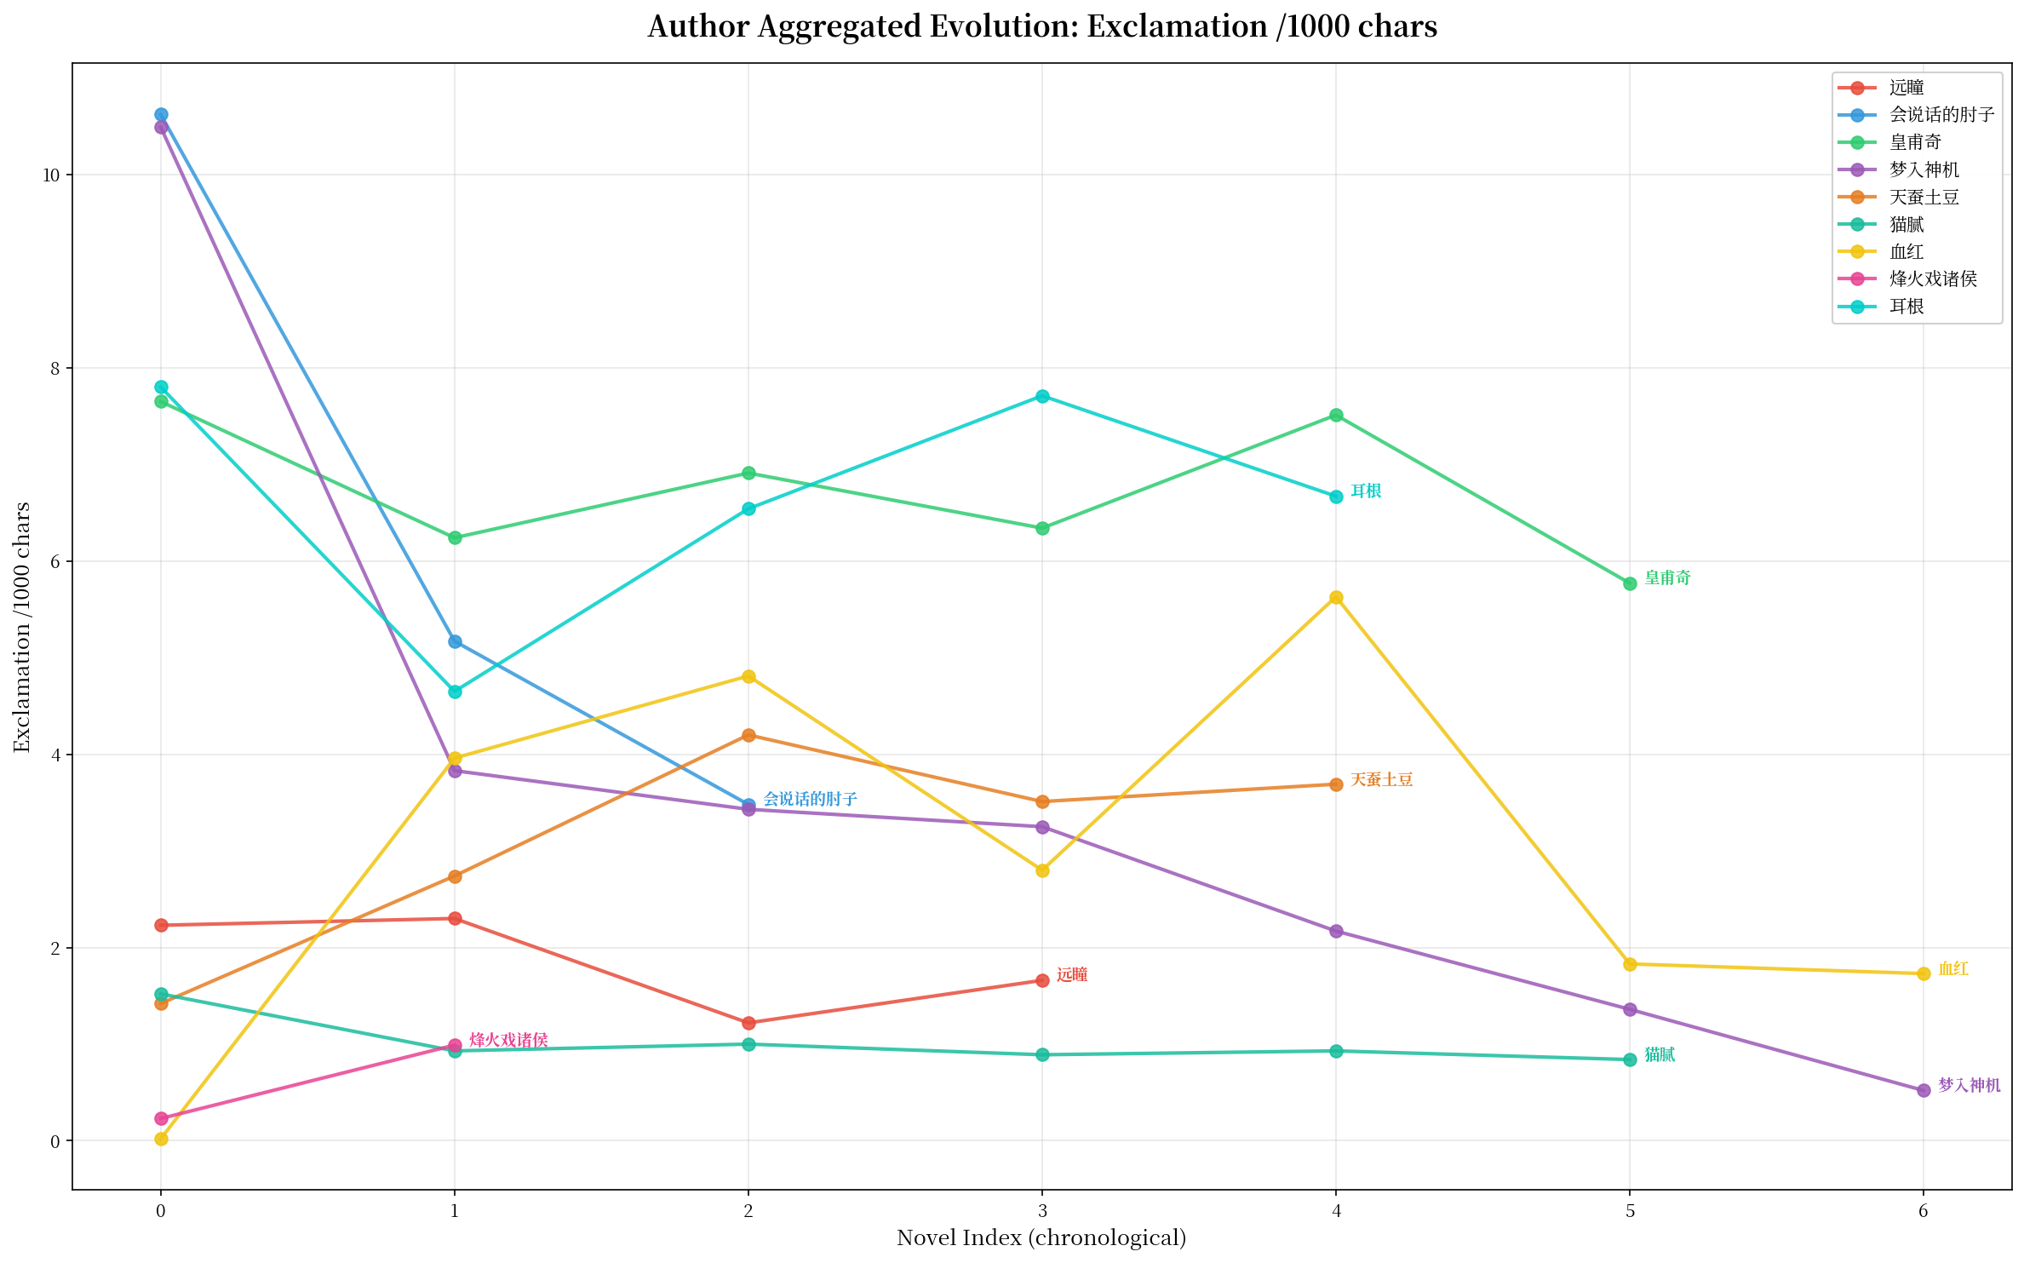

4.2 Period (Breathing) Comparison
Huangfuqi shows widest period range. Mengru Shenji has lowest periods. Er Gen most stable.
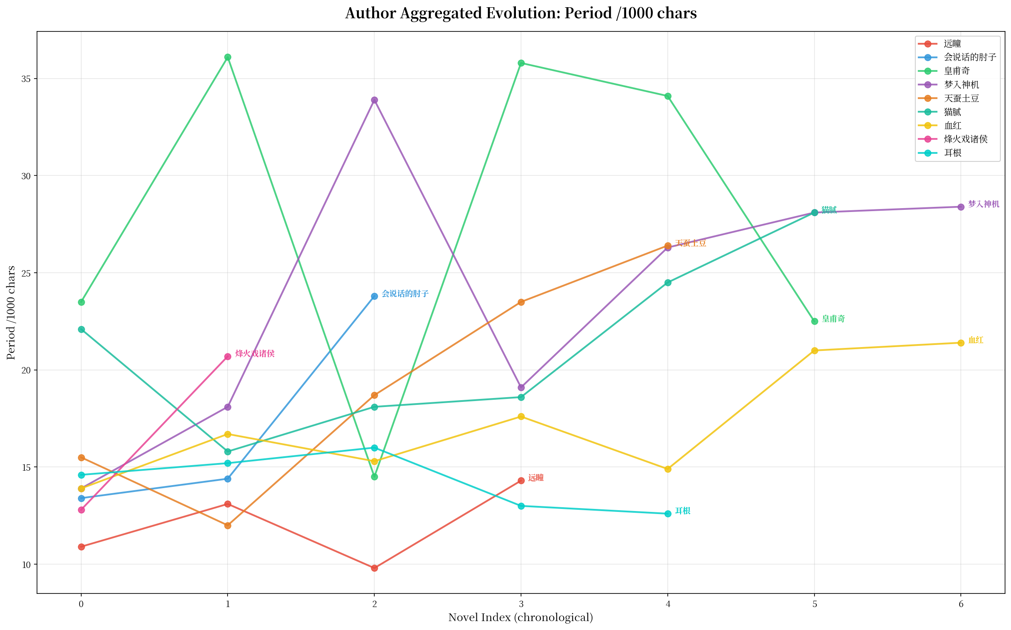

4.3 Comma Comparison
Mengru Shenji highest (84.6 peak). Yuantong lowest (40-48 range). Most authors cluster 50-70.
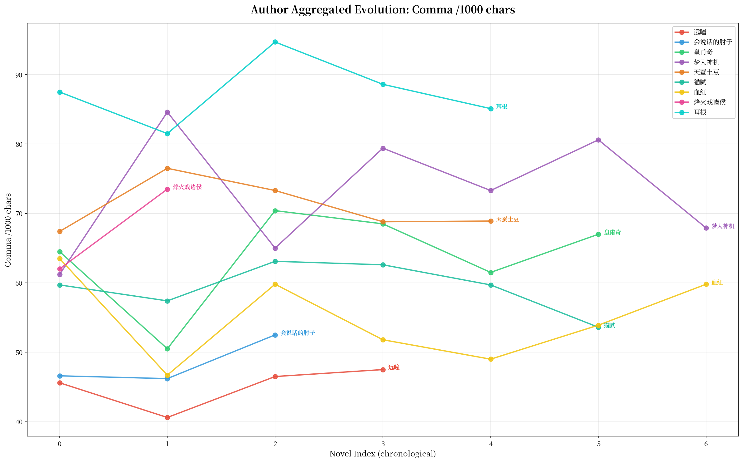

4.4 Ellipsis Comparison
Tian Can Tu Dou collapses to zero. Huangfuqi consistently low. Zhouzi moderate.
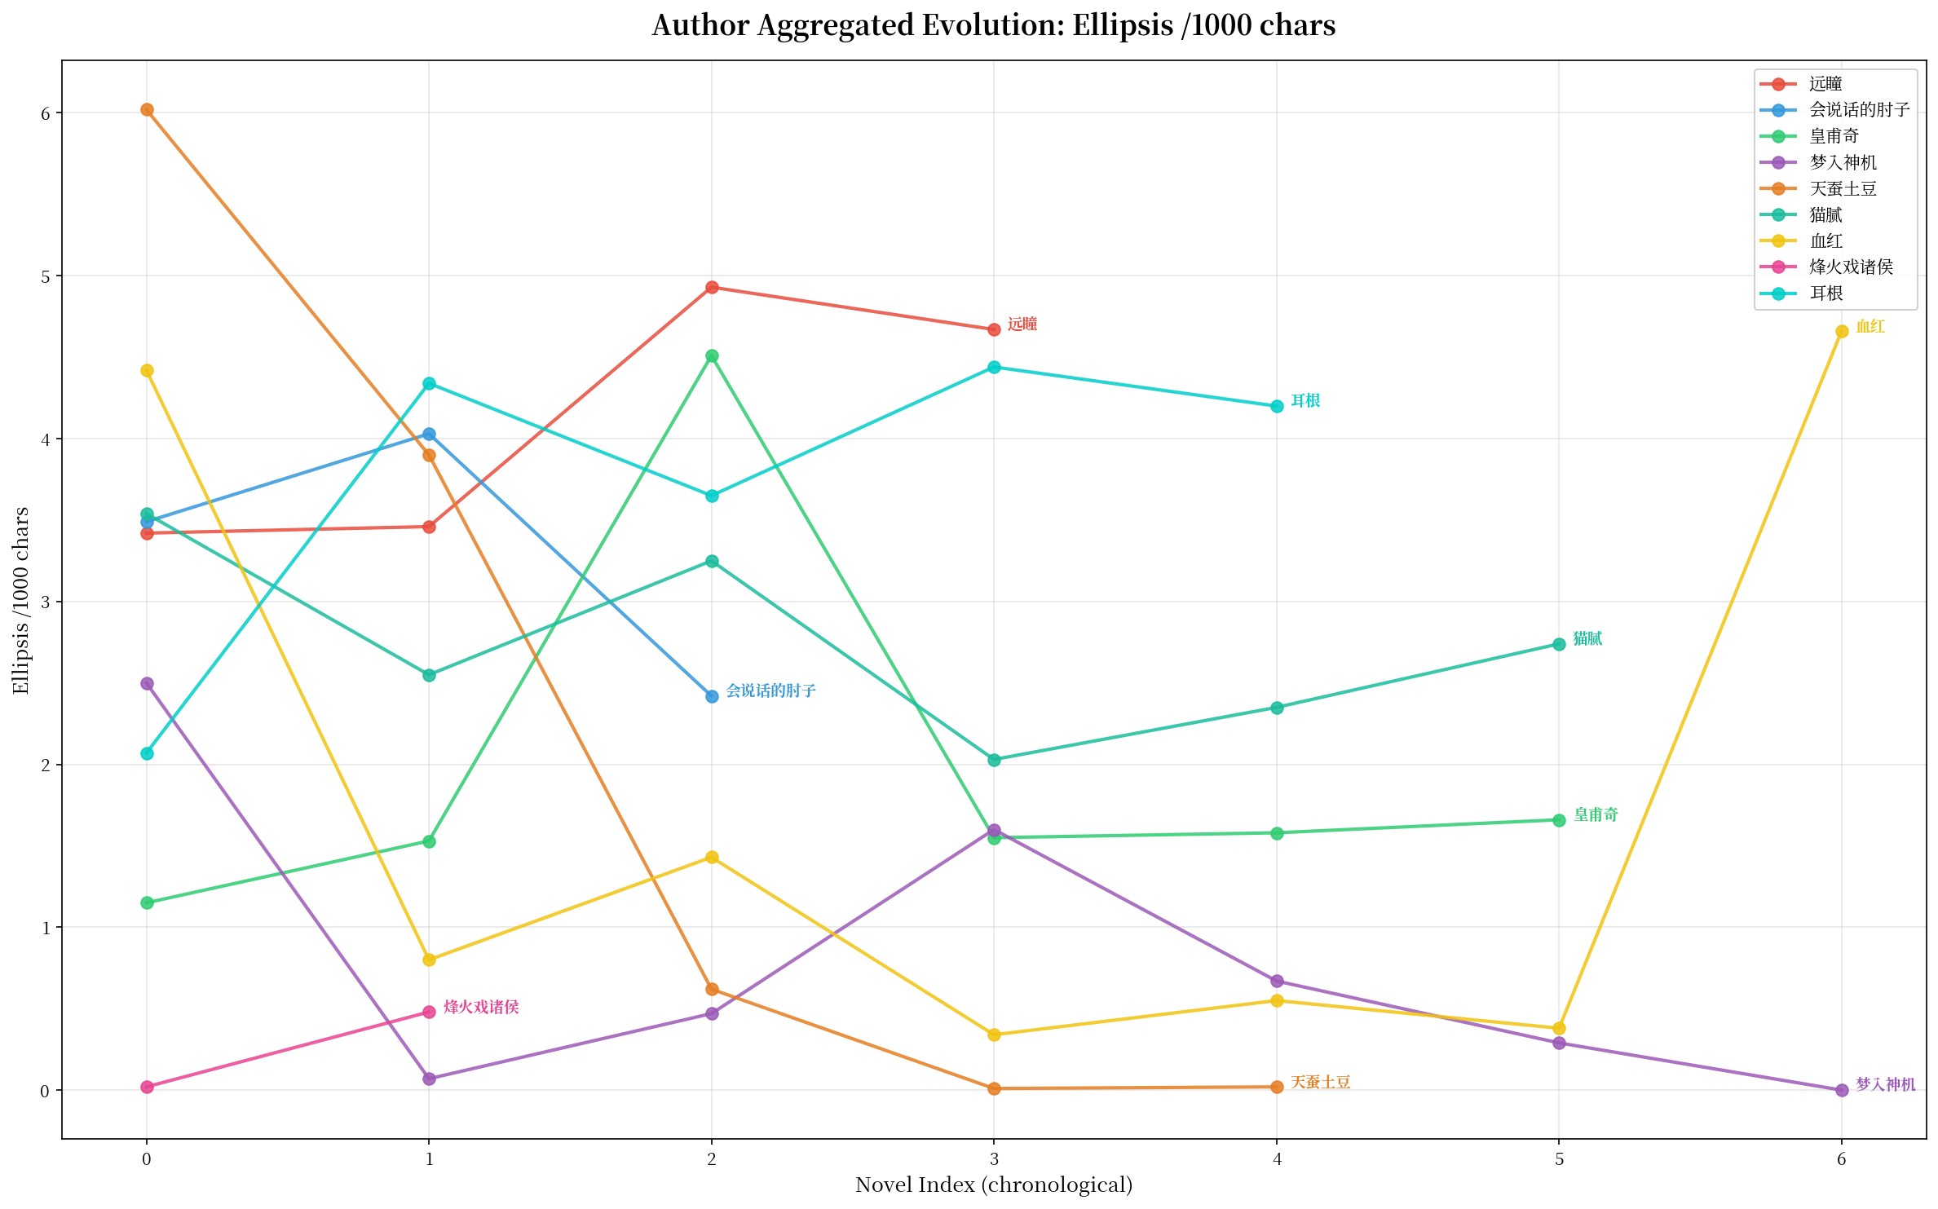

4.5 Four-Metric Grid Overview
Side-by-side view of all 4 metrics for quick pattern recognition.
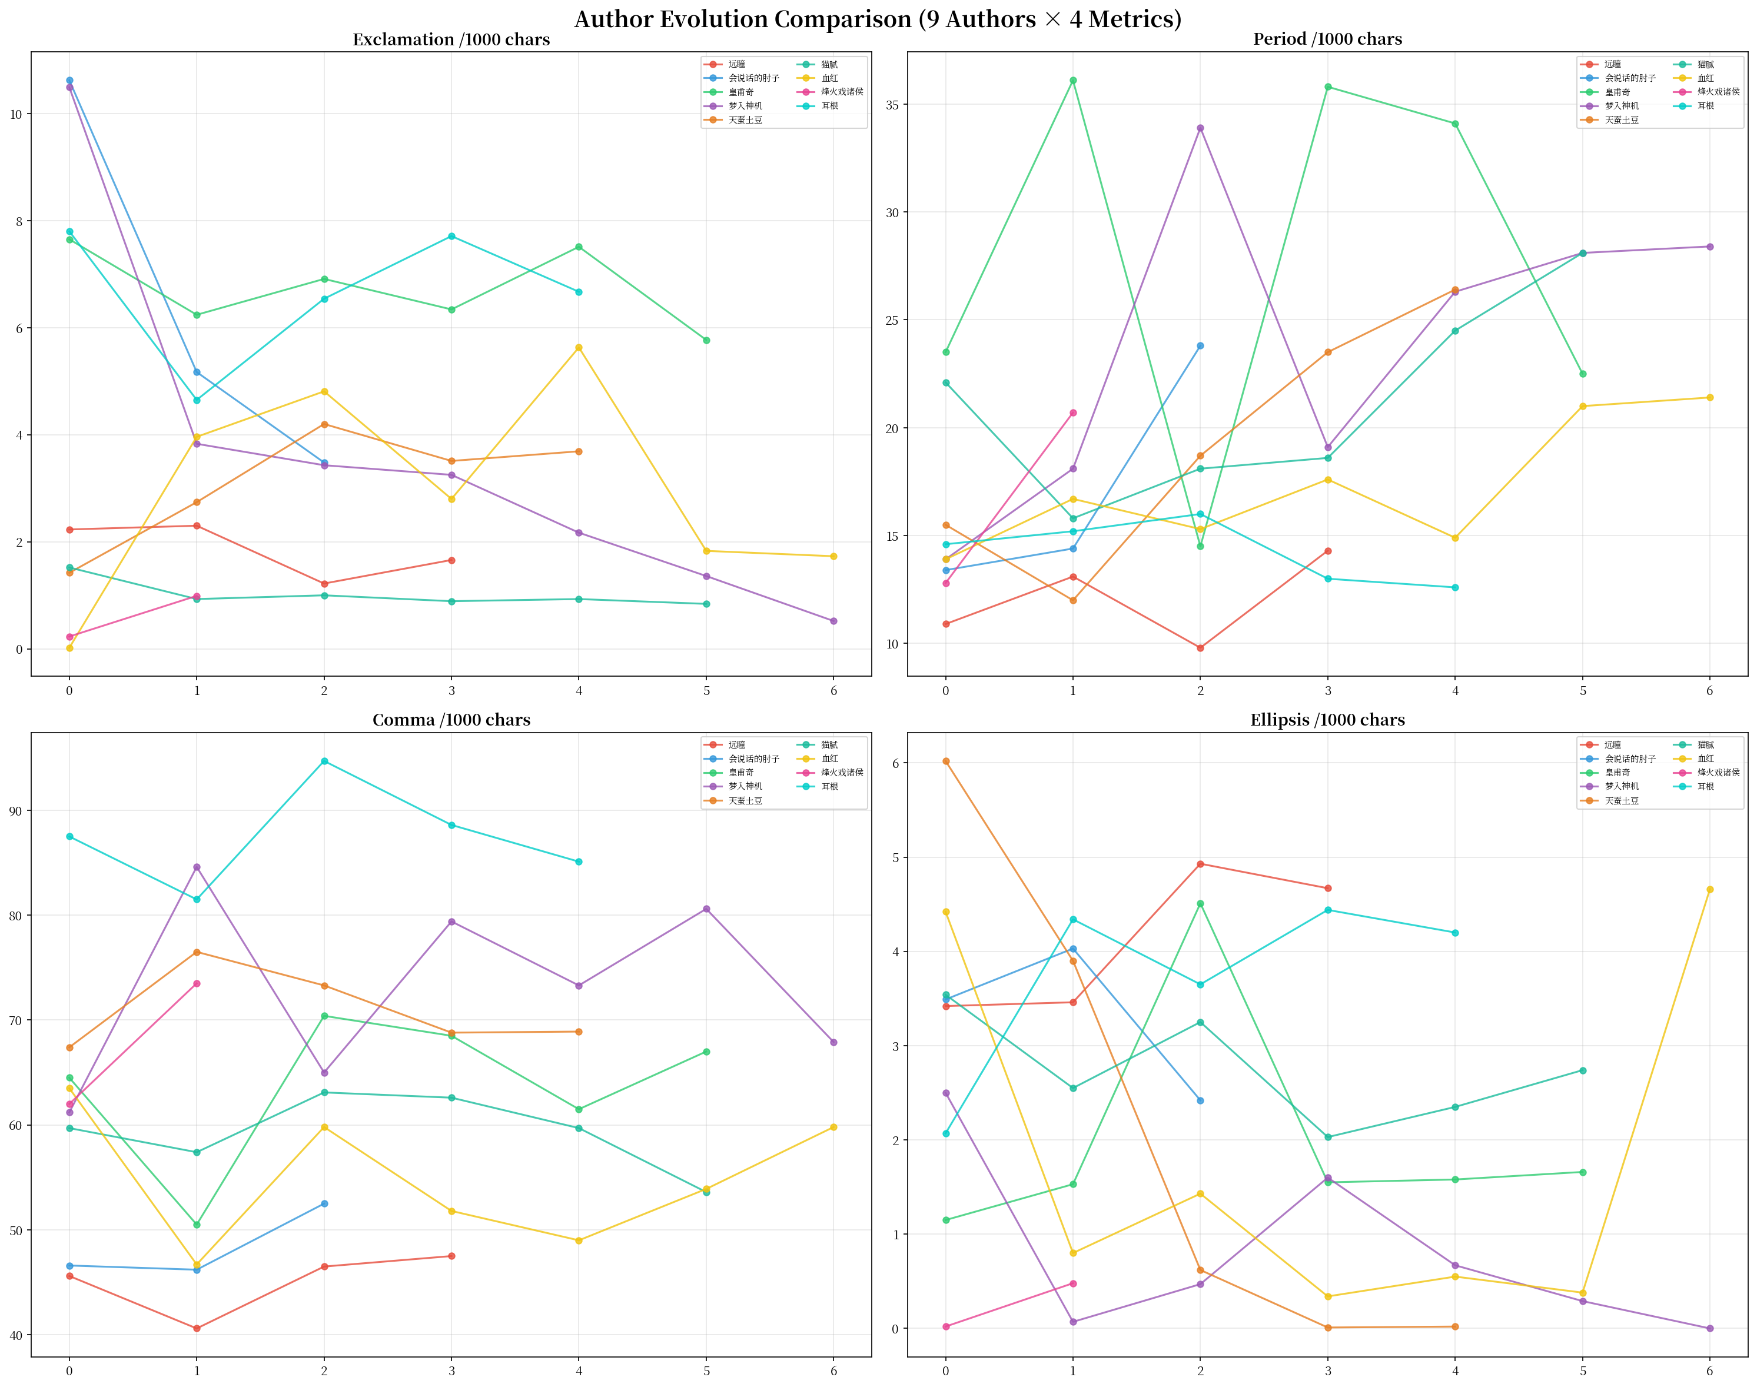

4.6 Additional Authors (3+ novels)
Extended comparison including authors with 3+ novels in the library.
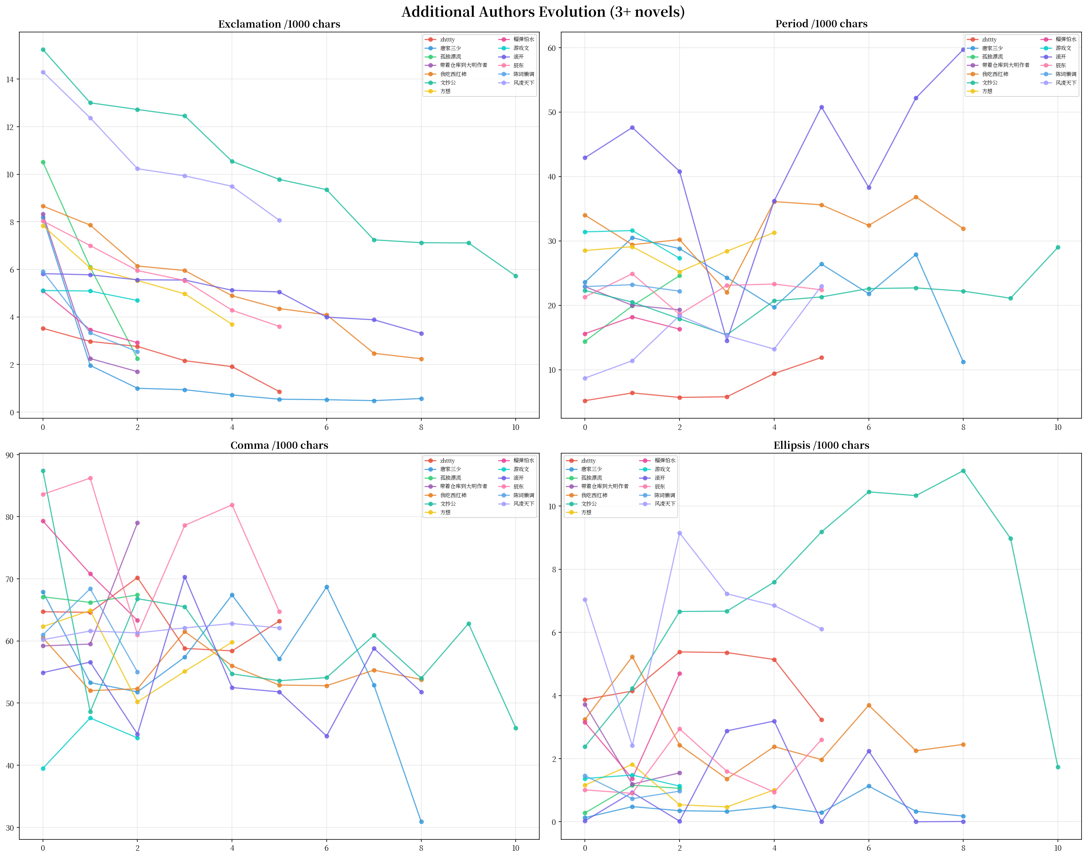

Part 5: Key Findings Summary

5.1 Seriousness Distribution (286 novels)
• Extreme Hot-blooded (ek>=10): 20 novels (7%)
• Hot-blooded (ek 6-10): 59 novels (21%)
• Medium (ek 3-6): 99 novels (35%)
• Cold Pen (ek 1.5-3): 56 novels (20%)
• Extreme Cold (ek<1.5): 46 novels (16%)
• Finding: bimodal — hot-blooded (28%) vs cold+extreme-cold (36%)

5.2 Breathing Pattern Distribution
• Very Slow (pk<12): 23 novels (8%)
• Slow (pk 12-18): 69 novels (24%)
• Normal (pk 18-28): 128 novels (45%)
• Fast (pk 28-40): 52 novels (18%)
• Very Fast (pk>40): 8 novels (2%)

5.3 Notable Evolution Patterns
• Linear Convergence: Mengru Shenji (ek 10.49->0.52, 95%)
• Exclamation Cliff: Zhouzi (10.62->3.48, -67%), Warehouse Author (8.33->2.25)
• Breathing Transformation: Zhouzi period 13->24 (near double)
• U-Curve: Mao Ni period 22->16->28
• Genre-Driven Oscillation: Huangfuqi period swings 149%
• Ellipsis Collapse: Tian Can Tu Dou (6+ -> ~0)
• Ultra-Constant: Wang Yu (period 27-29), Fang Xiang (stable core)

5.4 Library Records
• Highest exclamation: 射门 44.01/1000
• Highest comma: 我欲封天 94.7/1000
• Highest ellipsis: 惊悚乐园 14.44/1000
• Lowest exclamation: 点道为止 0.52/1000
• Longest avg sentence (original): 陈二狗 68.1 chars
• Longest avg paragraph: 宰执天下 109.5 chars
• Highest emotion density: 射门 48.2/1000

