Musical Festival for Events Folder:

thmc-event-1.jpg
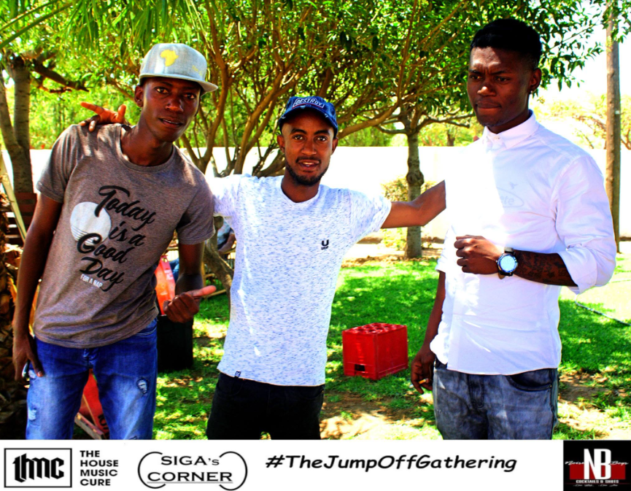
- Source Website: https://www.facebook.com/TheHouseMusicCure1
- Source URL: https://www.facebook.com/photo.php?fbid=373873713417648&set=pb.100057054056101.-2207520000&type=3
- Date Accessed: 20/28/2026

thmc-event-2.jpg
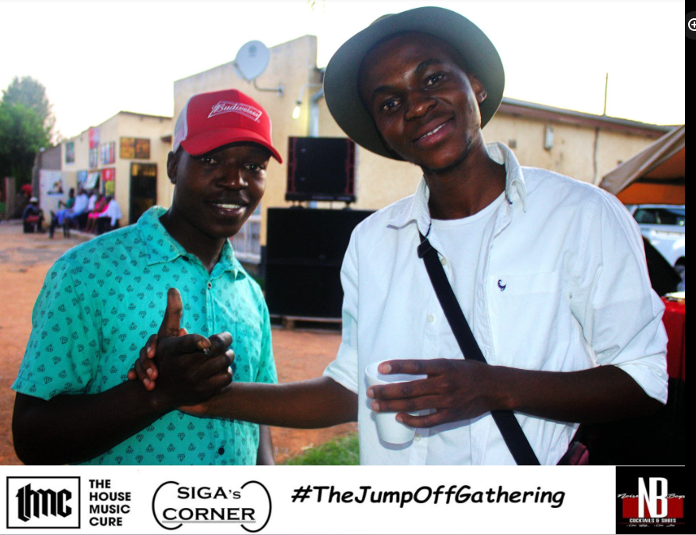
- Source Website: https://www.facebook.com/TheHouseMusicCure1
- Source URL: https://www.facebook.com/photo.php?fbid=373874480084238&set=pb.100057054056101.-2207520000&type=3
- Date Accessed: 20/28/2026

thmc-event-3.jpg
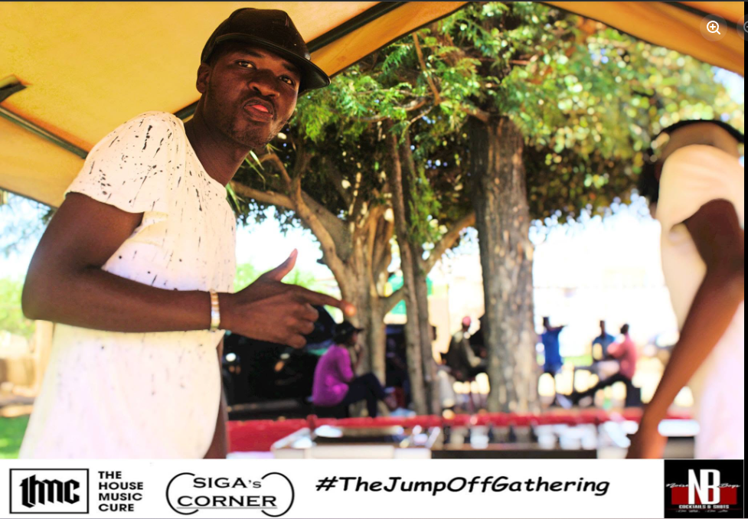
- Source Website: https://www.facebook.com/TheHouseMusicCure1
- Source URL: https://www.facebook.com/photo.php?fbid=373875073417512&set=pb.100057054056101.-2207520000&type=3
- Date Accessed: 20/28/2026

thmc-event-4.jpg
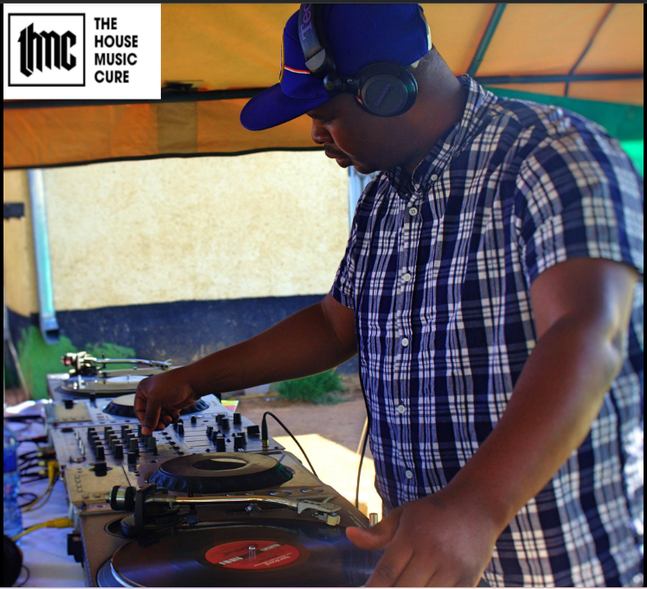
- Source Website: https://www.facebook.com/TheHouseMusicCure1
- Source URL: https://www.facebook.com/photo.php?fbid=373875823417437&set=pb.100057054056101.-2207520000&type=3
- Date Accessed: 20/28/2026

thmc-event-5.jpg
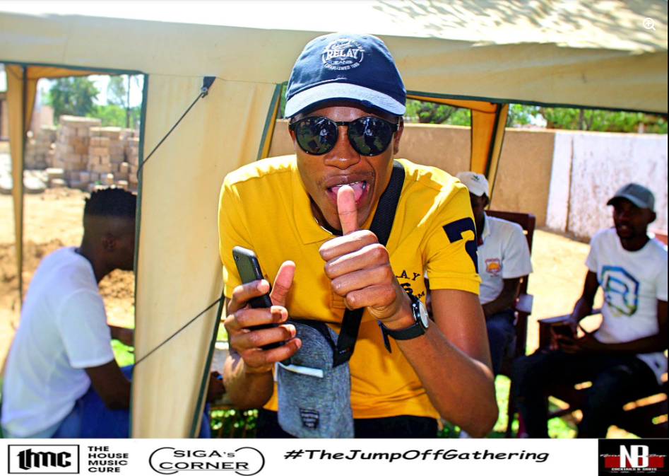
- Source Website: https://www.facebook.com/TheHouseMusicCure1
- Source URL: https://www.facebook.com/photo.php?fbid=373876196750733&set=pb.100057054056101.-2207520000&type=3
- Date Accessed: 20/28/2026

thmc-event-6.jpg
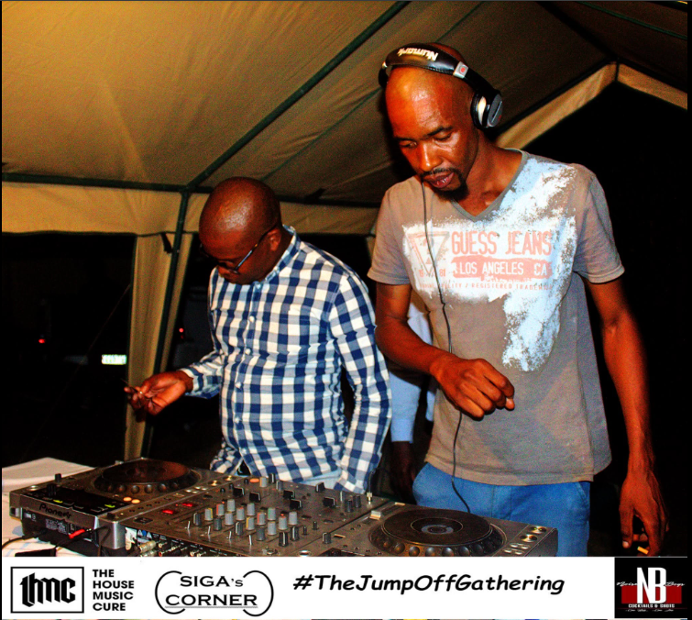
- Source Website: https://www.facebook.com/TheHouseMusicCure1
- Source URL: https://www.facebook.com/photo.php?fbid=373877590083927&set=pb.100057054056101.-2207520000&type=3
- Date Accessed: 20/28/2026

thmc-event-7.jpg
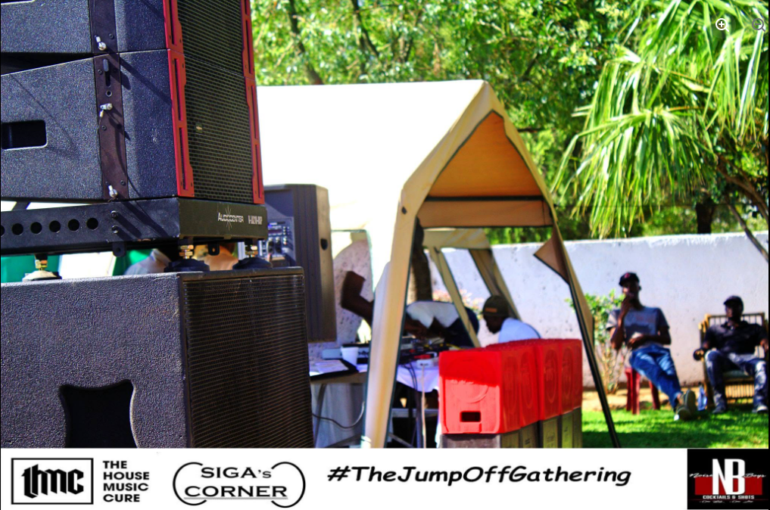
- Source Website: https://www.facebook.com/TheHouseMusicCure1
- Source URL: https://www.facebook.com/photo.php?fbid=373877803417239&set=pb.100057054056101.-2207520000&type=3
- Date Accessed: 20/28/2026

Tke-events-1.jpg
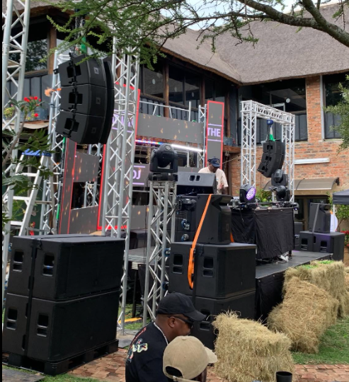
- Source Website: https://www.facebook.com/thakgowaeventsequipmentshire
- Source URL: https://www.facebook.com/photo.php?fbid=1427516436045490&set=pb.100063614407416.-2207520000&type=3
- Date Accessed: 20/28/2026

Tke-events-2.jpg
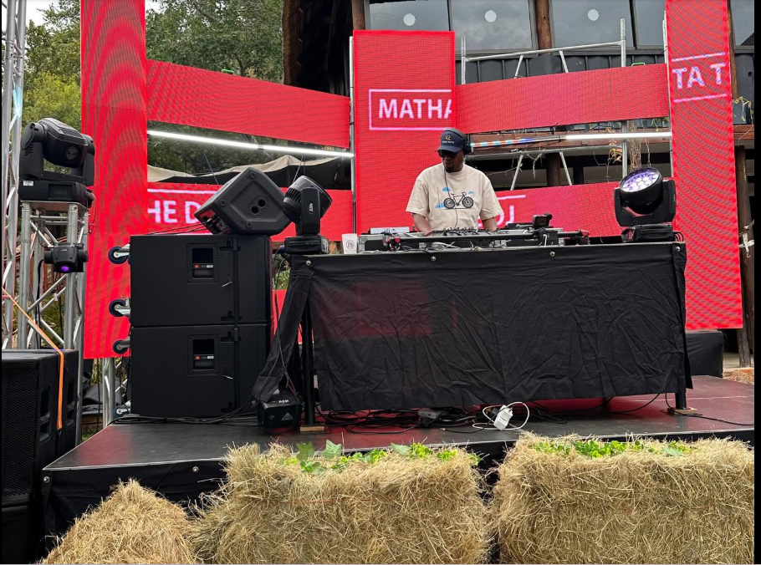
- Source Website: https://www.facebook.com/thakgowaeventsequipmentshire
- Source URL: https://www.facebook.com/photo.php?fbid=1427516436045490&set=pb.100063614407416.-2207520000&type=3
- Date Accessed: 20/28/2026

Tke-events-3.jpg
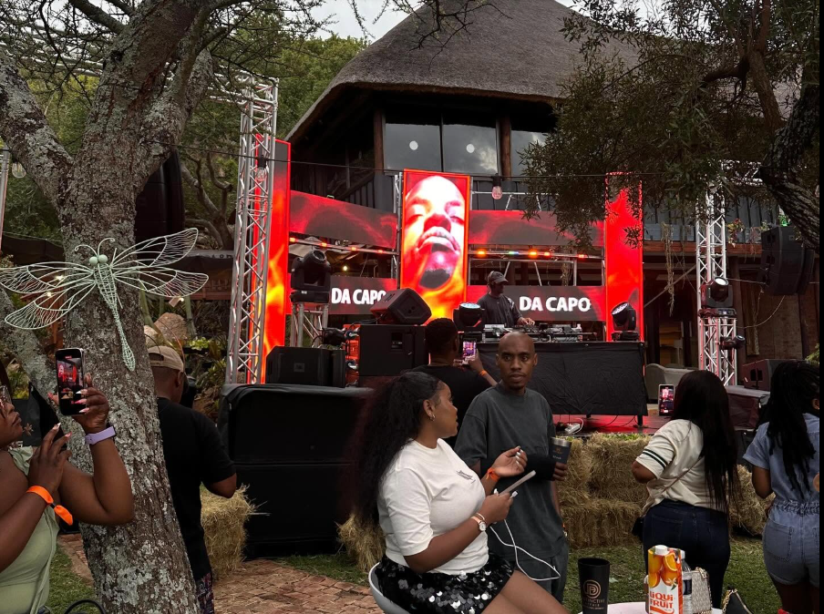
- Source Website: https://www.facebook.com/thakgowaeventsequipmentshire
- Source URL: https://www.facebook.com/photo.php?fbid=1427516436045490&set=pb.100063614407416.-2207520000&type=3
- Date Accessed: 20/28/2026

Tke-events-4.jpg
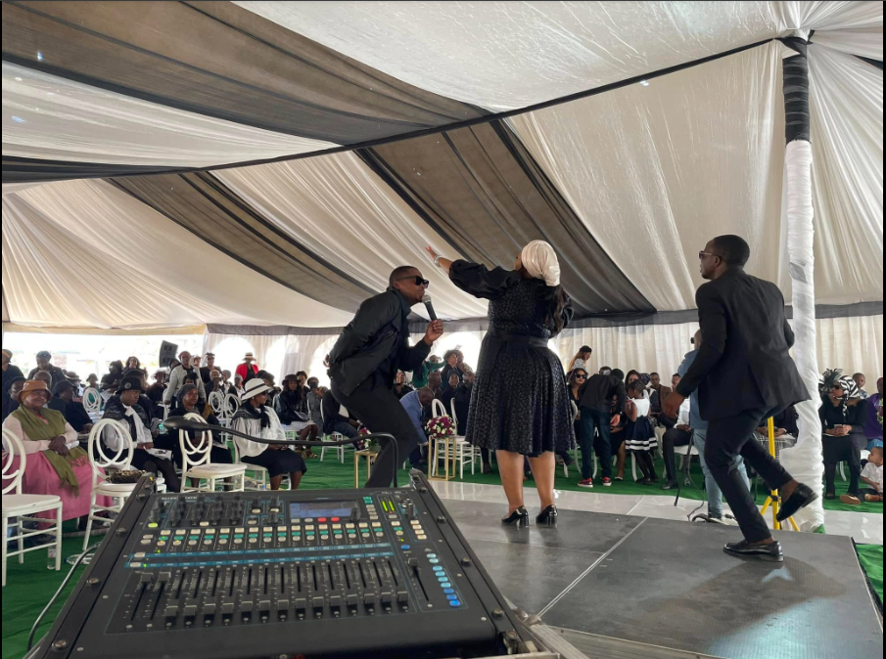
- Source Website: https://www.facebook.com/thakgowaeventsequipmentshire
- Source URL: https://www.facebook.com/photo.php?fbid=835338811929925&set=pb.100063614407416.-2207520000&type=3
- Date Accessed: 20/28/2026

Tke-events-5.jpg
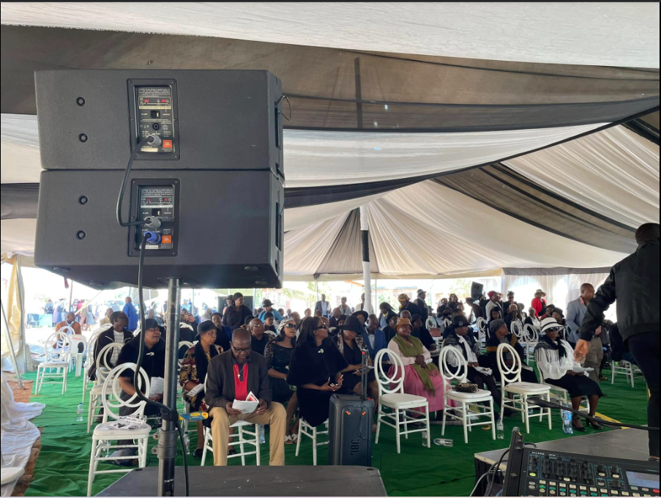
- Source Website: https://www.facebook.com/thakgowaeventsequipmentshire
- Source URL: https://www.facebook.com/photo.php?fbid=835338755263264&set=pb.100063614407416.-2207520000&type=3
- Date Accessed: 20/28/2026

Tke-events-6.jpg
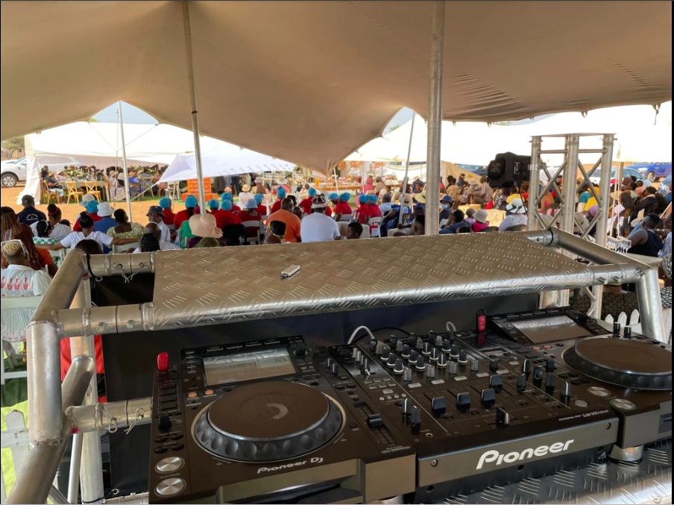
- Source Website: https://www.facebook.com/thakgowaeventsequipmentshire
- Source URL: https://www.facebook.com/photo.php?fbid=1427516436045490&set=pb.100063614407416.-2207520000&type=3
- Date Accessed: 20/28/2026

Tke-events-7.jpg
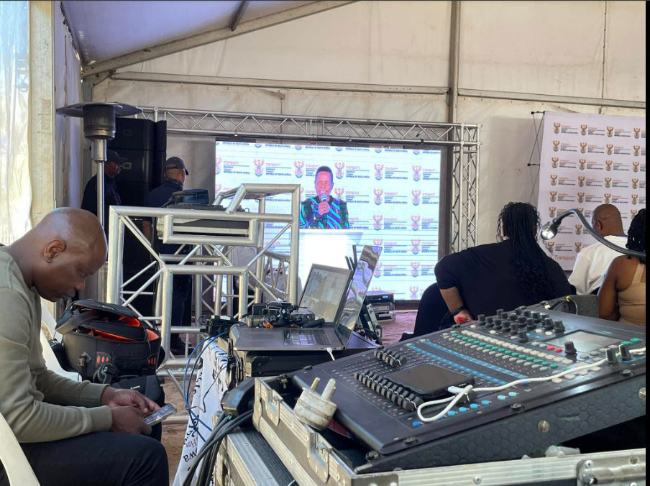
- Source Website: https://www.facebook.com/thakgowaeventsequipmentshire
- Source URL: https://www.facebook.com/photo.php?fbid=743978291065978&set=pb.100063614407416.-2207520000&type=3
- Date Accessed: 20/28/2026

Equipment Pictures for Equipment Folder :

- Source Website: https://www.facebook.com/thakgowaeventsequipmentshire
- Source URL:
- Date Accessed: 20/28/2026

