# Week3-Thu-meeting

## Agenda

Questions from Tuesday’s meeting:

* Module/Function division
* Document job
* What should we do in these stages?:
  + TTS
  + Email
* Trello
* Git
* We should also talk about requirement engineering – we should contact other stakeholders and think about what other users might want. This involves thinking about who our users/stakeholders are

### Questions

The report should contain evidences of the meetings

What is peer programming

Does the advisor say that if we are considering using google docs to save documents then the link needs to be provided to them?

Personal or business email

### Module/Function division

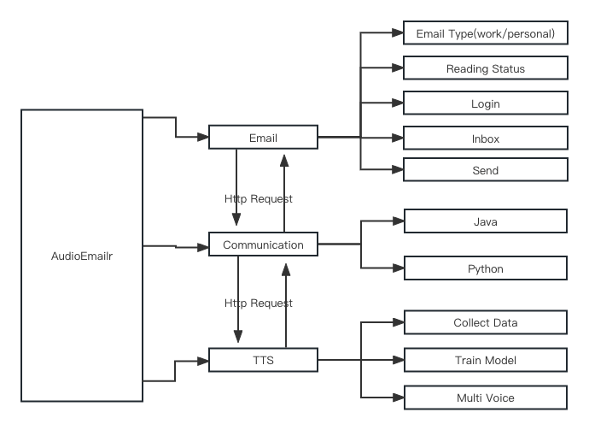

### If you have any comments, I can make adjustments to it. Document

### What documentation needs to be prepared during the project?

### 

### What should to do in this stage

Is there anything else you think needs to be changed. And assigning tasks. TTS

Use python to send and receive http request, and send voice(demo) Research on training text-to-speech model

How to collect data

TTS schematic

……

Alternate Plans (If anyone is interested)

How to use Microsoft api, and the fee Policy

#### Email

Email Part

Demo of sending and receiving emails

The general style of the front end

#### Trello

How to manage development progress with Trello.

#### Git

Command Line

GUI

IDE

#### Command Line

Git

One person/module , one branch(different version of the project), On week 5, Ziyu will manually merge them into one branch.

1

# Create and switch branches

2

git checkout -b mq

3

# It is a combination of the following two commands 4

git branch mq

5

git checkout mq

Clone the code, change it and commit it

1

2

3

4

5

6

7

8

9

10

git clone <url>

# download the project

git add .

# add the change in current folders

git commit -m "your comment"

# commit the change and add some comment git pull

11

# Pull other people's updates to local, to know whether the local code conflict with the cloud code

12

# If your code have confict with the code in gitlab, you need to handle them manually

13

# Then you should do the following action again

14

# git add .

# git commit -m "your comment"

15

16

git push

17

# upload you change to the project

After running git pull , you will see the following prompt in git if a conflict arises.

CONFLICT(content): Merge conflict in README.md

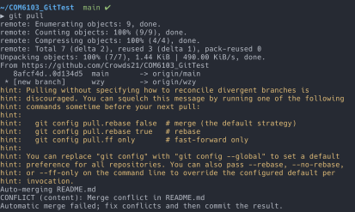In this example, open REAME.md , you can see

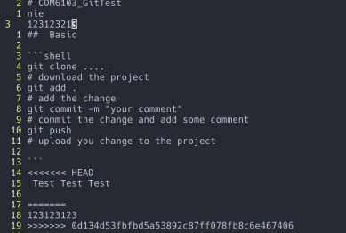

1

<<<<<<< HEAD

2

Test Test Test

3

4

=======

5

123123123

6

>>>>>>> 0d134d53fbfbd5a53892c87ff078fb8c6e467406

And you need to decide what content to keep and what to delete. In this case, I keep all of them

1 2

Test Test Test 12312312

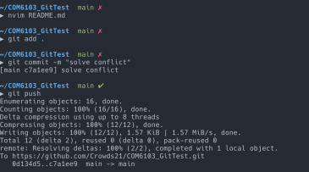

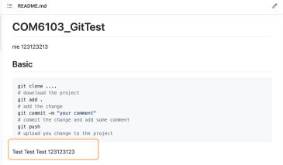

#### GUI and IDEA

Both Pycharm and Intellij have Git integration, so the overall process is similar to the one described above, and with a graphical interface, it's much easier to use.

Or you can use GitHub Desktop

### Plan

* Build development environment Mingqing and nana Send and receive Mail