* We need to define our requirements and rephrase them as user stories, in a formal document
* Prototyping and getting documents ready for Ola to check them next Tuesday
  + [Moqups](https://app.moqups.com/6lww63hD6oOOhGunQR6bFo0iNwOnPUT1/edit/page/a17264112)
  + Documents
    - Use case diagrams
    - Sequence diagrams
    - User story mapping
    - The priority of the user stories
      * For the priority, we can follow the features list, as it is in importance order.
    - Other things that need to be included?
* [Why we need to use json](https://drive.google.com/file/d/1BWeSnndCPuFJkVzE4F-Hm-DCZLXqIxHP/view?usp=sharing)
* Everyone should create their own branch on gitlab, and push something
* How to handle HTML in email body
  + Tell the user directly that you cannot read this email
  + Or read the text part of it, by text processing
    - For example, the regular expression. The regular expressions in java and python are the same. So it doesn't matter who does this part.
* Adjustments to function divisions
  + 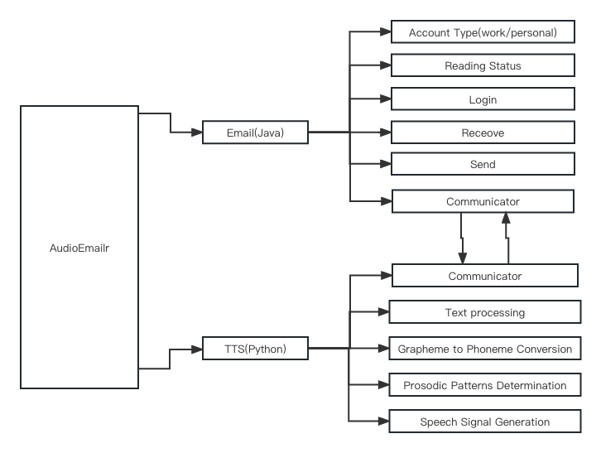
* Technology to synthesise audio? What input is required from the NLP part?
* Json
  + Send
    - Mail_id:”xxxxx”
    - Content:”xxxxx”
  + Receive
    - Mail_id:”xxxx”
    - Voice:”xxxxxx”