## Bug

The test_html files in TTS/test/ cannot be converted properly.  
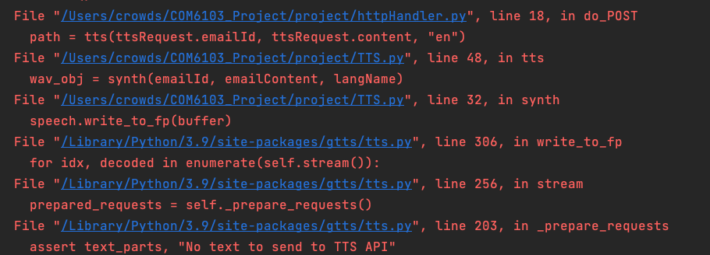

* Maybe we should ignore the dash
* Seems the punctuation can cause the problem
* Need to test unknown words like Café, Fiancé. These are non-English alphabet words that may appear in English articles

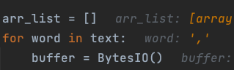

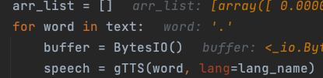

## Template of test cases

It is recommended to provide specific test data. Like the email content (just one sentence is enough, or you could provide a summary, such as embedding non-English vocabulary in the email body).  
The same functionality can have multiple test cases written for it, which can be distinguished using unique identifiers.

#### Test Case: User Login (First time) No.1 Tester: xxxxxx

Test Steps(Input):

* `localhost:8083/audioMail/login/loading` Navigate to the login page.
* Enter valid username and password. (Personal account information is omitted here)
* Click on the "Login" button.
* User is redirected to the homepage.

Expected Results:

* User is able to successfully login with valid credentials.
* User is redirected to the homepage.
* User's name is displayed on the homepage.

Test Results:

* Test case passed

We can write black-box test cases based on the importance of the functionality. Here are some other examplesTest Case:

#### User Login (Second time) No.2

#### Test Case: Change Account (TODO I forget this function)

#### Test Case: Send Emails

#### Test Case: Read emails at scheduled intervals.

#### Test Case: Read emails at scheduled intervals.

#### Test Case: Convert html to voice

#### Test Case: Convert html to voice

## SpringShell

Normally, white-box test should be done using JUnit. However, I ran into some issues when configuring it, and I couldn't get it to start despite my best efforts. Therefore, we'll need to use SpringShell for unit testing. Like this. In the CLI package.  
