Test case:
Cardiology: I am 55 years old and have been experiencing intermittent chest pressure and palpitations for 2 days. I also have high blood pressure.
Pulmonology: I am 28 years old and have had a persistent cough, wheezing, chest tightness, and shortness of breath for 5 days. I have a history of seasonal allergies.
Neurology: I am 42 years old and have been experiencing recurrent headaches, dizziness, and occasional numbness in my right hand for 3 days.
Gastroenterology: I am 35 years old and have had abdominal pain, nausea, bloating, and diarrhea for 3 days.
Dermatology: I am 30 years old and have developed an itchy red rash on my arms and neck that has persisted for 4 days. I have not experienced breathing difficulty or facial swelling.
General Medicine: I am 30 years old and have had fever, fatigue, and mild body aches for 3 days. I do not have chest pain, breathing difficulty, severe abdominal pain, or neurological symptoms.
Emergency / Safety Gate:
I am 45 years old and have severe crushing chest pain for 2 hours, with sweating and shortness of breath.

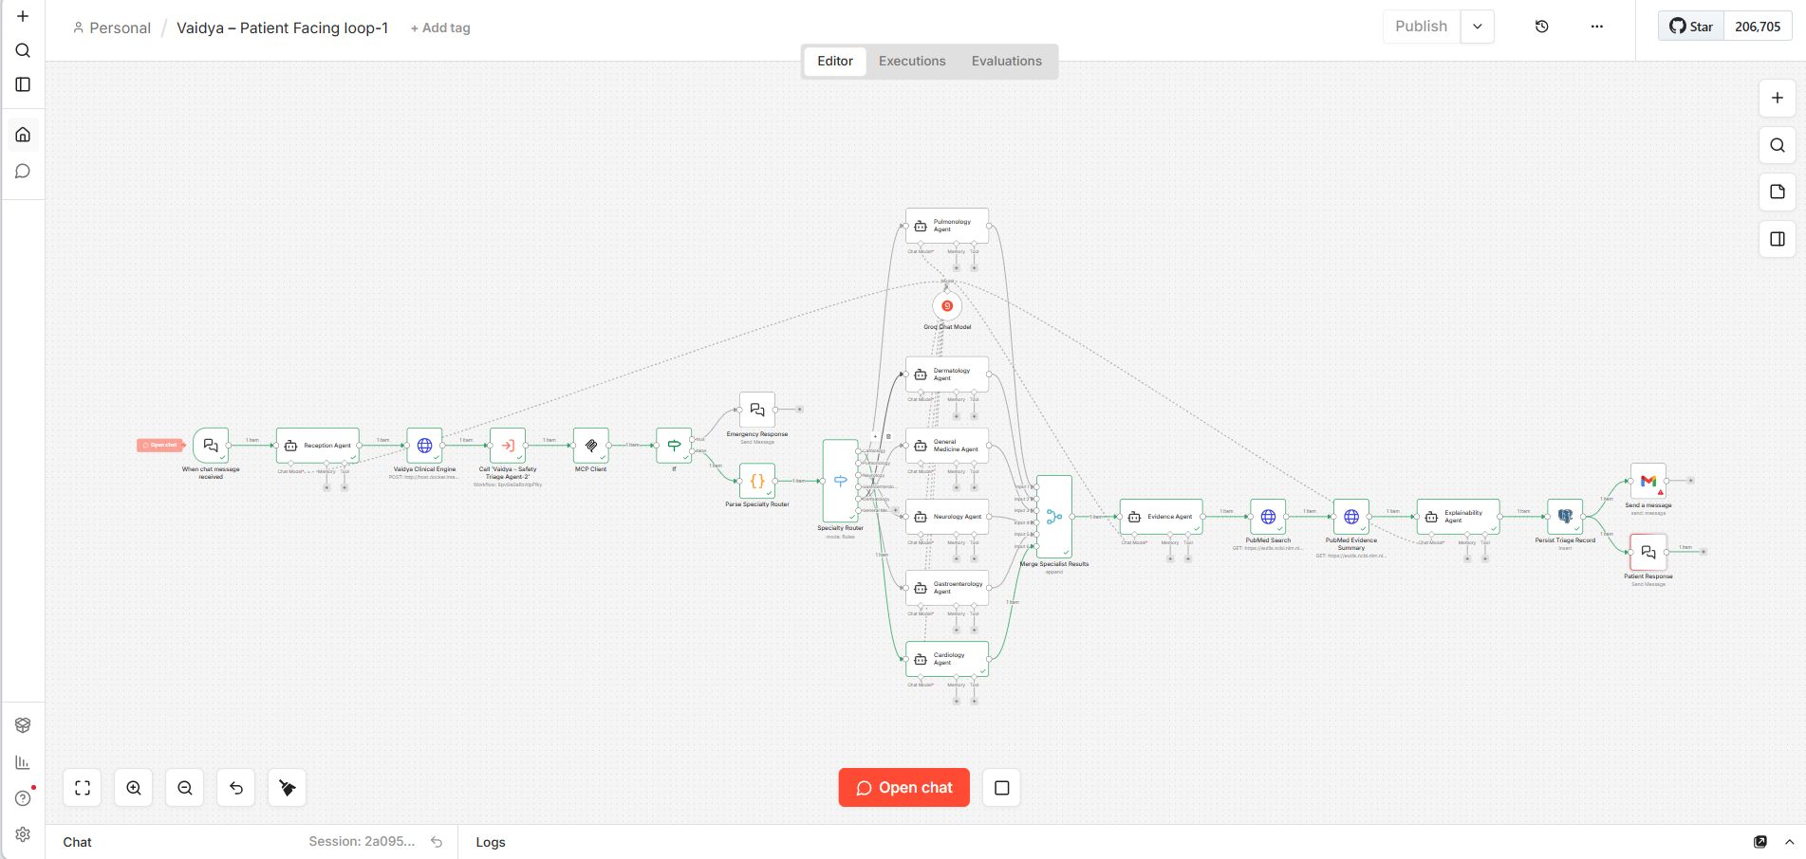
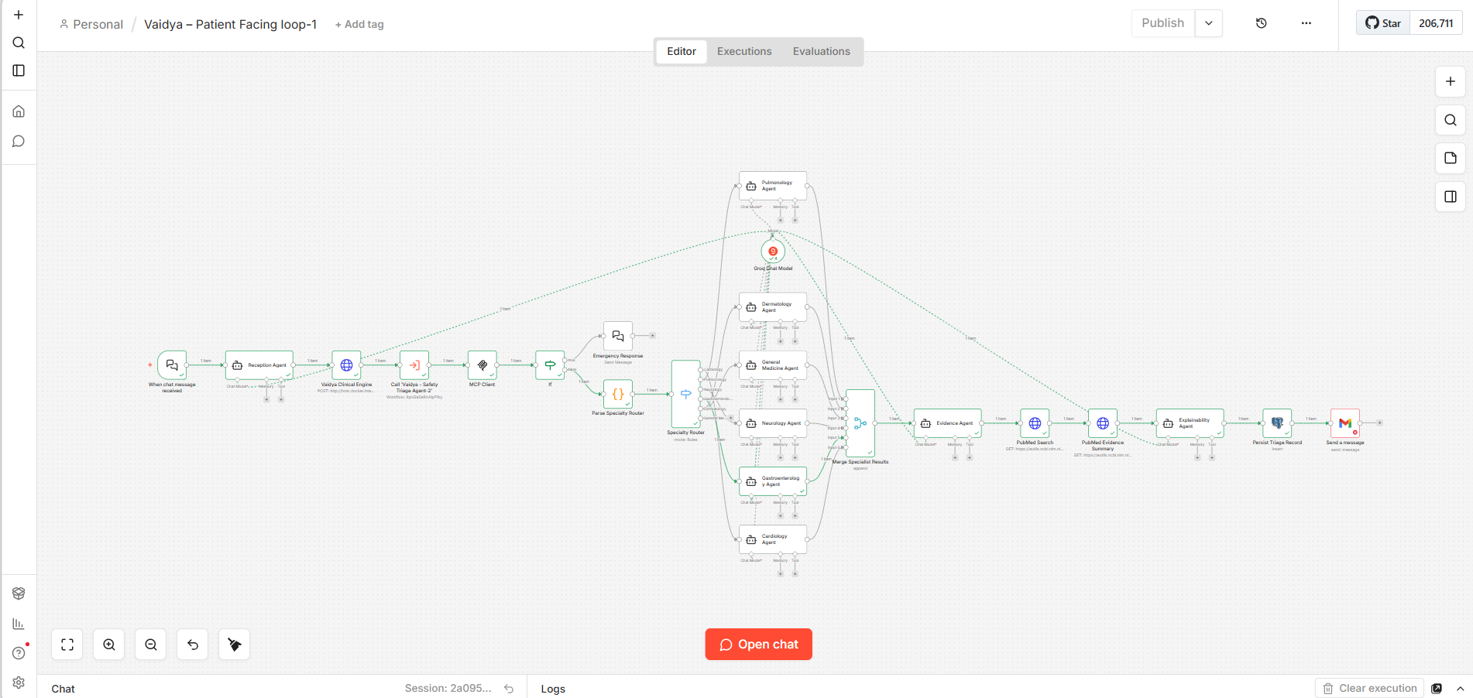
Complete workflow- Gmail authentication free token finished.
http://localhost:5000/dashboard
Username: admin
Password: vaidya123
Tested:
I am 35 years old and have had abdominal pain, nausea, bloating, and diarrhea for 3 days.
I am 30 years old, fever and fatigue for 3 days.

Complete functional workflow in n8n:
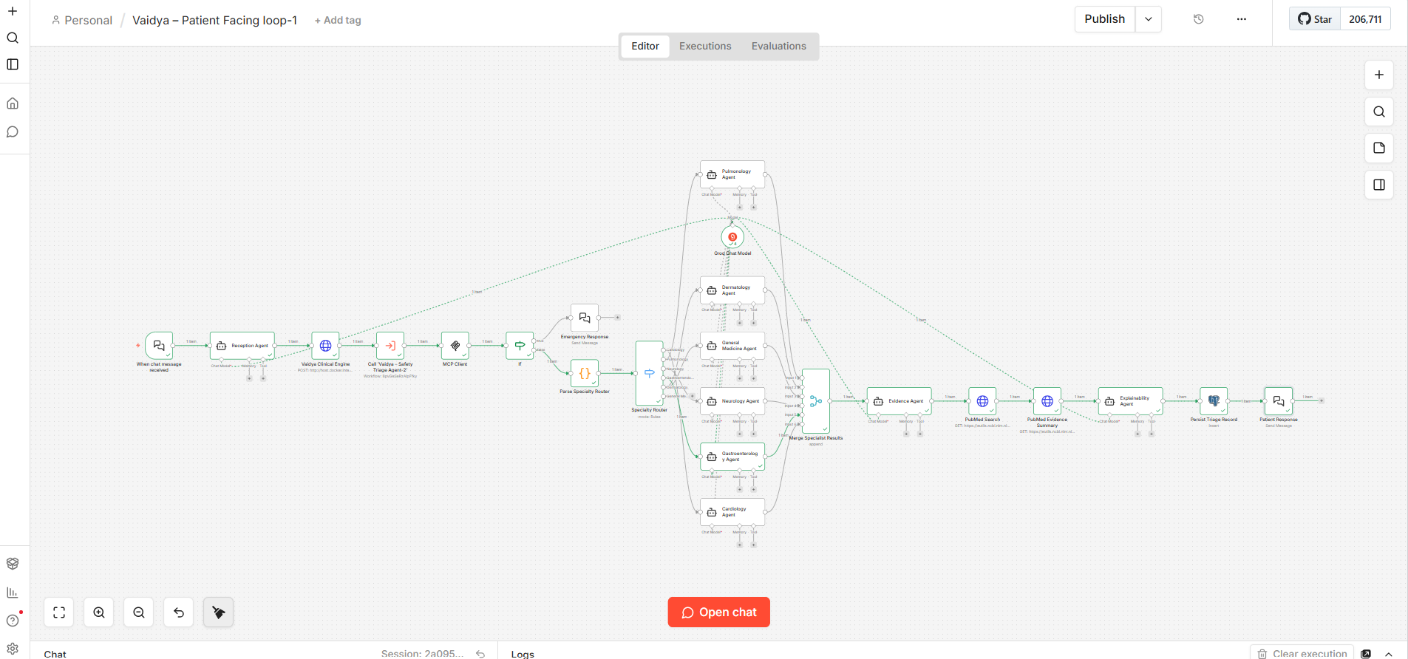
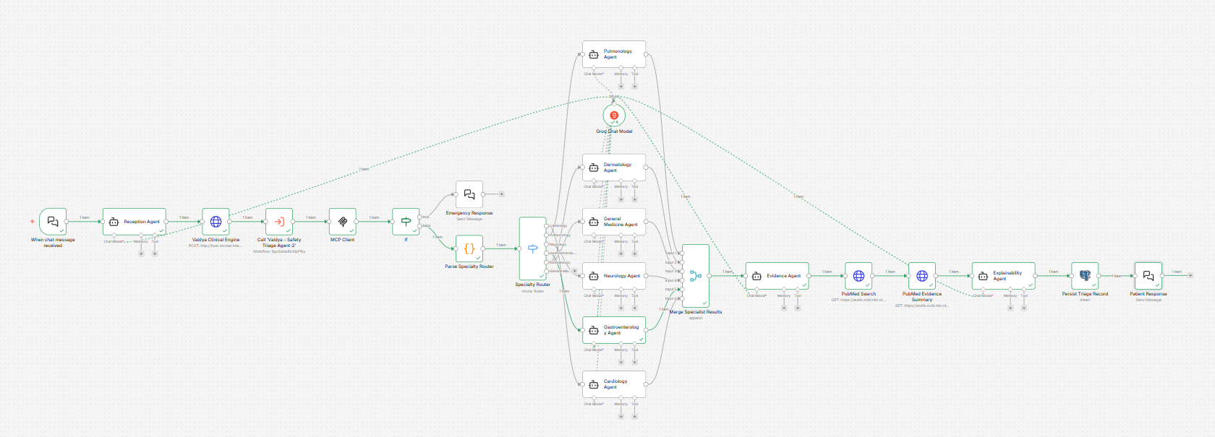

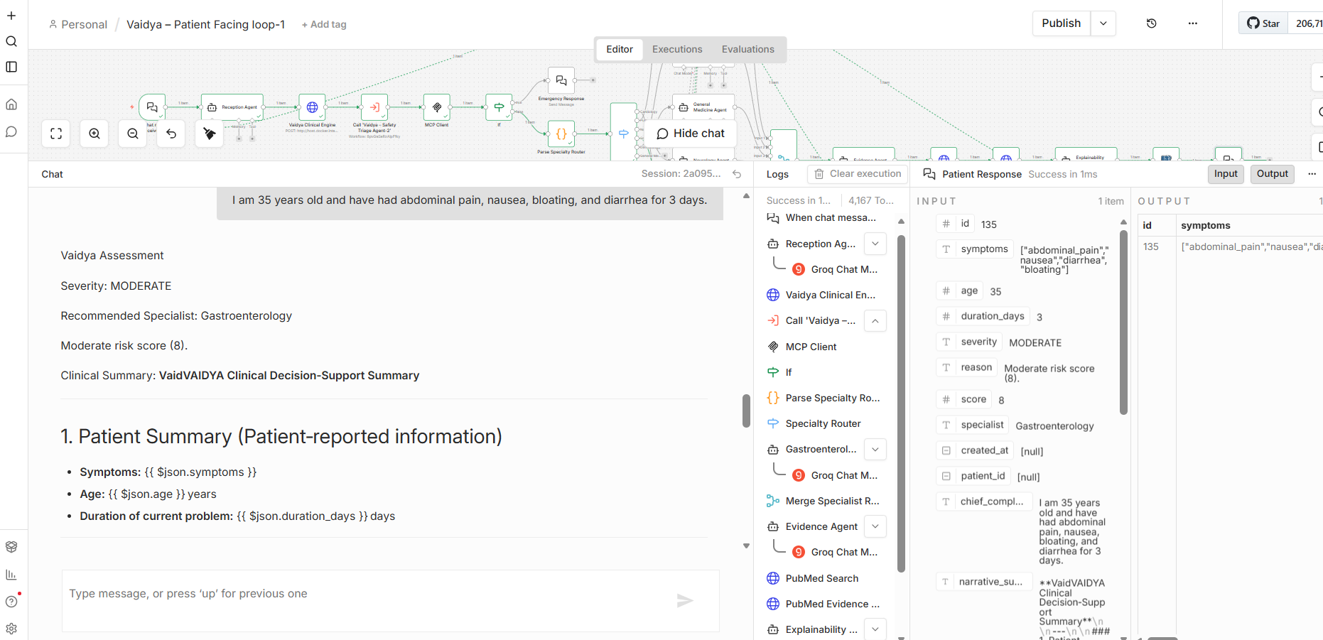
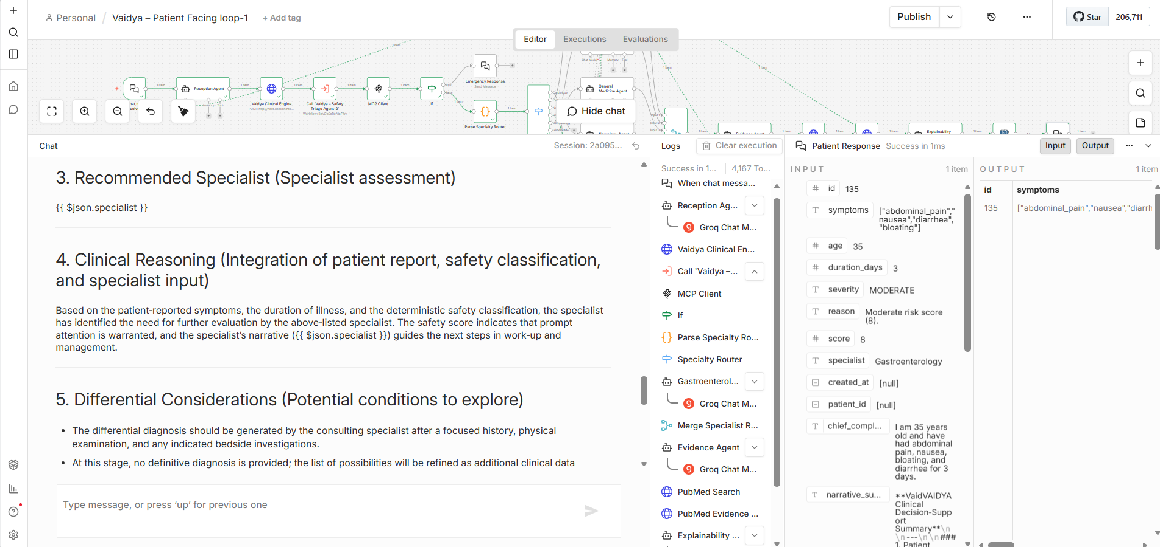
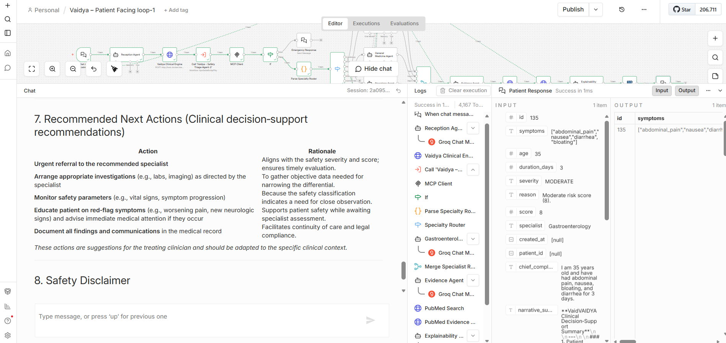
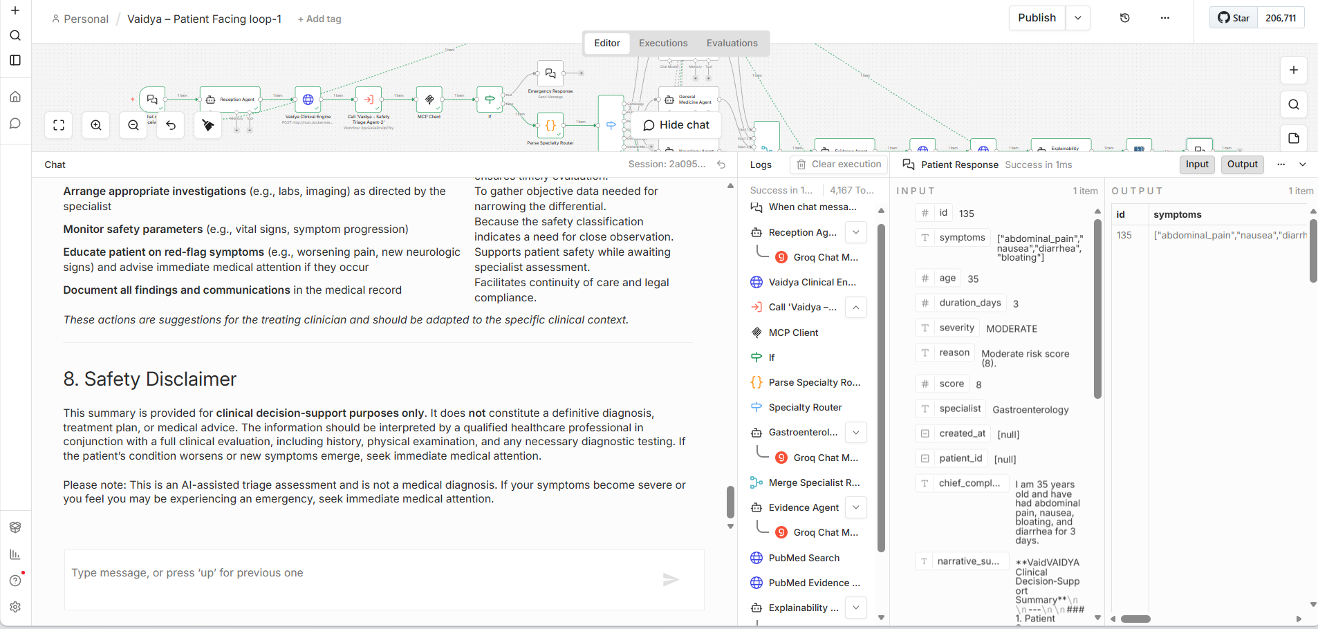
Now, same case is visible on the dashboard or flask interface as well:
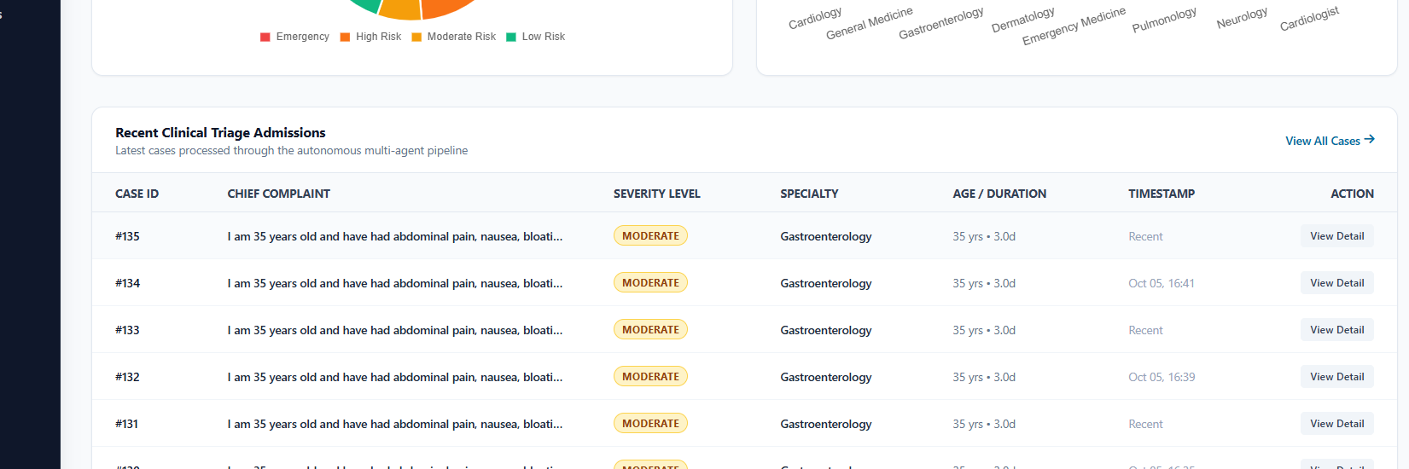
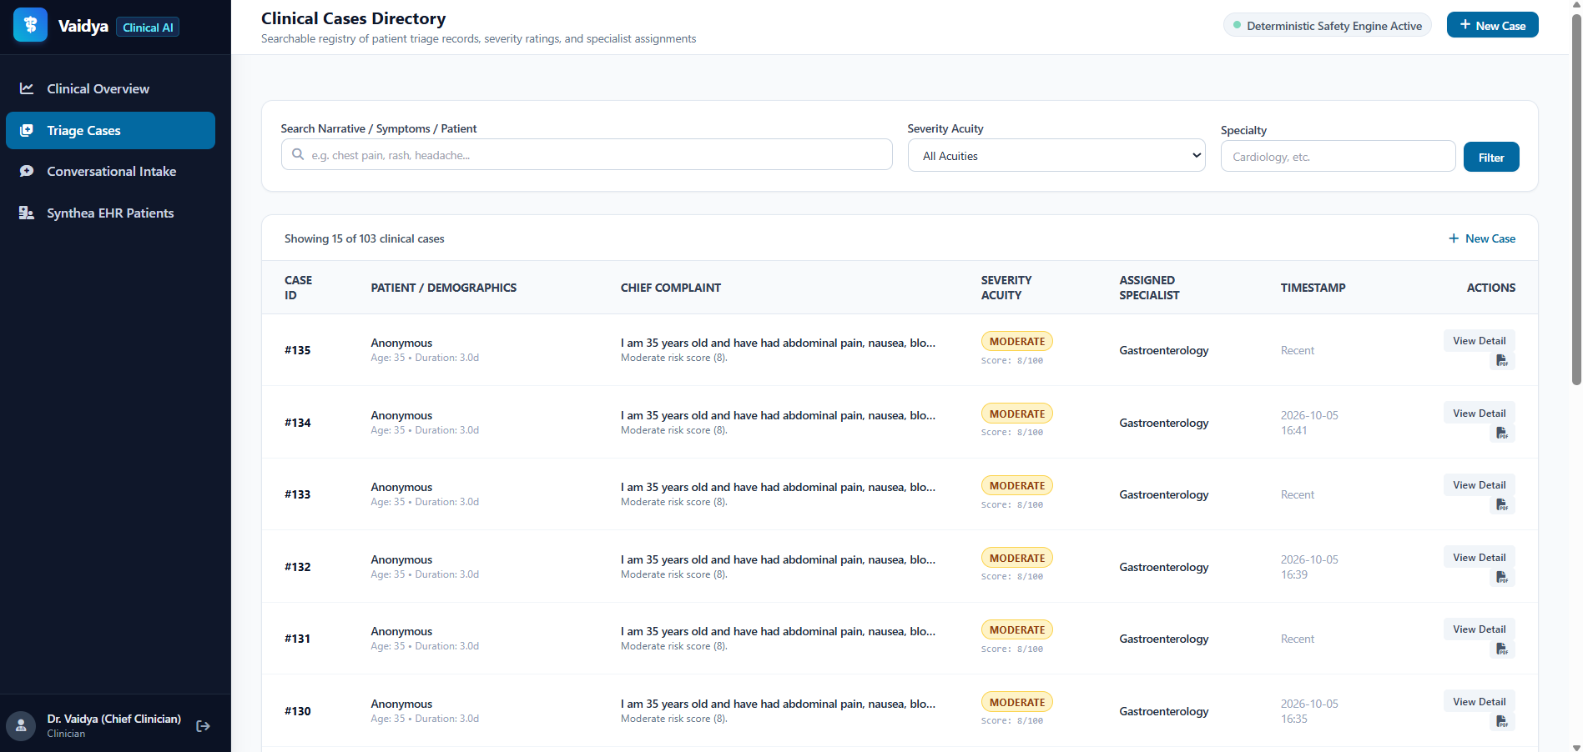
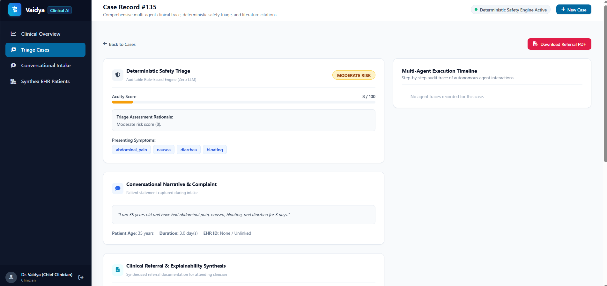
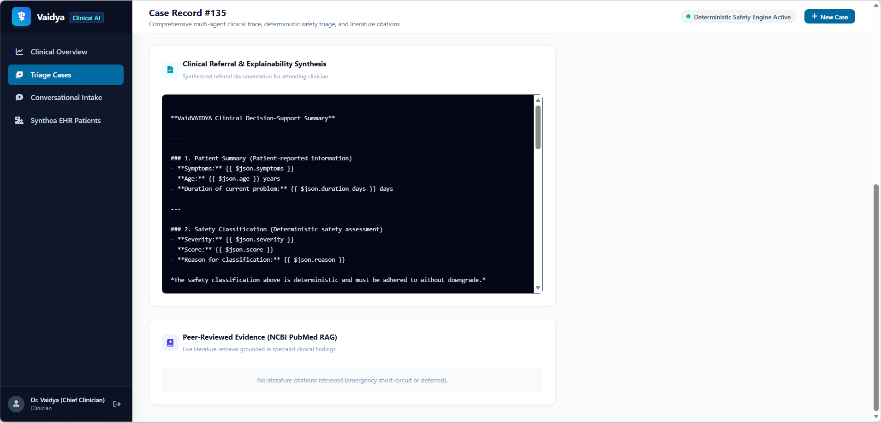

General Dashboard Overview:
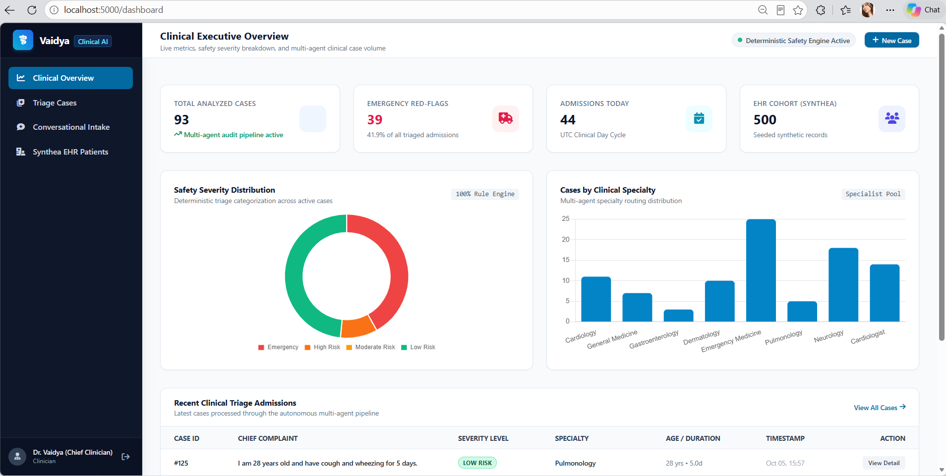
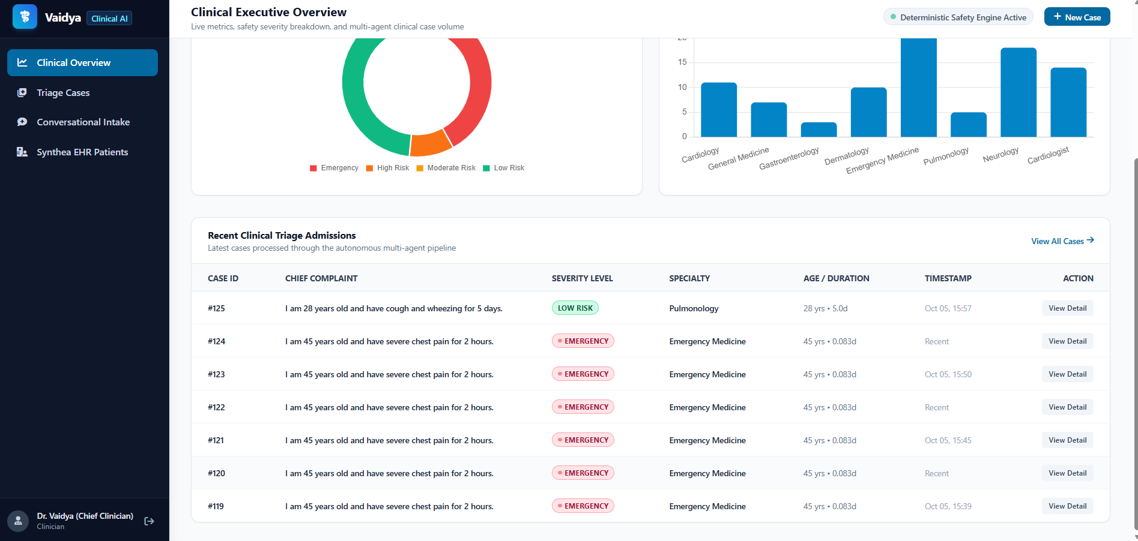

Recent tested case in n8n which is visible on the system: Two cases demonstrated below
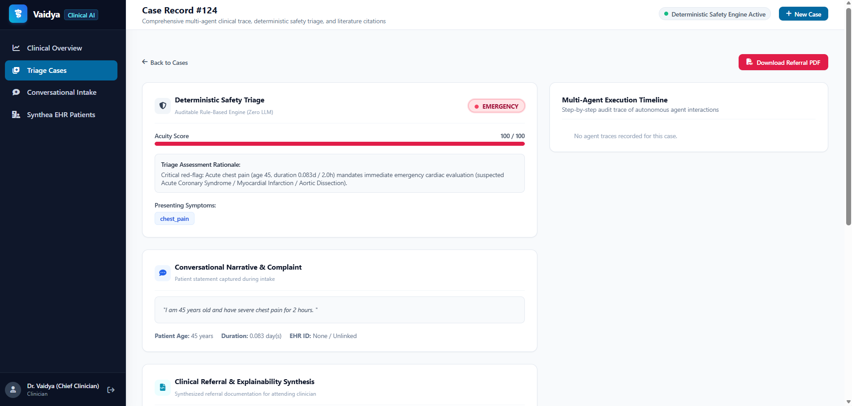
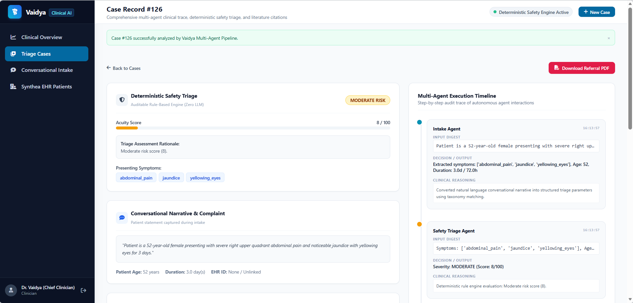

Downloadable report for each case:
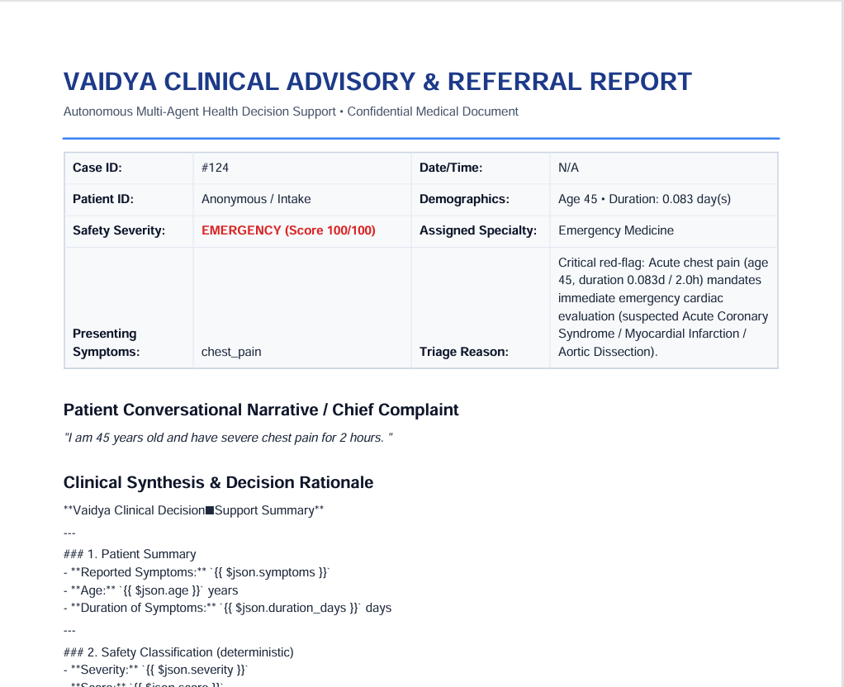

Prompts for Explainability:
Prompt/user message:
{{ `
Generate a personalized Vaidya clinical assessment.

PATIENT COMPLAINT:
${$('When chat message received').first().json.chatInput || 'Not provided'}

PATIENT DATA:
${JSON.stringify({
symptoms: $('Vaidya Clinical Engine').first().json.symptoms,
age: $('Vaidya Clinical Engine').first().json.age,
duration_days: $('Vaidya Clinical Engine').first().json.duration_days
}, null, 2)}

DETERMINISTIC TRIAGE:
${JSON.stringify({
severity: $('Vaidya Clinical Engine').first().json.severity,
score: $('Vaidya Clinical Engine').first().json.score,
reason: $('Vaidya Clinical Engine').first().json.reason,
specialist: $('Vaidya Clinical Engine').first().json.specialist
}, null, 2)}

SPECIALIST ASSESSMENT:
${JSON.stringify($('Merge Specialist Results').first().json, null, 2)}

RETRIEVED EVIDENCE:
${JSON.stringify($('PubMed Evidence Summary').first().json, null, 2).slice(0, 5000)}

Write the following sections:

1. Understanding Your Symptoms
Summarize the patient's actual complaint.

2. Your Triage Assessment
Explain the actual severity and reason without modifying them.

3. Recommended Specialist
Explain the recommended specialty.

4. What Could Be Causing Your Symptoms?
Summarize plausible possibilities from the specialist assessment.
Do not present these as diagnoses.

5. Recommended Next Steps
Provide practical and safe follow-up guidance.

6. When to Seek Urgent Help
Describe relevant warning signs.

7. Medical Disclaimer
State that this is AI-assisted triage, not a diagnosis.

IMPORTANT:
Do not ask for patient information already provided.
Do not output JSON, code, placeholders, or template instructions.
Do not invent PubMed citations.
Keep the response concise and patient-friendly.
` }}
System Message:
You are the Vaidya Clinical Explainability Agent.

Your responsibility is to transform completed clinical triage results, specialist assessments, and available research evidence into a clear, personalized, patient-friendly explanation.

Rules:
- Use the patient information explicitly supplied in the user message.
- Preserve the deterministic safety severity, score, and reason exactly.
- Never invent clinical findings, diagnoses, medications, or citations.
- Explain possible conditions as possibilities, not confirmed diagnoses.
- Explain why the recommended specialist is appropriate.
- Give practical, proportionate next steps.
- Mention urgent warning signs when relevant.
- Use research evidence only when relevant and verifiable.
- If evidence is unavailable, omit it rather than inventing references.
- Never describe your internal architecture, agents, algorithms, or workflow.
- Never produce empty templates or generic instructions to populate fields.
- If some details are missing, acknowledge only those specific limitations while using all available information.
- Do not repeat information unnecessarily.

Write naturally, clearly, and compassionately for patients.
Tested answer received in n8n:
Query:
I am 35 years old and have had abdominal pain, nausea, bloating, and diarrhea for 3 days.
Answer:
Vaidya Assessment
Severity: MODERATE
Recommended Specialist: Gastroenterology
Moderate risk score (8).
Clinical Summary: 1. Understanding Your Symptoms
You are 35 years old and have been experiencing abdominal pain, nausea, bloating, and diarrhea for the past three days.
2. Your Triage Assessment
The triage system has classified your situation as MODERATE severity with a score of 8. The reason given is simply “Moderate risk score (8).”
3. Recommended Specialist
Because the symptoms involve the gastrointestinal (GI) tract and the risk is moderate, the recommended specialist is a gastroenterologist—a doctor who focuses on conditions of the stomach, intestines, liver, and related organs.
4. What Could Be Causing Your Symptoms?
Based on the information you provided, a gastroenterologist might consider several common possibilities, such as:
- Acute infectious gastroenteritis (viral, bacterial, or parasitic infection) – often self-limited and can cause pain, nausea, bloating, and diarrhea.
- Inflammatory bowel disease flare (Crohn’s disease or ulcerative colitis) – chronic conditions that can present with similar GI upset.
- Peptic ulcer disease or gastritis – irritation of the stomach lining, sometimes related to NSAID use or alcohol.
- Functional gastrointestinal disorder (e.g., irritable bowel syndrome) – a pattern of symptoms without an obvious structural cause.
- Obstructive or ischemic issues (e.g., a small-bowel blockage or reduced blood flow) – less common but important to rule out if symptoms worsen.
These are possibilities, not confirmed diagnoses. The gastroenterologist will use a focused history, physical exam, and targeted tests to narrow them down.
5. Recommended Next Steps
- Contact a gastroenterology office (or your primary-care provider who can arrange the referral) within the next 24 hours for an outpatient evaluation.
- Provide a clear history when you speak with the clinician: any recent travel, sick contacts, new foods, medication use (especially NSAIDs or antibiotics), alcohol intake, and any prior GI problems.
- Ask the clinician to order baseline labs such as a complete blood count, basic metabolic panel, inflammatory markers (CRP/ESR), and stool studies (culture, ova/parasites, C. difficile toxin) given the diarrhea.
- Imaging may be considered if the exam suggests obstruction, severe inflammation, or other complications (e.g., an abdominal ultrasound or CT scan).
- Follow-up plan:
  - Urgent (same-day or within a few hours) if any red-flag signs appear (see below).
  - Routine outpatient appointment within 24-48 hours if no red flags are present.
6. When to Seek Urgent Help
Call emergency services or go to the nearest emergency department right away if you notice any of the following:
- Fever ≥ 38.5 °C (101.3 °F) or chills
- Persistent vomiting that prevents you from keeping fluids down
- Bloody or black/tarry stools (possible GI bleed)
- Severe, worsening abdominal pain or a rigid, board-like abdomen
- Signs of dehydration (dry mouth, dizziness, scant urine, rapid heartbeat)
- Inability to pass gas or stool (possible obstruction)
- Sudden, sharp pain that comes on suddenly and feels out of proportion to the rest of your symptoms
7. Medical Disclaimer
This information is generated by an AI-assisted triage system to help you understand your current situation. It is not a medical diagnosis and does not replace a professional evaluation by a qualified healthcare provider. Please follow up with a gastroenterologist or your primary-care clinician for personalized assessment and care.
Please note: This is an AI-assisted triage assessment and is not a medical diagnosis. If your symptoms become severe or you feel you may be experiencing an emergency, seek immediate medical attention.

