Onset, plateau and a district-level fragility function for wind-driven power outages: three years of operational records from a UK distribution network
Reproduction draft generated independently from the project samples. Tables and inserted analysis figures come from this run. The inherited narrative is a historical review template: its hand-entered numbers, causal interpretations and literature claims require revision against the computed results before publication.
[Author list and affiliations — to be completed]

Abstract
UK Power Networks recorded 60,453 weather- and asset-related outage incidents across London, the South East and the East of England between April 2021 and March 2024, including seven named storms. Event-level exposure (customers affected) and recovery (restoration time) outcomes are reconstructed from stage-level regulatory records under Ofgem's definitions, correcting a factor-of-two undercount that results from using the earliest stage alone. A specification search with district-grouped cross-validation shows that the wind response of the exposure margin is piecewise-linear rather than smooth: flat below an onset gust of 14 m/s (95% interval 13–15 m/s), rising at 0.12 log-units per m/s to 25 m/s (24–28 m/s), and constant beyond — a constraint the data do not reject and physics requires, since customers affected cannot fall with gust. On the 16% of incidents attributed to weather the response is V-shaped, because calm-wind weather incidents (lightning, flooding, snow) are large but not wind-driven, and its ramp slope of 0.08 per m/s accounts for about two-thirds of the pooled rise, the remainder being the rising share of weather faults. Restoration time rises smoothly with the square of gust and is far more predictable among weather incidents (out-of-sample R² 0.28 against 0.11). Reconstructing a panel of 121,656 district-days shows that the probability of an outage of a given size occurring in a district on a day follows a lognormal fragility function with a background rate: median gust 23–25 m/s for outages of up to 100 customers and 30 m/s for outages above 1,000, dispersion 0.24–0.44, and a floor equal to the technical-fault base rate. This is the first network-scale wind fragility function estimated from operational records, and it is directly comparable to structure-level fragility curves from simulation and testing.
Keywords: power outage; wind fragility; distribution network; piecewise regression; extreme weather; storm resilience

1. Introduction
Storms are the most common cause of power disruption in Great Britain [1]. Storm Arwen in November 2021 left more than one million customers without supply [2]; three months later Storms Dudley, Eunice and Franklin struck within five days, and within the service area of UK Power Networks (UKPN) Eunice produced a peak gust of 39.4 m/s at Lewes on 18 February 2022, 1,601 weather-related outage events across 101 local authority districts and an estimated 376,712 affected customers. Such events show that outage impact does not scale in fixed proportion with wind: a given increase in gust can correspond to a negligible change in outcome under some conditions and a disproportionate one under others. Whether that response has an identifiable onset, whether it saturates, and whether it can be expressed as a fragility function of the kind used in structural engineering, are questions that bear directly on how distribution network operators (DNOs) set weather-response thresholds and pre-position restoration resources.
Two literatures address adjacent versions of these questions without meeting. Statistical outage studies for hurricane- and ice-storm-affected utilities [3–6] fit regression or machine-learning models that relate weather intensity to customers affected or restoration time; they report fitted relationships but do not test for a distinguishable threshold, and they model outcomes conditional on an outage having occurred rather than the probability that one occurs. Structural engineering, by contrast, derives fragility curves — the probability of failure of a pole, tower or line as a function of wind speed — from finite-element simulation or scaled testing of a single component [7–10]. Those curves are threshold-shaped: failure probability sits near a baseline below a critical wind speed and rises steeply above it [10]. Whether a comparable threshold-shaped response exists at the scale of a whole network, where outcomes aggregate a heterogeneous population of assets, ages and local conditions, is not something either literature can answer on its own.
This paper answers it using three years of continuous operational records from UKPN, a period long enough to contain both routine operating conditions and seven named storms on the same network. We ask two questions. First, what is the shape of the network's wind response — for the size of an outage once it has occurred, for the time taken to restore it, and for the probability that an outage of a given size occurs at all — and can that last quantity be written as a fragility function? Second, how much of the variation in outage outcomes does wind explain, across all incidents and among those that the operator itself attributes to weather?
Three results follow. The size of an outage responds to gust in a piecewise-linear way, with an onset at 14 m/s, a ramp to 25 m/s and a plateau beyond; a quadratic specification, of the kind used in earlier work and in an earlier version of this analysis, places a spurious turning point at 10.8 m/s that is a property of the parabola rather than of the data. Two-thirds of the ramp is recovered among weather-attributed incidents alone. And the probability that a district experiences an outage of a given size on a given day follows a lognormal fragility function in gust, with a background rate equal to the technical-fault rate, a median of 23–25 m/s and a dispersion of about 0.3 — a network-level counterpart to the component-level curves of [7–10].
Section 2 describes the data, the construction of event-level outcomes from stage-level records, and the three analysis samples. Section 3 sets out the regression framework, the specification search, the validation design and the fragility model. Section 4 reports results in five parts: the shape of the wind response on all incidents, the response on weather-attributed incidents, the explanatory weight of wind, the district-day fragility function, and checks against the named storms and an independent temporal holdout. Section 5 discusses the operational meaning of the two thresholds, the relation to structure-level fragility, restoration time, and limitations.

2. Data

2.1 Study setting and sources
UKPN operates the distribution network across London, the South East and the East of England and reports outage incidents to Ofgem under the RIIO-ED1 and RIIO-ED2 Annex F guidance [11, 12]. The records used here cover 1 April 2021 to 31 March 2024, three complete regulatory years. Each record is a restoration stage rather than a complete incident: an incident restored in several actions is represented by several stage-level records sharing an incident reference. Weather is matched to each incident from hourly ERA5-based reanalysis via the Open-Meteo historical API [13, 14], indexed to the incident's reported coordinates and starting hour. The primary wind variable is the instantaneous gust rather than the sustained speed, following wind-engineering practice in which short-duration gust governs structural loading and failure [15, 16]. Regional covariates at the local authority district (LAD) level — population, income deprivation rate, the within-district deprivation range, spatial clustering of deprivation (Moran's I [19]) and an urban–rural indicator — are drawn from ONS sources [17, 18, 20]. Figure 1 shows the three licence areas and the spatial density of incidents, which concentrates around London with a secondary concentration on the East Anglian coast.
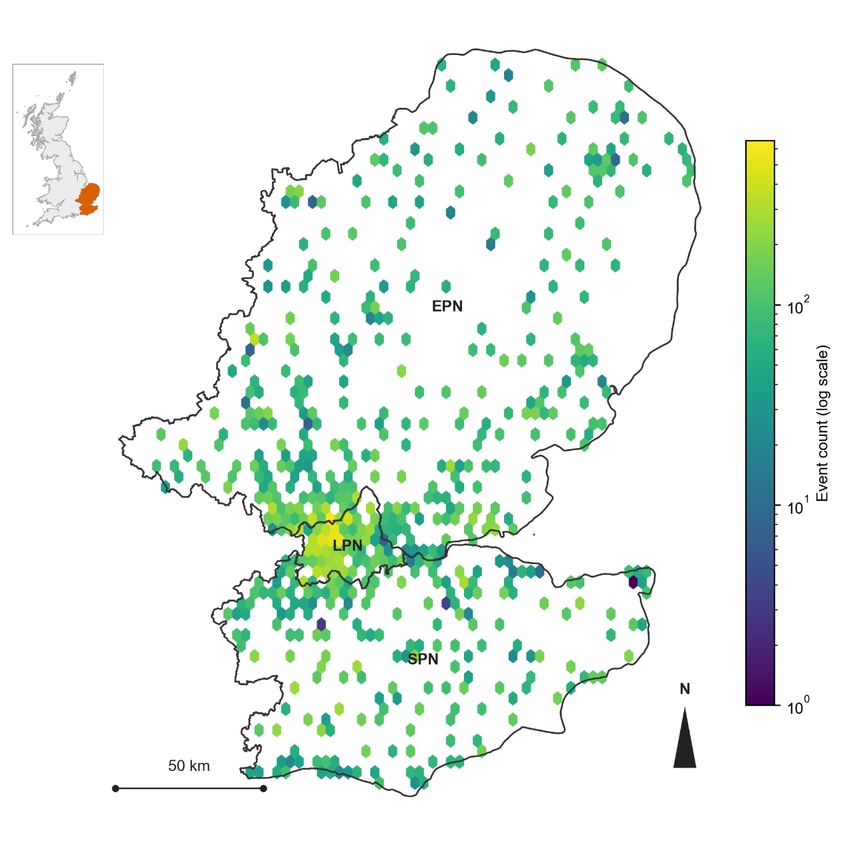
Figure 1. Study area and incident density. The three UKPN licence areas (London, South East, East of England) and the hexagonally binned density of all incidents in the analysis sample on a logarithmic count scale. Inset: location within Great Britain.

2.2 Outcome construction
Ofgem's Annex F defines two network-level measures, Customer Interruptions (CI) and Customer Minutes Lost (CML), both aggregated over a reporting period. We construct their incident-level analogues. Affected customers, Cᵢ, is the sum over the restoration stages of incident i of the customers reported at each stage, excluding stages flagged as re-interruptions so that customers are not double-counted. Restoration duration, Dᵢ, is the total span of the incident, from the earliest recorded stage start to the latest recorded stage end, including re-interruption stages. A customer-weighted duration analogous to CML was considered and rejected because it shares its weighting with Cᵢ by construction and therefore induces a spurious association between the two margins (Supplementary B). Aggregating customers across stages rather than taking the earliest stage alone raises the sample mean from 47.1 to 93.0 customers, a factor of 1.97, because incidents with more than one restoration stage are not captured by their first stage. The full processing pipeline, including boundary cases, is given in Supplementary B.

2.3 Descriptive statistics
Table 1 summarises the two outcomes and Figure 2 shows their distributions. Both are heavily right-skewed: the median incident affects two customers and the mean 93; the median restoration takes about seven hours and the maximum eight days. Log transformation removes the extreme tail that would otherwise dominate least squares but leaves visible structure. The exposure distribution has spikes at zero, one and two customers, which together account for 58% of incidents at five or fewer; this is a zero-inflated count, and Section 4.4 returns to what that implies. The recovery distribution, before cleaning, has a very tall spike at exactly one hour. Inspection shows that this spike is a placeholder: 8,661 incidents in the recovery sample interrupted no customers, and 66.5% of those carry a recorded duration of exactly 1.000 h, against 0.5% of all other incidents. A restoration time is undefined when nobody was interrupted, and these rows are removed from the recovery sample (Section 2.4). On the cleaned sample the low mode of the distribution sits at 30–35 minutes and corresponds to faults cleared by automatic reclosure.
Table 1. Descriptive statistics of the two outcome margins in the analysis samples (recovery after exclusion of zero-customer incidents).
Statistic | Affected customers (n=60,437) | log(1+affected customers) | Restoration duration, h (n=51,173) | log(restoration duration)
Mean | 93.024 | 2.138 | 12.423 | 1.868
Median | 2.000 | 1.099 | 7.417 | 2.004
SD | 410.963 | 2.019 | 18.505 | 1.218
Min | 0.000 | 0.000 | 0.050 | -2.996
Max | 27013.000 | 10.204 | 191.633 | 5.256
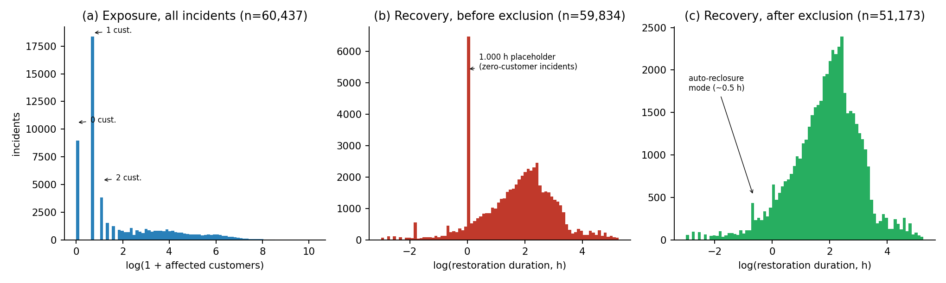
Figure 2. Outcome distributions on the log scale. (a) Exposure margin, all 60,437 incidents, with the spikes at zero, one and two affected customers marked. (b) Recovery margin before cleaning, showing the spike at exactly 1.000 h carried by zero-customer incidents. (c) Recovery margin after exclusion of zero-customer incidents (n = 51,173), with the automatic-reclosure mode near 0.5 h marked.

2.4 Analysis samples
UKPN records a cause code for every incident, grouped here into six categories (Supplementary A). Two — weather-related and asset-related — describe faults on the network itself; the other four (no fault found, third-party interference, human error, customer-side causes) are unrelated to wind by construction and are excluded, leaving 60,453 incidents. After weather matching and exclusion of incidents with missing regional covariates, the exposure sample contains 60,437 incidents. The recovery sample excludes incidents whose duration could not be computed or lay above the 99th percentile (59,834), and then the 8,661 zero-customer incidents described above, leaving 51,173.
Three samples are analysed. The all-incident samples just described pool weather- and asset-related faults; they are the operator's population of network faults. The weather-attributed samples restrict to incidents whose cause code names weather: 9,857 exposure incidents (16.3%) and 9,254 recovery incidents. The share of incidents attributed to weather rises steeply with gust, from 7% in the 0–4 m/s band to 91% above 30 m/s, so the two samples answer different questions: the all-incident sample describes what the network as a whole experiences at a given gust, the weather-attributed sample describes the weather-caused faults alone. Finally, a district-day panel is constructed for the fragility analysis in Section 3.5: all 121,656 combinations of the 111 districts and 1,096 days in the study period, of which 34.5% contain at least one incident and 5.0% a weather-attributed one.
Variance inflation factors for the continuous covariates in the final specifications are below 4 including the calendar effects (Supplementary A), so the covariate set is not collinear in the conventional sense [21]. The question of whether it over-fits is addressed by cross-validation rather than by VIFs (Section 3.3).

3. Methods

3.1 Regression framework
Both margins are modelled by ordinary least squares on a log-transformed outcome — log(1 + affected customers) for exposure and log(restoration duration in hours) for recovery — with weather covariates standardised on the training sample (gust, 24-h precipitation, temperature, mean sea-level pressure), unstandardised regional covariates, and additive year and month fixed effects. A log link keeps the multiplicative structure of the outcomes without the arbitrary scale of count or duration GLMs; negative-binomial, gamma and Tweedie alternatives were fitted and give the same gust coefficients in sign and significance (Supplementary H). Table 2 lists the covariates. The recovery model additionally includes log(1 + affected customers) and its square. We deliberately do not include district fixed effects. With 110 district dummies the model wins every in-sample criterion but is the worst of all candidates when whole districts are held out (cross-validated RMSE 2.10 against 1.99 for exposure and 1.50 against 1.27 for recovery), because a held-out district receives no intercept; the regional covariates capture the between-district variation that generalises.
Table 2. Covariates in the final specifications.
Variable | Category | Model
Gust speed (piecewise-linear for exposure; linear + squared for recovery) | Weather | Both
Gust × mean sea level pressure | Weather | Exposure
Gust × 24-h precipitation | Weather | Recovery
Mean sea level pressure; 24-h precipitation; temperature and its square | Weather | Both
Log population; income deprivation rate; local–national deprivation gap; Moran's I; urban–rural indicator | Regional (district) | Both
log(1+affected customers), linear and squared | Event | Recovery
Year and month fixed effects | Temporal | Both

3.2 Specification search and knot estimation
The functional form of the gust response is chosen by comparison rather than assumed. Starting from a linear-weather baseline, blocks of covariates are added in a nested ladder (gust², gust×pressure, regional, calendar) and then the gust term itself is replaced by alternatives: cubic, log-gust, step dummies at gust percentiles, and piecewise-linear forms with one or two knots. For the two-knot form a physical constraint is imposed and tested: because the number of customers affected cannot fall as gust rises, the slope beyond the second knot is fixed at zero, giving a three-segment response with a free slope below the onset, a ramp between the knots, and a plateau above (a two-parameter form). The unconstrained two-hinge form, with a free slope beyond the second knot, is fitted for comparison and the constraint tested by likelihood ratio. Candidates are compared on AIC, BIC and out-of-sample RMSE under three cross-validation schemes (Section 3.3). Table 3 summarises the comparison; the full ladder is in Supplementary C.
Knot locations are estimated, not chosen. For each margin and each piecewise form the residual sum of squares of the full covariate set is profiled over an exhaustive grid of knot positions in 1 m/s steps (single knot 8–30 m/s; pairs k₁ ∈ 8–20, k₂ ∈ 18–34, at least 4 m/s apart), in the spirit of segmented regression [27]. A likelihood-ratio test compares two knots against one, and a joint 95% profile region is the set of knot pairs whose likelihood-ratio statistic against the optimum is below the χ²₂ critical value. A district cluster bootstrap (500 resamples of whole districts with replacement, knots re-estimated each time) gives percentile intervals. A two-knot model is retained only if the second knot is significant at 1% and both bootstrap intervals are at most 6 m/s wide; otherwise the single profile-likelihood knot is used. Knots are re-estimated separately on the weather-attributed samples.
Table 3. Specification comparison for the gust functional form. ΔBIC relative to the best non-fixed-effects model; cross-validated RMSE with whole districts held out.
Specification (profile models use nested LAD CV) | Exposure ΔBIC versus best non-FE | Exposure CV RMSE | Recovery ΔBIC versus best non-FE | Recovery CV RMSE
Quadratic gust (M5) | +214.3 | 1.9887 | +17.6 | 1.2695
Cubic gust | +134.7 | 1.9871 | +21.7 | 1.2695
Log gust | +420.5 | 1.9923 | +384.0 | 1.2735
Gust percentile steps | +215.6 | 1.9882 | +155.8 | 1.2708
One free hinge (nested knot CV) | +118.3 | 1.9869 | +6.3 | 1.2695
Two free hinges (nested knot CV) | +85.0 | 1.9865 | +0.0 | 1.2694
E0 plateau plus temperature squared (nested knot CV) | +0.0 | 1.9850 | different sample | —
Quadratic plus LAD fixed effects | +125.1 | 2.1020 | +477.3 | 1.5039

3.3 Validation
Incidents on the same day and in the same district are not independent, so the primary validation holds out whole districts: five folds of 22–23 districts each, with all standardisation and knot selection repeated inside each training fold (nested cross-validation). A second scheme holds out whole years. A random incident-level split is reported for comparison only; it cannot detect the district-fixed-effects failure described in Section 3.1 and ranks that model best. The final specifications are also fitted separately on a development sample (1 April 2021 – 29 September 2023) and a confirmation sample (30 September 2023 – 31 March 2024), following the data-splitting logic of Cox [23]; the history of that split and of earlier modelling choices is in Supplementary E.

3.4 Inference
Standard errors are clustered by district and by date simultaneously [24, 29]. A single storm generates many incidents in one district on one day, and two-way clustering accommodates dependence along both dimensions; district-only clustering, which was the main inference in earlier work, understates the standard errors of the gust terms by a factor of 1.3–2.3. p-values use a t reference distribution with 110 degrees of freedom (the number of district clusters minus one).

3.5 District-day fragility
The regression models describe the size and duration of an outage conditional on one having occurred. A fragility function describes the probability that an outage of at least a given size occurs, and needs a denominator of exposure units rather than incidents. We define the exposure unit as a district-day and the damage states by the largest outage in the district on that day: any incident, more than 5, more than 100 and more than 1,000 customers, either from any cause or from a weather-attributed cause. The package of incident records contains no weather for district-days without incidents, so a daily district gust is interpolated to each district centroid from that day's incident-level gust observations by Gaussian-kernel inverse-distance weighting with a 40 km bandwidth (every date has at least 15 incidents in at least 13 districts, and incident gusts within a district-day vary by about 1.8 m/s). Leaving each district's own incidents out, the interpolated gust reproduces the observed district-day mean with RMSE 2.2 m/s, correlation 0.85 and no bias. This is a documented proxy for a gridded daily maximum, which would be preferable.
The fragility function is the lognormal form standard in earthquake and wind engineering [28, 30], augmented with a gust-independent background rate p₀ because technical faults occur in any weather: P(DS ≥ k | g) = p₀ + (1 − p₀)Φ((ln g − ln θ)/β), with median θ and dispersion β, fitted by binomial maximum likelihood on the 121,656 district-days. A gust × precipitation surface is fitted as a probit with an interaction term and log population as a covariate, and monotonicity in gust is checked numerically over the observed domain.

4. Results

4.1 The wind response is piecewise, not smooth
Figure 3 shows, for each margin, the mean residual of the full model fitted without any gust term, averaged within gust bands. These binned partial residuals owe nothing to a functional form and are the primary evidence for the shape of the response. For exposure the response is flat or slightly declining up to about 14 m/s, rises steeply between 16 and 26 m/s, and flattens above 26 m/s (band means 0.93, 1.03, 0.89 in the 23–26, 26–30 and 30–45 m/s bands). For recovery the response is flat to about 16 m/s and rises without an obvious plateau. Overlaid on the residuals are the quadratic, cubic and piecewise-linear fits. The quadratic misses the exposure response in both tails: it over-predicts by 0.3 log-units at 20–26 m/s and under-predicts by 0.8 above 30 m/s (Supplementary G), and its vertex at 10.8 m/s is pulled left of the empirical minimum (12–14 m/s) by the dense mass of calm-weather incidents. The cubic bends over but then predicts a decline. The piecewise forms show no residual bias in any band.
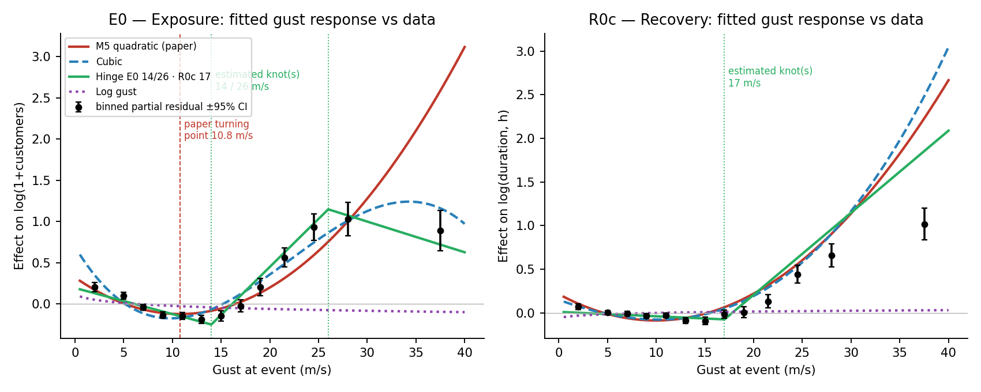
Figure 3. Wind response of the two margins, all incidents. Points: binned partial residuals (full model without gust terms) with 95% CI. Lines: fitted gust responses of the quadratic, cubic, piecewise-linear and log-gust specifications, shifted by a constant to the residual scale. Vertical lines: the vertex of the quadratic (10.8 m/s) and the estimated knots (14 and 25 m/s).
The knot estimation (Figure 4) makes this precise. For exposure an unconstrained two-hinge model at 14 and 26 m/s beats the quadratic by ΔBIC = −129 and the single-knot model by a likelihood ratio of 44 (p ≈ 2×10⁻¹⁰); its slope beyond the second knot is −0.155 against +0.146 below it, a net −0.009 ± 0.03 per m/s, indistinguishable from zero. Imposing the plateau — no change in affected customers beyond the second knot — is not rejected (likelihood ratio 1.5, p = 0.22), lowers BIC by a further 10 for one fewer parameter, and gives identical nested cross-validated error (1.9850 against 1.9851). The three-segment plateau form is therefore adopted, with knots re-profiled at 14 and 25 m/s: the onset knot is located at 13–14 m/s by the profile region and 13–15 m/s by the bootstrap; the plateau knot at 24–27 m/s and 24–28 m/s. Knots re-estimated inside each cross-validation fold fall at 13–14 and 24–28 m/s, and the nested-CV error of the plateau form (1.9850) improves on the quadratic (1.9872 with temperature²; 1.9887 without), so the gain survives selection without sight of the test districts. For recovery a second knot is nominally significant (p ≈ 2×10⁻⁴) but its first knot is not identified — the bootstrap interval spans 8–16 m/s — because the recovery response is flat below 17 m/s and there is nothing for a first knot to locate; a single knot at 17 m/s is BIC-preferred over the quadratic (Δ = −11) but gives identical out-of-fold error. The plateau form was also tested for recovery: its second knot lands at 33 m/s, at the edge of the search grid, with a bootstrap interval (29–34 m/s) that hits the boundary, and nested cross-validated error is indistinguishable from the quadratic (1.1501 against 1.1504); on weather-attributed incidents the same holds (knot 33 m/s, 1.2478 against 1.2476). Restoration time therefore rises through the observed gust range and any flattening lies above 30 m/s, where the record is too thin to locate it. The quadratic is therefore retained for recovery and the plateau form adopted for exposure.
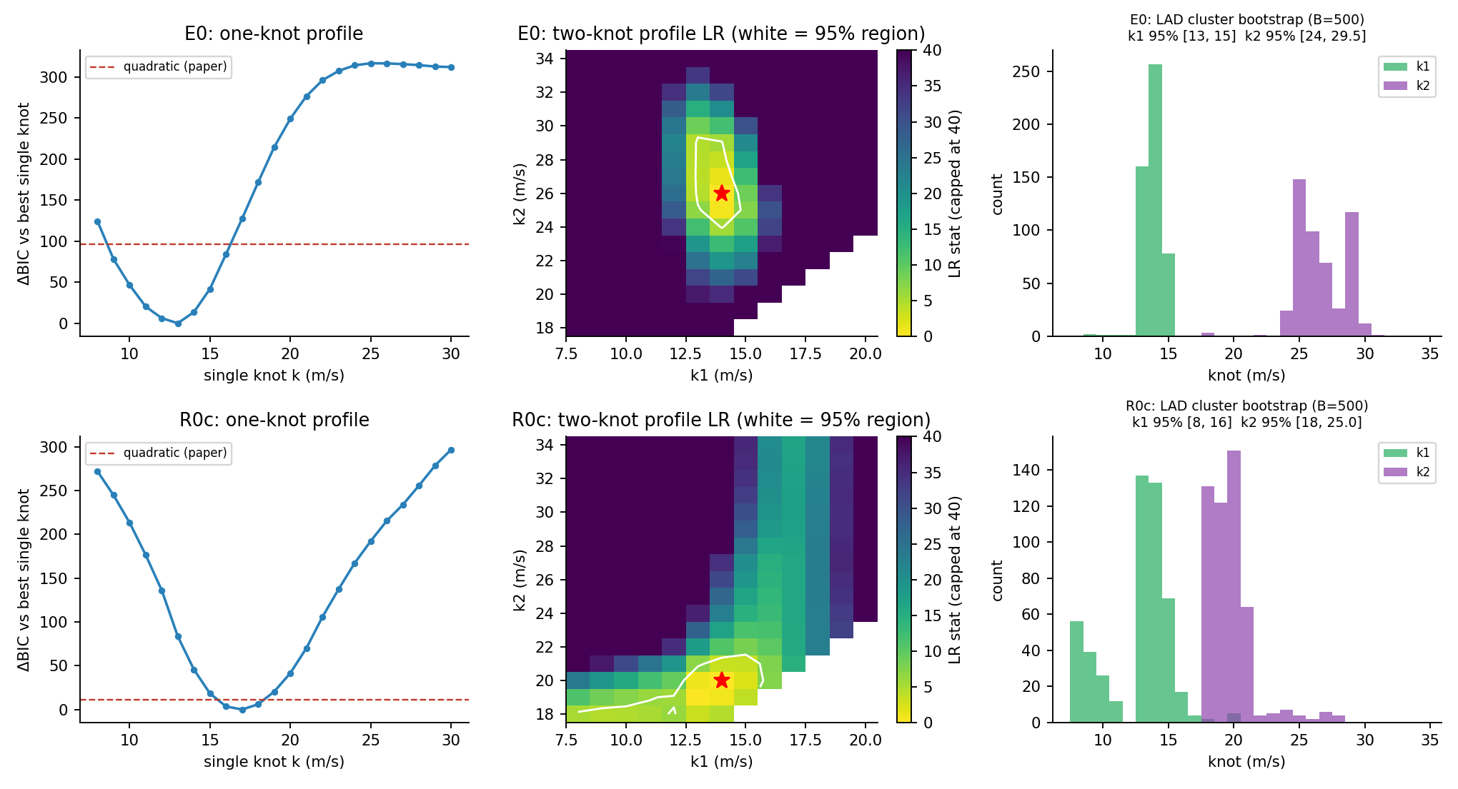
Figure 4. Knot estimation. Left: BIC profile for a single knot with the quadratic as reference. Centre: likelihood-ratio surface for two knots; white contour is the joint 95% region and the star the optimum. Right: district-bootstrap distributions of the two knots (B = 500; unconstrained two-hinge form, for which the second knot is 26 m/s; the plateau form re-profiles it at 25 m/s with bootstrap interval 24–28 m/s).
Table 4 reports the final specifications with two-way clustered inference. The exposure model adds temperature² (both cold and hot extremes raise affected customers) to the plateau gust response and retains gust × pressure, which is marginal (p = 0.0288). Below the onset affected customers decline slightly with gust (-0.0270 per m/s), the composition effect of technical faults at calm winds; between 14 and 25 m/s they rise by 0.1215 log-units, about 13%, per m/s of gust, a factor of 3.8 across the ramp; above 25 m/s they are constant by construction, and the data do not object. The recovery model drops gust × pressure, which is not significant in any specification, and adds temperature² and gust × precipitation; the latter is negative — wet storms are restored faster, an effect that recurs in the fragility surfaces of Section 4.4. Relative to the previous quadratic specifications the final models improve adjusted R² from 0.0336 to 0.0372 (exposure) and 0.1119 to 0.1124 (recovery, same cleaned sample), and district-grouped CV RMSE from 1.9887 to 1.9848 and 1.1506 to 1.1503. Figure 5 shows the final gust responses with their two-way 95% bands and the out-of-fold calibration of final against previous models.
Table 4. Final specifications, all incidents: weather and customer terms. Full coefficient tables in Supplementary F.
Margin | Term | Coef. | SE (district) | SE (district×date) | p (two-way, t₁₁₀)
E0 | Temperature (z) | -0.0341 | 0.0194 | 0.0288 | 0.239
E0 | Gust × pressure | -0.0349 | 0.0080 | 0.0158 | 0.0288
E0 | Temperature squared (z²) | 0.0566 | 0.0079 | 0.0221 | 0.0117
E0 | Gust below 14 m/s (per m/s) | -0.0270 | 0.0030 | 0.0044 | 1.76e-08
E0 | Gust ramp 14–25 m/s (per m/s; constant above 25) | 0.1215 | 0.0072 | 0.0138 | 2.48e-14
R0c | Gust (linear, z) | -0.0002 | 0.0085 | 0.0192 | 0.99
R0c | Temperature (z) | -0.0724 | 0.0093 | 0.0190 | 0.000238
R0c | Gust squared (z²) | 0.0810 | 0.0046 | 0.0074 | 3e-19
R0c | log(1+customers) (z) | -0.1964 | 0.0165 | 0.0171 | 1.33e-20
R0c | log(1+customers) squared | -0.1113 | 0.0137 | 0.0155 | 8.6e-11
R0c | Temperature squared (z²) | 0.0168 | 0.0038 | 0.0058 | 0.00474
R0c | Gust × precipitation | -0.0245 | 0.0063 | 0.0100 | 0.016
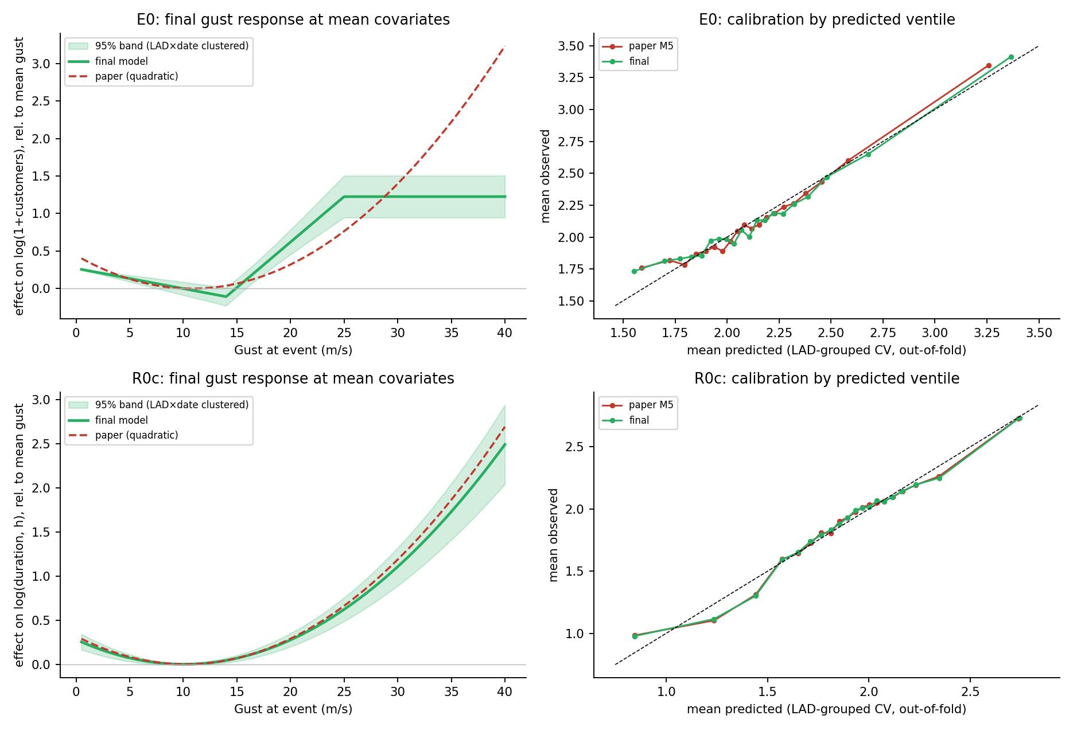
Figure 5. Final models. Left: gust response at mean covariates with district×date-clustered 95% bands, against the previous quadratic. Right: mean observed against mean out-of-fold predicted value within predicted-value ventiles under district-grouped cross-validation, final and previous specifications.
Two features of the recovery model deserve comment. On the cleaned sample the customer-count terms are both negative (Table 4): among incidents that interrupted someone, larger incidents are restored proportionally faster, consistent with dispatch prioritisation and contrary to the independence reported for US utilities [26]. And the calibration of the recovery model is now clean across its range (Figure 5, lower right); the systematic over-prediction of the shortest events reported in an earlier version of this analysis was entirely due to the placeholder rows.

4.2 The same response among weather-attributed incidents
Restricting to incidents the operator attributes to weather removes the composition effect — the rising share of weather faults with gust — and asks what the weather faults themselves do. Figure 6 and Table 5 give the answer. For exposure the response is V-shaped. Weather incidents at 0–6 m/s are lightning, flooding and snow events: large, but not wind-driven, so gust is the wrong intensity measure for them. The response falls to a minimum at 11 m/s (knots re-profiled on the subsample: 11 and 24 m/s; second-knot p ≈ 2×10⁻⁷) and rises at 0.0785 log-units per m/s to 24 m/s. That is about two-thirds of the pooled ramp slope (0.121), so roughly two-thirds of the pooled rise in affected customers between the onset and the plateau is the vulnerability of weather-caused faults and one-third is composition, the rising share of weather faults with gust; composition also shifts the pooled onset from 11 to 14 m/s, because the technical-fault mass pulls the first knot to the right. The plateau constraint is marginally rejected on this subsample (p = 0.011), entirely because of the 30–45 m/s band, which holds about 300 weather incidents and sits below the plateau with a wide interval; the constraint is imposed on physical grounds and the unconstrained fit is given in Supplementary C. The quadratic is mis-specified on this sample — gust² has p = 0.52 while the linear term is positive — because it is trying to fit a V, which is why an earlier analysis found a "physically impossible" turning point here. Temperature² is much stronger among weather incidents (0.0928, p < 10⁻⁴), consistent with cold-snap and heat-wave incidents sitting in the calm-wind part of the subsample.
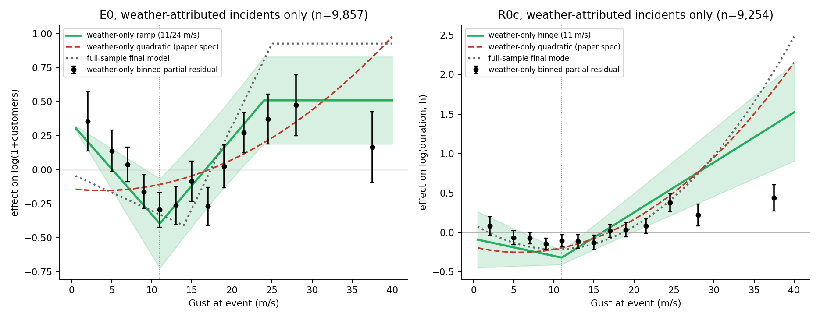
Figure 6. Wind response on weather-attributed incidents only. Black: binned partial residuals with 95% CI. Green: three-segment plateau fit with knots re-profiled on the subsample and two-way clustered 95% band. Red dashed: quadratic on the same subsample. Grey dotted: the all-incident final model, for comparison.
Table 5. Final specifications fitted to weather-attributed incidents only: weather and customer terms.
Margin | Term | Coef. | SE (district×date) | p (t₁₁₀)
E0 | Temperature (z) | 0.0272 | 0.0690 | 0.694
E0 | Gust × pressure | -0.0865 | 0.0340 | 0.0123
E0 | Gust below 11 m/s (per m/s) | -0.0595 | 0.0153 | 0.000175
E0 | Gust ramp 11–24 m/s (per m/s; constant above 24) | 0.0785 | 0.0100 | 3.24e-12
E0 | Temperature squared (z²) | 0.0928 | 0.0189 | 3.31e-06
R0c | Gust (linear, z) | -0.0545 | 0.0890 | 0.542
R0c | Temperature (z) | -0.1337 | 0.0634 | 0.0374
R0c | log(1+customers) (z) | -0.2948 | 0.0306 | 4.82e-16
R0c | log(1+customers) squared | 0.0923 | 0.0276 | 0.00116
R0c | gust_hinge_11 | 0.0696 | 0.0185 | 0.000286
R0c | Temperature squared (z²) | 0.0641 | 0.0153 | 5.59e-05
R0c | Gust × precipitation | -0.0562 | 0.0219 | 0.0117
Recovery time behaves differently. It is far more predictable among weather incidents — adjusted R² 0.29 against 0.11 on all incidents — because the technical-fault noise is removed and because storm timing is absorbed by the calendar effects. The quadratic and a single hinge at 11 m/s are equivalent, gust × precipitation is again negative (-0.0562, p = 0.0117), and the binned residuals flatten above about 25 m/s in a way neither smooth form captures; with about 900 weather incidents above 26 m/s this is suggestive of the same saturation seen for exposure rather than established.

4.3 How much wind explains
The results so far establish the shape of the wind response. They do not say how much of the variation in outcomes wind accounts for, and the two questions have different answers. Table 6 and Figure 7 decompose the out-of-sample R² of the final specifications, under district-grouped cross-validation, by adding blocks of covariates in sequence: regional and calendar effects, non-gust weather, gust, and (recovery only) affected customers. On all incidents gust contributes 1.49 percentage points to the exposure margin out of a total of 3.36%, and 0.70 points to the recovery margin, where affected customers contributes 5.97 points and the total is 10.74%. Among weather-attributed incidents the total rises to 4.43% for exposure and 28.12% for recovery, and gust's contribution rises to 1.56 and 1.88 points. For the recovery margin the ordering of gust and affected customers is reversed relative to their pooled values once only weather incidents are considered, but the largest single block on the weather sample is the calendar effects (20.18 points), which absorb storm timing: restoration times during the named storms are long for reasons — crew competition, access, sequential faults — that the month dummies pick up and the weather covariates do not.
Table 6. Marginal out-of-sample R² (percentage points) by variable group, final specifications, district-grouped cross-validation.
Variable group | Exposure, all (pp) | Exposure, weather-attributed (pp) | Recovery, all (pp) | Recovery, weather-attributed (pp)
Regional + calendar | 0.96 | 0.78 | 3.46 | 20.18
Non-gust weather | 0.91 | 2.08 | 0.61 | 2.53
Gust | 1.49 | 1.56 | 0.70 | 1.88
Affected customers | — | — | 5.97 | 3.54
Total out-of-sample R² | 3.36 | 4.43 | 10.74 | 28.12
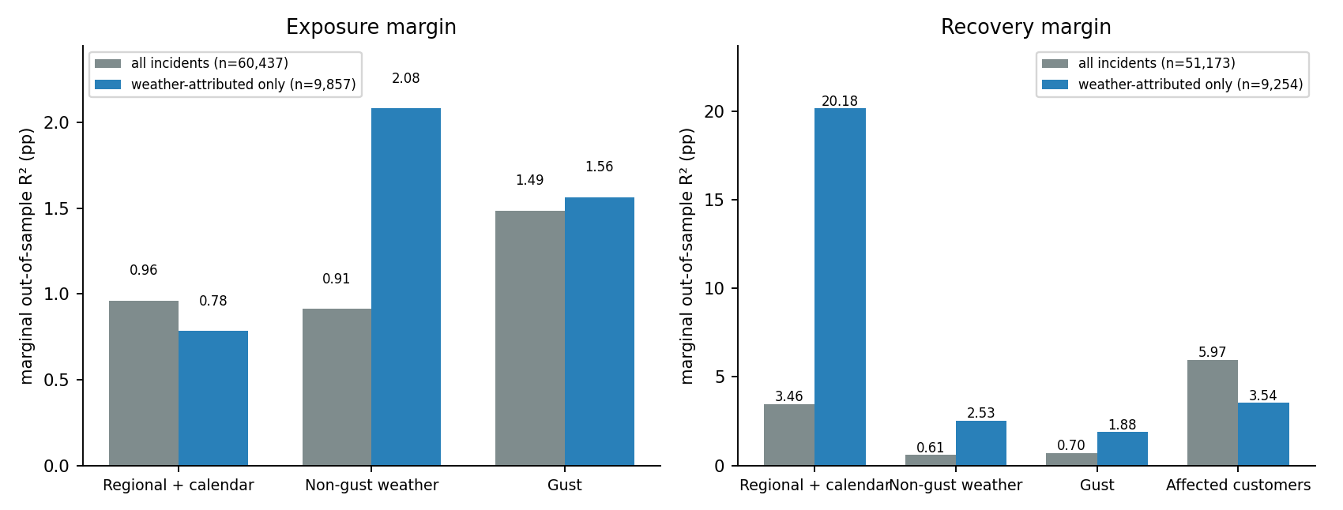
Figure 7. Marginal out-of-sample R² by variable group, both margins and both samples.
The conclusion is the one earlier work reached with different numbers: wind has a real and sharply nonlinear effect on outage size, but the size of an individual outage is dominated by factors outside the record — network configuration, asset condition, protection settings. The models in Sections 4.1–4.2 estimate the shape of the weather response, not the size of outages. The quantity that wind does predict well is the one the next section estimates.

4.4 A district-day fragility function
The exposure regressions are severity-given-occurrence models, and Section 4.2 shows why their exceedance probabilities cannot be read as fragility curves: conditional on an incident, the probability of exceeding 100 customers is 0.40 at calm winds, 0.29 at 12–18 m/s and 0.48 above 23 m/s, a V rather than a monotone function, because the calm-wind incidents are large non-wind events (Supplementary H gives the incident-level lognormal fits, which degenerate for exposure). The district-day panel changes the denominator from incidents to exposure units and gives a fragility function in the proper sense. Figure 8 shows it and Table 7 gives the parameters.
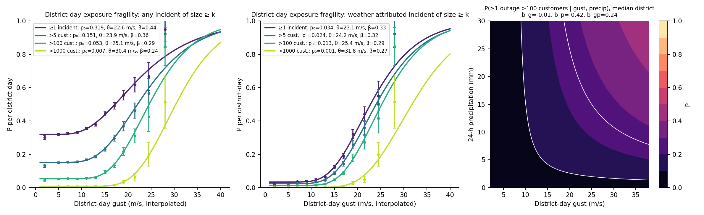
Figure 8. District-day exposure fragility. Left: probability that a district experiences at least one incident of the given size on a day, any cause. Centre: the same for weather-attributed incidents. Points: empirical frequencies by gust band with 95% CI; lines: background-rate lognormal fits. Right: probability of at least one outage above 100 customers as a function of gust and 24-h precipitation, at the median district (probit with interaction; white contours at 0.1, 0.25, 0.5).
Table 7. Background-rate lognormal fragility parameters per district-day, P = p₀ + (1 − p₀)Φ((ln g − ln θ)/β).
Size threshold | Occurrence | Base rate | p₀ | θ (m/s) | β
≥1 incident | any cause | 0.345 | 0.319 | 22.6 | 0.44
>5 cust. | any cause | 0.167 | 0.151 | 23.9 | 0.36
>100 cust. | any cause | 0.061 | 0.053 | 25.1 | 0.29
>1000 cust. | any cause | 0.008 | 0.007 | 30.4 | 0.24
≥1 incident | weather-attributed | 0.050 | 0.034 | 23.1 | 0.33
>5 cust. | weather-attributed | 0.036 | 0.024 | 24.2 | 0.32
>100 cust. | weather-attributed | 0.020 | 0.013 | 25.4 | 0.29
>1000 cust. | weather-attributed | 0.003 | 0.001 | 31.8 | 0.27
Three results. First, the empirical frequencies are monotone in gust, as a fragility should be, and the background-rate lognormal fits them closely; a plain lognormal without p₀ underfits badly because technical faults occur in any weather. Second, the medians are tightly grouped: θ = 22.6, 23.9 and 25.1 m/s for any incident, more than 5 and more than 100 customers, and 30.4 m/s for more than 1,000, with β between 0.24 and 0.44. The network's weather response switches on at about 23 m/s (Beaufort 9) whatever the size threshold, and the thresholds differ mainly in their floors, which reproduce the technical-fault base rates almost exactly (p₀ = 0.319 against a base rate of 0.345 for any incident; 0.053 against 0.061 for more than 100). Third, the weather-attributed curves for at least one, more than 5 and more than 100 customers nearly coincide (θ = 23.1, 24.2, 25.4 m/s): once a storm produces a weather outage in a district, that outage is usually large, which is the network-level counterpart of the flat-then-rising incident-level curves of Section 4.2. The plateau knot of the incident-level exposure model, 25 m/s, sits where the district-day curves pass through P ≈ 0.5: beyond it most districts already have an outage and the marginal incident adds little to the count.
The gust × precipitation surface (Figure 8, right) is monotone in gust over 99% of the observed domain, and precipitation attenuates the wind effect: at a given gust, wet days have a lower probability of a large outage than dry ones. The same sign appears in the recovery regressions (Section 4.1). Whether this reflects lower conductor loading in rain-bearing systems, better forecasting of wet storms, or a difference in the type of storm (convective versus frontal) cannot be resolved from these data.

4.5 Storm-period and temporal checks
Seven named storms — Arwen, Dudley, Eunice, Franklin, Babet, Ciarán and Henk — fall within the study period and span 27 days, 2.5% of the period, during which 8.2% of incidents and 14.7% of affected customers occurred. Predictions of the final models for the storm-period incidents (Supplementary I, reproducing the earlier storm-by-storm comparison) show the pattern expected from Section 4.3: the exposure model tracks the mean but not individual incidents, and the recovery model's fitted–observed correlation across all seven storms is positive and significant within the duration range it was fitted to. The independent temporal check is more informative with the piecewise specification than it was with the quadratic (Table 8). Fitted separately on the development and confirmation samples, the ramp slope of the exposure margin is 0.100 ± 0.014 and 0.149 ± 0.020 log-units per m/s — higher in the confirmation sample, which is a single autumn and winter and contains the storms Babet, Ciarán and Henk, but of the same order and the same sign — and the recovery quadratic term is 0.075 and 0.087. The instability of the quadratic's turning point between these two samples, which occupied a substantial part of the earlier analysis, does not arise for the plateau form because no ratio of coefficients is involved.
Table 8. Gust terms of the final specifications fitted separately on the development and confirmation samples (two-way clustered SE in parentheses).
Term | Development (Apr 2021–Sep 2023) | Confirmation (Oct 2023–Mar 2024) | Combined
Exposure: gust below 14 m/s (per m/s) | -0.031 (0.005) | -0.025 (0.010) | -0.027 (0.004)
Exposure: gust ramp 14–25 m/s (per m/s) | 0.100 (0.014) | 0.149 (0.020) | 0.121 (0.014)
Recovery: gust squared | 0.075 (0.008) | 0.087 (0.015) | 0.081 (0.007)
n (exposure / recovery) | 48,324 / 41,177 | 12,113 / 9,996 | 60,437 / 51,173

5. Discussion

5.1 Two operational numbers
The exposure margin has an onset at 14 m/s and a plateau from 25 m/s, both estimated with intervals rather than chosen, and both stable under district-grouped resampling, nested cross-validation and an independent temporal split. Between them, affected customers rise by about 13% per m/s of gust, a factor of 3.8 across the ramp; beyond 25 m/s they do not rise further, a constraint the unconstrained fit does not reject and physics requires. The onset corresponds to the top of Beaufort force 6 to 7 — the wind at which loose material, small branches and unsecured objects begin to move — and the plateau to Beaufort 10, storm force. Below the onset, wind is not what determines the size of an outage; above the plateau knot, the count of customers affected in a district is bounded by network topology and further gust does not increase it, even though restoration time keeps growing. An earlier version of this analysis reported a critical wind speed of 10.8 m/s from a quadratic fit. That number is the vertex of a parabola forced through a response with a floor and a plateau, and its movement between samples — which prompted extensive discussion of turning-point confidence intervals — was a symptom of mis-specification rather than of a fragile finding. We recommend that neither it nor any quadratic turning point be used as a planning reference.

5.2 Composition and vulnerability
The share of incidents attributed to weather rises from 7% at calm to 91% above 30 m/s, so any pooled analysis of outage records mixes a changing cause composition with the vulnerability of the network to wind. Two results separate them. The weather-attributed incidents alone show two-thirds of the pooled ramp slope, so most of the rise is vulnerability and the rest composition; and the district-day fragility function has a floor exactly equal to the technical-fault rate, so the composition is captured by p₀ and the lognormal term is the weather-driven part. The calm-wind weather incidents — lightning, flooding, snow — are the one group for which gust is simply the wrong intensity measure, and they are what makes the incident-conditional exceedance V-shaped.

5.3 Relation to structure-level fragility curves
The introduction cited fragility curves for transmission towers and distribution poles derived from simulation and testing [7–10], which express the probability of failure of a single component as a lognormal function of wind speed. The district-day function estimated here has the same form and can be read alongside them: a median gust of 23–25 m/s for an outage of up to 100 customers in a district on a day, dispersion 0.3, and a floor for non-weather faults. Its median is well below the medians typically reported for the structural failure of individual poles or towers, which is as it should be: a district contains thousands of spans, conductors, insulators and vegetation-clearance margins, any one of which can fail, so the network-level median is an extreme-value quantity of the component distribution. The function is directly usable in a hazard-consistent risk calculation — convolved with a district gust hazard curve it gives the annual frequency of an outage of a given size per district — which the incident-level regressions are not.

5.4 Restoration time
Restoration time rises smoothly with the square of standardised gust, from about 5 hours at mean gust to 12 hours at 30 m/s at mean covariates, and is much better predicted among weather incidents (R² 0.28) than overall (0.11). Unlike affected customers it does not plateau within the observed range: a three-segment fit places the upper knot at 33 m/s, at the edge of the data, with no improvement in out-of-sample error. The asymmetry is physical — customer count is bounded by network topology once most districts have an outage, whereas restoration time is bounded by crew capacity and access, which bind only in the most extreme storms — and the district-day fragilities show the same contrast, the exposure curves crossing P = 0.5 at 25 m/s while the ≥ 12 h and ≥ 48 h restoration curves keep rising to 40 m/s. Three secondary findings bear on operations. Larger incidents are restored proportionally faster once the placeholder rows are removed, consistent with dispatch prioritisation and contrary to the independence found for US utilities [26]. Wet storms are restored faster than dry ones at the same gust. And the low mode of the duration distribution, at 30–35 minutes, is automatic reclosure; weather alone cannot separate those faults from sustained ones, and a reclosure flag, if the operator's records carry one, would be the single most useful addition to the recovery model.

5.5 Limitations and further work
The district gust used for the fragility function is interpolated from the incident locations of the same day; it is validated against held-out districts (RMSE 2.2 m/s, r = 0.85) but a gridded daily maximum from the reanalysis would remove the dependence on incident coverage and should replace it. The incident-level models use public weather and demographic covariates and no asset information — age, material, construction type, vegetation management — any of which could explain more of the variation in outage size than the covariates used here. The confirmation sample covers six months of a single autumn and winter. The fragility function is estimated for a single DNO over three years and the curve above 30 m/s rests on a few hundred district-days; its extension to other networks is a question of transferability that the method, but not the numbers, supports. Finally, the models describe conditional associations in operational records, not mechanisms: connecting the onset, the plateau and the rain attenuation to specific physical or operational processes is the natural next step, as is the convolution of the fragility function with a district-level gust hazard to produce annual exceedance frequencies.
The approach — reconstructing event-level outcomes from stage-level regulatory records, estimating rather than assuming the shape of the weather response, and moving from incidents to exposure units to obtain a fragility function — is not specific to UKPN and can be applied to any distribution operator that reports at stage level under a comparable framework.

Data and code availability
The analysis samples, the district-day panel and all scripts (specification search, knot estimation, final models, weather-attributed regressions, fragility fitting, figure generation) are provided in the accompanying package STST2603_review. [Deposit DOI to be added.]

Supplementary Information (contents)
- A. Data dictionary, cause-code grouping, covariate distributions and VIFs
- B. Outcome-construction pipeline and the rejected customer-weighted duration
- C. Full specification ladder, both samples (12 specifications × 2 margins), with AIC, BIC and three cross-validation schemes
- D. Knot profiles, bootstrap distributions and nested-CV fold knots
- E. Development/confirmation split history
- F. Full coefficient tables, district-only and two-way clustered
- G. Predicted-versus-observed and calibration figures; residual bias by gust band
- H. Alternative links (negative binomial, gamma, Tweedie), ordinal-logit and incident-level lognormal exceedance curves, and why they are not fragility functions
- I. Storm-by-storm predicted-versus-observed comparison

References
[1] Institute for Government. Energy resilience [Internet]. [date unverified]. Available from: https://www.instituteforgovernment.org.uk/explainer/energy-resilience
[2] Ofgem. Storm Arwen report [Internet]. [title, date unverified]. Available from: https://www.ofgem.gov.uk/research/storm-arwen-report
[3] Guikema SD, Quiring SM, Han SR. Prestorm estimation of hurricane damage to electric power distribution systems. Risk Analysis. 2010;30(12):1744-1752.
[4] Liu H, Davidson RA, Apanasovich TV. Statistical forecasting of electric power restoration times in hurricanes and ice storms. IEEE Transactions on Power Systems. 2007;22(4):2270-2279.
[5] Nateghi R, Guikema SD, Quiring SM. Comparison and validation of statistical methods for predicting power outage durations in the event of hurricanes. Risk Analysis. 2011. [volume, pages unverified]
[6] Mukherjee S, Nateghi R, Hastak M. A multi-hazard approach to assess severe weather-induced major power outage risks in the U.S. Reliability Engineering & System Safety. 2018;175:283-305.
[7] Dikshit S, Alipour A. Characterizing probability of failure of transmission tower systems under multiple climatic hazards: wind and ice. Engineering Structures. 2025;342:120720.
[8] Zhu X, Ou G. Wind fragility modeling of transmission tower-line system based on threat-dependent structural robustness index. Structural Safety. 2025;114:102571.
[9] Ma L, Khazaali M, Bocchini P. Component-based fragility analysis of transmission towers subjected to hurricane wind load. Engineering Structures. 2021;242:112586.
[10] Kabre WW, Weimar MR. Fragility functions resource report: documented sources for electricity and water resilience valuation. PNNL-33587. Richland (WA): Pacific Northwest National Laboratory; 2022.
[11] Office of Gas and Electricity Markets. RIIO-ED1 regulatory instructions and guidance: Annex F. London: Ofgem. [date unverified].
[12] Office of Gas and Electricity Markets. RIIO-ED2 regulatory instructions and guidance: Annex F – interruptions. London: Ofgem; 2023.
[13] Open-Meteo. Historical weather API [Internet]. [date unverified]. Available from: [URL unverified]
[14] Hersbach H, Bell B, Berrisford P, Hirahara S, Horanyi A, Munoz-Sabater J, et al. The ERA5 global reanalysis. Quarterly Journal of the Royal Meteorological Society. 2020;146:1999-2049.
[15] American Society of Civil Engineers. Minimum design loads and associated criteria for buildings and other structures. ASCE/SEI 7. [edition unverified].
[16] [authors unverified]. The risk of cascading failures in electrical grids triggered by extreme weather events. arXiv:2107.00829. [publication status unverified].
[17] Office for National Statistics. Explore local statistics [Internet]. 2025. Available from: [URL unverified]
[18] Office for National Statistics. Mapping income deprivation at a local authority level [Internet]. 2021. Available from: [URL unverified]
[19] Moran PAP. Notes on continuous stochastic phenomena. Biometrika. 1950;37(1-2):17-23.
[20] Office for National Statistics. Local Authority Districts (December 2021) boundaries UK BGC [Internet]. Available from: https://open-geography-portalx-ons.hub.arcgis.com/datasets/ons::local-authority-districts-december-2021-boundaries-uk-bgc
[21] O’Brien RM. A caution regarding rules of thumb for variance inflation factors. Quality & Quantity. 2007;41(5):673-690.
[22] McCullagh P, Nelder JA. Generalized linear models. 2nd ed. London: Chapman and Hall; 1989.
[23] Cox DR. A note on data-splitting for the evaluation of significance levels. Biometrika. 1975;62(2):441-444.
[24] Cameron AC, Miller DL. A practitioner’s guide to cluster-robust inference. Journal of Human Resources. 2015;50(2):317-372.
[25] Oehlert GW. A note on the delta method. The American Statistician. 1992;46(1):27-29.
[26] Wu H, Meng X, Danziger MM, Cornelius SP, Tian H, Barabási AL. Fragmentation of outage clusters during the recovery of power distribution grids. Nature Communications. 2022;13:7372.
[27] Muggeo VMR. Estimating regression models with unknown break-points. Statistics in Medicine. 2003;22(19):3055-3071.
[28] Baker JW. Efficient analytical fragility function fitting using dynamic structural analysis. Earthquake Spectra. 2015;31(1):579-599.
[29] Cameron AC, Gelbach JB, Miller DL. Robust inference with multiway clustering. Journal of Business & Economic Statistics. 2011;29(2):238-249.
[30] Porter K, Kennedy R, Bachman R. Creating fragility functions for performance-based earthquake engineering. Earthquake Spectra. 2007;23(2):471-489.

