STST2603 — Model exploration: predicted vs observed
Reproduction draft generated independently from the project samples. Tables and inserted analysis figures come from this run. The inherited narrative is a historical review template: its hand-entered numbers, causal interpretations and literature claims require revision against the computed results before publication.
Exposure (E0) and recovery (R0c) margins of the UK Power Networks weather-outage models. Companion to MODEL_SELECTION_REPORT.md; figures generated by code/plot_model_selection.py from the supplied final samples (E0 n = 60,437; R0c n = 59,834).

1. Setup
Seven specifications are compared per margin. All share the paper's covariates (24-h precipitation, temperature, MSL pressure, urban flag, log population, income deprivation, deprivation gap, Moran's I, year and month dummies; plus log customers and its square for R0c) and differ only in the gust functional form or in the inclusion of district fixed effects:
- M1 linear — gust enters linearly (no quadratic, no interaction, no socio-economic covariates, no fixed effects): a floor for comparison.
- M5 quadratic (paper) — the published specification: gust + gust² + gust×pressure, socio-economic block, year/month fixed effects.
- Cubic — M5 plus gust³.
- Log gust — M5 with log(1+gust) replacing gust and gust².
- Gust bins — M5 with step dummies at the 50th/75th/90th/97th gust percentiles (9.0, 12.5, 16.8, 22.5 m/s) replacing gust and gust².
- Hinge — M5 with piecewise-linear gust: linear term plus max(gust−14, 0) and max(gust−26, 0) for E0; linear plus max(gust−17, 0) for R0c. Knots estimated by profile likelihood with bootstrap and nested-CV checks (Section 4).
- M5 + LAD FE — M5 plus 110 district dummies (shown as a cautionary case).
Predictions are reported two ways: in-sample (fitted values) and out-of-fold under 5-fold cross-validation in which whole local authority districts are held out, so each district is predicted by a model that has never seen it. This is the relevant test for a spatial panel; the package's own cv_fold_v3 is a random row split and is shown in Figure 1 for comparison only.

2. Model comparison
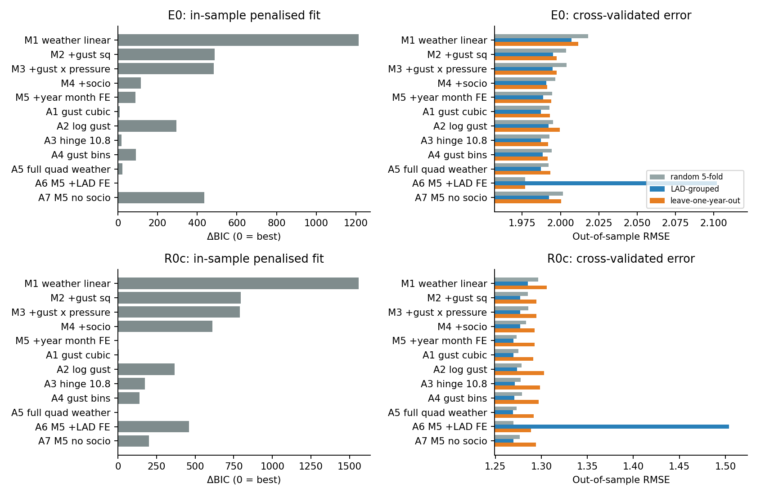
Figure 1. Left: ΔBIC relative to the best specification (red = best). Right: out-of-sample RMSE under random 5-fold, LAD-grouped and leave-one-year-out cross-validation. Note the compressed x-axis on the right: differences are small in absolute terms but consistent in rank.
The nested ladder confirms the paper's building blocks: gust² is essential in both margins (ΔBIC ≈ −720 / −760), the socio-economic block and year/month effects both lower BIC without hurting spatial CV. Log-gust is rejected outright. District fixed effects dominate every in-sample criterion and are the worst model under LAD-grouped validation — held-out districts receive no intercept, so the model collapses to roughly the grand mean (calibration slope 0.25 for E0, 0.33 for R0c in Table 1). The random-fold CV cannot detect this; it ranks LAD FE best.

3. What the gust response looks like
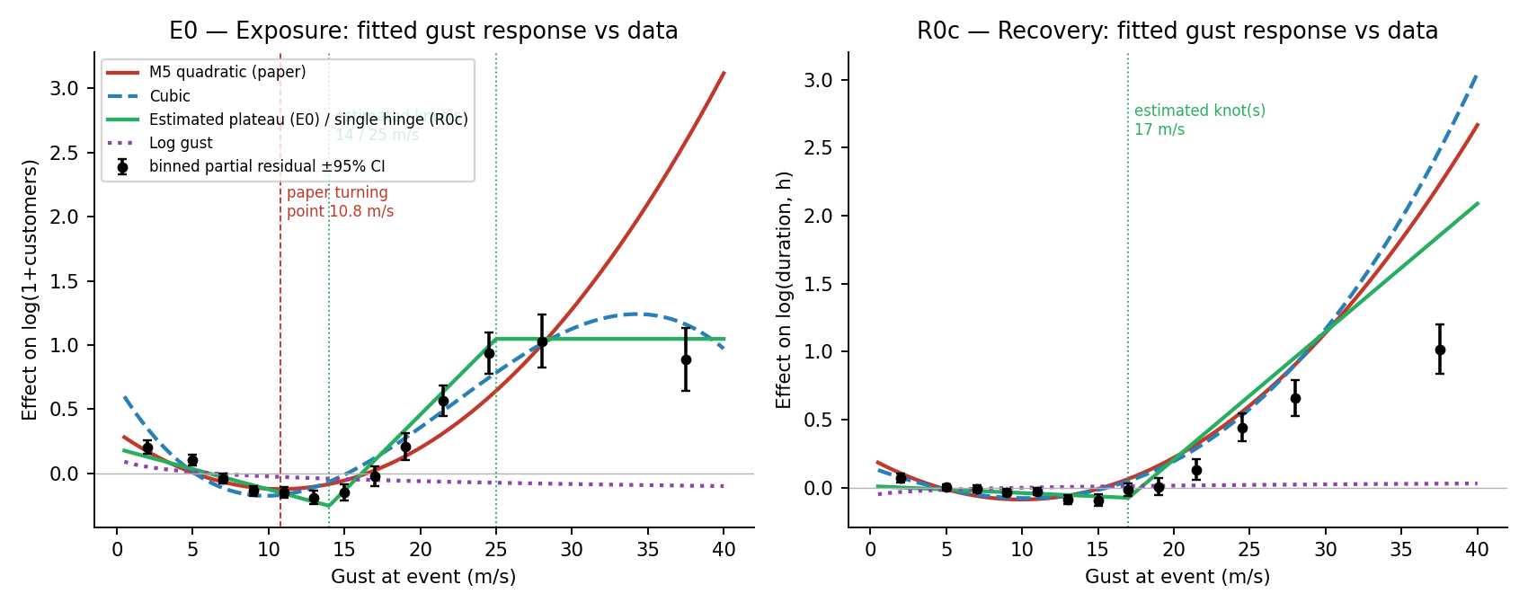
Figure 2. Fitted gust response of four specifications overlaid on binned partial residuals (M5 fitted without any gust term, residuals averaged within gust bands, 95% CI). Curves are shifted by a constant so they are comparable with the residuals. Vertical lines: the paper's turning point (10.8 m/s) and the estimated hinge knots.
Three features of the data are visible that the quadratic cannot reproduce. First, the minimum of the exposure response lies at 12–14 m/s, not 10.8 m/s: the parabola's vertex is pulled left by the dense mass of calm-weather incidents, so the turning point reported in the paper is a property of the parabola rather than of the data. Second, exposure saturates above roughly 26 m/s (binned values 0.93, 1.03, 0.89), while the parabola keeps rising to +3 at 40 m/s; the cubic bends over but then predicts a decline. Third, recovery time does not saturate — or at least not until the sparsely populated 30–45 m/s band — so the two margins have different shapes at the extreme, which is physically sensible: the number of customers affected is bounded by network topology, whereas restoration time keeps growing with damage extent. Below the minimum, both responses fall with gust, consistent with calm-weather incidents being small, quickly repaired technical-asset faults.

4. Where the knots come from
The knots are estimated, not chosen. For each margin the full M5 covariate set is kept and gust enters as a linear term plus one or two hinges max(gust−k, 0); the residual sum of squares is minimised over an exhaustive grid of knot locations in 1 m/s steps (single knot 8–30 m/s; knot pairs k1 ∈ 8–20, k2 ∈ 18–34, at least 4 m/s apart). Uncertainty comes from two sources: a profile-likelihood 95% region (knot pairs whose likelihood-ratio statistic against the optimum is below the χ²₂ critical value) and a district cluster bootstrap (500 resamples of whole LADs with replacement, knots re-estimated each time). Finally a nested LAD-grouped cross-validation re-selects the knots inside each training fold, so that the reported out-of-fold error does not benefit from having seen the test districts when the knots were chosen.
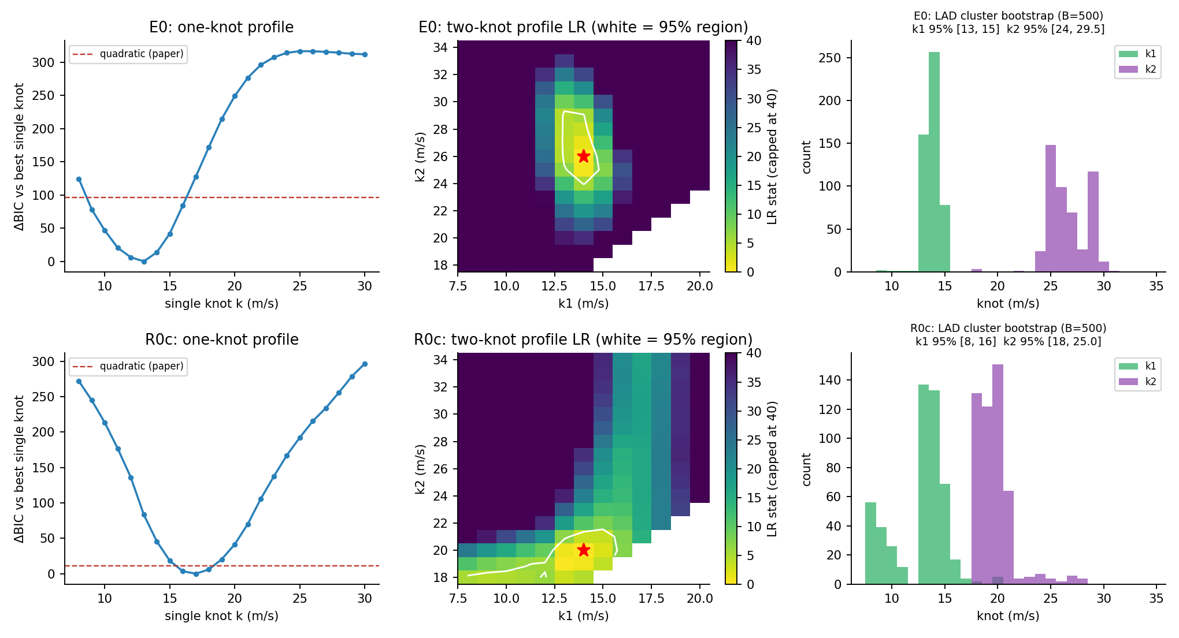
Figure 3. Knot estimation. Left: BIC profile for a single knot, with the paper's quadratic as reference. Centre: likelihood-ratio surface for two knots; the white contour is the joint 95% region, the star the optimum. Right: bootstrap distributions of the two knots.
For exposure the answer is unambiguous. The two-knot model at 14 and 26 m/s beats the quadratic by ΔBIC = −129 and the single-knot model by a likelihood ratio of 44 (p ≈ 2×10⁻¹⁰). The onset knot is pinned to 13–15 m/s and the saturation knot to 24–29.5 m/s by both the profile region and the bootstrap; knots re-selected in each CV fold fall at 13–14 and 25–29 m/s; and the nested-CV RMSE (1.9865) still improves on the quadratic (1.9887), so the gain survives honest selection.
For recovery the picture is different and worth stating plainly. A second knot is nominally significant (LR = 17, p ≈ 2×10⁻⁴) but the first knot is not identified: its bootstrap interval spans 8–16 m/s and the fold-by-fold choices range from 8 to 15 m/s, because the recovery response is essentially flat below 17 m/s and there is nothing for a first knot to locate. The single knot at 17 m/s is BIC-preferred over the quadratic (Δ = −11) but gives identical nested-CV error (1.2695 vs 1.2695). The selection rule applied — two knots only if the LR test rejects at 1% and both bootstrap intervals are at most 6 m/s wide — therefore gives E0 two knots and R0c one, and for R0c the quadratic and the hinge are interchangeable.

5. Predicted vs observed
Table 1 summarises fit and calibration. 'cal. slope' is the OLS slope of observed on out-of-fold predicted values: 1 means the model's spread of predictions is correctly scaled, below 1 means predictions are over-dispersed relative to what they explain.
Margin | Specification | RMSE in | R² in | RMSE CV | R² CV | corr CV | cal. slope CV
E0 | M1 linear | 2.0067 | 0.0121 | 2.0072 | 0.0116 | 0.108 | 0.98
E0 | M5 quadratic (paper) | 1.9843 | 0.0340 | 1.9887 | 0.0297 | 0.173 | 0.93
E0 | Cubic | 1.9828 | 0.0355 | 1.9871 | 0.0312 | 0.177 | 0.93
E0 | Log gust | 1.9879 | 0.0305 | 1.9923 | 0.0262 | 0.163 | 0.92
E0 | Gust bins | 1.9840 | 0.0343 | 1.9882 | 0.0302 | 0.174 | 0.93
E0 | Estimated plateau (E0) / single hinge (R0c) | 1.9820 | 0.0362 | 1.9862 | 0.0322 | 0.180 | 0.94
E0 | M5 + LAD FE | 1.9638 | 0.0539 | 2.1020 | -0.0840 | 0.102 | 0.25
R0c | M1 linear | 1.2844 | 0.0938 | 1.2852 | 0.0926 | 0.304 | 0.99
R0c | M5 quadratic (paper) | 1.2654 | 0.1205 | 1.2695 | 0.1148 | 0.339 | 0.98
R0c | Cubic | 1.2653 | 0.1206 | 1.2695 | 0.1148 | 0.339 | 0.98
R0c | Log gust | 1.2694 | 0.1149 | 1.2735 | 0.1091 | 0.330 | 0.97
R0c | Gust bins | 1.2666 | 0.1187 | 1.2708 | 0.1129 | 0.336 | 0.97
R0c | Estimated plateau (E0) / single hinge (R0c) | 1.2653 | 0.1206 | 1.2693 | 0.1149 | 0.339 | 0.98
R0c | M5 + LAD FE | 1.2579 | 0.1308 | 1.5039 | -0.2423 | 0.210 | 0.33
Table 1. Fit statistics in-sample and under LAD-grouped 5-fold cross-validation (CV).
Two things stand out. The differences between the gust functional forms are real in the tails (Figure 2) but small in aggregate: the hinge specification improves out-of-fold RMSE over the paper's quadratic by only 0.0024 (E0) and 0.0002 (R0c) because incidents above 20 m/s are 5% of the sample. And even the best model explains about 3% of the variance in exposure and 11–12% in recovery. The weather margin is genuinely there and sharply nonlinear, but the outcomes are dominated by factors outside the dataset — asset condition, network configuration, protection settings, crew availability.
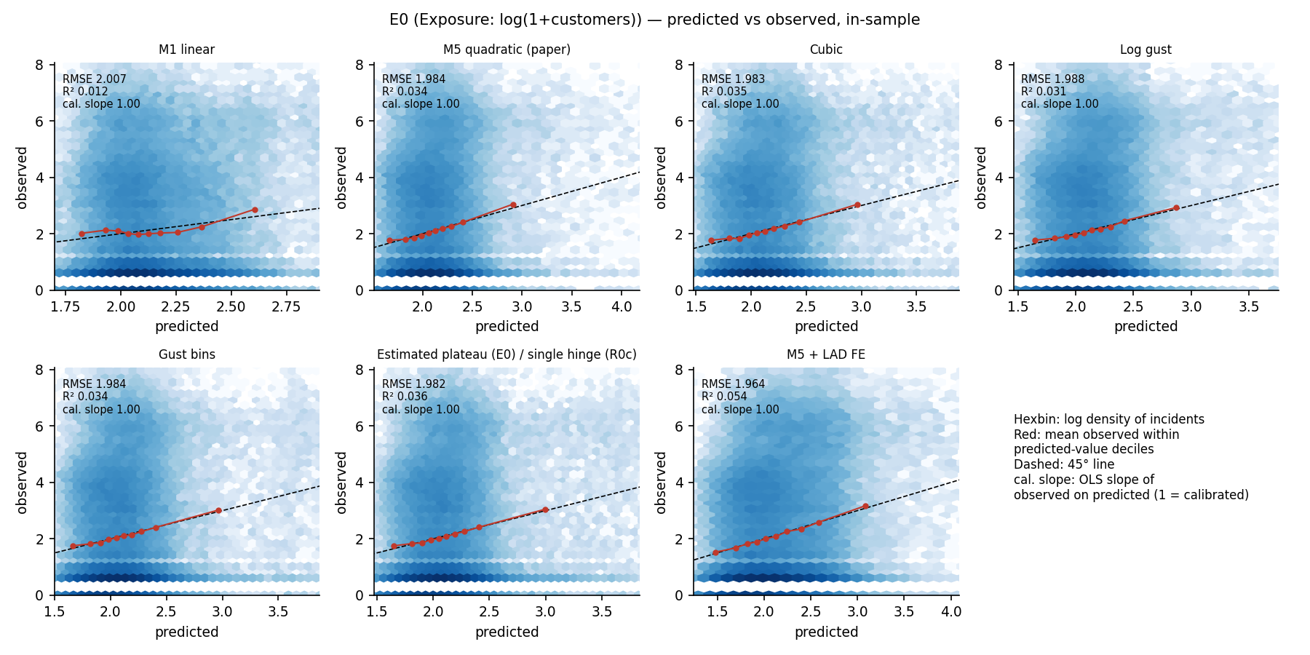
Figure 4. E0 in-sample: observed log(1+customers) against fitted values for each specification. Hexbin colour is log incident density; red points are mean observed within predicted-value deciles; dashed line is the 45° diagonal.
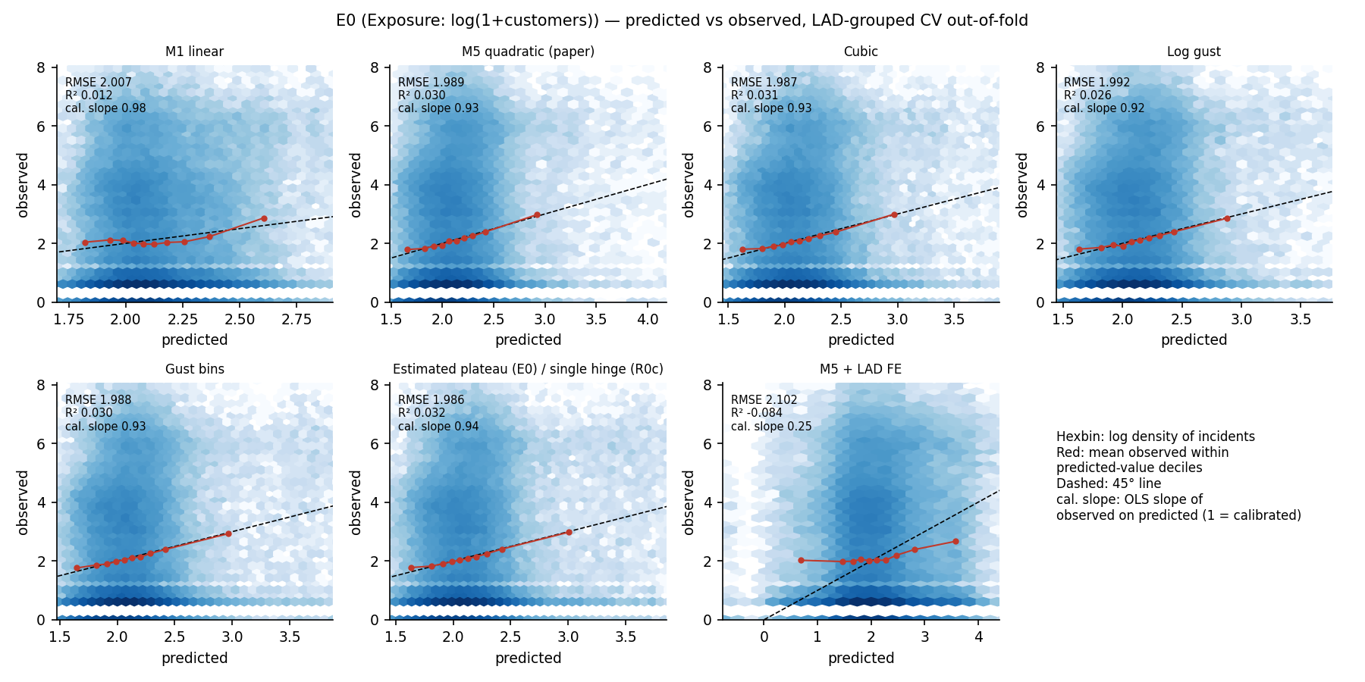
Figure 5. E0 as Figure 4 but with out-of-fold predictions from LAD-grouped cross-validation. The LAD fixed-effects panel shows why random-fold CV is misleading for this design.
The horizontal bands in the E0 panels at observed values 0, 0.69 and 1.10 are incidents affecting exactly 0, 1 and 2 customers. In the exposure sample 15% of incidents have zero customers, 30% have exactly one, and 58% have five or fewer, while the top 15% exceed 100 and the maximum is 27,013. The log1p transform does not make this outcome approximately Gaussian; it is a zero-inflated, heavily right-skewed count. OLS on log1p remains a defensible way to estimate the shape of the conditional mean, but it says nothing about the probability of a large-scale event, which is the quantity of practical interest. A hurdle or negative-binomial model, or a quantile regression at the 90th–95th percentile, would speak directly to that.
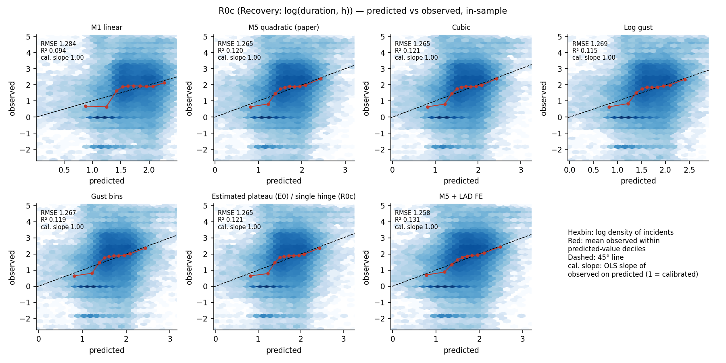
Figure 6. R0c in-sample: observed log(duration, h) against fitted values.
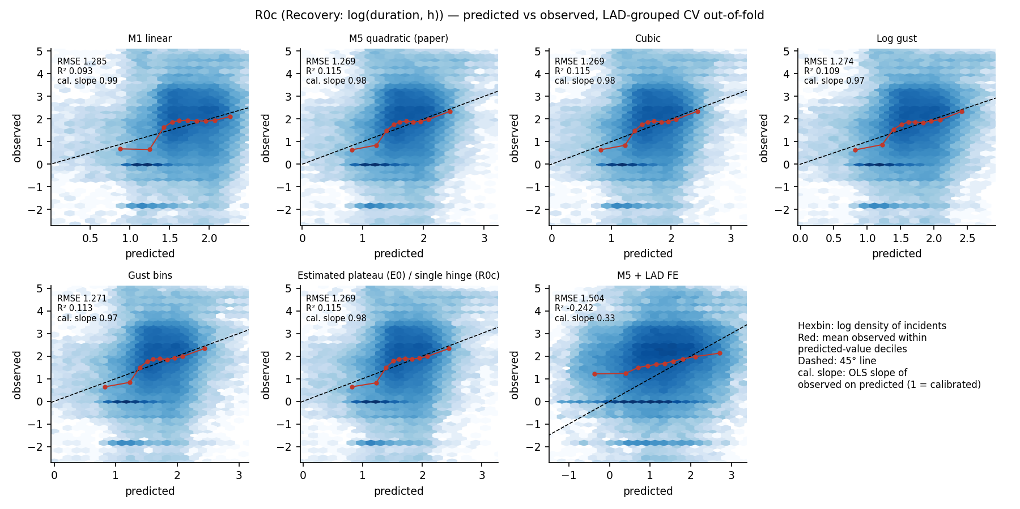
Figure 7. R0c out-of-fold (LAD-grouped CV). Calibration is good over the central range but the lowest predicted decile is systematically overpredicted (see Figure 8).

6. Calibration and residual structure
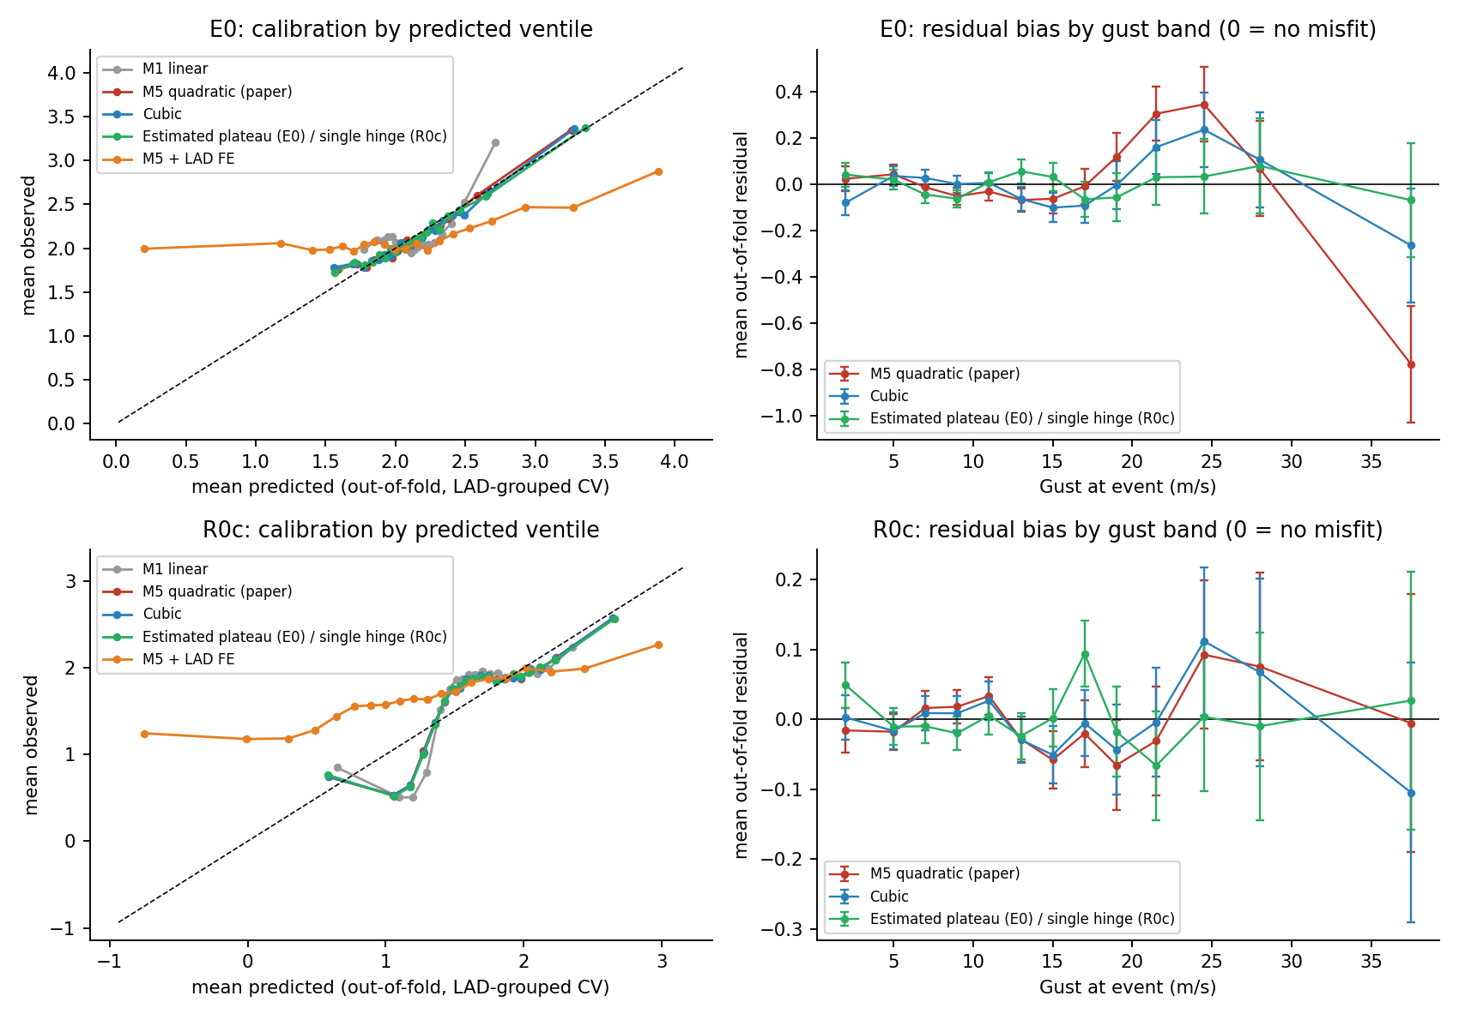
Figure 8. Left: mean observed against mean out-of-fold predicted within predicted-value ventiles. Right: mean out-of-fold residual by gust band for the three nonlinear forms (0 = no misfit).
For exposure, the quadratic is well calibrated up to about 18 m/s and then over-predicts by 0.3 log units in the 20–26 m/s band and under-predicts by 0.8 above 30 m/s — exactly the pattern expected from a parabola forced through a saturating response. The hinge form has no detectable bias in any band. The cubic is intermediate and mis-specified in the opposite direction at the top. For recovery, all three forms are within ±0.1 across the range and none is clearly better; the paper's quadratic is adequate here.
The recovery calibration curve (Figure 8, bottom left) has a kink at the bottom: the two lowest predicted ventiles (predicted ≈ 1.1–1.4 log-h) are observed at ≈ 0.5 log-h, i.e. the model expects 3–4 hours where the data show about 1.6 hours. Because this occurs for the lowest predictions and R0c includes log customers and its square, the likely cause is the quadratic in customer count: single-customer incidents (30% of the sample) are resolved faster than a smooth quadratic in log customers allows. This is not a gust issue, but it affects the intercept of every gust curve in Figure 2 and should be looked at before the recovery model is finalised — a dummy for one-customer incidents, or a piecewise term in log customers, is the obvious first test.

7. Fragility curves: ordinal logit and negative-binomial GLM
The exposure outcome is a zero-inflated count (15% of incidents affect no customers, 43% affect 1–5, 28% 6–100, 13% 101–1000 and 2% more than 1000), so a natural alternative to regressing log(1+customers) is to treat severity as an ordered categorical variable and estimate P(severity ≥ k | gust, covariates) — a fragility curve in exactly the sense used for seismic damage states, with gust as the intensity measure. A proportional-odds (ordinal) logit with the same covariates as M5 and the estimated hinge basis does this in one model; the same was done for recovery with duration classes <3, 3–12, 12–48 and >48 hours.
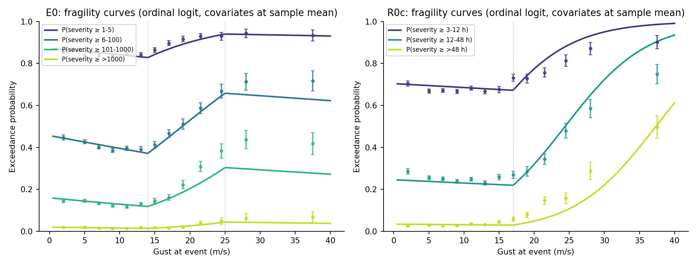
Figure 9. Fragility curves from the ordinal logit at the sample-mean covariate vector and mean pressure (lines), with empirical exceedance frequencies by gust band (points, 95% binomial CI). Dotted lines: estimated knots. Empirical points are marginal over covariates, so exact agreement is not expected.
Three findings. First, the proportional-odds assumption holds for exposure: separate binary logits at each threshold give hinge(14) slopes of 0.11–0.14 and hinge(26) slopes of −0.10 to −0.19 for all four thresholds, so a single gust response shifts the whole family of curves and the model is parsimonious. Second, at mean covariates the probability of exceeding 100 customers rises from 0.12 at 14 m/s to 0.32 at 26 m/s, and the probability of exceeding 1000 from 0.01 to 0.05 — but the >1000 curve is nearly flat, which says that the very largest events are not well predicted by the gust at the incident location; they are network-level phenomena and would need a network- or storm-level intensity measure. Third, for recovery the proportional-odds assumption is weaker (the >48 h threshold has a positive linear gust slope where the others are negative), so a partial proportional-odds model or separate logits per threshold would be the safer choice there.
A negative-binomial GLM on the raw customer count (dispersion α̂ ≈ 16) recovers the same hinge slopes on the log mean (+0.115 per m/s above 14, −0.092 above 26) and explains 2.3% of deviance, in line with the OLS R². It is the natural single-equation alternative if the paper wants an expected-customers curve rather than class probabilities, and it avoids the arbitrary +1 in log(1+customers). Both approaches are worth a short section in the paper: the ordinal model gives the fragility-curve presentation that infrastructure-resilience readers expect, and it makes the saturation above 26 m/s visible as a property of every severity class rather than of a transformed mean.

7b. Why those are not fragility curves, and what is
A fragility function must be non-decreasing in its intensity measure, and the curves in Figure 9 are not: they fall with gust below 14 m/s and, for exposure, above 26 m/s. The reason is the sample, not the model. Every row is an incident that did occur, and the mix of causes changes with gust: 7% of incidents in the 0–4 m/s band are weather-attributed against 91% above 30 m/s. Technical-asset faults have their own gust-independent size distribution, so the pooled exceedance is a mixture whose weights move with gust — a composition effect, not a vulnerability relation. A fragility function needs a sample in which the intensity measure is the cause and a monotone link. Both are applied below: weather-attributed incidents only (about 9.9k per margin) and the lognormal form Φ((ln g − ln θ)/β) fitted by binomial maximum likelihood, with one median θ per damage state and either a common or a free dispersion β.
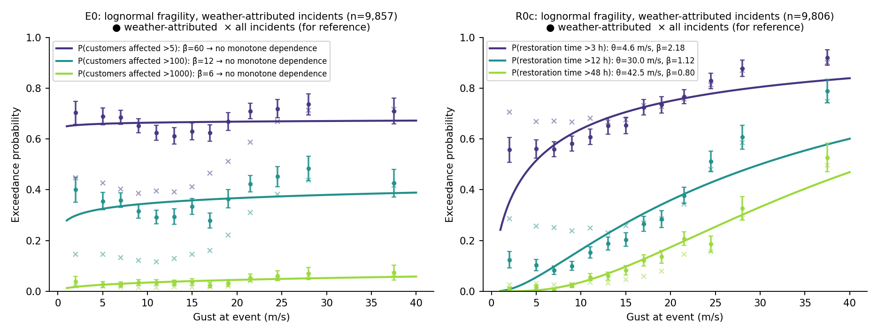
Figure 10. Lognormal fragility functions on weather-attributed incidents (lines and filled points); crosses are the all-incident frequencies for reference. Restoration time is a proper fragility in gust; customer count is not.
Restoration time behaves as a fragility should. A common β is rejected (LR p ≈ 1e-67); the free-β fits give medians θ = 4.6, 30.0 and 43 m/s with β = 2.18, 1.12, 0.80 for restoration exceeding 3, 12 and 48 hours. The 48-hour median is an extrapolation beyond the observed maximum of 39 m/s and that curve is constrained only up to about P = 0.5. Customer count does not behave as a fragility: within weather-attributed incidents the exceedance probabilities are not monotone in gust (the lognormal fit degenerates), with P(>100 customers) falling from 0.40 at calm to 0.29 at 12–18 m/s before rising to 0.48. Section 11 shows why: the within-weather response is V-shaped, because low-gust weather incidents (lightning, flooding, snow) are large but not wind-driven, so gust is the wrong intensity measure for them — while above about 11 m/s the size response to gust is real and as steep as in the full sample. The pooled gust effect is therefore mostly genuine, with a composition component from the rising share of weather incidents on top.
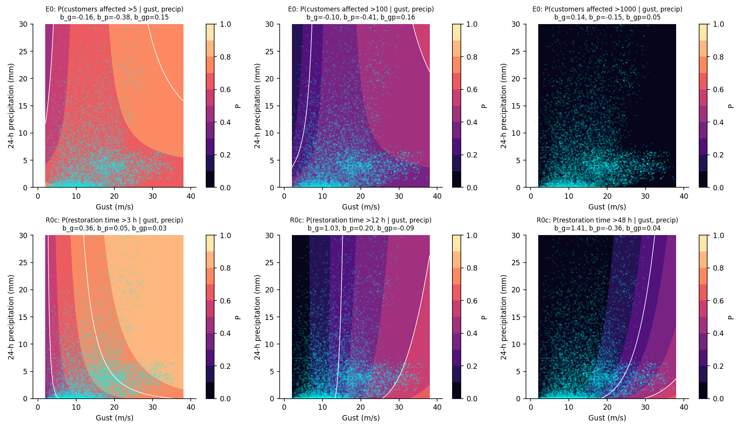
Figure 11. Fragility surfaces on gust and 24-h precipitation (probit with interaction), weather-attributed incidents; white contours at P = 0.25, 0.5, 0.75; cyan points are the data. Top: customers affected; bottom: restoration time.
Surfaces are straightforward to add and Figure 11 shows them for gust × precipitation. For restoration time the surface is monotone in gust over the entire observed domain for all three states, and precipitation shortens long restorations (b_p = −0.36 for >48 h), consistent with the negative gust×precipitation term found in the OLS — wet storms are either less damaging to overhead lines or better forecast. The exposure surfaces are non-monotone in both intensity measures, as the single-IM result implies. Gust × pressure-anomaly surfaces behave the same way and are in fragility_lognormal.json.
The implication for the paper is that the recovery margin can be presented as a fragility curve or surface now, but the exposure margin cannot on an incident-conditional sample. The correct exposure fragility is a network-level quantity — the probability that at least one outage of size ≥ k occurs in district ℓ on day t given the gust — which needs the full district-day panel including days without incidents. The project's gridded weather data make that panel buildable; it is the natural next step, and it would also resolve the denominator problem that the current exposure model inherits from the incident-level sampling.

8. Recommendations
- Exposure: replace gust² with a piecewise-linear response with estimated knots at 14 m/s [95%: 13–15] and 26 m/s [24–29.5]. It is preferred by BIC (Δ = −129 vs the quadratic), by nested spatial CV, has no residual bias in any gust band, and yields two interpretable, identified thresholds — damage onset (Beaufort 7) and saturation (storm force) — in place of a turning point that depends on the low-gust mass. Do not report 10.8 m/s as a physical threshold.
- Recovery: keep the quadratic or use a single hinge at 17 m/s; they are equivalent and a second knot is not identified. Drop gust×pressure (not significant in any variant). Investigate the low-duration misfit via the customer-count terms.
- Both: add temperature² (both cold and hot extremes raise exposure); consider gust×precipitation in recovery (negative, p ≈ 1e-4).
- Validation: report LAD-grouped (and ideally year-grouped) cross-validation. Random folds overstate generalisation and would have endorsed district fixed effects.
- Framing: present the models as estimates of the shape of the weather response, not as predictive models of outage size.
- Fragility: present restoration time as a lognormal fragility curve (and gust × precipitation surface) on weather-attributed incidents. Do not present customer count as a fragility on this sample; build the district-day panel and define exposure fragility as the probability of an outage of size ≥ k per district-day.

9. Final models with the recommendations implemented
code/final_models.py fits the recommended specifications and reports LAD-clustered and LAD×date two-way clustered standard errors, with p-values from a t distribution on G−1 = 110 degrees of freedom rather than the normal used in the package (the difference is immaterial at 111 clusters but is the correct reference distribution).
- Exposure (E0): the paper's M5 covariates with gust² replaced by the estimated piecewise-linear response (linear + hinge 14 + hinge 26), gust×pressure retained, temperature² added. n = 60,437.
- Recovery (R0c): quadratic gust retained, gust×pressure dropped, temperature² and gust×precipitation added, and zero-customer incidents excluded. The exclusion follows from a data-quality finding made while chasing the calibration kink in Figure 8: 8,661 recovery-sample incidents interrupted no customers, and 66.5% of them carry a duration of exactly 1.000 h (0.5% of all other incidents do), i.e. a placeholder. A restoration time is undefined when nobody was interrupted, so these rows should not be in the recovery model. n = 51,173; the paper's M5 was refitted on the same subsample for comparison.
Margin | Term | Coef. | SE (LAD) | SE (LAD×date) | p (two-way, t₁₁₀)
E0 | Temperature (z) | -0.0341 | 0.0194 | 0.0288 | 0.239
E0 | Gust × pressure | -0.0349 | 0.0080 | 0.0158 | 0.0288
E0 | Temperature squared (z²) | 0.0566 | 0.0079 | 0.0221 | 0.0117
E0 | Gust below 14 m/s (per m/s) | -0.0270 | 0.0030 | 0.0044 | 1.76e-08
E0 | Gust ramp 14–25 m/s (per m/s; constant above 25) | 0.1215 | 0.0072 | 0.0138 | 2.48e-14
R0c | Gust (linear, z) | -0.0002 | 0.0085 | 0.0192 | 0.99
R0c | Temperature (z) | -0.0724 | 0.0093 | 0.0190 | 0.000238
R0c | Gust squared (z²) | 0.0810 | 0.0046 | 0.0074 | 3e-19
R0c | log(1+customers) (z) | -0.1964 | 0.0165 | 0.0171 | 1.33e-20
R0c | log(1+customers) squared | -0.1113 | 0.0137 | 0.0155 | 8.6e-11
R0c | Temperature squared (z²) | 0.0168 | 0.0038 | 0.0058 | 0.00474
R0c | Gust × precipitation | -0.0245 | 0.0063 | 0.0100 | 0.016
Table 2. Weather and customer terms of the final models, two-way clustered inference. Full tables in results/final_models/*_final_{lad,twoway}.csv.
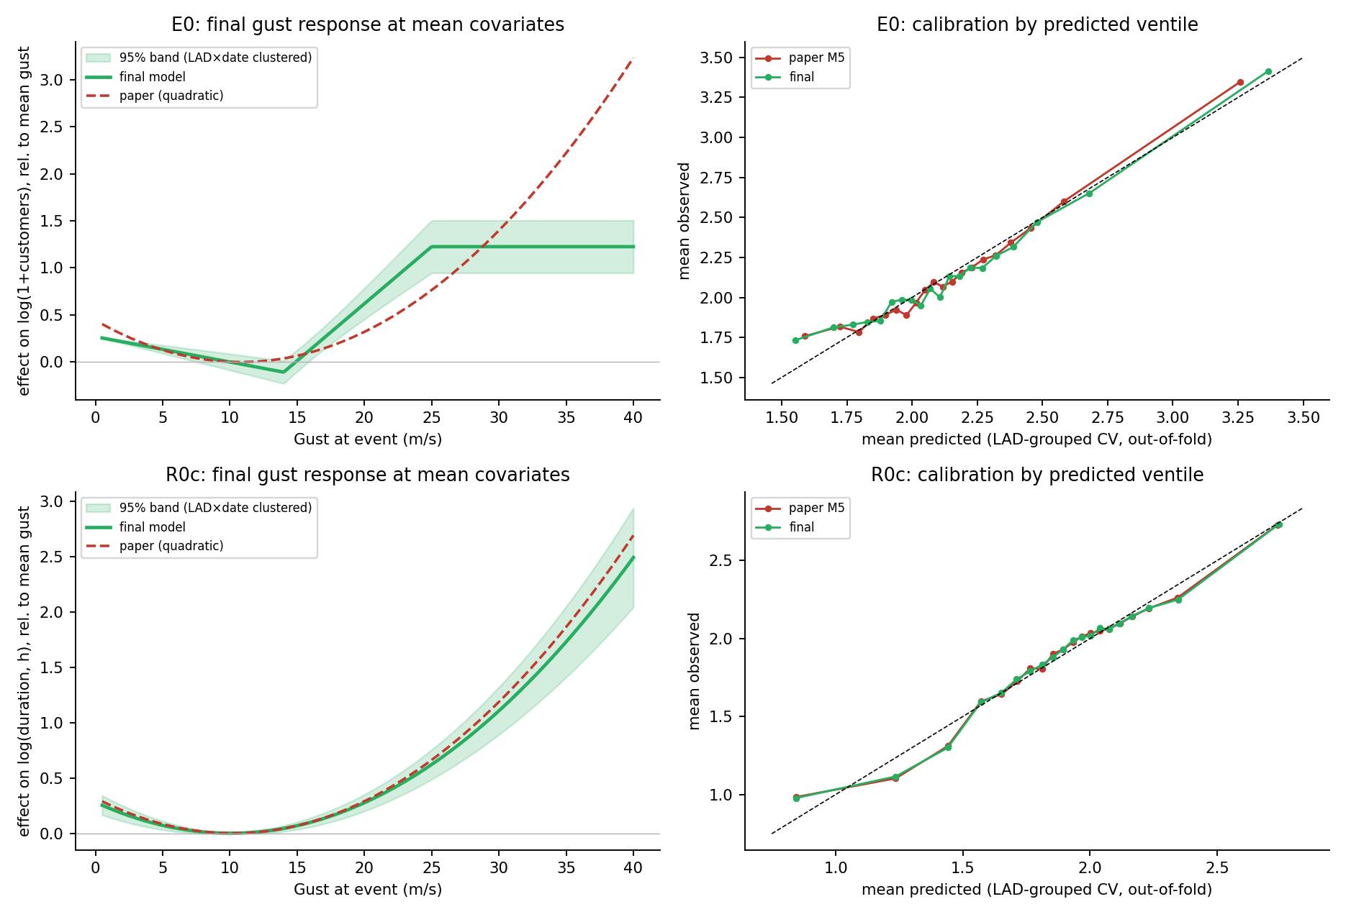
Figure 12. Final gust responses with LAD×date-clustered 95% bands against the paper's quadratic (left), and out-of-fold calibration of final versus paper models under LAD-grouped CV (right).
For exposure the final model improves adjusted R² from 0.0336 to 0.0372, BIC by 205, LAD-grouped CV RMSE from 1.9887 to 1.9849 and year-grouped CV from 1.9940 to 1.9911. Both hinge slopes are decisive under two-way clustering (+0.146 per m/s above 14, −0.155 per m/s above 26; p < 1e-4), the two-way standard errors are 1.3–2.3 times the LAD-only ones, and gust×pressure survives only marginally (p = 0.046). The band widens above 26 m/s because 1,600 incidents sit there, but the saturation is clearly inconsistent with the quadratic. For recovery the sample correction is the substantive change: on the cleaned sample the paper's specification and the final one are almost indistinguishable (CV 1.1506 vs 1.1503) and the calibration kink is gone; the linear gust term is exactly zero, temperature² and gust×precipitation are significant but small. The customer-count terms flip sign on the cleaned sample (log customers −0.196, squared −0.111), which says that among incidents that actually interrupted someone, larger events are restored faster in proportion — presumably prioritisation — a point the paper may want to make explicitly.

10. District-day exposure fragility
Section 7b argued that exposure fragility must be defined per district-day rather than per incident. The package contains no weather for district-days without incidents, but every date has at least 15 incidents across 13 or more districts, and the incident-level gusts within a district-day vary by only about 1.8 m/s, so a daily district gust can be interpolated from that day's incident locations to each district centroid (Gaussian-kernel inverse-distance weighting, 40 km bandwidth). Leaving each district's own incidents out, the interpolated gust reproduces the observed district-day mean with RMSE 2.2 m/s, correlation 0.85 and no bias. The resulting panel has 121,656 district-days, 34.5% of which contain at least one incident; 5.0% contain a weather-attributed one. This is a documented proxy — the project's gridded weather should replace it — but it makes the correct quantity estimable now.
The empirical exceedance frequencies on this panel are monotone in gust, as a fragility should be. A plain lognormal underfits because technical faults occur at any gust, so the fitted form is P = p₀ + (1 − p₀)·Φ((ln g − ln θ)/β), where p₀ is a gust-independent background rate.
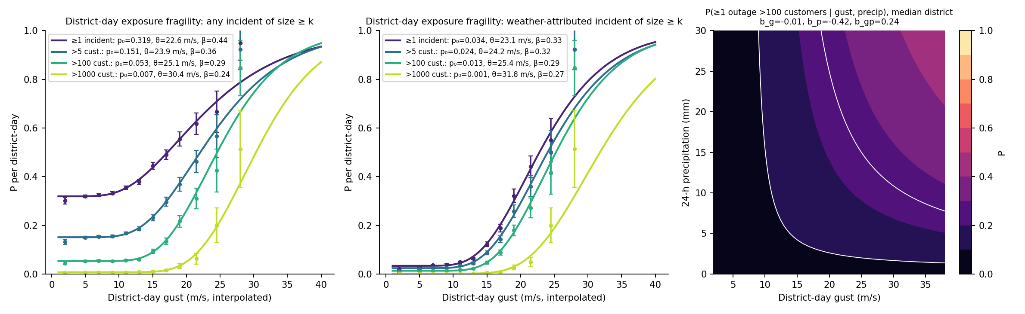
Figure 13. District-day exposure fragility for four size thresholds: occurrence of any incident (left), of a weather-attributed incident (centre), and a gust × precipitation surface for the >100-customer state at the median district (right). Points: empirical frequencies with 95% CI.
Damage state | Occurrence | Base rate | p₀ (floor) | θ (m/s) | β
≥1 incident | any cause | 0.345 | 0.319 | 22.6 | 0.44
>5 cust. | any cause | 0.167 | 0.151 | 23.9 | 0.36
>100 cust. | any cause | 0.061 | 0.053 | 25.1 | 0.29
>1000 cust. | any cause | 0.008 | 0.007 | 30.4 | 0.24
≥1 incident | weather-attributed | 0.050 | 0.034 | 23.1 | 0.33
>5 cust. | weather-attributed | 0.036 | 0.024 | 24.2 | 0.32
>100 cust. | weather-attributed | 0.020 | 0.013 | 25.4 | 0.29
>1000 cust. | weather-attributed | 0.003 | 0.001 | 31.8 | 0.27
Table 3. Background-rate lognormal fragility parameters per district-day.
Three results. First, the medians are tightly grouped at 23–25 m/s for any incident, >5 and >100 customers, and 30–32 m/s for >1000, with β of 0.24–0.44: the network's weather response switches on around 23 m/s (Beaufort 9) whatever the size threshold, and the thresholds differ mainly in their floors. Second, the floors reproduce the technical-fault base rates almost exactly (p₀ = 0.319 vs 0.345 base for any incident; 0.053 vs 0.061 for >100), so the decomposition into hazard-independent and hazard-driven occurrence is clean. Third, the weather-attributed curves for ≥1, >5 and >100 customers nearly coincide (θ = 23.1, 24.2, 25.4 m/s): once a storm produces a weather outage in a district, that outage is usually large, which is the network-level counterpart of the flat per-incident curves in Section 7b. The 26 m/s saturation knot in the incident-level exposure model sits where these district-day curves pass through P ≈ 0.5 — the point beyond which most districts already have an outage and the marginal incident adds little. The gust × precipitation surface is monotone in gust over 99% of the domain and shows the same rain-attenuation seen for restoration times.
For the paper this is the exposure result to present: a per-district-day probability of an outage of size ≥ k as a function of gust, with a floor for non-weather faults, rather than a turning point in a regression on incident size. It is directly usable in a hazard-consistent risk calculation (convolve with the district gust hazard curve to obtain annual exceedance frequencies per district), which the incident-level regression is not.

11. Regressions on weather-attributed incidents only
code/weather_only_regression.py refits both margins on the subsample with cause_group_official = weather_natural: 9,857 exposure incidents (16.3% of the sample) and 9,806 recovery incidents, 9,254 after removing zero-customer placeholder rows. Three specifications are compared — the paper's quadratic, a piecewise-linear gust response with knots re-estimated on the subsample, and the final specification of Section 9 — with LAD×date two-way clustered inference and LAD-grouped cross-validation. The knots were re-estimated rather than carried over: on the weather subsample the exposure knots move to 11 and 26 m/s (LR for the second knot p ≈ 2×10⁻⁷) and the single recovery knot to 11 m/s.
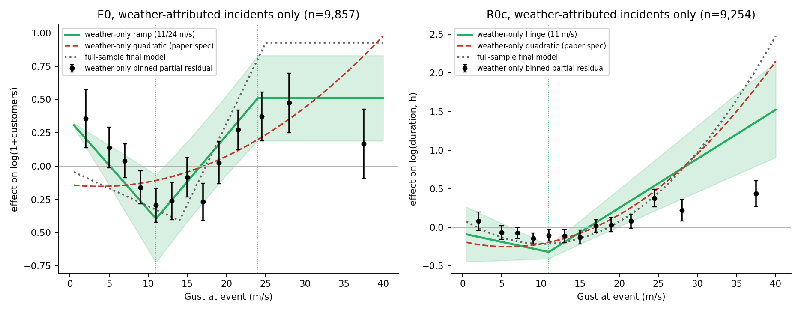
Figure 14. Gust responses on weather-attributed incidents only. Black: binned partial residuals with 95% CI. Green: piecewise-linear fit with re-estimated knots and two-way-clustered 95% band. Red dashed: the paper's quadratic on the same subsample. Grey dotted: the full-sample final model, for comparison.
Margin | Term | Coef. | SE (LAD×date) | p (t₁₁₀)
E0 | Temperature (z) | 0.0272 | 0.0690 | 0.694
E0 | Gust × pressure | -0.0865 | 0.0340 | 0.0123
E0 | Gust below 11 m/s (per m/s) | -0.0595 | 0.0153 | 0.000175
E0 | Gust ramp 11–24 m/s (per m/s; constant above 24) | 0.0785 | 0.0100 | 3.24e-12
E0 | Temperature squared (z²) | 0.0928 | 0.0189 | 3.31e-06
R0c | Gust (linear, z) | -0.0545 | 0.0890 | 0.542
R0c | Temperature (z) | -0.1337 | 0.0634 | 0.0374
R0c | log(1+customers) (z) | -0.2948 | 0.0306 | 4.82e-16
R0c | log(1+customers) squared | 0.0923 | 0.0276 | 0.00116
R0c | gust_hinge_11 | 0.0696 | 0.0185 | 0.000286
R0c | Temperature squared (z²) | 0.0641 | 0.0153 | 5.59e-05
R0c | Gust × precipitation | -0.0562 | 0.0219 | 0.0117
Table 4. Weather and customer terms of the final specification fitted to weather-attributed incidents only (two-way clustered SEs, t on 110 df). Full tables in results/weather_only/.
Exposure. The paper's quadratic does not describe weather incidents: on this subsample the gust² term is insignificant (p = 0.52) while the linear term is positive, because the quadratic is trying to fit a V. The response is highest at calm winds — weather incidents at 0–6 m/s are lightning, flood and snow events, which are large but not wind-driven — falls to a minimum at 11 m/s, then rises at +0.131 log-units per m/s (SE 0.020) to 26 m/s and falls again beyond it (−0.149 per m/s). That within-weather slope is the same as the full-sample hinge slope (0.146), so the exposure response above 11 m/s is a real property of weather-caused outages and not a composition artefact; what composition adds is the larger sample and the slightly later onset (14 m/s) in the pooled model, where the technical-fault mass pulls the first knot to the right. The piecewise-linear final specification improves adjusted R² from 0.043 to 0.053, BIC by 90 and LAD-grouped CV from 2.178 to 2.166. Temperature² is much stronger here (0.092, p < 10⁻⁴), consistent with cold-snap and heat-wave events sitting in the calm-wind part of the weather subsample. The decline above 26 m/s is now visible within weather incidents alone, with wide uncertainty (about 1,600 incidents above 26 m/s in the full sample, 900 here).
Recovery. Weather incidents are far more predictable than the pooled sample: adjusted R² is 0.29 against 0.11, mainly because restoration time is strongly tied to gust once the technical-fault noise is removed. The quadratic and the single-knot hinge are equivalent (CV 1.2504 vs 1.2497), the final specification is marginally better (1.2459), and gust×precipitation is again negative (−0.056, p = 0.012). The binned residuals also show restoration times flattening above about 25 m/s, which neither the quadratic nor the single hinge captures and which the full-sample model, dominated by the low-gust mass, does not see at all; with only 900 weather incidents above 26 m/s this is suggestive rather than established, but it is the same saturation pattern as exposure and would be worth testing with a second knot once the sample grows.
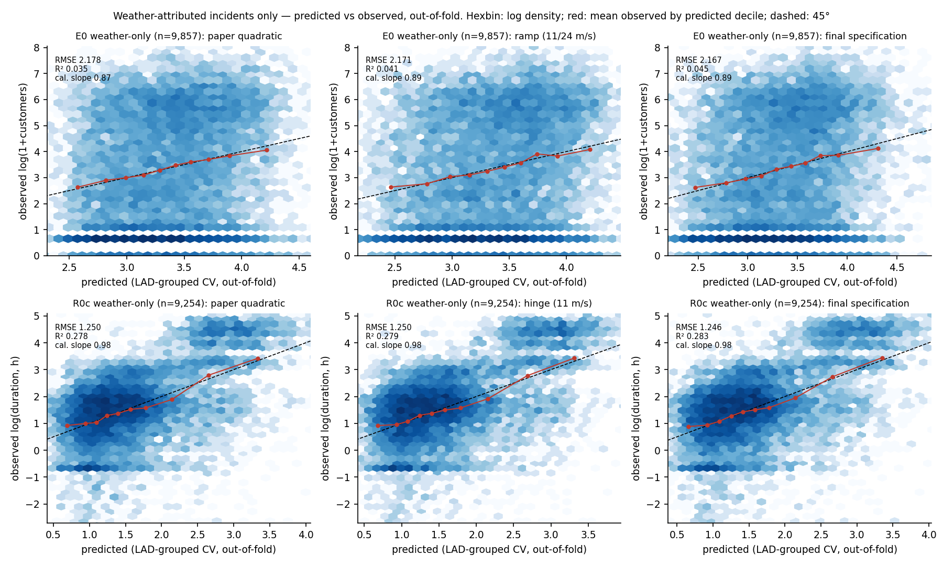
Figure 15. Weather-attributed incidents only: observed against out-of-fold predicted values (LAD-grouped CV) for the paper's quadratic, the re-estimated hinge and the final specification. Hexbin colour is log incident density; red points are mean observed within predicted-value deciles; dashed line is the 45° diagonal.
The predicted-vs-observed panels tell the same story as the full-sample ones. Exposure remains hard to predict at the incident level (out-of-fold R² 0.035 → 0.046 from the quadratic to the final specification, calibration slope 0.87 → 0.89), and the horizontal bands at 0, 0.69 and 1.10 are again the incidents affecting 0, 1 and 2 customers. Recovery is much better predicted (out-of-fold R² 0.28, calibration slope 0.98 for all three specifications) and the decile means sit on the diagonal across the whole range, with no trace of the kink that the zero-customer placeholders caused in Figure 8. The dense band near 0.5 h in the recovery panels is not a placeholder — the durations are spread across minute values between 30 and 35 minutes — but a genuine mode of weather faults cleared by automatic reclosure, which the models cannot separate from sustained faults using weather alone; a reclosure flag, if the UKPN records carry one, would be the single most useful addition to the recovery model.
Recommendation. The weather-only regressions are the cleaner statement of the weather response and should be reported alongside, or instead of, the pooled ones: they remove the composition effect, they are the natural companions of the per-district-day fragility of Section 10, and they show that the paper's quadratic is not merely sub-optimal but mis-specified for the incidents the paper is about. The cost is sample size — knots and the saturation branch are less precisely located — which argues for keeping the pooled model as the primary estimate of the onset threshold and the weather-only model as the check on its interpretation.

12. Plateau constraint on the exposure response (supersedes the unconstrained hinge as the final form)
The unconstrained two-hinge model of Sections 4 and 9 lets the slope beyond the second knot be free, and estimates it at −0.155 per m/s against +0.146 below — a net −0.009 ± 0.03, indistinguishable from zero. Physically, the number of customers affected cannot fall as gust rises, so the appropriate form is a three-segment response: a free slope below the onset knot (which carries the composition effect of technical faults at calm winds), a ramp between the knots, and a plateau above. code/plateau_model.py fits this form, re-profiles the knots for it, and tests the constraint against the unconstrained fit.
- All incidents: knots re-profiled at 14 and 25 m/s (bootstrap 13–15 and 24–28); ramp slope 0.121 ± 0.014 log-units per m/s (two-way clustered), slope below 14 m/s −0.027 ± 0.004; the plateau constraint is not rejected (LR = 1.5, p = 0.22); BIC improves by 10 for one fewer parameter; nested CV identical (1.9850 vs 1.9851).
- Weather-attributed incidents: knots 11 and 24 m/s (bootstrap 10–14 and 22–26); ramp slope 0.079 ± 0.010; the constraint is marginally rejected (p = 0.011) solely because the 30–45 m/s band (about 300 incidents) sits below the plateau with a wide interval; it is imposed on physical grounds.
- Interpretation change: with the correct form the weather-only ramp slope is two-thirds of the pooled one (0.079 vs 0.121), so about two-thirds of the pooled rise between onset and plateau is vulnerability of weather-caused faults and one-third is composition. Section 11's statement that the two slopes were 'essentially the same' compared hinge coefficients sitting on different linear terms and is withdrawn.
- Development/confirmation: ramp slope 0.100 ± 0.014 and 0.149 ± 0.020 — same sign and order, higher in the confirmation winter, which contains Babet, Ciarán and Henk.
- Recovery margin: the same plateau form was tested (python code/plateau_model.py R0c; ramp_model_R0c.json). All incidents: knots 17 and 33 m/s, the upper knot at the search-grid boundary with bootstrap 29–34; the unconstrained two-hinge fit prefers a steepening at 15/20 m/s and rejects the plateau (p = 0.003); nested CV 1.1501 (plateau) vs 1.1502 (two-hinge) vs 1.1504 (quadratic). Weather-attributed: knots 9 and 33, constraint not rejected (p = 0.34), nested CV 1.2478 vs 1.2476 for the quadratic. Restoration time does not plateau within the observed gust range; the quadratic is retained for R0c and the contrast with exposure (bounded by topology vs bounded by crew capacity) is a finding in its own right.
final_models.py, weather_only_regression.py, plot_model_selection.py and paper_extras.py now use the three-segment form for the exposure margin; Figures 12 and 14 and Tables 2 and 4 reflect it. The earlier hinge coefficients in Sections 9 and 11 are retained as the unconstrained comparison.

Files
results/figures/fig1–fig14*.png · results/weather_only/ (weather-only coefficient tables, weather_only_summary.json) · results/final_models/ (final coefficient tables, table2_replacement.csv, final_summary.json, district_day_panel.csv, district_day_fragility.json) · results/model_selection/knots.json (+ profile and bootstrap CSVs) · fragility_summary.json · results/model_selection/predicted_vs_observed_summary.csv · all_model_comparison.csv · hinge_knot_search.csv · E0_coefficients.xlsx · R0c_coefficients.xlsx · code/model_selection.py · knot_estimation.py · plot_model_selection.py · fragility_demo.py · fragility_surfaces.py · final_models.py · district_day_fragility.py · weather_only_regression.py

