A network-scale wind fragility function for electricity distribution outages from three years of operational records
Reproduction draft generated independently from the project samples. Tables and inserted analysis figures come from this run. The inherited narrative is a historical review template: its hand-entered numbers, causal interpretations and literature claims require revision against the computed results before publication.
[Author list and affiliations — to be completed]. Nature Communications format: main text ≈ 3,300 words, five figures and one table; Methods ≈ 1,900 words; Supplementary Information from the extended paper.

Abstract
Wind is the leading cause of power disruption in temperate networks, yet the wind vulnerability of a whole distribution network has only been described by smooth statistical fits to outage records or by fragility curves of single poles and towers from simulation. Here we use three years of stage-level regulatory records from UK Power Networks — 60,453 network-fault incidents including seven named storms — to estimate the shape of the wind response rather than assume it. Outage size is flat below an onset gust of 14 m/s (95% interval 13–15), rises by 13% per m/s to 25 m/s (24–28), and is constant beyond — a constraint the data do not reject; two-thirds of that rise is found on the 16% of incidents the operator attributes to weather alone. Reconstructing 121,656 district-days, we show that the probability that a district experiences an outage of a given size on a day follows a lognormal fragility function in gust with a background rate equal to the technical-fault rate: median 23–25 m/s for outages of up to 100 customers, 30 m/s above 1,000, dispersion about 0.3. This is a network-level counterpart of component fragility curves and is directly usable with a wind hazard to obtain annual outage-exceedance frequencies.

Introduction
Storms are the most common cause of power disruption in Great Britain [1]; Storm Arwen in 2021 left more than a million customers without supply [2], and Storm Eunice three months later produced the highest gust in the record examined here, 39.4 m/s, with 1,601 weather-related outage events on one network in a day. Two literatures describe what wind does to a distribution network, and they do not meet. Statistical outage studies for hurricane- and ice-storm-affected utilities [3–6] fit regression or machine-learning models relating weather intensity to customers affected or restoration time; they report smooth fitted curves, do not test for a threshold, and model the size of an outage conditional on one having occurred. Structural engineering derives fragility curves — the probability that a pole, tower or line fails as a function of wind speed — from finite-element simulation or scaled testing of a single component [7–10]; those curves are threshold-shaped, with failure probability near a baseline below a critical wind speed and rising steeply above it. Whether a threshold-shaped response exists at the scale of a whole network, and whether the probability of an outage at the network scale can be written as a fragility function at all, has not been established from operational records.
We answer both questions with three years of continuous records from UK Power Networks (UKPN), which serves London, the South East and the East of England, a period containing routine operation and seven named storms on the same network. Rather than assuming a functional form, we search over specifications with whole districts held out, estimate the location of any thresholds with intervals, and separate the changing mix of weather and technical faults from the vulnerability of the network to wind. We then move the unit of analysis from the incident to the district-day to obtain the probability of occurrence that the incident-level literature cannot provide.

Results

Outage size responds to wind in a piecewise, not smooth, way
Event-level outcomes — customers affected and restoration duration — are reconstructed from 116,064 stage-level records under Ofgem's definitions (Methods), correcting a factor-of-two undercount that results from using the earliest stage of each incident alone. Both are modelled on the log scale with weather, district and calendar covariates, and the shape of the gust term is chosen by comparison among quadratic, cubic, logarithmic, step and piecewise-linear forms on out-of-sample error with whole districts held out. Figure 1 shows the binned partial residuals of the full model fitted without any gust term, which owe nothing to a functional form, together with the fitted candidates. Outage size is flat or slightly declining to about 14 m/s, rises steeply to 26 m/s, and flattens above; restoration time is flat to about 16 m/s and rises without a plateau. A quadratic — the form used by earlier statistical studies and by an earlier version of this analysis — over-predicts by 0.3 log-units at 20–26 m/s and under-predicts by 0.8 above 30 m/s, and its vertex at 10.8 m/s is pulled left of the empirical minimum by the dense mass of calm-weather incidents. An unconstrained two-hinge form with knots estimated by profile likelihood at 14 and 26 m/s beats the quadratic by ΔBIC = −129 and shows no residual bias in any gust band; its net slope beyond 26 m/s is −0.009 ± 0.03 per m/s. Because affected customers cannot fall as gust rises, we impose a plateau beyond the second knot: the constraint is not rejected (likelihood ratio 1.5, p = 0.22), lowers BIC by a further 10, and re-profiles the knots at 14 and 25 m/s, with a district cluster bootstrap placing the onset at 13–15 m/s and the plateau at 24–28 m/s (Supplementary Fig. 1). Nested cross-validated error with knots re-selected inside each training fold improves on the quadratic (1.9850 against 1.9872). Between the knots, affected customers rise by 13% per m/s of gust, a factor of 3.8 across the ramp (Table 1). Fitted separately on the first 30 and the last 6 months of the record, the ramp slope is 0.100 ± 0.014 and 0.149 ± 0.020 log-units per m/s — higher in the confirmation winter, which contains three named storms, but of the same order; the instability that the quadratic's turning point showed between the same two samples does not arise because no ratio of coefficients is involved. Restoration time is adequately described by the square of gust: a second knot is nominally significant but not identified, because the response is flat below 17 m/s, and a plateau form places its upper knot at the edge of the observed gust range (33 m/s, bootstrap 29–34) with no gain in cross-validated error — exposure saturates within the data, recovery does not.
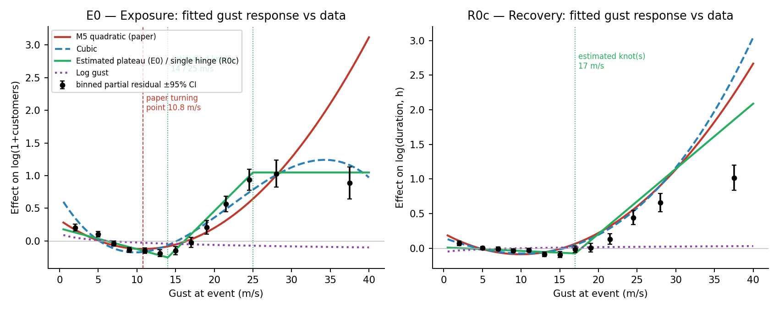
Fig. 1 | The wind response of outage size and restoration time is piecewise. Points: mean residual of the full model fitted without gust terms, within gust bands, with 95% CI, for all 60,437 (exposure) and 51,173 (recovery) incidents. Lines: fitted gust responses of the quadratic, cubic, piecewise-linear and log-gust specifications on the same scale. Vertical lines mark the quadratic's vertex (10.8 m/s) and the estimated knots (14 and 25 m/s).
Table 1 | Final specifications, all incidents: weather and customer terms, standard errors clustered by district and date, p-values from t with 110 degrees of freedom.
Margin | Term | Coef. | SE (district) | SE (district×date) | p (two-way, t₁₁₀)
E0 | Temperature (z) | -0.0341 | 0.0194 | 0.0288 | 0.239
E0 | Gust × pressure | -0.0349 | 0.0080 | 0.0158 | 0.0288
E0 | Temperature squared (z²) | 0.0566 | 0.0079 | 0.0221 | 0.0117
E0 | Gust below 14 m/s (per m/s) | -0.0270 | 0.0030 | 0.0044 | 1.76e-08
E0 | Gust ramp 14–25 m/s (per m/s; constant above 25) | 0.1215 | 0.0072 | 0.0138 | 2.48e-14
R0c | Gust (linear, z) | -0.0002 | 0.0085 | 0.0192 | 0.99
R0c | Temperature (z) | -0.0724 | 0.0093 | 0.0190 | 0.000238
R0c | Gust squared (z²) | 0.0810 | 0.0046 | 0.0074 | 3e-19
R0c | log(1+customers) (z) | -0.1964 | 0.0165 | 0.0171 | 1.33e-20
R0c | log(1+customers) squared | -0.1113 | 0.0137 | 0.0155 | 8.6e-11
R0c | Temperature squared (z²) | 0.0168 | 0.0038 | 0.0058 | 0.00474
R0c | Gust × precipitation | -0.0245 | 0.0063 | 0.0100 | 0.016

The same slope among weather-attributed incidents
Only 16% of incidents are attributed by the operator to weather, and that share rises from 7% in the 0–4 m/s band to 91% above 30 m/s, so a pooled response mixes a changing cause composition with the network's vulnerability. Refitting on the 9,857 weather-attributed exposure incidents with knots re-estimated on the subsample (Fig. 2) separates the two. The response is V-shaped: weather incidents at calm winds are lightning, flooding and snow events, large but not wind-driven, so gust is the wrong intensity measure for them; the response bottoms at 11 m/s and then rises at 0.0785 log-units per m/s to a plateau at 24 m/s (knots re-profiled on the subsample). That is two-thirds of the pooled ramp slope of 0.121: most of the pooled rise is the vulnerability of weather-caused faults and the remainder is composition, which also shifts the pooled onset from 11 to 14 m/s by adding technical-fault mass at low gusts. The quadratic is not merely sub-optimal on this sample but mis-specified (gust² p = 0.52), which is why an earlier analysis found a physically impossible turning point here. Restoration time is far more predictable among weather incidents (out-of-sample R² 0.28 against 0.11 on all incidents) and rises faster on dry days than wet ones at the same gust (gust × precipitation -0.0562, p = 0.0117).
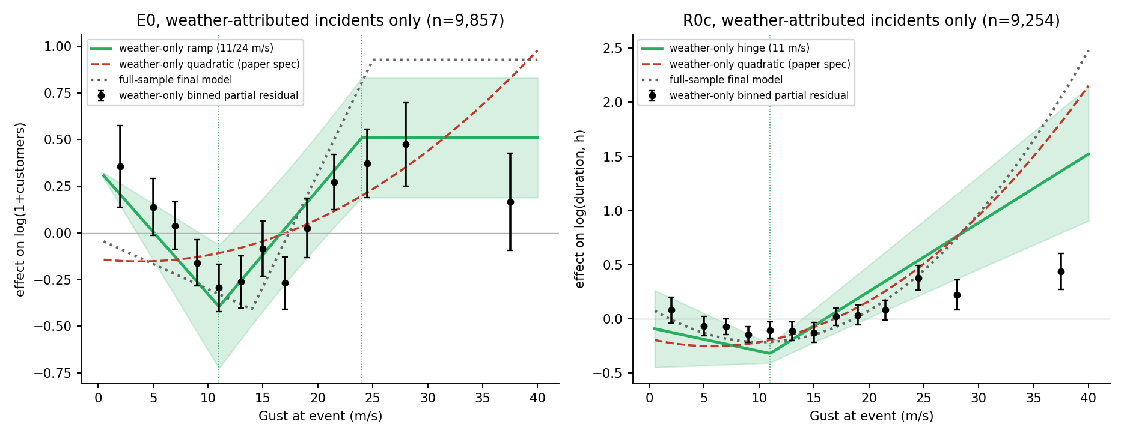
Fig. 2 | The wind response on weather-attributed incidents only. Black: binned partial residuals with 95% CI (n = 9,857 exposure; 9,254 recovery). Green: three-segment plateau fit with knots re-profiled on the subsample and district×date-clustered 95% band. Red dashed: quadratic on the same subsample. Grey dotted: the all-incident model of Fig. 1.

Wind explains little of outage size and much of outage occurrence
Under district-grouped cross-validation, gust adds 1.49 percentage points to the out-of-sample R² of outage size on all incidents, out of a total of 3.36%, and 1.56 points out of 4.43% among weather incidents (Supplementary Fig. 2). The size of an individual outage is dominated by network configuration, asset condition and protection settings that the record does not contain, and the incident-level models estimate the shape of the wind response, not the size of outages. The quantity wind does predict is whether an outage occurs, and the incident-level record cannot estimate it, because its exceedance probabilities are conditional on an incident: given that one occurred, the probability of exceeding 100 customers is 0.40 at calm winds, 0.29 at 12–18 m/s and 0.48 above 23 m/s, a V rather than a monotone function (Supplementary Fig. 3). A fragility function needs a denominator of exposure units.

A district-day fragility function
We reconstruct all 121,656 combinations of the 111 districts and 1,096 days in the record, of which 34.5% contain at least one incident and 5.0% a weather-attributed one, and assign each district-day a gust interpolated from that day's incident locations (leave-district-out RMSE 2.2 m/s, r = 0.85; Methods). The probability that a district experiences an outage of at least a given size on a day is then monotone in gust (Fig. 3) and is closely fitted by a lognormal fragility function with a background rate, P = p₀ + (1 − p₀)Φ((ln g − ln θ)/β). The medians are tightly grouped — 22.6, 23.9 and 25.1 m/s for any incident, more than 5 and more than 100 customers, and 30.4 m/s for more than 1,000 — with dispersions of 0.24–0.44, and the floors reproduce the technical-fault base rates (p₀ = 0.319 against 0.345 for any incident; 0.053 against 0.061 for more than 100). The network's weather response switches on at about 23 m/s, Beaufort 9, whatever the size threshold, and the thresholds differ mainly in their floors. For weather-attributed occurrence the curves for at least one, more than 5 and more than 100 customers nearly coincide (θ = 23.1, 24.2, 25.4 m/s): once a storm produces a weather outage in a district, that outage is usually large. The plateau knot of the incident-level model, 25 m/s, is where the district-day curves pass through P ≈ 0.5, beyond which most districts already have an outage and the marginal incident adds little. A gust × precipitation surface (Fig. 4) is monotone in gust over 99% of the observed domain and shows that rain attenuates the wind effect, the same sign found for restoration time.
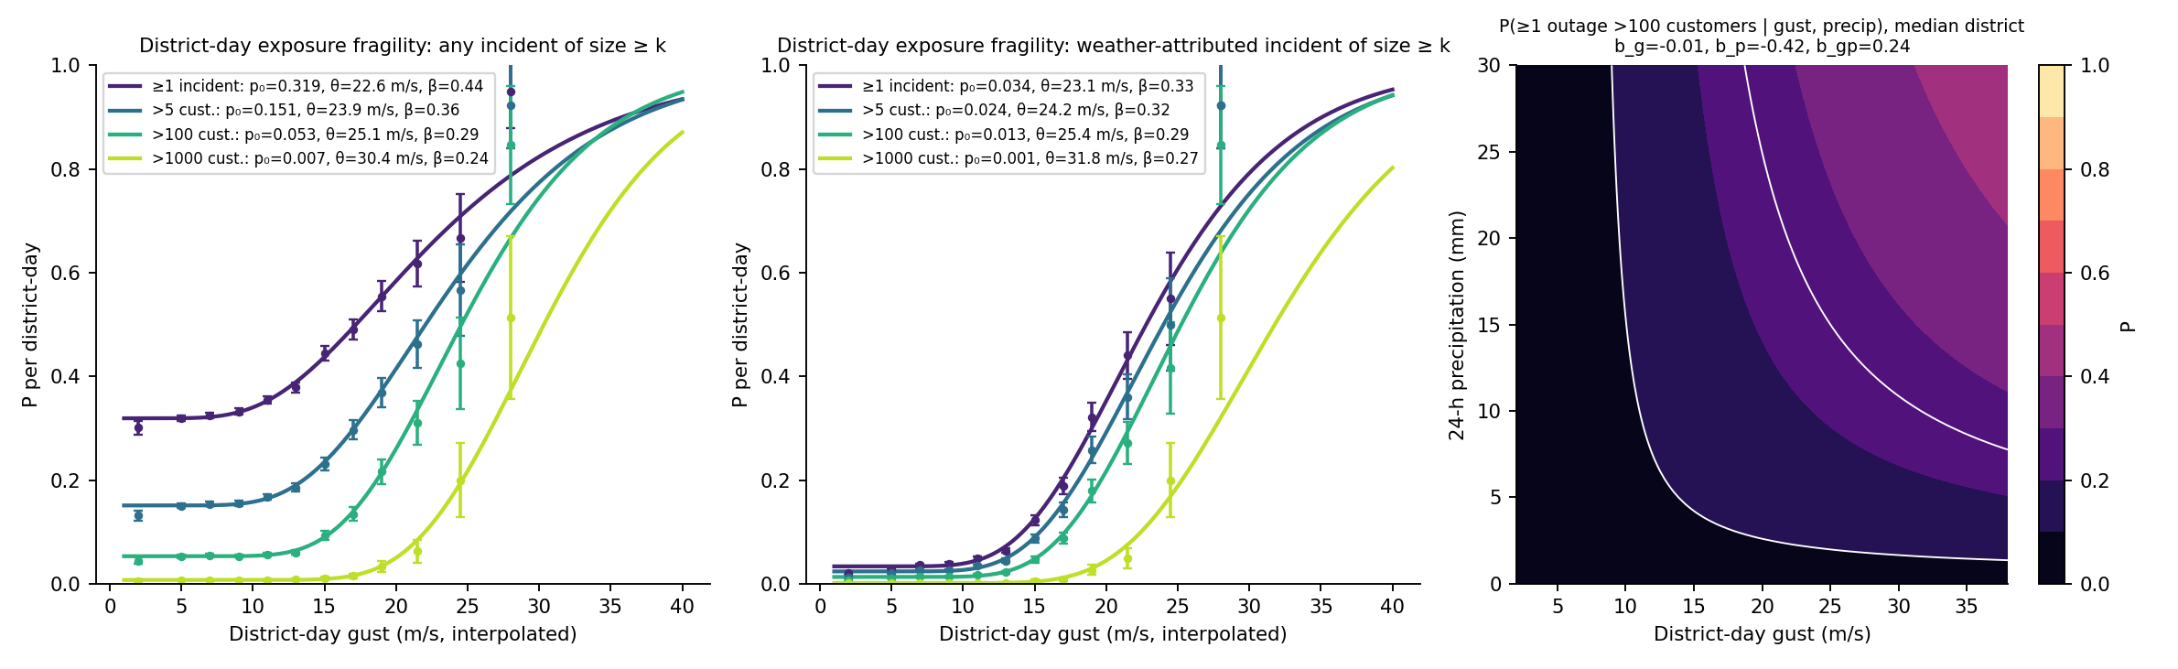
Fig. 3 | District-day exposure fragility. Left: probability that a district experiences at least one incident of the given size on a day, any cause. Centre: weather-attributed incidents. Points: empirical frequencies by gust band with 95% CI over 121,656 district-days; lines: background-rate lognormal fits. Right: probability of at least one outage above 100 customers as a function of gust and 24-h precipitation at the median district, probit with interaction; white contours at 0.1, 0.25 and 0.5. (In the submitted version the right panel becomes Fig. 4.)
Table 2 | Fragility parameters per district-day (in the submitted version, merged into Fig. 3 as an inset).
Size threshold | Occurrence | Base rate | p₀ | θ (m/s) | β
≥1 incident | any cause | 0.345 | 0.319 | 22.6 | 0.44
>5 cust. | any cause | 0.167 | 0.151 | 23.9 | 0.36
>100 cust. | any cause | 0.061 | 0.053 | 25.1 | 0.29
>1000 cust. | any cause | 0.008 | 0.007 | 30.4 | 0.24
≥1 incident | weather-attributed | 0.050 | 0.034 | 23.1 | 0.33
>5 cust. | weather-attributed | 0.036 | 0.024 | 24.2 | 0.32
>100 cust. | weather-attributed | 0.020 | 0.013 | 25.4 | 0.29
>1000 cust. | weather-attributed | 0.003 | 0.001 | 31.8 | 0.27

Discussion
Two numbers summarise the incident-level results and are, we argue, the operational thresholds a distribution operator should carry: an onset at 14 m/s (Beaufort 7, the wind at which loose material and small branches begin to move) below which wind does not determine the size of an outage, and a plateau from 25 m/s (Beaufort 10) above which the customers affected in a district are bounded by network topology — a constraint the unconstrained fit does not reject — while restoration time keeps growing. Both are estimated with intervals, both survive district-grouped resampling, nested cross-validation and an independent temporal split, and neither is a turning point of a parabola. The critical wind speed of 10.8 m/s reported from a quadratic fit in an earlier version of this analysis is the vertex of a curve forced through a response with a floor and a plateau; its instability between samples was a symptom of mis-specification, and we recommend against its use.
The district-day fragility function is the result that connects operational records to the engineering literature. It has the same lognormal form as component fragility curves [7–10, 28, 30], a median of 23–25 m/s for an outage of up to 100 customers in a district, and a floor for faults that do not depend on weather. Its median is well below those reported for the structural failure of individual poles or towers, as it should be: a district contains thousands of spans, conductors and vegetation-clearance margins, any of which can fail, so the network-level median is an extreme-value quantity of the component distribution. Convolved with a district gust hazard curve, the function gives the annual frequency of an outage of a given size per district — a calculation the incident-level regressions cannot support, and the natural next step. The near-coincidence of the weather-attributed curves across size thresholds says that the question for a storm is not whether the outage will be large but whether it will occur, which is also why the incident-conditional models, which ask how large, explain so little.
Three secondary findings bear on operations. Larger incidents are restored proportionally faster once 8,661 zero-customer incidents carrying a placeholder duration of exactly 1.000 h are removed from the record — consistent with dispatch prioritisation and contrary to the independence found for US utilities [26]. Wet storms produce fewer large outages and shorter restorations than dry ones at the same gust; whether this reflects conductor loading, forecast quality or storm type cannot be resolved here. And the low mode of the restoration-time distribution, at 30–35 minutes, is automatic reclosure, which weather alone cannot separate from sustained faults; a reclosure flag would be the most useful single addition to the record.
The district gust used for the fragility function is interpolated from the same day's incident locations; it is validated against held-out districts but a gridded daily maximum should replace it. The models contain no asset information, the confirmation sample covers a single winter, and the curves above 30 m/s rest on a few hundred district-days. The approach — reconstructing event-level outcomes from stage-level records, estimating rather than assuming the shape of the response, and moving from incidents to exposure units — applies to any operator that reports at stage level.

Methods

Data and outcome construction
UKPN's outage records for 1 April 2021 – 31 March 2024, reported under Ofgem's RIIO-ED1/ED2 Annex F guidance [11, 12], comprise 116,064 restoration stages. Incidents are grouped by cause code into six categories; the weather-related and asset-related categories (network faults; 60,453 incidents) are retained and the four others (no fault found, third-party, human error, customer-side) excluded as unrelated to wind by construction. Affected customers Cᵢ is the sum over an incident's stages of the customers reported at each stage, excluding re-interruption stages; restoration duration Dᵢ is the span from earliest stage start to latest stage end. Weather at each incident's coordinates and starting hour is taken from ERA5-based hourly reanalysis via Open-Meteo [13, 14]: instantaneous gust, temperature, mean sea-level pressure and 24-h cumulative precipitation. District covariates (log population, income deprivation rate, within-district deprivation range, Moran's I of deprivation, urban–rural indicator) are from ONS [17–20]. After weather matching and covariate completeness the exposure sample has 60,437 incidents. The recovery sample excludes durations above the 99th percentile (59,834) and then incidents that interrupted no customers (51,173): 66.5% of those carry a duration of exactly 1.000 h against 0.5% of other incidents, and a restoration time is undefined when nobody was interrupted. Weather-attributed samples restrict to cause codes naming weather (9,857 and 9,254).

Regression models
Both margins are fitted by ordinary least squares on the log outcome (log(1 + Cᵢ); log Dᵢ) with weather covariates standardised on the training sample, unstandardised district covariates, and additive year and month effects. The exposure model uses a three-segment gust response — a free slope below the onset knot k₁ (min(g, k₁)), a ramp between the knots (min(max(g − k₁, 0), k₂ − k₁)) and no term beyond k₂, so that affected customers are constant above the plateau knot — with gust × pressure, and temperature and its square; the recovery model uses gust and gust², gust × precipitation, temperature and its square, and log(1 + Cᵢ) and its square. District fixed effects are excluded because with 110 dummies the model is best in-sample and worst when whole districts are held out (cross-validated RMSE 2.10 against 1.99 for exposure). Negative-binomial, gamma and Tweedie alternatives give the same gust coefficients in sign and significance (Supplementary H).

Specification search and knot estimation
Candidate gust forms (linear, quadratic, cubic, log, percentile step dummies, one-knot hinge, unconstrained two-hinge, and the three-segment plateau) are compared with the same covariates on AIC, BIC and out-of-sample RMSE under three cross-validation schemes: random incident split, five folds of whole districts, and leave-one-year-out. Knots are estimated by profiling the residual sum of squares over 1 m/s grids (single knot 8–30 m/s; pairs k₁ ∈ 8–20, k₂ ∈ 18–34, gap ≥ 4 m/s) [27]; two knots are tested against one by likelihood ratio (2 df), a joint 95% region is the set of pairs within the χ²₂ critical value of the optimum, and percentile intervals come from 500 bootstrap resamples of whole districts with knots re-estimated each time. A two-knot model is retained only if the second knot is significant at 1% and both bootstrap intervals are at most 6 m/s wide; the plateau constraint (zero slope beyond k₂) is tested against the unconstrained two-hinge form by likelihood ratio with one degree of freedom. Nested cross-validation re-selects the knots inside each district-grouped training fold. Knots are re-estimated on the weather-attributed samples.

Validation and inference
The primary validation holds out whole districts (five folds), with standardisation and knot selection repeated inside each training fold; leave-one-year-out is secondary; a random incident split is reported for comparison only. The final specifications are also fitted separately on a development sample (to 29 September 2023) and a confirmation sample (30 September 2023 – 31 March 2024) [23]. Standard errors are clustered by district and by date simultaneously [24, 29], with p-values from a t distribution on 110 degrees of freedom; district-only clustering understates the gust-term standard errors by a factor of 1.3–2.3. Marginal out-of-sample R² by variable group is obtained by adding blocks (district + calendar; non-gust weather; gust; affected customers) in sequence under district-grouped cross-validation.

District-day panel and fragility functions
The panel comprises the 121,656 combinations of 111 districts and 1,096 days. Daily district gust and precipitation are interpolated to each district's incident-weighted centroid from that day's incident-level observations by Gaussian-kernel inverse-distance weighting (bandwidth 40 km, minimum five neighbours); every date has at least 15 incidents in at least 13 districts, and incident gusts within a district-day have a standard deviation of about 1.8 m/s. Leaving each district's own incidents out, the interpolated gust reproduces the observed district-day mean with RMSE 2.2 m/s, correlation 0.85 and bias −0.08 m/s. Damage states are defined by the largest outage in the district on the day (any; >5; >100; >1,000 customers), for any cause and for weather-attributed cause. The fragility function P(DS ≥ k | g) = p₀ + (1 − p₀)Φ((ln g − ln θ)/β) is fitted by binomial maximum likelihood [28, 30] with p₀ on a logit scale and multiple starting values. The gust × precipitation surface is a probit in ln g, ln(1 + p), their product and log population, with monotonicity in gust checked from the sign of the partial derivative of the linear index over the observed domain.

Data availability
Analysis samples, the district-day panel and all results tables are provided with the code package. [Deposit DOI to be added.] The underlying stage-level records are available from UK Power Networks under its open-data licence.

Code availability
All analysis and figure code (Python 3.12; pandas, numpy, scipy, statsmodels, matplotlib) is provided in the package STST2603_review. [Repository URL to be added.]

References
[1] Institute for Government. Energy resilience [Internet]. [date unverified]. Available from: https://www.instituteforgovernment.org.uk/explainer/energy-resilience
[2] Ofgem. Storm Arwen report [Internet]. [title, date unverified]. Available from: https://www.ofgem.gov.uk/research/storm-arwen-report
[3] Guikema SD, Quiring SM, Han SR. Prestorm estimation of hurricane damage to electric power distribution systems. Risk Analysis. 2010;30(12):1744-1752.
[4] Liu H, Davidson RA, Apanasovich TV. Statistical forecasting of electric power restoration times in hurricanes and ice storms. IEEE Transactions on Power Systems. 2007;22(4):2270-2279.
[5] Nateghi R, Guikema SD, Quiring SM. Comparison and validation of statistical methods for predicting power outage durations in the event of hurricanes. Risk Analysis. 2011. [volume, pages unverified]
[6] Mukherjee S, Nateghi R, Hastak M. A multi-hazard approach to assess severe weather-induced major power outage risks in the U.S. Reliability Engineering & System Safety. 2018;175:283-305.
[7] Dikshit S, Alipour A. Characterizing probability of failure of transmission tower systems under multiple climatic hazards: wind and ice. Engineering Structures. 2025;342:120720.
[8] Zhu X, Ou G. Wind fragility modeling of transmission tower-line system based on threat-dependent structural robustness index. Structural Safety. 2025;114:102571.
[9] Ma L, Khazaali M, Bocchini P. Component-based fragility analysis of transmission towers subjected to hurricane wind load. Engineering Structures. 2021;242:112586.
[10] Kabre WW, Weimar MR. Fragility functions resource report: documented sources for electricity and water resilience valuation. PNNL-33587. Richland (WA): Pacific Northwest National Laboratory; 2022.
[11] Office of Gas and Electricity Markets. RIIO-ED1 regulatory instructions and guidance: Annex F. London: Ofgem. [date unverified].
[12] Office of Gas and Electricity Markets. RIIO-ED2 regulatory instructions and guidance: Annex F – interruptions. London: Ofgem; 2023.
[13] Open-Meteo. Historical weather API [Internet]. [date unverified]. Available from: [URL unverified]
[14] Hersbach H, Bell B, Berrisford P, Hirahara S, Horanyi A, Munoz-Sabater J, et al. The ERA5 global reanalysis. Quarterly Journal of the Royal Meteorological Society. 2020;146:1999-2049.
[15] American Society of Civil Engineers. Minimum design loads and associated criteria for buildings and other structures. ASCE/SEI 7. [edition unverified].
[16] [authors unverified]. The risk of cascading failures in electrical grids triggered by extreme weather events. arXiv:2107.00829. [publication status unverified].
[17] Office for National Statistics. Explore local statistics [Internet]. 2025. Available from: [URL unverified]
[18] Office for National Statistics. Mapping income deprivation at a local authority level [Internet]. 2021. Available from: [URL unverified]
[19] Moran PAP. Notes on continuous stochastic phenomena. Biometrika. 1950;37(1-2):17-23.
[20] Office for National Statistics. Local Authority Districts (December 2021) boundaries UK BGC [Internet]. Available from: https://open-geography-portalx-ons.hub.arcgis.com/datasets/ons::local-authority-districts-december-2021-boundaries-uk-bgc
[21] O’Brien RM. A caution regarding rules of thumb for variance inflation factors. Quality & Quantity. 2007;41(5):673-690.
[22] McCullagh P, Nelder JA. Generalized linear models. 2nd ed. London: Chapman and Hall; 1989.
[23] Cox DR. A note on data-splitting for the evaluation of significance levels. Biometrika. 1975;62(2):441-444.
[24] Cameron AC, Miller DL. A practitioner’s guide to cluster-robust inference. Journal of Human Resources. 2015;50(2):317-372.
[25] Oehlert GW. A note on the delta method. The American Statistician. 1992;46(1):27-29.
[26] Wu H, Meng X, Danziger MM, Cornelius SP, Tian H, Barabási AL. Fragmentation of outage clusters during the recovery of power distribution grids. Nature Communications. 2022;13:7372.
[27] Muggeo VMR. Estimating regression models with unknown break-points. Statistics in Medicine. 2003;22(19):3055-3071.
[28] Baker JW. Efficient analytical fragility function fitting using dynamic structural analysis. Earthquake Spectra. 2015;31(1):579-599.
[29] Cameron AC, Gelbach JB, Miller DL. Robust inference with multiway clustering. Journal of Business & Economic Statistics. 2011;29(2):238-249.
[30] Porter K, Kennedy R, Bachman R. Creating fragility functions for performance-based earthquake engineering. Earthquake Spectra. 2007;23(2):471-489.

Supplementary Information (from the extended paper)
- Supplementary Fig. 1: knot estimation — profiles, likelihood-ratio surface, bootstrap (extended Fig. 4)
- Supplementary Fig. 2: marginal out-of-sample R² by variable group, both samples (extended Fig. 7)
- Supplementary Fig. 3: incident-level exceedance curves and why they are not fragility functions (extended Supplementary H)
- Supplementary Fig. 4: final-model responses with clustered bands and out-of-fold calibration (extended Fig. 5)
- Supplementary Fig. 5: predicted-versus-observed grids and residual bias by gust band (extended Supplementary G)
- Supplementary Fig. 6: storm-by-storm predicted-versus-observed (extended Supplementary I)
- Supplementary Tables: specification ladder; full coefficient tables; weather-attributed coefficients; development/confirmation comparison; fragility parameters with surfaces

