Appendix A. Variable definitions and data dictionary

A.1 Outcome variables
Affected customers ($C_{i}$) and restoration duration ($D_{i}$) follow Equations 1 and 2 in Section 2.2. A small number of boundary cases, for which $C_{i}$ is undefined rather than zero, are treated as missing and excluded from the estimation sample. These cases are detailed in Appendix B.4. Restoration duration is computed from the start and end timestamps of all recorded stages, including those flagged as re-interruptions. The exclusion applied to affected customers is not applied to restoration duration, because a re-interruption stage still represents a period during which some customers are without supply, even though it is excluded from the customer count to avoid double-counting.

A.2 Cause Code categories
UKPN records a numeric or short alphanumeric Cause Code for each incident. This paper groups these codes into six categories for analysis. Table A1 reports the original codes assigned to each category.
Table A1. Cause Code categories and their constituent original codes.
Category | Original codes
Weather-related | 01, 02, 03, 04, 05, 06, 07, 10, 18, 21, 23, 24, 25, 30, 32, 33
Asset-related | 14, 15, 16, 17, 19, 22, 26, 64, 67, 70, 71, 72, 73, 76, 77, 78, 90, A1, A2
Third-party | 39, 40, 41, 42, 43, 44, 45, 48, 49, 50, 53, 54, 55, 56, 57, 58
Human error | 60, 61, 62, 63, 65, 66, 68, 69, 81, 82, 83, 84
External or customer | 74, 80, 85, 86, 87, 88, 89
No fault found or unknown | 75, 97, 98, 99, D, X
These category labels are an analytical grouping constructed for this paper. A published mapping from individual numeric codes to official descriptive names (for example, a specific meaning for code 01) was not located in the underlying project records and is not required for the category-level analysis reported here.

A.3 Regional covariates
Table A2 reports the source, computation, and granularity of each regional covariate.
Table A2. Regional covariate sources.
Variable | Source | Computation | Granularity
Log population | ONS population estimates, detailed time series | Annual Local Authority District population estimates | LAD by year
Income deprivation rate | English Indices of Deprivation 2019, income deprivation domain | Official LAD-level rate, used as published | LAD, single cross-section
Deprivation gap | English Indices of Deprivation 2019 | Within-district range in income deprivation score between the most and least deprived neighbourhoods in each district, as published. Neighbourhoods are defined by Lower Layer Super Output Areas (LSOAs), a smaller ONS statistical geography nested within each LAD | LAD, single cross-section
Moran's I | English Indices of Deprivation 2019 | Official LAD-level spatial clustering statistic for income deprivation, used as published | LAD, single cross-section
Urban-rural indicator | English Indices of Deprivation 2019, rural-urban classification | Binary indicator, coded 1 where the underlying text classification contains "urban" | LAD
Moran's I, as used in this paper, is calculated separately for each district, using only the Lower Layer Super Output Areas (LSOAs) within that district's own boundary. It is not calculated on a single nationwide network of neighbouring LSOAs, and it does not treat districts themselves as adjacent to one another. This district-bounded construction means that deprivation clusters spanning a district boundary, such as a continuous deprived area split between two neighbouring districts, are not captured by either district's individual value [18]. It is not a spatial autocorrelation term computed on outage outcomes, and the two should not be conflated. The specific spatial weighting scheme used within each district's set of LSOAs (for example, shared-boundary or shared-vertex adjacency) is not stated in the available published documentation and is not established here. The deprivation gap is a within-district measure of internal disparity, the range between the most and least deprived neighbourhoods inside a given district, and does not compare a district against a national figure despite its name. Income deprivation rate, the deprivation gap, and Moran's I are all drawn from the same underlying deprivation dataset and are moderately to highly correlated with one another at the district level, as would be expected of related measures of the same underlying construct.

A.4 Geographic boundaries
Local Authority District boundaries follow the December 2021 generalised boundary product published by the Office for National Statistics, in the British National Grid coordinate system (EPSG:27700). All geographic figures in this paper are projected to this coordinate system.

A.5 Distribution fitting for continuous covariates
The continuous covariates listed in Table 2, together with gust speed, were each fitted to 89 candidate continuous probability distributions to describe their marginal shapes. Parameters were estimated by maximum likelihood using a fixed random subsample of 5,000 observations per variable for computational efficiency. The reported means and standard deviations were calculated from the full final combined sample. Candidate distributions were ranked within each variable by their residual sum of squares (RSS). Table A3 reports the selected distributions, fitted parameters, sample summary statistics, and Kolmogorov–Smirnov (KS) statistics. The KS statistic measures the maximum absolute difference between the empirical and fitted cumulative distribution functions, providing a scale-free measure of fit for comparison across variables.
Table A3. Best-fitting distribution for each continuous covariate.
Variable | Best-fitting distribution | Parameters | Mean | SD | KS statistic
Gust speed | mielke | k = 2.0819, s = 3.7633  loc = 0.7695, scale = 10.4598 | 9.9100 | 5.2796 | 1.2393
Mean sea level pressure | alpha | a = 4.8929 × 10⁻⁸  loc = -0.3395, scale = 0.5585 | 3.2509 | 5.2595 | 2.5637
Temperature | alpha | a = 14.7723  loc = -76.8672, scale = 1304.2349 | 11.8834 | 6.0988 | 0.3071
24-hour cumulative precipitation | weibull_min | c = 8.6102  loc = 917.9236, scale = 99.6371 | 1012.0745 | 13.0751 | -0.6525
Log population | weibull_min | c = 2.4375  loc = 11.0309, scale = 1.1746 | 12.0712 | 0.4847 | -0.2888
Income deprivation rate | triang | c = 2.1946 × 10⁻⁹  loc = 0.0530, scale = 0.1585 | 0.1088 | 0.0382 | 0.4282
Deprivation gap | foldnorm | c = 1.7815  loc = 0.1130, scale = 0.0868 | 0.2725 | 0.0829 | 0.4199
Moran's I | dgamma | a = 1.8303  loc = 0.2549, scale = 0.0761 | 0.2795 | 0.1669 | 0.1113
Note: Distribution names and parameters follow scipy.stats; loc and scale denote location and scale parameters, respectively, and the remaining parameters control distribution shape. Before location and scale transformations, Mielke (Beta-Kappa) is a flexible positive-valued distribution with two shape parameters; Alpha is the reciprocal of a normal random variable conditioned to be positive; Weibull (minimum) is the minimum extreme-value form of the Weibull family; Triangular has a piecewise-linear density on a bounded interval; Folded normal is the distribution of the absolute value of a normal random variable; and Double gamma is a symmetric extension of the gamma distribution to both sides of zero. Mean, SD (standard deviation), and skewness are sample statistics, not moments of the fitted distributions. “Best-fitting” denotes the lowest RSS among the candidate distributions.
Mean sea level pressure, gust speed, and temperature have the lowest KS statistics (0.0119–0.0217), indicating the closest agreement between their empirical and fitted cumulative distributions. Precipitation has the highest KS statistic (0.1989). Its poorer fit is consistent with the substantial concentration of observations at zero: 28.6 percent of incidents (17,282 of 60,453) have zero recorded 24-hour cumulative precipitation. A continuous distribution cannot assign positive probability mass to this single value. A two-part model combining a point mass at zero with a continuous distribution for positive precipitation would explicitly represent this feature, but was not fitted here. Figure A1 compares the observed marginal distributions with the fitted probability density functions for all eight variables.
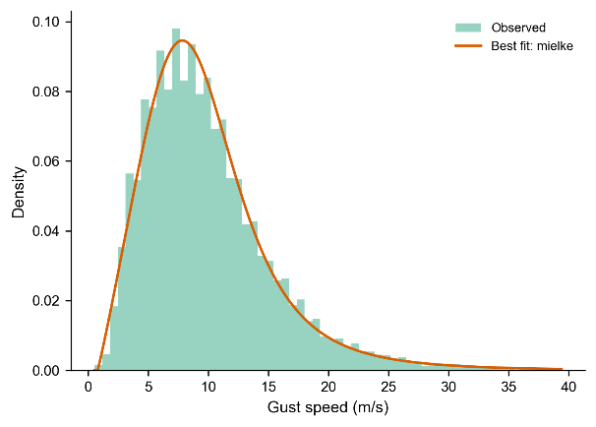 | 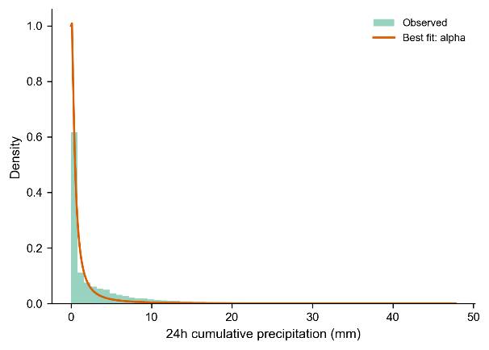
(a) | (b)
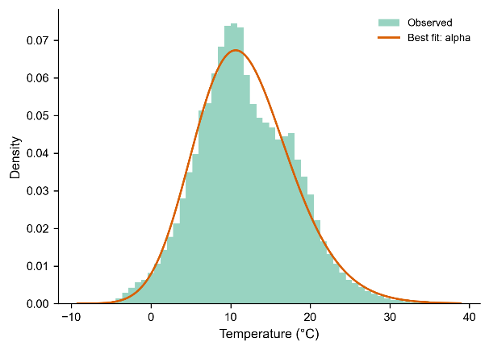 | 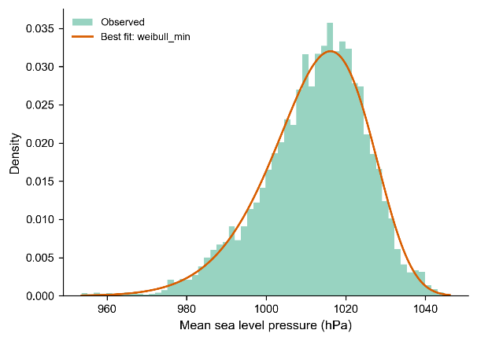
(c) | (d)
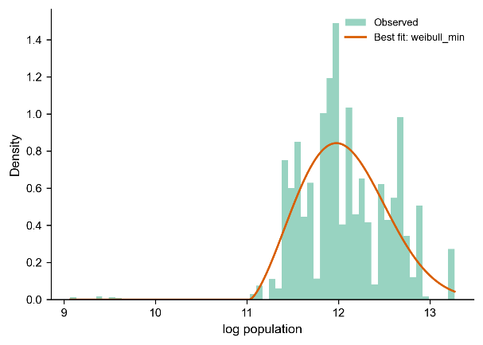 | 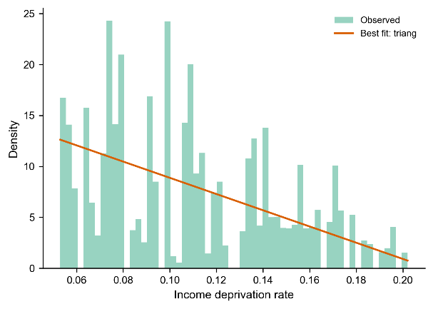
(e) | (f)
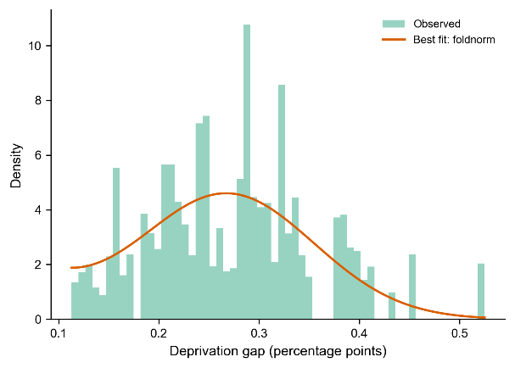 | 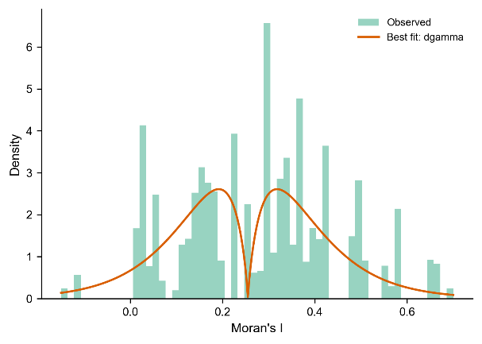
(g) | (h)
Figure A1. Observed and fitted marginal distributions of continuous covariates.
Panels show: (a) gust speed, (b) 24-hour cumulative precipitation, (c) temperature, (d) mean sea level pressure, (e) log population, (f) income deprivation rate, (g) deprivation gap, and (h) Moran’s I.
Note: Green histograms show the observed probability densities, and orange curves show the fitted probability density functions for the distributions reported in Table A3.

A.6 Open items in the data dictionary
Two aspects of the underlying data could not be confirmed at the level of an official data dictionary or regulatory documentation. First, the exact meaning of incidents recorded with zero affected customers has not been confirmed. Candidate explanations, such as brief voltage disturbances or automatic reclosure events that do not correspond to a sustained loss of supply, remain plausible but unverified. This limitation is also noted in Section 5. Second, a separate field recording whether an incident was linked to an officially designated exceptional event is present in the underlying data, but is populated for only a small fraction of incidents and was not examined further in this paper.

Appendix B. Data reconstruction: full evidence chain

B.1 Comparison against the earliest-stage convention
Within the final analysis sample (n = 60,437), the mean of affected customers computed by aggregating across stages, following Equation 1, is 93.02. The mean computed using only the customer count reported in the earliest stage of each incident, the convention used when an incident is treated as equivalent to its first recorded stage, is 47.13. The two figures differ by a factor of 1.97 within the same sample.

B.2 Choice of restoration duration measure
Two candidate measures of restoration duration were considered before settling on the definition used throughout this paper. The first, referred to during development as a customer-weighted average stage duration, weights each stage's duration by the number of customers affected at that stage. The second is the total incident span defined in Equation 2. Across the full reconstructed dataset (n = 135,025), the customer-weighted measure differs from the earliest-stage convention for 30.6 percent of incidents (those with more than one restoration stage), with a median relative difference of 54.3 percent among this subset.
The customer-weighted measure was found to share its underlying weighting denominator with affected customers by construction, producing a correlation between the two that is not present when a measure with a different pointwise construction is used instead. A counterfactual check, applying the same weighting logic to the current best simplified alternative, found that the coefficient collapse observed when controlling for the customer-weighted measure's construction does not occur when the shared-denominator relationship is absent. On this basis, the total incident span (restoration duration, as reported throughout this paper) was adopted in preference to the customer-weighted measure. This comparison, including the specific correlation coefficients between the two candidate measures, was carried out on data collected before the contamination described in Appendix E was identified and corrected, and has not been repeated on the corrected sample. The choice it supports did, however, materially inform the selection of restoration duration as defined in Equation 2. Restoration duration, as defined, does not exclude short intervals during an incident when supply was briefly restored between recorded stages. It measures the full recorded span of the incident from its first to its last stage.

B.3 Manual cross-check
A sample of 500 incidents (250 drawn from incidents with a single restoration stage and 250 from incidents with more than one stage, using a fixed random seed) was independently reconstructed directly from the underlying stage-level fields, without reference to any pre-aggregated columns in the dataset. Affected customers matched exactly for all 500 incidents. Restoration duration matched to within floating-point precision (maximum absolute difference on the order of ${10}^{-15}$ hours) for all 500 incidents.

B.4 Boundary cases
Sixty-nine incidents, all with more than one recorded restoration stage, have every stage flagged as a re-interruption. For these incidents, affected customers is undefined under Equation 1 and is recorded as missing rather than zero. These incidents are excluded from both the exposure and recovery models on this basis.

B.5 Incidents with an apparently missing first stage
Restoration stages are numbered sequentially within each incident. For 14,264 incidents (10.56 percent of the full reconstructed dataset of 135,025 incidents), the lowest recorded stage number is 2 or higher, meaning no stage numbered 1 is present in the data. This pattern is distributed evenly across the study period rather than concentrated at its boundaries, consistent with a general property of how stages are numbered in the underlying reporting system rather than a data quality problem specific to any part of the study period. These incidents are retained in the analysis sample without adjustment. A sensitivity check comparing results with and without these incidents was identified as a candidate check during data reconstruction but was not subsequently carried out.

Appendix C. Sample restriction: full six-category comparison
A complete coefficient table, covering every covariate in the recovery model, is available for the two-category sample used as the main specification throughout this paper (Appendix F). An equivalent complete table for the full six-category sample was not produced during this project. Only the gust coefficients were compared across the two samples at the time this check was carried out. Table C1 reports this comparison.
Table C1. Gust coefficients, six-category sample versus the two-category main specification.
Term | Six categories (n = 116,064) | Main specification (n = 59,834)
Linear term, same sign across folds | 5/5 | 5/5
Linear term, significant folds | 5/5 | 0/5
Linear term, mean coefficient | 0.0257 | 0.0002
Quadratic term, same sign across folds | 5/5 | 5/5
Quadratic term, significant folds | 5/5 | 5/5
Quadratic term, mean coefficient | 0.0608 | 0.0792
Quadratic term, coefficient of variation | 19.82% | 12.5%
Restricting the sample from six categories to the two used as the main specification leaves the quadratic term essentially unchanged in magnitude and fold-level significance, while the linear term collapses from a stable, significant effect to one indistinguishable from zero.

Appendix D. The apparent non-monotonic relationship between affected customers and restoration duration
Section 2.3 reports that affected customers and restoration duration are close to independent under linear and monotonic measures of association, but not under a nonlinear dependence measure. This appendix reports the investigation behind that finding and behind the treatment of affected customers as a covariate in the recovery model.

D.1 Number of restoration stages
Restoration stages per incident, denoted $n_{stages}$, range from a single stage to several hundred. The investigation in Sections D.1 to D.6 was carried out on the development sample described in Section 3.2 (n = 47,840), a subset of the final combined sample (n = 59,834) used elsewhere in this paper. Table D1 reports the distribution of restoration stages within this development sample.
Table D1. Distribution of restoration stages per incident.
Stages | n | Share
1 | 28,328 | 59.2%
2 | 7,563 | 15.8%
3–4 | 6,361 | 13.3%
5–9 | 4,786 | 10.0%
10+ | 802 | 1.7%

D.2 Relationship within incidents with a single stage
Among incidents with exactly one restoration stage (59.2 percent of the sample), affected customers and restoration duration show a monotonic negative relationship: mean restoration duration falls from 11.45 hours in the lowest range of affected customers to 3.80 hours in the highest range, with the two lowest ranges close to one another and the decline concentrated at higher values of affected customers.

D.3 Relationship within incidents with more than one stage
Among incidents with more than one restoration stage, the same relationship is also monotonically negative, both pooled across all such incidents and within each stratum defined by the exact number of stages (two stages, three to four stages, and five or more stages). No individual stratum shows a rise followed by a fall.

D.4 Source of the apparent non-monotonic pattern in the pooled sample
When affected customers and restoration duration are examined without separating incidents by the number of restoration stages, the relationship between them appears to rise and then fall. This pattern arises because incidents with more restoration stages both tend to have higher affected customers, by construction, and tend to have longer restoration durations, for reasons unrelated to affected customers itself. As affected customers increases, the pooled sample contains a growing share of multi-stage incidents, which carries longer typical restoration durations into the middle of the affected-customers range. This composition shift, not a direct effect of affected customers on duration, accounts for the rising portion of the pooled pattern.
Figure D1 illustrates this directly. Affected customers is divided into four quartile bins computed on the full sample (n = 59,834), a common set of bins applied across all four restoration-stage strata so that the two panels can be compared on the same horizontal axis. These bins differ from the subset-specific quantile bins used in Sections D.1 and D.3, which were computed separately within each subset and are not comparable to one another on a shared axis. Figure D1a shows mean restoration duration by this shared customer bin, separately for each stratum. Figure D1b shows the same relationship without separating by stratum.
In Figure D1a, three of the four strata (single-stage, two-stage, and three-to-four-stage incidents) decline from the first bin onward, with the three-to-four-stage stratum showing the steepest decline, from 40.6 hours in the lowest bin to 9.4 hours in the highest. The stratum of five or more stages does not show a clean decline under this shared binning: mean duration rises from the lowest to the second bin before levelling off and then declining slightly. The lowest two bins for this stratum contain only 22 and 18 incidents respectively, because multi-stage incidents rarely fall into the lowest customer bins, and this pattern is treated as a small-sample artefact of the shared binning rather than as a systematic feature of this stratum, which shows a mild decline under its own subset-specific bins in Section D.3. In Figure D1b, the pooled relationship rises from 11.65 hours in the lowest bin to a peak of 14.19 hours in the second bin, before declining to 9.87 hours in the highest bin. No stratum in Figure D1a shows a comparable rise over the same two bins, other than the small-sample pattern noted above.

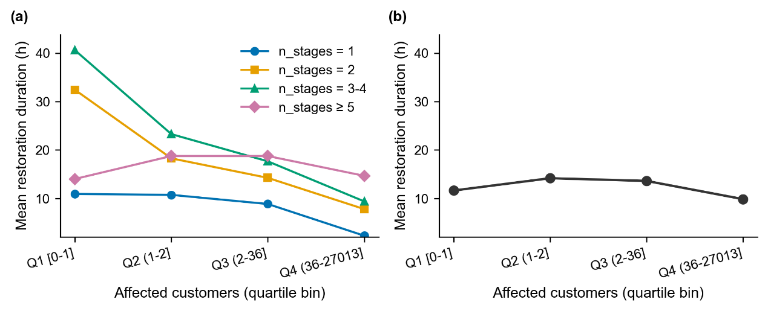
Figure D1. Mean restoration duration by affected-customers quartile bin (computed on the full sample). (a) By number of restoration stages. (b) Pooled across all incidents, without separating by stage count.

D.5 Regression evidence
Table D2 reports the coefficients on affected customers in the recovery model, with and without a control for the logarithm of the number of restoration stages, estimated on the development sample described in Section D.1 (n = 47,840). These coefficients differ from the corresponding uncontrolled coefficients reported for the final combined sample in Table F2 (n = 59,834, affected customers coefficients of 0.339 and -0.396), because the two tables use different samples under an otherwise identical specification, not because of any difference in method.
Table D2. Coefficients on standardised log(1 + affected customers) and its square, with and without log(stage count), earlier-period recovery sample (n = 47,840).
Term | Without control | With control for log(stages)
Linear term | +0.307 (p < 0.001) | -0.236 (p < 0.001)
Quadratic term | -0.381 (p < 0.001) | -0.301 (p < 0.001)
log(stages) | — | +0.971 (p < 0.001)
Adding log(stage count) changes the linear customer coefficient from +0.307 to -0.236 and reduces the magnitude of the negative quadratic coefficient by approximately 21 percent. For the standardised log-customer predictor $X$, the fitted slope is $a+2bX$, so the linear coefficient alone does not establish monotonicity over its observed support. The change is consistent with sensitivity to stage composition; a full derivative-based comparison would require the relevant scaling and covariate range.

D.6 Interpretation
The stratified means and the regression with a stage control show that the pooled customer–duration pattern depends on restoration-stage composition. Stage count is positively associated with duration, but additional records within the same time window would not necessarily lengthen the span. Stage count may itself reflect fault complexity and restoration sequencing, so it is not automatically a pre-existing confounder. These checks do not identify crew prioritisation, prove that composition is the only explanation or rule out mediation. Gust curvature was reported to remain positive when the stage control was added; this is a sensitivity observation on related data.

D.7 The same investigation within the weather-attributed subsample
This section describes the reported weather-attributed recovery subset from the final combined sample, rather than the earlier-period-only regression basis of Table D2. Its reported multi-stage share is 49.7 percent. For the final combined recovery sample, the stage counts given in Section D.1 imply a multi-stage share of approximately 40.5 percent. The weather-subset single-stage customer–duration pattern was reported as decreasing in grouped summaries.
In the weather-attributed subset, the linear customer coefficient is already negative without a stage control and becomes more negative after adding it. This differs from the earlier-period main-sample sign reversal in Table D2. The findings indicate sensitivity to sample and conditioning, but do not fully identify its source. The available local audit does not provide a new full coefficient table for this subset; no additional numerical estimates are inferred here.

Appendix E. Discovery and correction of development-sample contamination
An earlier version of the development sample used to establish the model specification in Sections 2 and 3 was found to include a portion of the period later designated as the confirmation sample. The confirmation sample, covering 30 September 2023 to 31 March 2024 (184 consecutive days), was subsequently separated out and excluded from all specification decisions. Table E1 reports the extent of this overlap across three stages of sample construction.
Table E1. Extent of development-sample contamination before correction.
Stage | Contaminated sample | Corrected sample | Removed | Share removed
Full reconstructed dataset | 135,025 | 109,250 | 25,775 | 19.09%
After Cause Code restriction | 66,079 | 53,114 | 12,965 | 19.63%
After weather matching | 62,927 | 50,345 | 12,582 | 20.00%
The share of contamination remains close to one fifth of the sample at each stage of construction.
A small number of incidents (32, or 0.03 percent of the corrected development sample) begin within the development period but extend into the confirmation period. These incidents were retained in the development sample based on their start date, because the weather covariates used throughout this paper are constructed from conditions at and before the start of each incident and do not depend on how the incident subsequently resolves.
Table E2 reports the effect of this correction on the exposure margin's critical wind speed, alongside the final estimate reported in Section 4.1.
Table E2. Critical wind speed for the exposure margin, before and after correction.
Sample | n | Point estimate (m/s) | Coefficient of variation across folds | Bootstrap interval crosses zero
Contaminated development sample | approx. 60,453 | 10.69 | 38.6% | Yes
Corrected development sample | 48,323 | 12.13 | 22.0% | No
Final combined sample (development and confirmation) | 60,437 | 10.81 | — | Yes
The point estimate for the final combined sample coincides numerically with the estimate from the contaminated sample, but this reflects a different underlying sample composition: the contaminated sample mixed development and confirmation data without separating them for validation purposes, whereas the final combined sample deliberately pools the corrected development sample with the confirmation sample after both have served their separate roles in model development and confirmation.

Appendix F. Full robustness results under single and two-way clustering
Section 4.4 reports the two-way clustering result for the core gust coefficients. Tables F1 and F2 report the full coefficient set for both models, comparing standard errors clustered by Local Authority District alone against standard errors clustered by both district and date. Point estimates are identical under both clustering methods, because clustering affects only the standard errors, not the coefficients themselves.
Table F1. Exposure model, full coefficient set under single and two-way clustering (n = 60,437).
Term | Coefficient | SE (LAD) | p (LAD) | SE (two-way) | p (two-way)
Intercept | 3.2846 | 1.0410 | 0.0016 | 1.0453 | 0.0017
Gust (linear) | -0.0360 | 0.0140 | 0.0100 | 0.0217 | 0.0975
Gust (squared) | 0.1060 | 0.0084 | <0.001 | 0.0320 | <0.001
Precipitation | 0.0456 | 0.0105 | <0.001 | 0.0162 | 0.0049
Temperature | -0.0112 | 0.0208 | 0.5922 | 0.0418 | 0.7893
Pressure | -0.0906 | 0.0112 | <0.001 | 0.0231 | <0.001
Gust × pressure | -0.0466 | 0.0087 | <0.001 | 0.0276 | 0.0914
Urban indicator | -0.1557 | 0.0766 | 0.0422 | 0.0768 | 0.0427
Log population | -0.0775 | 0.0887 | 0.3823 | 0.0887 | 0.3821
Income deprivation rate | -3.1798 | 0.9048 | <0.001 | 0.9168 | <0.001
Deprivation gap | 0.1744 | 0.5466 | 0.7497 | 0.5429 | 0.7481
Moran's I | -0.0257 | 0.2408 | 0.9149 | 0.2395 | 0.9144
Year 2022 | 0.0908 | 0.0271 | <0.001 | 0.0358 | 0.0113
Year 2023 | 0.0162 | 0.0304 | 0.5945 | 0.0387 | 0.6753
Year 2024 | -0.0185 | 0.0454 | 0.6843 | 0.0712 | 0.7956
Month 2 | 0.0238 | 0.0425 | 0.5760 | 0.0791 | 0.7639
Month 3 | -0.0251 | 0.0463 | 0.5886 | 0.0693 | 0.7175
Month 4 | -0.0804 | 0.0478 | 0.0923 | 0.0694 | 0.2467
Month 5 | -0.0044 | 0.0521 | 0.9333 | 0.0802 | 0.9566
Month 6 | 0.2606 | 0.0590 | <0.001 | 0.1083 | 0.0161
Month 7 | 0.3059 | 0.0572 | <0.001 | 0.0813 | <0.001
Month 8 | 0.1439 | 0.0556 | 0.0096 | 0.1136 | 0.2052
Month 9 | 0.0614 | 0.0549 | 0.2640 | 0.1018 | 0.5465
Month 10 | -0.0532 | 0.0512 | 0.2987 | 0.0837 | 0.5249
Month 11 | -0.1245 | 0.0425 | 0.0034 | 0.0729 | 0.0877
Month 12 | 0.0750 | 0.0403 | 0.0629 | 0.0628 | 0.2329
Table F2. Recovery model, full coefficient set under single and two-way clustering (n = 59,834).
Term | Coefficient | SE (LAD) | p (LAD) | SE (two-way) | p (two-way)
Intercept | 1.6364 | 0.2610 | <0.001 | 0.2667 | <0.001
Gust (linear) | -0.0010 | 0.0091 | 0.9130 | 0.0181 | 0.9561
Gust (squared) | 0.0850 | 0.0061 | <0.001 | 0.0081 | <0.001
Precipitation | 0.0536 | 0.0060 | <0.001 | 0.0100 | <0.001
Temperature | -0.0713 | 0.0094 | <0.001 | 0.0179 | <0.001
Pressure | -0.0415 | 0.0076 | <0.001 | 0.0158 | 0.0085
Gust × pressure | 0.0214 | 0.0091 | 0.0191 | 0.0174 | 0.2192
Urban indicator | 0.1388 | 0.0364 | <0.001 | 0.0369 | <0.001
Log population | 0.0166 | 0.0228 | 0.4653 | 0.0228 | 0.4652
Income deprivation rate | 0.1832 | 0.5423 | 0.7355 | 0.5457 | 0.7371
Deprivation gap | -0.1821 | 0.4649 | 0.6953 | 0.4610 | 0.6929
Moran's I | 0.2626 | 0.1258 | 0.0368 | 0.1238 | 0.0339
Affected customers (linear) | 0.3356 | 0.0206 | <0.001 | 0.0229 | <0.001
Affected customers (squared) | -0.3958 | 0.0210 | <0.001 | 0.0240 | <0.001
Year 2022 | 0.0400 | 0.0184 | 0.0294 | 0.0262 | 0.1268
Year 2023 | -0.1092 | 0.0194 | <0.001 | 0.0259 | <0.001
Year 2024 | -0.2486 | 0.0315 | <0.001 | 0.0665 | <0.001
Month 2 | 0.3498 | 0.0444 | <0.001 | 0.1037 | <0.001
Month 3 | -0.0184 | 0.0264 | 0.4861 | 0.0381 | 0.6294
Month 4 | -0.0725 | 0.0336 | 0.0309 | 0.0431 | 0.0921
Month 5 | -0.0690 | 0.0349 | 0.0479 | 0.0483 | 0.1525
Month 6 | 0.1164 | 0.0408 | 0.0044 | 0.0549 | 0.0342
Month 7 | 0.0912 | 0.0392 | 0.0201 | 0.0522 | 0.0808
Month 8 | 0.0789 | 0.0371 | 0.0332 | 0.0541 | 0.1444
Month 9 | -0.0021 | 0.0383 | 0.9573 | 0.0495 | 0.9669
Month 10 | -0.0554 | 0.0382 | 0.1470 | 0.0502 | 0.2697
Month 11 | -0.0561 | 0.0306 | 0.0669 | 0.0489 | 0.2513
Month 12 | 0.0110 | 0.0323 | 0.7335 | 0.0461 | 0.8112
Standard errors are generally wider under two-way clustering than under single clustering. The quadratic gust term remains significant beyond conventional thresholds under both clustering methods, for both models. The linear gust term and the gust-pressure interaction term lose significance under two-way clustering for the exposure margin. For the recovery margin, the gust-pressure interaction term likewise loses significance, while the linear gust term, already not significant under single clustering, remains not significant. This is the only systematic pattern of weakening observed across the full covariate set. The same pattern, in which the linear and interaction terms lose significance while the quadratic terms remain significant, was also found when this check was independently repeated on an earlier version of this dataset.

Appendix G. Cause Code assignment and gust speed
Section 4.3 reports that gust's marginal contribution to the exposure margin, while still positive, is smaller within the subsample restricted to incidents for which weather is the recorded cause than in the main sample. This appendix reports the evidence behind the proposed explanation, that Cause Code assignment is not independent of gust speed.
Incidents in the final combined sample were grouped into ten equally sized bins by gust speed, and the share assigned to the weather-related Cause Code category was computed within each bin. This share rises from 6.93 percent in the lowest bin to 57.06 percent in the highest bin, increasing at every one of the nine steps between adjacent bins.
Table G1. Share of incidents assigned to the weather-related Cause Code category, by gust decile.
Gust decile | Share weather-related
Lowest | 6.93%
2nd | 8.06%
3rd | 9.19%
4th | 10.10%
5th | 10.62%
6th | 10.89%
7th | 12.42%
8th | 15.17%
9th | 23.54%
Highest | 57.06%
An incident occurring in calm weather is therefore markedly less likely to be classified as weather-related than an otherwise similar incident occurring in strong wind. Therefore, the subsample of weather-attributed incidents is disproportionately drawn from higher-gust conditions relative to the full sample. Of the incidents below the exposure margin's turning point (10.81 m/s), 65.03 percent fall within the full combined sample, compared with only 37.88 percent within the weather-attributed subsample. Part of this gap reflects the turning point itself, which is estimated slightly higher than in earlier versions of this analysis. The qualitative pattern, that weather-attributed incidents are concentrated above the turning point while the full sample is not, holds regardless of this small shift. This selective depletion of low-gust observations is consistent with the smaller, though still positive, marginal contribution reported for the exposure margin in Table 4, and with the recovery margin being less affected, since its quadratic coefficient does not depend on locating a precise turning point.

Appendix H. Alternative model comparison: functional form and distributional assumptions
Section 3.1 reports that the appropriateness of the quadratic gust term and the log-OLS specification has been checked against alternative curve shapes and alternative distributional assumptions. This appendix reports that check in full. The comparison is a post-hoc exercise carried out after the main specification had already been selected, not a pre-registered blind comparison, and this appendix should be read accordingly. Its purpose is narrow: to establish whether any alternative shows a clear and consistent enough advantage to justify replacing the quadratic specification. It does not establish that the quadratic specification is optimal, that the alternatives considered are practically equivalent to it, or that the quadratic specification is more stable than its alternatives, and none of these three claims is made anywhere in this appendix.

H.1 Problem and comparison protocol
Two families of alternatives are considered. The first varies the functional form used for gust, holding the estimation target, sample, and distributional assumption fixed. The second varies the distributional assumption applied to the outcome, holding the quadratic functional form for gust fixed. Both are checked against the same underlying question: does a more flexible or differently specified model change the conclusions drawn from the simpler main specification.
The functional-form comparison uses the same estimation target as the main specification (log(1 + affected customers) for the exposure margin, log(restoration duration) for the recovery margin), the same final combined sample and truncation rule, and the same five-fold, date-grouped cross-validation protocol described in Section 3.2. One simplification was necessary and is disclosed here directly: none of the four candidate curve shapes include the gust-pressure interaction term present in the main specification, because constructing an equivalent interaction term for the spline and softplus candidates is not straightforward, and including it only for the quadratic candidate would bias the comparison in its favour. The quadratic candidate reported in this appendix is therefore a simplified version of the paper's main specification, omitting this one interaction term. A separate check confirmed that this simplification does not introduce a directional bias: the full main specification's in-sample R-squared (0.0340) and this appendix's simplified quadratic baseline's out-of-sample R-squared (0.0300) are of the same order of magnitude.

H.2 Candidates and construction cost
Four curve shapes for gust are compared, all under the log-OLS specification. The quadratic form is the main specification's baseline, with two parameters and no tuning. A free natural cubic spline, with four degrees of freedom, uses knot positions determined independently within each training fold from that fold's own gust distribution. The degree of freedom itself was fixed in advance rather than selected by a tuning search. A monotonic, U-shaped hinge spline enforces a single-dip shape by constraining two segments to move in opposite, non-negative directions around a knot. The knot position was selected once, by grid search over the full sample, and then applied to all five folds without being re-searched within each fold. A softplus-based form is fitted as a monotonic function of gust, with its two shape parameters found by a multi-start numerical search. This form is mathematically incapable of producing a decline followed by a rise, a property discussed further in Section H.4.
Three distributional alternatives to log-OLS are compared, all under the quadratic functional form for gust, on the final combined sample described in Section 2.4: a negative binomial and a Tweedie specification for the exposure margin, and a gamma and a Tweedie specification for the recovery margin.

H.3 Results
Table H1. Curve-shape candidates, out-of-sample performance relative to the quadratic baseline (log scale). RMSE denotes root mean squared error.
Candidate | Margin | out-of-sample R-squared | High-gust subset R-squared | RMSE difference vs quadratic [95% CI]
Quadratic (baseline) | Exposure | 0.0300 | 0.0303 | —
Free spline (df = 4) | Exposure | 0.0330 | 0.0531 | -0.0031 [-0.0079, 0.0000]
U-shaped hinge spline | Exposure | 0.0332 | 0.0548 | -0.0033 [-0.0084, -0.0002]
Softplus (monotonic) | Exposure | 0.0314 | 0.0538 | -0.0014 [-0.0068, 0.0020]
Quadratic (baseline) | Recovery | 0.1129 | 0.1017 | —
Free spline (df = 4) | Recovery | 0.1124 | 0.0976 | +0.0003 [-0.0002, 0.0011]
U-shaped hinge spline | Recovery | 0.1119 | 0.0935 | +0.0007 [-0.0002, 0.0019]
Softplus (monotonic) | Recovery | 0.1118 | 0.0930 | +0.0008 [-0.0002, 0.0021]
For the exposure margin, the free and U-shaped splines show a small improvement over the quadratic form, with the U-shaped spline's confidence interval not crossing zero, and a more pronounced improvement within the highest decile of observed gust speeds. For the recovery margin, the quadratic form has the best point estimate of the four candidates on both the full sample and the high-gust subset, though none of the three alternatives' confidence intervals excludes zero. Taken together, no single candidate shows a consistent advantage over the quadratic form across both margins. A crossing confidence interval is not treated here as evidence of equivalence between two candidates, only as an absence of a clearly distinguishable difference.
The three distributional alternatives were re-estimated on the same corrected final sample used throughout this paper, reproducing the check reported for an earlier version of this dataset in Section 3.1. Table H2 reports the core gust coefficients under each.
Table H2. Distributional alternatives, gust coefficients (quadratic functional form throughout).
Model | Margin | Gust (linear) | Gust (squared)
Log-OLS (baseline) | Exposure | -0.036 (p = 0.010) | 0.106 (p < 0.001)
Negative binomial | Exposure | -0.137 (p < 0.001) | 0.094 (p < 0.001)
Tweedie | Exposure | -0.131 (p < 0.001) | 0.078 (p < 0.001)
Log-OLS (baseline) | Recovery | -0.001 (p = 0.913) | 0.085 (p < 0.001)
Gamma | Recovery | -0.001 (p = 0.892) | 0.081 (p < 0.001)
Tweedie | Recovery | 0.012 (p = 0.201) | 0.076 (p < 0.001)
The quadratic gust term is positive and significant at a similar order of magnitude under all three distributional assumptions, for both margins. The linear gust term is not significant under any distributional assumption for the recovery margin, and is negative and significant under all three for the exposure margin, although its significance level under log-OLS is markedly weaker than under the negative binomial or Tweedie alternatives. Residual diagnostics depart from normality under log-OLS, consistent with what is expected at this sample size and reported in Section 3.1, without affecting the validity of the coefficient estimates.
The curve-shape candidates and the distributional candidates are not reported on a common numeric scale in a single table, because the loss functions involved (least squares on the log scale, and deviance under each distributional family) are not directly comparable. Reporting them side by side under a shared column would imply a comparability that does not exist, and no such conversion was attempted.

H.4 Shape and evidentiary support
Two distinct questions are addressed separately in this section, following the same distinction drawn in Section 4.1 between the shape of a fitted curve and its specific numerical features. Figure H1 shows all four curve shapes for both margins on a shared gust axis, alongside the density of observed gust speeds.
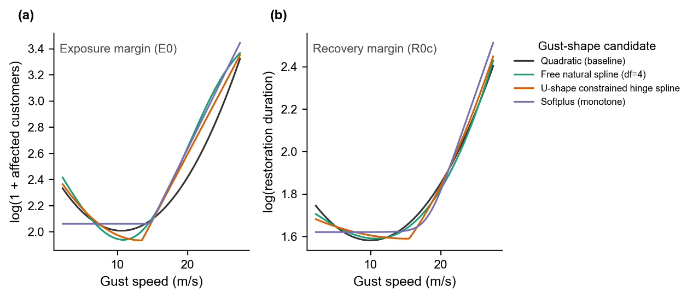
Figure H1. Fitted curves for all four curve-shape candidates, exposure and recovery margins, on a shared gust axis (log scale), with the observed gust density shown beneath each panel.
Overall predictive accuracy is not strongly sensitive to the choice of curve shape. Table H1 shows differences of less than half of one percentage point in out-of-sample R-squared across all four candidates, for both margins.
This finding about overall accuracy does not, by itself, say anything about whether the specific low-gust decline captured by the quadratic term's linear component is a genuine feature of the data or an artefact of assuming a quadratic form. This is checked separately, using the free spline, the only candidate not constrained to have any shape and capable of representing a monotonic relationship, multiple local turning points, or any other pattern supported by the data. Table H3 reports the turning point implied by each candidate.
Table H3. Turning point location by curve shape.
Candidate | Exposure turning point (m/s) | Recovery turning point (m/s) | Decline-then-rise shape
Quadratic | 10.59 | 9.96 | Yes, by construction
Free spline (unconstrained) | 10.85 | 10.72 | Yes, not imposed
U-shaped hinge spline | 13.39 (fixed knot) | 15.42 (fixed knot) | Yes, by construction
Softplus | Not applicable | Not applicable | No, structurally impossible
The free spline, without any shape constraint, independently converges to a turning point close to the quadratic form's, for both margins. This is treated here as evidence that the decline-then-rise shape reflects a feature of the data rather than an artefact of assuming a quadratic function, though this evidence comes from the same dataset used to select the candidates being compared, and does not constitute independent confirmation in the way a separate dataset or a pre-registered comparison would.
The softplus form, which cannot represent a decline under any parameter values, performs similarly to the other three candidates on overall predictive accuracy (Table H1). This does not mean the low-gust decline is unimportant or absent. It means that a model's overall predictive accuracy, summarised as a single number across the full range of gust, is not sensitive enough to distinguish between a curve with this decline and a curve without it. The absence of a large accuracy penalty for ruling out the decline is not evidence against the decline's existence, and is not treated as such here.
At gust speeds above approximately 20 m/s, the four curve shapes converge closely for both margins, with fitted values differing by less than 4 percent of their range at the highest observed gust speeds. The specific curvature of the rising portion of the curve is not strongly dependent on which of the four shapes is used.

H.5 Rationale and limitations
The quadratic specification is retained as the main specification in this paper on three grounds. It is the simplest of the candidates considered, requiring no tuning and no additional construction decisions such as knot placement or starting values. It performs comparably to the alternatives within the range of gust speeds observed in this dataset, without requiring an assumption that the relationship is bounded or saturates outside this range. None of the additional candidates considered shows a sufficiently clear and consistent advantage, across both outcome margins, to justify the added complexity of fitting and reporting them as the primary specification.
This comparison has several limitations. It is a post-hoc check carried out after the quadratic specification had already been adopted, not a pre-registered comparison. The curve-shape comparison omits the gust-pressure interaction present in the main specification, for the reasons given in Section H.1. Two of the four curve-shape candidates fix a structural choice, the spline's degrees of freedom and the hinge spline's knot location, without a tuning search across folds, and this choice was not varied to test its effect on the results reported here. A direct comparison of fold-to-fold stability between the quadratic form and its closest alternatives was not carried out, and no claim about the relative stability of any candidate is made in this appendix.

Appendix I. Global sensitivity analysis
Section 3.3 includes a gust-pressure interaction term in the main specification. This appendix quantifies how much of the fitted models' output variance this interaction, together with the quadratic gust term, accounts for, using global sensitivity analysis. This is a property of the fitted model itself, examined by varying its inputs, not a re-estimation of any coefficient.

I.1 Method
The fitted coefficients from the final combined sample were used to construct a deterministic function mapping standardised gust, pressure, and, for the recovery margin, affected customers, to the fitted log-scale outcome. Remaining covariates were held fixed, which does not affect the resulting sensitivity indices, since variance decomposition is unaffected by an additive constant. Sobol' first-order and total-effect indices [27] were computed using the SALib Python library [29], with input samples drawn via a Sobol' sequence and mapped to each variable's own empirical distribution through quantile transformation, rather than assuming a parametric distribution such as the normal. The quadratic and interaction terms were computed deterministically from the sampled linear terms within the model function, rather than sampled as separate, nominally independent inputs, which would violate the independence assumption underlying the Sobol' decomposition. Sample sizes were 49,152 model evaluations for the exposure margin (two inputs) and 65,536 for the recovery margin (three inputs). The PAWN method [28], which compares the full output distribution rather than decomposing its variance, was used as a cross-check.
Gust speed and pressure are correlated in the underlying data (Pearson correlation -0.494), reflecting the physical association between strong wind and low pressure. Standard Sobol' analysis assumes independent inputs. This is a known approximation in the results reported here, not addressed by a correlation-aware method such as Kucherenko indices.

I.2 Results
Figure I1 shows the first-order and total-effect indices for both margins side by side. Table I1 reports the same indices with their numerical confidence bounds.
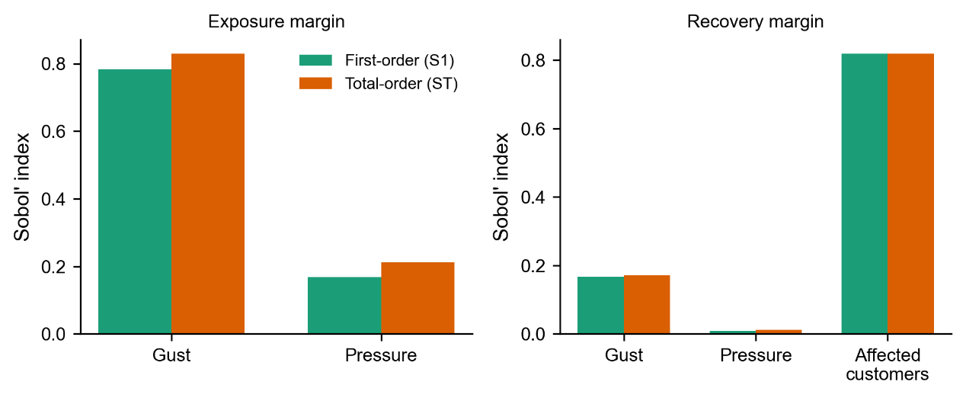
Figure I1. Sobol' first-order and total-effect sensitivity indices, exposure and recovery margins.
Table I1. Sobol' sensitivity indices.
Margin | Variable | First-order (S1) | Total-effect (ST) | ST − S1 | PAWN median
Exposure | Gust | 0.784 (±0.079) | 0.830 (±0.031) | 0.046 | 0.284
Exposure | Pressure | 0.169 (±0.019) | 0.213 (±0.021) | 0.045 | 0.321
Recovery | Gust | 0.168 (±0.023) | 0.171 (±0.016) | 0.003 | 0.103
Recovery | Pressure | 0.010 (±0.003) | 0.012 (±0.001) | 0.003 | 0.096
Recovery | Affected customers | 0.818 (±0.043) | 0.819 (±0.026) | 0.001 | 0.626
For the exposure margin, gust accounts for the largest share of output variance (first-order index 0.784). The gap between its total-effect and first-order index (0.046), closely matched by the same gap for pressure (0.045) and by a directly estimated second-order interaction index of 0.050, attributes approximately 4.5 to 4.6 percentage points of output variance to the gust-pressure interaction specifically, equivalent to about 5.5 percent of gust's own first-order contribution. For the recovery margin, affected customers dominates (first-order index 0.818), and the gap between total-effect and first-order indices is smaller than one percentage point for all three variables. Interactions among gust, pressure, and affected customers contribute little to output variance in the recovery model, in contrast to the exposure margin.
The PAWN method gives a different ranking from Sobol' for the exposure margin specifically: pressure has a higher PAWN median (0.321) than gust (0.284), while Sobol's first-order index ranks gust well above pressure (0.784 versus 0.169). This reflects a difference in what each method measures. Sobol' indices decompose output variance. PAWN measures the influence of each input on the shape of the full output distribution, which need not produce the same ranking. For the recovery margin, Sobol' and PAWN agree on the ranking (affected customers, then gust, then pressure).

