Abstract
UK Power Networks records 60,453 weather- and asset-related outage incidents across London, the South East, and the East of England between April 2021 and March 2024, including seven officially named storms. Event-level exposure and recovery outcomes are reconstructed from stage-level regulatory records according to Ofgem's official definitions, correcting a systematic undercount that results from using the earliest recorded stage alone. A quadratic specification identifies a nonlinear relationship between gust speed and both outcomes, including a critical wind speed of approximately 10.8 m/s for the exposure margin. The quadratic shape underlying this relationship is confirmed under alternative distributional assumptions, within an independent temporal holdout, and within a subsample restricted to incidents for which weather is the recorded cause. Predicted outcomes from this model are also compared against observed outcomes during the seven named storms. The specific numerical value of the exposure margin's threshold is not confirmed under the same holdout and is reported as an approximate reference rather than an externally validated figure. Gust accounts for a modest share of total variation in outage outcomes across the full population of incidents, well below the share accounted for by the number of affected customers. Within the subset of incidents for which weather is the recorded cause, however, gust's contribution more than doubles and exceeds that of affected customers. Two independent lines of evidence, one based on recorded cause and one based on real storm events, point to the same conclusion. These results provide field-level evidence of a nonlinear wind-outage response at the scale of a full distribution network, complementing fragility curves derived from simulation or testing of individual structures.

Keywords
Power outage; wind fragility; critical wind speed; distribution network; variance decomposition; extreme weather

Introduction
Storms and other extreme weather events are the most common cause of power disruptions in Great Britain [1]. In November 2021, Storm Arwen alone left more than one million customers without power [2]. Three months later, three named storms struck the United Kingdom within five days: Dudley, Eunice, and Franklin. Within the service area of UK Power Networks (UKPN), which covers London, the South East, and the East of England, Storm Eunice produced a peak observed gust of 39.4 m/s in Lewes, East Sussex, on 18 February 2022. This value is the highest gust recorded across the entire study period examined in this paper. The storm was associated with 1,601 weather-related outage events across 101 Local Authority Districts, a cumulative estimate of 376,712 affected customers, and a mean restoration time of 52.7 hours. Two days later, Storm Franklin affected the same network and produced a further 1,187 events.
These events illustrate a general pattern in electricity distribution networks: outage impact, measured either by the number of customers affected (referred to hereafter as the exposure margin) or by the time needed for restoration (referred to hereafter as the recovery margin), does not scale in a fixed proportion with wind intensity. A given increase in gust speed can correspond to a small change in outcome under some conditions and a disproportionately large change under others. Identifying whether this relationship follows a specific functional form, and whether it contains an identifiable threshold, is directly relevant to how distribution network operators (DNOs) set weather-related response thresholds and allocate restoration resources in advance of a forecast storm.
Existing empirical work on power outage duration and customer impact under severe weather has established regression- and machine-learning-based approaches for hurricane- and ice-storm-affected US utilities [3–6]. A separate line of engineering research addresses the wind vulnerability of individual distribution and transmission structures directly. This work typically derives fragility curves, which express the probability of structural failure as a function of wind speed, from finite element simulation or scaled physical testing of a specific structure type, such as a transmission tower or a distribution pole [7–10]. These fragility curves are commonly expressed as threshold-based functions in which failure probability remains near a baseline level below a critical wind speed and increases sharply once this threshold is exceeded [10]. This threshold structure is consistent with the general expectation that wind-induced damage to electrical infrastructure is nonlinear rather than proportional to wind intensity.
Fragility curves of this kind describe the vulnerability of a single, well-defined structure under controlled or simulated loading conditions. They do not by themselves indicate whether a comparable nonlinear, threshold-like response is observable in the operational record of a full distribution network, where outage outcomes reflect a heterogeneous population of structures, ages, and local conditions rather than a single modelled component. This gap, together with a further limitation in the outage-modelling literature, motivates the present study.
First, statistical outage studies [3–6] generally report fitted relationships between weather intensity and outage outcomes without testing for a distinguishable threshold. Together with the limitation of structure-specific fragility curves described above, this leaves a gap in field-level evidence at the network scale. Second, prior work identifies important predictors of outage risk among hazard and infrastructure factors [6], but does not compare wind conditions directly with affected-customer scale. This paper asks whether their relative importance changes between the full population of outages and the subset for which weather is the recorded cause.
Addressing both gaps requires an observational record long enough, and varied enough, to include both routine operating conditions and several distinct severe wind events within the same network. The UKPN dataset examined in this paper spans three years of continuous operation, from April 2021 to March 2024, and includes seven officially named storms, among them Storm Eunice described above. This combination of duration and event coverage makes it possible to estimate a continuous response function across the full range of observed wind conditions, and to examine that function specifically under the seven storm events, rather than relying on a single simulated structure or a short observation window.
This paper addresses these two gaps using outage records from UKPN covering April 2021 to March 2024. The first gap is addressed by characterising the exposure and recovery response to gust intensity using a quadratic specification, and by identifying a critical wind threshold for the exposure margin. This provides field-level evidence at the network scale that complements structure-specific fragility curves obtained from simulation or testing, though the two describe different quantities: a fragility curve gives the probability that a structure fails at a given wind speed, while this paper models the scale and duration of outages conditional on an incident having already occurred. The second gap is addressed by quantifying the explanatory weight of gust relative to the affected-customer scale, both across the full population of weather- and asset-related outages and within the subset of events for which weather is the recorded cause. Both findings are examined against an independent temporal holdout not used during model development, and against the seven named storms. This establishes the extent to which each result can be confirmed independently of the exploratory modelling process.
The remainder of this paper is organised as follows. Section 2 describes the UKPN dataset, the construction of event-level exposure and recovery metrics from stage-level regulatory records, and the descriptive properties of the resulting sample. Section 3 presents the empirical framework, including the model specification and the two-stage development-confirmation design used to assess the results independently of the exploratory analysis. Section 4 reports the results in four parts. Section 4.1 establishes the nonlinear gust-outage response and reports the critical wind threshold identified for the exposure margin. Section 4.2 quantifies the explanatory weight of gust relative to the affected-customer scale across the full population of outages. Section 4.3 examines whether this weight changes within the subset of events attributed to weather and during the seven named storms. Section 4.4 confirms the findings of Sections 4.1 to 4.3 against the independent temporal holdout. Section 5 discusses the implications, boundaries, and limitations of these findings, and outlines directions for future work.

Data and Study Setting

Study setting and data sources
UKPN operates the electricity distribution network across London, the South East, and the East of England, and reports outage incidents to Ofgem, the energy regulator for Great Britain, under the regulatory reporting framework set out in the RIIO-ED1 and RIIO-ED2 Annex F guidance [11, 12]. RIIO-ED1 and RIIO-ED2 are successive multi-year price control periods during which Ofgem sets the revenue and performance requirements for UK electricity distribution network operators. This paper draws on UKPN's outage incident records covering 1 April 2021 to 31 March 2024, a period of three complete regulatory years spanning both the RIIO-ED1 and RIIO-ED2 price control periods. Each record corresponds to a restoration stage rather than a complete outage incident. An incident that requires more than one restoration action, for example because power is restored to part of the affected area before the remainder, is represented by more than one stage-level record sharing a common incident reference. Section 2.2 describes how event-level outcome variables are constructed from these stage-level records.
Weather variables are matched to each incident using hourly reanalysis data from the Open-Meteo historical weather API [13], which is based on the ERA5 global reanalysis dataset [14]. Data are indexed to the latitude and longitude reported for each incident and the hour in which it began. The primary wind variable used throughout this paper is instantaneous gust speed rather than sustained wind speed. This choice follows the convention in structural wind engineering, where design wind loads are based on a short-duration (3-second) gust rather than a longer-averaged sustained speed, because peak instantaneous loading determines structural response and failure [15]. This convention has been applied specifically to wind-induced damage in electrical grid infrastructure [16]. In the final analysis sample, gust speed has a mean of 9.91 m/s and a standard deviation of 5.28 m/s, referenced in Section 4.1 when reporting the exposure margin's turning point in physical units.
Regional covariates are drawn from Office for National Statistics (ONS) data at the Local Authority District (LAD) level and merged to each incident by its reported location. These comprise resident population from ONS local authority population estimates [17], and income deprivation rate, the within-district range in income deprivation between its most and least deprived neighbourhoods, and spatial clustering of income deprivation measured by Moran's I, all drawn from the ONS dataset mapping income deprivation at a local authority level [18]. Moran's I follows the spatial autocorrelation statistic introduced by Moran [19]. An urban-rural classification is drawn from the same ONS local statistics resource used for the population and deprivation data [17]. LAD boundaries as at December 2021 are taken from the ONS Open Geography Portal [20].
Figure 1 shows the three UKPN licence areas and the spatial density of incidents across the study period. Incident density is not uniform across the service area. It is concentrated around London, which sits at the boundary between the South East and East of England licence areas. A smaller, secondary concentration is visible near the north-east coast of the East of England licence area. The remainder of the service area shows a comparatively even lower density of incidents.
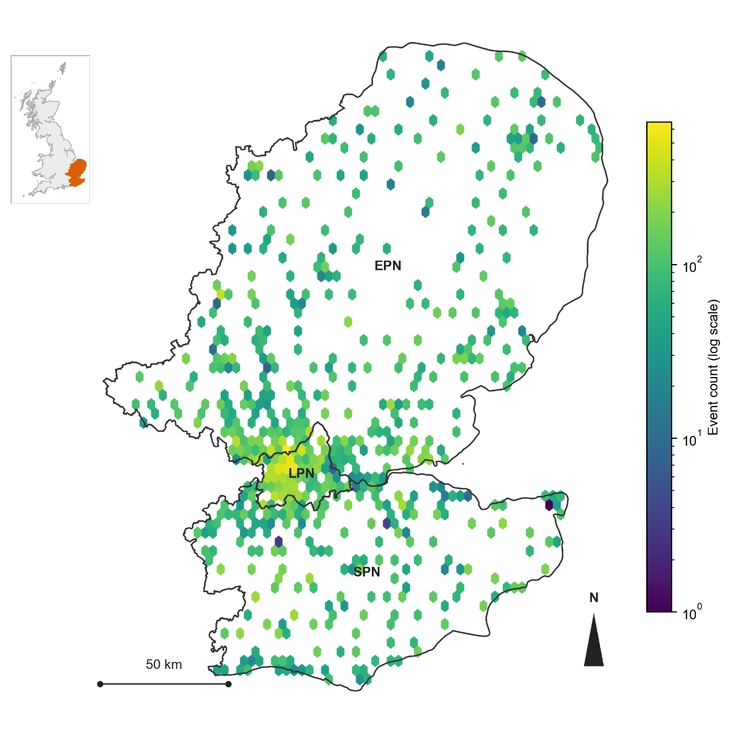
      - Study area and event density. The map shows the three UKPN licence areas (London, South East, East of England) and the spatial density of all incidents in the final analysis sample, rendered as a hexagonal binning of incident coordinates on a logarithmic count scale. The inset shows the location of the UKPN service area within Great Britain.

Outcome variable construction
Ofgem's Annex F guidance defines two network-level outcome measures for outage reporting [11, 12]. Customer Interruptions (CIt) counts the total number of customers affected across a reporting period, summed across restoration stages and excluding stages flagged as re-interruptions to avoid double-counting the same customers. Customer Minutes Lost (CMLt) is a customer-weighted measure of total interruption time across a reporting period, computed as the sum, over restoration stages, of the number of customers affected multiplied by the duration of that stage. Both are network-wide aggregates for reporting period $t$, not incident-level statistics. This paper constructs an incident-level variable, denoted $C_{i}$, following the same aggregation logic as CIt: customers are summed across stages, excluding re-interruptions, for incident $i$ rather than reporting period $t$. The recovery margin, denoted $D_{i}$, is defined differently. Rather than a customer-weighted measure analogous to CMLt, $D_{i}$ is the total recorded time span of the incident, from the earliest recorded start time across all stages to the latest recorded end time, including stages flagged as re-interruptions. This simpler definition was chosen over a customer-weighted alternative because the latter shares its underlying weighting with $C_{i}$ by construction, which produced a spurious statistical relationship between the two measures, described further in Appendix B.2.
The exposure margin is measured by the number of customers affected by an incident, referred to hereafter as affected customers, and constructed as
Ci=r∈Ri, r∉Ii​Ni,r
where $C_{i}$ is affected customers for incident $i$, $R_{i}$ is the set of restoration stages recorded for incident $i$, $I_{i}⊂R_{i}$ is the subset of those stages flagged as re-interruptions, and $N_{i,r}$ is the customer count reported at stage $r$.
The recovery margin is measured by the total duration of the incident, referred to hereafter as restoration duration, and constructed as:
$$D_{i}=\max_{r ∈ R_{i}}T_{i,r}^{\text{end}}-\min_{r ∈ R_{i}}T_{i,r}^{\text{start}}$$
where $D_{i}$ is restoration duration for incident $i$, and $T_{i,r}^{\text{start}}$ and $T_{i,r}^{\text{end}}$ are the start and end times recorded at stage $r$.
Constructing affected customers by aggregating across stages, rather than taking the customer count reported in the earliest stage of each incident, changes the sample mean from 47.13 to 93.02 customers, a difference of a factor of 1.97, within the same final analysis sample reported in Table 1. This difference reflects incidents with more than one restoration stage, in which the earliest stage alone does not capture the full extent of the customers affected as the incident evolves. Appendix B reports the full data processing pipeline underlying Equations 1 and 2, including the handling of a small number of boundary cases not covered by the general definitions above.

Descriptive statistics and visualization
Table 1 reports descriptive statistics for affected customers and restoration duration in the final analysis sample, on the original scale and after log transformation. Both variables are heavily right-skewed on the original scale, with the mean well above the median (93.0 versus 2.0 for affected customers, 11.8 versus 6.3 hours for restoration duration). Figure 2 shows the distribution of each variable before and after transformation. The log transformations substantially reduce this skew, but they do not produce a fully symmetric distribution in either case. The transformed affected-customers variable shows a sawtooth pattern at low values, reflecting the fact that many incidents affect a small integer number of customers. The transformed restoration-duration variable shows two distinct modes, one near one hour and one near seven to twelve hours, separated by a clear trough. This pattern is consistent with the composition effect linked to the number of restoration stages per incident, described further in Section 4.1 and Appendix D. Despite this remaining structure, the log transformation is still used for both variables, because it removes the extreme right tail that would otherwise dominate ordinary least squares (ols) fit.
          - Descriptive statistics for affected customers and restoration duration, final analysis sample.
Statistic | Affected customers (n=60,437) | log(1+affected customers) | Restoration duration, hours (n=59,834) | log(restoration duration)
Mean | 93.02 | 2.138 | 11.84 | 1.656
Median | 2.00 | 1.099 | 6.27 | 1.835
SD | 410.96 | 2.019 | 19.96 | 1.349
Min | 0.00 | 0.000 | 0.05 | -2.996
25th pct. | 1.00 | 0.693 | 2.03 | 0.710
75th pct. | 35.00 | 3.584 | 12.67 | 2.539
Max | 27,013.00 | 10.204 | 192.08 | 5.258
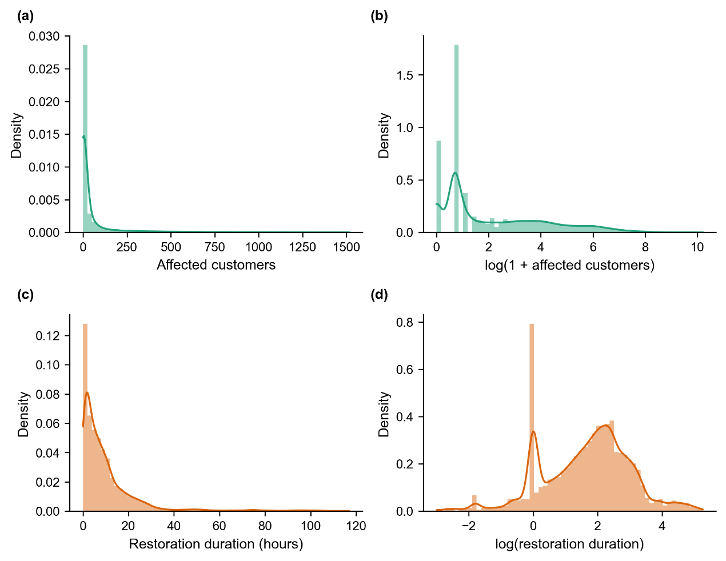
      - Distribution of affected customers and restoration duration, original scale and after log transformation. (a) Affected customers, original scale. (b) log(1+affected customers). (c) Restoration duration, original scale (hours). (d) log(restoration duration).
The Pearson correlation between affected customers and restoration duration in the final analysis sample (n = 60,437) is -0.016 on the original scale and -0.011 on the log scale. The Spearman correlation is 0.110. Both linear and monotonic measures of association are small in magnitude. A nonlinear dependence measure gives a different picture: the distance correlation between the two variables is 0.199, and a mutual information test rejects independence at a very high level of significance (permutation test, z = 160.4). Affected customers and restoration duration are therefore not statistically independent at the event level, although the form of their association is not captured by a simple linear or monotonic measure. Section 4.1 and Appendix D trace this association to the number of restoration stages recorded for each incident, rather than to a direct relationship between the scale of an incident and its duration. This is also why affected customers and restoration duration are treated as two separate outcome margins in this paper, modelled with their own covariates, rather than combined into a single severity index or assumed to be independent of one another.

Sample construction and predictor variables
UKPN records a Cause Code for each outage incident, describing its underlying original cause at a more granular level than is used in this paper. These codes are grouped into six categories for analysis, listed in full in Appendix A.2. Two of these six categories correspond respectively to codes attributed directly to weather and to codes attributed to the condition of network assets, referred to hereafter as the weather-related and asset-related categories. The remaining four categories cover incidents with no fault found on investigation, third-party interference, human error, and causes attributed to the customer or an external party. The recorded cause for incidents in these four categories is unrelated to wind conditions by construction, though this does not rule out some influence of weather on how these incidents are subsequently resolved. No-fault-found incidents alone account for approximately 39 percent of all recorded incidents in the study period. Including these four categories in the analysis sample would mix incidents with no expected relationship between their recorded cause and gust intensity into the estimation of that relationship. The theoretical case for this restriction is supported directly by re-estimating the recovery model on all six Cause Code categories (n = 116,064) rather than the weather-related and asset-related subset used in this paper (n = 59,834). The quadratic gust term is of the same order of magnitude and significant in all five cross-validation folds under both samples (mean coefficient 0.061 for six categories versus 0.079 for the two-category subset). The linear gust term, by contrast, is significant in all five folds under the six-category sample (mean coefficient 0.026) but indistinguishable from zero under the two-category subset (mean coefficient 0.0002, significant in none of the five folds). This indicates that part of the linear-term signal observed when pooling all six categories reflects composition effects from categories unrelated to weather-driven failures, rather than a physically robust wind effect, and supports restricting the main specification to the weather-related and asset-related categories. Section 3.2 reports the history of when this restriction was decided relative to the development and confirmation samples used elsewhere in this paper.
The resulting sample comprises 60,453 incidents. After matching weather data and excluding incidents with missing regional covariates, 60,437 incidents are available for the exposure model and 59,834 for the recovery model, the difference reflecting incidents for which restoration duration could not be computed or fell above the 99th percentile of the restoration duration distribution.
The full covariate set comprises gust speed and its square, an interaction between gust speed and mean sea level pressure, 24-hour cumulative precipitation, temperature, mean sea level pressure, log population, income deprivation rate, the within-district range in income deprivation, Moran's I, an urban-rural indicator, and calendar year and month fixed effects. The recovery model additionally includes affected customers and its square as covariates, discussed further in Section 4.1.
Variance inflation factors for all continuous covariates in the final model specification are below 4, with the highest value, 3.76, corresponding to the gap between local income deprivation and the national average. This has been confirmed using the complete design matrix, including the calendar year and month fixed effects, rather than the continuous covariates alone. Including these fixed effects changes the highest VIF by less than 0.01, indicating no meaningful collinearity between them and the remaining covariates. Values of 5 and 10 are commonly cited as informal thresholds for concern regarding multicollinearity, although O'Brien [21] cautions that these thresholds are heuristic rather than absolute, and that a given VIF value should be interpreted alongside the sample size and the strength of the effect under study rather than treated as a fixed cutoff. The VIF values obtained here are below both commonly cited thresholds regardless of this qualification.

Empirical Framework

Modelling approach and rationale
This paper uses a parametric regression model, not a machine learning model. The reason is straightforward. The shape of the relationship between gust intensity and outage outcomes needs to be identified. So does whether this relationship contains a threshold, and if so, at what wind speed. In its simplest form, before the covariates described in Section 3.3 are added, this relationship is written as:
$$Y=β_{1}G+β_{2}G^{2}$$
where $Y$ denotes the outcome margin (affected customers or restoration duration, in the log scale described in Section 3.3), and $G$ denotes gust speed. A regression model of this form gives a closed-form turning point, $G^{*}=-β_{1}/\left(2β_{2}\right)$, found by setting the first derivative to zero. This closed-form solution is not unique to a linear model on the log scale. A generalised linear model with a log link and the same quadratic predictor gives the same first-order condition, because the derivative of a strictly positive link function does not change its sign. The parametric approach used in this paper is chosen for consistency between the two margins, and because it gives a single set of coefficients from which the turning point and its uncertainty can both be derived directly, not because it is the only specification capable of producing a turning point. Section 4.1 examines whether the turning point has a clear interpretation for each margin. This assessment considers its estimated location and uncertainty, rather than the significance of the linear coefficient alone. If the location is too uncertain, we report only the quadratic relationship, which describes how the outcome increases with the squared distance from a reference gust level.
The same model type is used throughout this paper. Ordinary least squares is applied to a log-transformed dependent variable, for both the exposure margin and the recovery margin, and for every sample examined in Section 4. Affected customers and restoration duration are both non-negative and right-skewed, as shown in Figure 2. Count-based or duration-based alternatives, such as a negative binomial, gamma, or Tweedie generalised linear model, are a common choice for outcomes of this kind [22].
This choice has been checked directly, rather than assumed. The exposure model was re-estimated using negative binomial and Tweedie specifications, and the recovery model was re-estimated using gamma and Tweedie specifications, on the same final sample described in Section 2.4. In every case, the quadratic gust term retained the same sign and remained significant at a similar or stronger level than under the log-OLS specification. This includes the recovery model, where the quadratic term is the central finding of this paper.
The choice of a quadratic function for gust, as distinct from the choice of log-OLS itself, has also been checked directly. The exposure and recovery models were re-estimated with three alternative curve shapes for gust in place of the quadratic term: an unconstrained spline, a spline constrained to a single decline-then-rise shape, and a monotonic form structurally incapable of representing any decline. None of the three alternatives showed a consistent advantage over the quadratic form across both margins, and the quadratic form gave the best fit of the four candidates for the recovery margin specifically. The unconstrained spline, without being given any shape to follow, independently converged on a turning point close to the quadratic form's for both margins. This is treated as evidence that the low-gust decline captured by the quadratic form's linear term reflects a feature of the data, rather than an artefact of assuming a quadratic function, though this check uses the same data used to select the candidates compared and does not constitute independent confirmation in the way a separate dataset would. Full results, including the construction of each candidate and a figure comparing the fitted curves, are reported in Appendix H.
Residual diagnostics for the log-OLS specification are also reported in Appendix H. Residuals depart from normality in both models, which is expected at this sample size and does not affect the validity of the coefficient estimates under ordinary least squares. The exposure model's residuals show a distinct pattern linked to the share of incidents with zero recorded customers, rather than a general problem with the model. Taken together, these checks support the use of the log-OLS specification with a quadratic gust term, while also showing that the central findings of this paper do not depend on this specification alone.
A machine learning model, such as a random forest, can often predict outcomes more accurately. It does not, however, give a simple, interpretable threshold value in the same way. For this reason, machine learning is not used as the main method in this paper. A machine learning comparison could still be a useful robustness check in future work. This point is revisited in Section 5.

Model development and retrospective evaluation
Building this model involved many choices. A decision was needed on which Cause Code categories to include. A decision was needed on how to define customer counts and outage duration from the raw stage-level records. A decision was needed on how to handle a small number of unusual events. Each of these choices could, in principle, be adjusted until the results looked as clean as possible. This is a known risk in applied statistics. Cox [23] proposed a simple way to guard against it. The data are split into two parts before any exploration begins. One part is used to make all the modelling choices. The other part is set aside and not examined until the modelling choices are final. Once the model is finalised on the first part, it is applied once to the second part, without further adjustment.
This approach is followed here for the model specification described in Section 3.3. Several earlier methodological choices were made before the data were divided into development and confirmation samples. These included the choice between candidate duration measures, the restriction to two Cause Code categories, and the initial specification of the critical-wind-speed methodology. The need for this separation was recognised only after these choices had been made. Appendix E reports this history in full. Most of these choices have since been re-examined on properly separated data: the Cause Code restriction and the variance decomposition results reported in Sections 4.2 and 4.3 are reproduced on the final combined sample described in Section 3.3, and the critical-wind-speed methodology is itself the subject of the temporal confirmation reported in Section 4.4. One comparison, between two candidate measures of restoration duration reported in Appendix B.2, has not been re-examined on separated data. It does not affect any result reported in this paper, because the candidate measure it discouraged was not used in any subsequent analysis. The first part of the data, referred to as the development sample, covers 1 April 2021 to 29 September 2023. The second part, referred to as the confirmation sample, covers 30 September 2023 to 31 March 2024. Its outcome data were not used to fit or select the final model specification reported in Section 3.3, though, as described above, several earlier methodological choices were made before this sample had been separated out. Section 4.4 reports what happens when the finalised model, unchanged, is estimated separately on this confirmation sample. Figure 3 shows this split alongside the seven named storms described in Section 4.3. Four of these storms (Arwen, Dudley, Eunice, and Franklin) occurred within the development sample, and three (Babet, Ciarán, and Henk) occurred within the confirmation sample, so the confirmation sample is not a period free of severe weather of its own.
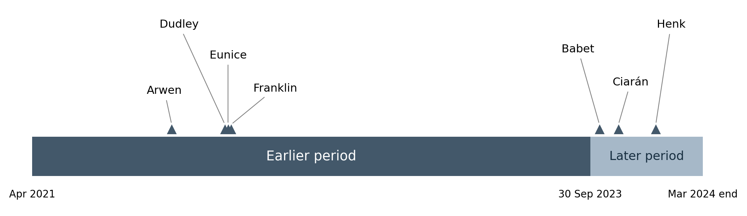
      - Study period timeline (April 2021 to March 2024), showing the development and confirmation samples and the position of the seven named storms within each.
Within the development sample itself, five-fold cross-validation is also used to check that the coefficient estimates are stable. The folds are built by date, not by individual record, so that all records from a given day fall into the same fold. This matters because a single storm can generate many outage records on the same day. These records are not independent of each other. The same five folds are also used to compute an out-of-sample R-squared for each model, reported in Section 4.2: the model is fitted on four folds at a time, predictions are made for the fifth, held-out fold, and this is repeated across all five folds. The resulting held-out predictions are pooled across all five folds before a single R-squared is computed against the full sample's outcome variance, so that the reported figure reflects predictive accuracy on data not used to estimate the coefficients, rather than the fit of the model to its own training data. This pooled statistic is not the same as the simple average of five separately computed per-fold R-squared values, since it weights each observation equally regardless of which fold it falls in, rather than weighting each fold equally regardless of its size.
One specific number illustrates why the confirmation sample matters. An early estimate of the critical wind speed for the exposure margin, computed while the development sample still contained the contamination described in Appendix E, gave 10.69 m/s. Once this contamination was identified and removed, leaving a corrected development sample on its own, the estimate changed to 12.13 m/s. Combining this corrected development sample with the confirmation sample, to produce the final combined sample used throughout Section 4, brought the estimate to 10.81 m/s, the number reported in Section 4.1. These estimates do not reflect the same evidence: the first came from an uncorrected sample not yet separated into development and confirmation parts, and the second came from the deliberate recombination of both parts once each had served its role. Appendix E reports this history and the corresponding sample sizes in full. This history is reported here because it shows why a single estimate, produced early in an exploratory process, should not be treated as final.

Model specification
Standardisation is applied selectively, not uniformly, across the covariate set. Gust speed, 24-hour cumulative precipitation, temperature, and mean sea level pressure are each standardised to zero mean and unit variance, using the training fold's own mean and standard deviation, before entering the model, including the quadratic gust term and the gust-pressure interaction. For the recovery model, log1p(affected customers) is standardised the same way. The five region-level covariates listed in Table 2, and the calendar year and month fixed effects, are entered in their original scale (log population is log-transformed but not additionally standardised). Gust speed in Equations 3 and 4 therefore denotes standardised gust, and a value of zero corresponds to the sample mean gust speed rather than to calm conditions. This standardisation is applied consistently across estimation and reporting, including the turning point and its confidence intervals reported in Section 4.1. Coefficients on the standardised covariates are directly comparable to one another as effects per one standard deviation of the underlying variable, while coefficients on the unstandardised covariates retain their natural units.
The final model specification is the same for both outcome margins, except that the recovery model includes two additional terms. This is the full version of Equation 3, with the additional covariates included, given by
$$ln\left(Y_{i}\right)=β_{1}G_{i}+β_{2}G_{i}^{2}+β_{3}\left(G_{i}×P_{i}\right)+X_{i}'γ+δ_{y\left(i\right)}+θ_{m\left(i\right)}+ε_{i}$$
where $Y_{i}$ denotes the outcome for incident $i$ (one plus affected customers for the exposure margin, or restoration duration for the recovery margin), $G_{i}$ denotes gust speed, $P_{i}$ denotes mean sea level pressure, $X_{i}$ denotes the remaining weather and regional covariates listed below, $δ_{y\left(i\right)}$ and $θ_{m\left(i\right)}$ denote year and month fixed effects, and $ε_{i}$ is the error term. For the recovery margin, $X_{i}$ additionally includes affected customers and its square.
Year and month fixed effects are additive, entered as separate sets of dummy variables rather than as a year-by-month interaction, and the gust-pressure interaction term is the direct product of the two standardised variables. For the exposure margin, the dependent variable is the natural logarithm of one plus affected customer. For the recovery margin, the dependent variable is the natural logarithm of restoration duration, and the model additionally includes affected customers and its square as covariates.
Table 2 lists the covariates denoted $X_{i}$ in Equation 4, beyond gust speed, its square, and the gust-pressure interaction, which are reported separately in Section 4.1. Appendix A reports the source and processing of each variable in full, including the marginal distribution of each continuous covariate.
          - Covariates included in $X_{i}$, in addition to gust speed, its square, and the gust-pressure interaction.
Variable | Category | Model
Mean sea level pressure | Weather | Both
24-hour cumulative precipitation | Weather | Both
Temperature | Weather | Both
Log population | Regional | Both
Income deprivation rate | Regional | Both
Gap between local and national income deprivation | Regional | Both
Moran's I (income deprivation) | Regional | Both
Urban-rural indicator | Regional | Both
Affected customers (linear and squared) | Event-level | Recovery only
Year fixed effects | Temporal | Both
Month fixed effects | Temporal | Both
Standard errors are clustered by Local Authority District, following standard practice for regression models with grouped data [24]. A given storm can affect many incidents in the same district on the same day, so errors within a district are unlikely to be independent of each other. Section 4.4 also reports what happens when standard errors are clustered by both district and date at the same time. This is a more conservative check, and the full results are given in Appendix F.

Results

Nonlinear gust–outage response and conditional fitted minima
This section establishes the shape of the gust-outage relationship for each margin, then examines how far this shape can be refined into a single, specific value. Sections 4.2 to 4.4 then examine how much this relationship matters, and how well it holds up outside the sample used to estimate it.
Table 3 reports the gust coefficients from the final model specification, estimated on the full analysis sample described in Section 2.4. For both outcome margins, the quadratic gust term is significant at a much stronger level than the linear term: p < 0.001 in both cases, compared with p = 0.010 for the exposure margin's linear term and p = 0.913, not significant, for the recovery margin's. The quadratic term is also the consistent feature of the relationship reported throughout this paper: it remains stable in sign and significance under alternative distributional assumptions (Section 3.1), within an independent temporal holdout (Section 4.4), and within a subsample restricted to weather-attributed incidents (Section 4.3). The quadratic term is therefore established first, as the dominant and more robust feature of the relationship in both margins, before either relationship is examined for a specific numerical threshold. The two margins differ in whether the linear gust term is also different from zero, and this difference determines how far each relationship can be refined beyond the quadratic term into a specific value.
          - Gust coefficients, final model specification.
Term | Exposure margin | Recovery margin
Gust (linear) | -0.036 (p = 0.010) | -0.001 (p = 0.913)
Gust squared | 0.106 (p < 0.001) | 0.085 (p < 0.001)
n | 60,437 | 59,834
For the exposure margin, the linear gust term is negative and significant, so the two coefficients jointly determine the shape of the curve. This negative linear term is small in magnitude relative to the quadratic term, and Section 4.4 reports that it is less stable across samples and clustering methods than the quadratic term. Most incidents at low gust levels are unrelated to weather, as reported in Section 2.4, so this small negative slope may reflect factors other than wind conditions in this part of the range, rather than a direct physical relationship between mild wind and fewer affected customers. Its small size is also consistent with ordinary estimation variability, and it is not treated as a finding requiring a specific mechanistic explanation.
The full model in Equation 4 also includes an interaction between gust and pressure, so the point at which the curve turns depends on the pressure level at which it is evaluated. Holding pressure at its sample mean, zero on the standardised scale, this point is given by:
$$G^{*}\left(P=0\right)=-\frac{β_{1}}{2β_{2}}$$
where $β_{1}$ and $β_{2}$ are the linear and quadratic gust coefficients from Table 3. At other pressure levels, the corresponding location is $G^{*}\left(P\right)=-\left(β_{1}+β_{3}P\right)/\left(2β_{2}\right)$, where $β_{3}$ is the gust-pressure interaction coefficient. The value reported throughout this paper is specific to average pressure conditions. throughout this paper is specific to average pressure conditions. Appendix I quantifies this interaction's contribution to the exposure model's output variance directly, at approximately 4.5 percentage points. Because this turning point is a ratio of two estimated coefficients, its uncertainty cannot be read directly from the standard errors of $β_{1}$ and $β_{2}$ alone. Section 4.4 shows that this same ratio is more sensitive to sample and specification than the quadratic term on its own, including under a clustering method that affects the significance of $β_{1}$ specifically. Two methods are used to construct a confidence interval for $G^{*}\left(P=0\right)$: the delta method [25], and a bootstrap procedure that resamples entire days rather than individual incidents, to preserve the fact that incidents on the same day are not independent. For the exposure margin, the two methods give different results when applied to the standardised turning-point statistic. The delta method produces a 95 percent confidence interval that does not cross zero. Converted to physical units using the sample mean and standard deviation, this interval spans 10.13 to 11.48 m/s. The bootstrap procedure produces a wider interval on the standardised scale, -0.143 to 0.426, that does cross zero, meaning the data cannot statistically rule out the turning point coinciding with the sample-mean gust speed (9.91 m/s) rather than lying strictly above or below it. A ratio of two random coefficients does not follow a normal distribution in general, and the delta method, which relies on a first-order approximation, can understate the width of the true sampling distribution. A direct check of the bootstrap replicates shows that the quadratic coefficient, the denominator of this ratio, remains comfortably positive throughout the resampling distribution, so denominator instability is not the source of this difference. The linear coefficient, the numerator, is itself small relative to its resampling variability and changes sign in about 10 percent of replicates, which is a more plausible contributor to the skewed, heavy-tailed sampling distribution of the ratio observed in the bootstrap. A standardised interval crossing zero does not imply that the corresponding physical-unit interval crosses 0 m/s: because a standardised value of zero corresponds to the sample-mean gust speed rather than calm conditions, the same bootstrap resamples translate into a strictly positive physical-unit range of 9.16 to 12.16 m/s. The resulting turning point, 10.81 m/s, falls within the range covered by the data rather than at its extreme. A turning point close to this value is also reproduced independently by an unconstrained curve shape for gust, not given any shape to follow, reported in Appendix H.
A quadratic function is symmetric around its turning point. The distinction between the two margins therefore concerns the location and precision of the fitted minimum, rather than symmetry. For the exposure margin, "critical wind speed" refers to the 10.81 m/s point estimate, subject to the uncertainty described above and the temporal check in Section 4.4.
For the recovery margin, the linear gust term is not distinguishable from zero (Table 3), so the turning point implied by the fitted coefficients sits close to the sample mean gust speed itself, rather than at a location clearly displaced from it. A specific numerical threshold is not reported for this margin. Its relationship to gust is instead described by the quadratic coefficient on its own: an outcome that grows with the squared distance from the sample mean gust speed, in either direction, rather than a threshold located at a specific wind speed away from that mean.
Figure 4 shows the fitted response curves on the log scale, with other covariates held at their sample means. Both curves fall and then rise. Their apparent imbalance reflects the observed gust range: its lower end lies within about two standard deviations of the sample mean, whereas its upper end extends beyond three. With both minima close to the mean, the right-hand endpoints lie farther from the minima and show larger changes in fitted values. On the original outcome scales, the differences between the two arms are several-fold. The log scale used in Figure 4 compresses these differences.
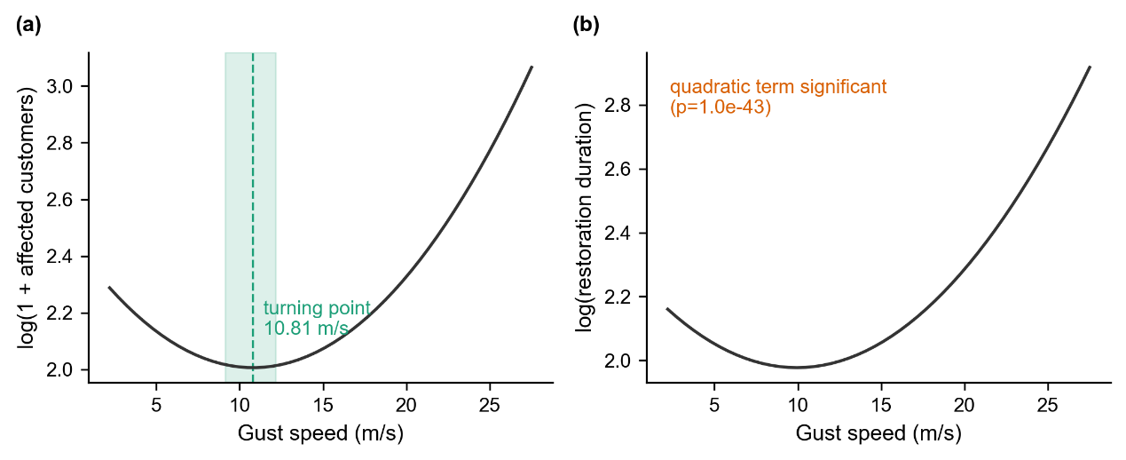
      - Fitted gust-outcome response curves, shown on the log scale on which each model is estimated, other covariates held at their sample means (zero on the standardised scale used throughout this paper). For the recovery margin, this includes affected customers and its square, both set consistently to this same reference point. (a) Exposure margin: fitted $log(1 + affected customers)$ against gust speed, with the turning point at 10.81 m/s and its 95 percent bootstrap confidence interval shown as a shaded band. (b) Recovery margin: fitted $log(restoration duration)$ against gust speed.
The recovery model also includes affected customers and its square as covariates. Affected customers is a stable predictor of restoration duration within the main specification, in the sense that its sign and significance do not change under the temporal holdout examined in Section 4.4. Its relationship to duration is more sensitive to how the sample is restricted by cause: Appendix D.7 reports that its sign in the subsample of weather-attributed incidents examined in Section 4.3 differs from its sign in the main specification. A closely related, more detailed question is why the coefficient on affected customers takes the sign and shape that it does in the main specification. Appendix D shows that this shape is linked to the number of restoration stages recorded for each incident, rather than to the scale of the incident on its own. This does not affect the coefficient on gust, which is stable whether the number of restoration stages is considered, but it does mean that affected customers and gust should be read as two separate predictors of restoration duration, rather than one working through the other.
The turning point identified for the exposure margin marks where the slope of the fitted curve changes from negative to positive. It does not indicate a change in curvature, since the second derivative of a quadratic function is constant, and it does not correspond to a change in the underlying mechanism linking gust to outage outcomes. Near the turning point itself, the slope is close to zero, so the outcome does not begin to rise sharply exactly at this location, but only somewhat beyond it. This paper also models outcomes conditional on an incident having already occurred, rather than the probability that an incident occurs at a given wind speed, which would require observations of periods without an incident and is not estimated here. The turning point is reported as an estimated feature of the fitted response function under the reference conditions described above, rather than as a physical damage threshold or an operational trigger point.

Population-level weight of wind
The results in Section 4.1 establish that gust has a real, stable relationship with both outcome margins. They do not establish how much of the variation in these outcomes gust explains, relative to other factors. These are separate questions. A coefficient can be estimated precisely and remain stable across many samples while still accounting for only a small share of the total variation in the outcome. This section addresses the second question directly.
Nested models are used to decompose the explained variance for each margin. Starting from a baseline of regional covariates and calendar fixed effects, non-gust weather variables are added first, and gust is added last. The increase in out-of-sample R-squared at each step, measured using the five-fold cross-validation described in Section 3.2, gives the marginal contribution of each group of variables. Figure 5 shows this decomposition for both margins. For the exposure margin, gust contributes 1.29 percentage points, out of a total out-of-sample R-squared of 2.99 percent for the full model. For the recovery margin, gust contributes 1.06 percentage points, and affected customers, added after gust in this sequence, contributes 7.80 percentage points, out of a total out-of-sample R-squared of 11.30 percent for the full recovery model. The bar for affected customers is close to 7.4 times the height of the bar for gust in the recovery model, and this difference is the single most visible feature of Figure 5. A second, smaller pattern is also visible in Figure 5: for the baseline and non-gust weather groups, the recovery-model bar is taller than the exposure-model bar, but for the gust group these ordering reverses, and the exposure-model bar becomes the taller of the two.
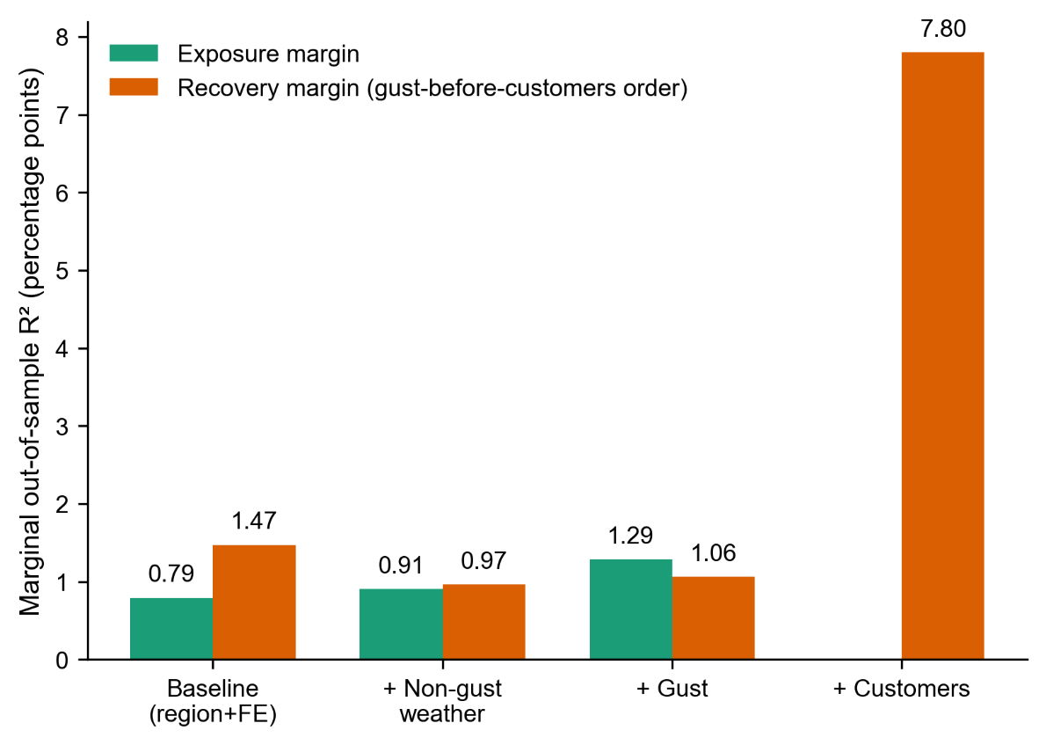
      - Marginal out-of-sample R-squared by variable group, exposure and recovery margins. Bars show the increase in out-of-sample R-squared from adding each group of variables in sequence: regional covariates and calendar fixed effects, non-gust weather, gust, and, for the recovery margin only, affected customers.
Figure 6 provides a further point of comparison, using the observed variation in regional covariates rather than in gust or affected customers. Weather conditions and affected customers are both held fixed at their sample means, and only the five region-level covariates described in Section 2.4 are allowed to vary across Local Authority Districts. Figure 6a shows the resulting fitted values, on the log scale, for affected customers by district, and Figure 6b shows the same for restoration duration. In Figure 6a, a ring of districts immediately surrounding central London shows higher predicted values than the London core itself, with a further contiguous band of higher values extending north from this ring. In Figure 6b, the London core is again low, but the surrounding pattern is more scattered, and the northward band visible in Figure 6a is largely absent. The two panels do not share the same set of high-value districts. This is consistent with a negative correlation, reported separately as -0.755 (Pearson) and -0.771 (Spearman) between the two predicted surfaces across districts, on the log scale shown in Figure 6.
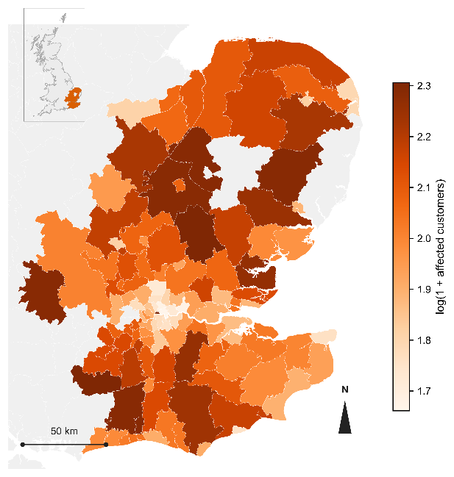 | 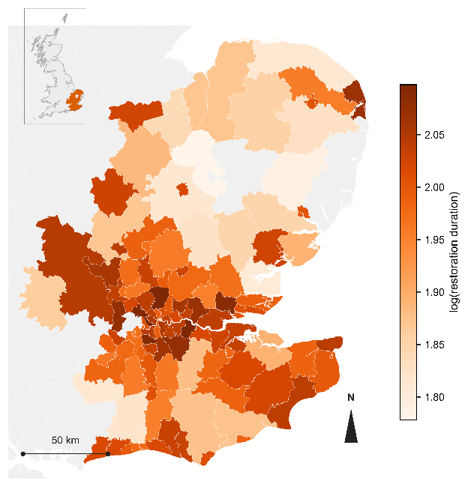
(a) | (b)
      - Baseline regional variation in fitted outcomes, shown on the log scale on which each model is estimated, under a fixed reference weather scenario. (a) Fitted log(1 + affected customers) by Local Authority District. (b) Fitted log(restoration duration) by Local Authority District. In both panels, weather conditions and affected customers are held at their sample means, and only the five region-level covariates listed in Section 2.4 vary across districts.
The same comparison can also be made directly in terms of predicted outcomes, rather than in terms of variance shares. Figure 7 compares three ratios, each defined as the highest fitted value divided by the lowest fitted value across the plotted range of the driving variable (its 1st to 99th percentile). For a curve with an interior turning point, this ratio need not equal the ratio between the two endpoint values themselves, since the lowest fitted value can fall inside the range rather than at either end. Holding other covariates fixed, this ratio is 2.88 for gust on the exposure margin and 2.56 for gust on the recovery margin, in both cases with the lowest fitted value close to the turning point reported in Section 4.1 rather than at the lower end of the range. Holding gust fixed, the corresponding ratio for affected customers on the recovery margin is 6.02. This third ratio is more than twice either of the first two. All three ratios are well above one, meaning that none of the three variables leaves the predicted outcome unchanged across its observed range, but the ratio for affected customers is clearly the largest of the three.
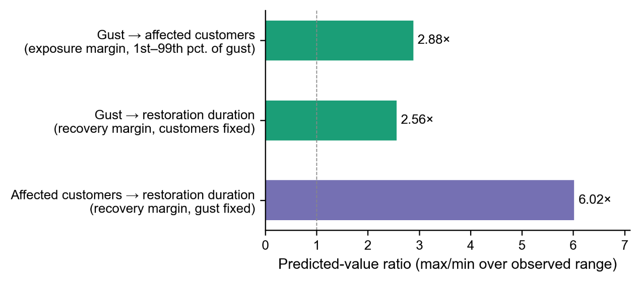
      - Ratio of the highest to the lowest fitted value across the plotted range (1st to 99th percentile) of the driving variable. Three ratios are shown: gust on the exposure margin (2.88), gust on the recovery margin (2.56), and affected customers on the recovery margin (6.02). A dashed reference line marks a ratio of one, corresponding to no change in the predicted outcome.
The predicted values underlying Figure 6 vary, on the original scale before the log transformation shown in the map, by a factor of 1.96 for affected customers and 1.41 for restoration duration across the range of districts observed. Both ratios are of a similar order of magnitude to the gust-driven ratios reported above (2.88 and 2.56), and neither approaches the ratio associated with affected customers itself (6.02). Figure 6 therefore does not show that regional characteristics matter more than gust. It shows that the observed variation in these five regional covariates is comparable in scale to the observed variation in gust, and that both are considerably smaller in their effect on predicted outcomes than the observed variation in affected customers.
Taken together, the results in this section support two conclusions rather than one. Gust accounts for a small share of the total variation in outage outcomes at the population level. Among the variables considered here, affected customers accounts for a substantially larger share. Section 4.3 asks whether this ordering still holds once the sample is restricted to incidents for which weather is the recorded cause.

Weather-attributed incidents and storm-period evidence
Section 4.2 describes the full population of weather- and asset-related incidents, most of which have nothing to do with weather. This section asks a narrower question: among incidents that can be identified, independently of the outcome, as weather-driven, does gust still account for only a small share of the variation, or does it account for more? This question is examined using the Cause Code recorded for each incident. A separate check, using seven real storms with an independently documented date and identity, then examines how well the main specification's predictions hold up during these specific events.
The recovery model described in Section 3.3 was re-estimated on the subset of incidents for which the Cause Code identifies weather as the direct cause, rather than the combined weather- and asset-related sample used elsewhere in this paper. This subset contains 9,758 incidents, about 16 percent of the main sample. Because this subsample's date and duration distributions differ from the main sample's, its truncation point for restoration duration (142.8 hours) and its cross-validation folds are both re-derived from the subsample itself, rather than carried over from the main specification. The comparison that follows therefore reflects the combined effect of the Cause Code restriction together with these necessary re-derivations, not the Cause Code restriction in isolation. Table 4 compares the two samples directly. The quadratic gust term is close to the same magnitude in both samples and remains significant in both. For the recovery margin, the marginal contribution of gust to out-of-sample R-squared rises from 1.06 percentage points in the main sample to 2.76 percentage points in the weather-only subset, and exceeds the marginal contribution of affected customers, which falls to 1.32 percentage points in this subset. Figure 8 shows this comparison. Figure 8a reports the exposure margin, where the marginal contribution of gust falls from 1.29 percentage points in the main sample to 0.45 percentage points in the weather-only subset, smaller but still positive. Figure 8b reports the recovery margin, where the relative height of the gust and affected-customers bars is reversed between the two samples, from affected customers close to 7.4 times the height of gust in the main sample to gust exceeding affected customers in the weather-only subset.
Table 4. Marginal out-of-sample R-squared, main sample versus weather-only subset.
Margin | Variable | Main sample | Weather-only subset
Exposure | Gust | +1.29 pp | +0.45 pp
Recovery | Gust | +1.06 pp | +2.76 pp
Recovery | Affected customers | +7.80 pp | +1.32 pp
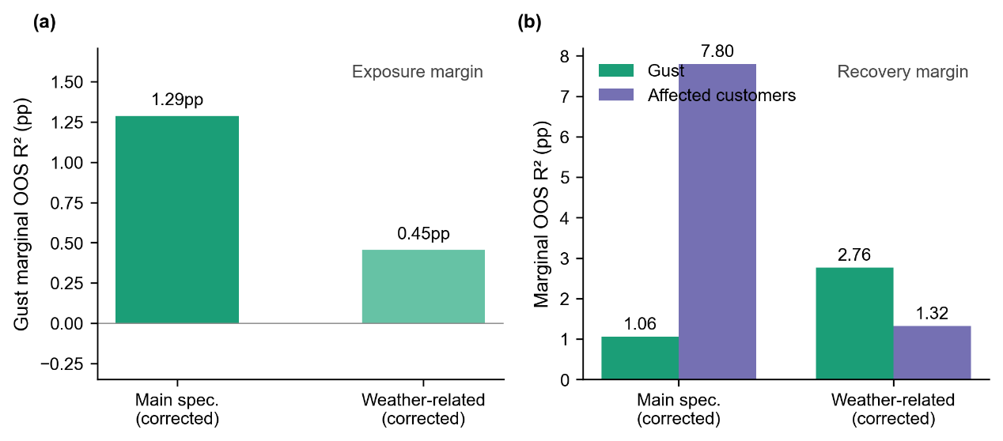
      - Marginal out-of-sample R-squared, main sample versus weather-only subset. (a) Exposure margin. (b) Recovery margin, gust and affected customers shown separately.
The smaller marginal contribution of gust to the exposure margin in the weather-only subset, relative to the main sample, is not treated here as evidence against the finding in Section 4.1. A plausible account of this pattern, reported in Appendix G, is that Cause Code assignment is not independent of gust speed: an incident occurring in calm weather is less likely to be classified as weather-driven than an otherwise similar incident occurring in strong wind, which depletes the weather-only subset of low-gust observations relative to the full sample. This selective depletion affects the exposure margin's turning point specifically, because locating it depends on having enough observations below the turning point to identify the falling part of the curve. Re-estimated on this subsample, the exposure model's implied turning point falls at a negative, physically impossible gust speed, and is not treated as a usable estimate. It affects the recovery margin less, because the quadratic coefficient reported there does not depend on locating a precise turning point.
A second, independent way of restricting attention to weather-driven incidents is to examine periods of documented severe storms directly, rather than relying on a recorded cause. This follows a similar logic to prior work that validates a fitted outage model against a small number of distinct, named storms not used to fit the model [5]. Seven storms with an officially recorded name and date fall within the study period: Arwen, Dudley, Eunice, Franklin, Babet, Ciarán, and Henk. Together, these seven storms span 27 days, or 2.46 percent of the total study period. Within these 27 days, 8.15 percent of all incidents in the final sample occurred, accounting for 14.72 percent of total affected customers. Incident density during these seven storms is therefore around 3.3 times the average incident density across the study period as a whole, and the concentration of affected customers during these storms is around six times the study-period average.
The finalised exposure and recovery models, unchanged from Section 4.1, were then used to predict outcomes for the incidents recorded during each of the seven storms, using the gust and other covariate values actually observed during that storm. Figure 9 compares these predictions against the observed outcomes. For the exposure margin, Figure 9a, the predicted values are systematically higher than the observed values for incidents with a low observed customer count, visible as vertical clusters of points sitting well above the reference line at the low end of the horizontal axis. Predictions come closer to the reference line only among incidents with a comparatively high observed customer count. For the recovery margin (Figure 9b), most incidents fall within the restoration-duration range used to fit the model. Within this range, points are more evenly distributed around the reference line, without the one-sided pattern seen for the exposure margin. Eunice and Franklin nevertheless form distinct local clusters. Eunice's cluster lies slightly above the reference line, whereas Franklin's lies below it. A small number of storm-period incidents (48, marked separately in Figure 9b) have a restoration duration beyond the threshold used to exclude extreme values when fitting the recovery model, described in Section 2.4. These incidents were never part of the data used to estimate the model and are shown separately rather than combined with the rest of the storm-period comparison.
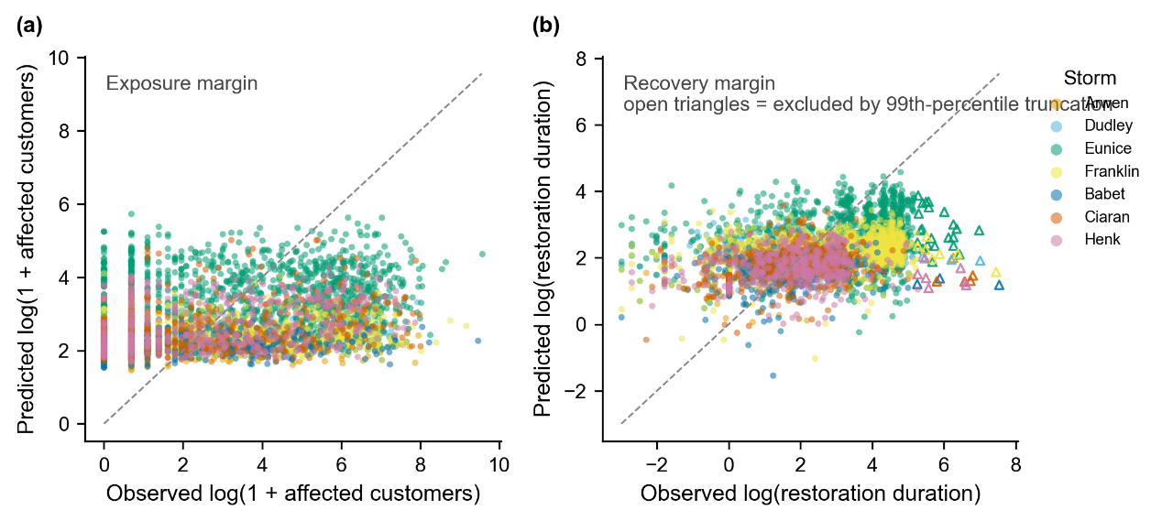
      - Fitted against observed outcomes during the seven named storms, coloured by storm, with a 45-degree reference line. (a) Exposure margin. (b) Recovery margin, with incidents beyond the recovery model's duration threshold marked separately as open triangles.
The fitted-observed correlation for each margin was also computed separately within each storm and compared against the correlation for the full sample. For the exposure margin, the full-sample correlation is 0.179, and the seven storm-specific correlations range from 0.116 to 0.341, without a consistent direction relative to the full-sample value. For the recovery margin, restricted to incidents within the model's duration threshold, the correlation across all seven storms combined is 0.378, and is significant well beyond conventional thresholds. Among the 48 incidents beyond this threshold, the correlation is -0.382, also significant, but in the opposite direction: the model has no demonstrated predictive value for restoration durations beyond the range it was fitted to, and the point estimate here suggests the opposite of a predictive relationship for this small group specifically.
The exposure pattern in Figure 9a is consistent with the model's modest explanatory power (Section 4.2). Such a model is not expected to track individual incidents closely, particularly when storms concentrate unmodelled sources of variation, such as competition for restoration crews, into a short period. The recovery margin shows a different pattern within its training range: a positive, statistically significant relationship between fitted and observed values for storm-period incidents, and no demonstrated predictive relationship for the small number of storm-period incidents whose duration falls beyond that range.
The predictions evaluated against storm-period outcomes in this section come from a model fitted on the full sample, which includes the incidents recorded during these seven storms. This comparison therefore checks how well the fitted model describes these specific events, rather than testing the model on data withheld from it in the way the temporal holdout in Section 4.4 does.
The Cause Code approach and the storm-period approach identify weather-driven incidents in different ways and are affected by different limitations. The Cause Code approach is subject to the selection account described above for the exposure margin. The storm-period approach draws on a comparatively small number of incidents and evaluates predictive fit rather than directly comparing the marginal contribution of gust against affected customers within storm periods specifically. The reversal in the ordering of marginal contributions reported in Table 4 is established by the Cause Code comparison. The storm-period comparison in this section provides a complementary check on how the fitted model performs during real, named extreme events, rather than a second, independent computation of the same reversal.

Retrospective temporal and clustering checks
The results reported in Sections 4.1 to 4.3 use the final combined sample, which pools the development sample with the confirmation sample once both had served their separate roles, as described in Appendix E. This section reports a more stringent check: the model specification is estimated separately on the development sample alone and on the confirmation sample alone, to assess whether the same finding holds in each part independently. The confirmation sample, covering 30 September 2023 to 31 March 2024, was not used to fit or select the final model specification, though, as Section 3.2 describes, some earlier methodological choices were made before this sample had been separated out.
For the exposure margin, the linear gust term changes sign between the two separately estimated samples, from negative in the development sample to positive in the confirmation sample, and the turning point moves from a position above the sample mean gust speed to a position below it. The 95 percent bootstrap confidence interval for the turning point, which excludes zero in the development sample, includes zero in the confirmation sample. The quadratic term itself remains positive and significant in both samples and is in fact larger in the confirmation sample than in the development sample. For the recovery margin, the quadratic gust term is positive and significant in both separately estimated samples, at 0.074 in the development sample and 0.073 in the confirmation sample. The linear gust term is not significant in either sample. The sample mean gust speed differs by approximately 11.6 percent between the two samples, higher in the confirmation sample, consistent with this period falling entirely within autumn and winter. Standard deviations are close between the two samples, to within about one percent, so quadratic terms are directly comparable, but a coefficient defined relative to each sample's own mean gust speed, such as the linear term, corresponds to a different physical wind speed in each sample.
Figure 10 compares the quadratic gust coefficient across four settings: the development sample, the confirmation sample, and the final combined sample's estimate under single and two-way clustered standard errors. For the recovery margin, all four confidence intervals are narrow and overlap closely. For the exposure margin, the confirmation-sample point estimate is visibly higher than the other three, which are themselves close to one another, though its confidence interval is not the widest of the four shown for this margin. The widest interval for this margin is instead the two-way clustered estimate.
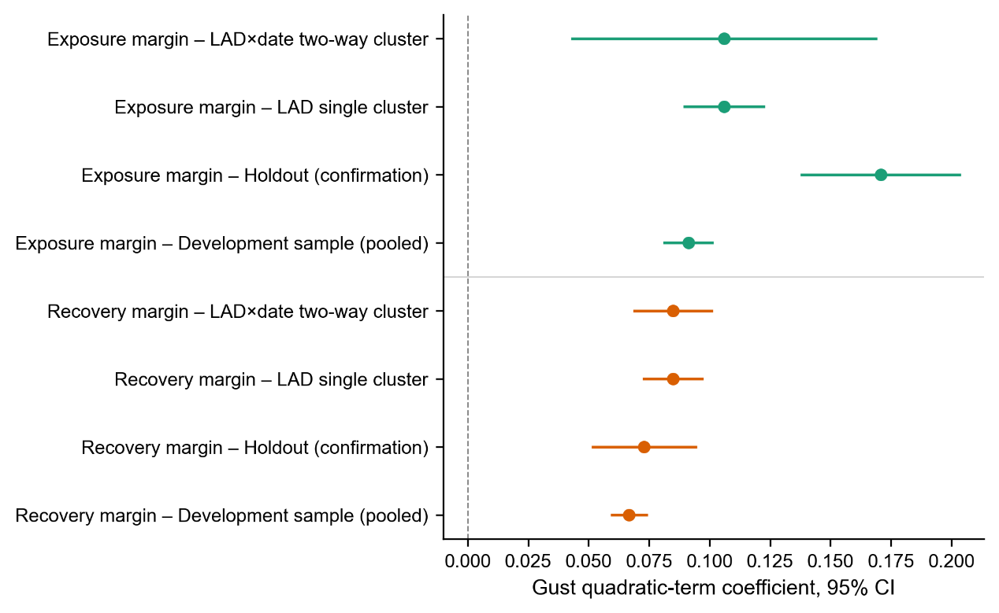
      - Quadratic gust coefficient, exposure and recovery margins, under four settings: development sample, confirmation sample, single clustering by Local Authority District, and two-way clustering by district and date. Points show coefficient estimates and horizontal lines show 95 percent confidence intervals.
The confirmation sample covers six months within a single autumn and winter period, rather than a full annual cycle, and is substantially smaller than the development sample. Both differences are expected to widen confidence intervals and to make a single point estimate less stable, independently of whether the underlying relationship has changed. A change in the exposure margin's specific turning point value is therefore not read here as a failure of the exposure model. The quadratic shape of the exposure response, and the full quadratic response of the recovery margin, are both confirmed in the sense used throughout this section: the same sign, and a similar or greater level of significance, in a sample that played no part in fitting the final model. The specific numerical value of the exposure margin's turning point is not confirmed in this same sense and is reported in Section 4.1 with this qualification in mind.
Standard errors clustered by both Local Authority District and date, rather than by district alone, were also checked for the final combined sample, as a further check on inference given the spatial clustering of incidents during a single storm. The quadratic gust term for the recovery margin remains significant under two-way clustering, with a p-value of 1.58 times ten to the power of minus 25, compared with 1.01 times ten to the power of minus 43 under single clustering. The quadratic gust term for the exposure margin also remains significant under two-way clustering (p = 0.000918). The linear gust term for the exposure margin (p = 0.010 under single clustering) is no longer significant at conventional thresholds under two-way clustering (p = 0.098), and the interaction between gust and pressure loses significance under two-way clustering for both margins (exposure p = 0.091, recovery p = 0.219). This same pattern, in which the quadratic terms remain significant while the linear term and the interaction term do not, was also found when this check was independently repeated on an earlier version of this dataset, providing an independent point of comparison for the pattern observed here.

Conclusion

Summary of findings
The two central findings of this paper concern the shape of the gust-outage relationship and the weight of gust relative to other explanatory variables. A pattern recurs across Sections 4.1, 4.3, and 4.4 concerning the first of these. A result that depends on a ratio of two estimated coefficients, such as a turning point, changes more between samples than a result that depends on a single coefficient, such as a quadratic term on its own. The recovery margin, for which no turning point is reported, is confirmed consistently throughout this paper. The exposure margin's turning point value is the one number that moves between samples. Readers using the results in this paper should place more weight on the quadratic terms on their own, and treat any specific turning-point value with the same qualifications reported in the section where it first appears.
Although its exact numerical value moves across the specifications considered in this paper, from 10.59 m/s in the simplified specification used for the comparison in Appendix H to 12.13 m/s in the corrected development sample considered on its own, every specification examined places the exposure margin's turning point within a consistent range, approximately 10 to 12 m/s. This range is also recovered by an unconstrained spline, reported in Appendix H, which was not given any functional form to follow and converged on 10.85 m/s independently. A structurally different candidate in the same appendix, whose turning point is fixed by a separate search over the full sample rather than allowed to emerge from the fit itself, gives a higher value of 13.39 m/s, consistent with the same general range though obtained by a different route. This consistency, across variation in sample composition, distributional assumption, and functional form, supports treating the existence of a nonlinear, threshold-like response to gust as a robust feature of the exposure margin in this dataset. Its precise numerical location, within this range, should not be treated as fixed.
The second finding is that gust's weight relative to affected customers is not fixed: modest across the full population of outages, but reversed within the subset of incidents for which weather is the recorded cause, where gust's marginal contribution exceeds that of affected customers.
Section 4.1 reports that affected customers, once the number of restoration stages per incident is considered, is associated with shorter restoration duration. This observed association is consistent with a dispatch-priority explanation, in which larger incidents receive earlier attention from restoration crews, but this paper does not evaluate any specific dispatch policy directly, and the association does not on its own establish that such a policy is the cause. Prior work using outage data from United States utilities has instead reported that the recovery duration of an outage is independent of the number of customers affected [26]. The direction of this relationship may depend on factors not examined in this paper, such as differences in network density between service areas, or differences in how restoration stages are defined and reported across utilities and regulatory frameworks.

5Practical implications, limitations, and future work
A practical implication follows from the second finding: real-time gust data is likely to carry more operational value once an incident is already known or strongly suspected to be weather-driven, such as during a declared storm, than as a general-purpose input for incidents of undetermined cause.
The critical wind speed identified for the exposure margin may be useful as an approximate reference point for storm-response planning, marking the gust level above which affected customer numbers begin to rise sharply, though it is better treated as an approximate operational reference than as a precise design threshold. More broadly, a dispatch or resourcing rule based on gust speed alone would not be well supported by the evidence in this paper. Gust speed is one input among several relevant factors, not a sufficient basis on its own for automated escalation decisions.
This paper describes conditional associations between weather conditions and outage consequences, not a complete decision model linking cause to consequence through an identified mechanism, as noted in Section 4.1. The relationships reported here are observational. They reliably describe what is associated with what in this dataset, but they do not on their own identify why gust, affected customers, or the number of restoration stages relate to outcomes in the way observed. A distribution network is a complex system with many interacting levels, from individual assets through substations to the wider network, and isolating a specific causal mechanism within this structure from incident-level outage records alone is not attempted in this paper. Mechanism identification, connecting the associations reported here to specific physical or operational processes within the network, is left for future work.
Several limitations affect how far these results can be applied in practice. The temporal holdout used in Section 4.4 covers six months within a single autumn and winter period, rather than a full annual cycle, which limits confidence in treating the exposure margin's specific turning-point value as a year-round planning reference rather than one calibrated to this season. The models in this paper use weather and regional covariates drawn from public meteorological and demographic sources, not asset-specific engineering information such as component age, material, or maintenance history. Any of these could plausibly explain more of the variation in outage consequences than the covariates used here, and their absence reflects a limitation of the available data rather than a judgement that they are unimportant. The exact meaning of incidents recorded with zero affected customers was not confirmed at the level of Ofgem's underlying data dictionary, which limits how confidently these specific incidents can be interpreted operationally. A method that uses the geographic coordinates of each incident directly, rather than grouping incidents into districts for clustering standard errors, was not attempted here and is left for future work.
This paper treats the affected-customers and restoration-duration margins as outcomes to be explained, without asking whether the relationship between them changes according to the type of hazard involved, or whether concurrent outages on the same network interact with each other. Both questions are left for future work, along with a comparison between the parametric approach used here and a machine learning approach of the kind introduced in Section 3.1.
The approach used in this paper, reconstructing event-level outcome measures from stage-level regulatory records according to their official definitions, and confirming the resulting model against both an independent time-period and a set of real storm events, is not specific to UK Power Networks. The same approach could be applied to any distribution network operator that reports outage incidents at the level of individual restoration stages, under a comparable regulatory framework.

Reference
[1] Hodgkin R, Haile D. Energy resilience [Internet]. Institute for Government; updated 20 March 2026. Available from: https://www.instituteforgovernment.org.uk/explainer/energy-resilience
[2] Office of Gas and Electricity Markets. Storm Arwen report [Internet]. 9 June 2022. Available from: https://www.ofgem.gov.uk/research/storm-arwen-report
[3] Guikema SD, Quiring SM, Han SR. Prestorm estimation of hurricane damage to electric power distribution systems. Risk Analysis. 2010;30(12):1744-1752.
[4] Liu H, Davidson RA, Apanasovich TV. Statistical forecasting of electric power restoration times in hurricanes and ice storms. IEEE Transactions on Power Systems. 2007;22(4):2270-2279.
[5] Nateghi R, Guikema SD, Quiring SM. Comparison and validation of statistical methods for predicting power outage durations in the event of hurricanes. Risk Analysis. 2011. [volume, pages unverified]
[6] Mukherjee S, Nateghi R, Hastak M. A multi-hazard approach to assess severe weather-induced major power outage risks in the U.S. Reliability Engineering & System Safety. 2018;175:283-305.
[7] Dikshit S, Alipour A. Characterizing probability of failure of transmission tower systems under multiple climatic hazards: wind and ice. Engineering Structures. 2025;342:120720.
[8] Zhu X, Ou G. Wind fragility modeling of transmission tower-line system based on threat-dependent structural robustness index. Structural Safety. 2025;114:102571.
[9] Ma L, Khazaali M, Bocchini P. Component-based fragility analysis of transmission towers subjected to hurricane wind load. Engineering Structures. 2021;242:112586.
[10] Kabre WW, Weimar MR. Fragility functions resource report: documented sources for electricity and water resilience valuation. PNNL-33587. Richland (WA): Pacific Northwest National Laboratory; 1 October 2022. DOI: 10.2172/1969999.
[11] Office of Gas and Electricity Markets. RIIO-ED1 regulatory instructions and guidance: Annex F -- interruptions. London: Ofgem; 18 June 2015.
[12] Office of Gas and Electricity Markets. RIIO-ED2 regulatory instructions and guidance: Annex F -- interruptions. London: Ofgem; 2023.
[13] Zippenfenig P. Open-Meteo.com weather API [Computer software]. Zenodo; 2023. DOI: 10.5281/ZENODO.7970649.
[14] Hersbach H, Bell B, Berrisford P, Hirahara S, Horanyi A, Munoz-Sabater J, et al. The ERA5 global reanalysis. Quarterly Journal of the Royal Meteorological Society. 2020;146:1999-2049.
[15] American Society of Civil Engineers. Minimum design loads and associated criteria for buildings and other structures. ASCE/SEI 7-22. Reston (VA): ASCE; 2022.
[16] Sturmer JM, Plietzsch A, Anvari M. The risk of cascading failures in electrical grids triggered by extreme weather events. In: Proceedings of ENERGY 2021: The Eleventh International Conference on Smart Grids, Green Communications and IT Energy-aware Technologies; 2021. Page range not available.
[17] Office for National Statistics. Explore local statistics [Internet]. Continuously updated service; quality and methodology information last revised 25 April 2025. Available from: https://www.ons.gov.uk/explore-local-statistics/
[18] Office for National Statistics. Mapping income deprivation at a local authority level [Internet]. 24 May 2021. Available from: https://www.ons.gov.uk/peoplepopulationandcommunity/personalandhouseholdfinances/incomeandwealth/datasets/mappingincomedeprivationatalocalauthoritylevel
[19] Moran PAP. Notes on continuous stochastic phenomena. Biometrika. 1950;37(1-2):17-23.
[20] Office for National Statistics. Local Authority Districts (December 2021) boundaries UK BGC [Internet]. Available from: https://open-geography-portalx-ons.hub.arcgis.com/datasets/ons::local-authority-districts-december-2021-boundaries-uk-bgc
[21] O'Brien RM. A caution regarding rules of thumb for variance inflation factors. Quality & Quantity. 2007;41(5):673-690.
[22] McCullagh P, Nelder JA. Generalized linear models. 2nd ed. London: Chapman and Hall; 1989.
[23] Cox DR. A note on data-splitting for the evaluation of significance levels. Biometrika. 1975;62(2):441-444.
[24] Cameron AC, Miller DL. A practitioner's guide to cluster-robust inference. Journal of Human Resources. 2015;50(2):317-372.
[25] Oehlert GW. A note on the delta method. The American Statistician. 1992;46(1):27-29.
[26] Wu H, Meng X, Danziger MM, Cornelius SP, Tian H, Barabási AL. Fragmentation of outage clusters during the recovery of power distribution grids. Nature Communications. 2022;13:7372.
[27] Sobol' IM. Global sensitivity indices for nonlinear mathematical models and their Monte Carlo estimates. Mathematics and Computers in Simulation. 2001;55(1-3):271-280.
[28] Pianosi F, Wagener T. A simple and efficient method for global sensitivity analysis based on cumulative distribution functions. Environmental Modelling & Software. 2015;67:1-11.
[29] Herman J, Usher W. SALib: An open-source Python library for sensitivity analysis. Journal of Open Source Software. 2017;2(9):97.

